Importing OCR Nationals Results to SIMS in the Summer Series

1 Download and import the Basedata

Please note that SIMS cannot import summer results before June 15th of any year.
Go to your June/Summer season within SIMS Exams Organiser.
Download the revised Basedata for the summer series from the OCR website at http://www.ocr.org.uk/ocr-for/exams-officers/basedata/
Import the revised Basedata into SIMS Exams Organiser.
Nothing more needs to be done with the Basedata files.

2 Take a copy of the results file
Download your results files from A2C
Go to your Sims → Examin folder¹. Find the OCR Nationals results file you want to amend. The file(s) will be named ‘Rnnnnn72.Xnn’
Copy and save somewhere separately. Keeping a copy of the original is good practice.
¹ The directory name is usually ‘Examin’. However it could be different in your centre. Check with your SIMS support if you are unsure.

3 Edit your results file
Open the results file saved in ‘Examin’¹ with a text editor, eg Notepad (see page 2).
At the top you will see two lines containing the season details. In the example below the header reference is 9N12 for September 2012:
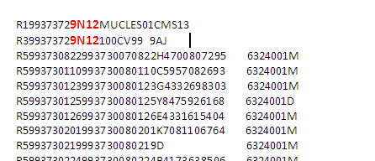
Amend this to 6N13 for June 2013 as shown below. Remember to edit the year so that the results go into the correct season. Save the file in the ‘Examin’¹ directory.
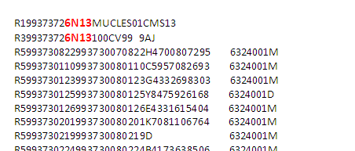
¹ The directory name is usually ‘Examin’. However it could be different in your centre. Check with your SIMS support if you are unsure.

4 Import the results file
You can now import the amended file (e.g. Rnnnnn72.Xnn) to the June series as per your normal process. Remember to import the amended file and not the backup of the original.

Opening a file using Microsoft Notepad
When you open a basedata file for the first time, you will receive the following prompt:
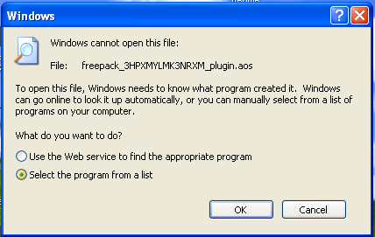
Choose ‘Select the program from a list’, click ‘OK’ and select ‘Notepad’ from the list of programs.


