Unit R113 – Electronic principles

Principles, units and measurement

Task 1
Electronic circuits are constructed using devices such as batteries, resistors, inductors and capacitors to name but a few. These devices perform various circuit functions, often together, to make the circuit work. They do this through a range of electrical principles.

Each of these principles has an associated electrical unit which can be measured.

Your task, working individually or in pairs, is to answer the questions on the worksheet. You may use whatever means you like to research your answers.

1.

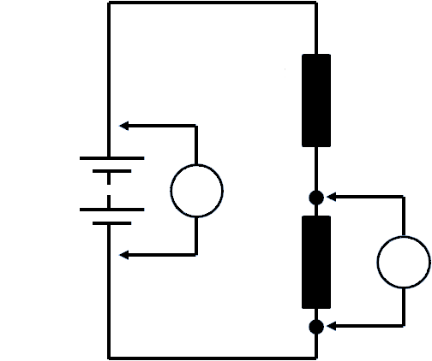
Resistor

M1
Battery
1
Resistor

M2

2

- What quantity is meter M1 measuring – electromotive force (EMF) or potential difference (PD)?

- What quantity is meter M2 measuring - electromotive force (EMF) or potential difference (PD)?

- What is the unit of measurement for both meter M1 and M2?

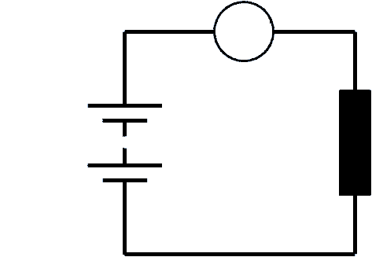
2.
Resistor
M
Battery

- What is meter M measuring in the circuit?

- What are the units of measurement?

- Match (by drawing a line as shown) the principle/quantity to their unit of measurement:

Principle/Quantity
Units of Measurement

EMF | amps
current | volts
resistance | ohms
power | henry
inductance | farads
capacitance | hertz
frequency | watts

- Will the current flowing in the circuit increase or decrease if the value of the resistance (resistor) is increased?
Current
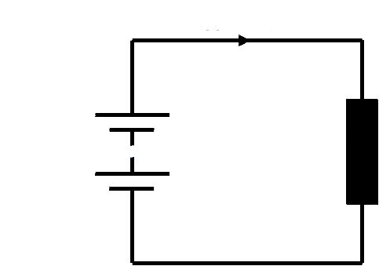

Resistor

Battery

- The capacitor in the circuit is connected to the battery with the switch at position 1.

What will be shown by the lamp when the switch is moved from position 1 to position 2?

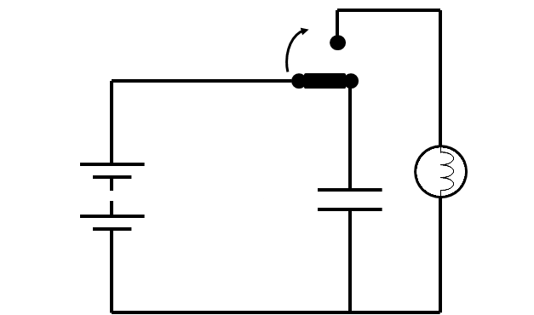
Capacitor
Battery
2
1

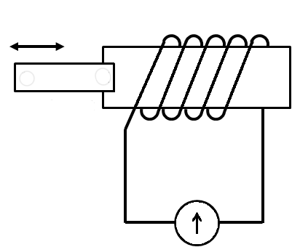
6.
Magnet
S
N
Coil

- What will happen to the pointer on the meter when the magnet is moved in and out of the coil of wire?

- What principle is being shown?

- When an inductor is disconnected from a supply a back-EMF is generated.
Explain what back-EMF is and how this happens?

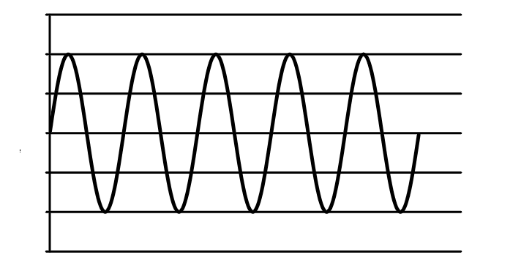

Voltage
1 second
Time

- What is the frequency of the a.c. voltage supply shown?

- What is the frequency of the mains a.c. supply?

- Power is transferred from the power supply to the circuit.

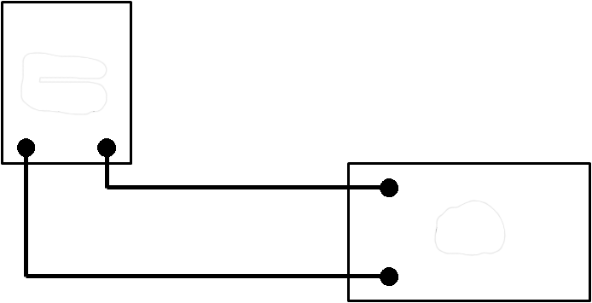
Power supply

Circuit

If the power supply voltage is fixed, what affects how much power the circuit draws?

- The picture shows a domestic electric meter.
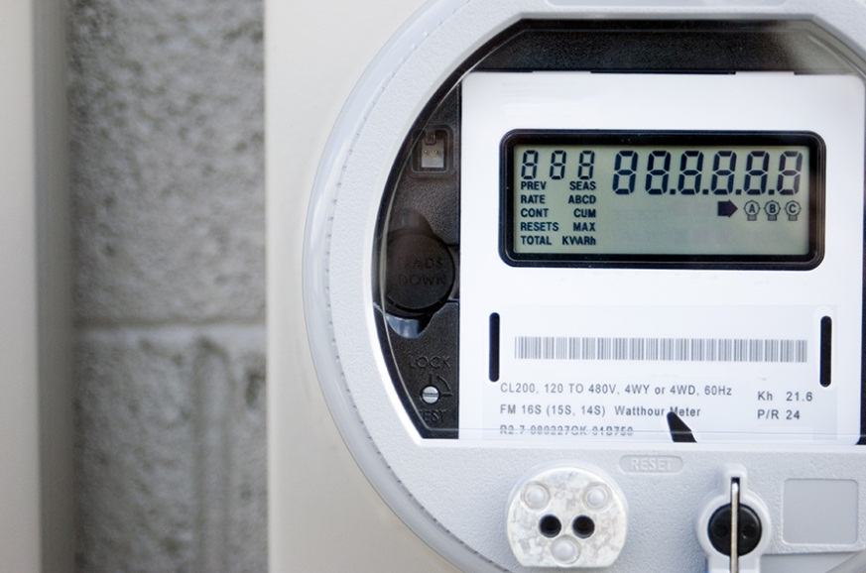

What does the meter read and what are the units?

OCR Resources: the small print
OCR’s resources are provided to support the teaching of OCR specifications, but in no way constitute an endorsed teaching method that is required by the Board, and the decision to use them lies with the individual teacher. Whilst every effort is made to ensure the accuracy of the content, OCR cannot be held responsible for any errors or omissions within these resources.
© OCR 2014 - This resource may be freely copied and distributed, as long as the OCR logo and this message remain intact and OCR is acknowledged as the originator of this work.

OCR acknowledges the use of the following content: Maths and English icons: Air0ne/Shutterstock.com, satellite: puchan/Shutterstock.com,
shoes: Natali Glado/Shutterstock.com, mp3 player: You can more//Shutterstock.com, Tennis racket: ID1974/Shutterstock.com, Washing machine:
KKulikov/Shutterstock.com, London eye: 1000 words/Shutterstock.com, Sports car: GuoZhongHua/Shutterstock.com,
Bread: v.s.anandhakrishna/Shutterstock.com,

