Unit R114 – Simulate, construct and test electronic circuits

Using test equipment

Task 1
Once an electronic circuit has been designed and built then it is normally tested. This will ensure that it has been constructed correctly, and is functioning as it should. If the circuit is not working as expected then fault finding techniques can be used to diagnose the problem.

In order to electrically test a circuit a range of test equipment is used. This will often include a power supply, multimeter, logic probe, signal generator and oscilloscope.

You task is to research, for each item of test equipment, how it is used in the testing of an electronic circuit and the functions it performs. For each item also consider how the equipment should be used safely (to protect both the user and the circuit being tested). Complete the following table which shows typical pictures of each of these items of test equipment.

 | Functions and features used when considering testing: | Safety issues to consider:
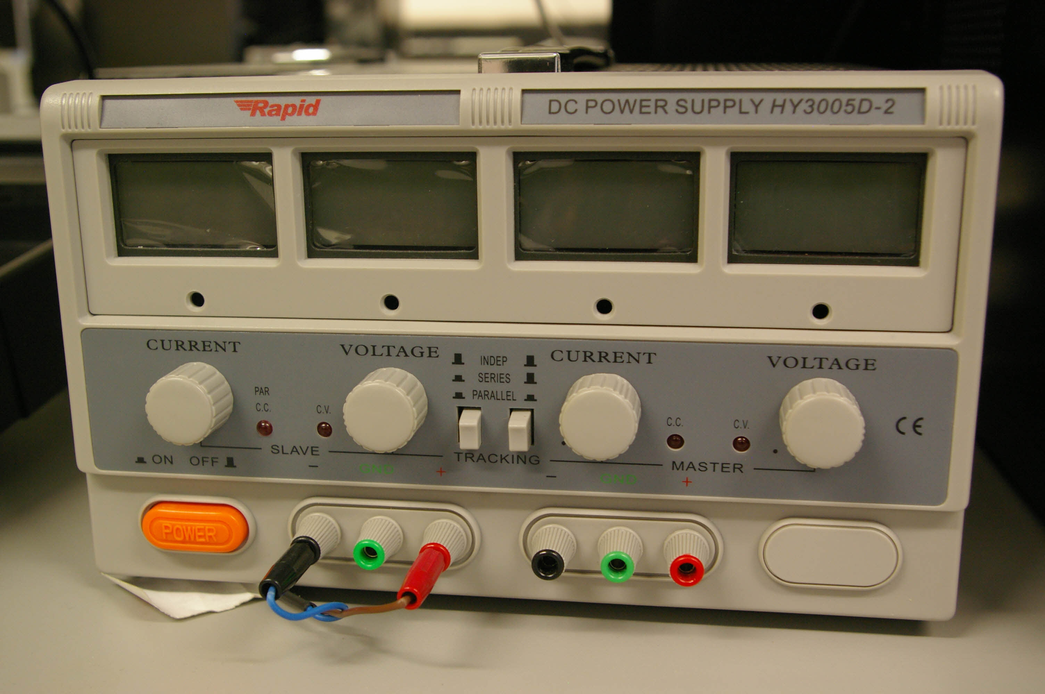
Power Supply

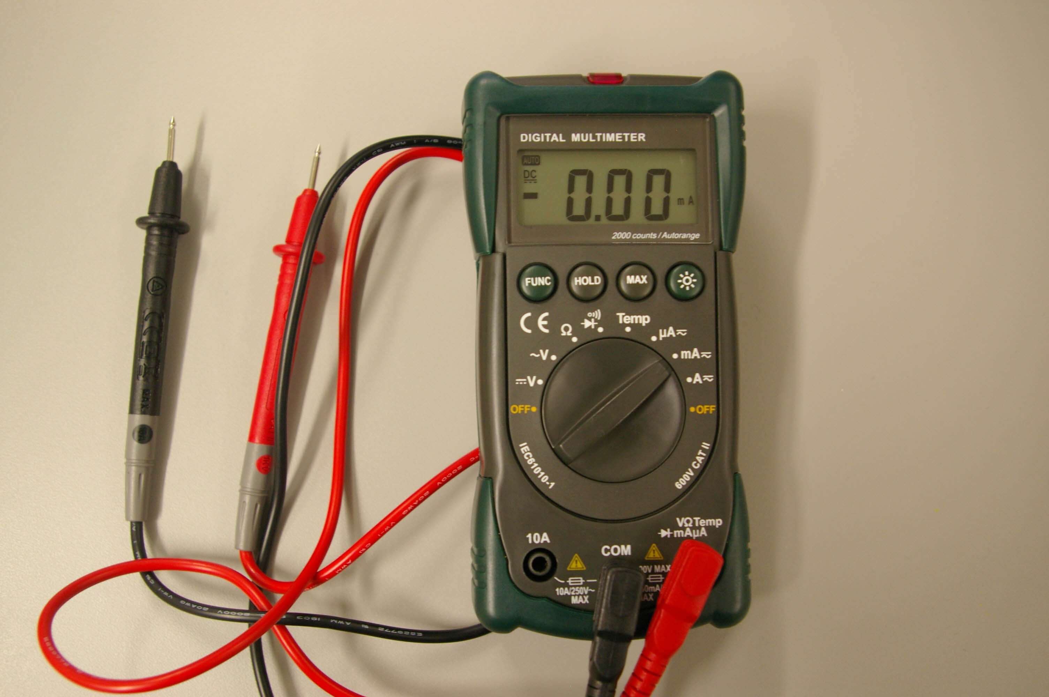
Multimeter

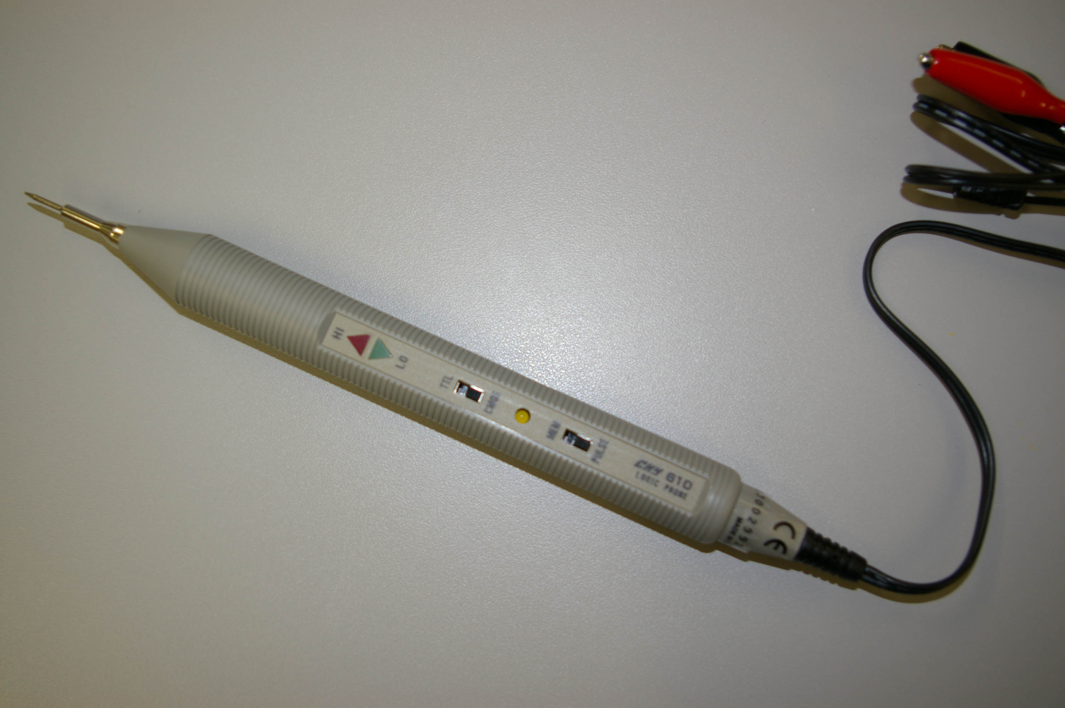
Logic Probe
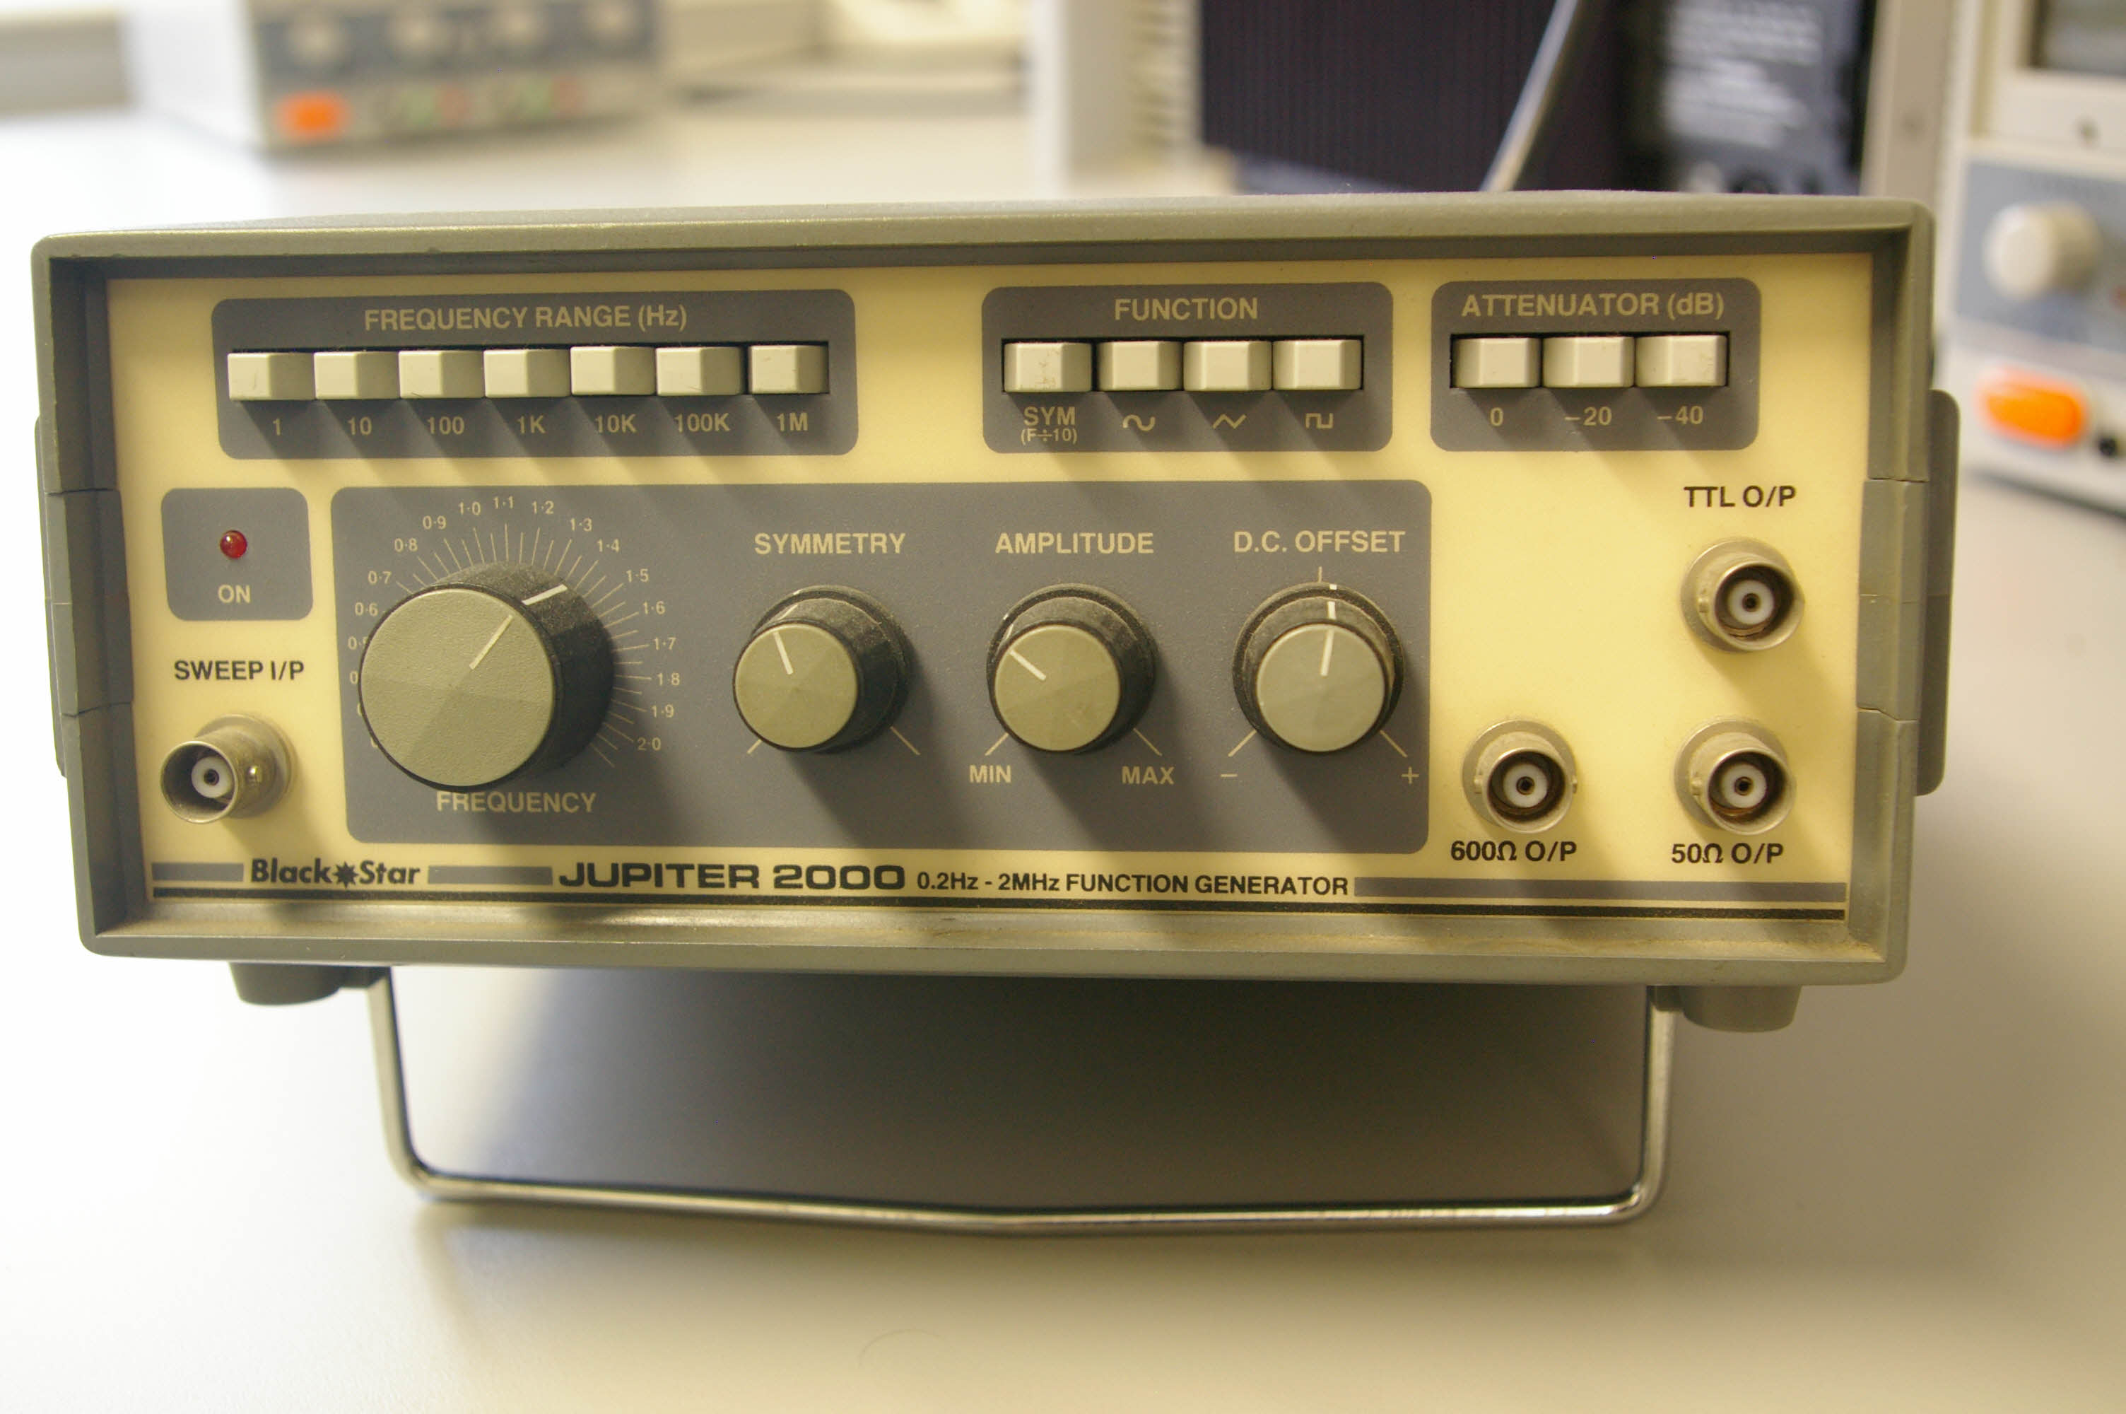
Signal or Function
Generator

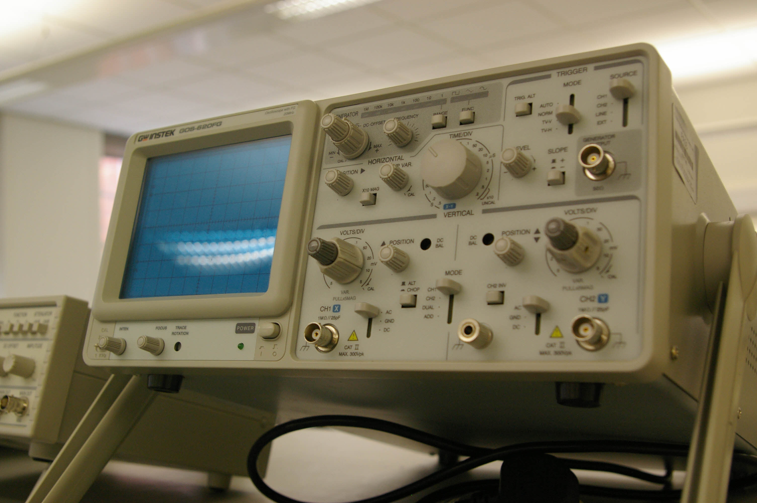
Oscilloscope

OCR Resources: the small print
OCR’s resources are provided to support the teaching of OCR specifications, but in no way constitute an endorsed teaching method that is required by the Board, and the decision to use them lies with the individual teacher. Whilst every effort is made to ensure the accuracy of the content, OCR cannot be held responsible for any errors or omissions within these resources.
© OCR 2014 - This resource may be freely copied and distributed, as long as the OCR logo and this message remain intact and OCR is acknowledged as the originator of this work.

OCR acknowledges the use of the following content: Maths and English icons: Air0ne/Shutterstock.com, satellite: puchan/Shutterstock.com,
shoes: Natali Glado/Shutterstock.com, mp3 player: You can more//Shutterstock.com, Tennis racket: ID1974/Shutterstock.com, Washing machine:
KKulikov/Shutterstock.com, London eye: 1000 words/Shutterstock.com, Sports car: GuoZhongHua/Shutterstock.com,
Bread: v.s.anandhakrishna/Shutterstock.com,

