Lesson Element

Genetically Modified Organisms Dating Game - Game Cards
Red-border gene donor organism cards:
Image on front | Information on back
Name Phyllomedusa bicolor
Giant Leaf Frog
Key gene
DRS B1
Properties of gene product
B1dermaseptin protein kills bacteria and fungi.
GM use
To prevent blight and bacterial diseases in potato crops.

Image on front | Information on back
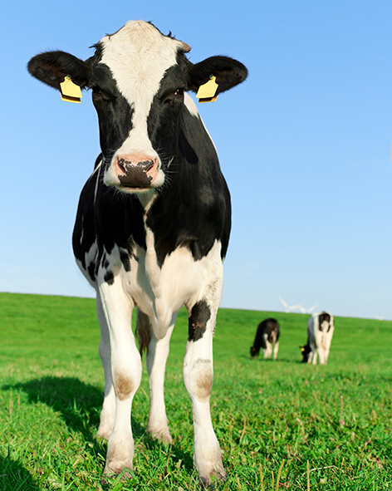 | Name Bos primigenius  Cattle  Key gene  Cym  Properties of gene product  Chymosin is a protease enzyme that curdles milk.  GM use  GM bacteria produce the enzyme which is purified and used to make cheese. Previously chymosin was extracted from the stomachs of calves so cheese made in this way was not acceptable to vegetarians. 80-90% of the cheese sold in Britain is made with GM bovine chymosin.
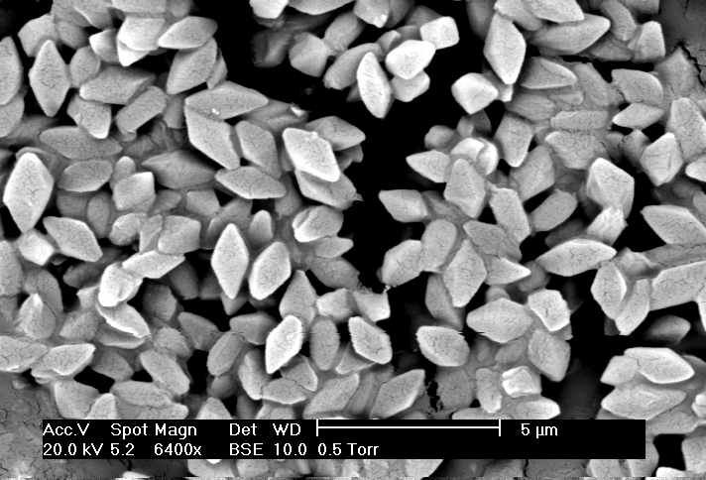  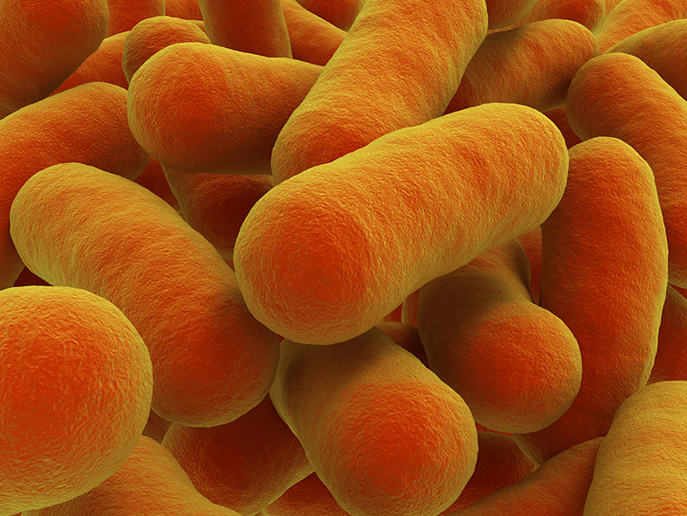 | Name Bacillus thuringensis  Key gene  Cry  Properties of gene product  Crystal protein kills caterpillars, maggots and beetles that eat the protein.  GM use  To make crops such as maize, cotton and soya bean resistant to herbivorous insects.  Name Agrobacterium sp C4 strain  Key gene  C4 EPSPS  Properties of gene product  EPSP synthase performs a crucial metabolic step in plant chloroplasts. The bacterial version is undamaged by glyphosate.  GM use  To make crops resistant to glyphosate so it can be used as a weed killer without harming the maize, cotton or soya bean crops.
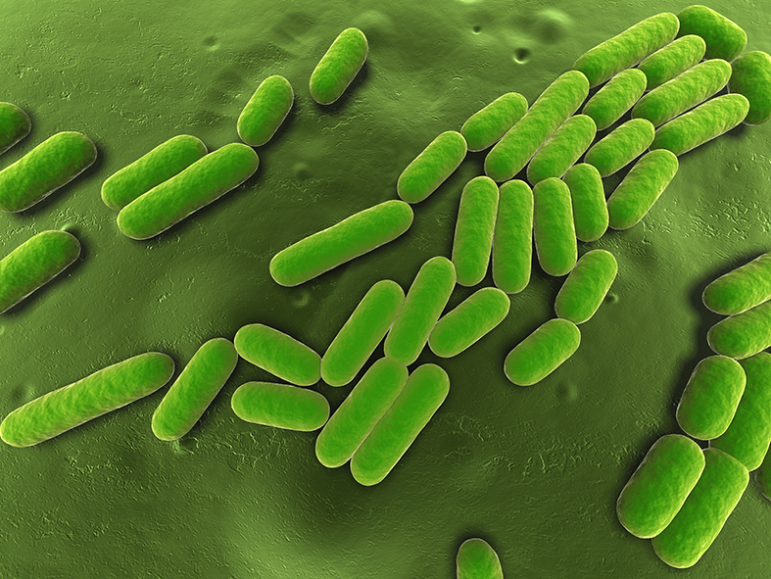 | Name Bacillus subtilis  Key gene  cspB  Properties of gene products  Cold shock protein B helps organisms metabolise normally during abiotic stress.  GM use  To make maize grow more and produce a higher yield under drought conditions.

Image on front | Information on back
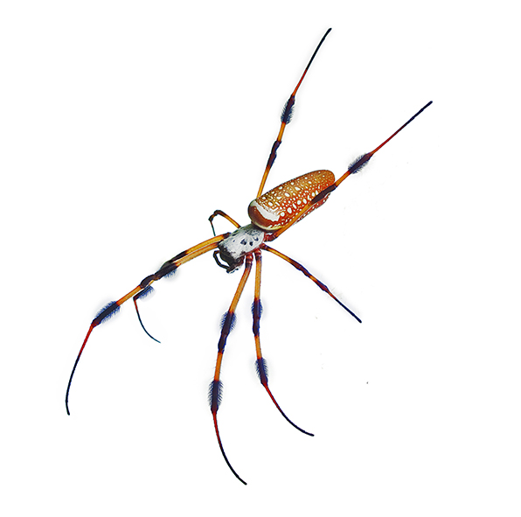 | Name Nephila clavipes  Golden Orb Weaver  Key gene  MaSp  Properties of gene product  High-strength silk fibre for webs.  GM use  Gene is switched on in mammary glands of GM goats to mass-produce the silk fibre for artificial tendons and ligaments and for bullet-proof vests and parachutes.
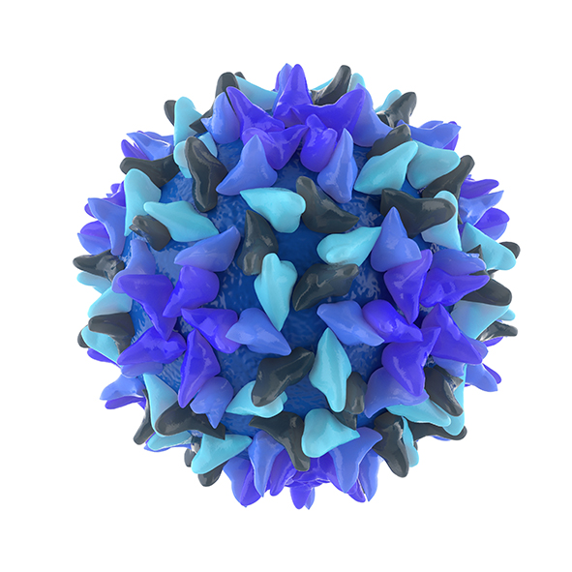  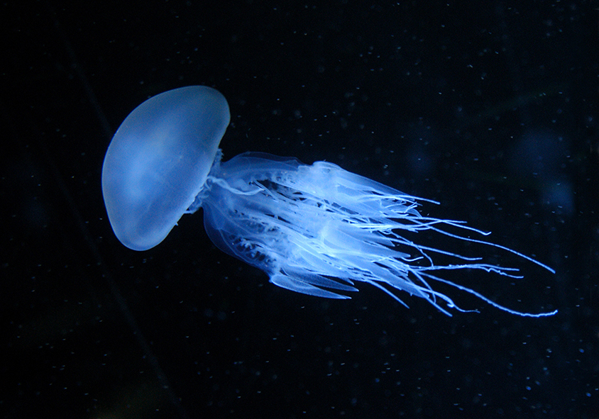 | Name Hepatitis B virus  Key gene  HBsAg  Properties of gene product  Surface antigen of virus stimulates an immune response in humans if injected or given orally.  GM use  GM potatoes eaten raw in small quantities boost immunity to hepatitis B. Cheap way of delivering vaccines in developing world..  Name Aequorea Victoria  Jellyfish  Key genes  GFP  Properties of gene products  Green Fluorescent Protein glows under UV light.  GM use  The gene is extensively used as a marker to reveal which organisms have taken up a foreign gene and in which tissues the gene is switched on. Spin-offs include Glo-FishTM and NeonMice sold as pets in the USA.
Name Homo sapiens
Human
Key genes
Mutated version of BRCA1 and activated Ras oncogene.
Properties of gene products
Cause cancer. The products of the normal versions of the genes repair DNA mutations and suppress tumours.
GM use
Creating cancer research models.
GM mice engineered to carry the mutant alleles are used to study cancer and treatments for cancer.

Image on front | Information on back
Name Homo sapiens
Human
Key genes
Normal alleles coding for insulin, lactoferrin, Factor IX, anti-thrombin III and glucosidase.
Properties of gene products
Insulin controls blood glucose concentration.
Lactoferrin is an antimicrobial found in colostrum and milk.
Factor IX helps blood clot.
Anti-thrombin III stops blood clotting.
Glucosidase in lysosome function
GM use
Pharmaceutical drugs
Insulin from GM bacteria treats diabetics.
Lactoferrin in GM rice treats diarrhoea in children.
Factor IX from GM sheep’s milk treats people with haemophilia B.
Anti-thrombin III from GM goats’ milk is used as an anti-coagulant in surgical procedures.
Glucosidase from GM carrot cells in culture treats people with Gaucher’s disease.
Name Homo sapiens
Human
Key genes
CFTR
RPE65
Properties of gene products
CFTR protein allows normal mucus production in lungs and gut.
RPE65 protein is needed in rods and cones for normal vision.
GM use
Gene therapy
Normal CFTR allele is introduced into lung epithelial cells of cystic fibrosis patients.
RPE65 inserted into retinal cells of blind patients with Leber’s Congenital Amaurosis restored sight.

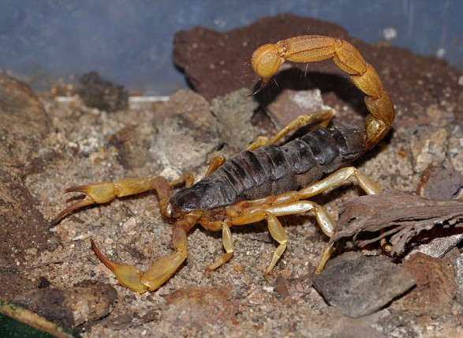 | Name Androctonus australis hector  Scorpion  Key genes  AaHIT1  Properties of gene products  Toxic to insects but not harmful to mammals.  GM use  To kill insects on GM cotton crops.

Blue-border recipient organism cards:

Image on front | Information on back
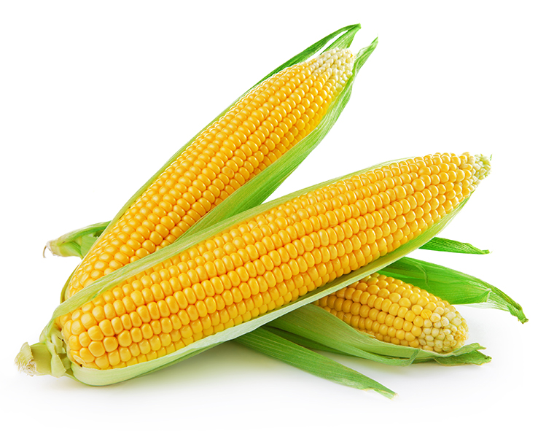 | Name Zea mays  Maize or Sweetcorn  Suitability as a GM recipient  Major food source for animals and humans and as a source of starch and sugars for processed food. Many insects attack the crop however, its yield falls in drought conditions and the crop must be kept free of weeds.
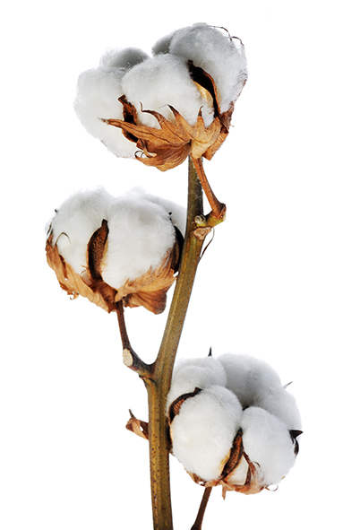 | Name Gossypium hirsutum  Cotton  Suitability as a GM recipient  Important crop for textile fibres but many insect pests attack it and the crop must be kept free of weeds.
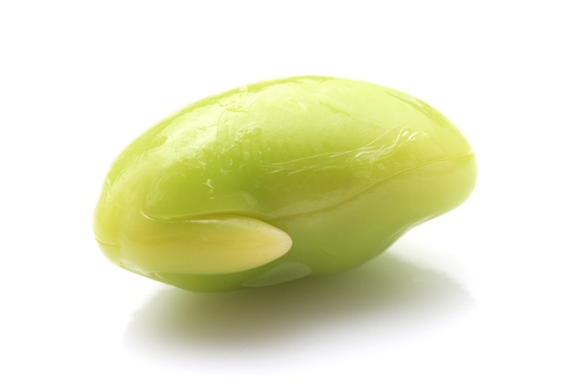 | Name Glycine max  Soya bean  Suitability as a GM recipient  Major food source for animals and for humans as a source of protein in processed food. Many insects attack the crop however and the crop must be kept free of weeds.
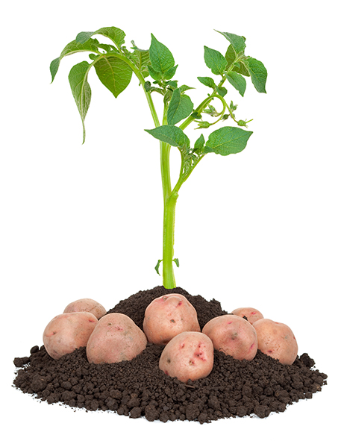 | Name Solanum tuberosum  Potato  Suitability as a GM recipient  Major carbohydrate food source in Europe and America. Potatoes are easy to grow and can give high yields but suffer from many diseases such as blight, which lower yields. They can be engineered to make vaccines but these must be grown under cover to prevent gene flow to other potatoes and to stop antigenic potatoes accidentally entering the human food chain.
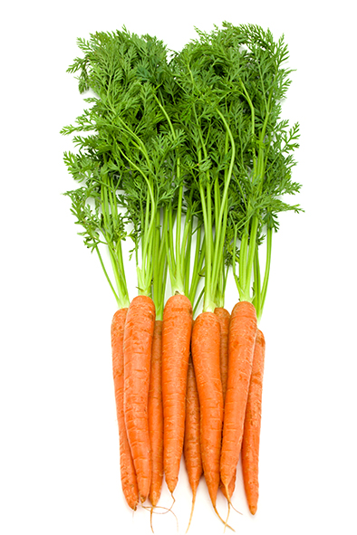 | Name Daucus carota  Carrot  Suitability as a GM recipient  Field-grown crops generally have been found to be unsafe to use as vehicles for production of pharmaceutical drugs but carrot cells grown in culture in bioreactors are a new ‘expression platform’ for human proteins that can be used as medical drugs.
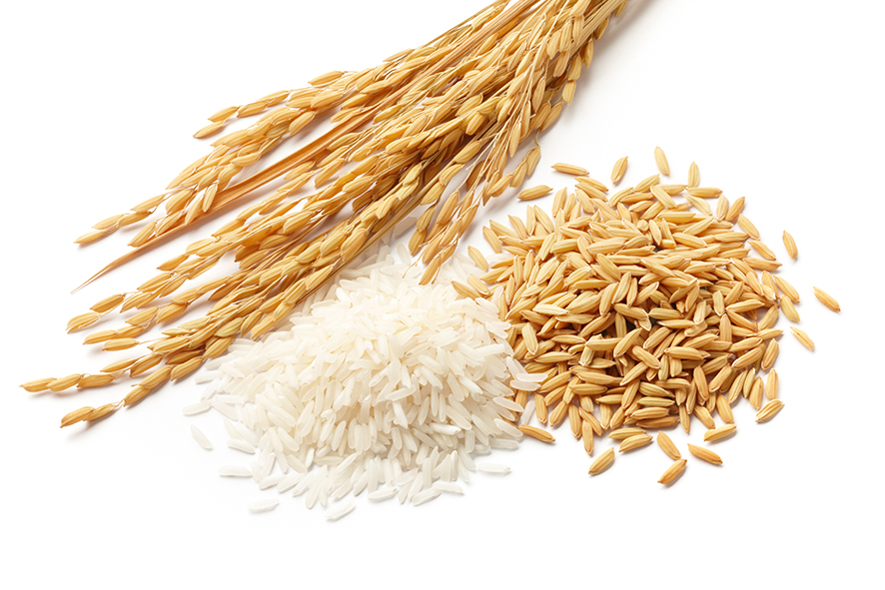 | Name Oryza sativa  Rice  Suitability as a GM recipient  Major food source in Asia and a suitable vehicle for therapies like treating children with diarrhoea (rice enhanced with human lactoferrin) and preventing vitamin A deficiency (genes from maize or daffodil and a soil bacterium).
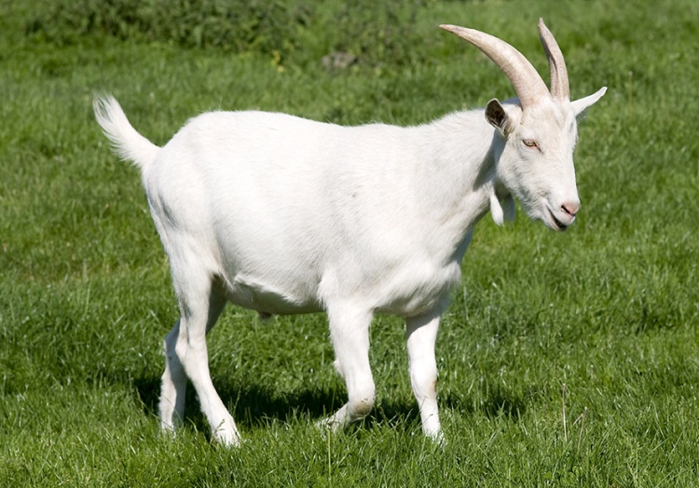 | Name Capra aegagrus hircus  Goat  Suitability as a GM recipient  Female goats produce plenty of milk. A gene is linked to a promoter to switch the gene on in the mammary glands, so that the protein product appears in the milk. So-called ‘spider-goats’ produce silk in their milk for medical and military applications. Other GM goats produce a drug, human anti-thrombin III, used as an anticoagulant in surgery.
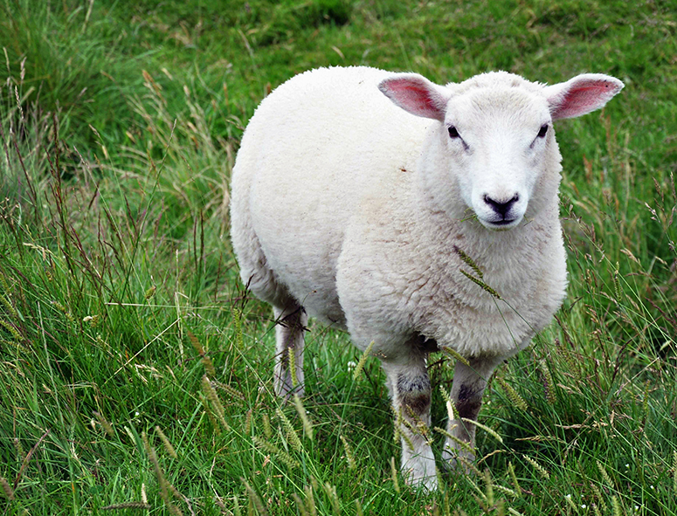 | Name Ovis aries  Sheep  Suitability as a GM recipient  Female sheep produce plenty of milk. A gene for a pharmaceutical protein is linked to a promoter to switch the gene on in the mammary glands, so that the protein appears in the milk. Sheep have been used to make factor IX to treat sufferers of haemophilia B.
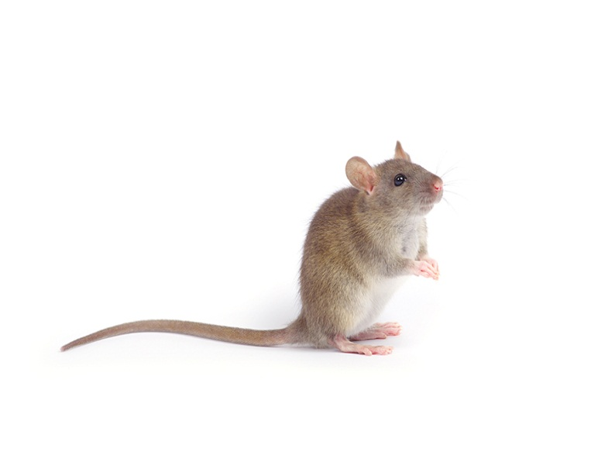 | Name Mus musculus  Mouse  Suitability as a GM recipient  It is a genetic model organism with a well-known, fully-sequenced genome. As a mammal its genome is very similar to that of humans. Mice are small so are cheap to feed and house. Many GM techniques applicable to humans or farm mammals are first tried on mice. Fluorescent GM NeonMice are sold as pets in the USA.
Name Homo sapiens
Human
Suitability as a GM recipient
People suffering from genetic diseases caused by two recessive non-functional alleles can be treated with gene therapy. The dominant functional allele is inserted into affected somatic cells. Trials have included treatment of cystic fibrosis and Leber’s congenital amaurosis. The limitation on treating a human with another human allele is whether the cells that need the foreign DNA are accessible (eg lung epithelium) and stable (not replaced every few days).
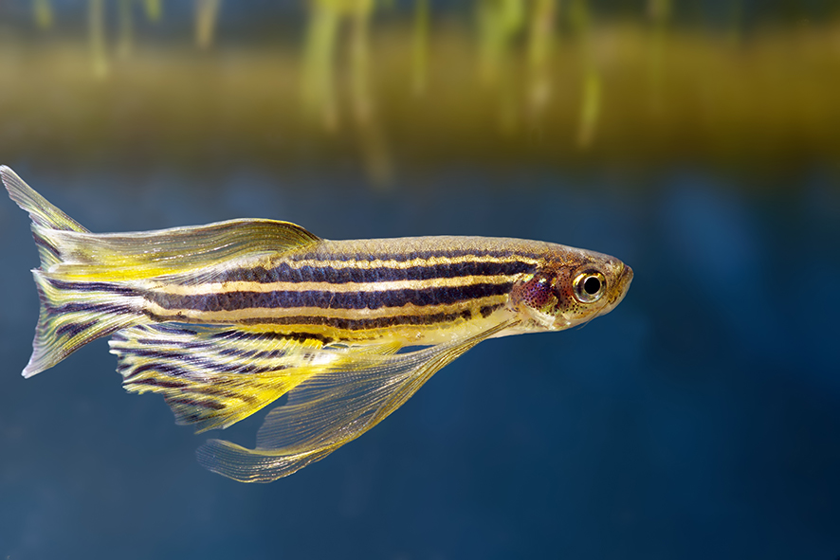 | Name Rerio danio  Zebrafish  Suitability as a GM recipient  It is a genetic model organism with a well-known, fully-sequenced genome. It is a useful simple vertebrate for research. GM zebrafish expressing genes for fluorescent proteins are on sale in the pet trade in the USA marketed as Glo-FishTM.
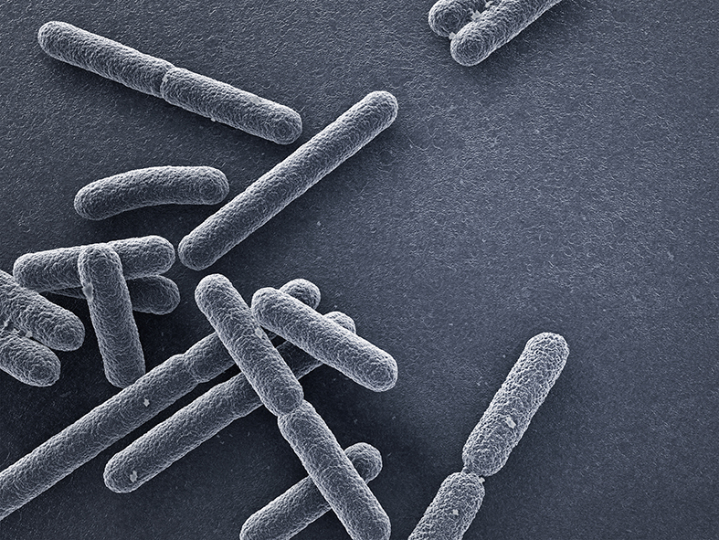 | Name Escherichia coli  Suitability as a GM recipient  GM bacteria divide rapidly in a fermenter to produce proteins like human insulin, and bovine chymosin for cheese-making.  E.coli is a genetic model organism with a well-known, fully-sequenced genome. Its plasmids are widely used as vectors. However some strains of E.coli are pathogenic and the GM process may involve inserting antibiotic resistance genes into the bacteria.

