Unit R106 – Product analysis and research

Disassembly Methods and Procedures

Task 1:
A good way of analysing existing products is to take them apart and to see how they are made and how they work. In order to take a product apart safely and to measure key features accurately then appropriate tools and instruments are required.

The following pictures show tools that are typically used to dismantle a product and instruments to measure key features.

Your task is to:

- Identify the tools and measuring instruments
- State what they would be used for when dismantling or analysing a product
- Explain what safety precautions should be taken

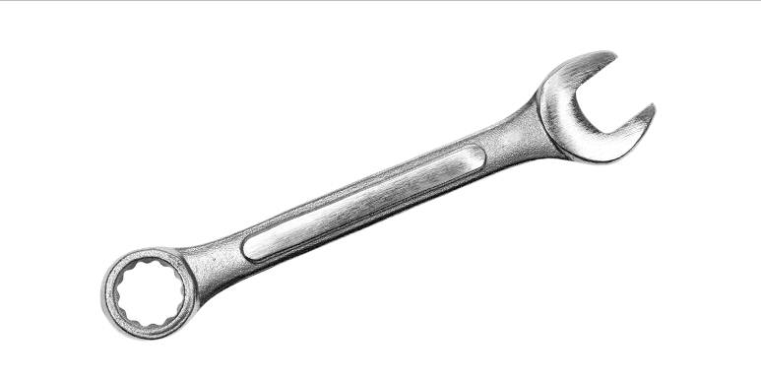
Tool 1

Used for | Safety

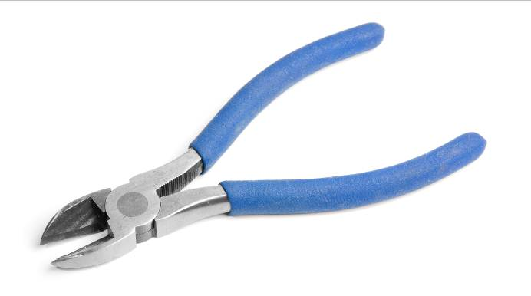
Tool 2

Used for | Safety

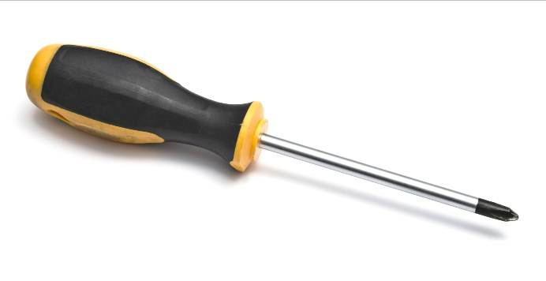
Tool 3

Used for | Safety

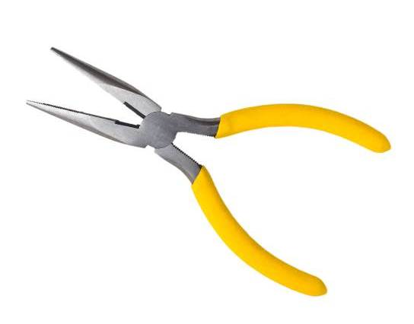

Tool 4

Used for | Safety

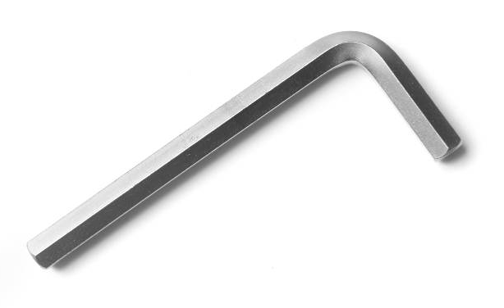
Tool 5

Used for | Safety

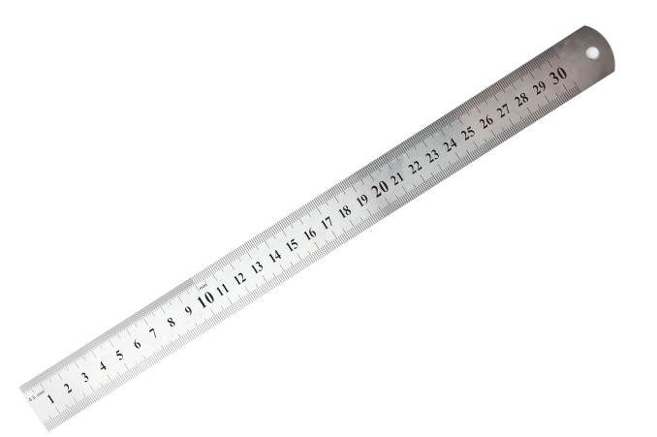
Measuring Instrument 1

Used for | Safety
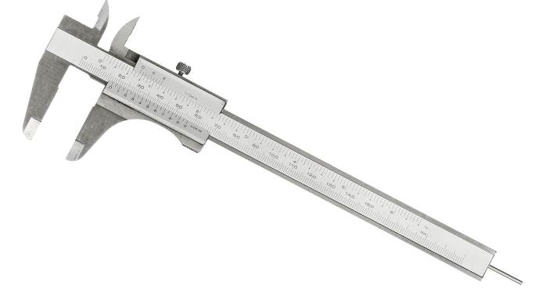
Measuring Instrument 2

Used for | Safety

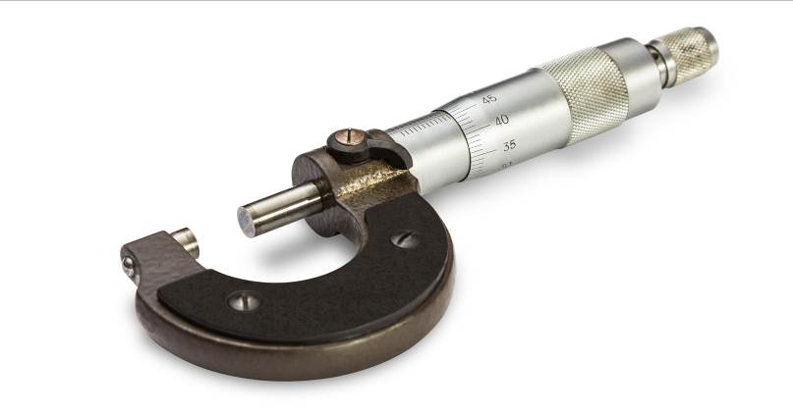
Measuring Instrument 3

Used for | Safety

