Unit R110 – Preparing and planning for manufacture

Producing pre-production plans

Task 1:
Making a cup of tea is an example of an activity where planning is required. As this is an everyday event then this planning might not be written down – but is in the head of the person making the tea. Your task (in pairs) is to write a plan explaining step-by-step how to make a cup of tea. State clearly the operation, equipment required, an estimate of how long it takes, any health and safety and also the quality control checks.

The tea is to be made using a tea bag in a cup (as shown below) and the tea drinker likes a little milk and two sugars.
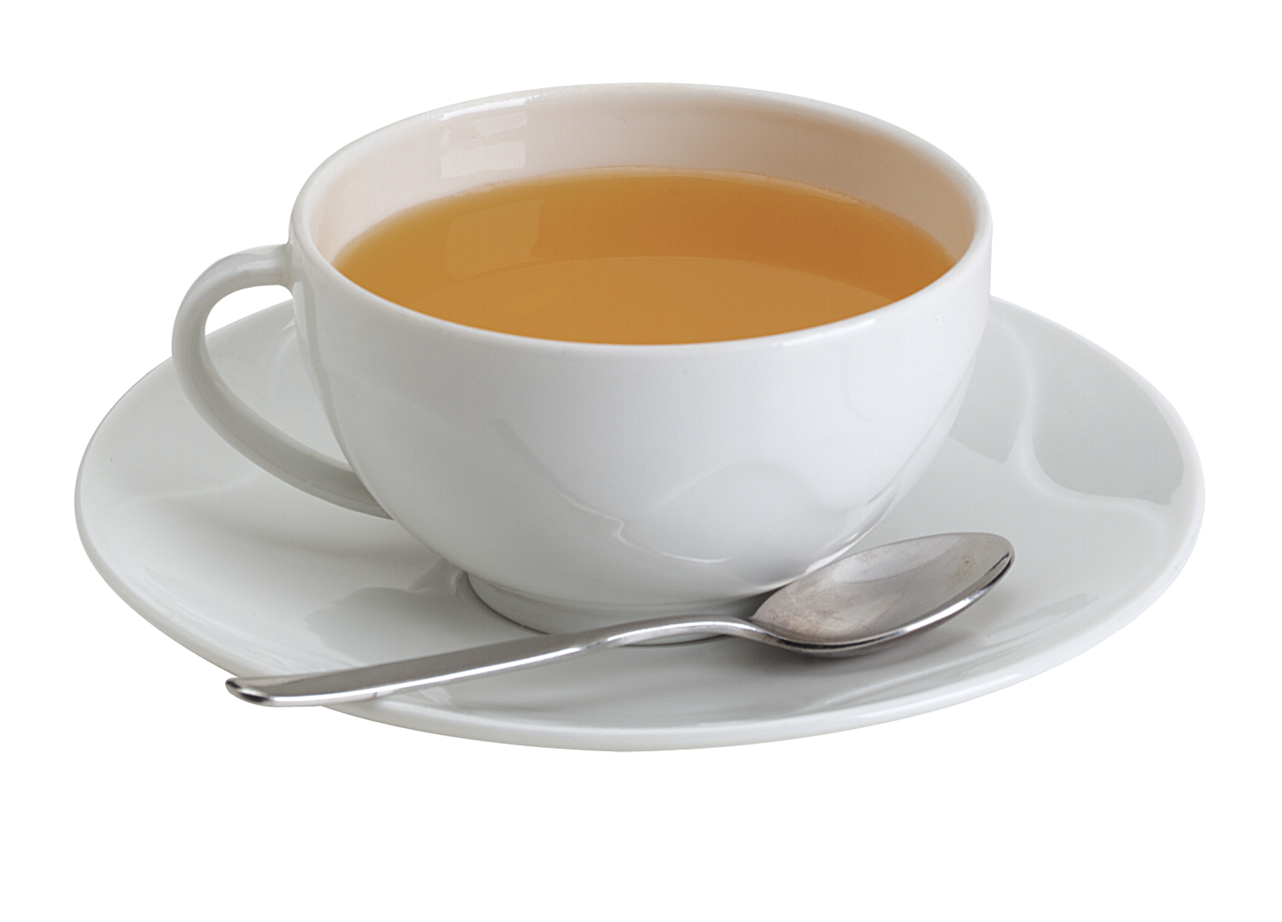

Complete the table – the first step is done for you!

Step | Operation | Equipment required | Time Estimate | Health and Safety | Quality Control Checks
1 | Remove cup and saucer from the cupboard | cup, saucer | 5 secs | Make sure not to drop cup/saucer  Make sure not to trap hand in cupboard door | Make sure cup and saucer are clean  Make sure cup rim is not chipped
2
3

