Unit R104 – Optimising Performance in Engineering Systems and Products

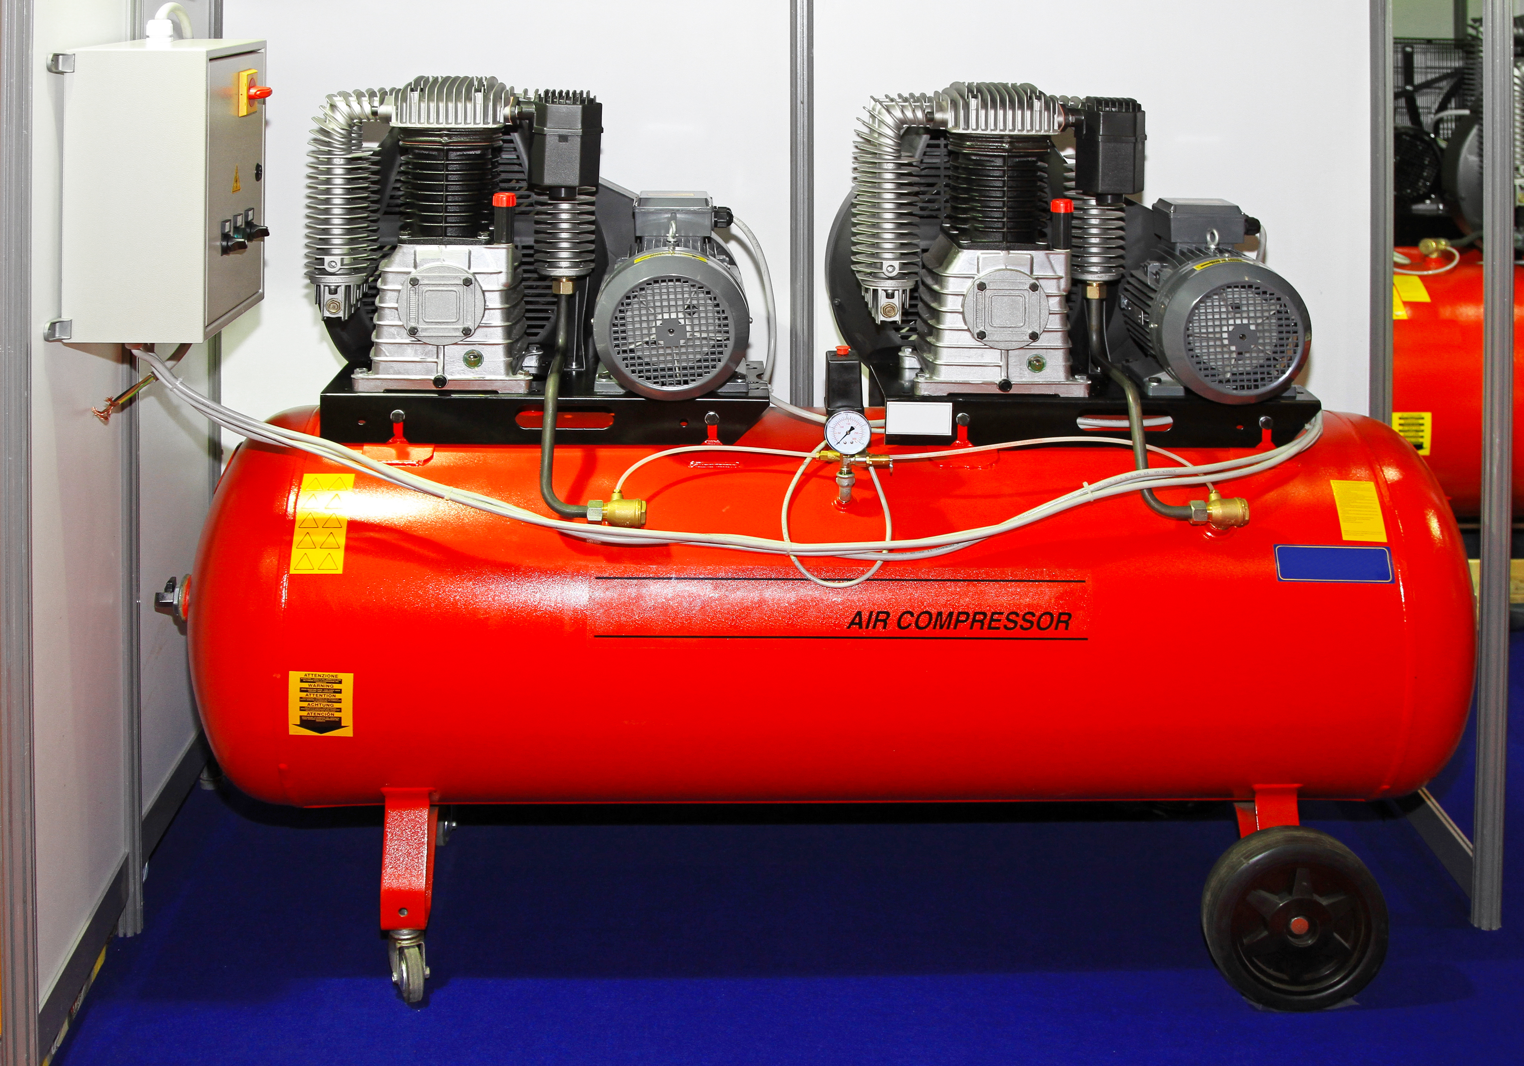
Design for maintenance and repair

Task 1
Workshop equipment requires regular maintenance and eventually repairs to be carried out.

Select an item of workshop equipment to analyse which parts of the equipment require regular servicing. You should report on the following areas.

You are not required to disassemble the equipment in this task.

- Which parts require servicing?

- What features require the product to be maintained for quality and performance?

- Which parts are designed to be replaced as part of maintenance and repairs?

- Which parts are likely to require repair at some time?

- What features of the equipment make it easy to maintain and repair?

- What materials used as part of the maintenance procedure will need to be disposed of?

- What are the environmental considerations for disposing of waste packaging and consumables?

