This Checkpoint Task should be used in conjunction with the KS3–KS4 Gateway Science Suite, Physics A Transition Guide – Wave behaviour and interactions

Wave behaviour and interactions

Activity 1 – Picture the sound
Use the following words to describe the sound waves below and compare them to each other:
High pitch | Low pitch | Loud | Soft

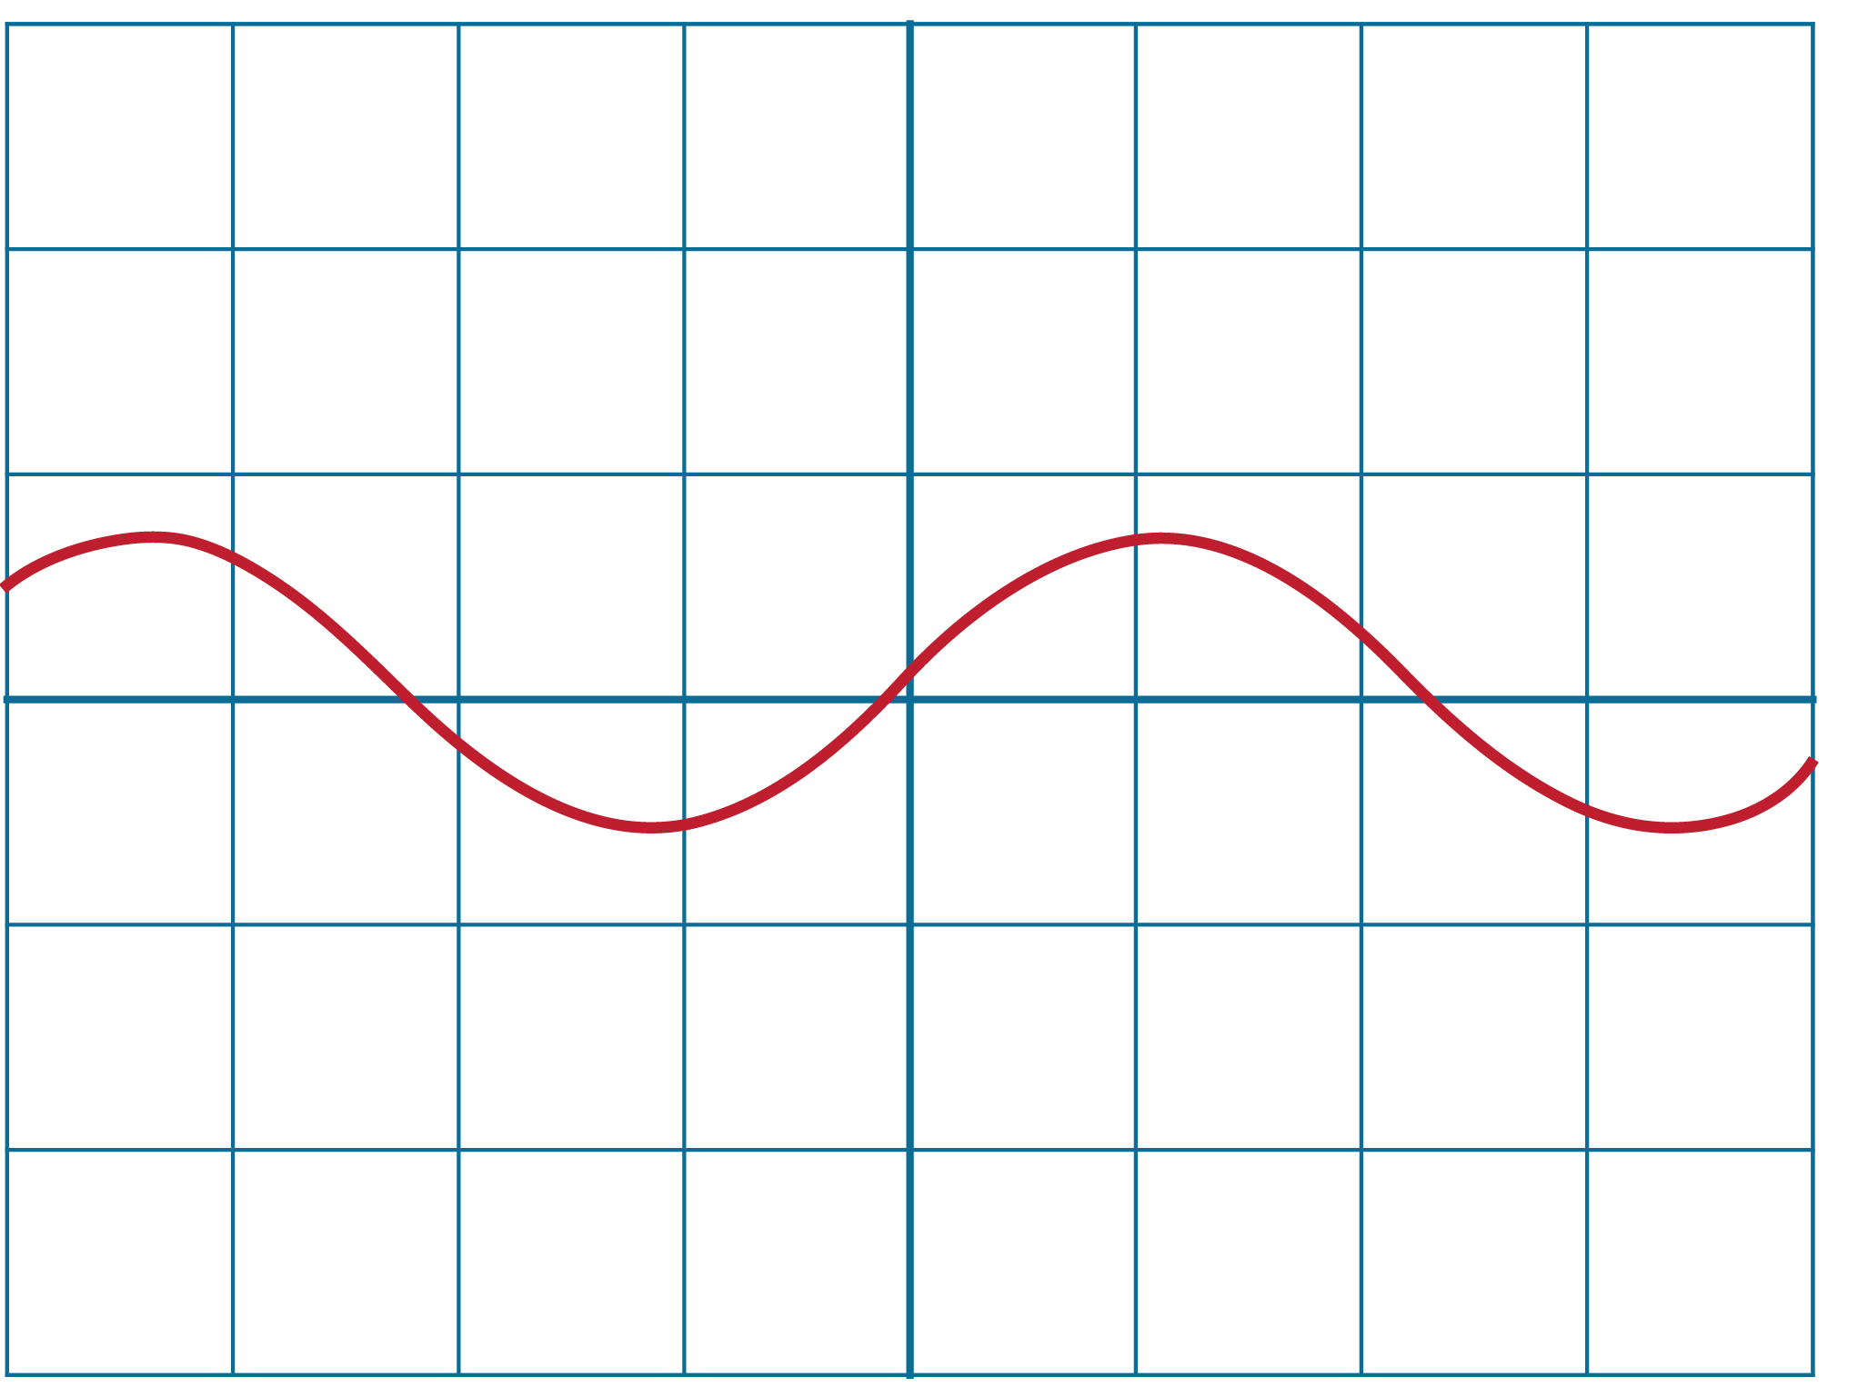 | 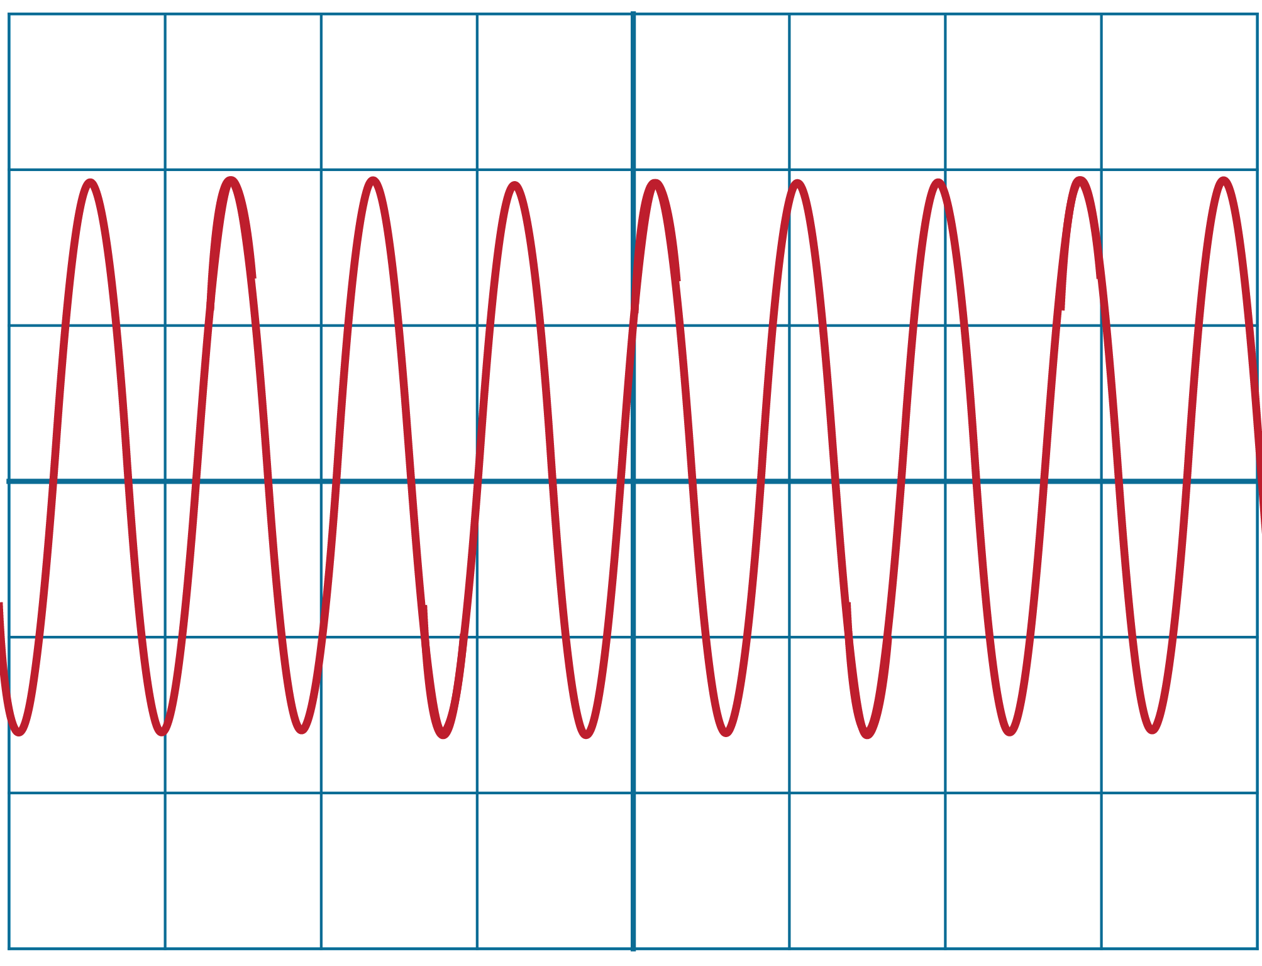
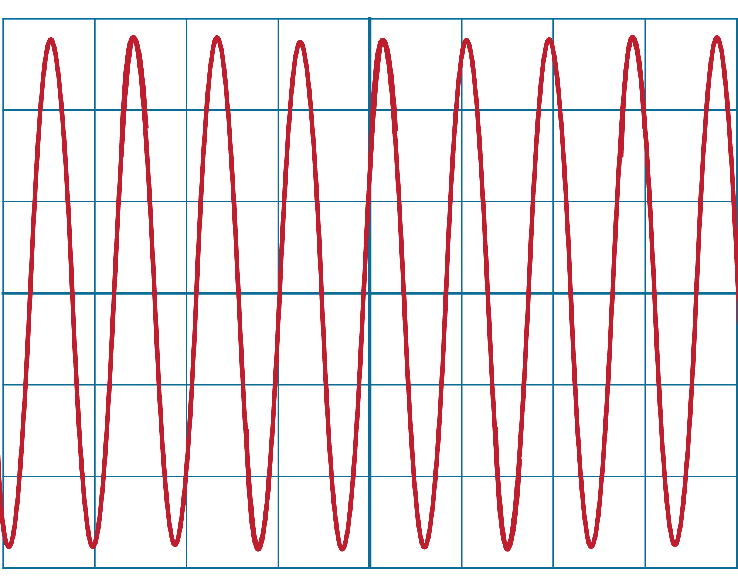 | 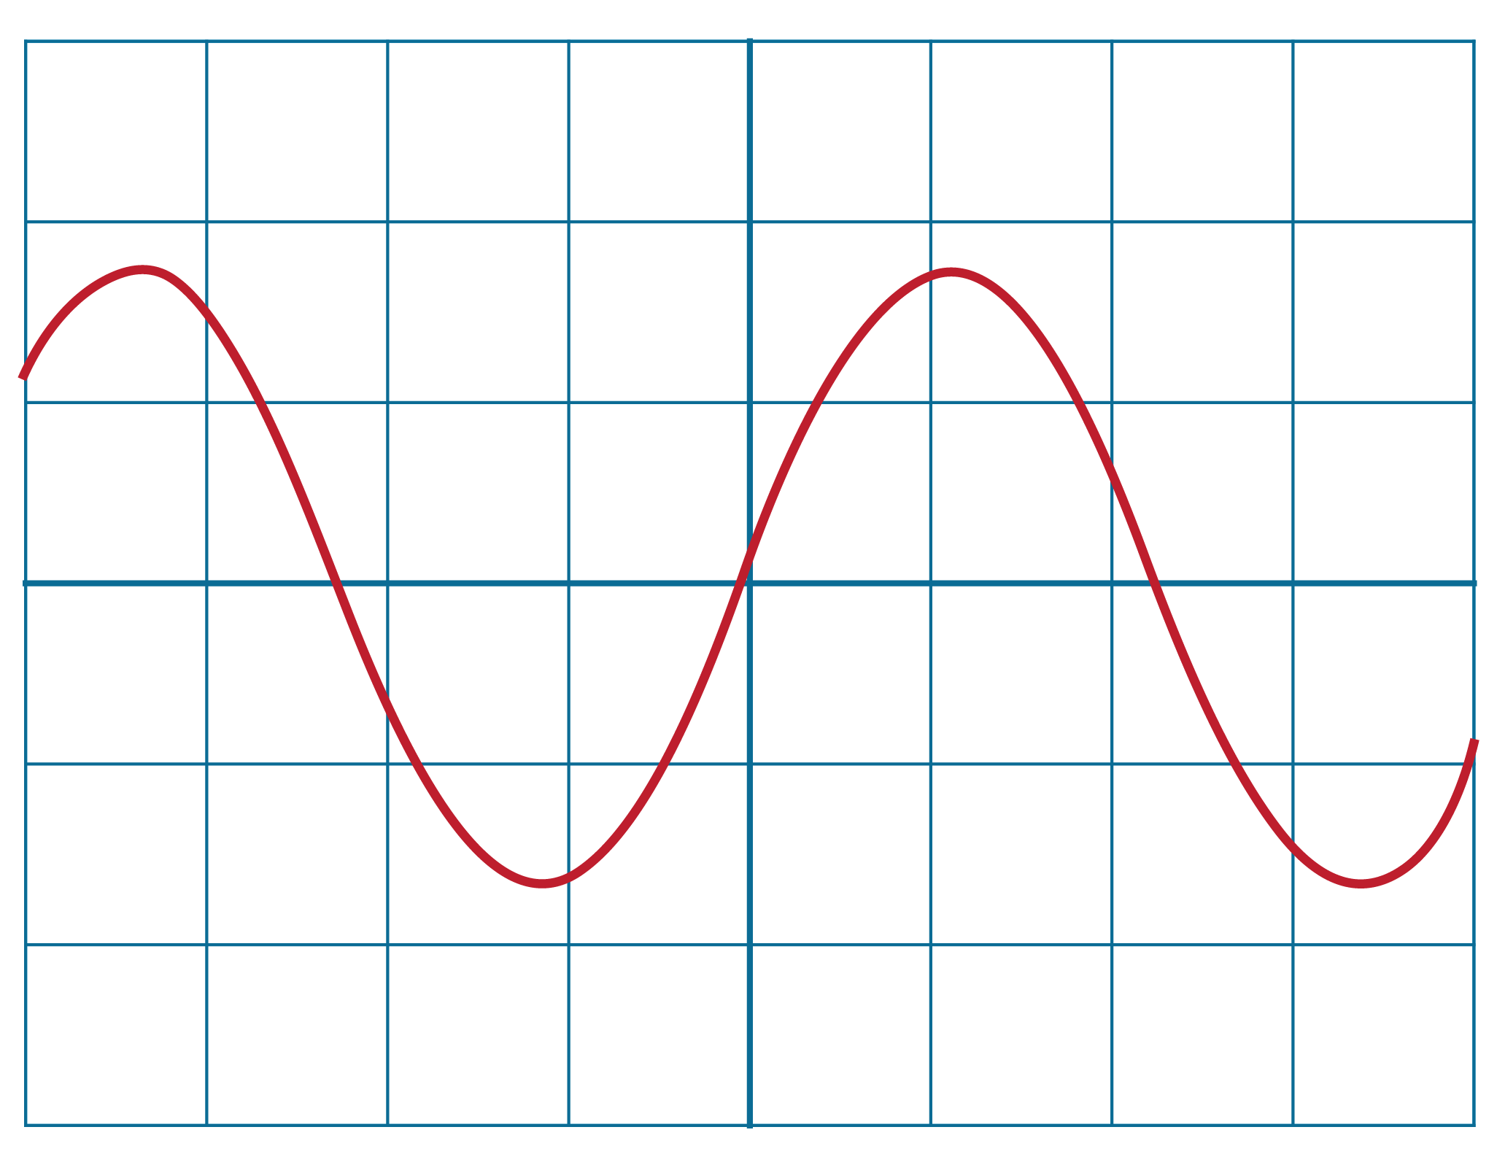
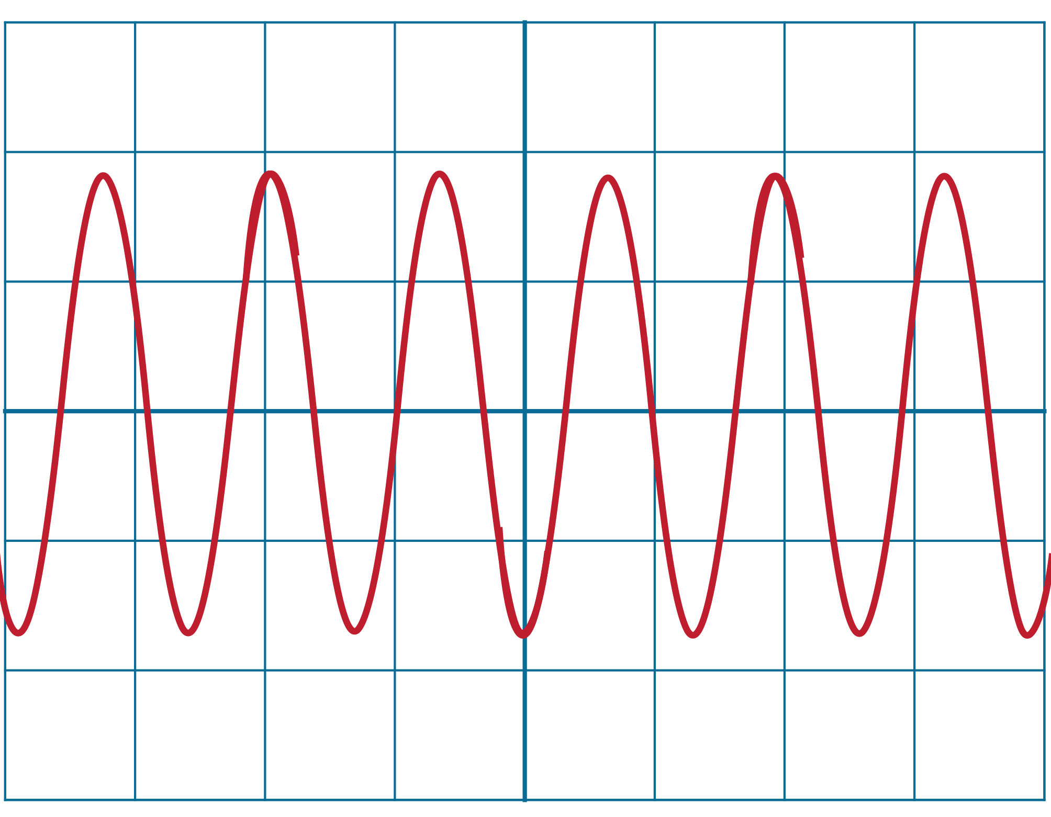 | 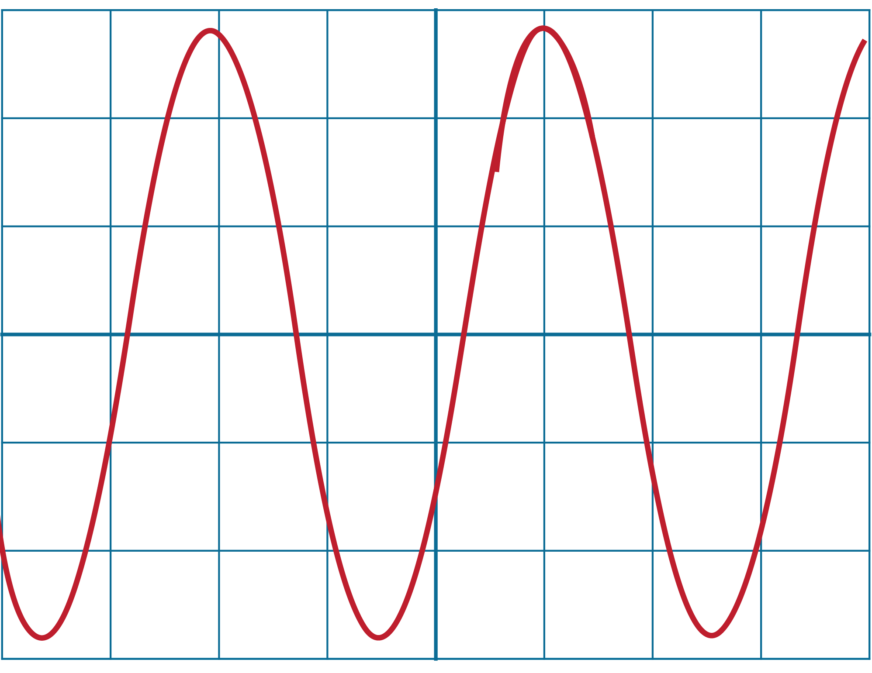

Activity 2 – Energy or matter
What is a wave? How does it move?

Use the pictures below to describe and explain how the wave is behaving and how energy is being transferred.
oscillate | energy | matter | vibration
Keywords you may want to use:

 | 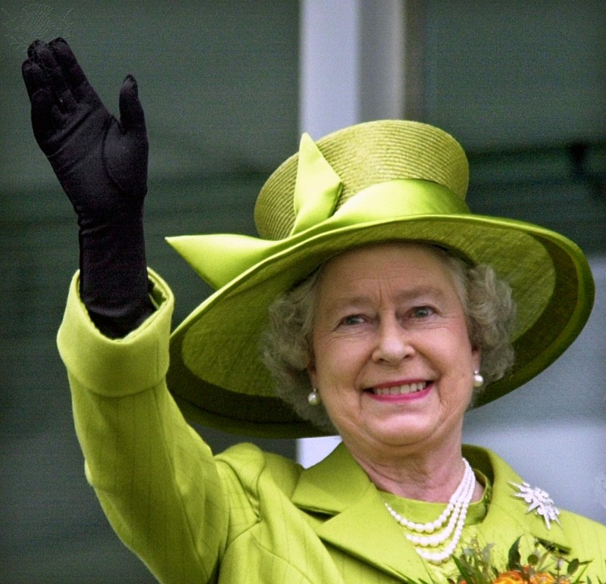
 | 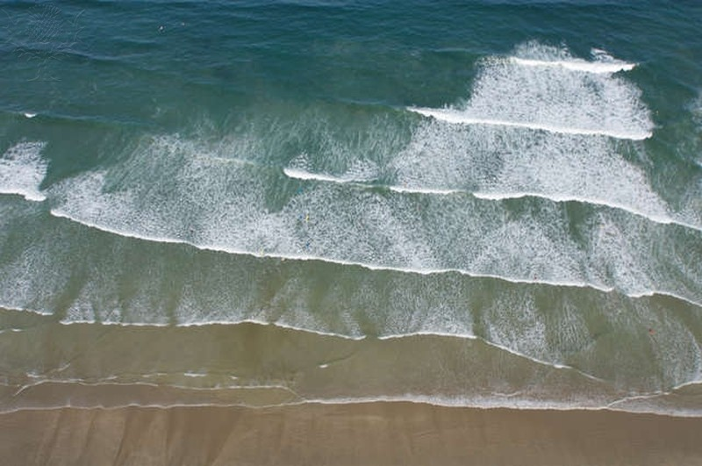

Activity 3 – Seeing colours
Fill in the missing labels with the colour (of the light or of the box). You must be able to justify your decisions. For some boxes, there may be more than one correct answer.


white
red
white
blue
white
blue
yellow
cyan
blue
red

red

yellow

