This activity sheet should be used in conjunction with the GCSE (9–1) Gateway Chemistry A KS3 – KS4 Transition Guide – Particles, Atoms and Elements.

# Particles, Atoms and Elements

### Task 1 – Chemical Reactions

(Low demand)

1. State what each of these words means or give examples:
2. reactant

Reactants are substances found on the left-hand side of a chemical equation that react together to produce new substances/substance

1. product

Products/product are the new substances/substance that is produced when other substances react together

1. evaporation

This is where a liquid turns into gas e.g. boiling water.

1. condensation

This where a gas turns into a liquid e.g. cooling steam

1. mixture

A mixture is where two or more substances are combined together without reacting.

1. draw the particles in a liquid, gas and solid:

liquid gas solid

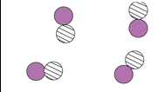

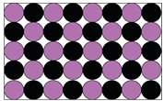

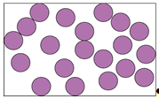

1. Below is a reaction between carbon and oxygen. Label 'R' for the reactant and 'P' for the product in this reaction.

carbon + oxygen carbon dioxide

R

R R R

P

1. Chemical reactions are irreversible changes. Below circle ALL of the irreversible chemical reactions

frying an egg dissolving salt in water bomb explosion

1. Complete the missing words in this sentence:

dioxide

carbon

food

Plants can make their own by combining

glucose

oxygen

water

and to make and a sugar called .

(Standard demand)

1. Green plants use sunlight to make food from water and carbon dioxide. What is the scientific name given to this process?

Photosynthesis

1. Describe what is happening at points A and B in the procedure shown below.

A – water is evaporating from the ink, liquid water is becomes steam

B – steam condenses to liquid water

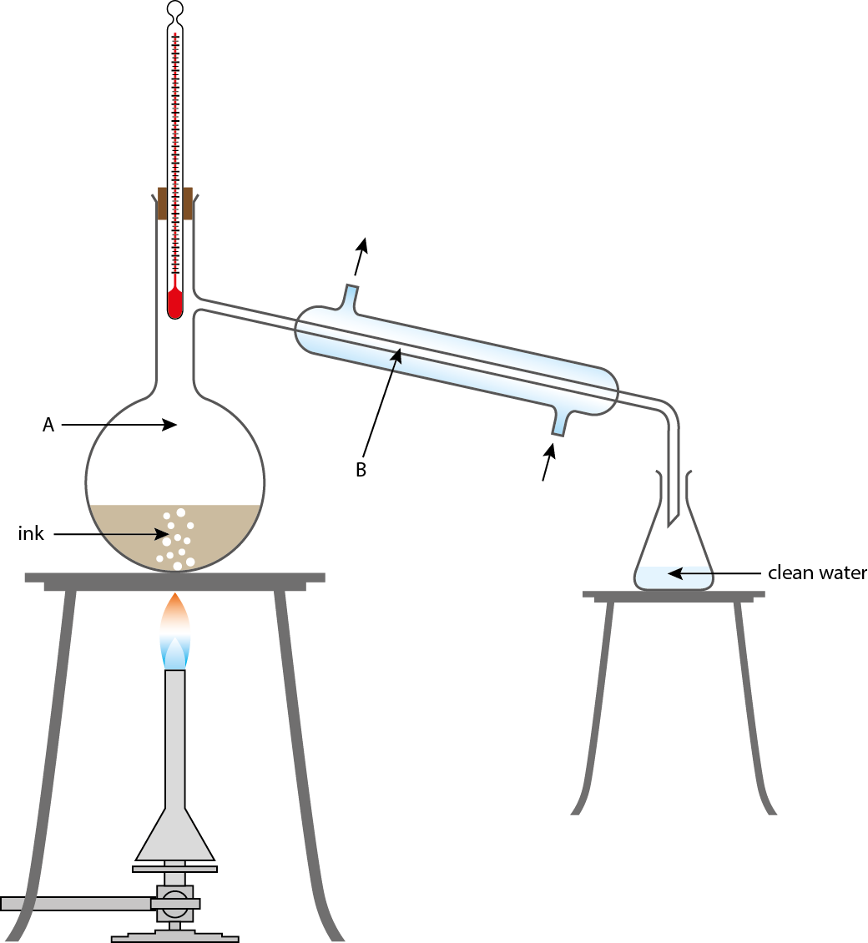

1. How could you tell how many dyes are in the ink used in the procedure in question 6?

Use chromatography/make a chromatogram of the ink and look at the number of spots produced.

1. Butane gas is a hydrocarbon used to fuel camp stoves. Complete the word equation for butane burning in air:

Carbon dioxide

water

oxygen

butane +  +

1. Magnesium is a silver metal which can be used in sparklers. When sparklers are lit, the magnesium burns and a metal oxide is made.
2. What element does magnesium react with?

oxygen

1. What is the chemical name for the white, grey ash left behind?

magnesium oxide

(High demand)

1. A symbol equation shows reactant and products as symbols, as seen in the periodic table. For example carbon on the periodic table = C. Using a periodic table, complete these two symbol equations:

CaO

Ca + O2 

O2

Fe +  FeO

### Task 2 – Elements and compounds

1. Read these statements about atoms, elements and compounds and decide whether they are true or false.

|  |  |  |
| --- | --- | --- |
| Statement | True | False |
| Iron contains only one type of atom. | ✓ |  |
| There are more compounds than elements. | ✓ |  |
| All elements are solids. |  | ✓ |
| An apple is an element. |  | ✓ |
| Very few elements are liquids at room temperature. | ✓ |  |
| Water is an element: it is made up of water and oxygen atoms. |  | ✓ |
| The carbon atoms in you have been on Earth since it was first formed. | ✓ |  |
| All gases are elements. |  | ✓ |
| Wood is a compound. | ✓ |  |
| The symbol for sodium is So. |  | ✓ |
| All metals are elements. | ✓ |  |
| Compounds always contain different types of atoms. | ✓ |  |
| Everything on Earth is made of atoms. | ✓ |  |
| Lead atoms are heavier than helium atoms. | ✓ |  |
| There are about 1000 different elements in existence. |  | ✓ |

1. **Match ‘em up**

Match the pictures to the correct boxes

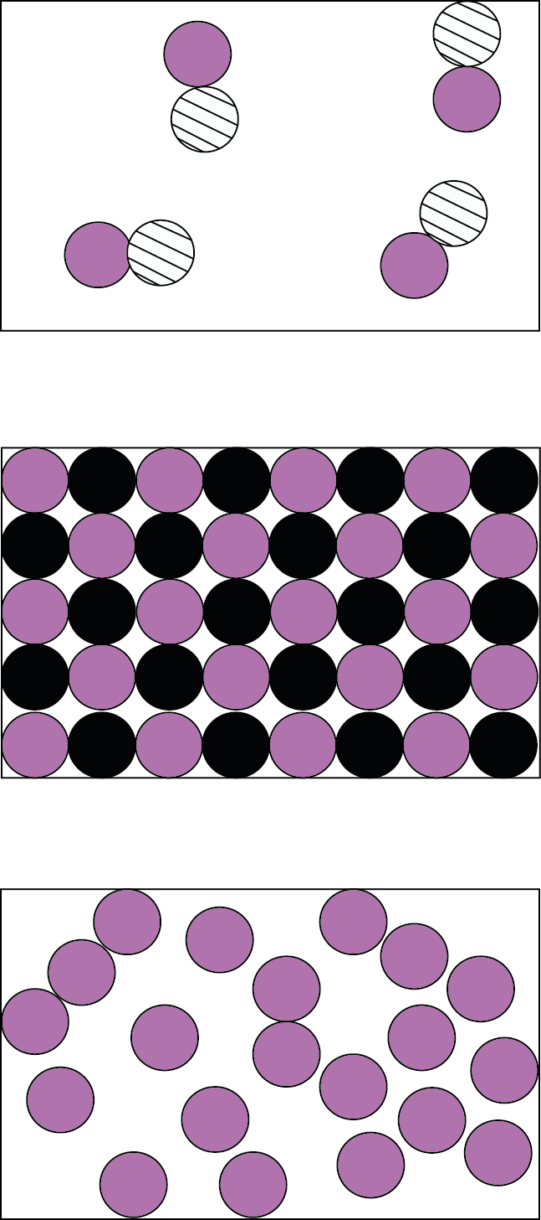

**A compound**

**A gas**

**An element**

**A liquid**

**A solid**

**A compound**

### Task 3 - 10 things you should be able to do

1. Label an atom with protons, neutrons and electrons

Diagram like the one below with proton and neutron labelled as parts of the nucleus and the electron labelled around the nucleus.

neutron

electron

proton

2

1. Explain that the first shell of electrons can hold a maximum of electrons. The second shell can hold a maximum of electrons.

8

1. Name an element in the same group as sulfur.

oxygen / selenium / tellurium / polonium / livermorium

1. Name an element in the same period as hydrogen.

helium

1. Identify elements as metals or non-metals:

metal

metal

non-metal

Iron is a ,chlorine is a , chromium is a ,

non-metals

metal

sodium is a , neon is a .

1. Match the compounds with their names:

CO2 calcium oxide

CaCO3 water

CaO calcium carbonate

H2O carbon dioxide

1. Determine which equation is correctly balanced:

Mg + HCl 🡪MgCl2 + H2

Mg + 2HCl 🡪 MgCl2 + H2

2Mg + HCl 🡪MgCl2 + 2H2

2Mg + 2HCl 🡪 2MgCl2 + H2

Mg + 2HCl 🡪 MgCl2 + H2

1. Determine if compounds have ionic or covalent bonding:

covalent

ionic bonding

covalent

ionic bonding

NaCl has FeBr3 has , CO2 has , CH4 has ,

Ionic bonding

Li2O has .

Know the names of groups in the periodic table:

Halogen

Alkali metal

Noble gas

1. Neon is a , Fluorine is a , Potassium is a ,

Transition metal

Copper is a .

1. Iron-56 has a relative atomic mass of 56. How many neutrons does it contain?

56 – 26 = 30 iron-56 contains 30 neutrons

### Task 4 – Naming compounds

|  |  |  |  |  |  |
| --- | --- | --- | --- | --- | --- |
| **Easy** | | **Medium** | | **Hard** | |
| Formula | Name | Formula | Name | Formula | Name |
| AgBr | silver bromide | CCl4 | carbon tetrachloride | BaCrO4 | barium chlorate |
| ZnI2 | zinc iodide | NO2 | nitrogen dioxide | K2Cr2O7 | potassium chromate (VI)/ potassium dichromate |
| HBr | hydrogen bromide | MnCO3 | manganese carbonate | MgCrO4 | magnesium chromate |
| CuS | copper sulfide | KClO3 | potassium chlorate | FeCO3 | iron carbonate |
| SiCl4 | silicon chloride | V2O3 | vanadium(III) oxide | LiBrO3 | lithium bromate |
| AlCl3 | aluminium chloride | KMnO4 | potassium manganate(VII)/ potassium permanganate | Pb(NO3)2 | lead nitrate |

### Task 5 – Writing word equations

Write a word equation for each of the reactions below:

1. When methane is burned in oxygen, carbon dioxide and water are created.

methane + oxygen carbon dioxide + water

1. Calcium carbonate can be decomposed to make calcium oxide and carbon dioxide.

calcium carbonate calcium oxide + water

1. Water can be formed by reacting oxygen and hydrogen together.

hydrogen + oxygen water

1. Sodium hydroxide is formed when sodium reacts with water. Hydrogen is also produced in the form of bubbles.

sodium + water sodium hydroxide + hydrogen

1. Calcium hydroxide is also called limewater, it reacts with carbon dioxide forming a cloudy substance called calcium carbonate. Water is also produced.

calcium hydroxide + carbon dioxide calcium carbonate + water

1. Ammonia is the product of the Haber process which reacts hydrogen with nitrogen.

hydrogen + nitrogen ammonia

### Task 6 – Element match dominoes

|  |  |  |  |  |
| --- | --- | --- | --- | --- |
| fluorine | Nobel gas used to fill balloons. | this element has six protons | copper | http://www.msnsymbols.com/wp-content/uploads/2009/10/msn-scissors-symbol-300x300.png |
| group 6 gas which is essential for life | sulfur | this element reacts in a similar way to magnesium | most reactive group 1 metal |  |
| francium | finish | a non-metal element in group 3 | oxygen |  |
| this group of Elements are very unreactive | carbon | element with 16 neutrons | Nobel Gases |  |
| helium | boron | explosive non-metal with outer electron | calcium |  |
| very conductive metal with a mass of 63.5 | hydrogen | Start | element with two shells and seven outer electrons |  |
| http://www.msnsymbols.com/wp-content/uploads/2009/10/msn-scissors-symbol-300x300.png | |  |

### Task 7 – Relative Formula mass calculations

**Relative formula mass (M*r*)**

You will need a periodic table to help you with these. You can also use a calculator.

Calculate the relative formula mass (M*r*) for the following:

|  |  |  |  |
| --- | --- | --- | --- |
| O2 | 32 | B2H6 | 27.6 |
| Cl2 | 70 | Na2CO3 | 106 |
| CO2 | 62 | Fe2(SO4)3 | 399.9 |
| NH3 | 17 | Zn(OH)2 | 99.4 |
| KOH | 56.1 | HNO3 | 63 |
| Al2O3 | 102 | Ca(HCO3)2 | 162.1 |
| Ca(OH)2 | 74.1 | Na2CO3.10H2O | 186 |
| Fe2O3 | 159.6 | MgSO4.7H2O | 246.4 |
| CaCO3 | 100.1 | CuSO4.5H2O | 249.6 |
| (NH4)2SO4 | 132.1 | FeSO4.7H2O | 277.9 |

### Task 8 – Chromatography true or false

Chromatography questions: Tick correct answers.

Some questions have **more than one answer**.

1. Chromatography is:
2. a way to separate similar chemicals
3. a way to change the colour of inks

✓

1. a tool used to analyse chemicals
2. The liquid in thin layer chromatography is called:
3. the solution

✓

1. the solvent
2. the mobile phase
3. the stationary phase
4. The more ink in a spot:
5. the bigger it is
6. the further it moves

✓

1. darker the colour
2. the larger the Rf value
3. In Image 1:

✓

1. mixture B contains at least 2 substances
2. A and C are the same mixture

✓

1. all three have one substance in common.
2. C contains the substance with the smallest Rf value
3. 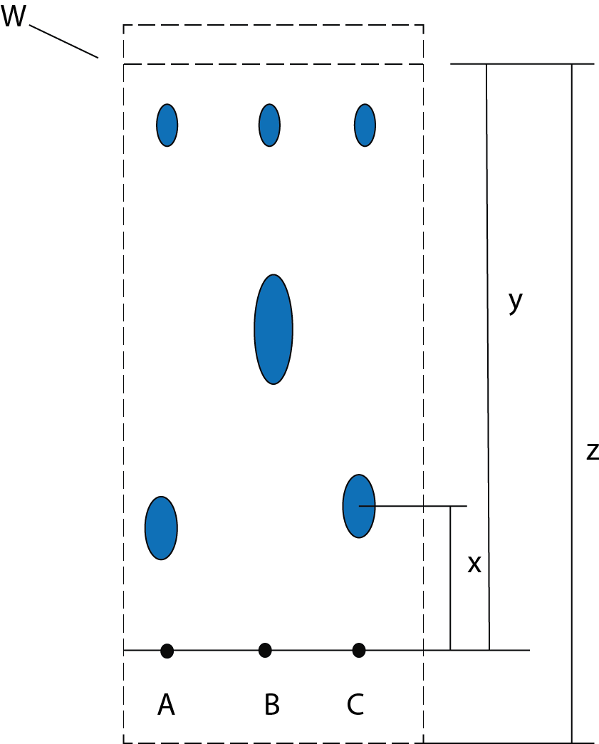The solvent front is shown by:

**Image 1**

1. Z
2. X

✓

1. W
2. Y
3. The Rf can be worked out by:

✓

1. z/x
2. x/z
3. x/y
4. z/y
5. The Rf for the lowest spot on C is approximately:

✓

1. 1.00
2. 0.75
3. 0.50
4. 0.24
5. compared to previous similar tests
6. A chemical will travel less far up the plate if:

✓

1. it is darker
2. it ‘sticks’ to the plate more
3. it is heavier
4. it ‘sticks’ to the solvent less
5. there is more of it

**Image 2**

1. 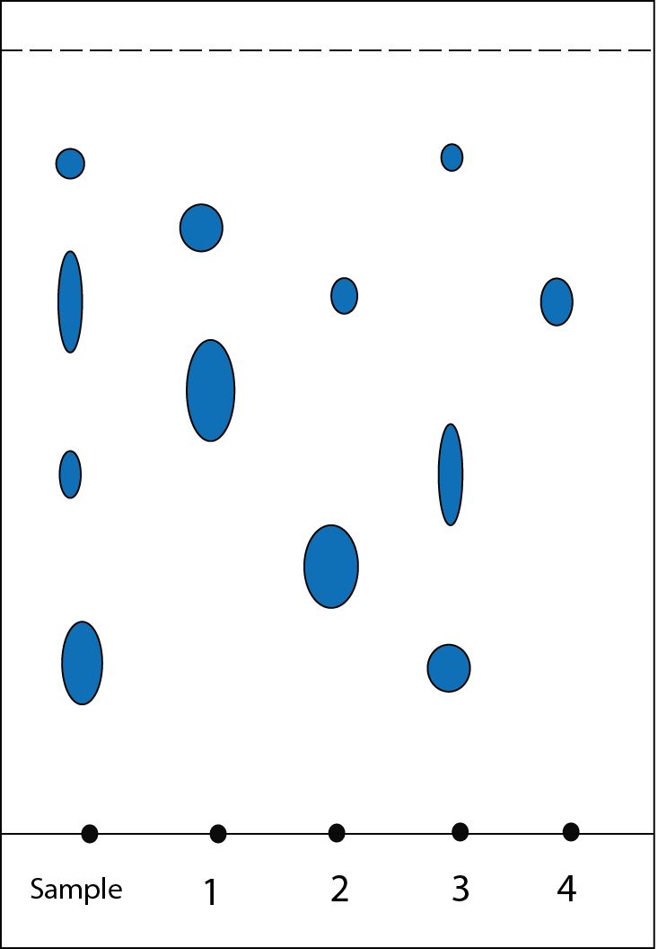In Image 2 the sample:

✓

1. does not match ink 1

✓

1. could contain ink 2
2. could contain ink 4
3. has five substances in
4. may be a mix of 2 and 4

✓

1. may be a mix of 3 and 4
2. On the plate:

✓

1. ink 4 probably contains only one substance
2. there are 5 different substances in total

✓

1. the sample could contain more than one ink

### Task 9 – PEN and ions

**Recap**

Complete the table below:

|  |  |  |  |  |  |  |
| --- | --- | --- | --- | --- | --- | --- |
| Element | Protons | Electrons | Neutrons | Outer electrons | Gain or lose electrons to get a full shell | Ion charge |
| Li | 3 | 3 | 4 | 1 | lose | Li+ |
| 35C*l* | 17 | 17 | 18 | 7 | gain | C*l* - |
| O | 8 | 8 | 8 | 6 | gain | O2- |
| 137Ba | 56 | 56 | 81 | 2 | lose | Ba+2 |
| F | 9 | 9 | 10 | 7 | gain | F- |
| 32S | 16 | 16 | 16 | 6 | gain | S2- |
| N | 7 | 7 | 7 | 5 | gain | N3- |
| A*l* | 13 | 13 | 14 | 3 | lose | A*l*3+ |

**READ BELOW**

Lithium and bromine ions bond as shown below:

Li+ + Br- 🡪 LiBr They have EQUAL and OPPOSITE charge, so one of each can bond together.

**2**Li+ + O-2 🡪 Li**2**O Here, oxygen has *double the charge*, so TWO Li are needed to balance the charge.

Complete the following equations: (Name the compounds if you can)

MgO

Mg+2 + O-2 🡪

3

A*l*+3 + C*l*- 🡪 A*l*C*l*3

H+ + O-2 🡪

2C*l* -

Fe2+

H2O

2

+ 🡪 FeC*l*2

7O2-

2K+

+ Cr+6 + 🡪 K2Cr2O7

**Extra hard:** (if you can work these out you are doing the **AS** topic of **oxidation numbers**)

4O2-

Mn7+

K+

= + + 🡪 KMnO4

A*l*2O3

2-

3

3+

2

A*l* + O 🡪

3O2-

2Cu3+

+ 🡪 Cu2O3

### Task 10 - Empirical Formulas

1. In an experiment, it was found that 11.775g of Sn combined with 3.180g of O. Write the empirical formula and name the compound that is formed.

RAM Sn = 118.7 so number of moles = 11.775/118.7= 0.1

RAM O = 16.0 so number of moles = 3.180/16.0 = 0.2

So 1 mole of tin to 2 moles of oxygen

Empirical formula = SnO2

1. A compound is 44.82% potassium, 18.39% sulfur and 36.79% oxygen by mass. Write the empirical formula and name the compound.

Pick the element with largest RAM to calculate possible RMM

RMM for compound = 32.1/0.1839 = 174.6

moles of potassium = 174.6 x 0.4482/39.1 = 2

moles of oxygen = 174.6 x 0.3679/16 = 4

moles of sulfur = 174.6 x 0.1839/32.1= 1

Empirical formula = K2SO4

Potassium sulfate

1. A compound is 52.0% zinc, 9.6% carbon and 38.4% oxygen by mass. Calculate the empirical formula of the compound.

Pick the element with largest RAM to calculate possible RMM

RMM for compound = 12/0.096 = 125.0

moles of zinc = 125.0 x 0.52/65.4 = 1

moles of oxygen = 125.0 x 0.384/16 = 3

moles of carbon = 125.0 x 0.096/12 = 1

Empirical formula = ZnCO3

1. A compound contains 21.6% Na, 33.3% Cl and 45.1% O by mass. Write the empirical formula and name the compound that is formed.

Pick the element with largest RAM to calculate possible RMM

RMM for compound = 35.5/0.333 = 106.6

moles of chlorine = 106.6 x 0.333/35.5 = 1

moles of oxygen = 106.6 x 0.451/16 = 3

moles of sodium = 106.6 x 0.216/23 = 1

Empirical formula = NaClO3

Sodium chlorate

1. A compound is 32.3% Na, 22.6% S and 45.0% O by mass. What is its empirical formula?

Pick the element with largest RAM to calculate possible RMM

RMM for compound = 32.1/0.226 = 142.0

moles of S = 142 x 0.226/ 32.1 = 1

moles of oxygen = 142 x 0.45/16 = 4

moles of sodium = 142 x 0.323/23 = 2

Empirical formula = Na2SO4

1. A compound is 21.20% nitrogen, 6.06% hydrogen, 24.30% sulfur and 48.45% oxygen by mass. Write the empirical formula and name the compound.

Pick the element with largest RAM to calculate possible RMM

RMM for compound = 32.1/0.2430 =132.10

moles of S = 132.1 x 0.2430/32.1 = 1

moles of oxygen = 132.1 x 0.4845/16 = 4

moles of nitrogen = 132.1 x 0.2120/14 = 2

moles of hydrogen = 132.1 x 0.0606/1 = 1

Empirical formula = (NH4)2SO4

Name ammonium sulphate

1. A compound is 24.7% calcium, 1.2% hydrogen, 14.8% carbon and 59.3% oxygen by mass. Write the empirical formula and name the compound.

Pick the element with largest mass to calculate possible RMM

RMM for compound = 40.1/0.247 = 162.4

moles of H = 162.4 x 0.012/ 1.0 = 2

moles of carbon = 162.4 x 0.148/12 = 2

moles of oxygen = 162.4 x 0.593/16 = 6

moles of Ca = 162.4 x 0.247/40.1 = 1

Empirical formula = Ca(HCO3)2

Name calcium hydrogen carbonate

1. An experiment uses a catalyst that is 23.3% Co, 25.3% Mo and 51.4% Cl by mass. What is the empirical formula of the compound? (HINT if you get half values eg C1.5H4 try doubling everything 🡪C3H8)

Pick the element with largest mass to calculate possible RMM

RMM for compound = 95.9/0.253 = 379.1

moles of Co = 379.1 x 0.233/ 58.9 = 1.5

moles of C*l* = 379.1 x 0.514/35.5 = 5.5

moles of Mo = 379.1 x 0.253/95.9 = 1

Ratio of Mo:Co:C*l* is 1:1.5:5.5 =2:3:11

So empirical formula is Mo2Co3C*l*11

### Task 11 – Reacting mass

1. NaH2PO4 🡪 NaPO3 + H2O

If 12g of NaH2PO4 is reacted, how much NaPO3 is formed?

Ratio 1:1

Moles of NaH2PO4 used = 12/120 = 0.1moles

Therefore 0.1 moles of NaPO3 made = 102 x 0.1 = 10.2g

1. H2CO3 🡪 H2O + CO2

If 6g of CO2 is needed, how much H2CO3 should be reacted?

Ratio 1:1

Moles of CO2 made = 6/44.0 = 0.136 moles

Therefore 0.136 moles of H2CO3 needed = 62.0 x 0.136 = 8.4g or 8.5g

1. 2P + 5Cl2 🡪 2PCl5

If 15g of P is reacted, how much PCl5 is formed?

Ratio 1:1

Moles of P used = 15/31 = 0.48 moles

Therefore 0.48 moles of PC*l* 5 made = 208.5 x 0.48 = 100.1g or 100.2g

1. CaCO3 🡪 CaO + CO2

If 54g of CaO is needed, how much CaCO3 should be reacted?

Ratio 1:1

Moles of CaO made = 54/56.1 = 0.96 moles

Therefore 0.96 moles of CaCO3 needed = 100.1 x 0.96 = 96.1g or 96.4g

1. CaO + H2O 🡪 Ca(OH)2

If 22g of CaO is reacted, how much Ca(OH)2 is formed?

Ratio 1:1

Moles of CaO used = 22/56.1 = 0.39 moles

Therefore 0.48 moles of Ca(OH)2 made = 74.1 x 0.39 = 28.9g or 29.1g

1. 2H2O2 🡪 2H2O + O2

If 500g of O2 is needed, how much H2O2 should be reacted?

Ratio 2:1

Moles of O2 to be made = 500/32 = 15.625 moles

Therefore 31.25 moles of H2O2 needed = 34 x 31.25 = 1062.5g or 1.0625 kg

1. NaPO3 + CuO 🡪 NaCuPO4

If a scientist reacts 450g of Copper oxide, how much Sodium Copper Phosphate would be formed

Ratio 1:1

Moles of CuO used = 450/79.5 = 5.66 moles

Therefore 5.66 moles of NaCuPO4­ made = 181.5 x 5.66 = 1027.3g or 1027.4g

1. Na2O + H2O 🡪 2NaOH

Sodium Hydroxide is a powerful alkali used in cleaning. A manufacturer wants to make 8kg (1kg =

1000g) of Sodium Hydroxide, what mass of Sodium Oxide should he expect to use?

Ratio 1:2

Moles of NaOH to be made = 8000/40 = 200 moles

Therefore 100 moles of Na2O needed = 62.0 x 100 = 6200g or 6.2 kg

1. Na2SO3 + S 🡪 Na2S2O3

Sodium Sulfite can be converted into a complex salt by further reaction with pure Sulfur.

What mass of salt will be produced if 140g of Sulfur are reacted?

Ratio 1:1

Moles of S used = 140/32.1 = 4.36 moles

Therefore 4.36 moles of Na2S2O3 made = 158.2 x 4.36 = 689.8g or 670.0g

1. Li2O + H2O 🡪 2LiOH

A scientist reacts 13g of water with Lithium oxide, how much Lithium Hydroxide will be made?

The answer is the theoretical yield.

If only 3g are actually made what is the % yield?

**Actual yield / theoretical yield x 100 = % yield**

Ratio 1:2

Number of moles of H2O reacting = 13/18 = 0.72

Therefore number of moles of LiOH produced = 1.44

Theoretical yield = 23.9 x 1.44 = 34.42g

% yield = 3/34.42 x 100 = 8.7%

### Task 12 – Calculations practice

**Formula mass**

Determine the M*r* of the following compounds:

|  |  |  |  |  |  |  |  |  |  |
| --- | --- | --- | --- | --- | --- | --- | --- | --- | --- |
| Compound | H2O | CO2 | NH3 | H2SO4 | CaCO3 | Li2SO4 | (NH4)2SO4 | Mg3(PO4)2 | Ca(NO3)2 |
| **M*r*** | 18.0 | 44.0 | 17.0 | 98.1 | 100.1 | 109.9 | 132.1 | 262.9 | 164.1 |

Answers (not in order, plus some extra so you can’t guess)

17.0 20.2 44.0 18.0 132.1 38.2 100.1 262.9 164.1 303.3 109.9 98.8 227.3 63.1

**Percent composition**

Find the percentage of the element by mass in **bold** for each compound:

|  |  |  |  |  |  |  |  |  |  |
| --- | --- | --- | --- | --- | --- | --- | --- | --- | --- |
| Compound | **Fe**Cl3 | Li2**O** | **P**Cl5 | Na**O**H | **Ag**NO3 | N**H4**Cl | Mg(O**H**)2 | **Al2**(SO4 )3 | (NH4)3**P**O4 |
| **Percentage** | 34.4 | 53.7 | 14.9 | 40.0 | 63.5 | 7.5 | 3.4 | 15.8 | 20.8 |

Answers (not in order, plus some extra so you can’t guess)

14.9% 34.4% 7.5% 53.7% 15.8% 58.2% 91.3% 18.6% 40.0% 25.2% 20.8% 63.5% 3.4%

**Empirical formula**

Determine the empirical formula from the information given:

|  |  |
| --- | --- |
| Information | **Empirical formula** |
| Cu – 66.5% O – 33.5% | CuO2 |
| Ti - 19.4% Cl – 28.7% O - 51.9% | Ti(ClO4)2 |
| C – 52.1% H – 13.12% O- 34.7% | C2H6O |
| Mn – 34.8g K – 24.7g O – 40.5g | KMnO4 |
| P – 16.6% Na – 49.2% O – 34.2% | Na4PO4 |
| C – 88.8% H – 11.1% | C2H3 |

Answers (not in order, plus some extra so you can’t guess)

C2H3 CuO2 KMnO4  C2H6O Ti(ClO4)2 Na4PO4 C4H4 Cu2O3 K2Mn2O4 CH3O TiClO

**Reacting masses**

For the equations below calculate the mass of substance made or required:

|  |  |
| --- | --- |
| Equation | **Mass of substance** |
| 4Li + O2 🡪 2Li2O  How much Li2O can be made from 30g of Li? | 64.8g |
| 2C2H6 + 7O2 🡪 4CO2 + 6H2O  How much CO2 can be made from 6g of C2H6? | 4.4g |
| CaCO3 + 2HNO3 🡪 Ca(NO3)2 + CO2 + H2O  How much CaCO3 is needed to make 18g of Ca(NO3)2? | 11.0g |

Answers (not in order, plus some extra so you can’t guess)

78.6g 17.6g 9.8g 11.0g 64.8g 18.5g 4.4g

# Particles, Atoms and Elements

### Task 1 – Chemical Reactions

(Low demand)

1. State what each of these words means or give examples:
2. reactant
3. product
4. evaporation
5. condensation
6. mixture
7. draw the particles in a liquid, gas and solid:

liquid gas solid

1. Below is a reaction between carbon and oxygen. Label 'R' for the reactant and 'P' for the product in this reaction.

carbon + oxygen carbon dioxide

R

1. Chemical reactions are irreversible changes. Below circle ALL of the irreversible chemical reactions

frying an egg dissolving salt in water bomb explosion

1. Complete the missing words in this sentence:

d

c

f

Plants can make their own by combining

g

o

w

and to make and a sugar called .

(Standard demand)

1. Green plants use sunlight to make food from water and carbon dioxide. What is the scientific name given to this process?
2. Describe what is happening at points A and B in the procedure shown below.



1. How could you tell how many dyes are in the ink used in the procedure in question 6?
2. Butane gas is a hydrocarbon used to fuel camp stoves. Complete the word equation for butane burning in air:

butane +  +

1. Magnesium is a silver metal which can be used in sparklers. When sparklers are lit, the magnesium burns and a metal oxide is made.
2. What element does magnesium react with?
3. What is the chemical name for the white, grey ash left behind?

(High demand)

1. A symbol equation shows reactant and products as symbols, as seen in the periodic table. For example carbon on the periodic table = C. Using a periodic table, complete these two symbol equations:

Ca + O2 

Fe +  FeO

### Task 2 – Elements and compounds

1. Read these statements about atoms, elements and compounds and decide whether they are true or false.

|  |  |  |
| --- | --- | --- |
| Statement | True | False |
| Iron contains only one type of atom. |  |  |
| There are more compounds than elements. |  |  |
| All elements are solids. |  |  |
| An apple is an element. |  |  |
| Very few elements are liquids at room temperature. |  |  |
| Water is an element: it is made up of water and oxygen atoms. |  |  |
| The carbon atoms in you have been on Earth since it was first formed. |  |  |
| All gases are elements. |  |  |
| Wood is a compound. |  |  |
| The symbol for sodium is So. |  |  |
| All metals are elements. |  |  |
| Compounds always contain different types of atoms. |  |  |
| Everything on Earth is made of atoms. |  |  |
| Lead atoms are heavier than helium atoms. |  |  |
| There are about 1000 different elements in existence. |  |  |

1. **Match ‘em up**

Match the pictures to the correct boxes



**A compound**

**A gas**

**An element**

**A liquid**

**A solid**

**A compound**

### Task 3 - 10 things you should be able to do

1. Label an atom with protons, neutrons and electrons
2. Explain that the first shell of electrons can hold a maximum of electrons. The second shell can hold a maximum of electrons.
3. Name an element in the same group as sulfur.
4. Name an element in the same period as hydrogen.
5. Identify elements as metals or non-metals:

metal

Iron is a ,chlorine is a , chromium is a ,

sodium is a , neon is a .

1. Match the compounds with their names:

CO2 calcium oxide

CaCO3 water

CaO calcium carbonate

H2O carbon dioxide

1. Determine which equation is correctly balanced:

Mg + HCl 🡪MgCl2 + H2

Mg + 2HCl 🡪 MgCl2 + H2

2Mg + HCl 🡪MgCl2 + 2H2

2Mg + 2HCl 🡪 2MgCl2 + H2

1. Determine if compounds have ionic or covalent bonding:

ionic bonding

NaCl has FeBr3 has , CO2 has , CH4 has ,

Li2O has .

1. Know the names of groups in the periodic table:

l

Noble gas

Neon is a , fluorine is a , Potassium is a , Copper is a .

1. Iron-56 has a relative atomic mass of 56. How many neutrons does it contain?

### Task 4 – Naming compounds

|  |  |  |  |  |  |
| --- | --- | --- | --- | --- | --- |
| **Easy** | | **Medium** | | **Hard** | |
| Formula | Name | Formula | Name | Formula | Name |
| AgBr |  | CCl4 |  | BaCrO4 |  |
| ZnI2 |  | NO2 |  | K2Cr2O7 |  |
| HBr |  | MnCO3 |  | MgCrO4 |  |
| CuS |  | KClO3 |  | FeCO3 |  |
| SiCl4 |  | V2O3 |  | LiBrO3 |  |
| AlCl3 |  | KMnO4 |  | Pb(NO3)2 |  |

### Task 5 – Writing word equations.

### Write a word equation for each of the reactions below:

1. When methane is burned in oxygen, carbon dioxide and water are created.
2. Calcium carbonate can be decomposed to make calcium oxide and carbon dioxide.
3. Water can be formed by reacting oxygen and hydrogen together.
4. Sodium hydroxide is formed when sodium reacts with water. Hydrogen is also produced in the form of bubbles.
5. Calcium hydroxide is also called limewater, it reacts with carbon dioxide forming a cloudy substance called calcium carbonate. Water is also produced.
6. Ammonia is the product of the Haber process which reacts hydrogen with nitrogen.

### Task 6 – Element match dominoes

|  |  |  |  |  |
| --- | --- | --- | --- | --- |
| fluorine | Nobel gas used to fill balloons. | this element has six protons | copper | http://www.msnsymbols.com/wp-content/uploads/2009/10/msn-scissors-symbol-300x300.png |
| group 6 gas which is essential for life | sulfur | this element reacts in a similar way to magnesium | most reactive group 1 metal |  |
| francium | finish | a non-metal element in group 3 | oxygen |  |
| this group of Elements are very unreactive | carbon | element with 16 neutrons | Nobel Gases |  |
| helium | boron | explosive non-metal with outer electron | calcium |  |
| very conductive metal with a mass of 63.5 | hydrogen | Start | element with two shells and seven outer electrons |  |
| http://www.msnsymbols.com/wp-content/uploads/2009/10/msn-scissors-symbol-300x300.png | |  |

### Task 7 – Relative Formula mass calculations

**Relative formula mass (M*r*)**

You will need a periodic table to help you with these. You can also use a calculator.

Calculate the relative formula mass (M*r*) for the following:

|  |  |  |  |
| --- | --- | --- | --- |
| O2 |  | B2H6 |  |
| C*l*2 |  | Na2CO3 |  |
| CO2 |  | Fe2(SO4)3 |  |
| NH3 |  | Zn(OH)2 |  |
| KOH |  | HNO3 |  |
| Al2O3 |  | Ca(HCO3)2 |  |
| Ca(OH)2 |  | Na2CO3.10H2O |  |
| Fe2O3 |  | MgSO4.7H2O |  |
| CaCO3 |  | CuSO4.5H2O |  |
| (NH4)2SO4 |  | FeSO4.7H2O |  |

### Task 8 – Chromatography true or false

Chromatography questions: Tick correct answers.

Some questions have **more than one answer**.

1. Chromatography is:
2. a way to separate similar chemicals
3. a way to change the colour of inks
4. a tool used to analyse chemicals
5. The liquid in thin layer chromatography is called:
6. the solution
7. the solvent
8. the mobile phase
9. the stationary phase
10. The more ink in a spot:
11. the bigger it is
12. the further it moves
13. darker the colour
14. the larger the Rf value
15. In Image 1:
16. mixture B contains at least 2 substances
17. **A** and **C** are the same mixture
18. all three have one substance in common
19. **C** contains the substance with the smallest Rf value
20. The solvent front is shown by:

**Image 1**

1. Z
2. X
3. W
4. Y
5. The Rf can be worked out by:
6. z/x
7. x/z
8. x/y
9. z/y
10. The Rf for the lowest spot on C is approximately:

a) 1.00

b) 0.75

c) 0.50

d) 0.24

e) compared to previous similar tests

1. A chemical will travel less far up the plate if:
2. it is darker
3. it ‘sticks’ to the plate more
4. it is heavier
5. it ‘sticks’ to the solvent less
6. there is more of it

**Image 2**

1. In Image 2 the sample:
2. does not match ink 1
3. could contain ink 2
4. could contain ink 4
5. has five substances in
6. may be a mix of 2 and 4
7. may be a mix of 3 and 4
8. On the plate:
9. ink 4 probably contains only one substance
10. there are 5 different substances in total
11. the sample could contain more than one ink

### Task 9 – PEN and ions

**Recap**

Complete the table below:

|  |  |  |  |  |  |  |
| --- | --- | --- | --- | --- | --- | --- |
| Element | Protons | Electrons | Neutrons | Outer electrons | Gain or lose electrons to get a full shell | Ion charge |
| Li | 3 | 3 | 4 | 1 | lose | Li+ |
| 35C*l* |  |  |  |  |  |  |
| O |  |  |  |  |  |  |
| 137Ba |  |  |  | 2 |  | Ba+2 |
| F |  |  |  |  |  |  |
| 32S |  |  |  |  |  |  |
| N |  |  |  |  |  |  |
|  |  |  | 14 | 3 |  |  |

**READ BELOW**

Lithium and bromine ions bond as shown below:

Li+ + Br- 🡪 LiBr They have EQUAL and OPPOSITE charge, so one of each can bond together.

**2**Li+ + O-2 🡪 Li**2**O Here, oxygen has *double the charge*, so TWO Li are needed to balance the charge.

Complete the following equations: (Name the compounds if you can)

Mg+2 + O-2 🡪

A*l*+3 + C*l*- 🡪 A*l*C*l*3

H+ + O-2 🡪

+ 🡪 FeC*l*2

+ Cr+6 + 🡪 K2Cr2O7

**Extra hard:** (if you can work these out you are doing the **AS** topic of **oxidation numbers**)

= + + 🡪 KMnO4

A*l* + O 🡪

+ 🡪 Cu2O3

### Task 10 - Empirical Formulas

1. In an experiment, it was found that 11.775g of Sn combined with 3.180g of O. Write the empirical formula and name the compound that is formed.
2. A compound is 44.82% potassium, 18.39% sulfur and 36.79% oxygen by mass. Write the empirical formula and name the compound.
3. A compound is 52.0% zinc, 9.6% carbon and 38.4% oxygen by mass. Calculate the empirical formula of the compound.
4. A compound contains 21.6% Na, 33.3% Cl and 45.1% O by mass. Write the empirical formula and name the compound that is formed.
5. A compound is 32.3% Na, 22.6% S and 45.0% O by mass. What is its empirical formula?
6. A compound is 21.20% nitrogen, 6.06% hydrogen, 24.30% sulfur and 48.45% oxygen by mass. Write the empirical formula and name the compound.
7. A compound is 24.7% calcium, 1.2% hydrogen, 14.8% carbon and 59.3% oxygen by mass. Write the empirical formula and name the compound.
8. An experiment uses a catalyst that is 23.3% Co, 25.3% Mo and 51.4% Cl by mass. What is the empirical formula of the compound? (HINT if you get half values eg C1.5H4 try doubling everything 🡪C3H8)

### Task 11 – Reacting mass

1. NaH2PO4 🡪 NaPO3 + H2O

If 12g of NaH2PO4 is reacted, how much NaPO3 is formed?

1. H2CO3 🡪 H2O + CO2

If 6g of CO2 is needed, how much H2CO3 should be reacted?

1. 2P + 5Cl2 🡪 2PCl5

If 15g of P is reacted, how much PCl5 is formed?

1. CaCO3 🡪 CaO + CO2

If 54g of CaO is needed, how much CaCO3 should be reacted?

1. CaO + H2O 🡪 Ca(OH)2

If 22g of CaO is reacted, how much Ca(OH)2 is formed?

1. 2H2O2 🡪 2H2O + O2

If 500g of O2 is needed, how much H2O2 should be reacted?

1. NaPO3 + CuO 🡪 NaCuPO4

If a scientist reacts 450g of Copper oxide, how much Sodium Copper Phosphate would be formed

1. Na2O + H2O 🡪 2NaOH

Sodium Hydroxide is a powerful alkali used in cleaning. A manufacturer wants to make 8kg (1kg =

1000g) of Sodium Hydroxide, what mass of Sodium Oxide should he expect to use?

1. Na2SO3 + S 🡪 Na2S2O3

Sodium Sulfite can be converted into a complex salt by further reaction with pure Sulfur.

What mass of salt will be produced if 140g of Sulfur are reacted?

1. Li2O + H2O 🡪 2LiOH

A scientist reacts 13g of water with Lithium oxide, how much Lithium Hydroxide will be made?

The answer is the theoretical yield.

If only 3g are actually made what is the % yield?

**Actual yield / theoretical yield x 100 = % yield**

### Task 12 – Calculations practice

**Formula mass**

Determine the M*r* of the following compounds:

|  |  |  |  |  |  |  |  |  |  |
| --- | --- | --- | --- | --- | --- | --- | --- | --- | --- |
| Compound | H2O | CO2 | NH3 | H2SO4 | CaCO3 | Li2SO4 | (NH4)2SO4 | Mg3(PO4)2 | Ca(NO3)2 |
| **M*r*** |  |  |  |  |  |  |  |  |  |

Answers (not in order, plus some extra so you can’t guess)

17.0 20.2 44.0 18.0 132.1 38.2 100.1 262.9 164.1 303.3 109.9 98.8 227.3 63.1

**Percentage composition**

Find the percentage of the element by mass in **bold** for each compound:

|  |  |  |  |  |  |  |  |  |  |
| --- | --- | --- | --- | --- | --- | --- | --- | --- | --- |
| Compound | **Fe**Cl3 | Li2**O** | **P**Cl5 | Na**O**H | **Ag**NO3 | N**H4**Cl | Mg(O**H**)2 | **Al2**(SO4 )3 | (NH4)3**P**O4 |
| **Percentage** |  |  |  |  |  |  |  |  |  |

Answers (not in order, plus some extra so you can’t guess)

14.9% 34.4% 7.5% 53.7% 15.8% 58.2% 91.3% 18.6% 40.0% 25.2% 20.8% 63.5% 3.4%

**Empirical formula**

Determine the empirical formula from the information given:

|  |  |
| --- | --- |
| Information | **Empirical formula** |
| Cu – 66.5% O – 33.5% |  |
| Ti - 19.4% Cl – 28.7% O - 51.9% |  |
| C – 52.1% H – 13.12% O- 34.7% |  |
| Mn – 34.8g K – 24.7g O – 40.5g |  |
| P – 16.6% Na – 49.2% O – 34.2% |  |
| C – 88.8% H – 11.1% |  |

Answers (not in order, plus some extra so you can’t guess)

C2H3 CuO2 KMnO4  C2H6O Ti(ClO4)2 Na4PO4 C4H4 Cu2O3 K2Mn2O4 CH3O TiClO

**Reacting masses**

For the equations below calculate the mass of substance made or required:

|  |  |
| --- | --- |
| Equation | **Mass of substance** |
| 4Li + O2 🡪 2Li2O  How much Li2O can be made from 30g of Li? |  |
| 2C2H6 + 7O2 🡪 4CO2 + 6H2O  How much CO2 can be made from 6g of C2H6? |  |
| CaCO3 + 2HNO3 🡪 Ca(NO3)2 + CO2 + H2O  How much CaCO3 is needed to make 18g of Ca(NO3)2? |  |

Answers (not in order, plus some extra so you can’t guess)

78.6g 17.6g 9.8g 11.0g 64.8g 18.5g 4.4g

**OCR Resources**: *the small print*OCR’s resources are provided to support the delivery of OCR qualifications, but in no way constitute an endorsed teaching method that is required by the Board, and the decision to use them lies with the individual teacher. Whilst every effort is made to ensure the accuracy of the content, OCR cannot be held responsible for any errors or omissions within these resources.   
© OCR 2017 - This resource may be freely copied and distributed, as long as the OCR logo and this message remain intact and OCR is acknowledged as the originator of this work.

OCR acknowledges the use of the following content: n/a

Please get in touch if you want to discuss the accessibility of resources we offer to support delivery of our qualifications: [resources.feedback@ocr.org.uk](mailto:resources.feedback@ocr.org.uk)

We’d like to know your view on the resources we produce. By clicking on ‘[Like](mailto:resources.feedback@ocr.org.uk?subject=I%20liked%20the%20GCSE%20(9-1)%20Chemistry%20Transition%20Guide%20Learner%20Activity%20-%20Particles,%20Atoms%20and%20Elements)’ or ‘[Dislike](mailto:resources.feedback@ocr.org.uk?subject=I%20disliked%20the%20GCSE%20(9-1)%20Chemistry%20Transition%20Guide%20Learner%20Activity%20-%20Particles,%20Atoms%20and%20Elements)’ you can help us to ensure that our resources work for you. When the email template pops up please add additional comments if you wish and then just click ‘Send’. Thank you.

Whether you already offer OCR qualifications, are new to OCR, or are considering switching from your current provider/awarding organisation, you can request more information by completing the Expression of Interest form which can be found here: [www.ocr.org.uk/expression-of-interest](http://www.ocr.org.uk/expression-of-interest)

Looking for a resource? There is now a quick and easy search tool to help find free resources for your qualification:   
[www.ocr.org.uk/i-want-to/find-resources/](http://www.ocr.org.uk/i-want-to/find-resources/)