DNA Modelling

Activity 1
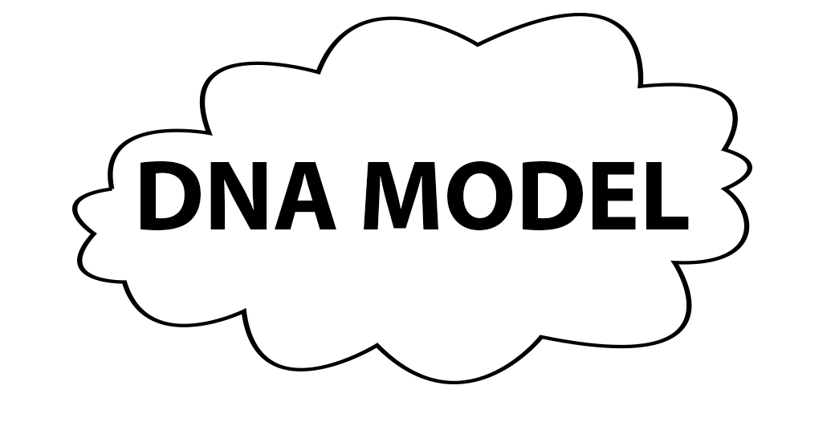

- Line all the twisted together segments in a ladder line.
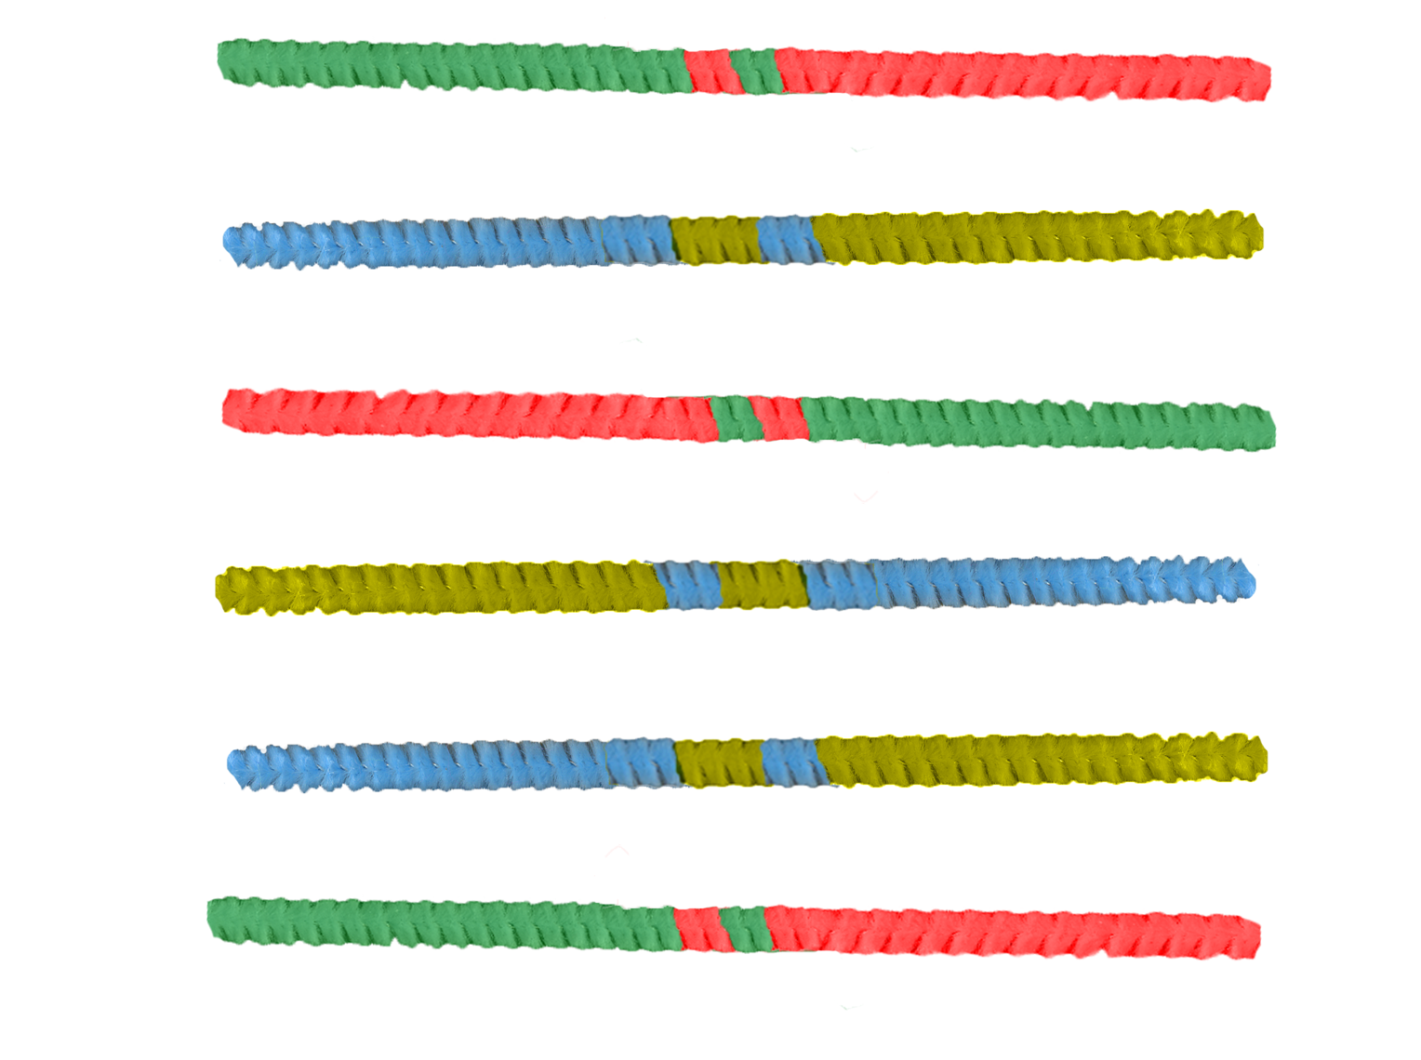
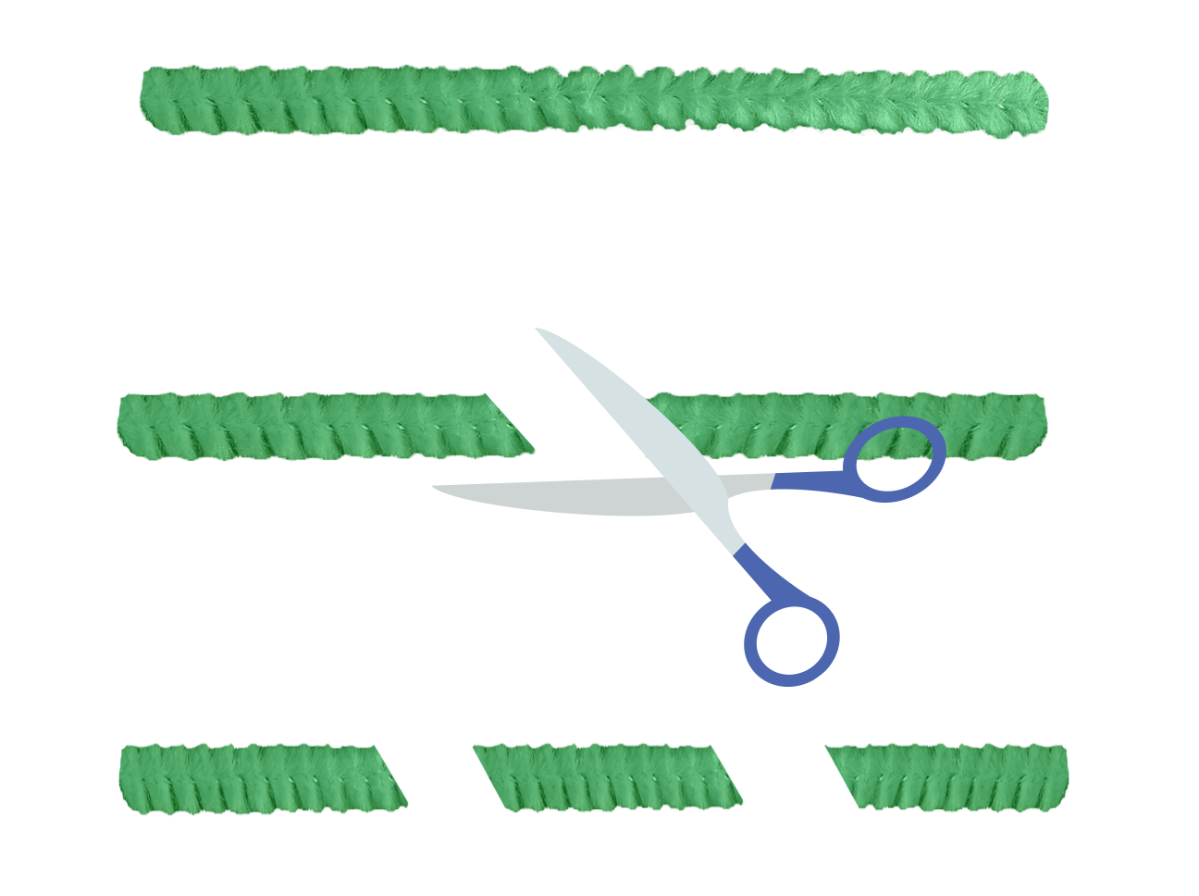
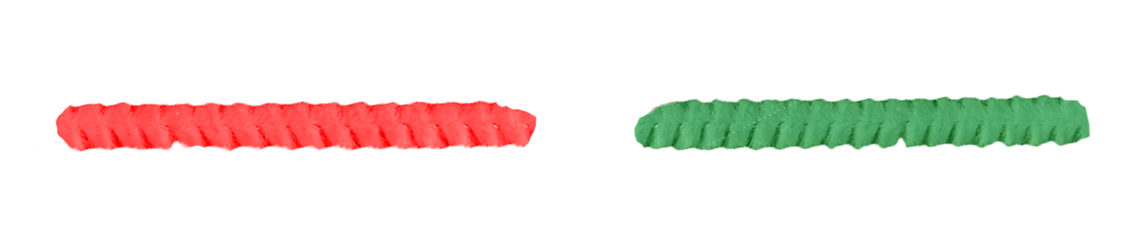
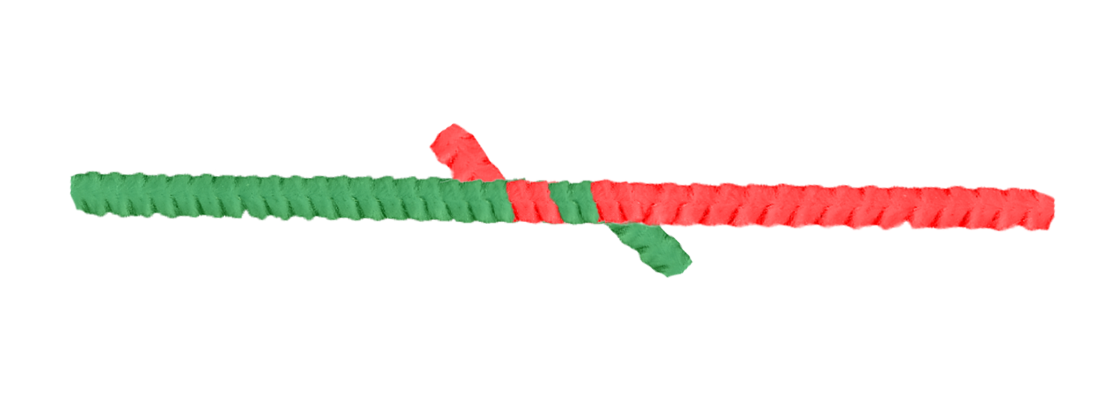
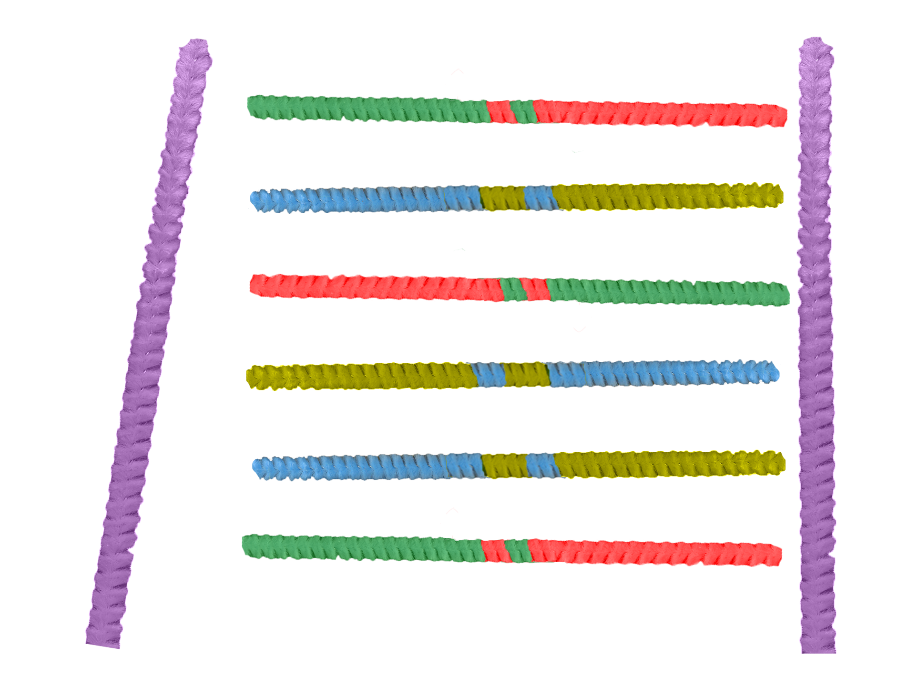
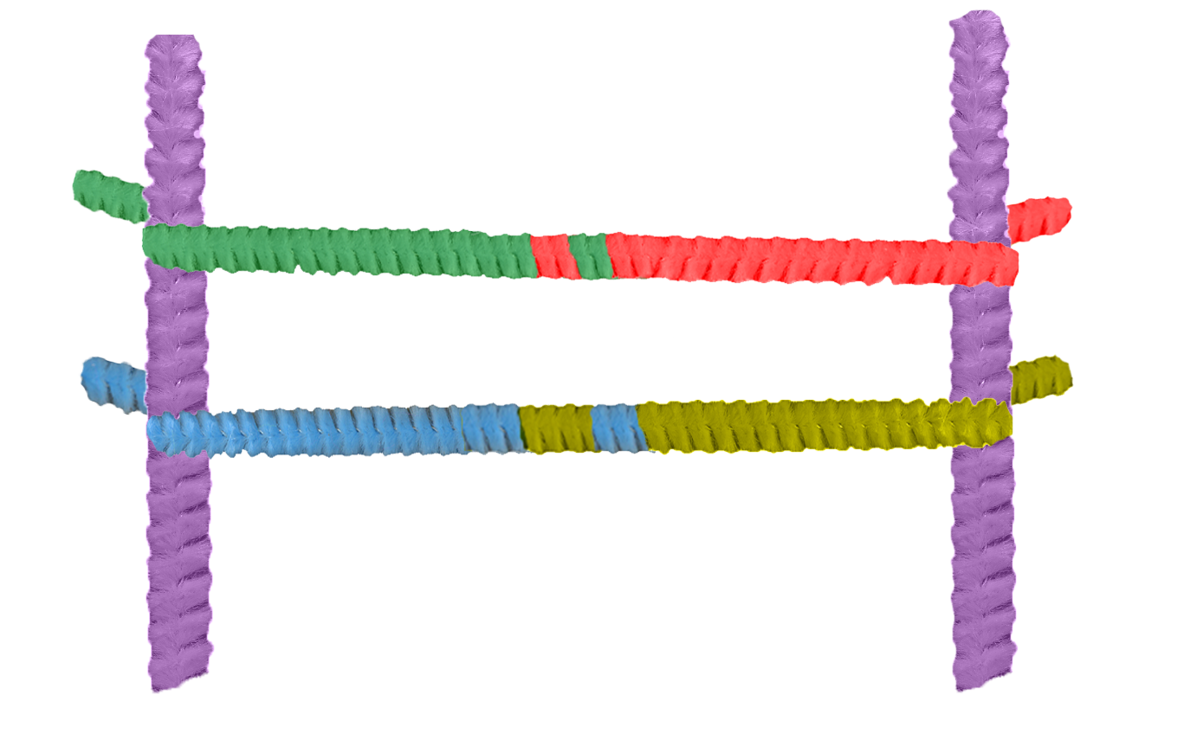
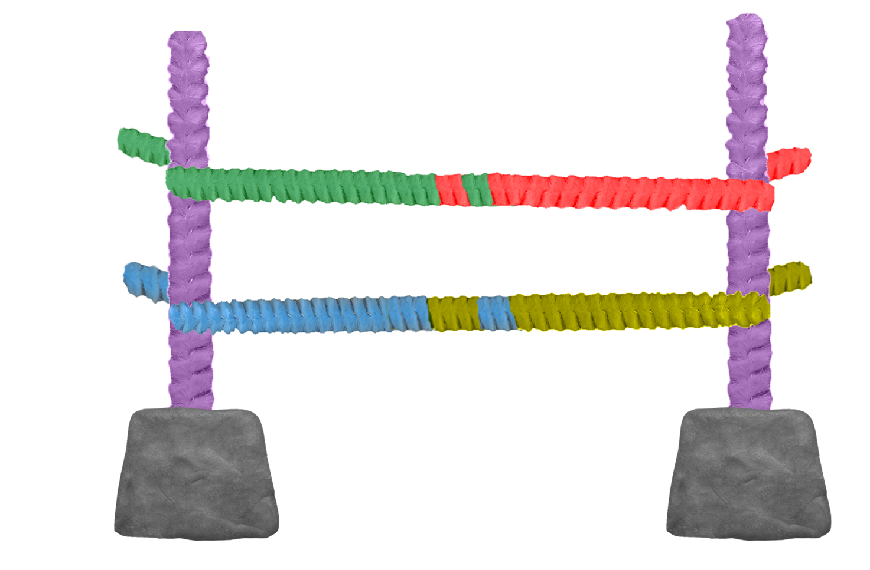
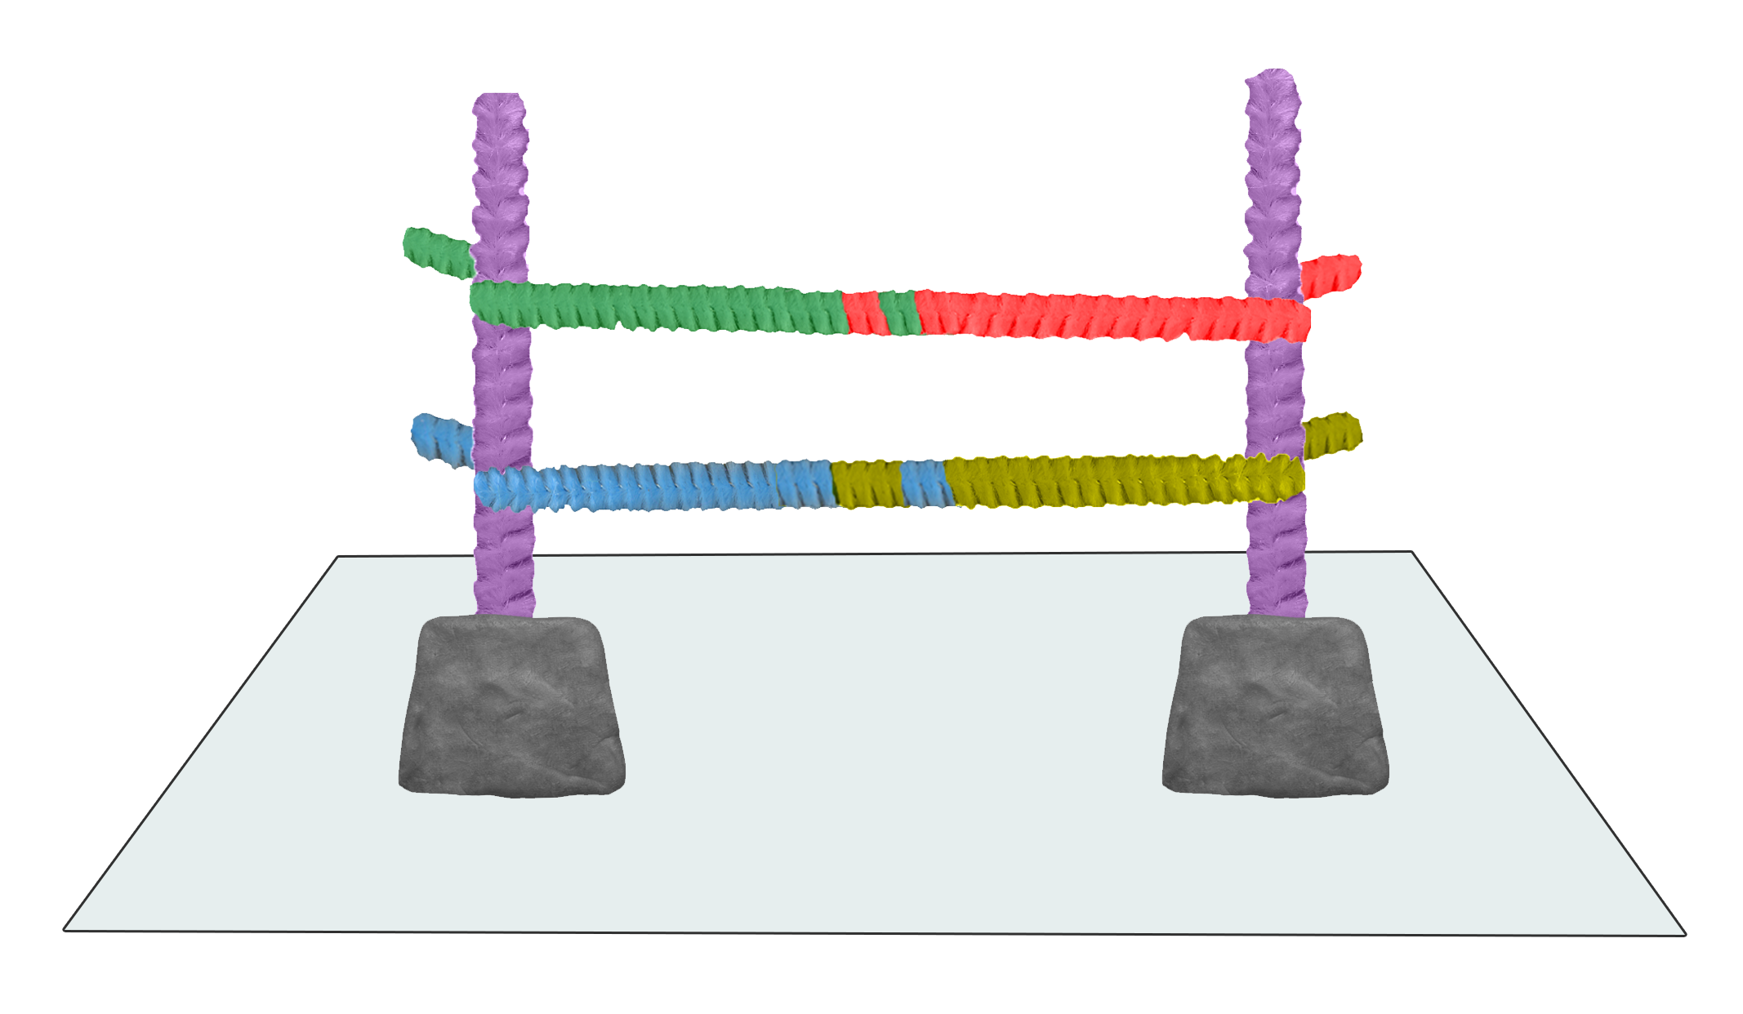
- Put the 2 pipe cleaners of the same colour to one side – these should not be cut.

- Using the remaining 4 different coloured pipe cleaners decide which colour represents which DNA base e.g. Red = A
Green = T
Blue = G
Yellow = C.
- Cut each pipe cleaner into 3 equal lengths.
- Match up the cut segments into the corresponding base pairs.

- Twist the pipe cleaners together at one end.
- Do the same for all the base pairs. Be careful! Only match the corresponding colours together
e.g. Red + Green (A + T)
Blue + Yellow (G + C).
- Collect the 2 pipe cleaners of the same colour that were set aside earlier place each down either side of the ladder line.
- Twist the ends of the base pair segments onto the long pipe cleaners.
- Stick the modelling clay onto the card.
- Twist the ladder structure to form a double helix.
A T
- Stick the end of the 2 pipe cleaners into the modelling clay.
Equipment needed:
- 6 pipe cleaners (2 of one colour and 4 pipe cleaners in different colours)
- A small lump of modelling clay
- Strong card

Questions on triplet code
20 different amino acids make the many thousands of proteins that are found in all living organisms. The instructions to build all these proteins must be coded within the DNA molecule.

If you read the bases in threes along a gene, it is possible to predict the amino acids that will be made and the order they will be made in. This is the triplet code. Each triplet, a group of three bases, codes for a specific amino acid.

Here are the triplet codes for four different amino acids:

alanine GCA methionine ATG glutamine CAA serine TCA isoleucine ATA

1. Write down the order of the amino acids in the protein coded for by this length of DNA:
CAAATGATAGCATCA.

2. Write down the sequence of bases which would code for this chain of amino acids:
serine-methionine–isoleucine-glutamine–alanine.

