Pressure

Student Task Sheet 1

Expanding and collapsing balloons
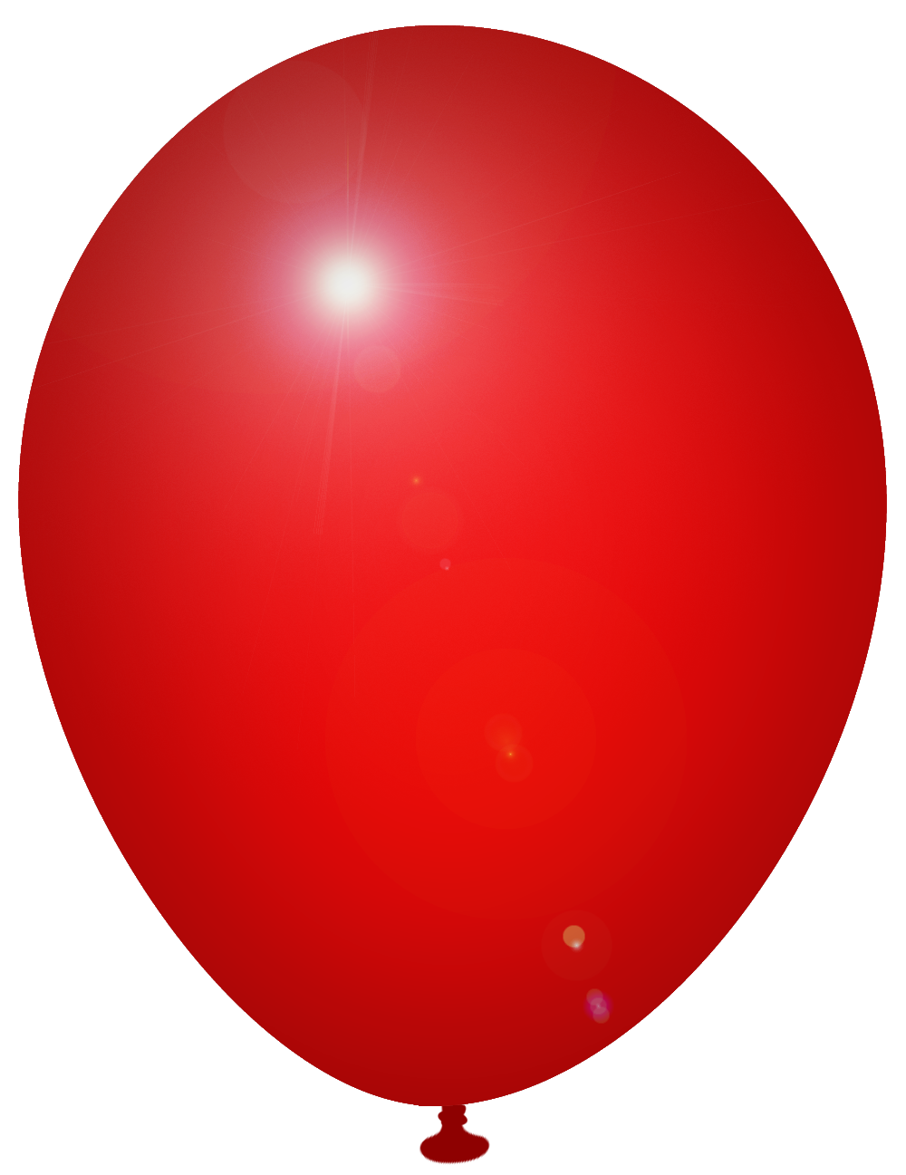
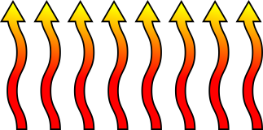
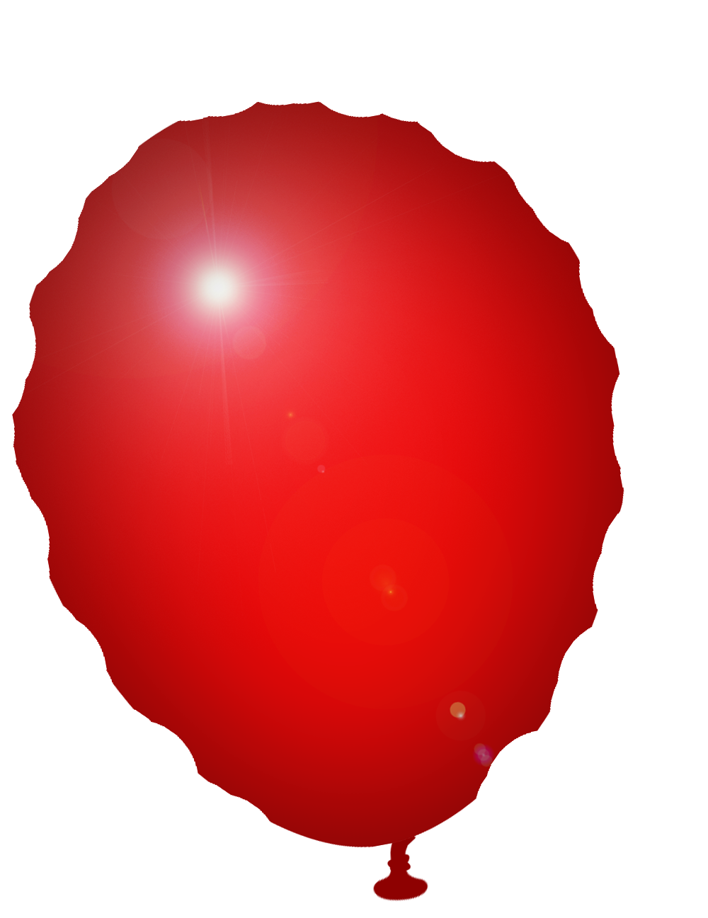
Look at the diagrams of 2 balloons, below.
HEAT
Balloon 1
Balloon 2

Balloon 1 has been on a radiator for 10 minutes. Balloon 2 has been in a freezer for the same length of time. Describe what has happened to the gas particles in each balloon and how this affects the pressure. Use the following words: temperature, pressure, volume, speed, energy and collision.

Student Task Sheet 2

Felix Baumgartner’s space jump
Here are 2 pictures of Felix Baumgartner’s helium balloon. The first is near the ground and the second at the edge of space before Felix jumped. Describe what has happened to the gas particles within each balloon and how this affects the pressure. Use the following words: pressure, balloon, volume and density.
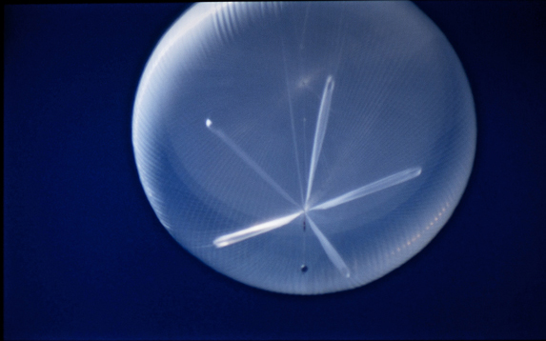
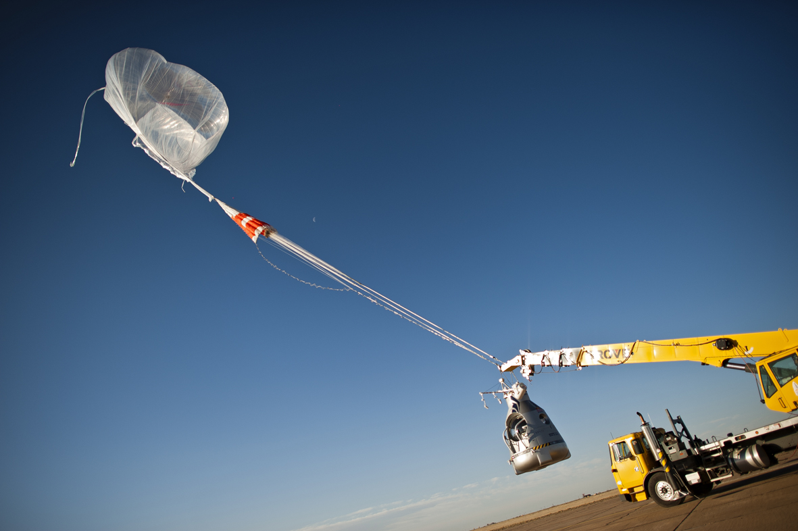

(c) Joerg Mitter / Red Bull Strato (c) Joerg Mitter / Red Bull Stratos
Balloon near the ground
Balloon at edge of space

Student Task Sheet 3

Compressing and expanding gases
Here are 2 drawings of the syringe demonstration that you have just completed. Underneath each one describe what you did and what you observed. Draw how you imagine the gas particles are arranged in the two syringes.
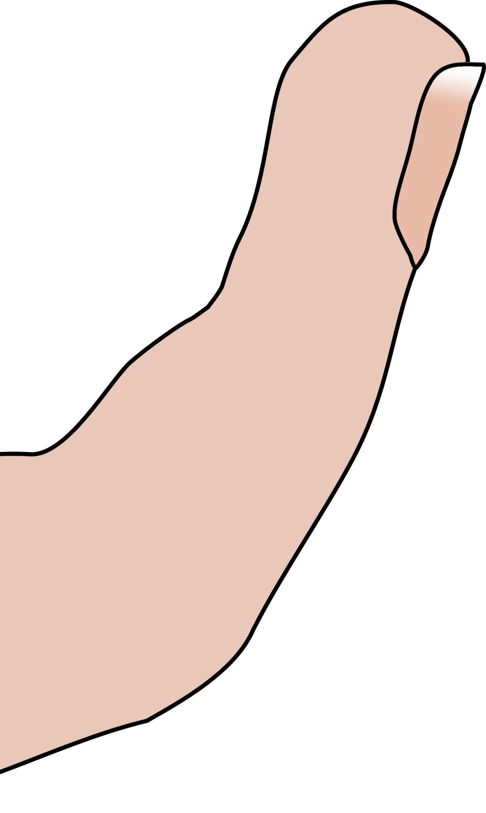
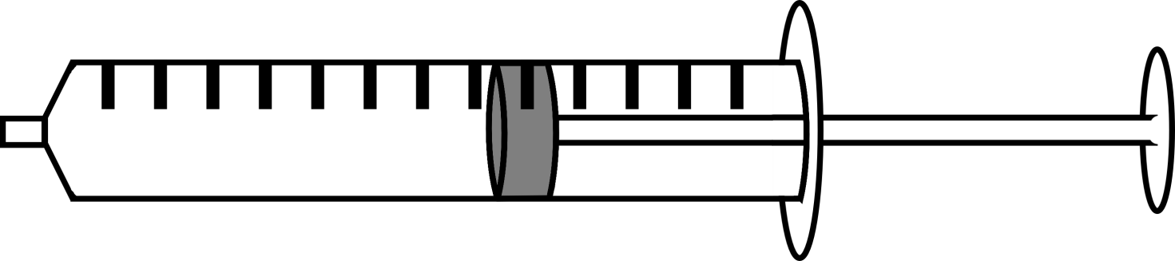
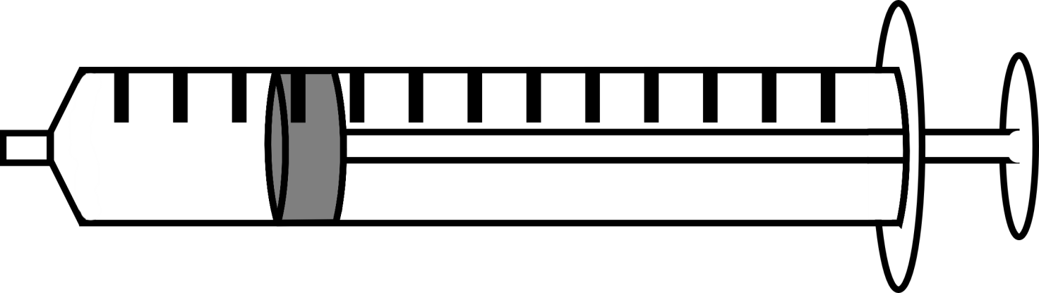

Compressing Gases
Expanding Gases

Arrangement of gas particles
Arrangement of gas particles

Student Task Sheet 4

Doing work on a gas
You and your teacher have just pumped up an inner tube using a bicycle pump. Both the pump itself and the inner tube should feel warm.
Draw diagrams to show the difference between an empty and full inner tube.

Empty Inner Tube
Full Inner Tube

Explain why a full inner tube feels hard:

Explain why the pumped up tube feels warm:

