Probability, Symbols and Significance Levels
As part of the data recording, analysis and presentation section of research methods, you are required to demonstrate knowledge and understanding of the analysis and presentation of normal and skewed distribution curves.

By the end of the activities on these hand outs, you will be able to:
• define probability
• calculate and convert probability events into decimals and percentages
• list and explain common mathematical symbols
• apply probability concepts to significance levels.

Probability
In order to understand inferential statistics, you will need to familiarise yourself with what probability is. This is not as difficult as some may perceive, as probability is ingrained in everyday life. You are dealing with probabilities, every time you buy a lottery ticket. Or even when you hear the news, for example, smoking increases your chances of coronary heart disease or lung cancer.

Activity 1 – Examples of Probability
In pairs/small groups think of as many other examples of probability as you can. These can be referred to later.
Examples

Introducing Probability - Youtube Resources
http://www.youtube.com/watch?v=mhlc7peGlGg- This video discusses the Monty Hall problem and is a nice introduction to probability. There are natural opportunities to pause and discuss points being made.
Notes

http://www.bbc.co.uk/skillswise/topic/probability - This clip explains probability simply with some good real life examples.
Notes

Activity 2 – Some commonly used examples to explore probability
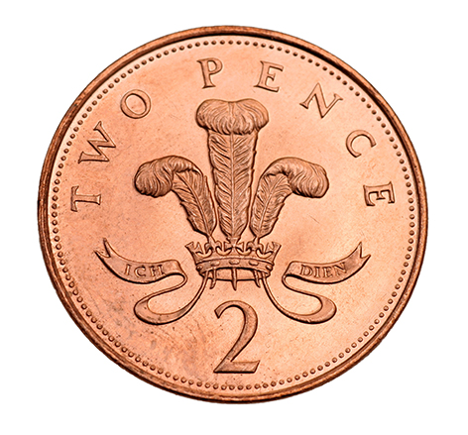
- Tossing the coin
- If you toss a coin, what is the probability of landing on the tails side of the coin? Explain why.
- After the coin lands on tails five times in a row, what is the probability of getting a tail on the sixth throw? Explain why.

- Rolling a dice
- What is the probability of rolling a 6? Explain why.
- What is the probability of rolling either a 2 or a 3? Explain why.
- What is the probability of rolling an odd number? Explain why.

- Choosing a card from a pack of cards

- From a pack of 52 cards, what are the chances of picking a heart? Explain why.
- What is the probability of choosing the queen of hearts? Explain why.
- What is the probability of a choosing a red card? Explain why.

- Picking a blue sweet from the teacher’s packet
How many sweets are there in the pack? How many are blue? Therefore what is the probability of choosing a blue sweet? Explain why.
Activity 2 – Some commonly used examples to explore probability:

- Tossing the coin
If you toss a coin, what is the probability of landing on the tails side of the coin?
After the coin lands on tails five times in a row, what is the probability of getting a tail on the sixth throw?

2) Rolling a dice
What is the probability of rolling a 6?

What is the probability of rolling either a 2 or a 3?

What is the probability of rolling an odd number?

3) Choosing a card from a pack of cards
From a pack of 52 cards, what are the chances of picking a heart?

What is the probability of choosing the queen of hearts?

What is the probability of a choosing a red card?

- Picking a blue sweet from the teacher’s packet
How many sweets are there in the pack? How many are blue? Therefore what is the probability of choosing a blue sweet?

Calculating Probabilities
As can be seen, probabilities are usually expressed in the form of decimal numbers ranging from 0 to 1. 0 means that the event/outcome will definitely not happen and 1 meaning that the event/outcome will definitely happen.

To calculate the probability of an event/outcome happening, such as tossing a coin, the number of occurrences of the desired outcome is divided by the total number of possible outcomes.

Probability = Desired Outcome
______________

Total number of possible outcomes

Getting tails on a flip of a coin = ½

Or 0.5 – To calculate percentages from decimal, simply multiply by 100.
Therefore, the probability of obtaining a tails when tossing a coin is 50% (0.5 x 100).

Activity 3 – Probability in standard form, decimal form and percentage
Probability - What is the probability of a letter being a vowel in the alphabet?

Decimal Form - Divide the desired outcome (vowels) by the total number of letter in the alphabet. What is the answer in decimal form? (You can use a calculator)

Percentage – Using the formula previously mentioned, what is the percentage chance of a letter being a vowel?

Activity 4 – Consolidating your knowledge
Task 1: Estimate the probability of each of these events happening, from 0 (not likely to happen) 1 (likely to happen)? Explain why.
- Finding a million pounds cheque in the next book you read.
- Sunshine following rain in the UK
- Ed Sheeran coming to your sixth form
- Politicians telling the truth all the time.

Task 2: Express the following probabilities as percentages, showing your calculations
- 0.30
- 0.77
- 1/5
- 1/3

Task 3: Express the following probabilities as decimals, showing your calculations:
- 1/9
- 15/20
- 40%
- 11%
Activity 5 – Do you know your symbols?

Figure out which definitions match the correct symbols.
Symbol | Definition
<
>
<<
>>
=
~
∞

- Greater than: one item has much greater value than the other
- One is equivalent to another
- Less than: one item has much less value than the other
- Greater than: one item has greater value than the other
- Less than: one item has less value than another
- One item is proportional to another

Extension task – What are the symbols for greater than or equal to and less than or equal to?
It is important to know these symbols as these will assist in explaining your results and findings, when exploring application of probability in significance levels.
Activity 6 – Use the correct symbol
For example, when comparing the size of a block cheese in comparison to the Eiffel Tower, we would suggest that The Eiffel Tower is much greater than cheese.
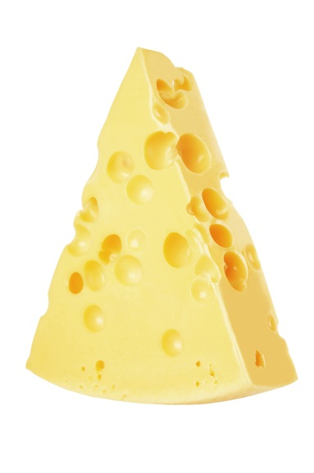

>>

Add the most suitable symbol for these examples and explain why:
1 | Number of goals scored by Lionel Messi last season _______ Goals scored by Cristiano Ronaldo last season
2 | Calories in a small bowl of soup _______ Calories in a large Doner Kebab
3 | Number of hours worked _______ Pay received
4 | Cost of Heinz Ketchup _______ Cost of Tesco Value Ketchup
5 | Weight of a new born baby _______ Weight of a new born puppy
6 | Wheels on a bicycle _______ Wheels on a motorbike
7 | Numbers of hours revision _______ Grade received on class test
8 | Age of teacher _________ Age of students
9 | Enjoyment score of Psychology A Level ______ Enjoyment of Sociology A Level.
10 | Age of the first born twin _________ Age of second born twin

Significance Levels
Significance levels are commonly associated in determining whether you reject or accept your null hypothesis. Associated with this is the use of probability. Many psychologists use the conventional rule that a probability of 5% or 0.05 is the cut-off point when either accepting or rejecting a null hypothesis. This basically means that that there is a 5% or less probability that the results are due to chance and a 95% probability that the results are due to the experimental conditions.

If we find a significant difference in results using this level, we can accept the experimental hypothesis and reject the null. If there is a particularly important piece of research we may be more strict with the setting of our significance level at 0.01 or 1%, this means that after using inferential statistics the probability that the results are due to chance is only 1% and that they are significant is 99%.

In addition, to the probability of 0.05, critical values, also determine the acceptance/rejection of your null hypothesis and acceptance/rejection of your experimental hypothesis. This is explored further in the inferential statistics guide.
Activity 7 – What do these formula mean?
p ≤ 0.05
p ≤ 0.5
p ≤ 0.01
p ≤ 0.025

Which are you most likely to see in psychology?

Activity 8 – Which study is significant?
Imagine that you are a researcher and have just finished conducting two studies. You have found in your first study a link between length of right hand and exam results. In your second study you have found a link between forehead length and height. The probability of observing the relationship in study 1 by chance if the null hypothesis were true is found to be 0.045, whereas in study 2 the probability is 0.0001. Which of these results is the most important to the Psychological community? Explain why.

