Lesson Element

Baron-Cohen et al. (1997)

Instructions and answers for teachers
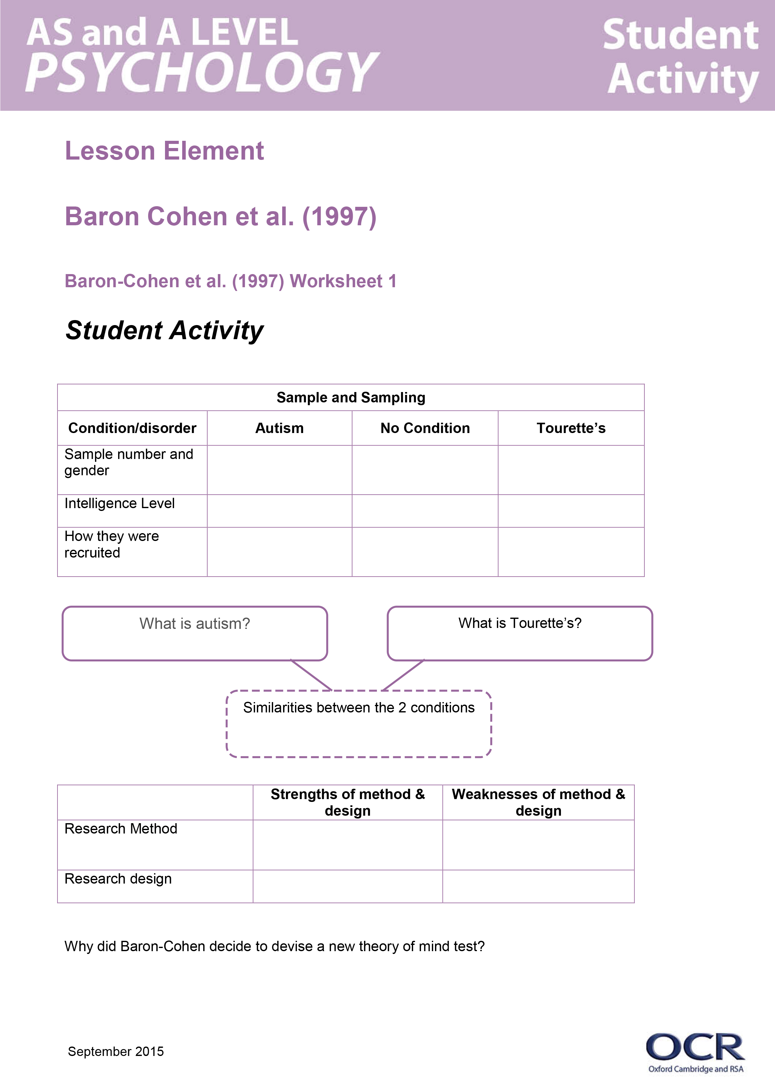
These instructions cover the student activity section which can be found on page 5. This Lesson element supports OCR AS and A Level Psychology.
When distributing the activity section to the students either as a printed copy or as a Word file you will need to remove the teacher instructions section.

Aim
The aim of this lesson element is to provide a structured activity that will enable learners to cover the specification requirements for Baron-Cohen et al.’s core study.
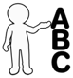
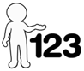
This activity offers an opportunity for English skills development.
This activity offers an opportunity for maths skills development.

Objectives
- To identity the sample and sampling technique.
- Explain the procedure of the study.
- Evaluate methodological issues in relation to Baron-Cohen’s study.
- Apply knowledge of the study to the key theme ‘understanding of disorders’ and the Individual Differences area of psychology.
- Explain how Baron-Cohen’s study compares with Freud’s study.

Introduction to the task

Background and Summary
Baron-Cohen’s study investigated Theory of Mind (TOM) in adults with autism. A new TOM task was devised by Baron-Cohen because existing TOM tests had ceiling effects. Baron-Cohen compared adults with either Autism or Asperger’s Syndrome, Tourette’s Syndrome, or no condition on their ability to identify emotion or mental states from photographs of eyes. One main finding was that the adults with Autism were significantly more impaired on the Eyes task (16.3 out of 25) than the adults with Tourette’s (20.4 out of 25) and the adults with no condition (20.3 out of 25). Baron-Cohen concluded that adults with Autism have an impaired TOM compared to adults with Tourette’s or adults with no condition.

Student Misconceptions
The Sally-Anne test is often referred to as ‘background’ research for investigating TOM. Learners will sometimes get this confused as being one of Baron-Cohen’s tasks in the current study and therefore write about this as being a task for the adults.
Learners sometimes have little understanding of the Strange Stories task and why it was used in Baron-Cohen’s study. It was used to check the validity of the Eyes Task as Baron-Cohen wanted to check that his newly devised Eyes Task was actually measuring TOM. He suggested that if the adults with Autism performed poorly on both the Strange Stories Task (which was already an established test for TOM) and the Eyes Task, then the Eyes Task should be measuring TOM. The adults with no condition did not complete the Strange Stories task; another possible student misconception is that in fact all participants did.
Learners sometimes don’t understand why the Eyes Task was conducted. It is good to inform learners of how individuals with Autism have been found to not focus on the eyes during communication.

Teacher preparation
Possible student questions:
Q: Why was the Basic Emotion Recognition task used?
A: This was a control task. It was used to check whether any impairments on the Eyes Task were down to a deficit in basic emotion recognition. If the adults with Autism did not perform well on this task, then they would probably not perform well on the Eyes Task (if they struggle to judge basic emotion).
Q: Why was the Gender Recognition task used?
A: This was a control task. ‘This is a social judgement without involving mind reading’. This was to check if impairments on the Eyes Task could be attributed to deficits in face perception. If the adults with Autism did not perform well on this task, then they would probably not perform well on the Eyes Task either (if they struggle to judge gender).
Q: Why were participants with Tourette’s used?
A: Both Tourette’s and Autism are developmental disorders. They are also both neurological disorders associated with abnormalities in the front of the brain.
Q: Why were the tasks presented in a random order to each participant?
A: To remove the chance of participants becoming affected by the previous task (order effects).

Task instructions
A copy of all four worksheets should be printed for each student.
For reference, the teacher should have a textbook/OCR Guide to Core Studies/presentation/original articles when learners are completing these activities.

Task 1
The specification states that learners must know how to ‘tell a story’ of each core study. In order to support learners with this, task 1 requires them to research the participants used in the study. This could be done using textbooks, the OCR Guide to Core Studies, the internet or the original article (particularly for high ability learners). Worksheet 1 also requires learners to research Autism and Tourette’s and be able to identify a couple of similarities between the two conditions.
The worksheet also requires learners to apply their previous knowledge of identifying the research method and design to Baron-Cohen’s study. Learners also need to apply their knowledge of strengths and weaknesses of the research method and design to the study. Finally, learners need to understand the rationale behind why Baron-Cohen devised a new test for TOM.
This could be completed individually or in pairs. There could also be discussion at the end of the task about Autism and Tourette’s.

Task 2
To support learners with understanding the procedure of Baron-Cohen’s study, Worksheet 2 requires learners to describe each of the four tasks used in Baron-Cohen’s study. In addition, learners must know the findings in relation to each task and conclusions from the results. This task could be conducted using various resources.

Task 3
The specification requires learners to be able to evaluate the core studies using methodological issues. Worksheet 3 uses some of these key issues, but asks learners to define the key issues (by applying prior knowledge) and then apply the issues to Baron- Cohen’s study. Learners could be asked to contextualise each answer as an extension. This table could also be made in to a mind-map if appropriate and additional issues could be added as an extension.
This resource could be completed without supporting resources, although some lower ability learners may benefit from using them.

Task 4
The specification requires learners to be able to apply their knowledge of the study to a key theme (in this case, ‘understanding disorders’) and an area of psychology (individual differences). This worksheet provides some questions that learners can answer in pairs, and use as a basis for a class discussion.
OCR Resources: the small print
OCR’s resources are provided to support the teaching of OCR specifications, but in no way constitute an endorsed teaching method that is required by the Board, and the decision to use them lies with the individual teacher. Whilst every effort is made to ensure the accuracy of the content, OCR cannot be held responsible for any errors or omissions within these resources.
© OCR 2015 - This resource may be freely copied and distributed, as long as the OCR logo and this message remain intact and OCR is acknowledged as the originator of this work.
OCR acknowledges the use of the following content: Maths an English icons: Air0ne/Shutterstock.com
Please get in touch if you want to discuss the accessibility of resources we offer to support delivery of our qualifications: resources.feedback@ocr.org.uk
We’d like to know your view on the resources we produce. By clicking on ‘Like’ or ‘Dislike’ you can help us to ensure that our resources work for you. When the email template pops up please add additional comments if you wish and then just click ‘Send’. Thank you.
If you do not currently offer this OCR qualification but would like to do so, please complete the Expression of Interest Form which can be found here: www.ocr.org.uk/expression-of-interest

Lesson Element

Baron-Cohen et al. (1997) - Worksheet 1

Sample and Sampling
Condition/disorder | Autism | No Condition | Tourette’s
Sample number and gender
Intelligence Level
How they were recruited?
What is Autism?

What is Tourette’s?

Similarities between the two conditions

 | Strengths of method & design | Weaknesses of method & design
Research Method

Research design

Why did Baron-Cohen decide to devise a new theory of mind test?

Baron-Cohen et al. (1997) - Worksheet 2

Tasks used by Baron-Cohen
Description | Findings from task
The Eyes Task
Basic Emotion Recognition Task
Gender Recognition Task
Strange Stories Task
Conclusions from this study

Baron-Cohen et al. (1997) Methodological Issues - Worksheet 3
Ethics | How the study is ethical and why | How the study is unethical and why
Definition:
Validity | How the study is valid and why | How the study is invalid and why
Definition:
Reliability | How the study is reliable and why | How the study is unreliable and why
Definition:
Ethnocentrism | How the study is ethnocentric | How the study is cross-cultural
Definition:
Sampling Bias | How the sampling method doesn’t have bias | How the sampling method has bias
Definition:

Baron-Cohen et al. (1997) Extension - Worksheet 4
How does the study apply to the key theme of ‘understanding disorders’?
How does the study apply to the area of ‘individual differences’?
What is one similarity and one difference between Baron-Cohen’s study and Freud’s study?
How does the study change our understanding of individual, social and cultural diversity?

