Learner Resource 1

Create a mnemonic for the names of the regions of the EM spectrum

Introduction
The electromagnetic spectrum is divided by scientists into bands according to characteristics of radiation at different frequencies. Try to come up with your own mnemonic (memory aid) to help you remember the order.

Activity
The bands, from the lowest frequencies to the highest, are called: Radio waves, Microwaves, Infrared, Visible light, Ultraviolet, X rays and Gamma rays. So your mnemonic needs to be a set of words that start with: M, I, V, U, X and G, in that order. Since the only word most people can think of starting with X is ‘xylophone’, its okay to use a word that starts with ‘ex’ (for example, ‘excellent’, or ‘exciting’) instead. Remember that this is in increasing order of frequency, and that, if we go from the shortest to the longest wavelengths, the letters will go in the opposite order.
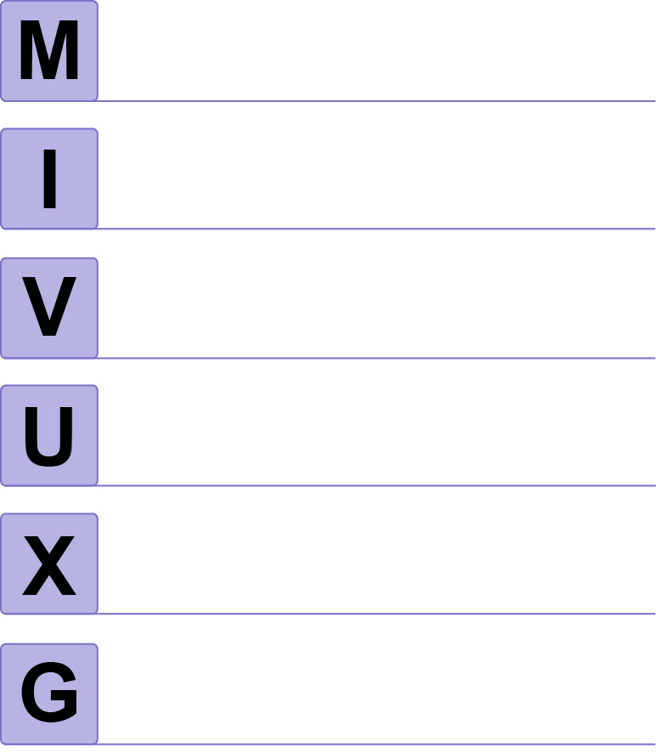

Extension activities/questions:
Question for advanced learners: Why is Gamma radiation named after the third letter of the Greek alphabet?

OCR Resources: the small print
OCR’s resources are provided to support the teaching of OCR specifications, but in no way constitute an endorsed teaching method that is required by the Board, and the decision to use them lies with the individual teacher. Whilst every effort is made to ensure the accuracy of the content, OCR cannot be held responsible for any errors or omissions within these resources.
© OCR 2015 - This resource may be freely copied and distributed, as long as the OCR logo and this message remain intact and OCR is acknowledged as the originator of this work.

Please get in touch if you want to discuss the accessibility of resources we offer to support delivery of our qualifications: resources.feedback@ocr.org.uk

