Lesson Element

Unit R018: Health and well-being for child development

The structure and function of the male and female reproductive systems

Instructions and answers for teachers

These instructions cover the learner activity section which can be found on page 7. This Lesson Element supports Cambridge Nationals Level 1/2 in Child Development.
When distributing the activity section to the learners, either as a printed copy or as a Word file, you will need to remove the teacher instructions section.

The activity
Using a speed dating activity, learners will learn the names and functions of the male and female reproductive organs.

Supporting documents/equipment
- reproduction cards
- timer/stop watch
- activity sheets
- PowerPoint

Suggested timings
- Activity 1: 35-40 minutes
- Activity 2: 10 minutes
- Activity 3: 10-15 minutes.
ABC – This activity offers an opportunity for English skills development.
123 – This activity offers an opportunity for maths skills development.

Activity 1
Your learners could work individually or in pairs depending on the size of your class.
Give a reproduction card to each of your learners (or each pair) and give them 5 minutes to ‘find out about themselves’.
Give your learners some speed dating advice:
- listen carefully to what your partner is saying
- look at them when they are talking to you
- ask lots of questions – check you have understood them.
Tell your learners that they are going to complete a ‘speed-dating’ activity. Each learner will represent a part of the male or female reproductive system. The objective of this exercise is for learners to find out about the parts of the male and female reproductive systems from each other.
They will need a pen and paper for making brief notes.
Give your learners a set time, approximately 5 minutes, for each ‘date’ and then move them on. The time could decrease as the lesson progresses.

Activity 2
Give your learners 5 minutes to label the male and female reproductive systems diagrams. Then go through this with the whole class to ensure their labelling is correct.

Structure of the Male reproductive System
Seminal vesicle

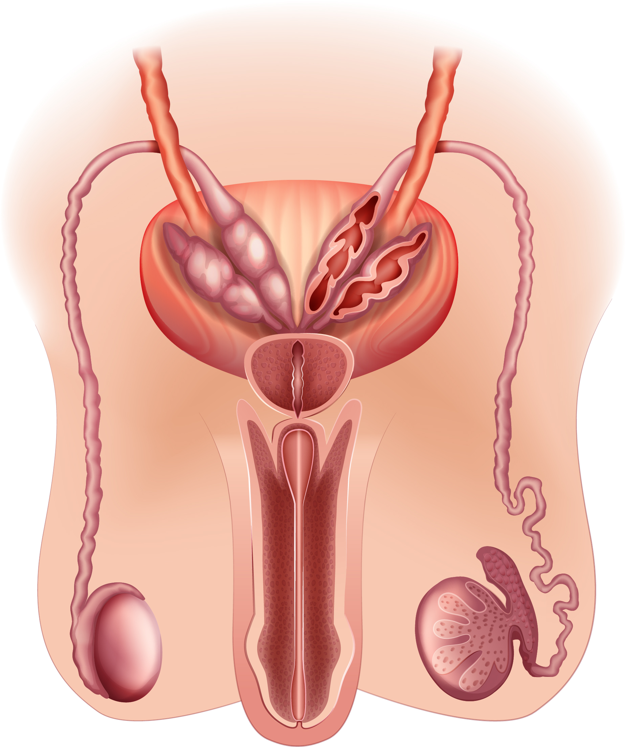
prostate gland

urethra
vas deferens

testis
penis
epididymis
testis

testis
scrotum

penis
testis
testis
testis
testis
scrotum

Structure of the Female reproductive System
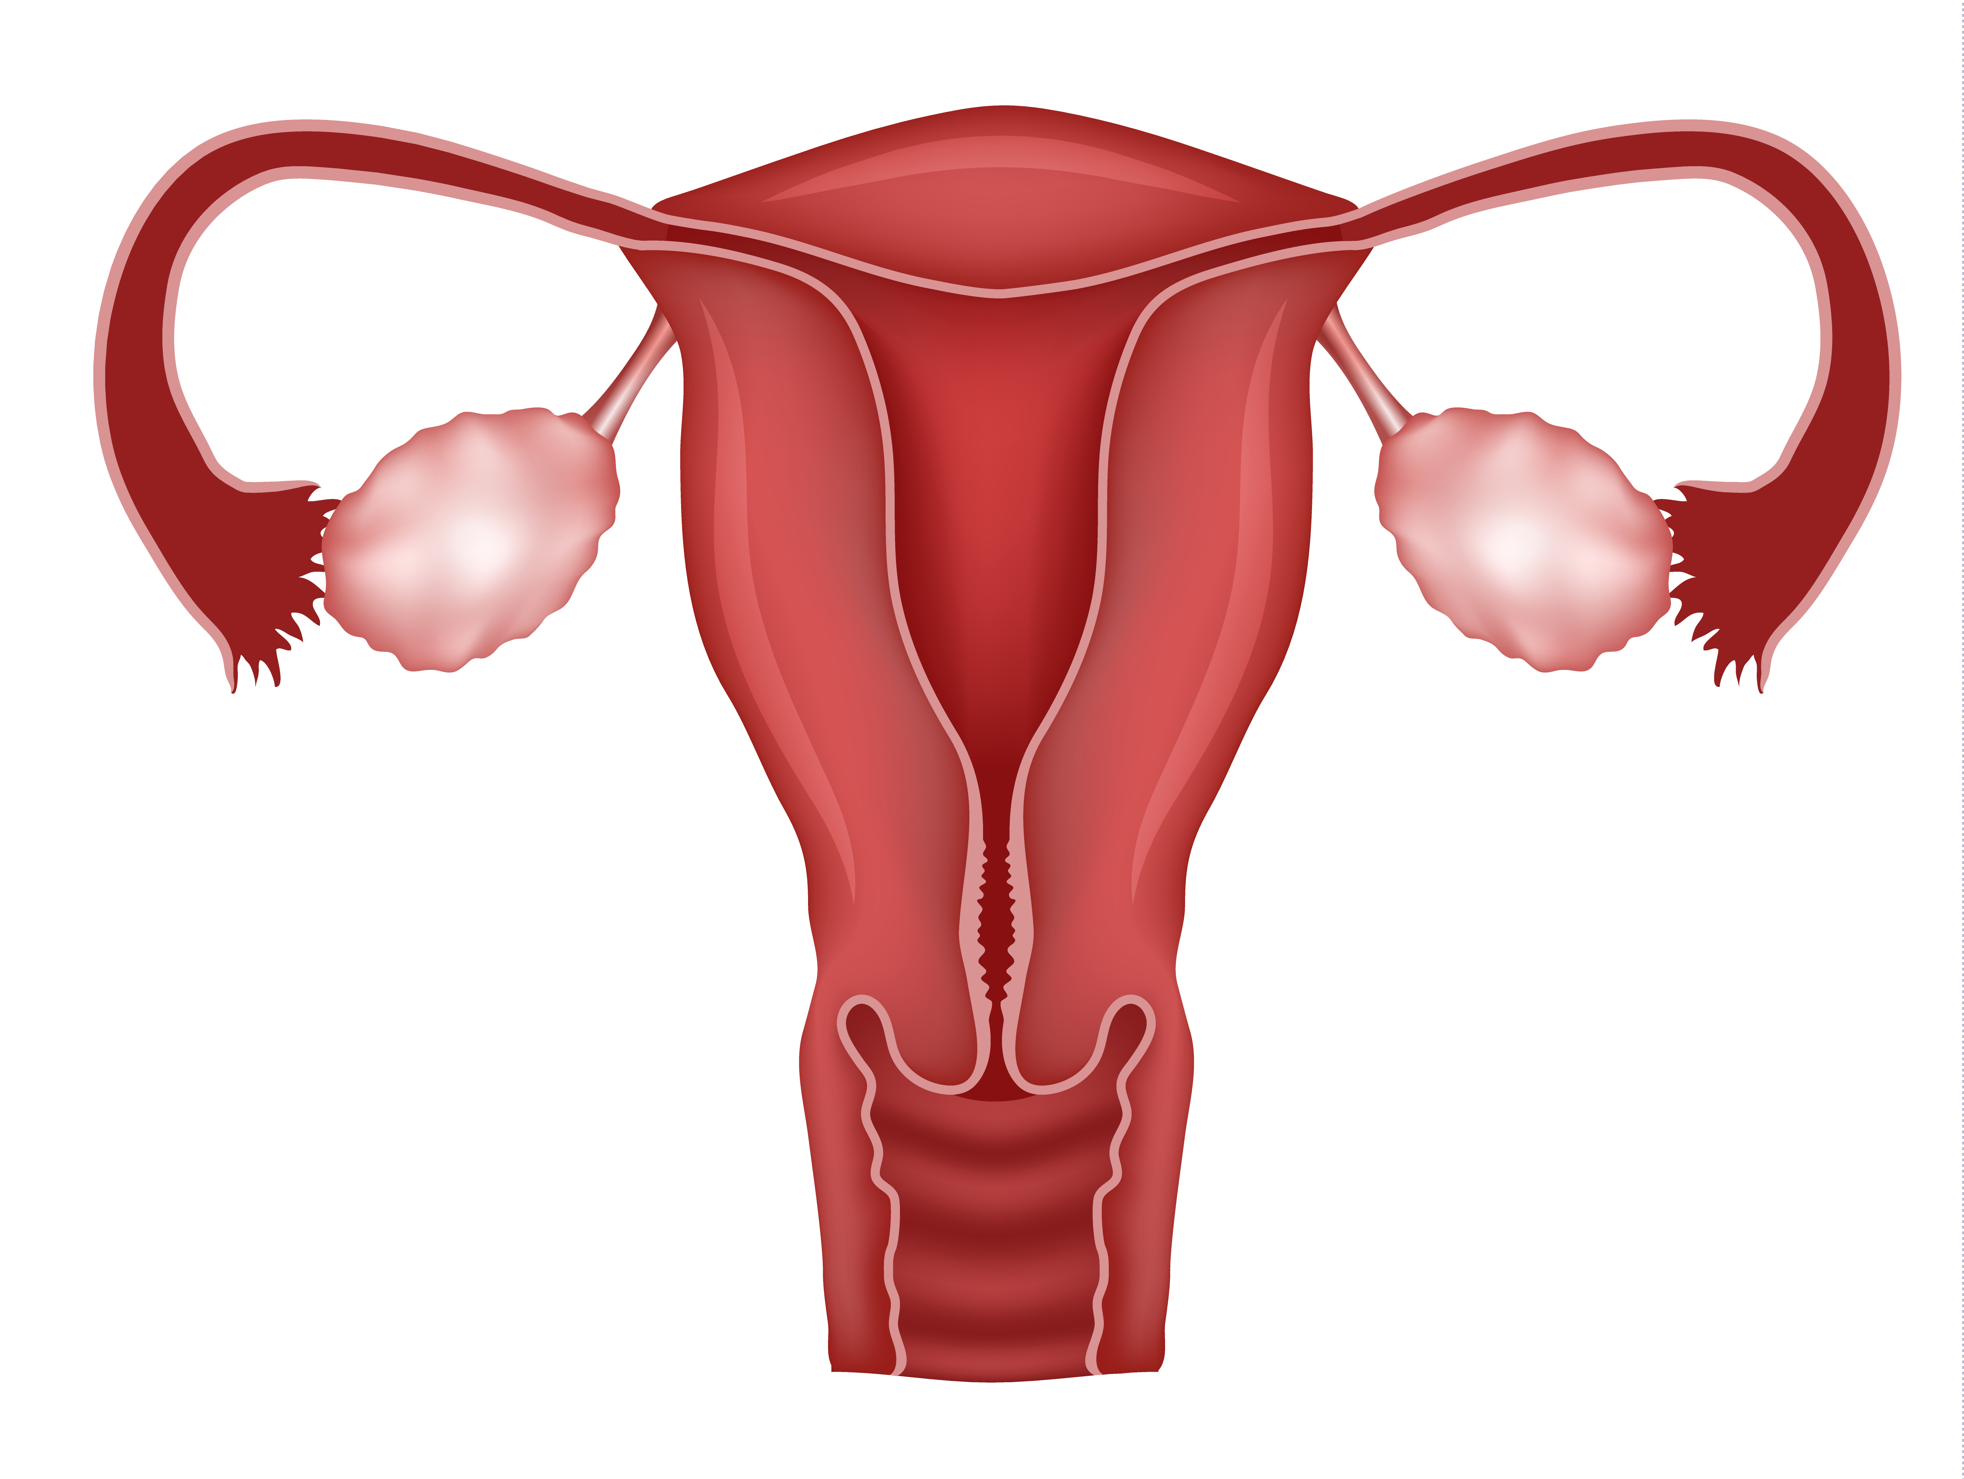
Vagina
Ovary
Fallopian tube

Uterus

Cervix

Activity 3
Ask your learners to use the knowledge gained through their ‘speed dating’ activity to complete the ‘functions’ factsheet.

Female | FUNCTION:
Ovary | There are two ovaries, one at the upper end of each of the fallopian tubes.  Function is to produce female hormones and to make the eggs which are released into the fallopian tubes.  Extra facts:  - The eggs produced are called ‘ova’ or ‘ovum’.  - The female hormones produced are called oestrogen and progesterone.  - Women are born with hundreds of undeveloped egg cells.
Fallopian tubes | There are two fallopian tubes, one on each side of the uterus. They connect the ovaries to the uterus.  Function is to transport the egg (also known as ovum) down to the uterus.  Extra facts:  - Also known as ‘oviduct’ or ‘egg tube’.  - Lined with tiny hairs called ‘cilia’ which help to move the egg through to the uterus.  - Fertilisation of the egg by the sperm takes place in the fallopian tubes.
Uterus | The uterus is connected to the lower end of the fallopian tubes. The lower part is called the cervix which leads to the vagina.  Function is to provide a place for the foetus to grow and develop. The fertilised egg (or ovum) implants into the uterus lining called the endometrium.  Extra facts:  - Is also known as the ‘womb’.  - Is a pear shaped muscular bag.  It goes through a series of monthly changes called the ‘menstrual cycle’, in preparation for a fertilised egg.
Cervix | Found at the neck of the uterus. Connects vagina to uterus. Function is to open gradually during labour to form the birth canal so that the baby can travel through the vagina. Produces mucous that changes in consistency during the menstrual cycle to prevent or promote pregnancy.  Extra facts:  - Opens a small amount to permit passage of menstrual flow.  - Softens to allow sperm to travel through on its way to the fallopian tubes.  - Dilates (opens) widely during childbirth to allow the baby to pass through.
Vagina | Leads into the uterus.  Function is to receive the sperm during intercourse. The sperm travel through the vagina to the cervix and up into the uterus and onwards into the fallopian tubes.  Extra facts:  - Is a muscular tube.  - The baby passes through the vagina at birth.  - Forms the ‘birth canal’ with the uterus and the cervix.

Male | FUNCTION:
Testes | There are two testes in the scrotum, which is a bag of skin that hangs below the abdomen.  Their function is to produce sperm and testosterone (the male hormone).  Extra facts:  - Scrotum stores sperm at a cooler temperature than if they were inside the body.  - Singular = testis. ‘Testes’ is the medical name for testicles.
Sperm duct system | The sperm duct system links the testes to the urethra. It is made up of two parts, the epididymis and a muscular tube called the vas deferens.  Function is to transport the sperm from the testes to the urethra. It stores the sperm in the epididymis. It produces fluids that provide the sperm cells with nutrients.  Extra facts:  - The mixture of sperm cells and fluids is known as ‘semen’.  - The vas deferens is sometimes called the ‘sperm tube’.  - The prostate gland and the seminal vesicle help to produce the fluid for the sperm cells.
Penis  (and Urethra) | Positioned above and in front of the testes.  Two functions:  1 – to pass urine out of the body.  2 – to pass semen into the vagina during sexual intercourse.  The urethra is used for both functions.  Extra facts:  - The exit from the bladder is closed during intercourse so that no urine is passed.  - Penis becomes erect (rigid) before and during intercourse.  - Penis ‘ejaculates’ (discharges) sperm into the vagina.


OCR Resources: the small print
OCR’s resources are provided to support the teaching of OCR specifications, but in no way constitute an endorsed teaching method that is required by the Board, and the decision to use them lies with the individual teacher. Whilst every effort is made to ensure the accuracy of the content, OCR cannot be held responsible for any errors or omissions within these resources.
© OCR 2015 - This resource may be freely copied and distributed, as long as the OCR logo and this message remain intact and OCR is acknowledged as the originator of this work.
OCR acknowledges the use of the following content: Maths and English icons: Air0ne/Shutterstock.com ● Male reproductive system BlueRingMedia/shutterstock.com ● Female reproductive system Tefi/shutterstock.com ● Reproductive system header Iculig/shutterstock.com ● Fallopian Tube diagram Suwin/shutterstock.com ● Close up ovary diagram Timonina/shutterstock.com ● Ovary diagram Tefi/shutterstock.com ● Close ovary diagram 2 sciencepics/shutterstock.com ● Uterus diagram joshya/shutterstock.com ● Uterus diagram with egg sciencepics/shutterstock.com ● Vagina diagram sciencepics/shutterstock.com ●Testes diagram joshya/shutterstock.com ● Testes close up Tefi/shutterstock.com ● Penis diagram PrettyVectors/shutterstock.com ● Sperm and egg SebastianKaulitzki/shutterstock.com
Please get in touch if you want to discuss the accessibility of resources we offer to support delivery of our qualifications: resources.feedback@ocr.org.uk

Please get in touch if you want to discuss the accessibility of resources we offer to support delivery of our qualifications: resources.feedback@ocr.org.uk
We’d like to know your view on the resources we produce. By clicking on ‘Like’ or ‘Dislike’ you can help us to ensure that our resources work for you. When the email template pops up please add additional comments if you wish and then just click ‘Send’. Thank you.
If you do not currently offer this OCR qualification but would like to do so, please complete the Expression of Interest Form which can be found here: www.ocr.org.uk/expression-of-interest

Lesson Element

Health and well-being for child development

Learner Activity

The structure and function of the male and female reproductive systems.
You are going to take part in a ‘speed dating’ activity. You will be a part of the male or female reproductive system and you will talk about ‘yourself’ to other learners as you meet them. You will also ask them questions about what part of the reproductive system they are and their function.
By taking part in this activity you will learn the names and functions of the male and female reproductive organs from your peers.

Activity 1
You have been given a reproduction card. You have 5 minutes to read it and ‘find out about yourself’.
You will now ‘speed date’ with the other learners in your class in order to find out about as many other parts of the male and female reproductive systems from them as you can.
Using the information on your card you will answer their questions and tell them about ‘yourself’. You will then ask them questions and learn about them.
Speed dating advice:
- listen carefully to what your partner is saying
- look at them when they are talking to you
- ask lots of questions – check you have understood them.
You may want to make brief notes.
Your teacher will tell you when your time is up and then you will move on to your next ‘date’.

Activity 2
Having found out about the male and female reproductive systems through the ‘speed dating’ activity you should now be able to apply the knowledge you have gained by labelling the diagrams your teacher will give to you.

Structure of the Male reproductive System

penis

testis

testis
testis
testis
testis
scrotum

Structure of the Female reproductive System

Female | FUNCTION:
Ovary
Fallopian tubes
Uterus
Cervix
Vagina

Male | FUNCTION:
Testes
Sperm duct system
Penis
(and Urethra)

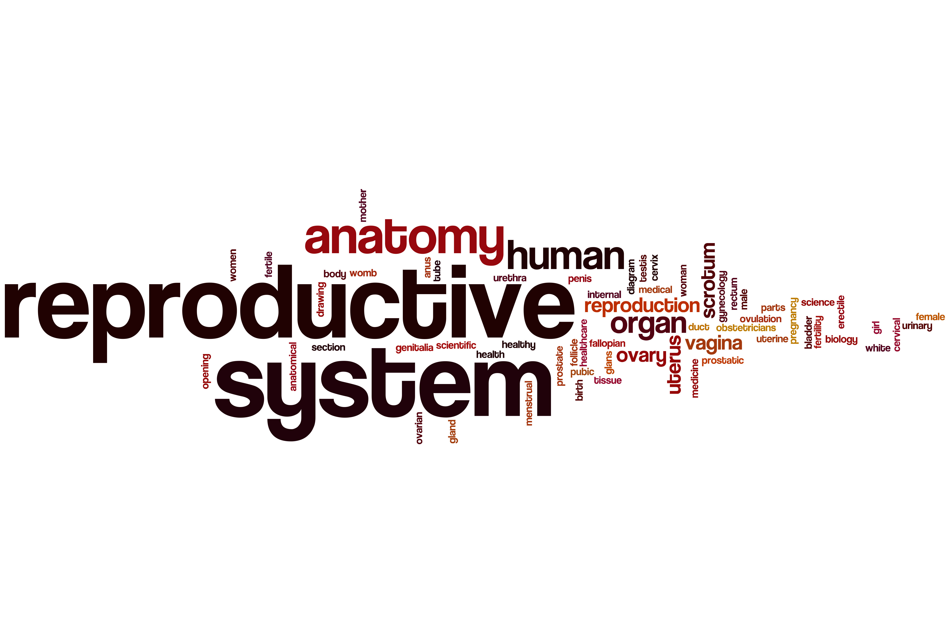

Fallopian Tubes

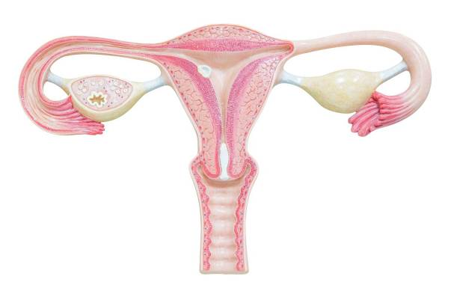
What is my name? Fallopian Tube
Where am I found?
I am found in females. There are two of me, one on each side of the uterus. We connect the ovaries to the uterus.
What is my job?
My job (or function) is to transport the egg (also known as ovum) down to the uterus.
Extra facts:
- I am also known as ‘oviduct’ or ‘egg tube’.
- I am lined with tiny hairs called ‘cilia’ which help to move the egg through me to the uterus.
- Fertilisation of the egg by the sperm takes place in me.
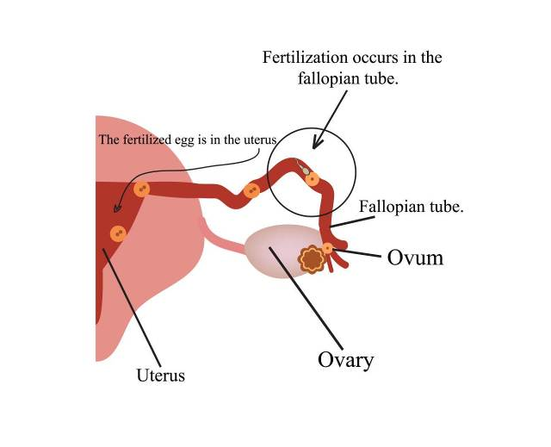

Ovaries

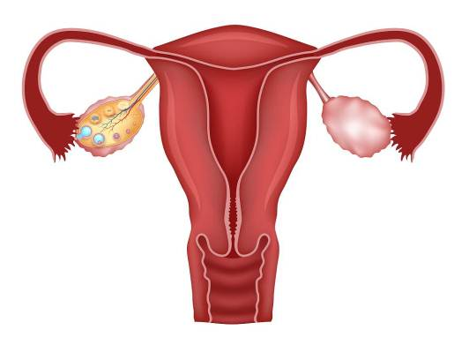

What is my name? Ovaries
Where am I found?
I am found in females. There are two of me, one at the upper end of each of the fallopian tubes.
What is my job?
My job (or function) is to produce female hormones. I also make the eggs which I release into the fallopian tubes.
Extra facts:
- The eggs I produce are called ‘ova’ or ‘ovum’.
- The female hormones I produce are called oestrogen and progesterone.
- Women are born with hundreds of undeveloped egg cells.

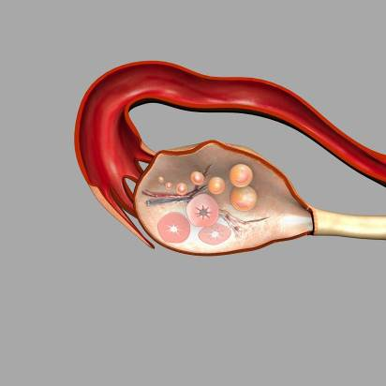

Uterus
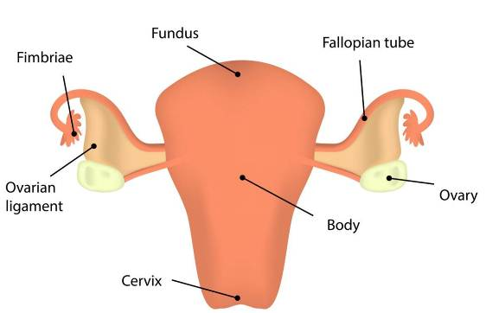
What is my name? Uterus
Where am I found?
I am found in females. There is one of me. At the top I am connected to the lower end of the fallopian tubes. My lower part is called the cervix and leads to the vagina.
What is my job?
My job (or function) is to provide a place for the foetus to grow and develop. The fertilised egg (or ovum) implants into my lining.
Extra facts:
- I am also known as the ‘womb’
- I am a pear shaped muscular bag
- I have a soft lining called the endometrium
- In preparation for a fertilised egg I go through a series of monthly changes called the ‘menstrual cycle’.
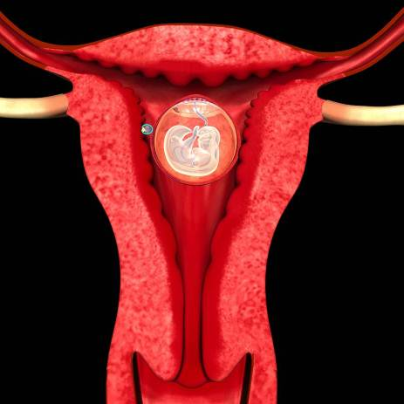

Vagina

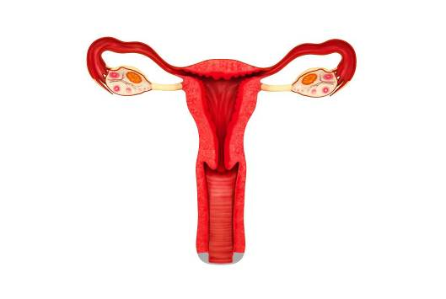
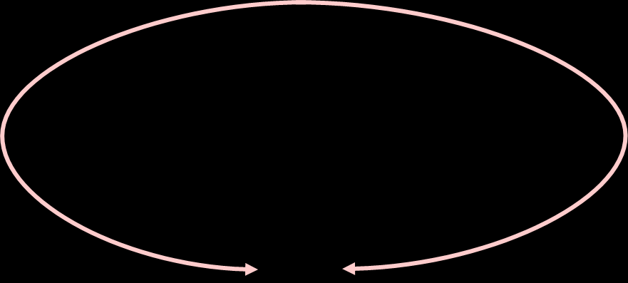

What is my name? Vagina
Where am I found?
I am found in females. There is one of me; I lead into the uterus (or womb).
What is my job?
My job (or function) is to receive the sperm during intercourse. The sperm travel through me to the cervix and up into the uterus and onwards into the fallopian tubes.
Extra facts:
- I am a muscular tube
- The baby passes through me at birth
- I form the ‘birth canal’ with the uterus and the cervix.
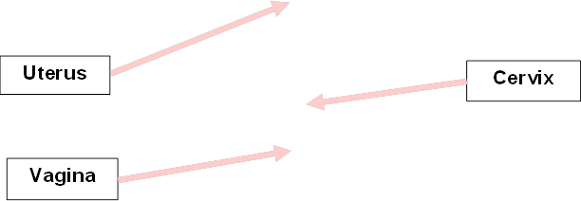
Vagina
Uterus
Cervix
Vagina
Uterus
Cervix
Vagina
Uterus
Cervix

Cervix

Cervix

What is my name? Cervix
Where am I found?
I am found in females. There is one of me. I am located at the neck of the uterus; I connect the vagina to the uterus (or womb.) I am usually closed.
What is my job?
My job (or function) is to open gradually during labour to form the birth canal so that the baby can travel through the vagina. I produce mucous that that changes in consistency during the menstrual cycle to prevent or promote pregnancy.
Extra facts:
- I open a small amount to permit passage of menstrual flow
- I soften to allow sperm to travel through me on its way to the fallopian tubes
- I dilate (open) widely during childbirth to allow the baby to pass through.
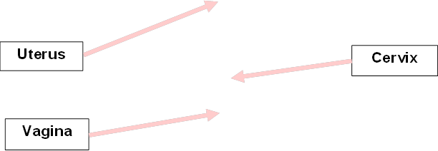
Vagina
Uterus
Cervix

Testes
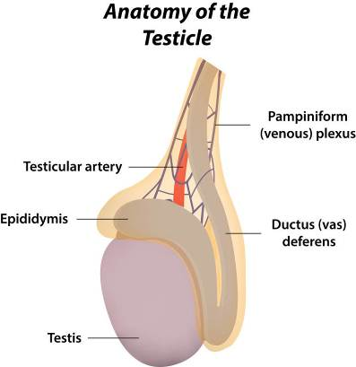

What is my name? Testes
Where am I found?
I am found in males. There are two of me in the scrotum; this is a bag of skin that hangs below the abdomen.
What is my job?
My job (or function) is to produce sperm and also testosterone which is the male hormone.
Extra facts:
- I store the sperm at a cooler temperature than if they were inside the body
- ‘Testes’ is the medical name for testicles
- Singular = testis.
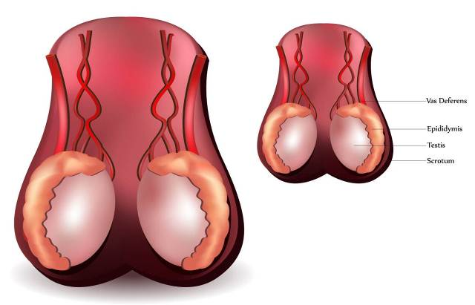

Sperm Duct System
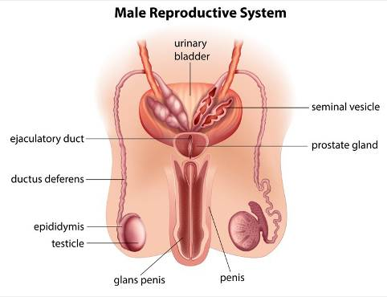
What is my name? Sperm duct system
Where am I found?
I am found in males linking the testes to the urethra. I am made up of two parts, the epididymis and a muscular tube called the vas deferens.
What is my job?
My job (or function) is to transport the sperm from the testes to the urethra. I store the sperm in the epididymis. I produce fluids that provide the sperm cells with nutrients.
Extra facts:
- The mixture of sperm cells and fluids is known as ‘semen’
- The vas deferens is sometimes called the ‘sperm tube’
- The prostate gland and the seminal vesicle help to produce the fluid for the sperm cells.

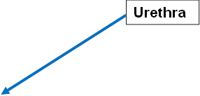
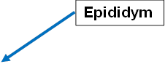

Vas deferens
Testis
Urethra
Urethra
Urethra
Urethra
Urethra
Epididymis

Penis
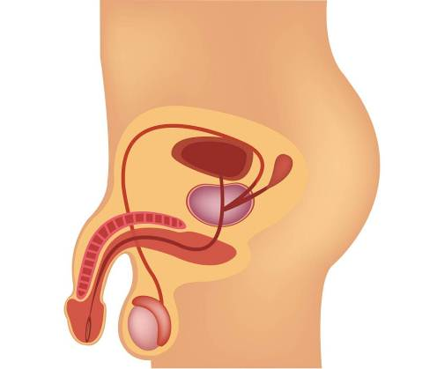

What is my name? Penis
Where am I found?
I am found in males, there is one of me. I am positioned above and in front of the testes.
What is my job?
I have two jobs (or functions.) One job is to pass urine out of the body. My second job is to pass semen into the vagina of a woman’s body during sexual intercourse. I use the urethra for both.
Extra facts:
- I close the exit from the bladder during intercourse so that no urine is passed
- I become erect (rigid) before and during intercourse
- I ‘ejaculate’ (discharge) sperm into the vagina.


