Lesson Element

Unit R019: Understanding the equipment and nutritional needs of children from birth to five years.

Selecting baby clothes and footwear

Instructions and answers for tutors

These instructions cover the learner activity section which can be found on page 4. This Lesson Element supports Cambridge Nationals Level 1/2 in Child Development.
When distributing the activity section to the learners either as a printed copy or as a Word file you will need to remove the tutor instructions section.

The activity
Completing this activity will help learners to understand the clothing needs of a baby 0 to 6 months old. After discussion, and carrying out research, they will be able to suggest suitable items of clothing for a 0 to 6 month old. Learners will have the opportunity to discuss the six factors to be considered when purchasing baby equipment.

Supporting documents and equipment
- Baby magazines and newspapers with clothing advertisements.
- Store magazines/advertising leaflets.
- Online baby clothing manufacturers/shops.
- Visit shops/outlets/local stores.

Suggested timings
- Activity 1: 15 minutes
- Activity 2: 15 minutes
- Activity 3: 30 minutes
ABC – This activity offers an opportunity for English skills development.
123 – This activity offers an opportunity for maths skills development.

Activity 1
Put your learners into pairs for this task. They should make a list of the factors to consider when buying clothes for a baby 0 to 6 months old.
Answers could include (this list is not exhaustive):
- soft
- warm
- size
- lightweight
- appropriate for the weather
- loose
- comfortable
- washable – easy to wash and dry
- non-irritant
- easy to breathe
- flame resistant
- easy to put on and take off
- avoid ribbons and bows.

Activity 2
Hold a class discussion about the six key factors for consideration (from the OCR Cambridge Nationals in Child Development specification):
- age-appropriateness
- safety
- cost
- design/ergonomics
- durability
- hygiene.
Ask the learners to make notes so that they understand how to apply these key factors for consideration to other types of baby equipment.

Activity 3
Learners should apply their learning from the previous activities to complete the chart by choosing six items of clothing with a picture, cost and brief explanation of why the item would be suitable for a baby 0 to 6 months old – considering each of the six key factors from Activity 2.
Clothing items could be chosen from the internet, catalogues and/or magazines.
Example answer:
Cardigan – Age 0-6 months fit. Used when extra layers are needed for warmth. Cotton fabric is soft to the skin.
Easy to wash and hard wearing. Many styles and colours are available. Cost is reasonable, given other high street prices for comparable garment.
Non-flammable materials used.

OCR Resources: the small print
OCR’s resources are provided to support the teaching of OCR specifications, but in no way constitute an endorsed teaching method that is required by the Board, and the decision to use them lies with the individual teacher. Whilst every effort is made to ensure the accuracy of the content, OCR cannot be held responsible for any errors or omissions within these resources.
© OCR 2016 - This resource may be freely copied and distributed, as long as the OCR logo and this message remain intact and OCR is acknowledged as the originator of this work.
OCR acknowledges the use of the following content: Maths and English icons: Air0ne/Shutterstock.com Baby cardigan: Olga Popova/Shutterstock.com
Please get in touch if you want to discuss the accessibility of resources we offer to support delivery of our qualifications: resources.feedback@ocr.org.uk
We’d like to know your view on the resources we produce. By clicking on ‘Like’ or ‘Dislike’ you can help us to ensure that our resources work for you. When the email template pops up please add additional comments if you wish and then just click ‘Send’. Thank you.
If you do not currently offer this OCR qualification but would like to do so, please complete the Expression of Interest Form which can be found here: www.ocr.org.uk/expression-of-interest

Lesson Element

Selecting baby clothes and footwear

Learner Activity

Completing these tasks will help you understand the key factors to consider when choosing clothes for a baby 0 to 6 months old. You will know what items of baby clothes to buy and the key factors to look for when selecting each item.
The first set of baby clothes is often called the ‘layette’. Many mothers-to-be and new mums enjoy collecting and buying articles of clothing, but a new baby only requires a few. Remember babies grow out of their clothes very quickly.

Activity 1
In pairs, make a list of the things you should think about when buying clothes for a baby aged 0 to 6 months old.

When buying clothes for a new baby they should be:

_________________________________________________________________________
_________________________________________________________________________
_________________________________________________________________________
_________________________________________________________________________
_________________________________________________________________________
_________________________________________________________________________
_________________________________________________________________________
_________________________________________________________________________
_________________________________________________________________________
_________________________________________________________________________
_________________________________________________________________________

Activity 2
Your teacher will hold a class discussion about the six key factors for consideration when buying equipment for babies from birth to 12 months, taken from the OCR Cambridge National in Child Development. These are:
- age-appropriateness
- safety
- cost
- design/ergonomics
- durability
- hygiene.
Make notes, so that you can understand how to apply these key factors for consideration to any type of baby equipment in the future.

Activity 3
Research six baby clothing/footwear items and complete the chart to include a picture and cost of each item, which you have chosen (from a store, catalogue or online) giving an explanation of why it is a suitable choice, giving consideration to each of the six factors for consideration (discussed in the previous activity). One is completed for you, as an example.
Clothing | Picture | Cost | Reason for choice – considering the six key factors
Cardigan | 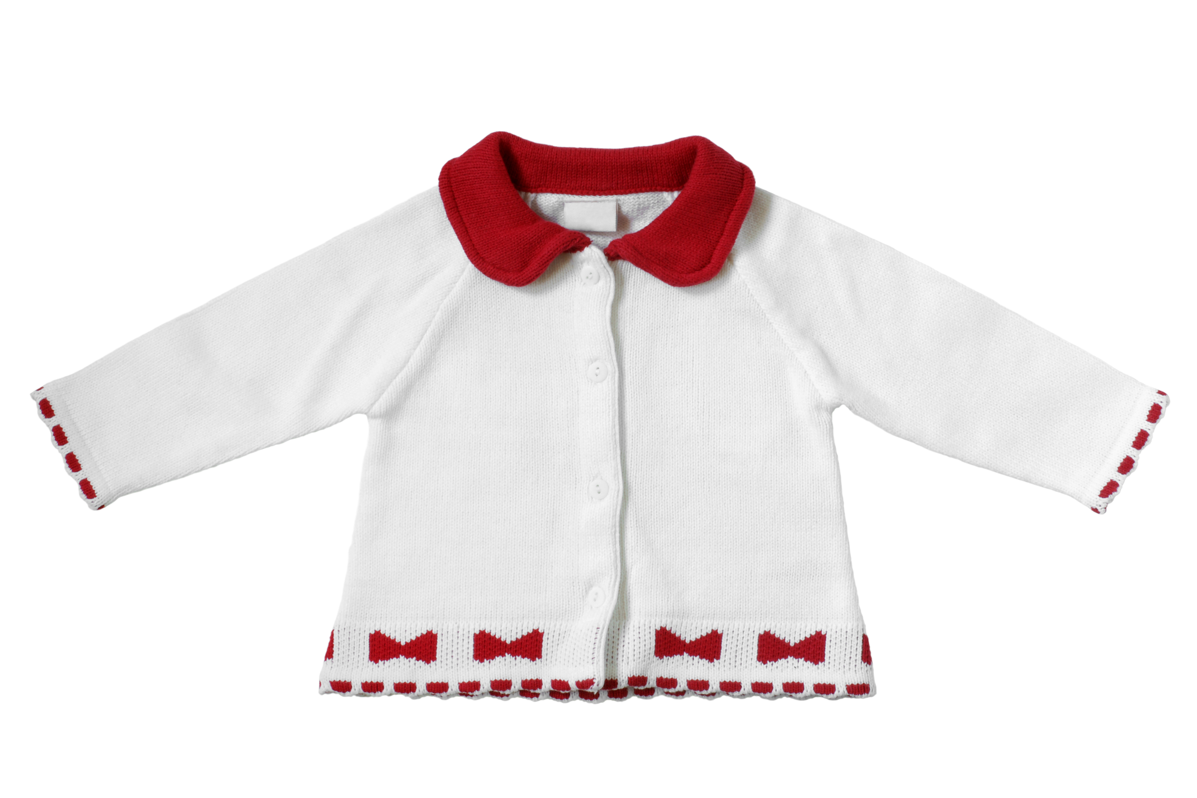 | £7 | Age 0-6 months fit. Used when extra layers are needed for warmth. Cotton fabric is soft to the skin.  Easy to wash and hard wearing. Many styles and colours available. Cost is reasonable, given other high street prices for comparable garment.  Non-flammable materials used.

