Physics PAG P1: Materials

Combined Science PAG P1: Materials

Suggested Activity 1: Determining density

Instructions and answers for teachers & technicians
These instructions cover the learner activity section which can be found on page 7. This Practical activity supports OCR GCSE Physics.
When distributing the activity section to the learners either as a printed copy or as a Word file you will need to remove the teacher instructions section.
This is a suggested practical activity that can be used as part of teaching the GCSE (9-1) Gateway Science (A) and Twenty First Century Science (B) specifications.
These are not controlled assessment tasks, and there is no requirement to use these particular activities.
You may modify these activities to suit your learners and centre. Alternative activities are available from, for example, Royal Society of Biology, Royal Society of Chemistry, Institute of Physics, CLEAPSS and publishing companies, or of your own devising.
Further details are available in the specifications (Practical Skills Topics), and in these videos.

OCR recommendations:
Before carrying out any experiment or demonstration based on this guidance, it is the responsibility of teachers to ensure that they have undertaken a risk assessment in accordance with their employer’s requirements, making use of up-to-date information and taking account of their own particular circumstances. Any local rules or restrictions issued by the employer must always be followed.
CLEAPSS resources are useful for carrying out risk-assessments: (http://science.cleapss.org.uk).
Centres should trial experiments in advance of giving them to learners. Centres may choose to make adaptations to this practical activity, but should be aware that this may affect the Apparatus and Techniques covered by the learner.

Introduction
In this experiment learners will be determining the density of a variety of objects both solid and liquid.

DfE Apparatus and Techniques covered
1a [1]: Use of appropriate apparatus to make and record a range of measurements accurately, including: i [i]) length; iii [iii]) mass; v [viii]) volume
1b [13]: Use of such measurements to determine: i) densities of solid objects; ii) densities of liquid objects

Aims
To use appropriate apparatus to take measurements of length, volume and mass.
To calculate densities using measurements taken.

Intended class time
50-60 minutes

Links to Specifications:

Gateway Science (Suite A) including Working Scientifically (WS)
P1.1d define density
P1.1f apply the relationship between density, mass and volume to changes where mass is conserved
WS1.2e Evaluate methods and suggest possible improvements and further investigations
WS1.4a Use scientific vocabulary, terminology and definitions
WS1.4b Recognise the importance of scientific quantities and understand how they are determined
WS1.4c Use SI units and IUPAC chemical nomenclature unless inappropriate
WS1.4e Interconvert units
WS1.4f Use an appropriate number of significant figures in calculations
WS2a Carry out experiments
WS2b Make and record observations and measurements using a range of apparatus and methods

Twenty First Century Science (Suite B) including Ideas about Science (IaS)
P6.1.1a define density
P6.1.1b describe how to determine the densities of solid and liquid objects using measurements of length, mass and volume
P6.1.2 recall and apply the relationship between density, mass and volume to changes where mass is conserved: density (kg/m³) = mass (kg) ÷ volume (m³)
IaS1.3 Recognise the importance of scientific quantities and understand how they are determined
IaS2.2 When processing data use SI units where appropriate (e.g. kg, g, mg, km, m, mm, kJ, J)
IaS2.5 When processing data interconvert units
IaS2.6 When processing data use an appropriate number of significant figures
IaS2.10 Evaluate an experimental strategy, suggest improvements and explain why they would increase the quality (accuracy, precision, repeatability and reproducibility) of the data collected, and suggest further investigations

Mathematical Skills covered
M1a Recognise and use expressions in decimal form
M1b Recognise and use expressions in standard form
M3b Change the subject of an equation
M3c Substitute numerical values into algebraic equations using appropriate units for physical quantities
M3d Solve simple algebraic equations
M5c Calculate areas of triangles and rectangles, surface areas and volumes of cubes

Health and Safety
This is a very safe experiment when performed sensibly; metal blocks may be heavy so care must be taken to not drop them.
It is safe to touch solid lead with bare hands, but you should wash your hands after touching lead.

Method 1: Finding the density regular shaped solids
Learners will use a ruler to measure the height, width and depth of the different material blocks, and use these measurements to calculate the volumes. They use the mass scales to record the mass in kg, and then they calculate the densities.

Method 2: Finding the density of irregular shaped solids
Learners will use Eureka beakers to find the volume of irregular shaped plasticine. They will use mass scales to record the mass of the plasticine, and then they calculate the density.

Method 3: Finding the densities of liquids
Learners will use mass scales and measuring cylinders to find the mass and volume of liquids and use these measurements to calculate the densities.

Notes
Learners should be able to give reasons why their results for densities would differ from the actual densities. Encourage learners to consider where the inaccuracies in their measurements may be. This is a good opportunity to look at the resolution of the measuring equipment they are using.

Technicians Notes
For this practical the teacher will require for a class of 30:
- 15 x cuboid blocks of wood (these can be varying sizes)
- 15 x cuboid blocks of lead (these can be varying sizes) NB this can be replaced by a different metal if needed
- 15 x cuboid blocks of plastic
- Plasticine (enough to make 15 small irregular shapes)
- 5 x mass scales
- 15 x Eureka beakers (if eureka beakers aren’t available these can be substituted for measuring cylinders)
- 30 cm rulers with mm divisions
- 15 x measuring cylinders (any size can be used but too big will lead to unnecessary spillage)
- Access to a tap
- Vegetable oil (a 1 litre bottle will be more than enough for a class)

Answers for quiz questions
1ai [3 marks]
Material | Height (m) | Width (m) | Depth (m) | Volume (m³) | Mass (kg)
Glass | 0.04 | 0.04 | 0.04 | 6.4x10⁻⁵ | 0.192
Lead | 0.02 | 0.02 | 0.02 | 8.0x10⁻⁶ | 0.09
Wood | 0.05 | 0.01 | 0.01 | 5.0x10⁻⁶ | 1.85x10⁻³

1aii [5 marks]
density = mass ÷ volume
apply equation to each material
Glass 3000 kg/m³
Lead 11 250 kg/m³
Wood 370 kg/m³
1bi [1 mark]
C
1bii [3 marks]
Either
Place irregular shaped object in Eureka beaker full of water with a spout collect displaced water in the measuring cylinder the volume of water collected will be the volume of the object
Or
Part fill the measuring cylinder with water and record the volume add the irregular shaped object and record the new value of the volume of water the difference between these two values is the volume of the object

Document updates
v1 Published on the qualification pages
v1.1 January 2017 Consolidated labelling of activities
v1.2 February 2017 Correction to Combined Science labelling
v1.3 June 2021 Updated to meet accessibility standards
v1.4 March 2023 Update to wording and equations
Please note – web links are correct at date of publication but other websites may change over time. If you have any problems with a link you may want to navigate to that organisation’s website for a direct search.

We’d like to know your view on the resources we produce. Click ‘Like’ or ‘Dislike’ to send us an auto generated email about this resource. Add comments if you want to. Let us know how we can improve this resource or what else you need. Your email will not be used or shared for any marketing purposes.
Looking for another resource? There is now a quick and easy search tool to help find free resources for your qualification.
OCR is part of Cambridge University Press & Assessment, which is itself a department of the University of Cambridge.
For staff training purposes and as part of our quality assurance programme your call may be recorded or monitored.
Oxford Cambridge and RSA Examinations is a Company Limited by Guarantee. Registered in England. Registered office
The Triangle Building, Shaftesbury Road, Cambridge, CB2 8EA. Registered company number 3484466. OCR is an exempt charity.
OCR operates academic and vocational qualifications regulated by Ofqual, Qualifications Wales and CCEA as listed
in their qualifications registers including A Levels, GCSEs, Cambridge Technicals and Cambridge Nationals.
OCR provides resources to help you deliver our qualifications. These resources do not represent any teaching method we expect you to use. We update our resources regularly and aim to make sure content is accurate but please check the OCR website so that you have the most up to date version. OCR cannot be held responsible for any errors or omissions in these resources.
Though we make every effort to check our resources, there may be contradictions between published support and the specification, so it is important that you always use information in the latest specification. We indicate any specification changes within the document itself, change the version number and provide a summary of the changes. If you do notice a discrepancy between the specification and a resource, please contact us.
© OCR 2023 - You can copy and distribute this resource freely if you keep the OCR logo and this small print intact and you acknowledge OCR as the originator of the resource.
OCR acknowledges the use of the following content: N/A
Whether you already offer OCR qualifications, are new to OCR or are thinking about switching, you can request more information using our Expression of Interest form.
Please get in touch if you want to discuss the accessibility of resources we offer to support you in delivering our qualifications.

Physics PAG P1: Materials

Combined Science PAG P1: Materials

Suggested Activity 1: Determining density

Learner Activity

Introduction
In this experiment you will be determining the density of a variety of objects both solid and liquid.

Aims
To use appropriate apparatus to take measurements of length, volume and mass.
To calculate densities using measurements taken.

Intended class time
50-60 minutes

Equipment (per group)
- Cuboid block of wood
- Cuboid block of lead
- Cuboid block of plastic
- Plasticine
- Mass scales
- Eureka beaker
- Ruler
- Measuring cylinder
- Vegetable oil

Health and Safety
This is a very safe experiment when performed sensibly; metal blocks may be heavy so care must be taken to not drop them.
It is safe to touch solid lead with bare hands, but you should wash your hands after touching lead.

Method 1: Finding the density regular shaped solids
1.Use the ruler to measure the height (h), width (w) and depth (d) of each block in m. Record the measurements in the table below and calculate the volume in m³, using the equation
volume = height × width × depth
h
d
w

2. Use the mass scales to weigh the blocks one at a time and record the masses in kg in the table below.
3. Use the mass in kg and the volume in m to calculate the densities of the regular solid objects in kg/m³ using the equation:
density = mass ÷ volume

Results
Material | Wood | Lead | Plastic
Height (m)
Width (m)
Depth (m)
Volume (m³)
Mass (kg)
Density (kg/m³)

Method 2: Finding the density of irregular shaped solids
- Take some plasticine and make any shape you like with it. Draw your shape in the table below
- Measure the mass of the shape using the scales and record the mass in kg in the table below
- Fill the Eureka beaker up with water, record the starting level of water in the table below
- Add your plasticine shape to the water and record the level of the water
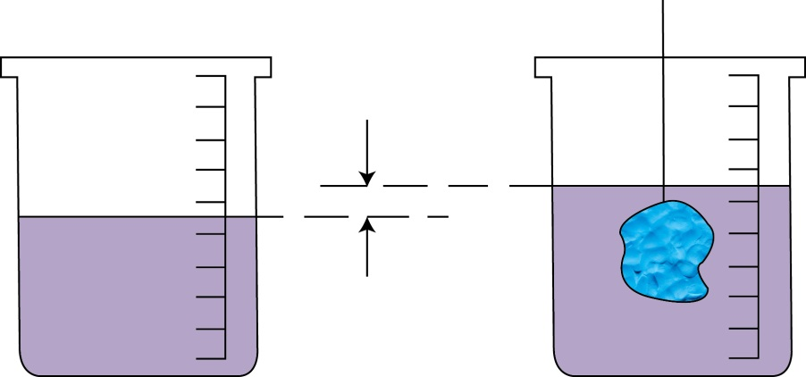
Change in volume (∆V) = volume of object

- Work out the volume of plasticine by using the calculation:
volume of object = volume of water after object added – volume of water before object added
- Calculate the density of the plasticine

Results
Plasticine shape | Mass (kg) | Initial volume of water (m³) | Final volume of water (m³) | Volume of plasticine (m³) | Density of plasticine (kg/m³)

Method 3: Finding the densities of liquids
- Take the empty measuring cylinder and place it on the mass scales. Record the mass in kg in the table below
- Fill the measuring cylinder with water and record the volume of water added in the table
- Place the measuring cylinder of water on the mass scales and record the mass in kg in the table
- Work out the mass of the liquid by using the calculation:

mass of liquid = mass of cylinder and liquid – mass of empty cylinder

- Calculate the density of the water
- Repeat the above steps instead using the vegetable oil rather than the water

Results
Liquid | Mass of empty cylinder (kg) | Mass of cylinder + liquid (kg) | Mass of liquid (kg) | Volume of liquid (m³) | Density of liquid (kg/m³)
Water
Oil

Evaluation
Material | Calculated density (kg/m³) | Actual density (kg/m³)
Lead
Plastic
Wood
Water
Oil

Suggest why there is a difference between the calculated and actual values for the densities.

Quiz - test your knowledge and understanding
- A student is trying to find the densities of the three different materials below.
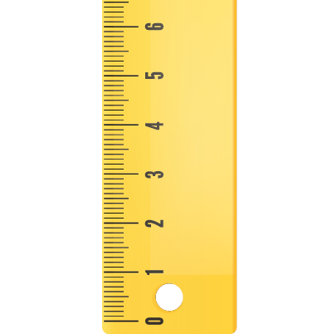
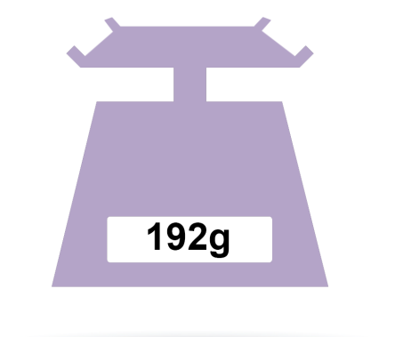
Glass Lead Wood
30 cm ruler

(a) (i) | Complete the table below with the missing values. Use the images above to help. [3 marks]
Material |  | Height (m) | Width (m) | Depth (m) | Volume (m³) | Mass (kg)
Glass |  | 0.04 | 0.04 | 0.04 | 6.4x10⁻⁵
Lead |  | 0.02 | 0.02 | 0.02 | 8.0x10⁻⁶ | 0.09
Wood |  |  | 0.01 | 0.01 |  | 1.85x10⁻³

(a) (ii) | Work out the densities of the materials. [5 marks]

Glass kg/m³

Lead kg/m³

Wood kg/m³

(b) (i) | Which instrument, A, B C or D could be used to determine the volume of an irregular shaped solid? [1 mark]
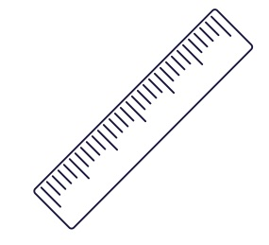
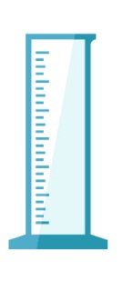
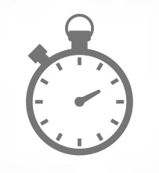
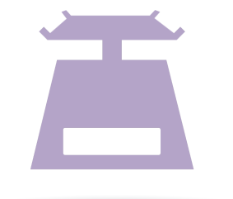
A B C D

(b) (ii) | How you would use it to find the volume? [3 marks]

DfE Apparatus and Techniques covered
If you are using the OCR Practical Activity Learner Record Sheet (Physics / Combined Science) you may be able to tick off the following skills:

Physics |  |  |  |  | Combined Science
1a-i | 1a-iii | 1a-v | 1b-i |  | 1-i | 1-iii | 1-viii | 13-i
1b-ii |  |  |  |  | 13-ii

