Lesson Element

Competing reactions in electrolysis

Instructions and answers for teachers

These instructions cover the student activity section which can be found on page 6. This Lesson Element supports OCR GCSE (9-1) Gateway Science Chemistry A and the Twenty First Century Science Chemistry B qualifications.
When distributing the activity section to the learners either as a printed copy or as a Word file you will need to remove the teacher instructions section.

Mapping to specification level (Learning outcomes)
GCSE (9–1) Gateway Science Chemistry A/Combined Science A
C3.4a recall that metals (or hydrogen) are formed at the cathode and non-metals are formed at the anode in electrolysis using inert electrodes
C3.4 b predict the products of electrolysis of binary ionic compounds in the molten state
C3.4 c describe competing reactions in the electrolysis of aqueous solutions of ionic compounds in terms of the different species present
C3.4 d describe electrolysis in terms of the ions present and reactions at the electrodes
C3.4e describe the technique of electrolysis using inert and non-inert electrodes
GCSE (9–1) Twenty First Century Science Chemistry B/Combined Science B
C3.3.7. describe competing reactions in the electrolysis of aqueous solutions of ionic compounds in terms of the different species present, including the formation of oxygen, chlorine and the discharge of metals or hydrogen linked to their relative reactivity

When an electric current is passed through an aqueous solution the water is electrolysed as well as the ionic compound. Less reactive metals, such as silver or copper, form on the negative electrode. If the solution contains ions of more reactive metals, hydrogen gas forms from the hydrogen ions from the water.

Introduction
This content is new to the GCSE but has often been covered by teachers in the past through Key Stage3 with the idea of ‘fruity batteries’. By altering the metals used in the ‘fruity battery’ there was a notable change in the voltage produced. At A Level learners learn about this ‘competing’ effect through electrode potentials. It is a difficult concept for learners to grasp and they need to have a solid grounding in atomic structure C2.1 the formation of ions C2.3 and how electrolysis works C3.3.

Teacher preparation
A series of questions could be used to check learners understanding of electronic configuration, ion formation and electrolysis before embarking on this. An example exam question has also been included to consolidate the understanding covered in this lesson element.

Task instructions and answers

Task 1
Provide learners with the questions to check understanding. They should not need longer than 10 minutes. You may choose to allow them to use their books/notes to help them answer. Provide the answers to the class and allow them to ‘self-assess’. This will allow them to identify any misconceptions they have and you can clear up any misconception that arise using the ‘help cards’ if necessary.
Answers
1. proton, electrons and neutrons
2. electrons
3. 7
4. 2
5. positive
6. negative
7. Mg²⁺
8. Cl –
9. the negative electrode (cathode)
10. the positive electrode (anode)

Task 2
These can be either carried out as practicals or demos. Ensure you risk assess the experiments before using them. Make sure the solutions are fresh and sufficient concentration and the metals in experiment 1 are clear of corrosion to give the best results possible. Small hand held voltmeters are available and should be checked that they all work properly before using. The voltage changes are not significant so small changes need to be detected. Collect a set of results before hand and demonstrate how to set up the ‘cell’ before the learners carry this out to avoid any difficulties the learners may have. For experiment 2 the learners should observe and decide on the products which are produced. This should open up opportunity for discussion.

Task 3
This task looks at the competing reactions that can occur when electrolysis of salts take place in aqueous solutions.
Answers:
Question 1:
Anode: Product: Cl₂ Half equation: 2Cl –(aq) → Cl₂(g) + 2e–
Cathode: Product: Cu Half equation: Cu²⁺(aq) + 2e– → Cu(s)
Overall: CuCl₂(aq) → Cu(s) + Cl₂(g)

Question 2:
Anode: Product: H₂ Half equation: 2H₂O(l) + 2e– → H₂(g) + 2OH–(aq)
Cathode: Product: Br₂ Half equation: 2Br –(aq) → Br₂(aq) + 2e–
Overall: 2Br –(aq) + 2H₂O(l) → Br₂(aq) + H₂(g) + 2OH–(aq)

Question 3:
Anode: Product: H₂ Half equation: 2H₂O(l) + 2e– → H₂(g) + 2OH–(aq)
Cathode: Product: O₂ Half equation: 2H₂O(l) → O₂(g) + 4H⁺(aq) + 4e–
Overall: 2H₂O(l) → 2H₂(g) + O₂(g)

Question 4:
Anode: Product: H₂ Half equation: 2H₂O(l) + 2e– → H₂(g) + 2OH–(aq)
Cathode: Product: O₂ Half equation: 2H₂O(l) → O₂(g) + 4H⁺(aq) + 4e–
Overall: 2H₂O(l) → 2H₂(g) + O₂(g)

Task 4
A sample practice question - Learners should work on this individually and either self/peer or teacher mark for checking understanding.

Answers
a) reading given
b) voltmeter
c) concentration of solution used or volume of solution used, same size electrodes
d) there is no voltage given, due to no difference in reactivity
e) magnesium and copper
f) magnesium (most reactive)

Supporting/further information
One experiment has been provided which you could use but there are many others depending on how much time you wish to spend on this topic. Linking into A Level Chemistry may be motivating for some able learners and may give them an insight into the A Level course. However be aware that this may be very challenging for less able learners so needs to have scaffold added appropriately for them to grasp the key areas of understanding.

The following links cover:
Alternative practicals
Electricity from pairs of metals.
http://www.bbc.co.uk/bitesize/standard/chemistry/metals/making_electricity/revision/1/

An Electrifying experiment
http://outreach.materials.ox.ac.uk/LearningResources/ElectricalPropertiesMaterials/anelectrifyingexperience.php

Simple electrode potentials experiment – Reactivity series and corrosion
http://outreach.materials.ox.ac.uk/LearningResources/Resourcesunderdevelopment/underdev.php

Summary of reactivity of metals and voltage readings
http://www.yenka.com/activities/Cells_-_Activity/

Further reading
Introduction to redox potentials Chemguide
http://www.chemguide.co.uk/physical/redoxeqia/introduction.html

We’d like to know your view on the resources we produce. By clicking on ‘Like’ or ‘Dislike’ you can help us to ensure that our resources work for you. When the email template pops up please add additional comments if you wish and then just click ‘Send’. Thank you.
Whether you already offer OCR qualifications, are new to OCR, or are considering switching from your current provider/awarding organisation, you can request more information by completing the Expression of Interest form which can be found here: www.ocr.org.uk/expression-of-interest
Looking for a resource? There is now a quick and easy search tool to help find free resources for your qualification:
www.ocr.org.uk/i-want-to/find-resources/
OCR Resources: the small print
OCR’s resources are provided to support the delivery of OCR qualifications, but in no way constitute an endorsed teaching method that is required by the Board, and the decision to use them lies with the individual teacher. Whilst every effort is made to ensure the accuracy of the content, OCR cannot be held responsible for any errors or omissions within these resources.
© OCR 2017 - This resource may be freely copied and distributed, as long as the OCR logo and this message remain intact and OCR is acknowledged as the originator of this work.
OCR acknowledges the use of the following content: n/a
Please get in touch if you want to discuss the accessibility of resources we offer to support delivery of our qualifications: resources.feedback@ocr.org.uk

Lesson Element

Competing reactions in electrolysis

Learner Activity

Introduction
This activity is designed to cover electrolysis of aqueous solutions of salts using inert and non-inert electrodes. It is an opportunity to consolidate your learning on atomic structure, reactivity of metals and electrolysis.

Task 1
Answer the following questions:
- Name the 3 subatomic particles in an atom.

- Which of the subatomic particles has a negative charge?

- How many electrons are in the outer shell of a chlorine atom?

- How many electrons are in the outer shell of a magnesium atom?

- If an atom loses electrons will its ion have a positive or negative charge?

- If an atom gains electrons will its ion have a positive or negative charge?

- Write the symbol including its charge for a magnesium ion.

- Write the symbol including its charge for a chlorine ion.

- In electrolysis there are two electrodes. Which electrode will the magnesium ions be attracted to?

- Which electrode will chlorine ions be attracted to?

After checking your answers with the teacher identify which area you need to improve on.
If you found question 1-4 difficult use HELP CARD 1
If you found question 5-8 difficult use HELP CARD 2
If you found question 9-10 difficult use HELP CARD 3

Task 2
Experiment 1 – Reactivity of Metals
Each pair requires
- A 100 ml beaker
- Voltmeter
- 2 wires
- 2 Crocodile clips
- 50 cm³ Sodium chloride solution
- 5 cm strips of copper, iron, zinc and magnesium
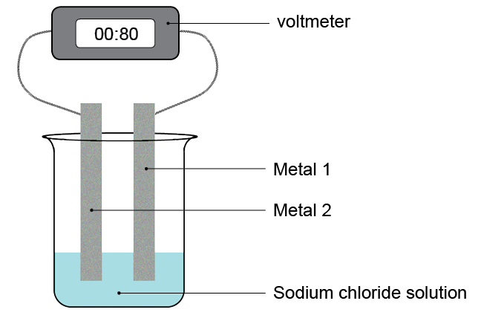
Set up the equipment as in the diagram below.

Try as many different combinations of metals as you can and record the voltage recorded.
Metal 1 | Metal 2 | Voltage (V)
Copper | Iron
Copper | Zinc
Copper | Magnesium
Iron | Zinc
Iron | Magnesium
Iron | Copper
Zinc | Magnesium
Zinc | Copper
Zinc | Iron
Magnesium | Copper
Magnesium | Iron
Magnesium | Zinc

Experiment 2 – Competing reactions in electrolysis of aqueous solutions
Each pair requires
- A 100 ml beaker
- Voltmeter
- 2 carbon electrodes
- 2 Crocodile clips
- 50 cm³ copper sulphate solution
- Power pack
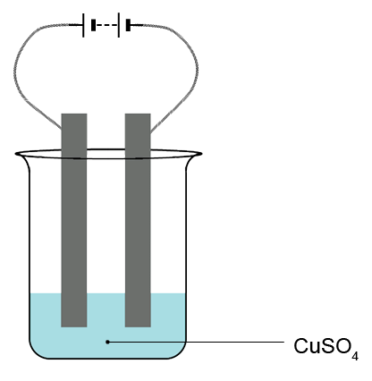
Set up the apparatus as shown in the diagram and record the observations that you see at each electrode.
Observation
Observation

Explain what is occurring at each electrode.

Task 3
Electrolysis of Aqueous Solutions
The electrolysis of molten salts involves:
- reduction of the positive ions (cations) at the negative electrode (cathode) – i.e. gain of electrons and formation of a neutral substance.
- oxidation of the negative ions (anions) at the positive electrode (anode) – i.e. loss of electrons and formation of a neutral substance
For example, the electrolysis of molten zinc chloride leads to production of zinc and chlorine:
Reduction: Zn²⁺(l) + 2e– → Zn(l)
Oxidation: 2Cl–(l) → Cl₂(g) + 2e–
Overall: ZnCl₂(l) → Zn(l) + Cl₂(g)

If electrolysis of salts is carried out in aqueous solution, then more than one reaction can take place at each electrode – these are termed competing reactions.

At the positive electrode, the presence and concentration of halide ions determines which reaction occurs:
- If there is a high concentration of a Group 7 (halide) ions (Cl–, Br– or I–) present, these will be oxidised, producing the halogen. For example:
2Br–(aq) → Br₂(aq) + 2e–
- Otherwise, if there is hydroxide (OH–), nitrate (NO₃–) or sulfate (SO₄^{2–}) ions present, water will be oxidised, producing oxygen gas:
2H₂O(l) → O₂(g) + 4H⁺(aq) + 4e–

At the negative electrode, the relative reactivity of the metal present will determine which reaction occurs:
- If a low reactivity metals is present, i.e. one lower than hydrogen in the reactivity series (e.g. copper and silver), these metal ions will be reduced, producing the metal. For example:
Cu²⁺(aq) + 2e– → Cu(s)
- Otherwise water will be reduced, producing hydrogen gas:
2H₂O(l) + 2e– → H₂(g) + 2OH⁻(aq)

Example
Predict the products of the electrolysis of CuSO₄(aq).
Write the half equation for the reaction at each electrode.

Anode
Sulfate ions are not a Group 7 ion so oxygen is produced.
Half equation: 2H₂O(l) → O₂(g) + 4H⁺(aq) + 4e–
Cathode
Copper is less reactive than hydrogen (below hydrogen in the reactivity series), so copper is produced.
Half equation: Cu²⁺(aq) + 2e– → Cu(s)
Overall reaction
2Cu²⁺(aq) + 2H₂O(l) → 2Cu(s) + O₂(g) + 4H⁺(aq)

Question 1:
Predict the products of the electrolysis of CuCl₂(aq)
Write the half equation for the reaction at each electrode.
Anode
Cathode
Overall reaction

Question 2:
Predict the products of the electrolysis of NaBr(aq)
Write the half equation for the reaction at each electrode.
Anode
Cathode
Overall reaction

Question 3:
Predict the products of the electrolysis of KOH(aq)
Write the half equation for the reaction at each electrode.
Anode
Cathode
Overall reaction

Question 4:
Predict the products of the electrolysis of Ca(NO₃)₂(aq)
Write the half equation for the reaction at each electrode.
Anode
Cathode
Overall reaction

Task 4
Some learners made an electric cell using two different metals and a solution of sodium chloride. They put strips of copper and zinc into saturated sodium chloride solution and connected them to the terminals of a voltmeter.

(a) Look at the diagram above. What evidence is there that they have made an electric cell?

(b) The learners had pieces of copper, zinc, iron and magnesium and some sodium chloride solution. They wanted to find out which pair of metals made the cell with the biggest voltage.

What equipment did they use to measure the voltage of their cells?
(c) In their investigation they used different pairs of metals. Give one factor that they should keep the same.

(d) The learners measured the voltage produced by different pairs of metals. Their results are recorded below.
 |  | Voltage recorded (volts)
 |  | Magnesium | Zinc | Iron | copper | Metal 1
Metal 2 | Copper | 1.7 | 0.9 | 0.8 | 0.0
Metal 2 | Iron | 1.3 | 0.1 | 0.0
Metal 2 | Zinc | 0.8 | 0.0
Metal 2 | magnesium | 0.0
Why should the learners not use pairs of the same type of metal?

e) If metal 1 is more reactive than metal 2 then the voltage measured is positive.
But if metal 2 is more reactive than metal 1 then the voltage measured is negative.
The bigger the difference in reactivity of the two metals, the larger the voltage produced.
Which two metals produced the largest positive voltage?

(f) Of the two metals you chose in (e) which would be metal 1?

Extension task
Using an A Level data book learners can research other electrode potentials. Give them a list of aqueous solutions and ask them to decide which products would be formed at each electrode as in task 1.
What you need to know
An atom contains three subatomic particles. Protons, Electrons and Neutrons.
Inside the nucleus are protons and neutrons. Protons are positively charged and Neutrons have no charge. They each have a relative mass of 1. A sum of this number is known as the Atomic mass.
The number of protons is the same as the atomic number. Due to electrons having a negative charge, they are equal in number to the protons. So overall the charge on an atom is zero.
Electrons are arranged in energy levels. There can be a maximum of 2 electrons in the first energy level, then 8, 8 and then 18. You should not need to go higher than this.

Can you…?

Use the periodic table to draw an atom of Chlorine and an atom of sodium.

Ensure you include the number of Protons, neutrons and electrons there are.
HELP CARD 1 – Atomic Structure

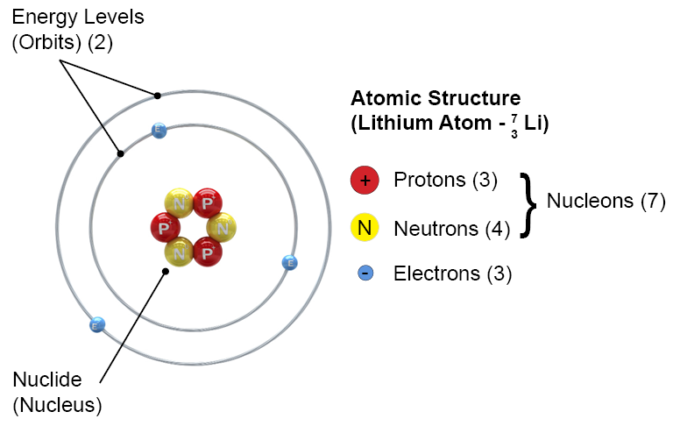

What you need to know
Metal atoms are found on the left hand side of the periodic table. All metals in Group 1 have 1 electrons in the outer shell. All metals in Group 2 have 2 electrons in the outer shell.
If atoms lose electrons from the outer shell. Then the balance between the number of protons and the number of electrons is unbalanced. There are now more protons than electrons so it is now a POSITIVE ION.

If atoms gain electrons in their outer shell. Then the balance of number of protons and the number of electrons is unbalanced. There are now more electrons than there are protons so it is now a NEGATIVE ION.
Can you…?

Use the periodic table and draw the formation of a:

Sodium ion

Magnesium ion

Oxygen ion

Chlorine ion
HELP CARD 2 – Formation of ions

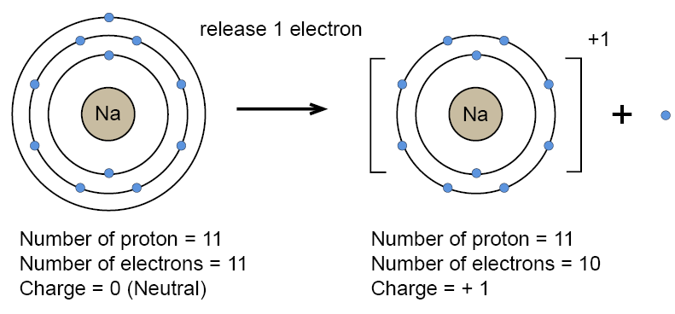

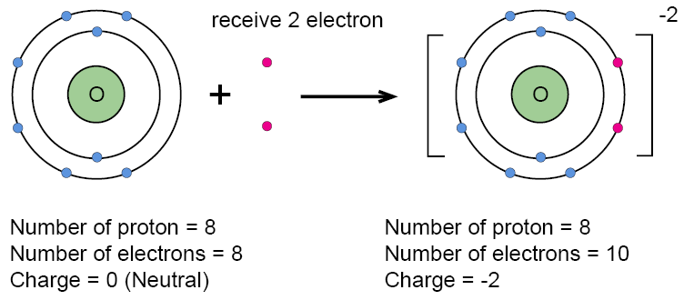

What you need to know
Electrolysis is a process where ionic substances can be broken using electricity. During electrolysis, products form at the electrodes.
One electrode is positive and one is negative.
It is commonly used to purify compounds, or extract metals.

Half equations show what happens at each electrode.
Al³⁺ + 3e⁻ → Al REDUCTION IS GAINING ELECTRONS
O²⁻ → O + 2e⁻ OXIDATION IS LOSING ELECTRONS
HELP CARD 3 – Electrolysis
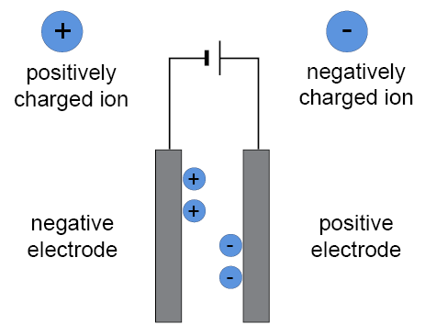
If Al₂O₃ underwent electrolysis the Al⁺³ ions would be attracted to the negative electrode. The O⁻² ions would be attracted to the positive electrode.

Can you…?

Explain what you would see happen if you used molten lead bromide PbBr₃. You should include diagrams if you can.

