Topic Exploration Pack

Global challenges Part 2

Instructions and answers for teachers 1
Introduction 3
Learner Activity 11

Instructions and answers for teachers

These instructions cover the student activity section which can be found on page 10. This Topic Exploration Pack supports OCR GCSE (9–1) Gateway Science Physics A.
When distributing the activity section to the learners either as a printed copy or as a Word file you will need to remove the teacher instructions section.

Mapping to spec level (Learning outcome)
PM8.2i - apply: potential difference across primary coil (V) x current in primary coil (A) = potential difference across secondary coil (V) x current in secondary coil (A)
P8.2a – describe the main energy sources available for use on Earth, compare the ways in which they are used and distinguish between renewable and non-renewable sources
P8.2b - explain patterns and trends in the use of energy resources
P8.2c - recall that, in the national grid, electrical power is transferred at high voltages from power stations, and then transferred at lower voltages in each locality for domestic use
P8.2d - recall that step-up and step-down transformers are used to change the potential difference as power is transferred from power stations
P8.2e - explain how the national grid is an efficient way to transfer energy
P8.2f – link the potential differences and numbers of turns of a transformer to the power transfer involved; relate this to the advantages of power transmission at high voltages
P8.2g - recall that the domestic supply in the UK is a.c. at 50Hz and about 230 volts
P8.2h - explain the difference between direct and alternating voltage
P8.2i - recall the differences in function between the live, neutral and earth mains wires, and the potential differences between these wires
P8.2j - explain that a live wire may be dangerous even when a switch in a mains circuit is open, and explain the dangers of providing any connection between the live wire and earth

Introduction
In topic P8.2 global challenges learners get to experience and look in depth at how electricity has transformed our lives. Learners get to look at the work and science that goes on behind the scenes when you switch on the kettle or your lights. This topic relates heavily to our daily lives and how we use electricity.
Learners look at the science of producing electrical energy from renewable and non-renewable sources (P8.2 a,b). More emphasis is placed on power stations and the method of transferring the electricity from power stations to houses using the national grid and transformers (P8.2 c,d,e,f,g,h). It also looks at transformers and how they work.
Learners should already be familiar with some concepts from Key Stage 3 such as calculations in a domestic context e.g. power used, cost of electricity and the units that are involved. They should already have looked at the basic concepts of electricity. At KS4 some of the concepts are revisited such as P3.2 simple circuits where leaners should have a good understanding of what electricity is. When looking at transformers and the magnetic field P4.1 magnetic fields is a useful topic.
Learners may have the following misconceptions or difficulties:
- A common area of misunderstanding is the definition of a fossil fuel, it can lead to the labelling of nuclear power as a fossil fuel.
- Learners may think that all the all the electrons that make up the current are contained inside the generator that is the source of electricity.
- Learners may have difficulty understanding how a transformer works so it is best to make it as visual and practical as possible, modelling it is a good starting point.
- Learners may think main sockets have current inside them, which comes out as a plug goes in.

Task 1 - Renewable and non-renewable energy
This task focuses on points P8.2 a,b. This task is split up in to 3 separate sub-tasks. It can be used as an assessment task after a lesson or as a method for testing learners’ Key Stage 3 knowledge. For task 1a learners are to read the text and underline statements that refer to renewable or non-renewable sources using two different colours. Task 1b learners place the different sources as either renewable or non- renewable energy source. Task 1c learners look at the advantages and disadvantages of each energy source.
Useful links:
https://www.youtube.com/watch?v=S0lc4mq8IIo - A video which shows how electricity can be made from renewable sources.
http://tinyurl.com/k9mu9ec - an interactive internet research task that learners can use to guide them through researching how electricity is generated
Task 1a
Read the following text and using 2 colours underline the appropriate sections.
Colour 1 – Underline what a renewable energy source is
Colour 2 – Underline what a non-renewable energy source is

Over the last 150 -200 years we have been increasing the amount of energy we get from fossil fuels. Our demand for energy is not decreasing and these sources are running out. Fossil fuels will eventually run out, they will not last forever. We need to start looking at other resources of power that will quickly replenish themselves again and again, such as the power of wind, sun and waves.

Task 1b
Sort the different sources into either renewable or non- renewable energy sources in the table below.
Coal
Wind
Geothermal
Tidal wave
Natural Gas
Biomass
Oil
Solar

Renewable energy sources | Non- renewable energy sources
Wind | Coal
Solar | Natural gas
Biomass | Oil
Tidal wave
Geothermal

Task 1c
Provide one advantage of renewable energy:
It is sustainable and will never run out
Generally requires less maintenance

Provide one disadvantage of renewable energy:
Difficult to generate large quantities of electricity
Reliability can be an issue as it often relies on weather

Provide one advantage of non -renewable energy
Large amounts of electricity can be obtained
Fairly cheap

Provide one disadvantage of non -renewable energy
Gives off green house gasses
Will run out in near future not sustainable.

Task 2 – Research task
This task focuses on points P8.2 a,b. The task is a group research based task which can be done as the main part of the lesson. Learners can work in pairs or groups. Each group is given one energy resource, it may be renewable or non-renewable. Learners must research and identify how electrical energy can be produced from that resource. This must then be presented to the rest of the class. Give each learner two minutes to present their ideas to the class. Each presentation must be accompanied with a poster and a plan of the device e.g. wind power could be a wind turbine.

Task 3 – National grid
This task would work well as a starter or plenary activity and focuses of points P8.2 c,d,e. Learners arrange the keywords of the national grid into the correct order and then write 100 words explaining how it transports electricity over large distances.
Useful links:
https://www.youtube.com/watch?v=-1SLFzqLU5k - a video which explains the national grid.
Arrange the following into the correct order showing the national grid.
Correct order:
Power station
Step up transformer
Pylons
Step down transformer
House

Extension
Using the above order explain how the national grid transfers electricity from powers station to the home (no more than 100 words)
Learners answer will vary so long as they cover each keyword above correctly within 100 words.

Task 4 - National grid memory exercise
This task can be done as a starter activity and focuses on points P8.2 c,d,e. Get a diagram of the complete national grid on the board and hide it from view of learners. Get learners into groups of three or four and explain to them that they will be shown a picture for a short time only. Get the group to number each member of the group 1-4. Call out all the number 1s and show them the picture for 45 seconds. After 45 seconds get them to go back to their groups and start drawing what they have just seen on to the A3 paper. Repeat again with number 2s but only for 30 seconds then 3s for 15 seconds and finally 4s for 10 seconds. They will build on their national grid each time.

National grid memory exercise
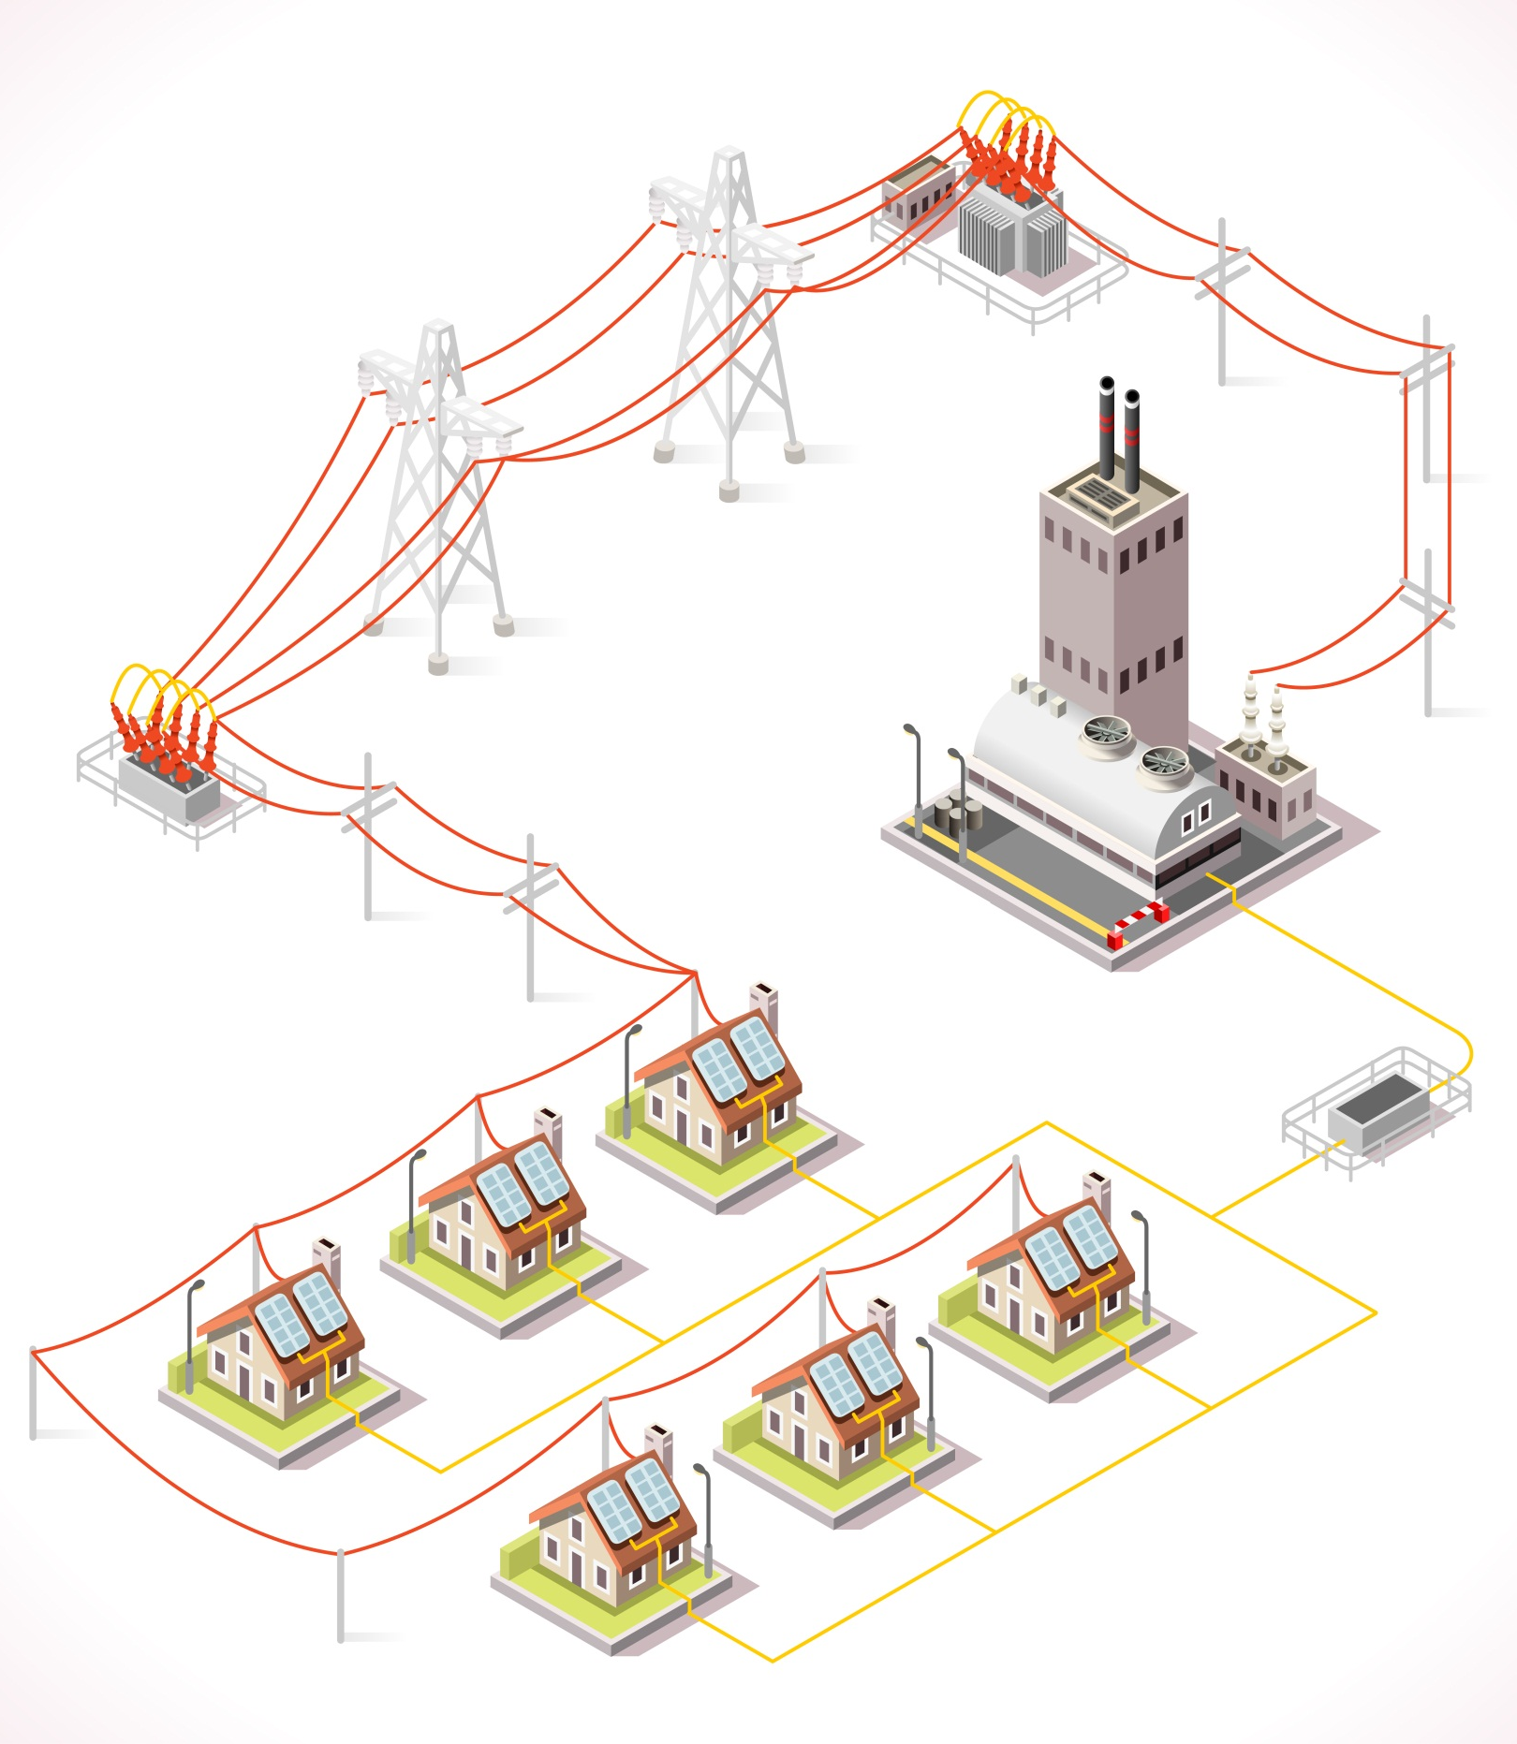

Task 5: Transformers
4
3
1
2
This task focuses on points P8.2 f,g. It can be done as a main to test learners’ understanding of transformers. This task focuses on the learners’ mathematical skills and their ability to complete calculations whilst applying the formula.
Useful links:
http://www.bbc.co.uk/schools/gcsebitesize/science/add_ocr_pre_2011/electric_circuits/mainsproducedrev5.shtml - good for general information about transformers.
https://www.youtube.com/watch?v=ZjwzpoCiF8A - video explaining how transformers work.
http://electronicsgurukulam.blogspot.co.uk/2012/07/how-transformer-works-animation.html - animation showing how transformers work.
Complete the diagram of a transformers below. Draw 10 turns on the primary coil and 20 turns on the secondary coil.
To device

20 turns
10 turns

- Is the transformer above a step up transformer or a step down transformer? Explain why?
Step up transformer because it has more turns on the secondary coil

- A transformer has 200 turns on its primary coil, and 50 on its secondary coil. Is this a Step up or Step down transformer?
Step down

- A transformer has a primary coil of 100 turns and a secondary coil of 300 turns. What will be the voltage out of the secondary coil if we apply 20 V to the primary?
60V

- If we need to change 240 V down to 12 V, and our transformer to has 2000 turns on its primary coil, how many turns should it have on its secondary coil?
100 turns

Task 6: Wiring a plug
This task focuses on points P8.2 I,j. Learners are to be provided with a plug that has been taken apart. They must assemble the plug back again positioning the Live, Neutral and Earth wires correctly.
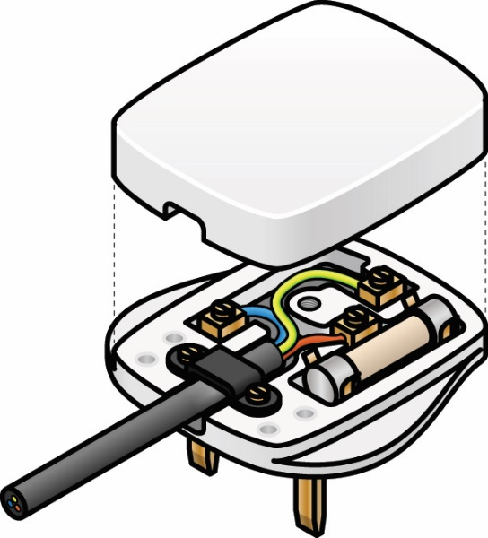
Alternatively, learners could label/colour the wires on the image below to show the correct position of each wire:
Neutral wire
Earth wire
OCR Resources: the small print
OCR’s resources are provided to support the teaching of OCR specifications, but in no way constitute an endorsed teaching method that is required by the Board, and the decision to use them lies with the individual teacher. Whilst every effort is made to ensure the accuracy of the content, OCR cannot be held responsible for any errors or omissions within these resources.
© OCR 2016 - This resource may be freely copied and distributed, as long as the OCR logo and this message remain intact and OCR is acknowledged as the originator of this work.
OCR acknowledges the use of the following content: Blue Car - Rawpixel.com/Shutterstock.com, Rulers - Dominik Hladik/Shutterstock.com
Please get in touch if you want to discuss the accessibility of resources we offer to support delivery of our qualifications: resources.feedback@ocr.org.uk
We’d like to know your view on the resources we produce. By clicking on ‘Like’ or ‘Dislike’ you can help us to ensure that our resources work for you. When the email template pops up please add additional comments if you wish and then just click ‘Send’. Thank you.
If you do not currently offer this OCR qualification but would like to do so, please complete the Expression of Interest Form which can be found here: www.ocr.org.uk/expression-of-interest
Live wire

Topic Exploration Pack

Learner Activity

Task 1 - Renewable and non-renewable energy
This task tests your knowledge on renewable and non-renewable methods of generating electricity. For task 1a read the text and underline the correct places. Task 1b place the different sources as either renewable or non- renewable energy source. Task 1c identify the advantages and disadvantages of each energy source.

Task 1a
Read the following text and using 2 colours underline the appropriate sections.
Colour 1 – Underline what a renewable energy source is
Colour 2 – Underline what a non-renewable energy source is

Over the last 150 -200 years we have been increasing the amount of energy we get from fossil fuels. Our demand for energy is not decreasing and these sources are running out. Fossil fuels will eventually run out, they will not last forever. We need to start looking at other resources of power that will quickly replenish themselves again and again, such as the power of wind, sun and waves.
.
Task 1b
Sort the different sources into either renewable or non- renewable energy sources in the table below.

Coal
Wind
Geothermal
Tidal wave
Natural Gas
Biomass
Oil
Solar

Renewable energy sources | Non- renewable energy sources

Task 1c
Provide one advantage of renewable energy:

Provide one disadvantage of renewable energy:

Provide one advantage of non -renewable energy

Provide one disadvantage of non -renewable energy

Task 2 – Research task
The task is a group research based. You will be provided with one energy resource, it may be renewable or non-renewable. You must research and identify how electrical energy can be made from that resource. This must then be presented to the rest of the class – you will have two minutes to present your ideas to the class. Each presentation must be accompanied with a poster and a plan of the device.

Task 3 – National grid
This tasks allows you to look in to the national grid in more detail. Arrange the keywords of the national grid into the correct order and then write 100 words explaining how it transports electricity over large distances.
Arrange the following into the correct order showing the national grid.
Pylons
Step up transformer
Step down transformer
House
Power station

Extension
Using the above order explain how the national grid transfers electricity from powers station to the home (no more than 100 words):

Task 5 – Transformers
This task focuses on your mathematical skills and your ability to complete calculations whilst applying the formula Vp/Vs = Np/Ns. Start off with some simple questions on transformers and then try the more complex questions.
Complete the diagram of the transformers below. Draw 10 turns on the primary coil and 20 turns on the secondary coil.
To device

- Is the transformer above a step up transformer or a step down transformer? Explain why?

- A transformer has 200 turns on its primary coil, and 50 on its secondary coil. Is this a Step up or Step down transformer?

- A transformer has a primary coil of 100 turns and a secondary coil of 300 turns. What will be the voltage out of the secondary coil if we apply 20 V to the primary?

- If we need to change 240 V down to 12 V, and our transformer to has 2000 turns on its primary coil, how many turns should it have on its secondary coil?

Task 6 - Wiring a plug
You will be provided with a plug that has been disassembled. Assemble the plug back together again positioning the Live, Neutral and Earth wires correctly.
Alternatively, label/colour the wires on the image below to show the correct position of each wire:
