Checkpoint Task

Waves

Instructions and answers for teachers

These instructions cover the learner activity section which can be found on page 10. This Checkpoint Task should be used in conjunction with the KS3–4 Twenty First Century Science Physics B Transition Guide Waves, which supports OCR GCSE (9–1) Twenty First Century Science Physics B.
When distributing the activity section to the students either as a printed copy or as a Word file you will need to remove the teacher instructions section.

Introduction
The following tasks have been designed to highlight learners’ understanding of the material covered in the waves topics of Key Stage 3. The tasks have been chosen to test key areas of understanding and can be used either as a starting point, in which the teacher marks the papers to determine weaknesses in learners’ prior understanding, or as a way for learners to revise the information that they should already know, in which case learners could discuss the questions in groups or peer mark each other’s work when given the appropriate answers.
An alternative approach would be to give learners the individual tasks as the various topics occur during teaching. In this case the amount of understanding being assessed is much smaller.
The first task is intended to assess learners’ understanding of the difference between transverse and longitudinal waves in what is probably an unfamiliar context. The key idea is that the directions of the ‘particle’ motions are different for each type of wave.
The second task is intended to assess learners’ understanding of the effects of amplitude and wavelength on the sound they hear. The first part gives learners a chance to show visually what happens when pitch and volume are changed, whilst the second part of the task asks them to verbalise their understanding. Teachers should be able to identify not only where there are misunderstandings but also what the misunderstandings are.
The final task is intended to give learners a chance to show their understanding of the differential absorption and transmission of light on colours of objects. Care should be taken here to ensure that learners understand that what they see is the remaining light and not the absorbed light
(i.e. red objects look red because they reflect or transmit red light, not because they absorb it).

Teacher preparation

Task 1 – Types of Waves
The learning outcomes are:
- To be able to identify the differences between transverse and longitudinal waves
- To recognise that sound is an example of a longitudinal wave and to be able to give an example of a transverse wave
Extension – the task could be extended for more able learners by get them to discuss the types of materials that mechanical transverse and longitudinal waves can pass through, as this is particularly relevant to the seismological context.

Task 2 – Describing Waves
The learning outcomes are:
- To be able to identify the effect of changing wavelength on the sound heard
- To be able to identify the effect of changing amplitude on the sound heard
Extension – learners could be asked to discuss how the factors of amplitude and frequency/ wavelength affected light waves; what would we see that was different. This links naturally into the third task.

Task 3 – Coloured Objects
- To be able to identify the effects of differential absorption on the colour of objects
- To be able to identify the effects of differential reflection on the colour of objects
Extension – learners could be asked to discuss, for example, what would happen if a yellow surface were to be used with green light, or similar more complex situations involving mixtures of light colours.
Task 1 Types of wave
There are two types of waves produced in the rocks during an earthquake. These are called
p-waves and s-waves and diagrams to represent each type of wave are shown below.
p-wave

s-wave
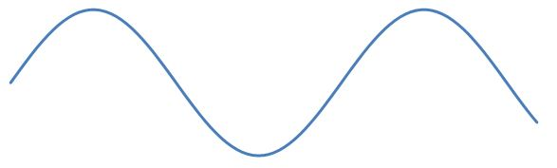
(a) For each type of wave draw an arrow  to show the direction that the wave is moving in. Label this arrow ‘direction of wave’.
Both waves should have arrows pointing to the right (or left).

(b) For each type of wave, draw a second arrow  to show the direction that the rock particles are moving. Label this ‘direction of particles’.
For the p-wave, the arrow should be pointing parallel to the wave direction (i.e. left to right on the paper) and for the s-wave it should be perpendicular to the wave direction (i.e. up and down on the paper). This is the key point here – the particle directions are different compared to the wave directions.

(c) What type of wave that a p-wave is?
P-waves are longitudinal. This is a question testing factual knowledge as are the next three questions.

(d) Can you give another example of this type of wave?
Sound.

(e) What type of wave is an s-wave?
S-waves are transverse

(f) Can you give another example of a wave that is the same type as an s-wave?
Light (electromagnetic) waves, water waves, waves on a string etc.

(g) What is the main difference between p-waves and s-waves? (Hint: Think about the arrows on the diagrams.)
For longitudinal waves (p-waves,) the directions of the wave motion and the particle oscillations are parallel to one another.
For transverse waves (s-waves), the direction of the wave motion and the particle oscillations are perpendicular to one another.

(h) At sporting events, the spectators sometimes take part in a Mexican wave. The spectators raise their arms so that it looks like a wave is going around the stadium. Can you explain how the movement of the wave and the movement of the people that make up the wave are different?
The wave is moving around the stadium but the people that make up the wave are only standing up and sitting down (or raising and lowering their arms). The people are not moving with the wave.
Task 2 – Describing Waves
Below is what a sound wave might look like if you could see it on TV.
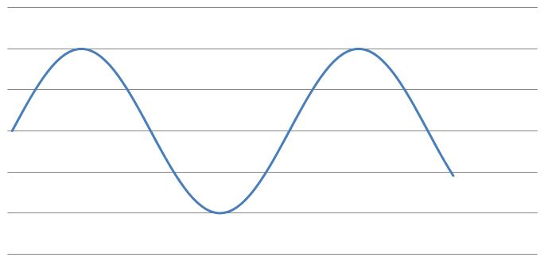

(a) Use a pencil to draw on the diagram what a louder sound of the same pitch would look like.
The wave should have a higher amplitude but the same wavelength.

(b) If the sound was the same loudness (volume) but lower pitched, then use a blue pen or pencil to draw this on the diagram.
The wave should have a longer wavelength but the same amplitude. This question allows the teacher to see whether the learners are aware of the effects of amplitude and wavelength on the sounds that they hear demonstrated visually.

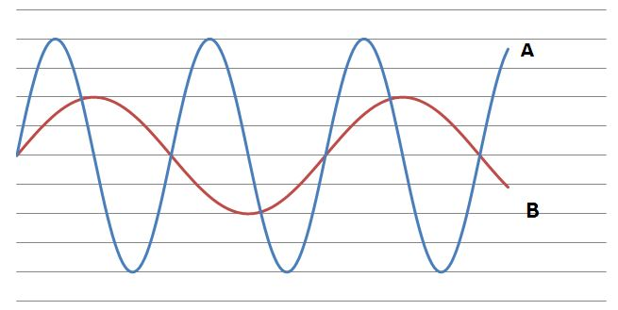
(c) Which of the sound waves in the diagram below, A or B, has the higher pitch?

A
Your answer
(d) Use scientific words where you can to explain how you can tell from the diagram.
There are more complete waves in A on the diagram. The wavelength is therefore less and this leads to waves with a higher frequency which means we would hear a higher pitched sound.

(e) Which of the sound waves is louder?
A

(f) Explain how you can tell from the diagram. Use scientific words where you can.
The amplitude of A is greater and therefore so is its volume. This question allows the teacher to assess quickly the learner’s use of the scientific terms frequency, wavelength and amplitude and to associate these with the sounds they hear.

Task 3 – Surfaces and Filters
These tasks are graded and become gradually more difficult. It should be possible to determine where learners understanding runs out by how far they successfully get through the tasks.
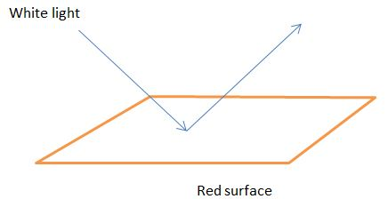
This task is about the colour of different surfaces when light is shining at them. In each diagram below you are given the colour and the surface and of the light shining at it.
Red
(i)

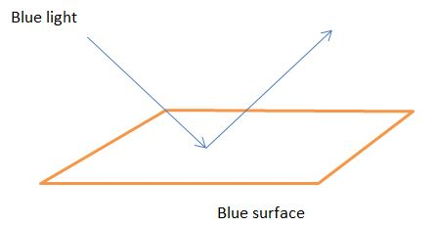
(ii)
Blue

Black
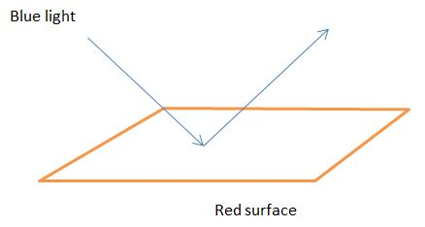
(iii)

(a) Can you work out the colour of the light reflected from each surface?
(i)
Red – of the colours of the spectrum only red light is reflected, the other colours are absorbed, and so we only see the red

(ii)
Blue – only blue light is reflected but we only have blue light and so we see the surface as blue

(iii)
Black – only red light would be reflected by the surface, all other colours would be absorbed, hence no light is reflected and the surface looks black

(b) Can you work out the colour of the light passing through the filters?
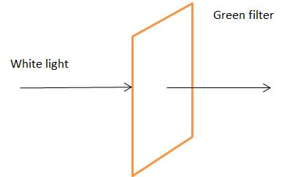
(i)

Green

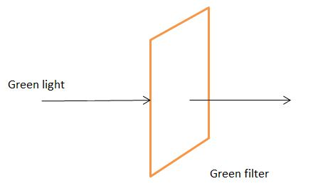
(ii)

Green

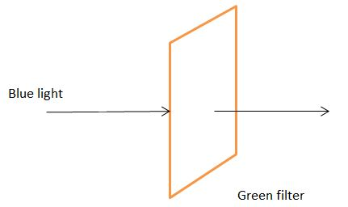
(iii)
Black
(i)
Green - of the colours of the spectrum only green light is transmitted, whilst the other colours are absorbed, and so we only see green light
(ii)
Green – only green light is transmitted but we only have green light and so we see the filter as green

(iii)
Black – the filter will only transmit green light and so the blue light is absorbed, which means that no light passes through

(c) Can you explain what is different about the way that filters work by comparison with the light coming off a surface?
OCR Resources: the small print
OCR’s resources are provided to support the teaching of OCR specifications, but in no way constitute an endorsed teaching method that is required by the Board, and the decision to use them lies with the individual teacher. Whilst every effort is made to ensure the accuracy of the content, OCR cannot be held responsible for any errors or omissions within these resources.
© OCR 2016 - This resource may be freely copied and distributed, as long as the OCR logo and this message remain intact and OCR is acknowledged as the originator of this work.
OCR acknowledges the use of the following content: n/a
Please get in touch if you want to discuss the accessibility of resources we offer to support delivery of our qualifications: resources.feedback@ocr.org.uk
We’d like to know your view on the resources we produce. By clicking on ‘Like’ or ‘Dislike’ you can help us to ensure that our resources work for you. When the email template pops up please add additional comments if you wish and then just click ‘Send’. Thank you.
If you do not currently offer this OCR qualification but would like to do so, please complete the Expression of Interest Form which can be found here: www.ocr.org.uk/expression-of-interest
Filters get their colour because they transmit one or more colours and absorb all of the others.
Surfaces get their colour because they reflect one or more colours and absorb all of the others.

Checkpoint Task

Waves

Student Activity

Task 1 Types of wave
There are two types of waves produced in the rocks during an earthquake. These are called
p-waves and s-waves and diagrams to represent each type of wave are shown below.
p-wave

s-wave
(a) For each type of wave draw an arrow  to show the direction that the wave is moving in. Label this arrow ‘direction of wave’.
(b) For each type of wave, draw a second arrow  to show the direction that the rock particles are moving. Label this ‘direction of particles’.

(c) What type of wave that a p-wave is?

(d) Can you give another example of this type of wave?

(e) What type of wave is an s-wave?

(f) Can you give another example of a wave that is the same type as an s-wave?

(g) What is the main difference between p-waves and s-waves? (Hint: Think about the arrows on the diagrams.)

(h) At sporting events, the spectators sometimes take part in a Mexican wave. The spectators raise their arms so that it looks like a wave is going around the stadium. Can you explain how the movement of the wave and the movement of the people that make up the wave are different?

Task 2 – Describing Waves
Below is what a sound wave might look like if you could see it on TV.

(a) Use a pencil to draw on the diagram what a louder sound of the same pitch would look like.
(b) If the sound was the same loudness (volume) but lower pitched, then use a blue pen or pencil to draw this on the diagram.
(c) Which of the sound waves in the diagram below, A or B, has the higher pitch?

Your answer
(d) Use scientific words where you can to explain how you can tell from the diagram.

(e) Which of the sound waves is louder?

Your answer

(f) Explain how you can tell from the diagram. Use scientific words where you can.

Task 3 – Surfaces and Filters
This task is about the colour of different surfaces when light is shining at them. In each diagram below you are given the colour and the surface and of the light shining at it.
(a) Can you work out the colour of the reflected light?
(i)

(ii)

(iii)

Now you are shining light through coloured filters (like the ones used in theatres). You know the colour of the filter and of the light.
(b) Can you work out the colour of the light passing through the filters?
(i)

(ii)

(iii)

(c) Can you explain what is different about the way that filters work by comparison with light coming off a surface?

