Checkpoint Task

Topic C2: Elements, compounds and mixtures

Instructions and answers for teachers

These instructions cover the learner activity section which can be found on page 18. This Checkpoint Task should be used in conjunction with the KS3–4 GCSE (9-1) Gateway Science Chemistry A Transition Guide: Elements, compounds and mixtures, which supports OCR GCSE (9-1) Gateway Science Chemistry A.
When distributing the activity section to the learners either as a printed copy or as a Word file you will need to remove the teacher instructions section.

C2.1 Purity and separating mixtures

1 Aspirin can be prepared in the laboratory from Salicylic acid in several steps.
These steps include distillation, filtration and crystallisation.
The product’s purity is tested using melting point and chromatography.

Look at a molecule of Aspirin.
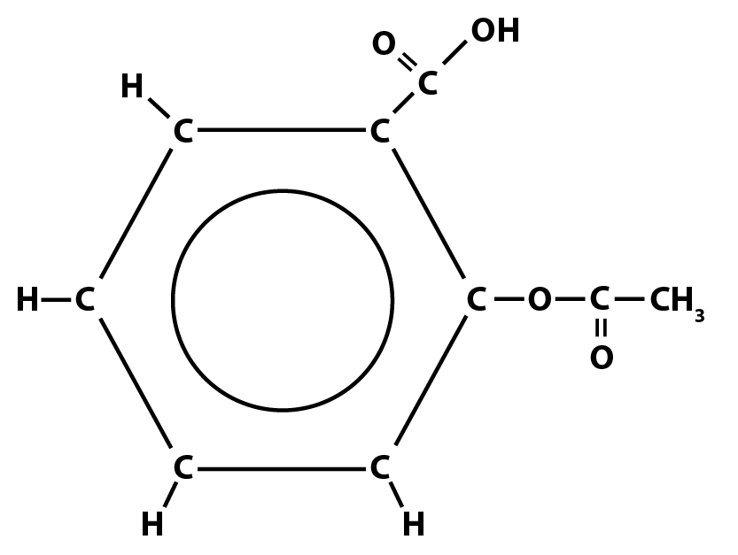

(a) Explain, in terms of atoms, elements and compounds, what a pure sample of Aspirin would contain.
It would only contain the compound Aspirin
This is made from the elements carbon, hydrogen and oxygen

[3]
(b)(i) Look at the structure of Aspirin above.
Write its molecular formula in the format C_{x}H_{y}O_{z}.
C₉H₈O₄

(ii) Use this formula to calculate the formula mass Aspirin.
(12.0 x 9) + (1.0 x 8) + (16.0 x 4) =180 g/mol

[2]

2 Melting points can be used to determine the purity of a sample.
Look at the melting point ranges of Aspirin and one common impurity formed in the process of making Aspirin.
Substance | Melting point (°C)
Aspirin | 138 – 140
impurity A | 158 – 160

A group of students prepared several samples of Aspirin, and determined the
melting points.
Sample | Melting point (°C)
A | 120 – 136
B | 138
C | 141
D | 145
E | 159

Use the information in the tables to answer the following questions:
(a)(i) Which samples show the best purity?
B and C

[1]
(ii) Which sample has the most of impurity A in it? Explain your answer.
E, its melting point is within the range 158-160°C

[2]
(iii) The student who prepared Sample A believes that his sample is fairly pure because it does not contain impurity A.
Do you agree? Explain your answer.
Do not agree
It does not contain impurity A BUT does not contain Aspirin.
It must contain an unknown impurity which lowers the melting point.

[3]
(b) The student compares his sample (A) against four possible impurities (1, 2, 3, 4) using thin layer chromatography (TLC).
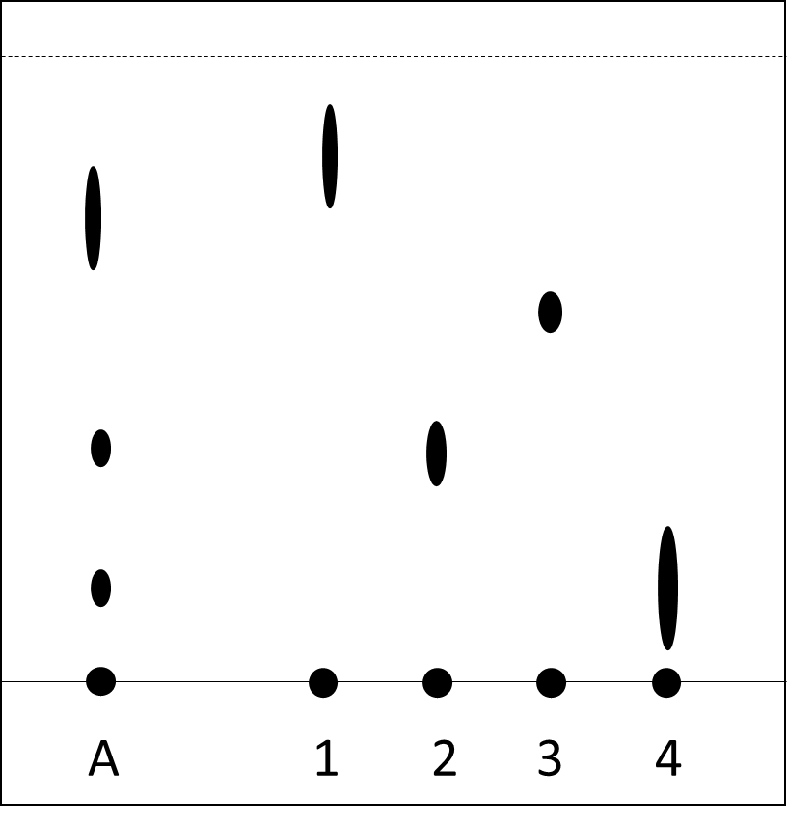

(i) What is the stationary phase in TLC?
Paper or silica gel.

Determine the R_{f} value of the spot created by impurity 1.
around 6/7 = 0.8-0.9
R_{f} =
[3]
(ii) Describe the composition of the sample in relation to the impurities shown.
A contains impurities 2 and 4.
It contains another unknown impurity.
It does not contain impurity 1 or 3.

[5]

C2.2 Bonding

1 Substances can be characterised by their chemical and physical properties.
Use each piece of evidence below to determine if the substance described is a metal or a non-metal.
metal
Substance 1 can bend and conduct electricity
metal
Substance 2 is shiny and reacts with oxygen when heated
non-metal
Substance 3 forms negative ions when it reacts
metal
Substance 4 has one electron in its outer shell
non-metal
Substance 5 is a solid found in Group 7
[5]
2 Magnesium is in Group 2 of the Periodic Table.
Use this information to explain what happens to when magnesium bonds with chlorine.
In your answer, discuss the movement of electrons, state the type of bonding formed and identify the compound created.
Magnesium loses 2 electrons
Chlorine gains 1 electron
Forms ionic bonds
Magnesium Chloride is formed
MgCl₂

[5]
3 Ammonia is made from the elements nitrogen (Group 5) and hydrogen (Group 1).
Pick the correct diagram from below and complete it with dots and crosses to show how these elements bond.
First diagram chosen
One Dot and one cross in overlap areas
2 unshared electrons


[3]

4 Dimitri Mendeleev made huge advancements in chemistry with his version of the periodic table.
His periodic table was ordered by atomic mass, whereas the modern periodic table is ordered by atomic number.
He also put elements into groups or columns based on the chemical properties.

(a) Look at the elements Cl, Ar, K and Ca on the modern periodic table.
Describe how Mendeleev would have ordered them in his version of the periodic table.
Cl, K, Ar, Ca
Because K has a larger mass

[2]
(b) This order put some of the elements in the wrong group compared to the modern periodic table.
Explain how Mendeleev would have identified this.
Comparison of chemical reactions
Elements in the same group have similar reactions
The reactions of the elements would not match

[3]
(c) Which two other elements, within the first four periods, have a similar problem?
Co and Ni

[1]

C2.3 Properties of materials

1 Diamond and graphite are materials with unique and useful properties.
Look at the table.
 | 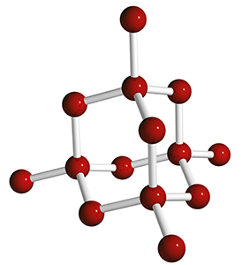  Diamond | 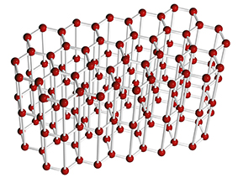  Graphite
Element in structure | carbon | carbon
Number of bonds per atom | 4 | 3
Hardness | hard and rigid | soft and malleable
Conductivity | none | high
Melting point | around 4000 °C | around 4000 °C

(a) Complete the first four boxes of the table.
[2]
(b) Use your knowledge and understanding of the structures of diamond and graphite to explain the properties in the table.
Graphite has layers which can slide making it malleable, diamond doesn’t.
Graphite has delocalised electrons which conduct.
Both contain strong covalent bonds which require high energy to melt.

[3]

2 The table shown below gives information about the first eight alkanes.
Name of alkane | Number of carbons | Chemical formula | Boiling point  (°C) | State at "Room Temperature"  (20 °C)
methane | 1 | CH₄ | -162 | gas
ethane | 2 | C₂H₆ | -89 | gas
propane | 3 | C₃H₈ | -42 | gas
butane | 4 | C₄H₁₀ | 0 | gas
pentane | 5 | C₅H₁₂ | 25 – 40 | liquid
hexane | 6 | C₆H₁₄ | 69 | liquid
heptane | 7 | C₇H₁₆ | 98 | liquid
octane | 8 | C₈H₁₈ | 126 | liquid

(a) Predict the boiling point for pentane and what its state is at room temperature.
[2]
(b) Use your understanding of intermolecular forces to explain the trend in boiling points.
Longer alkanes have more intermolecular forces which require more energy to break

[3]

3 Many rare and expensive metals like rhodium, platinum and palladium are used as catalysts.
In car exhausts, these catalysts remove pollutants from the exhaust gases.
Manufacturers are now working on using nano-particles of these metals in their products.
The information in the table below compares regular size particles to nano-particles.
Property | Regular size particles | Nano-particles
Size of particle | 1000-10000 atoms wide | 1-100 atoms wide
Quantity needed for a full coating of catalyst | 500-800 g | 1-2 g
Surface area : volume ratio | 1:10000 | 1:10
Cost of production | £1-2 per kg | £15-20 per kg
Health and safety | avoid inhalation | few studies, unknown risks

Use this information to evaluate whether manufacturers should use nano-particles in catalysts.
Opinion given
Two pros
Two cons
QWC

Regular pros - cheaper to make, known safety issues
Regular cons – Needs more metal, metal is expensive, low surface area, low reaction rate

Nano pros – needs less metal, save on metal costs, large surface area, high reaction rate
Nano cons – Unknown health risks, expensive production

[6]

OCR Resources: the small print
OCR’s resources are provided to support the teaching of OCR specifications, but in no way constitute an endorsed teaching method that is required by the Board, and the decision to use them lies with the individual teacher. Whilst every effort is made to ensure the accuracy of the content, OCR cannot be held responsible for any errors or omissions within these resources.
© OCR 2016 - This resource may be freely copied and distributed, as long as the OCR logo and this message remain intact and OCR is acknowledged as the originator of this work.
OCR acknowledges the use of the following content: Q1: Diamond – Vasilyev/Shutterstock.com, Graphite – Vasilyev/Shutterstock.com
Please get in touch if you want to discuss the accessibility of resources we offer to support delivery of our qualifications: resources.feedback@ocr.org.uk
We’d like to know your view on the resources we produce. By clicking on ‘Like’ or ‘Dislike’ you can help us to ensure that our resources work for you. When the email template pops up please add additional comments if you wish and then just click ‘Send’. Thank you.
If you do not currently offer this OCR qualification but would like to do so, please complete the Expression of Interest Form which can be found here: www.ocr.org.uk/expression-of-interest

Checkpoint Task

Topic C2: Elements, compounds and mixtures

Learner Activity

C2.1 Purity and separating mixtures
1 Aspirin can be prepared in the laboratory from Salicylic acid in several steps.
These steps include distillation, filtration and crystallisation.
The product’s purity is tested using melting point and chromatography.

Look at a molecule of Aspirin.

(a) Explain, in terms of atoms, elements and compounds, what a pure sample of Aspirin would contain.

[3]
(b)(i) Look at the structure of Aspirin above.
Write its molecular formula in the format C_{x}H_{y}O_{z}.

(ii) Use this formula to calculate the formula mass Aspirin.

[2]
2 Melting points can be used to determine the purity of a sample.
Look at the melting point ranges of Aspirin and one common impurity formed in the process of making Aspirin.
Substance | Melting point (°C)
Aspirin | 138 – 140
impurity A | 158 – 160
A group of students prepared several samples of Aspirin, and determined the
melting points.
Sample | Melting point (°C)
A | 120 – 136
B | 138
C | 141
D | 145
E | 159

Use the information in the tables to answer the following questions:
(a)(i) Which samples show the best purity?

[1]
(ii) Which sample has the most of impurity A in it? Explain your answer.

[2]
(iii) The student who prepared Sample A believes that his sample is fairly pure because it does not contain impurity A.
Do you agree? Explain your answer.

[3]
The student compares his sample (A) against four possible impurities (1, 2, 3, 4) using thin layer chromatography (TLC).

(b)(i) What is the stationary phase in TLC?

Determine the R_{f} value of the spot created by impurity 1.

R_{f} =
[3]
(ii) Describe the composition of the sample in relation to the impurities shown.

[5]

C2.2 Bonding

1 Substances can be characterised by their chemical and physical properties.
Use each piece of evidence below to determine if the substance described is a metal or a non-metal.

Substance 1 can bend and conduct electricity

Substance 2 is shiny and reacts with oxygen when heated

Substance 3 forms negative ions when it reacts

Substance 4 has one electron in its outer shell

Substance 5 is a solid found in Group 7
[5]
2 Magnesium is in Group 2 of the Periodic Table.
Use this information to explain what happens when magnesium bonds with chlorine.
In your answer, discuss the movement of electrons, state the type of bonding formed and identify the compound created.

[5]
3 Ammonia is made from the elements nitrogen (Group 5) and hydrogen (Group 1).
Pick the correct diagram from below and complete it with dots and crosses to show how these elements bond.
[3]

4 Dimitri Mendeleev made huge advancements in chemistry with his version of the periodic table.
His periodic table was ordered by atomic mass, whereas the modern periodic table is ordered by atomic number.
He also put elements into groups or columns based on the chemical properties.

(a) Look at the elements Cl, Ar, K and Ca on the modern periodic table.
Describe how Mendeleev would have ordered them in his version of the periodic table.

[2]
(b) This order put some of the elements in the wrong group compared to the modern periodic table.
Explain how Mendeleev would have identified this.

[3]
(c) Which two other elements, within the first four periods, have a similar problem?

[1]

C2.3 Properties of materials

1 Diamond and graphite are materials with unique and useful properties.
Look at the table.
 | Diamond | Graphite
Element in structure
Number of bonds per atom
Hardness | hard and rigid | soft and malleable
Conductivity | none | high
Melting point | around 4000 °C | around 4000 °C

(a) Complete the first four boxes of the table.
[2]
(b) Use your knowledge and understanding of the structures of diamond and graphite to explain the properties in the table.

[3]

2 The table shown below gives information about the first eight alkanes.
Name of alkane | Number of carbons | Chemical formula | Boiling point  (°C) | State at "Room Temperature"  (20 °C)
methane | 1 | CH₄ | -162 | gas
ethane | 2 | C₂H₆ | -89 | gas
propane | 3 | C₃H₈ | -42 | gas
butane | 4 | C₄H₁₀ | 0 | gas
pentane | 5 | C₅H₁₂
hexane | 6 | C₆H₁₄ | 69 | liquid
heptane | 7 | C₇H₁₆ | 98 | liquid
octane | 8 | C₈H₁₈ | 126 | liquid

(a) Predict the boiling point for pentane and what its state is at room temperature.
[2]
(b) Use your understanding of intermolecular forces to explain the trend in boiling points.

[3]

3 Many rare and expensive metals like rhodium, platinum and palladium are used as catalysts.
In car exhausts, these catalysts remove pollutants from the exhaust gases.
Manufacturers are now working on using nano-particles of these metals in their products.
The information in the table below compares regular size particles to nano-particles.
Property | Regular size particles | Nano-particles
Size of particle | 1000-10000 atoms wide | 1-100 atoms wide
Quantity needed for a full coating of catalyst | 500-800 g | 1-2 g
Surface area : volume ratio | 1:10000 | 1:10
Cost of production | £1-2 per kg | £15-20 per kg
Health and safety | avoid inhalation | few studies, unknown risks

Use this information to evaluate whether manufacturers should use nano-particles in catalysts.

[6]

