Checkpoint Task

Natural Selection

Instructions and answers for teachers

These instructions cover the learner activity section which can be found on page 7 . This Checkpoint Task should be used in conjunction with the KS3–4 Twenty First Century Science Biology B Transition Guide Natural Selection, which supports OCR GCSE (9–1) Twenty First Century Science Biology B.
When distributing the activity section to the learners either as a printed copy or as a Word file you will need to remove the teacher instructions section.

Introduction
Task 1
The idea of Checkpoint task 1 is to assess if learners can use the information given to develop their understanding of natural selection. The work at GCSE will help the learners develop their understanding of these concepts further.
The style of examination questions at GCSE may require learners to apply their knowledge of natural selection in a similar way. There may be some simple recall questions such as a gap fill activity but this topic is more commonly assessed by asking the learners to give more extended answers and apply their knowledge to unfamiliar situations. The simple natural selection concepts such as those studied in Key Stage 3 need to be covered in detail before moving onto the GCSE content and the application for this knowledge.
Task 2
The second checkpoint task is more challenging as it requires the learners to carefully think about natural selection as well as predict outcomes. The learners could complete this task after a homework task looking at the behaviour of wolves. This task is designed to push the learners’ knowledge and highlight those learners that may know the basic ideas of natural selection without being able to apply it to different situations. This can be a good guide to decide when and at what level to introduce the GCSE content to the lessons.
Further information:
Natural Selection and Evolution
https://www.stem.org.uk/elibrary/list/15239/natural-selection-and-evolution
This link provides a range of resources for how to teach natural selection and evolution.

Task 1
For each of cases below identify the key points of evolution by natural selection.
Rabbits (Oryctolagus cuniculus) are one of the most common wild animals in the UK. Female rabbits are pregnant for around 30 days before they give birth to a litter of up to 12 rabbits. The female will spend the next 30 days with her young after which she is able to mate again. This means that a female rabbit can give birth to around 40 rabbits each year. These young will have slight differences such as fur length, fur colour, ear size etc. In the UK, a wild rabbit is unlikely to survive more than one year due to difficulty finding enough food, a suitable place to build a burrow and difficulty avoiding predators.
- Individuals of the same species show a range of variation.
Differences such as fur length, fur colour, ear size.

- Some individuals in a population are better suited to survive than others.
Ear size might help avoid predators.

- Individuals can breed to pass their genes on to their offspring.
A female rabbit can give birth to around 40 rabbits each year.

- More offspring are produced than the environment can support.
Unlikely to survive more than one year due to difficulty finding enough food, a suitable place to build a burrow and difficulty avoiding predators.

It is estimated that there are 10.5 million common brown rats (Rattus norvegicus) in the UK. Rats fill a very valuable niche in the food chain as a predator for garden pests such as slugs and also as prey for foxes. A pair of rats can have up to 800 offspring in their lifetime (12-14 months). Rats can also eat much of the food we eat which can become a problem as they will enter commercial buildings like food factories. Humans try to control the rat population around these buildings by using poisons. However, scientists have noticed that some rats can tolerate the poison and survive, passing their genes onto their offspring. This means that only some of the rats are being killed by the poison but a large number of rats are not and this is producing a population of ‘super rats’.
- Individuals of the same species show a range of variation.
Some rats can tolerate the poison.

- Some individuals in a population are better suited to survive than others.
Some rats survive the poison whilst others do not.

- Individuals can breed to pass their genes on to their offspring.
Some rats can tolerate the poison and survive passing their genes onto their offspring.

- More offspring are produced than the environment can support.
A pair of rats can have up to 800 offspring.

Task 2
- What type of variation is fur length?
Continuous variation.

- Explain how having ‘medium’ length fur benefits wolves in the current climate.
The medium fur length provides enough protection from the cold winters but is not too warm in summer. This means most individuals can survive the environment.

- If the wolves experience a very cold winter which trait would give the wolves a selective advantage?
Those that have the slightly longer fur length as it keeps them warn and provides them with greater protection from the cold.

- The coat colours of these wolves ranges from almost white to very dark grey. Suggest how the coat colour may vary if global warming occurs.
White would not be an advantage as the snow would melt so the coat colours would become more grey in colour.

- Suggest what might happen to the wolf population if global warming occurs slowly over the next 1000 years.
The fur length of the population of wolves would get shorter and the coat colours would become more grey in colour.

- Suggest how the wolf population might be effected if global warming occurs quickly over the next 50 years.
The species may die out as the population cannot adapt quickly enough.

- Wolves are carnivores that prey upon a variety of hooved animals such as white tailed deer. What do you think would happen to the number of white tailed deer if global warming occurs quickly over the next 50 years?
The number of white tailed deer would increase as there would be fewer predators.

OCR Resources: the small print
OCR’s resources are provided to support the teaching of OCR specifications, but in no way constitute an endorsed teaching method that is required by the Board, and the decision to use them lies with the individual teacher. Whilst every effort is made to ensure the accuracy of the content, OCR cannot be held responsible for any errors or omissions within these resources.
© OCR 2016 - This resource may be freely copied and distributed, as long as the OCR logo and this message remain intact and OCR is acknowledged as the originator of this work.
OCR acknowledges the use of the following content: Charles Darwin 1874, John G Murdoch/Robert Ashby Collection/Wikimedia Commons: Pack of Wolves, Michael Roeder/Shutterstock.com
Please get in touch if you want to discuss the accessibility of resources we offer to support delivery of our qualifications: resources.feedback@ocr.org.uk
We’d like to know your view on the resources we produce. By clicking on ‘Like’ or ‘Dislike’ you can help us to ensure that our resources work for you. When the email template pops up please add additional comments if you wish and then just click ‘Send’. Thank you.
If you do not currently offer this OCR qualification but would like to do so, please complete the Expression of Interest Form which can be found here: www.ocr.org.uk/expression-of-interest

Checkpoint Task

Natural selection

Learner Activity

Task 1 – higher ability
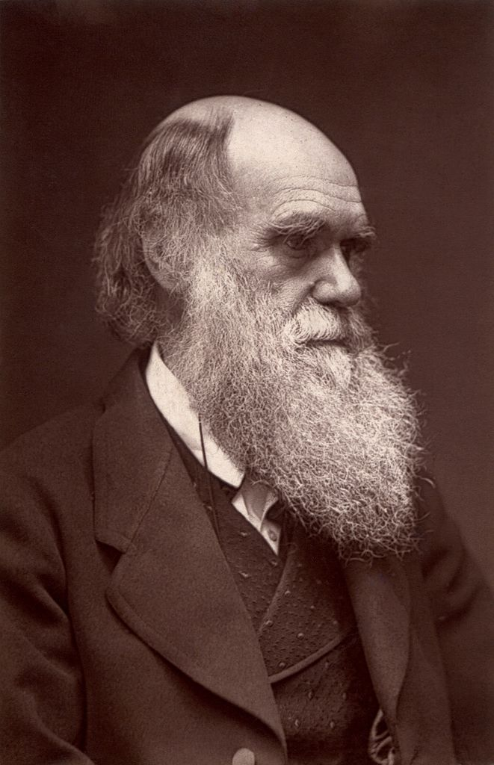

Charles Darwin was a naturalist best known for his contributions to Evolutionist theories. He travelled the world for 5 years aboard the ship HMS Beagle collecting samples of animals and plants. He conducted many practical investigations on his samples which lead him to develop his theory of Evolution by Natural selection.

Key points of evolution by natural selection:
- individuals of the same species show a range of variation

- some individuals in a population are better suited to survive than others

- individuals can breed to pass their genes on to their offspring

- more offspring are produced than the environment can support.
For each of cases below identify the key points of evolution by natural selection.

Rabbits (Oryctolagus cuniculus) are one of the most common wild animals in the UK. Female rabbits are pregnant for around 30 days before they give birth to a litter of up to 12 rabbits. The female will spend the next 30 days with her young after which she is able to mate again. This means that a female rabbit can give birth to around 40 rabbits each year. These young will have slight differences such as fur length, fur colour, ear size etc. In the UK, a wild rabbit is unlikely to survive more than one year due to difficulty finding enough food, a suitable place to build a burrow and difficulty avoiding predators.

- Individuals of the same species show a range of variation.

- Some individuals in a population are better suited to survive than others.

- Individuals can breed to pass their genes on to their offspring.

- More offspring are produced than the environment can support.

It is estimated that there are 10.5 million common brown rats (Rattus norvegicus) in the UK. Rats fill a very valuable niche in the food chain as a predator for garden pests such as slugs and also as prey for foxes. A pair of rats can have up to 800 offspring in their lifetime (12-14 months). Rats can also eat much of the food we eat which can become a problem as they will enter commercial buildings like food factories. Humans try to control the rat population around these buildings by using poisons. However, scientists have noticed that some rats can tolerate the poison and survive, passing their genes onto their offspring. This means that only some of the rats are being killed by the poison but a large number of rats are not and this is producing a population of ‘super rats’.

- Individuals of the same species show a range of variation.

- Some individuals in a population are better suited to survive than others.

- Individuals can breed to pass their genes on to their offspring.

- More offspring are produced than the environment can support.

Task 1 – lower ability

Charles Darwin was a naturalist best known for his contributions to Evolutionist theories. He travelled the world for 5 years aboard the ship HMS Beagle collecting samples of animals and plants. He conducted many practical investigations on his samples which lead him to develop his theory of Evolution by Natural selection.

Key points of evolution by natural selection:
- individuals of the same species show a range of variation

- some individuals in a population are better suited to survive than others

- individuals can breed to pass their genes on to their offspring

- more offspring are produced than the environment can support.
For each of cases below identify the key points of evolution by natural selection.

Rabbits (Oryctolagus cuniculus) are one of the most common wild animals in the UK. Female rabbits are pregnant for around 30 days before they give birth to a litter of up to 12 rabbits. The female will spend the next 30 days with her young after which she is able to mate again. This means that a female rabbit can give birth to around 40 rabbits each year. These young will have slight differences such as fur length, fur colour, ear size etc. In the UK, a wild rabbit is unlikely to survive more than one year due to difficulty finding enough food, a suitable place to build a burrow and difficulty avoiding predators.

- Individuals of the same species show a range of variation.

- Some individuals in a population are better suited to survive than others.

- Individuals can breed to pass their genes on to their offspring.

- More offspring are produced than the environment can support.

It is estimated that there are 10.5 million common brown rats (Rattus norvegicus) in the UK. Rats fill a very valuable niche in the food chain as a predator for garden pests such as slugs and also as prey for foxes. A pair of rats can have up to 800 offspring in their lifetime (12-14 months). Rats can also eat much of the food we eat which can become a problem as they will enter commercial buildings like food factories. Humans try to control the rat population around these buildings by using poisons. However, scientists have noticed that some rats can tolerate the poison and survive, passing their genes onto their offspring. This means that only some of the rats are being killed by the poison but a large number of rats are not and this is producing a population of ‘super rats’.

- Individuals of the same species show a range of variation.

- Some individuals in a population are better suited to survive than others.

- Individuals can breed to pass their genes on to their offspring.

- More offspring are produced than the environment can support.

Task 2
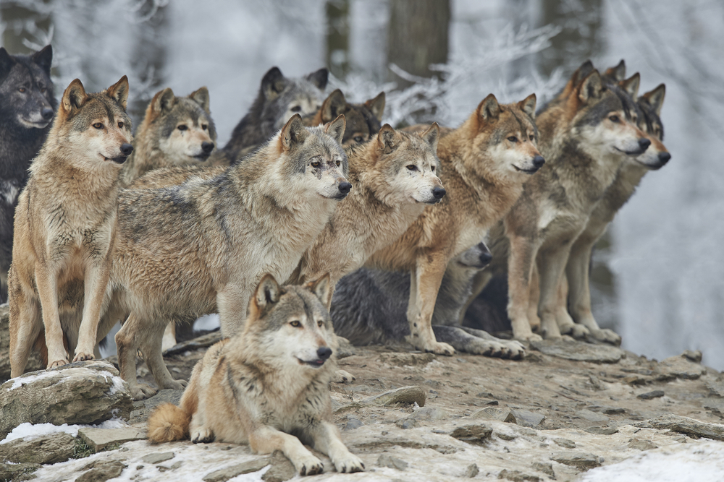

Wolves are pack animals that live and hunt together to provide food for their young. Wolves often have litters containing 5-6 pups but can have up to 11 pups at one time. These pups often have slight differences between them such as differences in fur length or differences in coat colour.
Wolves live in northern parts of America, Asia and Europe. They need to have a thick coat that can protect them from the cold weather in winter but not too thick that they get too hot in summer. Some scientists believe that global warming is occurring which may mean that mild winters and hot summers become more common.

- What type of variation is fur length?

- Explain how having ‘medium’ length fur benefits wolves in the current climate.

- If the wolves experience a very cold winter which trait would give the wolves a selective advantage?

- The coat colours of these wolves ranges from almost white to very dark grey. Suggest how the coat colour may vary if global warming occurs.

- Suggest what might happen to the wolf population if global warming occurs slowly over the next 1000 years.

- Suggest how the wolf population might be effected if global warming occurs quickly over the next 50 years.

- Wolves are carnivores that prey upon a variety of hooved animals such as white tailed deer. What do you think would happen to the number white tailed deer if global warming occurs quickly over the next 50 years?

