Chemistry PAG 2: Electrolysis

Combined Science PAG C1: Electrolysis

Suggested Activity 2: Microscale electrolysis of copper(II) chloride

Instructions and answers for teachers & technicians
These instructions cover the learner activity section which can be found on page 11. This Practical activity supports OCR GCSE Chemistry and Combined Science.
When distributing the activity section to the learners either as a printed copy or as a Word file you will need to remove the teacher instructions section.
This is a suggested practical activity that can be used as part of teaching the GCSE (9-1) Gateway Science (A) and Twenty First Century Science (B) specifications.
These are not controlled assessment tasks, and there is no requirement to use these particular activities.
You may modify these activities to suit your learners and centre. Alternative activities are available from, for example, Royal Society of Biology, Royal Society of Chemistry, Institute of Physics, CLEAPSS and publishing companies, or of your own devising.
Further details are available in the specifications (Practical Skills Topics), and in these videos.
OCR recommendations:
Before carrying out any experiment or demonstration based on this guidance, it is the responsibility of teachers to ensure that they have undertaken a risk assessment in accordance with their employer’s requirements, making use of up-to-date information and taking account of their own particular circumstances. Any local rules or restrictions issued by the employer must always be followed.
CLEAPSS resources are useful for carrying out risk-assessments: (http://science.cleapss.org.uk).
Centres should trial experiments in advance of giving them to learners. Centres may choose to make adaptations to this practical activity, but should be aware that this may affect the Apparatus and Techniques covered by the learner.

Introduction
In this activity, learners carry out a micro-scale electrolysis of copper(II) chloride solution in a petri-dish, producing copper solid and chlorine gas. Within the petri dish, the chlorine gas reacts with the potassium bromide and potassium chloride solutions via displacement reactions, and with damp blue litmus paper demonstrating the acid and bleaching nature of the chlorine gas in water.
This activity can be modified to reduce the number of observations the learners are making, allowing them to focus on less chemistry. For example, the set-up could be used without the potassium salt solutions, and just focus on the reaction of chlorine gas with the blue litmus paper. Such changes will affect the Apparatus and Techniques covered, so modification of the learner sheet may be appropriate.
This resource is adapted from the CLEAPSS experiment ‘The microelectrolysis of copper(II) chloride – https://www.youtube.com/watch?v=KvW-g1FQV9E
Further information and instructions for making the electrolysis cell can be found at:
- http://science.cleapss.org.uk/Resource-Info/GL163-Make-it-guide-microscale-electrolysis-apparatus.aspx
- http://science.cleapss.org.uk/Resource-Info/GL196-Make-it-guide-microscale-Hoffmann-voltameter.aspx
Another micro-scale electrolysis experiment is available from the Royal Society of Chemistry Microscale Chemistry publication http://www.rsc.org/learn-chemistry/resource/res00000541/electrolysis-using-a-microscale-hoffman-apparatus.

DfE Apparatus and Techniques covered
The codes used below match the OCR Practical Activity Learner Record Sheet (Chemistry / Combined Science) and Trackers (Chemistry / Combined Science) available online. There is no requirement to use these resources.
By doing this experiment, learners have an opportunity to develop the following skills:
3 [8]: Use of appropriate apparatus and techniques for: i) conducting and monitoring chemical reactions
6 [11]: Safe use and careful handling of gases, liquids and solids, including: ii) using appropriate apparatus to explore chemical changes and/or products
7 [12]: Use of appropriate apparatus and techniques to: i) draw electrochemical cells for separation and production of elements and compounds; ii) set up and use electrochemical cells for separation and production of elements and compounds
8: Use of appropriate qualitative reagents and techniques to analyse and identify unknown samples or products including: i) gas tests

Aims
To set-up a micro-scale electrolysis reaction of copper(II) chloride, and to analyse the products formed.

Intended class time
20-25 minutes

Links to Specifications:

Gateway Science (Suite A) – including Working Scientifically (WS)
C3.4a recall that metals (or hydrogen) are formed at the cathode and non-metals are formed at the anode in electrolysis using inert electrodes
C3.4d describe electrolysis in terms of the ions present and reactions at the electrodes
C3.4e describe the technique of electrolysis using inter and non-inert electrodes
C4.1a recall the simple properties of Groups 1, 7 and 0
C4.1b explain how observed simple properties of Group 1, 7 and 0 depend on the outer shell of electrons of the atoms and predict properties from given trends down the groups
C4.2a describe tests to identify selected gases
C6.1b explain why and how electrolysis is used to extract some metals from ores
W1.3a presenting observations and other data using appropriate methods
W1.3e interpreting observations and other data
W1.3f presenting reasoned explanations
W1.4a use scientific vocabulary, terminology and definitions
WS2a carry out experiments
WS2b make and record observations and measurements using a range of apparatus and methods
WS2c presenting observations using appropriate methods

Twenty First Century Science (Suite B) – including Ideas about Science (IaS)
C1.4.2 describe a test to identify chlorine (using blue litmus paper)
C2.2.6 recall the simple properties of Group 7 elements including their states and colours at room temperature and pressure, their colours as gases, their reactions with Group 1 elements and their displacement reactions with other metal halides
C2.2.7 describe experiments to identify the reactivity pattern of Group 7 elements including displacement reactions
C3.2.5 explain why electrolysis is used to extract some metals from their ores
C3.3.1 describe electrolysis in terms of the ions present and reactions at the electrodes
C3.3.3 recall that metals (or hydrogen) are formed at the cathode and non-metals are formed at the anode in electrolysis using inert electrodes
C3.3.4 use the names and symbols of common elements and compounds and the principle of conversation of mass to write half equations
C3.3.5 explain reduction and oxidation in terms of gain or loss of electrons, identifying which species is oxidised and which are reduced
C3.3.8 describe the technique of electrolysis of an aqueous solution of a salt
IaS2.1 present observations and other data using appropriate formats
IaS2.11 in a given context interpret observations and other data (presented in diagrammatic, graphical, symbolic or numerical form) to make inferences and to draw reasoned conclusions, using appropriate scientific vocabulary and terminology to communicate the scientific rationale for findings and conclusions

Mathematical Skills covered
No defined mathematical skill is covered in this experiment.

Technical Requirements – PER GROUP

Chemicals
Identity | Approximate quantity required or produced PER GROUP | Hazard information |  | Risk information
0.5 mol dm^{–3} aqueous copper(II) chloride solution, CuCl₂(aq) | 0.5 cm³ | Currently not classified as hazardous at this concentration
0.5 mol dm^{–3} aqueous potassium bromide solution, KBr(aq) | 0.2 cm³ | Currently not classified as hazardous at this concentration
0.2 mol dm^{–3} aqueous potassium iodide solution, KI(aq) | 0.2 cm³ | Currently not classified as hazardous at this concentration
chlorine | 1 cm³ produced (per group) |  | DANGER  May cause or intensity fire; oxidiser. Causes skin irritation. Causes serious eye irritation. Toxic if inhaled. May cause respiratory irritation. Very toxic to aquatic organisms. | Ensure learners keep the lid on the petri dish during and after the electrolysis. Keep the room well ventilated.

Equipment
- pre-prepared petri-dish with two small holes on opposite sides, and lid (see note below)
- two graphite or carbon-fibre (e.g. kite rods) electrodes
- 2 crocodile clips and wires
- power-pack/9 V battery
- blue litmus paper
- dropping pipettes
- blu-tack

Notes
55 mm OR 90 mm polystyrene petri dishes both work, and are widely available (e.g Timstar PE12035) for about 10p each. Drill two holes 1mm wider than the electrodes being used on opposite sides of the petri-dish base. Alternatively, carefully remove sections of the petri-dish side with a small pair of wire cutters. Alternatively, heat a large nail in a Bunsen flame and use this to melt holes through the petri dish. See http://science.cleapss.org.uk/Resource-Info/GL163-Make-it-guide-microscale-electrolysis-apparatus.aspx for further details.
4-6 stock bottles of the solutions with pipettes or dropper bottles will speed up the setting up of the electrochemical cells.

Health and Safety
Eye protection should be worn at all times.
Ensure the petri-dish is covered when the circuit is connected to the power source- this will help contain the chlorine gas while the learners are looking closely at set-up to make their observations.
Ensure the laboratory is well ventilated. Take particular care if you have any asthmatic members of the group.

Method
Learners will set up and run the electrochemical cell, producing copper at the cathode and chlorine at the anode. They will make a variety of observations including of the production of these substances and their chemical reactions.

Images from trials
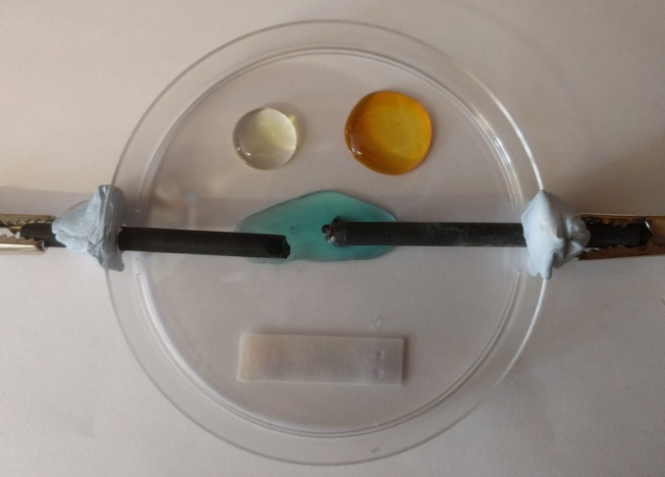  After the electrolysis is completed | 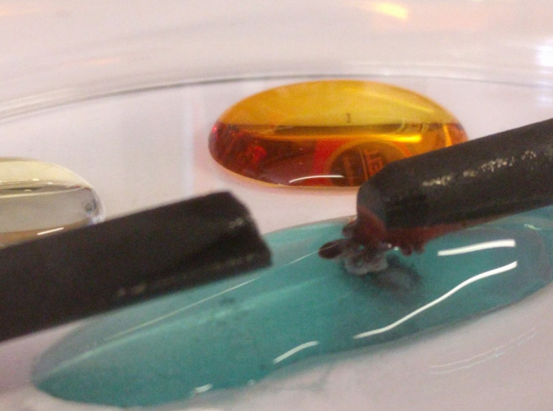  Showing the formation of copper at the cathode

Analysis of results – Trial results
You can draw your own table, or copy the one below:
Where? | Observation
potassium bromide drop | turned from colourless to light orange/brown
potassium iodide drop | turned from colourless to orange/brown
positive electrode (anode) | bubbles formed
negative electrode (cathode) | brown/black substance formed
damp blue litmus paper | turned pink then white
copper(II) chloride drop | slowly turned from pale blue to colourless

The questions you set your learners will depend on what the focus of the experiment is.
1. | Chlorine is an acidic and bleaching gas in solution. Describe and explain the evidence you have for the production of chlorine gas. [4 marks]
 | Blue litmus paper turns red in the presence of acids , and turns white in the presence of a bleach . The chlorine gas dissolved in the water forming hydrochloric acid which turned the litmus paper pink/red, and a bleach which turned the paper white.

2. | Chlorine is a reactive gas and will displace less reactive Group 7 elements from solution. Describe and explain the evidence that you have for the production of chlorine gas. [6 marks]
 | A gas is formed at the anode , where chloride ions can discharge . The reactivity of the halogens decreases down Group 7 , therefore chlorine is more reactive than bromine and iodine . When chlorine dissolves in the colourless potassium bromide solution, the solution turns pale orange/brown as bromine forms . When chlorine dissolves in the colourless potassium iodide solution, the solution turn dark brown as iodine forms .

3. | In solution, copper is present as Cu²⁺ ions and forms a blue substance (called a complex) with water. Describe and explain the evidence you have for the production of copper metal. [4 marks]
 | A brown/black substance forms at the negative electrode (cathode) where the positive copper ions discharge during electrolysis . The copper chloride solution slowly decolourised during the electrolysis as the copper ions come out of solution .

4. | Draw a diagram to show how you would carry out the electrolysis of a larger volume (e.g. 20 cm³) of copper(II) chloride. [4 marks]
+

–
power supply
graphite electrode (cathode)
graphite electrode (anode)
copper(II) chloride solution
beaker

Extension opportunities
1. | Write word and symbol equations for the different reactions that have occurred:
 | (a) | Copper(II) chloride drop: Two half equations and full redox equation [6 marks]
copper ions + electrons → copper
Cu²⁺(aq) + 2e– → Cu(s)
chloride ions → chlorine + electrons
2Cl–(aq) → Cl₂(g) + 2e–
copper ions + chloride ions → copper + chlorine ions
Cu²⁺(aq) + 2Cl–(aq)→ Cu(s) + Cl₂(g)

 | (b) | Displacement reaction in the potassium bromide drop [2 marks]
chlorine + bromide → chloride + bromine
Cl₂(g) + 2Br–(aq) → 2Cl–(aq) + Br₂(aq)

 | (c) | Displacement reaction in the potassium iodide drop [2 marks]
chlorine + iodide→ chloride +iodine
Cl₂(g) + 2I–(aq) → 2Cl–(aq) + I₂(aq)

2. | Predict, with explanation, what will happen to the rate of electrolysis over time.  [2 marks]
 | As the concentration of the copper(II) ions decreases, the solution becomes less conductive so the rate of electrolysis decreases . (In some observations, the discharged copper ‘grows’ from the cathode towards the anode, and an increase in the rate of bubble formation is seen, presumably as the effective size of the electrode is increased).

3. | Explain why the colour of the copper(II) chloride solution changes over time.  [2 marks]
 | The copper(II) ion forms a complex in solution (with six water molecules) which is blue . As the copper ions discharge at the cathode, the concentration of this complex decreases , hence the solution becomes less blue.

Document updates
v1 Published on the qualification pages
v1.1 January 2017 Consolidated labelling and formatting of activities
v1.2 February 2017 Correction of Combined Science labelling
v1.3 June 2021 Update to meet digital accessibility standards

We’d like to know your view on the resources we produce. Click ‘Like’ or ‘Dislike’ to send us an auto generated email about this resource. Add comments if you want to. Let us know how we can improve this resource or what else you need. Your email will not be used or shared for any marketing purposes.
Looking for another resource? There is now a quick and easy search tool to help find free resources for your qualification.
OCR is part of Cambridge Assessment, a department of the University of Cambridge.
For staff training purposes and as part of our quality assurance programme your call may be recorded or monitored.
Oxford Cambridge and RSA Examinations is a Company Limited by Guarantee. Registered in England. Registered office
The Triangle Building, Shaftesbury Road, Cambridge, CB2 8EA. Registered company number 3484466. OCR is an exempt charity.
OCR operates academic and vocational qualifications regulated by Ofqual, Qualifications Wales and CCEA as listed
in their qualifications registers including A Levels, GCSEs, Cambridge Technicals and Cambridge Nationals.
OCR provides resources to help you deliver our qualifications. These resources do not represent any particular teaching method we expect you to use. We update our resources regularly and aim to make sure content is accurate but please check the OCR website so that you have the most up to date version. OCR cannot be held responsible for any errors or omissions in these resources.
Though we make every effort to check our resources, there may be contradictions between published support and the specification, so it is important that you always use information in the latest specification. We indicate any specification changes within the document itself, change the version number and provide a summary of the changes. If you do notice a discrepancy between the specification and a resource, please contact us.
© OCR 2021 - You can copy and distribute this resource freely if you keep the OCR logo and this small print intact and you acknowledge OCR as the originator of the resource.
OCR acknowledges the use of the following content: N/A
Whether you already offer OCR qualifications, are new to OCR or are thinking about switching, you can request more information using our Expression of Interest form.
Please get in touch if you want to discuss the accessibility of resources we offer to support you in delivering our qualifications.

Chemistry PAG 2: Electrolysis

Combined Science PAG C1: Electrolysis

Suggested Activity 2: Microscale electrolysis of copper(II) chloride

Learner Activity

Introduction
In this activity, you will pass an electrical current through copper(II) chloride solution to form two electrolysis products, copper and chlorine. The reaction will be carried out as a microscale experiment, which allows multiple experiments to be conducted at the same time, while minimising the amount of reagents used and the risks associated with chlorine gas.

Aims
To set-up a microscale electrolysis reaction of copper(II) chloride, and to analyse the products formed.
+
+
+
–
crocodile clip
negative electrode (cathode)
power supply
potassium iodide solution
potassium bromide solution
copper(II) chloride solution
damp blue litmus paper
petri dish
positive electrode (anode)
wire
Figure 1: The electrochemical cell setup

Intended class time
20-25 minutes

Equipment (per group)
- pre-prepared petri-dish with two small holes on opposite sides, and a lid
- two graphite/carbon-fibre electrodes
- 2 crocodile clips and wires
- power-pack/9V battery
- 0.5 mol dm^{–3} aqueous copper chloride solution (low hazard)
- 0.5 mol dm^{–3} aqueous potassium bromide solution (low hazard)
- 0.2 mol dm^{–3} aqueous potassium iodide solution (low hazard)
- dropping pipettes
- blue litmus paper
- blu-tack

Health and Safety
- Eye protection should be worn at all times.
- Ensure the laboratory is well ventilated – chlorine gas (DANGER: Toxic and irritant) is produced. Your teacher will discuss this with you before the practical is carried out.
- Ensure the petri-dish is covered when the circuit is connected to the power source.

Method
- Set up the apparatus as shown in Figure 1. Slide the electrodes through the pre-drilled holes in the side of the petri-dish – the gap between the ends should be about 1 cm – and connect the crocodile clips to electrodes.. Do not turn on the power supply yet.
You may need to use blu-tack to prevent the ends of the electrodes from ‘tipping-up’ – see Figure 2 below.

- Pipette about 10 drops of the copper(II) chloride solution between the ends of the electrodes
Both electrodes need to be within the drop so that the circuit is complete and the current can flow.

- Pipette about five drops each of potassium bromide and potassium iodide separately onto the petri-dish.
These solutions will both react with one of the products of electrolysis of copper(II) chloride – you will be looking for a colour change.

- Dampen a 2-3 cm piece of blue litmus paper and place in the petri dish.
The indicator paper is usually used to test for acidic substances, but can also be used to test for substances that bleach – again you will be looking for a colour change.

- Turn on the power supply to about 3 V for up to two minutes and record your observations in a table. If you are using a battery, the reactions should be complete within about one minute.
Your observations will be in all three solution drops and the litmus paper. Do not run the electrolysis for more than two minutes.

- Dismantle your experimental set up. Place the indicator paper in the bin, and rinse the petri-dish and electrodes in a sink.

Analysis of results
You can draw your own table, or use the one below:
Where? | Observation
potassium bromide drop
potassium iodide drop
positive electrode (anode)
negative electrode (cathode)
damp blue litmus paper
copper(II) chloride drop

Your ability to analyse your observations may depend on how much of the GCSE Chemistry/Combined Science course you have studied. Your teacher will let you know which questions you should focus on:
1. | Chlorine is an acidic and bleaching gas in solution. Describe and explain the evidence you have for the production of chlorine gas. [4 marks]

2. | Chlorine is a reactive gas and will displace less reactive Group 7 elements from solution. Describe and explain the evidence that you have for the production of chlorine gas.[6 marks]

3. | In solution, copper is present as Cu²⁺ ions and forms a blue substance (called a complex) with water. Describe and explain the evidence you have for the production of copper metal. [4 marks]

4. | Draw a diagram to show how you would carry out the electrolysis of a larger volume (e.g. 20 cm³) of copper(II) chloride. [4 marks]

Extension opportunities
1. | Write word and symbol equations for the different reactions that have occurred:
 | (a) | Copper(II) chloride drop: Two half equations and full redox equation [6 marks]

 | (b) | Displacement reaction in the potassium bromide drop [2 marks]

 | (c) | Displacement reaction in the potassium iodide drop [2 marks]

2. | Predict, with explanation, what will happen to the rate of electrolysis over time.  [2 marks]

3. | Explain why the colour of the copper(II) chloride solution changes over time.  [2 marks]

DfE Apparatus and Techniques covered
If you are using the OCR Practical Activity Learner Record Sheet (Chemistry / Combined Science) you may be able to tick off the following skills:

Chemistry |  |  |  |  | Combined Science
3-i | 6-ii | 7-i | 7-ii |  | 8-i | 11-ii | 12-i | 12-ii
8-i

