Lesson Element

Plant growth hormones

Instructions and answers for teachers

These instructions cover the learner activity section which can be found on page 8. This Lesson Element supports OCR GCSE (9–1) Gateway Science Biology A and the Twenty First Century Science Biology B qualifications.
When distributing the activity section to the learners either as a printed copy or as a Word file you will need to remove the teacher instructions section.

Mapping to specification level (Learning outcomes)
GCSE (9–1) Gateway Science Biology A/Combined Science A

B3.2g Explain how plant hormones are important in the control and coordination of plant growth and development, with reference to the role of auxins in phototropisms and gravitropisms
B3.2h Describe some of the variety of effects of plant hormones, relating to auxins, gibberellins and ethane

GCSE (9–1) Twenty First Century Science Biology B/Combined Science B
B4.4.1 a explain how plant hormones are important in the control and coordination of plant growth and development, with reference to the role of auxins in phototropisms and gravitropisms
B4.4.1 b describe practical investigations into the role of auxin in phototropism

Introduction

Prior knowledge
Learners will have learnt about hormones involved in human reproduction and the menstrual cycle and in the body as examples of negative feedback earlier in the topic. They must now look at the effect of hormones on plants.
This lesson element would be ideal as the first lesson on this area of the specification, introducing the role of auxins in phototropism and gravitropism. Learners would then be required to move on to learning about the effects of gibberellins and ethane and the commercial uses for plant hormones in subsequent lessons.

Common learner misconceptions
- A number of learners will not realise that plant have hormones. They think only animals have hormones.
- Some learners will think that you must plant a seed the correct way up for the shoot to grow upwards and the roots to grow down.
- Some learners will have difficulty understanding that auxin has opposite effects on cells in the shoot compared with the root.
This lesson element addresses all of these misconceptions.

Teacher preparation
Teachers may want to ask their lab technician to plant some cress, radish, mustard or other relatively fast growing seeds in some compost 7 - 10 days in advance of the lesson and keep them somewhere where they have a light source from one side only. This shows learners positive phototropism in shoots.
If you don't have time for this, an internet search will give you a number of images to show learners instead.
Practical equipment and seeds will be needed for the gravitropism and phototropism practical. The teacher notes can be found on the SAPS website: http://www.saps.org.uk/secondary/teaching-resources/1239-tackling-tropisms-gravitropism-and-phototropism
Worksheets will need to be photocopied, 1 per learner.

Task 1 – Starter
Learners work in pairs to answer the questions:
- What is a hormone?
- Give some examples of hormones and their responses.
Examples: Oestrogen causes an egg to be released from the ovary, insulin and glucagon control blood sugar levels, ADH controls reabsorption of water in the kidney, adrenaline triggers the body's fight or flight response, auxin (rooting powder) encourages root growth etc.
Expect a number of examples for human hormones but fewer, if any examples of plant hormones. Highlight to learners that plants do have hormones and that is what they will be learning more about this lesson.
Ask learner pairs to write down what they think plants may need hormones to do.
Discuss their answers.
Learners add this information to the relevant section of their worksheet.
Hormone – Definition
A substance (chemical messenger) that is secreted in one part of an organism and travels to a target organ or tissue to bring about a response.

Examples of plant responses to hormones:  Root & shoot growth  Flower and leaf fall  Bud development  Fruit formation & ripening  Germination of seeds  Flowering time  etc. |  | A plant shows positive phototropism as it grows  light.  root  shoot  towards  A plant shows negative phototropism as it grows  light.  away from

Task 2 – Phototropism role play
OCR Resources: the small print
OCR’s resources are provided to support the delivery of OCR qualifications, but in no way constitute an endorsed teaching method that is required by the Board, and the decision to use them lies with the individual teacher. Whilst every effort is made to ensure the accuracy of the content, OCR cannot be held responsible for any errors or omissions within these resources.
© OCR 2015 - This resource may be freely copied and distributed, as long as the OCR logo and this message remain intact and OCR is acknowledged as the originator of this work.
OCR acknowledges the use of the following content: n/a
Please get in touch if you want to discuss the accessibility of resources we offer to support delivery of our qualifications: resources.feedback@ocr.org.uk
Show learners the seeds that have been grown with a light source from one side only (or an image of this). Ask learners what has happened and why this is beneficial to the plant.
Using two volunteers, explain to the class that one will be a plant and the other a light source. Ask the 'plant' to stick post-its/stickers randomly over the top half of their body, these stickers are molecules of auxin. Give the 'light source' a torch and ask them to shine from straight above the 'plant'. Explain to learners that in this situation, the auxin is evenly spread therefore all cells in the shoot grow at an even rate, so growth is straight up.
Now ask the 'light source' to shine onto one side of the 'plant'. The 'plant' now moves their stickers to the side of their body away from the 'light source'. Explain that auxin causes cells in shoots to grow and as the cells away from the light grow much faster now there is more auxin present, it causes that side to elongate and the plant bends towards the light. The learner should do this by stretching up the far side of their body and leaning towards the 'light source'.
Introduce the term PHOTOTROPISM.
This is a quick and simple demonstration that learners are far more likely to remember than using just images of auxin concentration in plant shoots.
Learners draw a cartoon strip to show the effect of auxin and phototropism on shoot growth on their worksheet.
Draw a cartoon strip to show how auxin affects phototropism in a shoot:
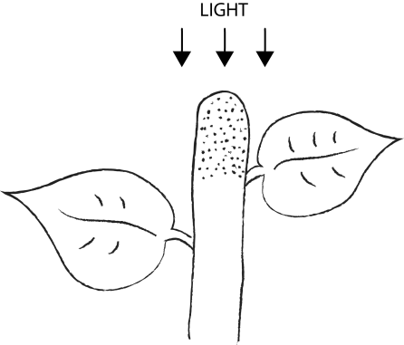  Diagram | 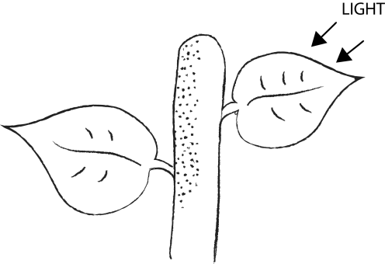 | 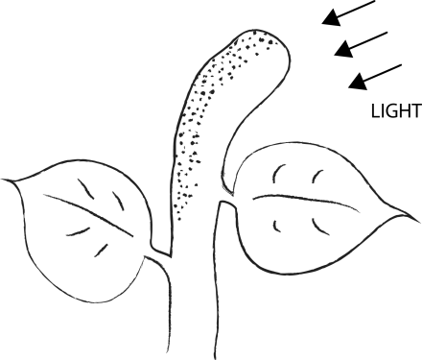
Explanation  Auxin is evenly distributed at the tip so all parts of the tip grow evenly, therefore straight | Auxin accumulates on the side of the tip away from the light source | Auxin cause the cells on the side away from the light to elongate faster, so the shoot bends towards the light

Task 3 – Phototropism experiment results
Learners use the information on their worksheet to predict what will happen to the growth of the shoot in the four experiments shown.
Auxins are found only in the tip of the shoot. Use this knowledge to draw how each of the following tips would look if left to grow for a few days.
Explain each result.
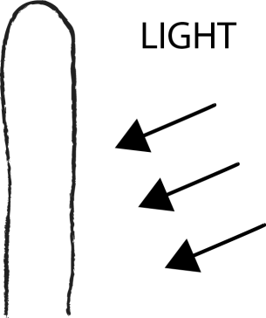
The shoot bends towards the light because auxin has accumulated on the side away from the light, causing the cells to elongate faster and resulting in the shoot bending.
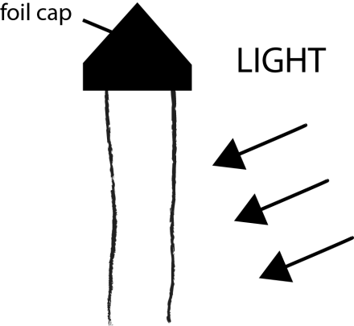
The shoot grows straight up as the foil prevents the tip of the shoot and the auxin from detecting the light, so auxin stays evenly spread.
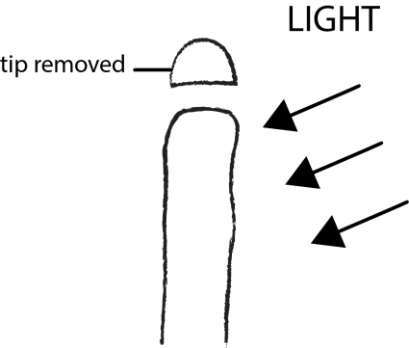
The shoot grows very little if at all as there is no auxin left in the shoot causing the cells to grow.
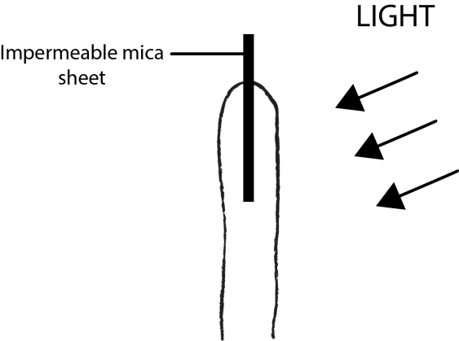
The shoot grows straight up as the auxin is evenly spread due to the mica preventing the movement of it from one side to the other.

Task 4 – Gravitropism practical
Learners sow some seeds onto damp cotton wool in petri dishes, place one on a flat surface and stick one vertically to the wall. Instructions and teacher notes can be found on the SAPS website: http://www.saps.org.uk/secondary/teaching-resources/1239-tackling-tropisms-gravitropism-and-phototropism
Learners should be able to see gravitropism occurring in approximately one week and add sketches and conclusions to the relevant section of their worksheet then.
Alternatively if time is short, an internet search will provide numerous images of gravitropism in roots and shoots of a plant.
For both sets of seeds, draw and describe your observations:
Seeds grown on a flat surface: | Seeds grown on a vertical surface:
Plant show positive gravitropism as they grow in the
direction that gravity acts.
roots
same
opposite
shoots
Plant show negative gravitropism as they grow in the
direction from gravity.
Use a coloured pencil to shade in the areas of the root and shoot where auxin will accumulate causing them to bend:
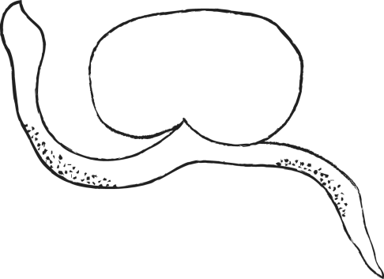
Explain the effect of auxin on the cells in the root:
In the root, auxin inhibits the elongation of cells, so the cells on the underside of the root grow much more slowly than the one on the top side, causing the root to bend downwards.

How is this different to its effect in the shoot?
It has the opposite effect in the shoot. In the shoot it elongates cells.

Task 5 – Gravitropism theory
Show learners a short clip of gravitropism in a root and a shoot: https://www.youtube.com/watch?v=mYZXax8V_L0
Discuss what is happening in the clip and introduce the term GRAVITROPISM. Learners complete the DARTS activity on their worksheet.
Ask learners to use their knowledge of auxin distribution in the shoot to shade in where they think auxin will accumulate, causing the shoot to bend upwards.
Now explain that auxin has the opposite effect on cells in the root as it inhibits growth/elongation. Using this information ask learners to shade in the area of the root where they think auxin will accumulate causing it to bend downwards.

Task 6 – Plenary
Hand out a large piece of paper and two different coloured pens to each pair of learners. Learner 1 writes a key fact they have learnt about plant hormones on the paper. Learner 2 checks it is correct and writes a different fact underneath. This continues backwards and forwards until one learner in the pair cannot think of another factor for 3 minutes timed by the teacher. The idea is not only to beat your partner by having the last fact on the sheet, but to be the pair who have more facts than the other pairs in the class.

Extension task
Learners could use the SAPS website: http://www.saps.org.uk/secondary/teaching-resources/185-learner-sheet-8-the-response-of-seedlings-to-light-phototropism-experiment
to plan an experiment to determine the effect of different coloured light on the growth of shoots.
Learners may also be interested to find out how astronauts grow their own veg in space under zero gravity: https://www.youtube.com/watch?v=SgpU08WJm0c
We’d like to know your view on the resources we produce. By clicking on ‘Like’ or ‘Dislike’ you can help us to ensure that our resources work for you. When the email template pops up please add additional comments if you wish and then just click ‘Send’. Thank you.
Whether you already offer OCR qualifications, are new to OCR, or are considering switching from your current provider/awarding organisation, you can request more information by completing the Expression of Interest form which can be found here: www.ocr.org.uk/expression-of-interest
Looking for a resource? There is now a quick and easy search tool to help find free resources for your qualification:
www.ocr.org.uk/i-want-to/find-resources/

OCR Resources: the small print
OCR’s resources are provided to support the delivery of OCR qualifications, but in no way constitute an endorsed teaching method that is required by the Board, and the decision to use them lies with the individual teacher. Whilst every effort is made to ensure the accuracy of the content, OCR cannot be held responsible for any errors or omissions within these resources.
© OCR 2017 - This resource may be freely copied and distributed, as long as the OCR logo and this message remain intact and OCR is acknowledged as the originator of this work.
OCR acknowledges the use of the following content: n/a
Please get in touch if you want to discuss the accessibility of resources we offer to support delivery of our qualifications: resources.feedback@ocr.org.uk

Lesson Element

Plant growth hormones

Learner Activity

Task 1 – Starter
Hormone – Definition

Examples of plant responses to hormones: |  | A plant shows positive phototropism as it grows  light.  A plant shows negative phototropism as it grows  light.

Task 2 – Phototropism role play
Diagram
Explanation

Task 3 – Phototropism experiment results
Drawing
Explanation
.
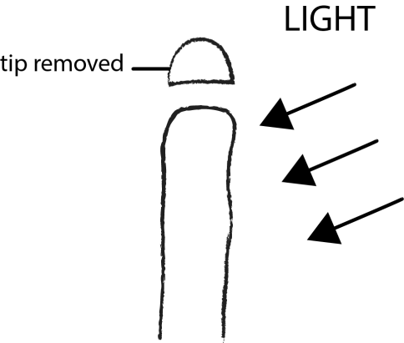
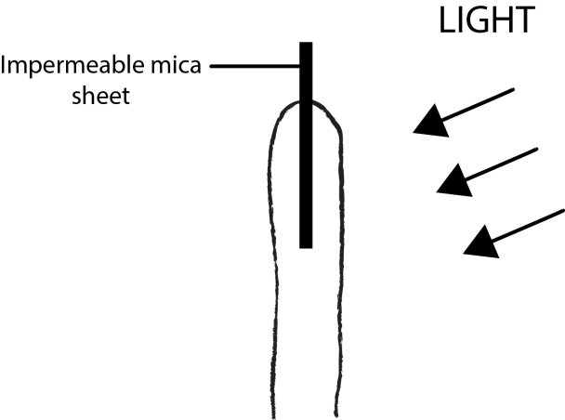

Task 4 – Gravitropism practical
Seeds grown on a flat surface: | Seeds grown on a vertical surface:
Plant show positive gravitropism as they grow in the
direction that gravity acts.

Plant show negative gravitropism as they grow in the
direction from gravity.

Use a coloured pencil to shade in the areas of the root and shoot where auxin will accumulate causing them to bend:
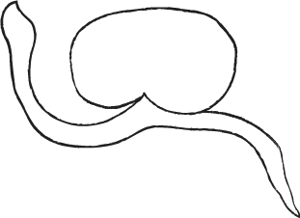
Explain the effect of auxin on the cells in the root:

How is this different to its effect in the shoot?

