Chemistry PAG 8: Measuring rates of reaction

Combined Science PAG C5: Measuring rates of reaction

Suggested Activity 4: Heat of a displacement reaction

Instructions and answers for teachers
and technicians
These instructions cover the learner activity section which can be found on page 11. This Practical activity supports OCR GCSE Chemistry and Combined Science.
When distributing the activity section to the learners, either as a printed copy or as a Word file, you will need to remove the teacher instructions section.
This is a suggested practical activity that can be used as part of teaching the GCSE (9-1) Gateway Science (A) and Twenty First Century Science (B) specifications.
These are not controlled assessment tasks, and there is no requirement to use these particular activities.
You may modify these activities to suit your learners and centre. Alternative activities are available from, for example, Royal Society of Biology, Royal Society of Chemistry, Institute of Physics, CLEAPSS and publishing companies, or of your own devising.
Further details are available in the specifications (Practical Skills Topics), and in these videos.
OCR recommendations:
Before carrying out any experiment or demonstration based on this guidance, it is the responsibility of teachers to ensure that they have undertaken a risk assessment in accordance with their employer’s requirements, making use of up-to-date information and taking account of their own particular circumstances. Any local rules or restrictions issued by the employer must always be followed.
CLEAPSS resources are useful for carrying out risk-assessments: (http://science.cleapss.org.uk).
Centres should trial experiments in advance of giving them to learners. Centres may choose to make adaptations to this practical activity, but should be aware that this may affect the Apparatus and Techniques covered by the learner.

Introduction
In this activity, learners will investigate the relationship between the concentration of a salt solution and the temperature rise of a displacement reaction. This activity allows this common experiment to be carried out at a reduced scale, minimising the cost and disposal issues with copper sulfate solutions.
This resource is adapted from the CLEAPSS experiment ‘Heat of reaction: the zinc / copper(II) sulfate(VI) reaction’ – http://science.cleapss.org.uk/Resource-Info/TL003-Heat-of-reaction-of-zinc-with-copper-II-sulfate-VI.aspx

DfE Apparatus and Techniques covered
The codes used below match the OCR Practical Activity Learner Record Sheet (Chemistry / Combined Science) and Trackers (Chemistry / Combined Science) available online. There is no requirement to use these resources.
By doing this experiment, learners have an opportunity to develop the following skills:
1 [1]: Use of appropriate apparatus to make and record a range of measurements accurately, including: i [iii]) mass; iii [v]) temperature; iv [vi]) volume of liquids
3 [8]: Use of appropriate apparatus and techniques for: i) conducting and monitoring chemical reactions
5 [10]: Making and recording of appropriate observations during chemical reactions including: i) changes in temperature
6 [11]: Safe use and careful handling of gases, liquids and solids, including: i) careful mixing of reagents under controlled conditions; ii) using appropriate apparatus to explore chemical changes and/or products

Aims
To determine the relationship between the concentration of copper sulfate and the temperature change when reacted with zinc.

Intended class time
30−40 minutes

Links to Specifications:

Gateway Science (Suite A) – including Working Scientifically (WS)
C3.2a distinguished between endothermic and exothermic reactions on the basis of the temperature change of the surroundings
C3.2b draw and label a reaction profile for an exothermic and an endothermic reaction [to include: activation energy, energy change, reactants and products]
WS1.2e evaluate methods and suggest possible improvements and further investigations
WS1.3a presenting observations and other data using appropriate methods
WS1.3b translating data from one form to another
WS1.3c carrying out and representing mathematical and statistical analysis
WS1.3e interpreting observations and other data
WS1.3f presenting reasoned explanations relating data to hypotheses
WS1.3g evaluating data in terms of accuracy, precision, repeatability and reproducibility
WS1.3h identifying potential sources of random and systematic error
WS1.4a use scientific vocabulary, terminology and definitions
WS1.4c use SI units and IUPAC chemical nomenclature unless inappropriate
WS1.4f use an appropriate number of significant figures in calculation
WS2a carry out experiments
WS2b make and record observations and measurements using a range of apparatus and methods
WS2c presenting observations using appropriate methods to include descriptive, tabular diagrammatic and graphically

Twenty First Century Science (Suite B) – including Ideas about Science (IaS)
C1.2.1 distinguish between endothermic and exothermic reactions on the basis of the temperature change of the surroundings
C1.2.2 draw and label a reaction profile for an exothermic and an endothermic reaction, identifying activation energy
IaS2.4. be able to translate data from one form to another
IaS2.6. when processing data use an appropriate number of significant figures
IaS2.7. when displaying data graphically select an appropriate graphical form, use appropriate axes and scales, plot data points correctly, draw an appropriate line of best fit, and indicate uncertainty (e.g. range bars)
IaS2.8. when analysing data identify patterns/trends, use statistics (range and mean) and obtain values from a line on a graph (including gradient, interpolation and extrapolation)
IaS2.9. in a given context evaluate data in terms of accuracy, precision, repeatability and reproducibility, identify potential sources of random and systematic error, and discuss the decision to discard or retain an outlier
IaS2.10. evaluate an experimental strategy, suggest improvements and explain why they would increase the quality (accuracy, precision, repeatability and reproducibility) of the data collected, and suggest further investigations
IaS2.11. in a given context interpret observations and other data (presented in diagrammatic, graphical, symbolic or numerical form) to make inferences and to draw reasoned conclusions, using appropriate scientific vocabulary and terminology to communicate the scientific rationale for findings and conclusions
IaS3.4. use a variety of models (including representational, spatial, descriptive, computational and mathematical models) to: i) solve problems, ii) make predictions, iii) develop scientific explanations and understanding, iv) identify limitations of models

Mathematical Skills covered
M1a Recognise and use expressions in decimal form
M1c Use ratios, fractions and percentages
M4a Translate information between graphical and numeric form
M4c Plot two variables from experimental or other data
M4d Determine the slope and intercept of a linear graph

Image from trials
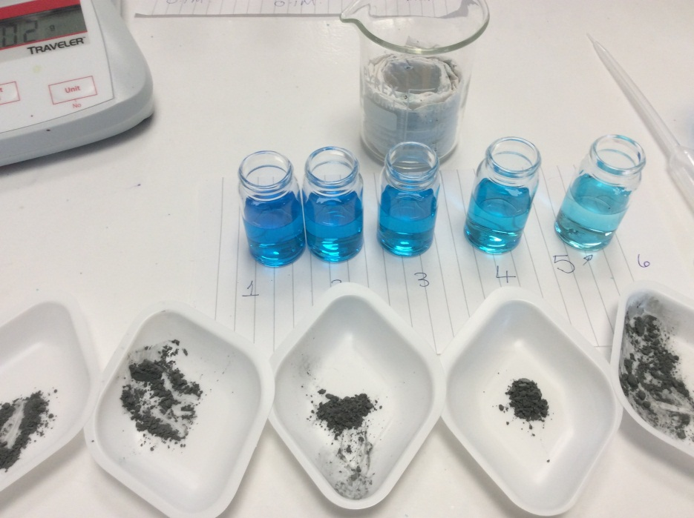
The experimental setup.

Technical Requirements – PER GROUP

Chemicals
Identity | Approximate quantity required or produced PER GROUP | Hazard information |  | Risk information
1.0 mol/dm³ copper sulfate(VI) solution | 40 cm³ |  | WARNING  Harmful if swallowed. Causes skin irritation. Causes serious eye irritation. | Brief students about disposal method before carrying out reaction.
zinc powder | 4 g |  | DANGER  Very toxic to aquatic life with long lasting effects. In contact with water releases flammable gases which ignite spontaneously. Catches fire spontaneously if exposed to air. | Ensure no naked flames in the laboratory.

Equipment
- beaker, glass or plastic (100 cm³)
- glass vials (c. 12-14 cm³) × 5– if unavailable, boiling tubes can be substituted
- weighing boats × 5
- dropping pipette with volume markings
- spatula
- thermometer (–10−110°C)
- cotton wool
- deionised water
- access to waste beaker/bucket
- access to accurate mass balance (2 decimal places)

Note: glass vials are available from e.g. TIMSTAR (VI6982) and SCICHEM (TVL060030)

Health and Safety
Eye protection should be worn at all times.
Learners should have access to a large beaker/bucket for disposal of their reactions mixture which should then be treated as follows:
- Wear eye protection. Use a fume cupboard in case a spray is produced.
- Take the disposal bucket containing the waste chemicals - add more water if necessary and stir the mixture to ensure all remaining copper sulfate has reacted with the zinc and the liquid is clear and colourless.
- Add 2 mol/dm³ sulfuric(VI) acid in 10 to 20 cm³ portions until there is no more fizzing (the acid reacts with any remaining zinc).
- Filter the mixture.
- Pour the filtrate (acidic zinc sulfate solution) into a bucket of water. Dispose of down the foul water drain.
- The metallic copper left on the filter paper appears quite black because (i) it is finely divided and (ii) some of it is air-oxidised.
- Once dry, the copper can be roasted in a metal crucible for 15 minutes. After cooling, the copper can be added to 1.5 M sulfuric(VI) acid, heated to boiling and then cooled. Pour the solution into a shallow tray for crystals of copper(II) sulfate(VI) to form (these can be used for other experiments).

Method
Learners will collect temperature data from the reaction between zinc and copper sulfate solution at various concentrations.
This activity provides a good opportunity to develop learners’ organisational skills and initial analysis. They should be encouraged to split the activity into i) set-up, ii) data collection and initial analysis, iii) clear-up and iv) data analysis and interpretation, and ensuring they carry out each step fully before moving to the next. This will give them opportunity to focus on the task at hand, minimising the likelihood of steps being missed and maximising their learning.

Analysis of results – Trial results
volume of 1 mol/dm³ copper sulfate solution / cm³ | initial temperature / °C | final temperature / °C | temperature difference / °C
2 | 26.0 | 35.0 | 9.0
4 | 25.0 | 43.0 | 18.0
6 | 24.5 | 49.0 | 24.0
8 | 25.0 | 55.5 | 30.5
10 | 24.5 | 61.0 | 36.5
(original data from CLEAPSS)

1. | Calculate the temperature difference for each of the reactions [2 marks]
1 mark for correct calculations
1 mark for all temperature differences to one decimal place
2. | Plot a graph of volume of copper sulfate against temperature difference [4 marks].
1 mark for correct y–axis
1 mark for accurate plotting (correct to within one small square on 2 mm graph paper)
1 mark for appropriate line of best fit

The change in temperature on addition of an excess of zinc powder to variable concentrations of copper(II) sulphate
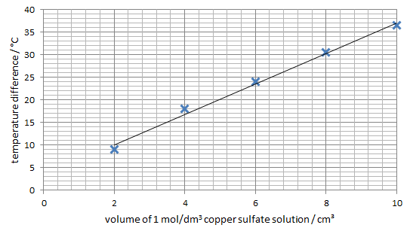

3. | From your line of best fit, calculate the temperature change per cm³ of copper sulfate [3 marks]
gradient = = 3.4 °C/cm³
1 mark for accurate reading from the graph
1 mark for correct calculation
1 mark for correct units

Extension Opportunities

1. | Based on your results, would you classify the reaction between zinc and copper sulfate solution as endothermic or exothermic? What evidence supports this classification? [2 marks]
Exothermic
The change in temperature is positive, indicating that the reaction produces heat.
2. | The energy change of this reaction can be calculated using: energy change = temperature difference x -42. The accepted value is -217kJ/mol. Comment on how close your calculated value is to the accepted value. [2 marks]
Calculation based on trial data.
Energy change = -42 x 3.4 = -140kJ/mol
This change is lower than the expected value possibly due to heat loss to the atmosphere.(accept any suitable comment)
3. | Describe how you would modify the experimental method to increase the accuracy of your results. [2 marks]
 | Carry out three repeats of each reaction and calculate a mean average temperature increase for each reaction .
4. | Describe one potential source of random error and one of systematic error and how you would modify the experimental method to minimise these errors. [4 marks]
Allow any suitable source of error and related modification (1 mark each).
For example:

random error: inaccuracy in measuring volumes with a pipette ; use a measuring cylinder for measuring volumes .

systematic error: concentration of the stock copper sulfate solution is higher than expected, leading to greater temperature increases make up fresh stock solution from a solid sample of the salt

Document updates
v1 November 2016 Published on qualification page
v1.1 January 2017 Consolidated labelling and formatting of activities
v1.2 June 2021 Updated to meet digital accessibility standards

We’d like to know your view on the resources we produce. Click ‘Like’ or ‘Dislike’ to send us an auto generated email about this resource. Add comments if you want to. Let us know how we can improve this resource or what else you need. Your email will not be used or shared for any marketing purposes.
Looking for another resource? There is now a quick and easy search tool to help find free resources for your qualification.
OCR is part of Cambridge Assessment, a department of the University of Cambridge.
For staff training purposes and as part of our quality assurance programme your call may be recorded or monitored.
Oxford Cambridge and RSA Examinations is a Company Limited by Guarantee. Registered in England. Registered office
The Triangle Building, Shaftesbury Road, Cambridge, CB2 8EA. Registered company number 3484466. OCR is an exempt charity.
OCR operates academic and vocational qualifications regulated by Ofqual, Qualifications Wales and CCEA as listed
in their qualifications registers including A Levels, GCSEs, Cambridge Technicals and Cambridge Nationals.
OCR provides resources to help you deliver our qualifications. These resources do not represent any particular teaching method we expect you to use. We update our resources regularly and aim to make sure content is accurate but please check the OCR website so that you have the most up to date version. OCR cannot be held responsible for any errors or omissions in these resources.
Though we make every effort to check our resources, there may be contradictions between published support and the specification, so it is important that you always use information in the latest specification. We indicate any specification changes within the document itself, change the version number and provide a summary of the changes. If you do notice a discrepancy between the specification and a resource, please contact us.
© OCR 2021 - You can copy and distribute this resource freely if you keep the OCR logo and this small print intact and you acknowledge OCR as the originator of the resource.
OCR acknowledges the use of the following content: N/A
Whether you already offer OCR qualifications, are new to OCR or are thinking about switching, you can request more information using our Expression of Interest form.
Please get in touch if you want to discuss the accessibility of resources we offer to support you in delivering our qualifications.

Chemistry PAG 8: Measuring rates of reaction

Combined Science PAG C5: Measuring rates of reaction

Suggested Activity 4: Heat of a displacement reaction

Learner Activity

Introduction
Measuring the temperature change during a reaction provides useful insight into the energetics of the reaction. You will likely have carried out this reaction at Key Stage 3, where you noted whether reactions got hotter (exothermic) or cooler (endothermic). In this activity, you will collect quantitative data on the reaction between zinc and copper sulfate.

Aims
To determine the relationship between concentration of copper sulfate and temperature change when reacted with zinc

Intended class time
30−40 minutes
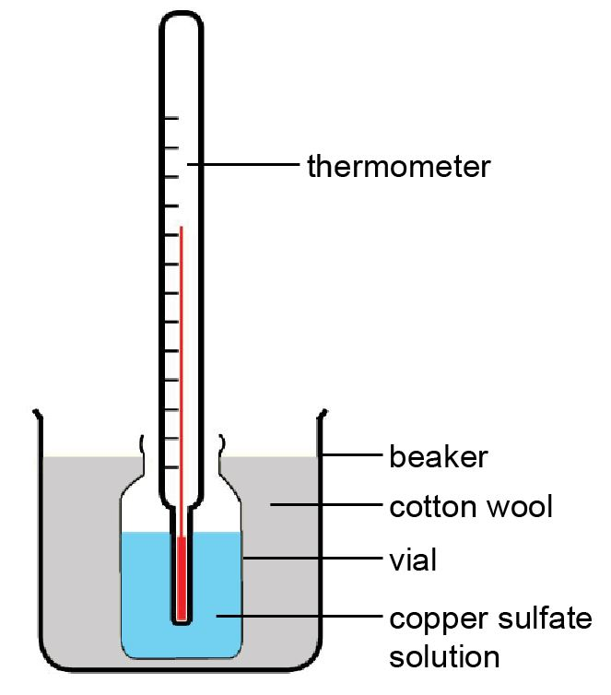

Chemicals and equipment (per group)
- beaker, glass or plastic (100 cm³)
- glass vials × 5
- weighing boats × 5
- dropping pipette with volume markings
- spatula
- thermometer (–10−110 °C)
- cotton wool
- deionised water
- access to waste beaker/bucket
- access to accurate mass balance (2 decimal places)
- 1 mol/dm³ copper sulfate(VI) solution (c. 40 cm³)
- zinc powder (c. 4 g)

Health and Safety
Eye protection should be worn at all times.
DO NOT tip the mixtures down the sink. Dispose of mixtures in the waste container as directed by your teacher.

Method
- Prepare an insulating reaction container by putting cotton wool into a 100 cm³ beaker, then make a vial-sized space in the middle – see Figure 1.
- Line up five vials (labelled 2, 4, 6, 8, 10)
- Use a 3 cm³ plastic pipette to add, respectively, 8, 6, 4, 2, and 0 cm³ of water to the vials.
- Using the same pipette, add, respectively, 2, 4, 6, 8 and 10 cm³ of 1 mol/dm³ copper sulfate solution to the vials.
- Weigh out separately in five weighing boats 0.65-0.75 g zinc power (the zinc is in excess).
- Place vial 2 in the insulated container, then measure and record the temperature of the solution to the nearest 0.5°C.
- Add a sample of zinc powder to the vial, hold the container with one hand, then carefully stir the mixture with the thermometer.
- Measure and record the highest temperature. Then rinse the thermometer.
- Repeat Steps 6-8 with the remaining vials.
- Place all waste mixtures in the waste container.

Analysis of results
You can draw your own table, or use the one below:
volume of 1 mol/dm³ copper sulfate solution / cm³ | initial temperature / °C | final temperature / °C | temperature difference / °C
2
4
6
8
10

Your ability to analyse your observations may depend on how much of the GCSE Chemistry/Combined Science course you have studied. Your teacher will let you know which questions you should focus on:
1. | Calculate the temperature difference for each of the reactions [2 marks]
2. | Plot a graph of volume of copper sulfate against temperature difference [4 marks].
3. | From your line of best fit, calculate the temperature change per cm³ of copper sulfate [3 marks]

Extension opportunities

1. | Based on your results, would you classify the reaction between zinc and copper sulfate solution as endothermic or exothermic? What evidence supports this classification? [2 marks]

2. | The energy change of this reaction can be calculated using: energy change = temperature difference x -42. The accepted value is -217kJ/mol. Comment on how close your calculated value is to the accepted value. [2 marks]
3. | Explain how you would modify the experimental method to increase the accuracy of your results. [2 marks]
4. | Describe one potential source of random error and one of systematic error and explain how you would modify the experimental method to minimise these errors.  [4 marks]

DfE Apparatus and Techniques covered
If you are using the OCR Practical Activity Learner Record Sheet (Chemistry / Combined Science) you may be able to tick off the following skills:

Chemistry |  |  |  |  | Combined Science
1-i | 1-iii | 1-iv | 3-i |  | 1-iii | 1-v | 1-vi | 8-i
5-i | 6-i | 6-ii |  |  | 10-i | 11-i | 11-ii

