Chemistry PAG 7: Production of salts

Combined Science PAG C4: Production of salts

Suggested Activity 2: Microscale copper sulfate synthesis

Instructions and answers for teachers
and technicians
These instructions cover the learner activity section which can be found on page 10. This Practical activity supports OCR GCSE Chemistry and Combined Science.
When distributing the activity section to the learners, either as a printed copy or as a Word file, you will need to remove the teacher instructions section.
This is a suggested practical activity that can be used as part of teaching the GCSE (9-1) Gateway Science (A) and Twenty First Century Science (B) specifications.
These are not controlled assessment tasks, and there is no requirement to use these particular activities.
You may modify these activities to suit your learners and centre. Alternative activities are available from, for example, Royal Society of Biology, Royal Society of Chemistry, Institute of Physics, CLEAPSS and publishing companies, or of your own devising.
Further details are available in the specifications (Practical Skills Topics), and in these videos.
OCR recommendations:
Before carrying out any experiment or demonstration based on this guidance, it is the responsibility of teachers to ensure that they have undertaken a risk assessment in accordance with their employer’s requirements, making use of up-to-date information and taking account of their own particular circumstances. Any local rules or restrictions issued by the employer must always be followed.
CLEAPSS resources are useful for carrying out risk-assessments: (http://science.cleapss.org.uk).
Centres should trial experiments in advance of giving them to learners. Centres may choose to make adaptations to this practical activity, but should be aware that this may affect the Apparatus and Techniques covered by the learner.

Introduction
In this activity, learners will synthesis copper(II) sulfate(VI) by a microscale method, minimising the amounts of substance used and the potentially hazardous heating of large volumes sulfuric acid. The activity can also be completed within a lesson from reaction to crystal formation, allowing better continuity of learning.
This method is based on the CLEAPSS activity http://science.cleapss.org.uk/Resource-Info/Hydrated-copper-sulfate-preparation-Microscale-method.aspx. A standard scale synthesis is available at http://science.cleapss.org.uk/Resource-Info/PP027-Making-copper-sulfate-crystals.aspx with associated video.
Another standard-scale synthesis is also available from the Royal Society of Chemistry/Nuffield Foundation Practical Chemistry project http://www.rsc.org/learn-chemistry/resource/res00001917/reacting-copper-ii-oxide-with-sulfuric-acid.

DfE Apparatus and Techniques covered
The codes used below match the OCR Practical Activity Learner Record Sheet (Chemistry / Combined Science) and Trackers (Chemistry / Combined Science) available online. There is no requirement to use these resources.
By doing this experiment, learners have an opportunity to develop the following skills:
1 [1]: Use of appropriate apparatus to make and record a range of measurements accurately, including: i [iii]) mass; ii [iv]) time; iv [vi]) volume of liquids; [ix] pH
2 [2]: Safe use of appropriate heating devices and techniques including use of: ii) a water bath OR an electric heater
3 [8]: Use of appropriate apparatus and techniques for: i) conducting and monitoring chemical reactions; ii) conducting and monitoring chemical reactions, including appropriate reagents and/or techniques for the measurement of pH in different situations
4 [9]: Safe use of a range of equipment to purify and/or separate chemical mixtures including: i) evaporation; ii) filtration; iii) crystallisation
6 [11]: Safe use and careful handling of gases, liquids and solids, including: i) careful mixing of reagents under controlled conditions; ii) using appropriate apparatus to explore chemical changes and/or products

Aims
To synthesis and crystallise hydrated copper(II) sulfate(VI).

Intended class time
30–40 minutes

Links to Specifications:

Gateway Science (Suite A) – including Working Scientifically (WS)
CM2.1ii provide answers to an appropriate number of significant figures
C2.1f describe, explain and exemplify the processes of filtration, crystallisation, simple distillation and fractional distillation [to include: knowledge of the techniques]
C3.3k describe techniques and apparatus used to measure pH
C4.1c recall the general properties of transition metals and their compounds and exemplify these by reference to a small number of transition metals [to include melting point, density, reactivity, formation of coloured ions with different charges and uses as catalysts]
WS1.3a presenting observations and other data using appropriate methods
WS1.4a use scientific vocabulary, terminology and definitions
WS1.4c use SI units and IUPAC chemical nomenclature unless inappropriate
WS1.4d use prefixes and powers of ten for orders of magnitude
WS2a carry out experiments
WS2b make and record observations and measurements using a range of apparatus and methods
WS2c presenting observations using appropriate methods to include descriptive, tabular diagrammatic and graphically

Twenty First Century Science (Suite B) – including Ideas about Science (IaS)
C2.5.1 recall the general properties of transition metals (melting point, density, reactivity, formation of coloured ions with different charges and uses as catalysts) and exemplify these by reference to copper, iron, chromium, silver and gold
C5.1.7 describe, explain and exemplify the processes of filtration, crystallisation, simple distillation and fractional distillation.
C6.1.4 recall that relative acidity and alkalinity are measured by pH including the use of universal indicator and pH meters
IaS1.6 plan experiments or devise procedures by constructing clear and logically sequenced strategies to: i) make observations, ii) produce or characterise a substance, iii) test hypotheses, iv) collect and check data, v) explore phenomena
IaS1.8 use appropriate scientific vocabulary, terminology and definitions to communicate the rationale for an investigation and the methods used using diagrammatic, graphical, numerical and symbolic forms
IaS2.1 present observations and other data using appropriate formats

Mathematical Skills covered
M1a Recognise and use expressions in decimal form
M1b Recognise and use expressions in standard form
M1c Use ratios, fractions and percentages
M2a Use an appropriate number of significant figures
M3a Understand and use the symbols: =, <, <<, >>, >, ∝, ~
M3b Change the subject of an equation
M3c Substitute numerical values into algebraic equations using appropriate units for physical quantities
M3d Solve simple algebraic equations

Technical Requirements – PER GROUP

Chemicals
Identity | Approximate quantity required or produced PER GROUP | Hazard information |  | Risk information
copper(II) oxide, CuO(s) | c. 0.2 g |  | WARNING  Harmful if swallowed. Very toxic to aquatic life with long-lasting effects | Avoid raising dust – see CLEAPSS Hazcard 26 and below.
1.4 mol/dm³ sulfuric(VI) acid, H₂SO₄(aq) | c. 1.5 cm³ |  | WARNING: Causes skin and serious eye irritation.
copper(II) sulfate(VI)-5-water PRODUCED | c. 0.5 g |  | Harmful if swallowed. Causes skin and serious eye irritation. Very toxic to aquatic life with long lasting effects. | Crystals can be saved for making CuSO₄(aq)
Note: CuO: if a fume cupboard is available, copper oxide should be weigh out on a mass balance in fume cupboard with the flow turned off, and the sash partly pulled down.

Equipment
- universal indicator paper
- cotton wool
- dropping pipette
- forceps
- glass marker pen
- glass vial (c. 14 cm³)
- plastic syringe (2 or 5 cm³)
- timer
- watch glass (c. 5 cm)
- weighing boat
- white tile
- access to a camera / smartphone camera (optional)
- access to a mass balance (2 decimal places)
- access to a sand bath (baking tray of sand on a hot plate)
Note: glass vials are available from e.g. TIMSTAR (VI6982) and SCICHEM (TVL060030)

Health and Safety
Eye protection should be worn at all times.
Learners will need to take care not to touch the sand when transferring glassware to and from the sand bath.

Method
This micro-scale method reduces the amount of substance used, reducing costs and hazards. An additional advantage is that learners can go from the dull black powder of copper oxide to the shiny blue crystals of hydrated copper sulfate within a lesson, allowing for a better flow of learning.
The method also allows the learners to experience techniques different to those likely used in their Key Stage 3 lessons, and those that will help develop their fine motor skills.
Measuring pH using universal indicator paper shows an increase in pH due to the neutralisation of the acid by the copper oxide. Note that the resultant copper sulfate solution doesn’t have a pH of 7, as the solution is weakly acidic. This may be a worth discussing with the learners.

Images from trials
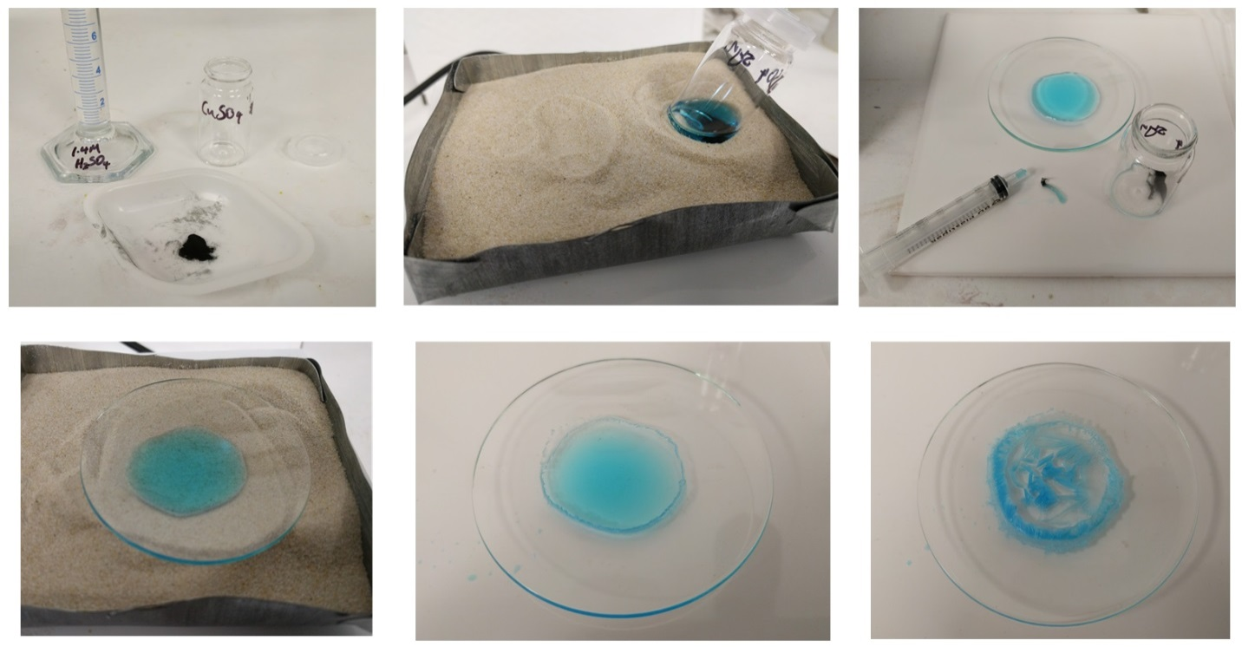
Figure 1 – Images from the trial

Results – Trial results
1. | Print and stick in a photo of your crystals and/or accurately sketch one of the crystals. [1 mark]
 | 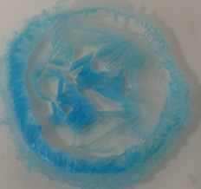

2. | pH measurements
 | before reaction: pH 1-2 | after reaction: 4-5

Extension opportunities
1. | Write the word equation, symbol equation and ionic equation for the reaction between copper oxide and sulfuric acid. Name the type of reaction occurring.  [5 marks]
copper oxide + sulfuric acid → copper sulfate + water
CuO(s) + H₂SO₄(aq) → CuSO₄(aq) + H₂O(l)
CuO(s) + 2H⁺(aq) → Cu²⁺(aq) + H₂O(l)
neutralisation reaction
the pH of the solution increased as the acid was neutralised by reaction with the copper oxide

2. | Using amount of substance calculations, show that copper oxide was in excess. Explain why this is preferable to having sulfuric acid in excess [6 marks]
amount of CuO: n = m / M_{r} = 0.20 / 79.5 = 2.5 × 10^{–3} mol
amount of H₂SO₄ : n = c × V = 1.4 × (1.5 / 1000) = 2.1 x 10^{–3} mol
reaction stoichiometry is 1 : 1
therefore CuO is in (molar) excess

3. | A student made 1.5 g of hydrated copper sulfate crystals (CuSO₄⋅5H₂O). Calculate the percentage by mass of copper in this substance, and hence the mass of copper present in the sample [4 marks]
M_{r}(CuSO₄⋅5H₂O) = 249.6
%(Cu in CuSO₄⋅5H₂O) = (63.5 / 249.6) × 100 = 25.4%
mass of copper in 1.5 g = 1.5 × 25.4% = 0.38 g

4. | Describe the equipment and methods you would use for making pure dry hydrated copper sulfate crystals on a larger scale [4 marks]
Any four suitable and safe steps – for example:
Calculate the mass of copper oxide and volume of sulfuric acid required
Heat the acid in a conical flask in a boiling water bath / with a Bunsen burner / electric heater
Add the copper oxide and stir until no further reaction occurs.
Filter the mixture through a filter paper in a funnel
Boil the mixture on a Bunsen burner / electric heater for 2-3 minutes
Pour the concentrated solution into a crystallising dish and allow to cool
After 24–48 hours, decant off any remaining liquid and allow the crystals to air dry.

Document updates
v1 November 2016 Published on qualification page
v1.1 January 2017 Consolidation of labelling and formatting of activities
v1.2 February 2017 Addition of pH measurement to practical and associated questions
v1.3 June 2021 Updated to meet digital accessibility standards

We’d like to know your view on the resources we produce. Click ‘Like’ or ‘Dislike’ to send us an auto generated email about this resource. Add comments if you want to. Let us know how we can improve this resource or what else you need. Your email will not be used or shared for any marketing purposes.
Looking for another resource? There is now a quick and easy search tool to help find free resources for your qualification.
OCR is part of Cambridge Assessment, a department of the University of Cambridge.
For staff training purposes and as part of our quality assurance programme your call may be recorded or monitored.
Oxford Cambridge and RSA Examinations is a Company Limited by Guarantee. Registered in England. Registered office
The Triangle Building, Shaftesbury Road, Cambridge, CB2 8EA. Registered company number 3484466. OCR is an exempt charity.
OCR operates academic and vocational qualifications regulated by Ofqual, Qualifications Wales and CCEA as listed
in their qualifications registers including A Levels, GCSEs, Cambridge Technicals and Cambridge Nationals.
OCR provides resources to help you deliver our qualifications. These resources do not represent any particular teaching method we expect you to use. We update our resources regularly and aim to make sure content is accurate but please check the OCR website so that you have the most up to date version. OCR cannot be held responsible for any errors or omissions in these resources.
Though we make every effort to check our resources, there may be contradictions between published support and the specification, so it is important that you always use information in the latest specification. We indicate any specification changes within the document itself, change the version number and provide a summary of the changes. If you do notice a discrepancy between the specification and a resource, please contact us.
© OCR 2021 - You can copy and distribute this resource freely if you keep the OCR logo and this small print intact and you acknowledge OCR as the originator of the resource.
OCR acknowledges the use of the following content: N/A
Whether you already offer OCR qualifications, are new to OCR or are thinking about switching, you can request more information using our Expression of Interest form.
Please get in touch if you want to discuss the accessibility of resources we offer to support you in delivering our qualifications.

Chemistry PAG 7: Production of salts

Combined Science PAG C4: Production of salts

Suggested Activity 2: Microscale copper sulfate synthesis

Learner Activity

Introduction
Many useful products in everyday life are salts, and can be synthesised and purified with simple chemistry. For example, hydrated copper sulfate can be used as a fungicide (controlling fungus on grapes), and an algicide (controlling algea in fish ponds). It is synthesised industrially by reacting copper with hot sulfuric acid. In the lab, it is safer to synthesise via the neutralisation of sulfuric(VI) acid with copper oxide.
In this activity, you will carry out a micro-scale synthesis and purification of hydrated copper sulfate. The reaction is relatively quick, and should allow you to go from black powder to blue crystals within one lesson.

Aims
To synthesise and purify hydrated copper sulfate.

Intended class time
30–40 minutes

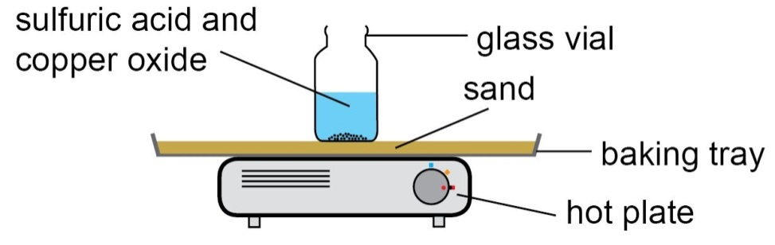
Figure 1: Producing copper sulfate with a sand bath

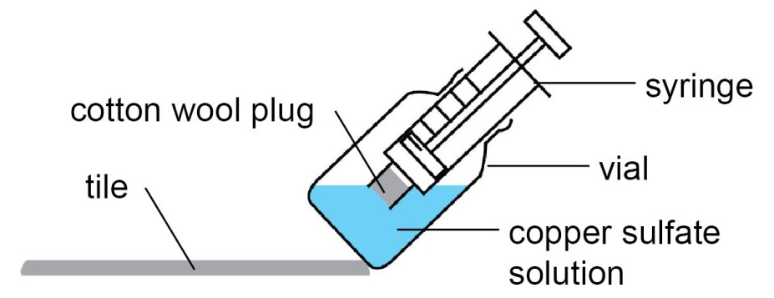

Figure 2: Purifying the copper sulfate by filtering

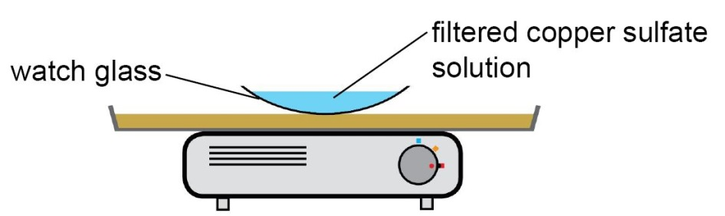

Figure 3: Purifiying the copper sulfate by evaporation and crystallisation.

Chemicals and equipment (per group)
- 1.4 mol/dm³ sulfuric(VI) acid (WARNING: causes skin and serious eye irritation)
- copper(II) oxide (WARNING: harmful if swallowed)
- universal indicator paper
- cotton wool
- dropping pipette
- forceps
- glass marker pen
- glass vial (c. 14 cm³)
- plastic syringe (2 or 5 cm³)
- timer
- watch glass (c. 5 cm)
- weighing boat
- white tile
- access to a camera / smartphone camera (optional)
- access to a mass balance (2 decimal places)
- access to a sand bath (baking tray of sand on a hot plate)

Health and Safety
- Eye protection should be worn at all times.
- Take care when transferring glassware to and from the sand bath – do not touch the sand.
- The product, copper sulfate, is harmful (WARNING: harmful if swallowed, causes skin and serious eye irritation) – dispose of as instructed by your teacher.

Method
- Using a dropping pipette, add 1.5 cm³ of sulfuric acid to a glass vial.
- Measure the pH of the acid with universal indicator paper.
- Weigh out 0.18–0.20 g of copper oxide in a weighing boat, and add to the acid.
- Place the vial in the sand-bath for 1–2 minutes (figure 1).
- The solution will turn blue with the formation of copper sulfate.

- Measure the pH of the solution with universal indicator paper.
- Remove the vial from the sand bath and allow to cool.
- Using forceps, place a small piece of cotton wool in the nozzle of a syringe.
‼ Make sure you don’t press the cotton wool all the way into the nozzle.

- Using a tile to help hold the vial at an angle, draw all of the reaction mixture up into the syringe through the cotton wool (figure 2)
- Remove the cotton wool, and carefully dispense the filtered solution into a watch glass.
- Using forceps, carefully place the watch glass on the sand bath (figure 3).
- Watch the solution carefully – when white solid appears at the edge of the solution remove the watch glass to a white tile.
‼ It is important not to evaporate too much solution on the sand-bath, otherwise you won’t get good quality crystals.

- Observe the solution over 5-10 minutes – if available, take a photo of your solution with a camera/smart phone for your records.

Results
1. | Print and stick in a photo of your crystals and/or accurately sketch one of the crystals.

2. | pH measurements
 | before reaction: | after reaction:

Extension opportunities
1. | Write the word equation, symbol equation and ionic equation for the reaction between copper(II) oxide and sulfuric(VI) acid. Name the type of reaction occurring and explain your evidence for this. [5 marks]

2. | Using amount of substance calculations, show that copper oxide was in excess. Use standard form and the appropriate number of significant figures in your answers. Explain why this is preferable to having sulfuric acid in excess [6 marks]

3. | A student made 1.5 g of hydrated copper sulfate crystals (CuSO₄⋅5H₂O). Calculate the percentage by mass of copper in this substance, and hence the mass of copper present in the sample. [4 marks]

4. | Describe a method for making hydrated copper sulfate crystals on a larger scale  [4 marks]

DfE Apparatus and Techniques covered
If you are using the OCR Practical Activity Learner Record Sheet (Chemistry / Combined Science) you may be able to tick off the following skills:

Chemistry |  |  |  |  | Combined Science
1–i | 1–ii | 1–iv | 2-ii |  | 1–iii | 1–iv | 1–vii | 1–ix
3–i | 3–ii | 4–i | 4–ii |  | 2-ii | 8–i | 8–ii | 9–i
4–iii | 6–i | 6–ii |  |  | 9–ii | 9–iii | 11–i | 11–ii

