Topic Exploration Pack

Atomic Structure and Radioactivity
Instructions and answers for teachers 2
Mapping to spec level 3
Introduction 4
Activity 1: Alpha 5
Activity 2: Beta 5
Activity 3: Gamma 6
Useful links: 6
Additional teacher preparation 7
Topic Exploration Pack 8
Atomic Structure and Radioactivity 8
Student Activity 8
Activity 1: Alpha 8
Activity 2: Beta 9
Activity 3: Gamma 10

Instructions and Answers for Teachers
These instructions cover the student activity section which can be found on page 8. This Topic Exploration Pack supports OCR GCSE (9–1) Twenty First Century Science Physics B.
When distributing the activity section to the students either as a printed copy or as a Word file you will need to remove the teacher instructions section.
123 – This activity offers an opportunity for maths skills development.
ABC – This activity offers an opportunity for English skills development.

Mapping to spec level
Learners will be required to:
P5.1.1. describe the atom as a positively charged nucleus surrounded by negatively charged electrons, with the nuclear radius much smaller than that of the atom and with almost all of the mass in the nucleus
P5.1.2. describe how and why the atomic model has changed over time to include the main ideas of Dalton, Thomson, Rutherford and Bohr
P5.1.3. recall the typical size (order of magnitude) of atoms and small molecules
P5.1.4. recall that atomic nuclei are composed of both protons and neutrons, and that the nucleus of each element has a characteristic positive charge
P5.1.5. recall that nuclei of the same element can differ in nuclear mass by having different numbers of neutrons, these are called isotopes
P5.1.6. use the conventional representation to show the differences between isotopes, including their identity, charge and mass
P5.1.7. recall that some nuclei are unstable and may emit alpha particles, beta particles, or neutrons, and electromagnetic radiation as gamma rays
P5.1.8. relate emissions of alpha particles, beta particles, or neutrons, and gamma rays to possible changes in the mass or the charge of the nucleus, or both
P5.1.9. use names and symbols of common nuclei and particles to write balanced equations that represent the emission of alpha, beta, gamma, and neutron radiations during radioactive decay
P5.1.10. explain the concept of half-life and how this is related to the random nature of radioactive decay
P5.1.11. calculate the net decline, expressed as a ratio, in a radioactive emission after a given (integral) number of half-lives
P5.1.12. interpret activity-time graphs to find the half-life of radioactive materials

Introduction
In most of the GCSE science courses, the structure of atoms is addressed only insofar as to consider the nuclei as stable and indivisible. While learners, especially those who have also been learning chemistry, and indeed to a lesser extent biology, will already have encountered examples of atoms losing and gaining electrons, but, as far as most of the other topics in the course are concerned, atomic nuclei might as well be as indivisible as the Greek origin of the word ‘atom’ suggests. Radioactivity was the first phenomenon that gave science an insight into the internal constitution of the nucleus itself, which in turn led to our modern understanding of the strong and weak nuclear forces, and more curious and advanced learners will certainly have questions about the nature of both radioactivity and the atom itself which cannot satisfactorily be answered without reference to them. Some have been dealt with, or at least referred to, in the main delivery guide, but it is always worth clarifying important points when dealing with topics at a conceptual level. Learners can be reminded that, when we describe particles and waves and matter and energy, we are, on a deeper level, only using analogies. We say that electron shells are made of separate electrons, but we mean that separate electrons are all you can put into and get out of them. Likewise, nucleons are themselves made of groups of quarks, which are only stable in certain arrangements.
Because of the nature of the topic, many more advanced experiments are not particularly safe in a classroom environment, and half-lives and models of decay rates should already have been dealt with sufficiently in the main body of the course, so the activities provided are of a largely qualitative nature, dealing with not only learners’ understanding of this area of the topic but also with their ability to research a topic and connect new information with what they have previously encountered to expand a relatively coherent picture of the phenomena being described.
They take the form of three related sets of questions, based around the three main types of radioactive decay; alpha, beta and gamma, which are of course very different from each other. Each activity has a choice between two or more questions, some of which naturally lend themselves to different approaches. The question of how to organise the learners’ responses is left to the discretion of the teacher. While some learners may enjoy thinking of them as essay questions, others will prefer an opportunity to create a project with visual representations or to get involved in a group discussion. Learners can be encouraged to research the topic themselves; their ability to bring in ideas they have encountered elsewhere in the course and outside is also called upon. Some useful source examples are given below, and references from the subtopic resources can be revisited if needed; these alone should provide enough material to compile a relatively interesting answer to one question in each activity.

Activity 1: Alpha
1(a) Why are big atomic nuclei less stable than smaller ones?
1(b) Why do helium nuclei (and all nuclei of heavier elements) need neutrons in order to be stable while hydrogen nuclei do not?
1(c) If alpha particles have such low energy that they can be stopped by human skin, why are alpha-emitters such as uranium considered dangerous?
1(d) If heavy elements are unstable, how did they get there in the first place?
1(e) What are protons and neutrons made of?
In the answers to these, look for an understanding of how the small-scale forces translate into the large-scale behaviour of nuclei, atoms and larger systems. The questions in each activity are almost paraphrases of each other; it can be noted that sometimes a single sentence can answer more than one question, but of course learners should be encouraged to expand on the topic. The answers to (c) and (d) are a little different; (c) is to do with the effect of ionising radiation on cells inside the body, and (d) requires at least a passing reference to nuclear fusion, stars and of course supernovae.

Activity 2: Beta
Research and produce a description of beta radiation that answers as many of the following questions as possible:
2(a) There are two types of beta radiation; usually called β- and β+. If a β- particle is an electron, what is a β+ particle?
2(b) Where are the electrons in an atom?
2(c) Normally, electrons happily orbit atomic nuclei, even if there are more or fewer of them than the proton number, so why do atoms sometimes spit out electrons at high energies?
2(d) What is a neutrino?
This should be an opportunity for more advanced learners to look into the range of particles that exist beyond the usual three or four mentioned in most science at this level, as well as to make connections with other areas, such as chemistry (part (b) is an ideal opportunity to look up electron orbitals and speculate on their effect on the properties of different elements).

Activity 3: Gamma
Research and produce a description of gamma radiation that answers as many of the following questions as possible:
3(a) Are gamma rays the same kind of thing as visible light? Are they produced by the same processes?
3(b) Usually we describe light as waves; sometimes it’s described as particles called photons. Electrons also behave like waves sometimes. What does that mean?
3(c) What does E=mc² mean?
3(d) Gamma rays are made of pure energy; they have no mass. Where in the atom was that energy before it was emitted?
This is the most conceptual of the activities; the ideas of wave/particle duality and energy/matter conversion are more or less explicitly asked for. Learners who come to this activity hoping to be able to regurgitate memorised phrases, though, should be disappointed; the idea is for the ‘what does x mean’ questions to stimulate them to think about the significance of the ideas in terms of understanding basic concepts in physics. Particularly when it comes to wave/particle duality, the jury is still very much out in terms of what it really means in any terms that aren’t abstract mathematics.

Useful links:
Gamma-rays | http://science.hq.nasa.gov/kids/imagers/ems/gamma.html | A brief recap on gamma rays and atmospheric absorption.
The Orbitron: a gallery of atomic orbitals and molecular orbitals | http://winter.group.shef.ac.uk/orbitron/AOs/1s/index.html | A really useful and interesting link; users should be encouraged to click on the various options on the left hand side; the lower ones have short animations depicting the deformation of various orbitals as atoms approach each other.
What’s a Proton, Anyway? | Of Particular Significance | https://profmattstrassler.com/articles-and-posts/largehadroncolliderfaq/whats-a-proton-anyway/ | An informative and amusing page about the difference between traditional representations of the inside of a proton and the reality that we know of.
Videos:
Your Mass is NOT From the Higgs Boson | https://www.youtube.com/watch?v=Ztc6QPNUqls | A Veritasium video making similar points to the ‘what’s a proton, anyway’ page, with added emphasis on mass.
The Electron: Crash Course Chemistry #5 | https://www.youtube.com/watch?v=rcKilE9CdaA | A video which mentions electron orbitals and their wave nature, with reference to the idea of their orbits as standing waves.
Nuclear Chemistry: Crash Course Chemistry #38 | https://www.youtube.com/watch?v=KWAsz59F8gA | Another video from the same source as the one above recapping what we know about radioactivity. Enthusiastic learners can be encouraged to follow the series on to the next video, which describes fission and fusion in more detail.
Creating the Elements - Sixty Symbols | https://www.youtube.com/watch?v=nhhdkYFmd7A | A video about how supernovae are needed to explain the natural occurrence of elements heavier than iron.

Additional teacher preparation
Preparation for these activities takes the form of whatever kind of research can be accessed, but some degree of group discussion is clearly useful before learners embark on the tasks. The idea is that various levels of complexity can be addressed, depending on how much depth learners want to go into, and of course the format of the responses/explanations can be decided depending on available time and resources and the preferences of the class.
We’d like to know your view on the resources we produce. By clicking on ‘Like’ or ‘Dislike’ you can help us to ensure that our resources work for you. When the email template pops up please add additional comments if you wish and then just click ‘Send’. Thank you.
If you do not currently offer this OCR qualification but would like to do so, please complete the Expression of Interest Form which can be found here: www.ocr.org.uk/expression-of-interest
OCR Resources: the small print
OCR’s resources are provided to support the teaching of OCR specifications, but in no way constitute an endorsed teaching method that is required by the Board, and the decision to use them lies with the individual teacher. Whilst every effort is made to ensure the accuracy of the content, OCR cannot be held responsible for any errors or omissions within these resources.
© OCR 2016 - This resource may be freely copied and distributed, as long as the OCR logo and this message remain intact and OCR is acknowledged as the originator of this work.
OCR acknowledges the use of the following content: Page 8 Crab Nebula, Appelleon/Shuitterstock.com
Please get in touch if you want to discuss the accessibility of resources we offer to support delivery of our qualifications: resources.feedback@ocr.org.uk

Topic Exploration Pack

Atomic Structure and Radioactivity

Student Activity

Activity 1: Alpha
Research and produce a description of alpha radiation that answers as many of the following questions as possible.
1(a) Why are big atomic nuclei less stable than smaller ones?

1(b) Why do helium nuclei (and all nuclei of heavier elements) need neutrons in order to be stable while hydrogen nuclei do not?

1(c) If alpha particles have such low energy that they can be stopped by human skin, why are alpha-emitters such as uranium considered dangerous?

1(d) If heavy elements are unstable, how did they get there in the first place?

1(e) What are protons and neutrons made of?

Activity 2: Beta
Research and produce a description of beta radiation that answers as many of the following questions as possible.
2(a) There are two types of beta radiation; usually called β- and β+. If a β- particle is an electron, what is a β+ particle?

2(b) Where are the electrons in an atom?

2(c) Normally, electrons happily orbit atomic nuclei, even if there are more or fewer of them than the proton number, so why do atoms sometimes spit out electrons at high energies?

2(d) What is the weak nuclear force?

Activity 3: Gamma
Research and produce a description of gamma radiation that answers as many of the following questions as possible.
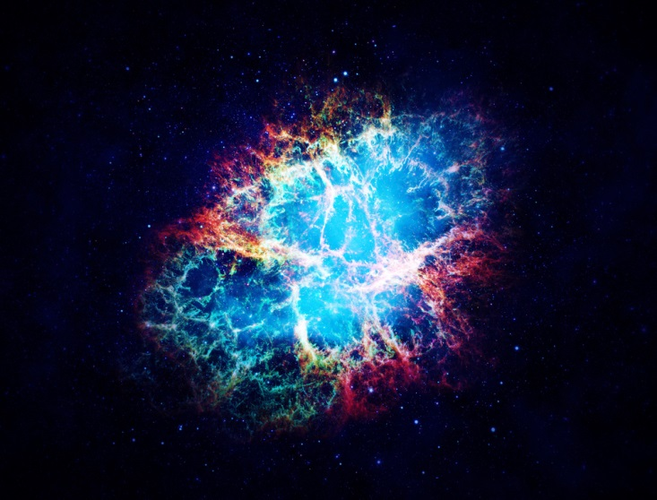
OCR acknowledges the use of this image: Crab Nebula, Appelleon/Shuitterstock.com

3(a) Are gamma rays the same kind of thing as visible light? Are they produced by the same processes?

3(b) Usually we describe light as waves; sometimes it’s described as particles called photons. Electrons also behave like waves sometimes. What does that mean?

3(c) What does E=mc² mean?

3(d) Gamma rays are made of pure energy; they have no mass. Where in the atom was that energy before it was emitted?

