Lesson Element

Unit R091: Designing a game concept

Creating visualisations for a digital game

Instructions and answers for tutors

These instructions cover the learner activity section which can be found on page 9. This Lesson Element supports Cambridge Nationals Level 1/2 in Creative iMedia.
When distributing the activity section to the learners either as a printed copy or as a Word file you will need to remove the tutor instructions section.

Suggested timings
Task 1 – 30 minutes
Task 2 – 30 minutes
Task 3 – 45 minutes
Task 4 – 45 minutes

This lesson element aims to develop skills in creating visualisation diagrams for a new game proposal and provides opportunities to apply what may already have been learned in R081. The visualisation diagrams will need to give the viewer an idea of what the game screens will look like for the player. When these are combined with a description of the new game, the reader of the game proposal should then have a clear idea in their mind what the game will look like and what the player will have to do in the game.

WORK – This activity offers an opportunity for work experience.
123 – This activity offers an opportunity for maths skills development.
ABC – This activity offers an opportunity for English skills development.

Teacher instructions: Activity 1
Expected duration: 30 minutes
Teachers could explain and demonstrate the options available for creating visualisation diagrams, an example that is in a suitable context for this unit is shown below.
50
BONUS
SPEED: 30
DISTANCE: 250m

To support the explanation, teachers could include both physical examples of visualisation diagrams (i.e. by combining pictures, hand drawn images and text on a sheet of paper) together with digital versions (e.g. combining digital images and text in a software application).
The teacher should clarify the difference between a mood board and a visualisation diagram in the context of this unit (as shown below) and refer back to pre-production R081 if applicable:
Mood board: may contain examples of game screen elements and similar games but does not illustrate the layout of a screen for a new game.
Visualisation diagram: Must illustrate what the game screen is intended to look like.
The teacher could identify examples of suitable software, which may include word processing, desktop publishing, presentation and image editing.
Teacher notes: The learners could be separated into groups so that they can discuss ideas for two components of a new game as shown in the following list. The ideas can be based on the game scenario supplied.
- A game character.
- A game environment.
Learners will make their own individual notes on what their character and environment may look like. Note that creating the visualisations for these is covered by the following activities so a clear idea of what they want to produce is all that is needed at this stage.
Game scenario:
Ideas for a fun and entertaining game is required that is based on a favourite pet that is in a cityscape maze. The object of the game is for the pet to find the food and avoid any predators. Character designs can be produced for the pet and/or the predators, which can take any form (even an alien). The cityscape maze can include roads and buildings, which can be 2D or 3D.

Teacher instructions: Activity 2
Expected duration: 30 minutes
In this activity learners will create a physical visualisation diagram such as one drawn by hand. The suggestion is to sketch one of the game characters, whether for the player (pet) or a non-player character (predator). Colour could be added to the character once an outline has been drawn.
Teachers Note: learners don’t have to be good artists and drawing skills are not assessed in the unit. It is the concepts that are important. However, feedback can be given to assist learning.

Teacher instructions: Activity 3
Expected duration: 45 minutes
This activity is based on creating digital versions of visualisation diagrams. In this task learners could create their diagrams using software applications. This first activity looks at creating a game start screen in PowerPoint. Once a basic template has been produced learners could modify this to create additional visualisations of different game elements, such as:
- Game settings menu.
- Examples of the game environment.
The second example also provides opportunities to show how images and photographs can be used as a background for the game. This can be created in presentation software by importing a picture and using it as the background.
Examples of software to create the visualisation diagrams may include word processing, desktop publishing, presentation and image editing. However, for the purposes of this activity presentation software is being used. Note that this process can be simplified if needed to create a more basic menu screen.
Process of creating the game screen as shown:
- Start PowerPoint software.
- From the file menu, select ‘New’ – ‘Blank presentation’.
Select ‘home’ tab – ‘Layout’ – blank (this should leave a completely blanks slide).
- Select ‘Insert’ tab – ‘Shape’ –‘Rounded rectangle’. Click and draw inside the slide, near the middle as shown.
Format – shape fill – blue.
- Format – Shape effects – preset 2 (this is in Office 365 – alternative 3D styles may be used).
- Right click on the shape – edit text - type “New game”.
Select the shape (mouse click) On the ‘Ribbon’ – select ‘Copy’ (or use CTRL + C).
- On the ‘Ribbon’ – select ‘Paste’ (or use CTRL + V) to create four additional shapes that are identical.
Drag and drop the shapes to align them as required on the slide layout.
- Click inside the text on each shape to edit the words. Use the titles as shown for Options, Player 1, Player 2 and Exit.
- Design tab – Ribbon - Format background – Gradient fill – shade from title (a basic solid fill could also be used) and then ‘apply to all’.
- Insert tab – Word Art – select style – enter text “Maze Chaser!” and position at the top
Format tab – Shape effects – preset 2 (this is in Office 365 – alternative 3D styles may be used).
- Save the file using a suitable name eg Game menu version 1.ppt.
The result of this ‘how to’ guide is shown below.
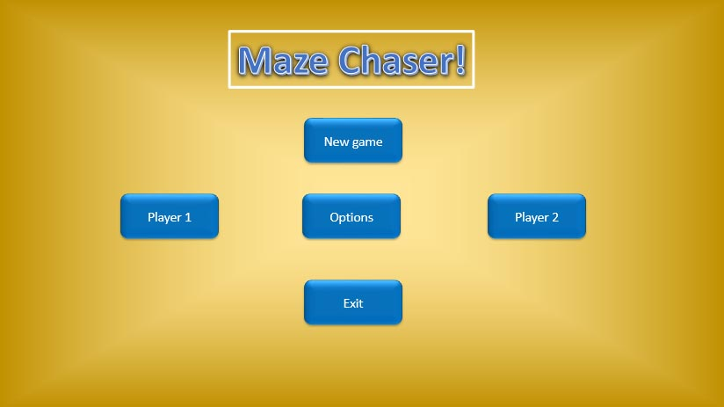

Teacher instructions: Activity 4
Expected duration: 45 minutes
This second digital activity looks at creating a game play screen in Photoshop although alternative image editing software could also be used but the tools and techniques may be slightly different. This activity will show how images and photographs can be used as a background for the game.

The process of creating the game environment scene in Adobe Photoshop:
- In the ‘File’ menu – select ‘New’ – ‘Web’ (640 × 480 pixels).
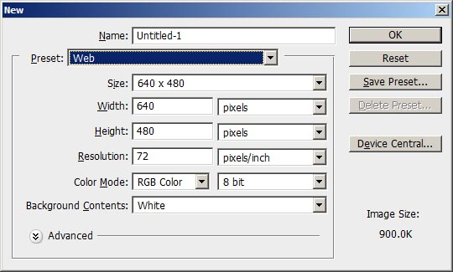
- Choose the ‘Type’ tool (T) Set the font size to 36pt, click in the top left and enter “Time: 17s”. Repeat at the top right for the score.
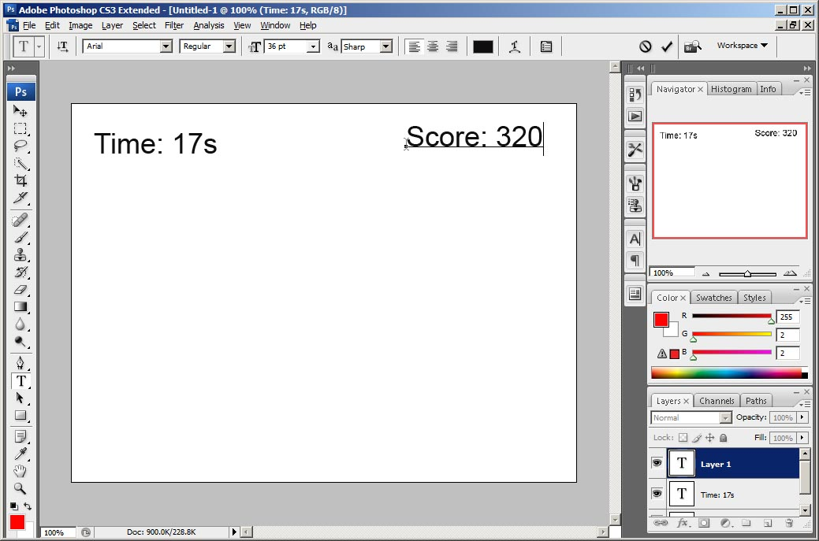
- Chose the ‘Move’ tool and align both text boxes.
- Create a new layer in the layer stack.
- Select the ‘Marquee’ tool and draw a rectangle all the way across the bottom of the image.
- Select the foreground colour box and select a dark green (other colours can be used).
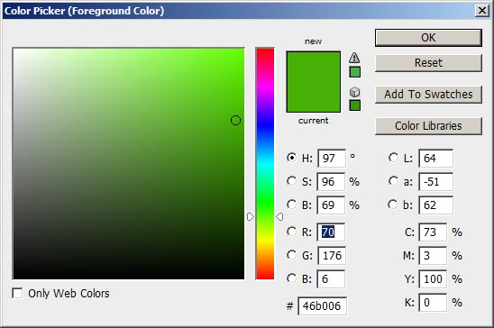
- Select the ‘Paint bucket’ tool and click inside the dotted box, this will fill it with the chosen colour.
- Repeat this process with the marquee tool to create a smaller box in the middle and fill with blue.
- Select the ‘Type’ tool and click inside the smaller box, change the text colour to white and point size to 24. Enter the word “Map”.
- Use the type tool again in the bottom left hand corner and enter “Speed: 30”.
- Use the type tool again in the bottom right hand corner and enter “Information area”.
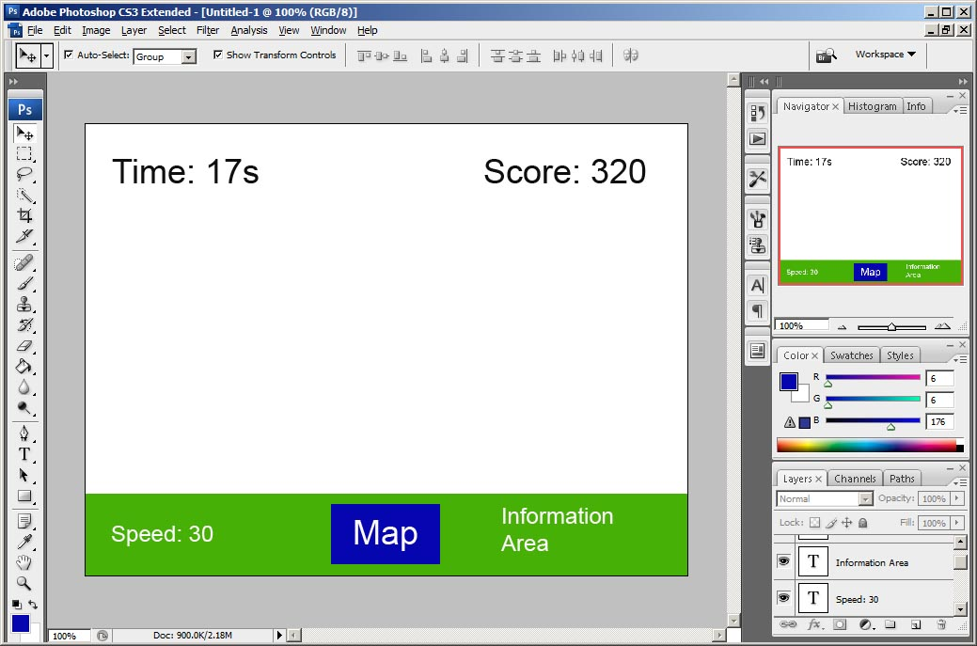
- Select the ‘Custom shape tool’. In the options bar, select the registration target 1 and change the colour to red. Draw a target at the required size in the middle of the image.
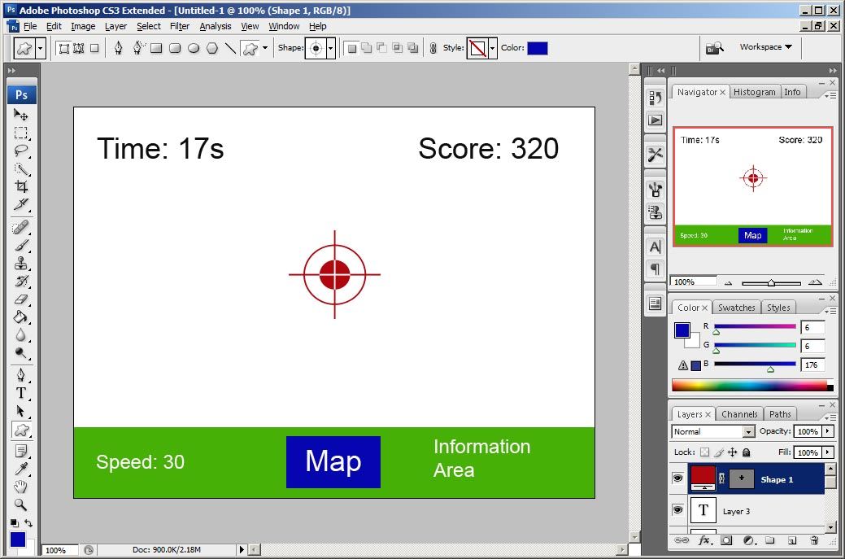
- Save your image file using a suitable name eg Game scene layout version 1.
- Open an image or photograph of a town or city ideally with a road or path (you can also use any other image that will be the game environment). Crop the image to be 640 x 480 pixels. This is best done by using the ‘Crop’ tool and enter the sizes in the options bar ie Width 640 px, Height 480 px, resolution can be set to 72 or 96 dpi.
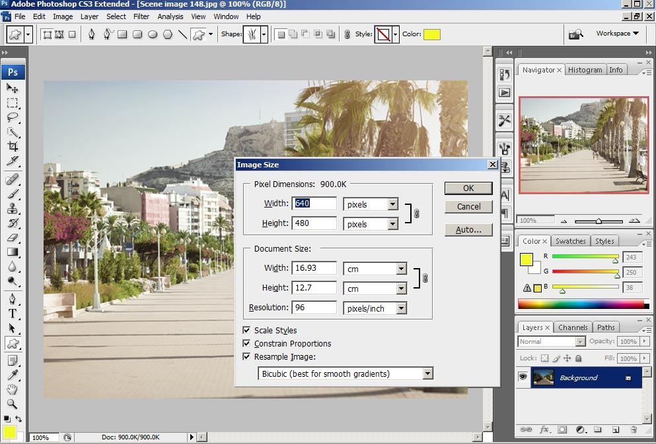
- Drag this background image onto a new layer in the game scene. Depending on what background image is used, you may need to change the colours of the text and registration target (for example, this can be done by selecting the text tool and text layer, then changing the colour in the options bar).
- Re-save with a new name eg Game scene 1 version 1.
The final image may look like this:
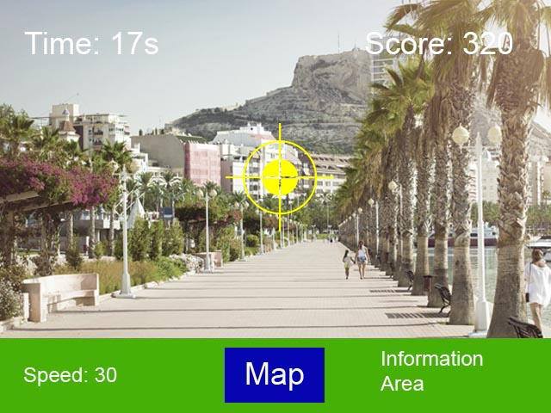
Time permitting, the teacher could then suggest that learners create some additional game scenes with different pictures. If so, these could be numbered as game scenes 2, 3, 4 etc.

OCR Resources: the small print
OCR’s resources are provided to support the delivery of OCR qualifications, but in no way constitute an endorsed teaching method that is required by the Board, and the decision to use them lies with the individual teacher. Whilst every effort is made to ensure the accuracy of the content, OCR cannot be held responsible for any errors or omissions within these resources.
© OCR 2016 - This resource may be freely copied and distributed, as long as the OCR logo and this message remain intact and OCR is acknowledged as the originator of this work.
OCR acknowledges the use of the following content: Adobe product screenshot(s) reprinted with permission from Adobe Systems Incorporated. Spanish avenue: chasdesign/Shutterstock.com
Please get in touch if you want to discuss the accessibility of resources we offer to support delivery of our qualifications: resources.feedback@ocr.org.uk
We’d like to know your view on the resources we produce. By clicking on ‘Like’ or ‘Dislike’ you can help us to ensure that our resources work for you. When the email template pops up please add additional comments if you wish and then just click ‘Send’. Thank you.
Whether you already offer OCR qualifications, are new to OCR, or are considering switching from your current provider/awarding organisation, you can request more information by completing the Expression of Interest form which can be found here: www.ocr.org.uk/expression-of-interest
Looking for a resource? There is now a quick and easy search tool to help find free resources for your qualification:
www.ocr.org.uk/i-want-to/find-resources/

Lesson Element:
Creating visualisations for a digital game

Learner Activity 1
Your teacher will explain the purpose and uses of visualisation diagrams for developing game concepts.
This will include both physical examples (i.e. by combining pictures, hand drawn images and text on a sheet of paper) together with digital versions (e.g. combining digital images and text in a software application).
You will learn some examples of software that could be used, including word processing, desktop publishing, presentation and image editing.
You may be able to experiment with the tools in some of these software applications to help decide what you will want to use later on.
Your task will be to work together with others and generate ideas on characters and game environments for the following.
Game scenario:
Ideas for a fun and entertaining game is required that is based on a favourite pet that is in a cityscape maze. The object of the game is for the pet to find the food and avoid any predators. Character designs can be produced for the pet and/or the predators, which can take any form (even an alien). The cityscape maze can include roads and buildings, which can be 2D or 3D.
Think about what sort of pet you would base your game on and what they might look like. What type of predator character would you choose? Would it be a normal animal, mutant or alien? Make some notes on type, style, colour and any special features. You could also produce ideas for the cityscape maze. Note that you are not yet creating your visualisation diagrams but you should have a clear idea of what you want to produce at the end of this stage.

Learner Activity 2
In this activity you will create a visualisation diagram of one character based on your ideas created in the previous activity. The character can be drawn by hand but keep in mind that you don’t have to be a good artist – it is the concepts that are important so don’t worry if you can’t draw very well.
You could choose to draw:
- The player character, which is a favourite pet.
- A non-player character such as a predator.
Once you have created the basic outline, try adding some colour to make it stand out.

Learner Activity 3
In this next activity you will create digital versions of visualisation diagrams using software applications.
To begin, you will create an example of a game start screen although your teacher may add some extra examples as well. The game here is called Maze Chaser! which has been created in PowerPoint. Your teacher will guide you with the tools and techniques needed.
The process of creating the game screen is as follows:
- Start PowerPoint software.
- From the file menu, select ‘New’ – ‘Blank presentation’.
- Select ‘home’ tab – ‘Layout’ – blank (this should leave a completely blanks slide).
- Select ‘Insert’ tab – ‘Shape’ –‘Rounded rectangle’. Click and draw inside the slide, near the middle as shown.
- Format – shape fill – blue.
- Format – Shape effects – preset 2 (this is in Office 365 – alternative 3D styles may be used).
- Right click on the shape – edit text – type “New game”.
- Select the shape (mouse click) On the ‘Ribbon’ – select ‘Copy’ (or use CTRL + C).
- On the ‘Ribbon’ – select ‘Paste’ (or use CTRL + V) to create four additional shapes that are identical.
- Drag and drop the shapes to align them as required on the slide layout.
- Click inside the text on each shape to edit the words. Use the titles as shown for Options, Player 1, Player 2 and Exit.
- Design tab – Ribbon - Format background – Gradient fill – shade from title (a basic solid fill could also be used) and then ‘apply to all’.
- Insert tab – Word Art – select style – enter text “Maze Chaser!” and position at the top.
Format tab – Shape effects – preset 2 (this is in Office 365 – alternative 3D styles may be used).
- Save the file using a suitable name eg Game menu version 1.ppt.
The result of this ‘how to’ guide is shown below.

Learner Activity 4
This second digital activity looks at creating a game play screen in Photoshop although alternative image editing software could also be used but the tools and techniques may be slightly different. This activity will show how images and photographs can be used as a background for the game. Later on, you could use some of your own photographs as a background scene for the game.
In this activity you will be using image editing software application. Your teacher will help you with what tools and techniques you will need.
- In the ‘File’ menu – select ‘New’ – ‘Web’ (640 × 480 pixels).
- Choose the ‘Type’ tool (T) Set the font size to 36pt, click in the top left and enter “Time: 17s”. Repeat at the top right for the score.

- Choose the ‘Move’ tool and align both text boxes.
- Create a new layer in the layer stack.
- Select the ‘Marquee’ tool and draw a rectangle all the way across the bottom of the image.
- Select the foreground colour box and select a dark green (other colours can be used).
- Select the ‘Paint bucket’ tool and click inside the dotted box, this will fill it with the chosen colour.
- Repeat this process with the marquee tool to create a smaller box in the middle and fill with blue.
- Select the ‘Type’ tool and click inside the smaller box, change the text colour to white and point size to 24. Enter the word “Map”.
- Use the type tool again in the bottom left hand corner and enter “Speed: 30”.
- Use the type tool again in the bottom right hand corner and enter “Information area”.
- Select the ‘Custom shape tool’. In the options bar, select the registration target 1 and change the colour to red. Draw a target at the required size in the middle of the image.
- Save your image file using a suitable name eg Game scene layout version 1.
- Open an image or photograph of a town or city ideally with a road or path (you can also use any other image that will be the game environment). Crop the image to be 640 × 480 pixels. This is best done by using the ‘Crop’ tool and enter the sizes in the options bar ie Width 640 px, Height 480 px, resolution can be set to 72 or 96 dpi.

- Drag this background image onto a new layer in the game scene. Depending on what background image is used, you may need to change the colours of the text and registration target (for example, this can be done by selecting the text tool and text layer, then changing the colour in the options bar).
- Re-save with a new name eg Game scene 1 version 1.

Your final image may look like this:

Your teacher might suggest that you create some additional game scenes with different pictures. If so, these could be numbered as game scenes 2, 3, 4 etc.

