Chemistry PAG 6: Titration

Suggested Activity 1: Titration of sodium hydroxide with hydrochloric acid

Instructions and answers for teachers
and technicians
These instructions cover the learner activity section which can be found on page 13. This Practical activity supports OCR GCSE Chemistry.
This is a suggested practical activity that can be used as part of teaching the GCSE (9-1) Gateway Science (A) and Twenty First Century Science (B) specifications.
These are not controlled assessment tasks, and there is no requirement to use these particular activities.
You may modify these activities to suit your learners and centre. Alternative activities are available from, for example, Royal Society of Biology, Royal Society of Chemistry, Institute of Physics, CLEAPSS and publishing companies, or of your own devising.
Further details are available in the specifications (Practical Skills Topics), and in these videos.

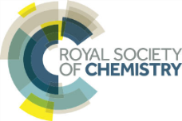 | This resource is adapted from the Practical Chemistry project, developed by the Nuffield Foundation and the Royal Society of Chemistry – http://www.rsc.org/learn-chemistry/collections/experimentation/practical-chemistry specifically the practical ‘Titrating sodium hydroxide with hydrochloric acid’ http://www.rsc.org/learn-chemistry/resource/res00000697/titrating-sodium-hydroxide-with-hydrochloric-acid.

OCR recommendations:
Before carrying out any experiment or demonstration based on this guidance, it is the responsibility of teachers to ensure that they have undertaken a risk assessment in accordance with their employer’s requirements, making use of up-to-date information and taking account of their own particular circumstances. Any local rules or restrictions issued by the employer must always be followed.
CLEAPSS resources are useful for carrying out risk-assessments: (http://science.cleapss.org.uk).
Centres should trial experiments in advance of giving them to learners. Centres may choose to make adaptations to this practical activity, but should be aware that this may affect the Apparatus and Techniques covered by the learner.

Introduction
In this activity, learners will practice their titration technique by titrating acid against alkali of known concentration, then against a sample of alkali of unknown concentration.
It is suggested that prior technique practice with the glassware is carried out using distilled water before titration with acids/alkalis are carried out.
Additionally, the suggested activity PAG7.1 The Vinegar Dilemma could be used to introduce the ideas behind titration before tackling volumetric titration here.

DfE Apparatus and Techniques covered
The codes used below match the OCR Practical Activity Learner Record Sheet (Chemistry / Combined Science) and Trackers (Chemistry / Combined Science) available online. There is no requirement to use these resources.
By doing this experiment, learners have an opportunity to develop the following skills:
1 [1]: Use of appropriate apparatus to make and record a range of measurements accurately, including: iv [vi]) volume of liquids
3 [8]: Use of appropriate apparatus and techniques for: ii) conducting and monitoring chemical reactions, including appropriate reagents and/or techniques for the measurement of pH in different situations
6 [11]: Safe use and careful handling of gases, liquids and solids, including: i) careful mixing of reagents under controlled conditions; ii) using appropriate apparatus to explore chemical changes and/or products
8: Use of appropriate qualitative reagents and techniques to analyse and identify unknown samples or products including; iv) the determination of concentrations of strong acids and strong alkalis

Aims
To determine the concentration of a sample of sodium hydroxide

Intended class time
45-60 minutes

Links to Specifications:

Gateway Science (Suite A) – including Working Scientifically (WS)
C3.3e recognise that aqueous neutralisation reactions can be generalised to hydrogen ions reacting with hydroxide ions to form water
C3.3h recall that relative acidity and alkalinity are measured by pH
C3.3i describe neutrality and relative acidity and alkalinity in terms of the effect of the concentration of hydrogen ions on the numerical value of pH (whole numbers only)
C3.3j recall that as hydrogen ion concentration increases by a factor of ten the pH value of a solution decreases by a factor of one
C3.3k describe techniques and apparatus used to measure pH
C5.1b describe the technique of titration
C5.1c explain the relationship between the volume of a solution of known concentration of a substance and the volume or concentration of another substance that reacts completely together
CM5.1ii provide answers to an appropriate number of significant figures
CM5.1iii covert units where appropriate particularly from mass to moles
CM5.1iv arithmetic computation, ratio, percentage and multistep calculations permeates quantitative chemistry
CM5.1vi change the subject of a mathematical equation
WS1.3a presenting observations and other data using appropriate methods
WS1.3c carrying out and representing mathematical and statistical analysis
WS1.3e interpreting observations and other data
WS1.3g evaluating data in terms of accuracy, precision, repeatability and reproducibility
WS1.4a use scientific vocabulary, terminology and definitions
WS1.4b recognise the importance of scientific quantities and understand how they are determined
WS1.4c use SI units and IUPAC chemical nomenclature unless inappropriate
WS1.4e interconvert units
WS1.4f use an appropriate number of significant figures in calculation
WS2a carry out experiments
WS2b make and record observations and measurements using a range of apparatus and methods
WS2c presenting observations using appropriate methods to include descriptive, tabular diagrammatic and graphically

Twenty First Century Science (Suite B) – including Ideas about Science (IaS)
C5.4.3 explain how the concentration of a solution in mol/dm³ is related to the mass of the solute and the volume of the solution and calculate the molar concentration using the formula
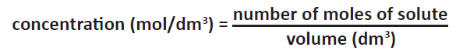
C5.4.4 describe neutralisation as acid reacting with alkali to form a salt plus water including the common laboratory acids hydrochloric acid, nitric acid and sulfuric acid and the common alkalis, the hydroxides of sodium, potassium and calcium.
C6.1.4 recall that relative acidity and alkalinity are measured by pH including the use of universal indicators and pH meters
C6.1.5 use and explain the terms dilute and concentrated (amount of substance) and weak and strong (degree of ionisation) in relation to acids including differences in reactivity with metals and carbonates
C6.1.6 use the idea that as hydrogen ion concentration increases by a factor of ten the pH value of a solution decreases by one
C6.1.7 describe neutrality and relative acidity and alkalinity in terms of the effect of the concentration of hydrogen ions on the numerical value of pH (whole numbers only)
IaS1.3 recognise the importance of scientific quantities and understand how they are determined.
IaS1.8 use appropriate scientific vocabulary, terminology and definitions to communicate the rationale for an investigation and the methods used using diagrammatic, graphical, numerical and symbolic forms.
IaS2.1. present observations and other data using appropriate formats
IaS2.2. when processing data use SI units where appropriate (e.g. kg, g, mg; km, m, mm; kJ, J) and IUPAC chemical nomenclature unless inappropriate
IaS2.3. when processing data use prefixes (e.g. tera, giga, mega, kilo, centi, milli, micro and nano) and powers of ten for orders of magnitude
IaS2.5. when processing data interconvert units
IaS2.6. when processing data use an appropriate number of significant figures
IaS2.8. when analysing data identify patterns/trends, use statistics (range and mean) and obtain values from a line on a graph (including gradient, interpolation and extrapolation),
IaS2.9. in a given context evaluate data in terms of accuracy, precision, repeatability and reproducibility, identify potential sources of random and systematic error, and discuss the decision to discard or retain an outlier
IaS2.11. in a given context interpret observations and other data (presented in diagrammatic, graphical, symbolic or numerical form) to make inferences and to draw reasoned conclusions, using appropriate scientific vocabulary and terminology to communicate the scientific rationale for findings and conclusions

Mathematical Skills covered
M1a Recognise and use expressions in decimal form
M1c Use ratios, fractions and percentages
M2a Use an appropriate number of significant figures
M2b Find arithmetic means
M2f Understand the terms mean, mode and median
M3a Understand and use the symbols: =, <, <<, >>, >, ∝, ~
M3b Change the subject of an equation
M3c Substitute numerical values into algebraic equations using appropriate units for physical quantities
M3d Solve simple algebraic equations

Technical Requirements – PER GROUP

Chemicals (per group)
Identity | Approximate quantity required or produced PER GROUP | Hazard information |  |  | Risk information
0.400 mol dm^{–3} aqueous hydrochloric acid, HCl(aq) | c. 300 cm³ | Currently not classified as hazardous at this concentration
0.400 mol dm⁻³ aqueous sodium hydroxide, NaOH(aq) | c. 100 cm³ |  |  | WARNING  Causes skin irritation and serious eye irritation
0.300 mol dm⁻³ aqueous sodium hydroxide, NaOH(aq)  Label as:  Sample A (PAG 6.1) | c. 100 cm³ |  | WARNING  Causes skin irritation and serious eye irritation

Equipment (per group) – either all larger volume apparatus or all smaller volume apparatus
- burette (25 or 50 cm³)
- pipette (10 or 25 cm³) and filler
- conical flask (100 or 250 cm³)
- beaker × 5 (100 cm³)
- small (filter) funnel (about 4 cm diameter)
- white tile or a piece of white paper
- stand
- burette clamp
- methyl orange indicator solution (dropper bottle) (DANGER: Toxic)
- phenolphthalein indicator solution (dropper bottle) (WARNING: Flammable)

Health and Safety
Eye protection should be worn at all times.
Burettes and pipettes are fragile glassware – inexperienced and rough handing can lead to very sharp broken glassware and potential for injury. Ensure learners are well trained and supervised.

Method
Learners will practice their titration technique by titrating 0.400 mol/dm³ hydrochloric acid against 0.400 mol/dm³ sodium hydroxide, with the expectation that their mean titre value is very close to the volume of sodium hydroxide used.
They will then carry out titration of 0.300 mol/dm³ sodium hydroxide as a solution of unknown concentration, to give them real data to process.
This method could be extended to include other strong acids or alkalis such as sulfuric acid or potassium hydroxide.

Images from the trial
The experimental setup | 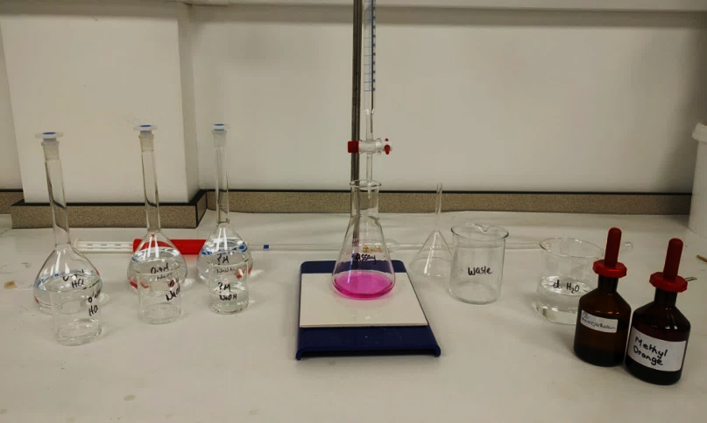
Taking readings from the burette | 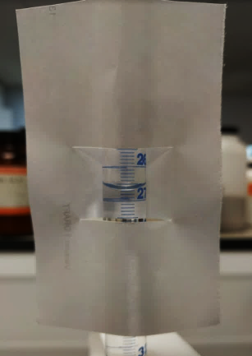
Phenolphtalein indicator in alkali, at the end point and in acidic solutions. | 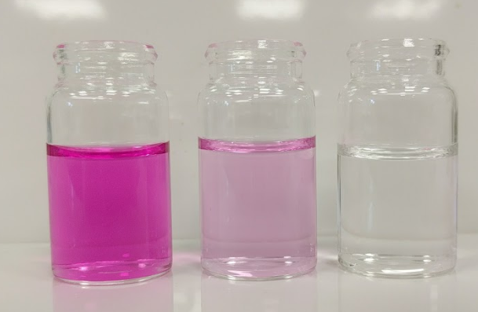
Methyl orange indicator in alkali, at the end point and in acidic solutions | 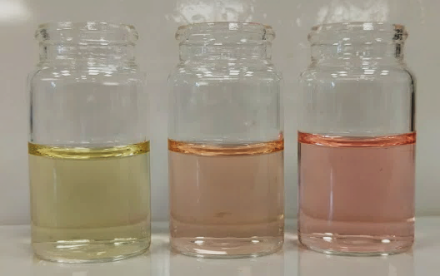

Analysis of results – Trial results
Stage 2
Titre | Example | Rough | 1 | 2 | 3 | 4
final volume (cm³) | 24.50 | 26.30 | 25.10 | 25.65 | 25.20
initial volume (cm³) | 1.55 | 0.10 | 0.10 | 0.15 | 0.10
titre (cm³) | 22.95 | 26.20 | 25.00 | 25.50 | 25.10
use in mean titre (/ X) | X | X |  | X

1. | Calculate the mean titre from your concordant titres. [2 marks]
 |  | Mean titre = V(HCl) = = 25.05 cm³ (correct answer given to 2 decimal places)
2. | Calculate the number of moles of hydrochloric acid used in your titration. [2 marks]
number of moles = concentration × titre =
n(HCl) = c(HCl) × V(HCl) = 0.400 × = 0.0100 mol (correct answer given to 3 significant figures)

3. | Calculate the number of moles of sodium hydroxide in your sample. [1 mark]
 |  | As one mole of HCl reacts with one mole of NaOH, n(NaOH) = 0.0100 mol
4. | Calculate the concentration of the sodium hydroxide. [2 marks]
 |  | c(NaOH) = == = 0.400 mol/dm³

Stage 3

Titre | Example | Rough | 1 | 2 | 3 | 4
final volume (cm³) | 24.50 | 20.20 | 18.95 | 37.75 | 19.05
initial volume (cm³) | 1.55 | 0.15 | 0.20 | 18.95 | 0.10
titre (cm³) | 22.95 | 20.05 | 18.75 | 18.80 | 18.95
use in mean titre (/ X) | X | X |  |  | X

1. | Calculate the mean titre from your concordant titres. [2 marks]
 |  | Mean titre = V(HCl) = = 18.78 cm³ (correct answer given to 2 decimal places)
2. | Calculate the number of moles of hydrochloric acid used in your titration. [2 marks]
number of moles = concentration × titre =
n(HCl) = c(HCl) × V(HCl) = 0.400 × = 0.00751 mol (correct answer given to 3 significant figures)

3. | Calculate the number of moles of sodium hydroxide in your sample. [1 mark]
 |  | As one mole of HCl reacts with one mole of NaOH, n(NaOH) = 0.00751 mol
4. | Calculate the concentration of the sodium hydroxide. [2 marks]
 |  | c(NaOH) = == = 0.300 mol/dm³

Extension opportunities
1. | Write word, symbol and ionic equations for the reaction between hydrochloric acid and sodium hydroxide. [3 marks]
Word hydrochloric acid + sodium hydroxide → sodium chloride + water
Symbol HCl (aq) + NaOH(aq) → NaCl(aq) + H₂O(l)
Ionic H⁺(aq) + OH–(aq) → H₂O(l)

2. | Describe how replacing hydrochloric acid with sulfuric acid (H₂SO₄) of the same concentration would affect your results. [2 marks]
 |  | Sulfuric acid produces two moles of hydrogen ions per mole compared to one mole of hydrogen ions per mole for hydrochloric acid therefore sulfuric acid titres would be half those of hydrochloric acid .
3. | Explain why you carry out a rough titration. [2 marks]
 |  | A rough titration allows you to quickly check that you can carry out the titration (i.e. reach the end-point) with the concentrations and volumes of solutions chosen and prevents the need to add the total volume of the acid drop-by-drop .
4. | Explain the purpose of carrying out repeated titrations until you obtain concordant results. [3 marks]
 |  | Concordant results are needed to ensure that an accurate mean final titre volume can be calculated which minimises the effect of random errors .

Document updates
v1.1 January 2017 Original - published on qualification page
We’d like to know your view on the resources we produce. By clicking on ‘Like’ or ‘Dislike’ you can help us to ensure that our resources work for you. When the email template pops up please add additional comments if you wish and then just click ‘Send’. Thank you.
If you do not currently offer this OCR qualification but would like to do so, please complete the Expression of Interest Form which can be found here: www.ocr.org.uk/expression-of-interest
Looking for a resource? There is now a quick and easy search tool to help find free resources for your qualification:
www.ocr.org.uk/i-want-to/find-resources/
OCR Resources: the small print
This formative assessment resource has been produced as part of our free GCSE teaching and learning support package. All the GCSE teaching and learning resources, including delivery guides, topic exploration packs, lesson elements and more are available on the qualification webpages.
If you are looking for examination practice materials, you can find Sample Assessment Materials (SAMs) on the qualification webpages: here

OCR’s resources are provided to support the teaching of OCR qualifications, but in no way constitute an endorsed teaching method that is required by the Board, and the decision to use them lies with the individual teacher. Whilst every effort is made to ensure the accuracy of the content, OCR cannot be held responsible for any errors or omissions within these resources.
© OCR 2017, © Royal Society of Chemistry/Nuffield Foundation – this resource may freely copied and distributed by teachers for teaching purposes, student assessment and private use and by students for private use only. The OCR logo, this message and the notice of Content from the Royal Society of Chemistry/Nuffield Foundation must remain intact.
OCR acknowledges the use of the following content: http://www.rsc.org/learn-chemistry/resource/res00000697/titrating-sodium-hydroxide-with-hydrochloric-acid.
Please get in touch if you want to discuss the accessibility of resources we offer to support delivery of our qualifications: resources.feedback@ocr.org.uk

Chemistry PAG 6: Titration

Suggested Activity 1: Titration of sodium hydroxide with hydrochloric acid

Learner Activity

Introduction
Titration is a quantitative analytical technique that allows you to accurately determine the concentration of an acidic or alkaline solution. For example, acid of known concentration is added to a known volume of alkali (of unknown concentration) until an acid-base indicator changes colour. With the volume and concentration of the acid now known, and the volume of the alkali known, the concentration of the alkali can be worked out mathematically.
In this activity you will first practice your titration technique by confirming the concentration of a sample of 0.400 mol/dm³ sodium hydroxide using 0.400 mol/dm³ hydrochloric acid, using one of two acid-base indicators (methyl orange or phenolphthalein). You will then determine the concentration of another sample of sodium hydroxide. An extension activity is available to determine the concentration of a solution of sulfuric acid.
This resource is adapted from the Practical Chemistry project, developed by the Nuffield Foundation and the Royal Society of Chemistry – http://www.rsc.org/learn-chemistry/collections/experimentation/practical-chemistry specifically the practical ‘Titrating sodium hydroxide with hydrochloric acid’ http://www.rsc.org/learn-chemistry/resource/res00000697/titrating-sodium-hydroxide-with-hydrochloric-acid.

Aims

To practice titration technique and to determine the concentration of a sample of sodium hydroxide

Equipment set-up
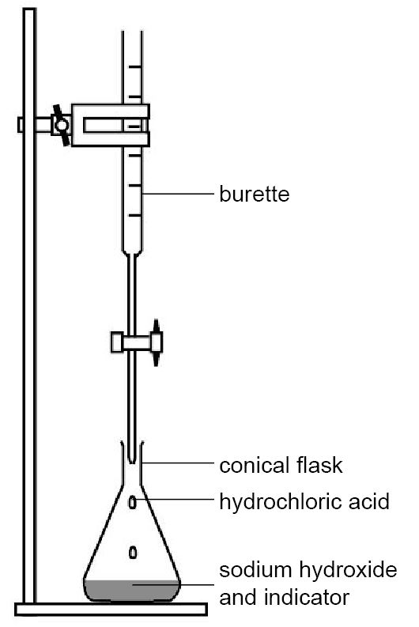

Phenolphthalein |  |  |  | Methyl orange
alkali | end point | acid |  | alkali | end point | acid
pink | just colourless | colourless |  | yellow | orange | red
(Note, if titrating from acid to alkali with phenolphthalein, the end-point is usually taken as the first permanent faint pink colouration, i.e. lasting at least 10 seconds.)

Intended class time
45-60 minutes

Chemicals and equipment (per group)
- burette (25 or 50 cm³)
- pipette (10 or 25 cm³) and filler
- conical flask (100 or 250 cm³)
- beaker × 5 (100 cm³)
- small (filter) funnel (about 4 cm diameter)
- white tile or a piece of white paper
- stand
- burette clamp
- methyl orange indicator solution (dropper bottle) (DANGER: Toxic)
- phenolphthalein indicator solution (dropper bottle) (WARNING: Flammable)
- 0.400 mol dm^{–3} hydrochloric acid
- 0.400 mol dm^{–3} sodium hydroxide solution (WARNING: Causes skin and eye irritation)
- sample A (sodium hydroxide solution of unknown concentration) (WARNING: Causes skin and eye irritation)

Health and Safety
- Eye protection should be worn at all times.
- Ensure the funnel is below eye level when filling the burette and the tap is closed
- Take particular care when handling the burette and pipette – these are fragile glassware and can make very sharp fragments if broken.
- Ensure you hold the pipette close to the end when twisting into the filler.

Method
NOTE: The instructions below are based on a 50 cm³ burette, 25 cm³ pipette and 250 cm³ conical flask. If you are using the smaller volume apparatus, use the volumes indicated in (brackets).

STAGE 1: Preparation
- Label your beakers ‘waste’, ‘0.400M HCl’, ‘0.400M NaOH’, ‘unknown NaOH’. Use these to collect samples from the relevant stock bottles.
- Place your waste beaker under your clamped burette and ensure the tap is closed.
- Using the funnel, pour about 10 cm³ 0.400 mol/dm³ hydrochloric acid into the burette.
- Open the tap and allow the acid to flow into the waste beaker until the tip is full – if an air bubble remains, speak to your teacher.
- Close the tap then fill the burette with the acid above the 0 cm³ mark.
- Slowly open the tap until the meniscus sits close to but below the 0 cm³ mark.

STAGE 2: Practice of titration technique
- Add 25 cm³ (10 cm³) 0.400 mol dm^{–3} sodium hydroxide to the 250 cm³ (100 cm³) conical flask.
- Add 2–3 drops of your chosen indicator.
- Make a note of your initial burette volume reading to two decimal places.
- Carry out a rough titration by adding 1-2 cm³ of the acid from the burette at a time to the conical flask with swirling.
- When you have reached the end-point (the indicator has changed colour), make a note of the final burette volume reading.
- Carefully rinse your conical flask and refill your burette if required.
- Add alkali and indicator to your conical flask (as in Steps 1 and 2).
- Carry out accurate titrations until you have concordant results (titres within 0.1 cm³) as follows:
  - Add acid to within 3-4 cm³ of your rough titre (e.g. if your rough titre was 23.50 cm³, about 20.00 cm³).
  - Add acid drop-by-drop (1 drop per second) with swirling until you reach the end-point.
  - Make a note of the final volume reading.

STAGE 3: Determining the concentration of alkali of unknown concentration
- Repeat Stage 2, using the sodium hydroxide of unknown concentration (sample A) in place of the 0.400 mol/dm³ sodium hydroxide.

Analysis of results
You will need one table for each set of titrations you carry out (i.e. one for Stage 2 and one for Stage 3). You can draw your own table, or use the one below:
STAGE 2
Titre | Example | Rough | 1 | 2 | 3 | 4
final volume (cm³) | 24.50
initial volume (cm³) | 1.55
titre (cm³) | 22.95
use in mean titre (/ X) | X

STAGE 3
Titre | Example | Rough | 1 | 2 | 3 | 4
final volume (cm³) | 24.50
initial volume (cm³) | 1.55
titre (cm³) | 22.95
use in mean titre (/ X) | X

Your ability to analyse your observations may depend on how much of the GCSE Chemistry course you have studied. Your teacher will let you know which questions you should focus on:
1. | Calculate the mean titre from your concordant titres. [2 marks per stage]
 | STAGE 2 | STAGE 3
2. | Calculate the number of moles of hydrochloric acid used in your titration. [2 marks per stage]
 | STAGE 2 | STAGE 3
3. | Calculate the number of moles of sodium hydroxide in your sample. [1 mark per stage]
 | STAGE 2 | STAGE 3
4. | Calculate the concentration of the sodium hydroxide. [2 marks per stage]
 | STAGE 2 | STAGE 3

Extension opportunities
1. | Write word, symbol and ionic equations for the reaction between hydrochloric acid and sodium hydroxide. [3 marks]

2. | Describe how replacing hydrochloric acid with sulfuric acid (H₂SO₄) of the same concentration would affect your results. [2 marks]
3. | Explain why you carry out a rough titration. [2 marks]
4. | Explain the purpose of carrying out repeated titrations until you obtain concordant results. [3 marks]

DfE Apparatus and Techniques covered
If you are using the OCR Practical Activity Learner Record Sheet (Chemistry / Combined Science) you may be able to tick off the following skills:

Chemistry |  |  |  |  | Combined Science
1-iv | 3-ii | 6-i | 6-ii |  | 1-vi | 8-ii | 11-i | 11-ii
8-iv

