Chemistry PAG 8: Measuring rates of reaction

Combined Science PAG C5: Measuring rates of reaction

Suggested Activity 1: Measuring the rate of reaction between Mg and HCl

Instructions and answers for teachers
and technicians
These instructions cover the learner activity section which can be found on page 10. This Practical activity supports OCR GCSE Chemistry and Combined Science.
When distributing the activity section to the learners either as a printed copy or as a Word file you will need to remove the teacher instructions section.
This is a suggested practical activity that can be used as part of teaching the GCSE (9-1) Gateway Science (A) and Twenty First Century Science (B) specifications.
These are not controlled assessment tasks, and there is no requirement to use these particular activities.
You may modify these activities to suit your learners and centre. Alternative activities are available from, for example, Royal Society of Biology, Royal Society of Chemistry, Institute of Physics, CLEAPSS and publishing companies, or of your own devising.
Further details are available in the specifications (Practical Skills Topics), and in these videos.

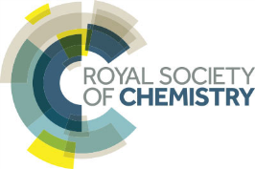 | This resource is adapted from the Practical Chemistry project, developed by the Nuffield Foundation and the Royal Society of Chemistry – http://www.rsc.org/learn-chemistry/collections/experimentation/practical-chemistry specifically the practical ‘The rate of reaction of magnesium with hydrochloric acid’ – http://www.rsc.org/learn-chemistry/resource/res00001916/the-rate-of-reaction-of-magnesium-with-hydrochloric-acid.

OCR recommendations:
Before carrying out any experiment or demonstration based on this guidance, it is the responsibility of teachers to ensure that they have undertaken a risk assessment in accordance with their employer’s requirements, making use of up-to-date information and taking account of their own particular circumstances. Any local rules or restrictions issued by the employer must always be followed.
CLEAPSS resources are useful for carrying out risk-assessments: (http://science.cleapss.org.uk).
Centres should trial experiments in advance of giving them to learners. Centres may choose to make adaptations to this practical activity, but should be aware that this may affect the Apparatus and Techniques covered by the learner.

Introduction
In this activity, learners will carry out the reaction between hydrochloric acid and magnesium metal at various temperatures to determine to effect of temperature on the rate of reaction. The activity requires good manual handling skills and organisation, and is best carried out in pairs.

DfE Apparatus and Techniques covered
The codes used below match the OCR Practical Activity Learner Record Sheet (Chemistry / Combined Science) and Trackers (Chemistry / Combined Science) available online. There is no requirement to use these resources.
By doing this experiment, learners have an opportunity to develop the following skills:
1 [1]: Use of appropriate apparatus to make and record a range of measurements accurately, including: iii [v]) temperature; iv [vi]) volume of liquids; v [vii]) volume of gases
2 [2]: Safe use of appropriate heating devices and techniques including use of: ii) a water bath OR an electric heater
3 [8]: Use of appropriate apparatus and techniques for: i) conducting and monitoring chemical reactions
5 [10]: Making and recording of appropriate observations during chemical reactions including: ii) the measurement of rates of reaction by a variety of methods such as production of gas
6 [11]: Safe use and careful handling of gases, liquids and solids, including: i) careful mixing of reagents under controlled conditions; ii) using appropriate apparatus to explore chemical changes and/or products

Aims

To determine the effect of temperature on the rate of reaction for an acid-metal reaction

Intended class time
30−40 minutes

Links to Specifications:

Gateway Science (Suite A) – including Working Scientifically (WS)
CM5.2i arithmetic computation, ratio when measuring rates of reaction
CM5.2iv proportionality when comparing factors affecting rate of reaction
C5.2a suggest practical methods for determining the rate of a given reaction
C5.2b interpret rate of reaction graphs
C5.2c describe the effect of changes in temperature, concentration, pressure, and surface area on rate of reaction
C5.2d explain the effects on rates of reaction of changes in temperature, concentration and pressure in terms of frequency and energy of collision between particles
C5.2f describe the characteristics of catalysts and their effect on rates of reaction
C5.2h explain catalytic action in terms of activation energy
WS1.1b use models to solve problems, make predictions and to develop scientific explanations and understanding of familiar and unfamiliar facts
WS1.2e evaluate methods and suggest possible improvements and further investigations
WS1.3a presenting observations and other data using appropriate methods
WS1.3b translating data from one form to another
WS1.3c carrying out and representing mathematical and statistical analysis
WS1.3e interpreting observations and other data
WS1.3f presenting reasoned explanations relating data to hypotheses
WS1.3g evaluating data in terms of accuracy, precision, repeatability and reproducibility
WS1.3h identifying potential sources of random and systematic error
WS1.4a use scientific vocabulary, terminology and definitions
WS1.4c use SI units and IUPAC chemical nomenclature unless inappropriate
WS1.4f use an appropriate number of significant figures in calculation
WS2a carry out experiments
WS2b make and record observations and measurements using a range of apparatus and methods
WS2c presenting observations using appropriate methods to include descriptive, tabular diagrammatic and graphically

Twenty First Century Science (Suite B) – including Ideas about Science (IaS)
C6.2.1 describe the effect on rate of reaction of changes in temperature, concentration, pressure, and surface area
C6.2.2 explain the effects on rates of reaction of changes in temperature, concentration and pressure in terms of frequency and energy of collision between particles
C6.2.3 describe the characteristics of catalysts and their effect on rates of reaction
C6.2.6 explain catalytic action in terms of activation energy
C6.2.7 suggest practical methods for determining the rate of a given reaction including measurement of physical factors iv: formation of a precipitate
C6.2.8 interpret rate of reaction graphs
C6.2.9 interpret graphs of reaction conditions versus rate
C6.2.10 use arithmetic computation and ratios when measuring rates of reaction
C6.2.13 use proportionality when comparing factors affecting rate of reaction
IaS2.1 present observations and other data using appropriate formats
IaS2.2 when processing data use SI units where appropriate (e.g. kg, g, mg; km, m, mm; kJ, J) and IUPAC chemical nomenclature unless inappropriate
IaS2.4 be able to translate data from one form to another
IaS2.6 when processing data use an appropriate number of significant figures
IaS2.7 when displaying data graphically select an appropriate graphical form, use appropriate axes and scales, plot data points correctly, draw an appropriate line of best fit, and indicate uncertainty (e.g. range bars)
IaS2.8 when analysing data identify patterns/trends, use statistics (range and mean) and obtain values from a line on a graph (including gradient, interpolation and extrapolation),
IaS2.9 in a given context evaluate data in terms of accuracy, precision, repeatability and reproducibility, identify potential sources of random and systematic error, and discuss the decision to discard or retain an outlier
IaS2.10 evaluate an experimental strategy, suggest improvements and explain why they would increase the quality (accuracy, precision, repeatability and reproducibility) of the data collected, and suggest further investigations
IaS2.11 in a given context interpret observations and other data (presented in diagrammatic, graphical, symbolic or numerical form) to make inferences and to draw reasoned conclusions, using appropriate scientific vocabulary and terminology to communicate the scientific rationale for findings and conclusions
IaS3.4 use a variety of models (including representational, spatial, descriptive, computational and mathematical models) to: i) solve problems, ii) make predictions, iii) develop scientific explanations and understanding, iv) identify limitations of models

Mathematical Skills covered
M1a: Recognise and use expressions in decimal form
M1c: Use ratios, fractions and percentages
M2a: Use an appropriate number of significant figures
M3a: Understand and use the symbols, =, <, ≪, ≫, >, α, ~
M3c: Substitute numerical values into algebraic equations using appropriate units for physical quantities
M4a: Translate information between graphical and numeric form
M4c: Plot two variables from experimental or other data

Technical Requirements – PER GROUP

Chemicals
Identity | Approximate quantity required or produced PER GROUP | Hazard information |  | Risk information
magnesium ribbon | 4 × 5 cm strip | Not currently classified as hazardous in this form. |  | Magnesium ribbon is flammable. Pre-cut the ribbon and supervise its distribution. Do not have the stock roll in the laboratory.
1.00 mol dm^{–3} aqueous hydrochloric acid, HCl(aq) | c. 125 cm³ | Currently not classified as hazardous at this concentration |  | Wear eye protection
hydrogen gas, H₂(g) PRODUCED | c. 30 cm³ per reaction |  | DANGER: Extremely flammable. | Wear eye protection. Ensure laboratory is well ventilated. Ensure there are no naked flames.

Equipment (per group)
- eye protection
- conical flask (100 cm³)
- bung and delivery tube
- measuring cylinders (25 cm³ and 50 cm³)
- thermometer (–10 – 100 °C)
- stand, boss and clamp
- trough / ice-cream tub or similar
- stop watch / timer
- access to an electric water bath / kettle and beaker (250 cm³)
- access to a waste bucket and sieve

Health and Safety
Eye protection should be worn at all times.
Hydrogen gas is extremely flammable – ensure there are no sources of ignition or naked flames in the laboratory.
Ensure the laboratory is well ventilated.

Method
Learners will carry out five reactions between magnesium and hydrochloric acid at various temperatures. They should be aware from prior discussion of theory that increasing temperature can significantly raise the rate of reaction, and will need to be particularly quick in placing the bung in the conical flask, and keeping a close eye on the volume of gas evolved.

Images from trial
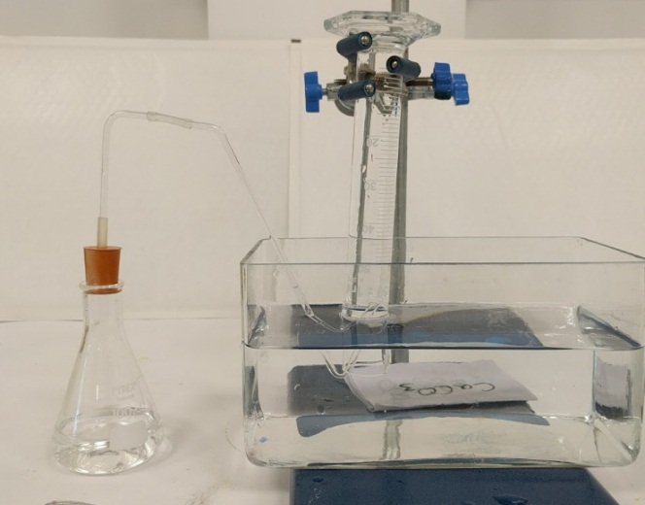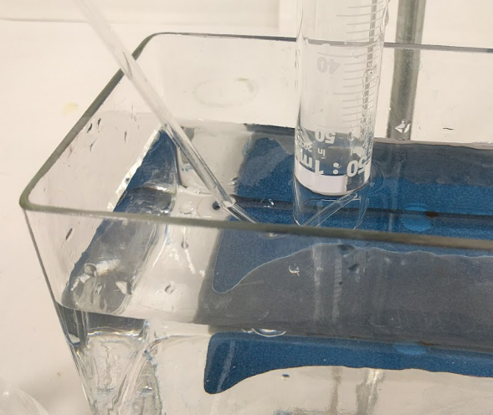

Analysis of results
1. | Calculate the rate of each reaction by dividing 30 by the time taken to produce the 30 cm³ of hydrogen gas.[2 marks]  - correct calculations  - all values given to 2 significant figures
2. Plot a graph of temperature of HCl against rate of reaction – include a line of best fit (THINK should this be a straight or curved line; should the graph extrapolate beyond the data points; should it start at the origin?) [4 marks]
- 1 mark for correct x-axis
- 1 mark for correct y-axis
- 1 mark for accurate plotting (correct to within one small square on 2 mm graph paper)
- 1 mark for appropriate line of best fit
3. Describe the relationship between temperature of HCl and its rate of reaction with magnesium.[2 marks]
As the temperature of HCl increases so does the rate of reaction , slowly at first, then faster at higher temperatures .

Extension opportunities
1. | By reference to collision theory, explain the relationship in the data you have collected.[4 marks]
As the temperature increased, the rate of reaction increased .
As the temperature increased, the particles moved faster, colliding more frequently and with more energy . This increased the chance that the molecules collided with activation energy (or more) , resulting in a reaction.
2. | You may have noticed the reaction getting warmer as it proceeded. Describe the effect this may have on your data.[2 marks]
 |  | The reaction is exothermic, which increases the temperature of the acid . This increases the rate of the reaction .

3. | When a piece of magnesium metal reacts with excess hydrochloric acid, the speed of bubble formation drops as the reaction proceeds. Explain this observation.  [2 marks]
 |  | As the reaction progresses, the magnesium surface area decreases decreasing the rate of reaction .

Document updates
v1.1 January 2017 Original – published on qualification page
v1.2 June 2021 Update to meet digital accessibility standards

We’d like to know your view on the resources we produce. Click ‘Like’ or ‘Dislike’ to send us an auto generated email about this resource. Add comments if you want to. Let us know how we can improve this resource or what else you need. Your email will not be used or shared for any marketing purposes.
Looking for another resource? There is now a quick and easy search tool to help find free resources for your qualification.
OCR is part of Cambridge Assessment, a department of the University of Cambridge.
For staff training purposes and as part of our quality assurance programme your call may be recorded or monitored.
Oxford Cambridge and RSA Examinations is a Company Limited by Guarantee. Registered in England. Registered office
The Triangle Building, Shaftesbury Road, Cambridge, CB2 8EA. Registered company number 3484466. OCR is an exempt charity.
OCR operates academic and vocational qualifications regulated by Ofqual, Qualifications Wales and CCEA as listed
in their qualifications registers including A Levels, GCSEs, Cambridge Technicals and Cambridge Nationals.
OCR provides resources to help you deliver our qualifications. These resources do not represent any particular teaching method we expect you to use. We update our resources regularly and aim to make sure content is accurate but please check the OCR website so that you have the most up to date version. OCR cannot be held responsible for any errors or omissions in these resources.
Though we make every effort to check our resources, there may be contradictions between published support and the specification, so it is important that you always use information in the latest specification. We indicate any specification changes within the document itself, change the version number and provide a summary of the changes. If you do notice a discrepancy between the specification and a resource, please contact us.
© OCR 2021 - You can copy and distribute this resource freely if you keep the OCR logo and this small print intact and you acknowledge OCR as the originator of the resource.
OCR acknowledges the use of the following content: N/A
Whether you already offer OCR qualifications, are new to OCR or are thinking about switching, you can request more information using our Expression of Interest form.
Please get in touch if you want to discuss the accessibility of resources we offer to support you in delivering our qualifications.

Chemistry PAG 8: Measuring rates of reaction

Combined Science PAG C5: Measuring rates of reaction

Suggested Activity 1: Measuring the rate of reaction between Mg and HCl

Learner Activity

Introduction
Measuring the rate of a chemical reaction is a key technique in chemistry, and gives insights into the how the reaction is occurring. Rates of reaction can be measured in a variety of ways such as the volume of gaseous products, changes in reaction masses, changes in colour and changes in pH.
In this activity, you will carry out the reaction of hydrochloric acid with magnesium metal at various temperatures to determine how temperature affects the rate of reaction. This activity gives you opportunities to refine your skills in handling experimental apparatus and in careful observation and measurement.
This resource is adapted from the Practical Chemistry project, developed by the Nuffield Foundation and the Royal Society of Chemistry – http://www.rsc.org/learn-chemistry/collections/experimentation/practical-chemistry specifically the practical ‘The rate of reaction of magnesium with hydrochloric acid’ – http://www.rsc.org/learn-chemistry/resource/res00001916/the-rate-of-reaction-of-magnesium-with-hydrochloric-acid.

Aims

To determine the effect of temperature on the rate of an acid-metal reaction.

Intended class time
30−40 minutes

Chemicals and equipment (per group)
- eye protection
- conical flask (100 cm³)
- bung and delivery tube
- measuring cylinders (25 cm³ and 50 cm³)
- thermometer (–10–100 °C)
- stand, boss and clamp
- trough / ice-cream tub or similar
- 1.00 mol/dm³ hydrochloric acid
- magnesium (4 cm strips) (DANGER: Flammable solid)
- stop watch / timer
- access to an electric water bath / kettle and beaker (250 cm³)
- access to a waste bucket / sieve

Health and Safety
- Eye protection should be worn at all times.
- Hydrogen gas is extremely flammable – ensure there are no sources of ignition or naked flames in the laboratory.
- Ensure the laboratory is well ventilated.

Equipment set-up
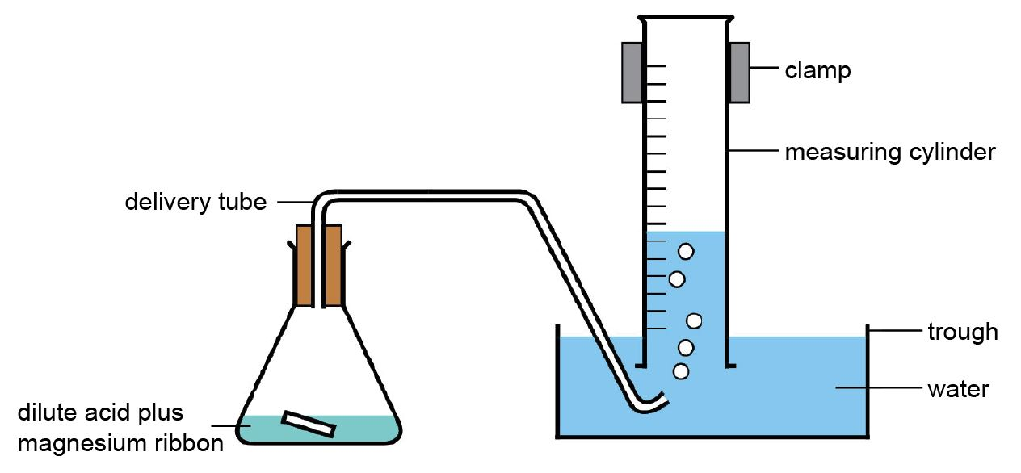
Figure 1 – the experimental setup

Method
- Set up the apparatus as shown in Figure 1. If the trough is too small to place the measuring cylinder on its side, fill the measuring cylinder to the top, hold a folded dampened piece of scrap paper over the top, and invert into the filled trough.
- For each temperature of HCl:
  - Measure 50 cm³ of 1.00 mol/dm³ hydrochloric acid into a 100 cm³ conical flask.
  - Heat the acid in a water bath to the required temperature – use a thermometer to monitor the temperature of the acid.
  - Quickly and safely, add a 4 cm strip of magnesium to the conical flask, attach the bung/delivery tube and start the stop watch.
  - Monitor the volume of gas produced – stop the stop-watch at 30 cm³.
  - Pour the acid/magnesium mixture into the waste bucket through the sieve, and rinse out the conical flask.

Analysis of results
You can draw your own table, or use the one below:
temperature of HCl(aq) / °C | time taken to produce 30 cm³ H₂(g) (t) / s | rate of reaction / s^{–1}  (rate of reaction = 30/t)
(room temperature) =
30
40
50
60

Your ability to analyse your observations may depend on how much of the GCSE Chemistry/Combined Science course you have studied. Your teacher will let you know which questions you should focus on:
1. | Calculate the rate of each reaction by dividing 30 by the time taken to produce the 30 cm³ of hydrogen gas.[2 marks]
2. Plot a graph of temperature of HCl against rate of reaction – include a line of best fit (THINK should this be a straight or curved line; should the graph extrapolate beyond the data points; should it start at the origin?) [4 marks]
3. Describe the relationship between temperature of HCl and its rate of reaction with magnesium.[2 marks]

Extension opportunities
1. | By reference to collision theory, explain the relationship in the data you have collected.[4 marks]
2. | You may have noticed the reaction getting warmer as it proceeded. Describe the effect this may have on your data.[2 marks]

3. | When a piece of magnesium metal reacts with excess hydrochloric acid, the speed of bubble formation drops as the reaction proceeds. Explain this observation.  [2 marks]

DfE Apparatus and Techniques covered
If you are using the OCR Practical Activity Learner Record Sheet (Chemistry / Combined Science) you may be able to tick off the following skills:

Chemistry |  |  |  |  | Combined Science
1-iii | 1-iv | 1-v | 2-ii |  | 1-v | 1-vi | 1-vii | 2-ii
3-i | 5-ii | 6-i | 6-ii |  | 8-i | 10-ii | 11-i | 11-ii

