Chemistry PAG 3: Separation techniques

Combined Science PAG C3: Separation techniques

Suggested Activity 1: Separation in synthesis

Instructions and answers for teachers
and technicians
These instructions cover the learner activity section which can be found on page 11. This Practical activity supports OCR GCSE Chemistry and Combined Science.
When distributing the activity section to the learners either as a printed copy or as a Word file you will need to remove the teacher instructions section.
This is a suggested practical activity that can be used as part of teaching the GCSE (9-1) Gateway Science (A) and Twenty First Century Science (B) specifications.
These are not controlled assessment tasks, and there is no requirement to use these particular activities.
You may modify these activities to suit your learners and centre. Alternative activities are available from, for example, Royal Society of Biology, Royal Society of Chemistry, Institute of Physics, CLEAPSS and publishing companies, or of your own devising.
Further details are available in the specifications (Practical Skills Topics), and in these videos.
OCR recommendations:
Before carrying out any experiment or demonstration based on this guidance, it is the responsibility of teachers to ensure that they have undertaken a risk assessment in accordance with their employer’s requirements, making use of up-to-date information and taking account of their own particular circumstances. Any local rules or restrictions issued by the employer must always be followed.
CLEAPSS resources are useful for carrying out risk-assessments: (http://science.cleapss.org.uk).
Centres should trial experiments in advance of giving them to learners. Centres may choose to make adaptations to this practical activity, but should be aware that this may affect the Apparatus and Techniques covered by the learner.

Introduction
In this activity, learners will use a variety of separation techniques to produce a sample of crystallised hydrated copper(II) sulfate. The focus on the experiment is on the different separation techniques involved.
The method is based on one from CLEAPSS, ‘Preparation of copper(II) sulfate-5-water’, Laboratory Handbook Section 13, pp1332-33: www.cleapss.org.uk/attachments/article/0/Sec13.pdf.

DfE Apparatus and Techniques covered
The codes used below match the OCR Practical Activity Learner Record Sheet (Chemistry / Combined Science) and Trackers (Chemistry / Combined Science) available online. There is no requirement to use these resources.
By doing this experiment, learners have an opportunity to develop the following skills:
1 [1]: Use of appropriate apparatus to make and record a range of measurements accurately, including: i [iii]) mass; iv [vi]) volume of liquids
4 [9]: Safe use of a range of equipment to purify and/or separate chemical mixtures including:
i) evaporation, ii) filtration, and iii) crystallisation
6 [11]: Safe use and careful handling of gases, liquids and solids, including: i) careful mixing of reagents under controlled conditions

Aims
To use a variety of separation techniques to produce hydrated copper(II) sulfate crystals.

Intended class time
30 minutes + overnight crystallisation

Links to Specifications:

Gateway Science (Suite A) – including Working Scientifically (WS)
C2.1f describe, explain and exemplify the processes of filtration, crystallisation, simple distillation and fractional distillation [to include: knowledge of the techniques]
C2.1j suggest suitable purification techniques given information about the substances involved
C3.1a use chemical symbols to write the formulae of elements and simple covalent and ionic compounds
C3.1b use the names and symbols of common elements and compounds and the principle of conservation of mass to write formulae and balanced chemical equations and half equations
C3.1c use the names and symbols of common elements from a supplied periodic table to write formulae and balanced chemical equations where appropriate
C3.1e construct balanced ionic equations
C3.1f describe the physical states of products and reactants using state symbols (s, l, g and aq)
C3.1k deduce the stoichiometry of an equation from the masses of reactants and products and explain the effect of a limiting quantity of a reactant
C3.3d describe neutralisation as acid reacting with alkali or a base to form a salt plus water
C4.1c recall the general properties of transition metals and their compounds and exemplify these by reference to a small number of transition metals (to include: melting point, density, reactivity, formation of coloured ions with different charges and uses as catalysts)
C5.1h calculate the percentage yield of a reaction product from the actual yield of a reaction
WS1.2e evaluate methods and suggest possible improvements and further investigations
WS1.3a presenting observations and other data using appropriate methods
WS1.3c carrying out and representing mathematical and statistical analysis
WS1.3e interpreting observations and other data
WS1.3g evaluating data in terms of accuracy, precision, repeatability and reproducibility
WS1.3h identifying potential sources of random and systematic error
WS1.4a use scientific vocabulary, terminology and definitions
WS1.4b recognise the importance of scientific quantities and understand how they are determined
WS1.4c use SI units and IUPAC chemical nomenclature unless inappropriate
WS1.4d use prefixes and powers of ten for orders of magnitude
WS1.4e interconvert units
WS1.4f use an appropriate number of significant figures in calculation
WS2a carry out experiments
WS2b make and record observations and measurements using a range of apparatus and methods
WS2c presenting observations using appropriate methods to include descriptive, tabular diagrammatic and graphically
WS2d communicating the scientific rationale for investigations, methods used, findings and reasoned conclusions

Twenty First Century Science (Suite B) – including Ideas about Science (IaS)
C1.1.9 use chemical symbols to write the formulae of elements and simple covalent compounds
C1.1.10 use the names and symbols of common elements and compounds and the principle of conservation of mass to write formulae and balanced chemical equations
C1.1.11 use arithmetic computations and ratios when balancing equations
C2.4.3 use the names and symbols of the first 20 elements, Groups 1, 7 and 0 and other common elements from a supplied Periodic Table to write formulae and balanced chemical equations where appropriate
C2.4.4 describe the physical states of products and reactants using state symbols (s, l, g and aq)
C2.5.1 recall the general properties of transition metals (melting point, density, reactivity, formation of coloured ions with different charges and uses as catalysts) and exemplify these by reference to copper, iron, chromium, silver and gold
C3.2.3 use the names and symbols of common elements and compounds and the principle of conservation of mass to write formulae and balanced chemical equations and ionic equations
C5.1.7 describe, explain and exemplify the processes of filtration, crystallisation, simple distillation, and fractional distillation
C5.1.8 suggest suitable purification techniques given information about the substances involved
C5.3.6 deduce the stoichiometry of an equation from the masses of reactants and products and explain the effect of a limiting quantity of a reactant
C5.3.12 calculate the percentage yield of a reaction product from the actual yield of a reaction (separate science only)
C5.4.4 describe neutralisation as acid reacting with alkali to form a salt plus water including the common laboratory acids hydrochloric acid, nitric acid and sulfuric acid and the common alkalis, the hydroxides of sodium, potassium and calcium
IaS1.2. suggest appropriate apparatus, materials and techniques, justifying the choice with reference to the precision, accuracy and validity of the data that will be collected
IaS1.6. plan experiments or devise procedures by constructing clear and logically sequenced strategies to: i) make observations, ii) produce or characterise a substance, iii) test hypotheses, iv) collect and check data, v) explore phenomena
IaS1.8. use appropriate scientific vocabulary, terminology and definitions to communicate the rationale for an investigation and the methods used using diagrammatic, graphical, numerical and symbolic forms
IaS2.1. present observations and other data using appropriate formats
IaS2.2. when processing data use SI units where appropriate (e.g. kg, g, mg; km, m, mm; kJ, J) and IUPAC chemical nomenclature unless inappropriate
IaS2.3. when processing data use prefixes (e.g. tera, giga, mega, kilo, centi, milli, micro and nano) and powers of ten for orders of magnitude
IaS2.6. when processing data use an appropriate number of significant figures
IaS2.10. evaluate an experimental strategy, suggest improvements and explain why they would increase the quality (accuracy, precision, repeatability and reproducibility) of the data collected, and suggest further investigations
IaS2.11. in a given context interpret observations and other data (presented in diagrammatic, graphical, symbolic or numerical form) to make inferences and to draw reasoned conclusions, using appropriate scientific vocabulary and terminology to communicate the scientific rationale for findings and conclusions

Mathematical Skills covered
M1a Recognise and use expressions in decimal form
M1c Use ratios, fractions and percentages
M1d Make estimates of the results of simple calculations
M2a Use an appropriate number of significant figures
M3a Understand and use the symbols: =, <, <<, >>, >, ∝, ~
M3c Substitute numerical values into algebraic equations using appropriate units for physical quantities
M3d Solve simple algebraic equations

Technical Requirements – PER GROUP

Chemicals
Identity | Approximate quantity required or produced PER GROUP | Hazard information |  | Risk information
copper(II) oxide, CuO(s) | c. 2 g |  | WARNING  Harmful if swallowed. Very toxic to aquatic life with long-lasting effects | Avoid raising dust – see CLEAPSS Hazcard 26 and below.
1.2 mol/dm³ sulfuric(VI) acid, H₂SO₄(aq) | c. 15 cm³ |  | WARNING: Causes skin and serious eye irritation.
copper(II) sulfate(VI)-5-water PRODUCED | c. 6 g |  | Harmful if swallowed. Causes skin and serious eye irritation. Very toxic to aquatic life with long lasting effects. | Crystals can be saved for making CuSO₄(aq)

Equipment
- eye protection
- beaker (250 cm³)
- boiling tube
- conical flask (100 cm³)
- crystallising dish / petri dish
- filter funnel
- filter paper (Whatman No. 1)
- Bunsen burner
- tripod, gauze and heat proof mat
- paper towel
- access to a mass balance
- access to a kettle

Health and Safety
Eye protection should be worn at all times.
Avoid raising dust when weighing the copper(II) oxide – use of a balance in a fume cupboard that is not switched on, with the sash partially pulled down is recommended. Otherwise, ensure there is good ventilation in the laboratory.
Take particular care to ensure conical flasks are stable on gauzes during heating, and learners know how to handle hot glassware safely – e.g with a folded paper towel.

Method
This is a good opportunity for learners to practice their skills in handling a variety of chemicals and apparatus, including dealing with hot glassware and solutions. Clear instructions are provided – talking through the safety implications before starting the practical work is recommended.

Images from trials
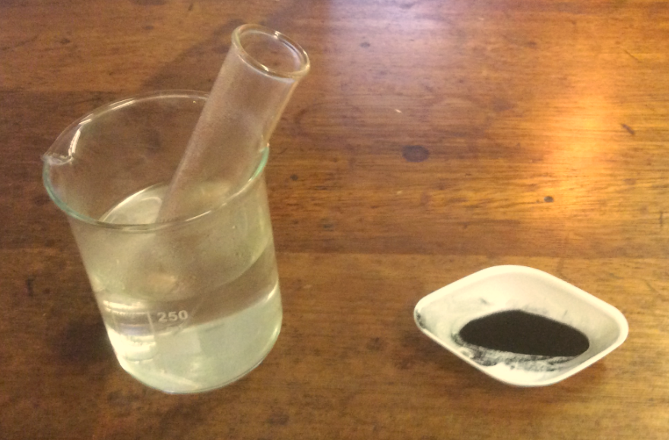 | 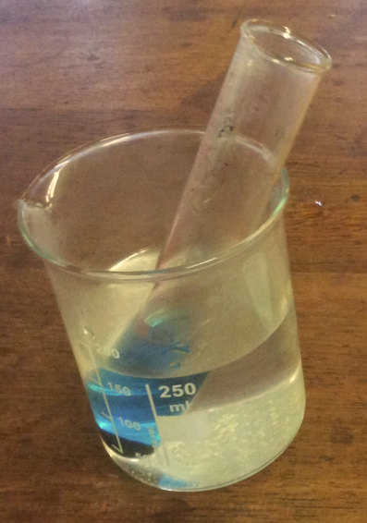 | 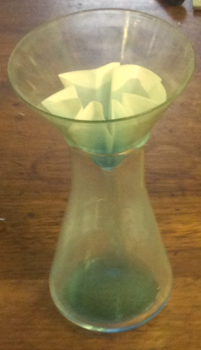
Warm sulfuric acid and copper oxide | Synthesised copper sulfate | Filtering the mixture
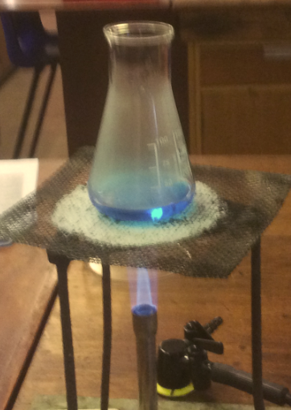 | 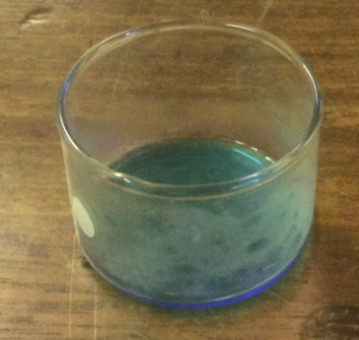 | 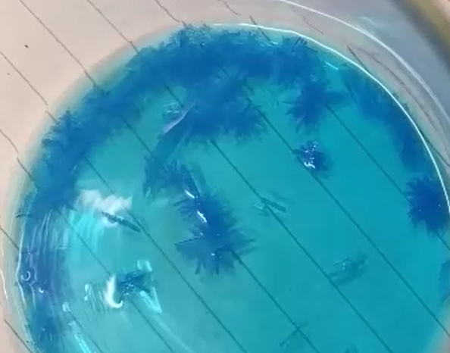
Evaporating some of the solvent | Saturated copper sulfate solution in a crystallising dish | Crystallisation of copper sulfate hydrate crystals

Analysis of results – Trial results
You can draw your own table, or use the one below:
Item | mass / g
crystallising/petri dish+ crystals (measured) | 54.48
dish (measured) | 50.15
crystals (calculated) | 4.33

1. | The theoretical yield for this reaction is 4.5 g. Showing you workings, calculate your percentage yield. [3 mark]
 | percentage yield = = = 96% (2 sig. fig )

2. | Evaluate the practical procedure, suggesting improvements that could be made to increase your percentage yield. [4 marks]
Any suitable limitations () and suggested improvements (). For example
- copper sulfate solution not fully transferred between equipment; rinse equipment with deionised water after transfer and add to solution
- some anhydrous copper sulfate produced during evaporation of solvent; reduce the evaporation by Bunsen burner time

Extension opportunities
1. | An alternative method for synthesising copper(II) sulfate is the reaction between basic copper(II) carbonate, which contains copper(II) carbonate and copper(II) hydroxide.  Write the word equation, symbol equation and ionic equation for the reactions between copper(II) carbonate and copper(II) hydroxide, and sulfuric acid. Name the type of reaction occurring. [7 mark]
copper(II) carbonate + sulfuric acid → copper sulfate + carbon dioxide + water
CuCO₃(s) + H₂SO₄(aq) → CuSO₄(aq) + H₂O(l)
CuCO₃(s) + 2H⁺(aq) → Cu²⁺(aq) + CO₂(g) + H₂O(l)
copper(II) hydroxide + sulfuric acid → copper sulfate + water
Cu(OH)₂(s) + H₂SO₄(aq) → CuSO₄(aq) + 2H₂O(l)
Cu(OH)₂(s) + 2H⁺(aq) → Cu²⁺(aq) + 2H₂O(l)
neutralisation reaction

2. | Describe how the method you use would be modified if an insoluble salt was being synthesised from two soluble salt solutions. [3 marks]
The two solutions would be mixed at room temperature – no heating would be required.
The product would be separated as the residue rather than the filtrate.
The product would be left to dry out, rather than to crystallise and then dry out.

Document updates
v1.1 February 2017 Original - published on qualification page
We’d like to know your view on the resources we produce. By clicking on ‘Like’ or ‘Dislike’ you can help us to ensure that our resources work for you. When the email template pops up please add additional comments if you wish and then just click ‘Send’. Thank you.
If you do not currently offer this OCR qualification but would like to do so, please complete the Expression of Interest Form which can be found here: www.ocr.org.uk/expression-of-interest
Looking for a resource? There is now a quick and easy search tool to help find free resources for your qualification:
www.ocr.org.uk/i-want-to/find-resources/
OCR Resources: the small print
This formative assessment resource has been produced as part of our free GCSE teaching and learning support package. All the GCSE teaching and learning resources, including delivery guides, topic exploration packs, lesson elements and more are available on the qualification webpages.
If you are looking for examination practice materials, you can find Sample Assessment Materials (SAMs) on the qualification webpages: here

OCR’s resources are provided to support the teaching of OCR qualifications, but in no way constitute an endorsed teaching method that is required by the Board, and the decision to use them lies with the individual teacher. Whilst every effort is made to ensure the accuracy of the content, OCR cannot be held responsible for any errors or omissions within these resources.
© OCR 2017 - This resource may be freely copied and distributed, as long as the OCR logo and this message remain intact and OCR is acknowledged as the originator of this work.
OCR acknowledges the use of the following content: n/a
Please get in touch if you want to discuss the accessibility of resources we offer to support delivery of our qualifications: resources.feedback@ocr.org.uk

Chemistry PAG 3: Separation techniques

Combined Science PAG C3: Separation techniques

Suggested Activity 1: Separation in synthesis

Learner Activity

Introduction
There are several common separation techniques that form part of the toolkit of a chemist, including filtration, evaporation of solvents and crystallisation. In this activity, you will prepare crystals of hydrated copper(II) sulfate by reaction of copper(II) oxide with hot sulfuric acid. Through filtration, evaporation of some of the water and crystallisation you will produce the beautiful blue crystals, which can then be used in other practical activities.

Aims
To use a variety of separation techniques to produce a hydrated copper(II) sulfate crystals.

Intended class time
30 minutes + overnight crystallisation

Chemicals and equipment (per group)
- eye protection
- beaker (250 cm³)
- boiling tube
- conical flask (100 cm³)
- crystallising dish / petri dish
- filter funnel
- filter paper (Whatman No. 1)
- Bunsen burner
- tripod, gauze and heat proof mat
- paper towel
- access to a mass balance
- access to a kettle
- copper(II) oxide (WARNING: Harmful)
- sulfuric acid (WARNING: Irritant)

Health and Safety
- Eye protection should be worn at all times.
- Take particular care with handling hot glassware – your teacher will demonstrate how to use folded paper towels to safely move hot apparatus (or by another method).
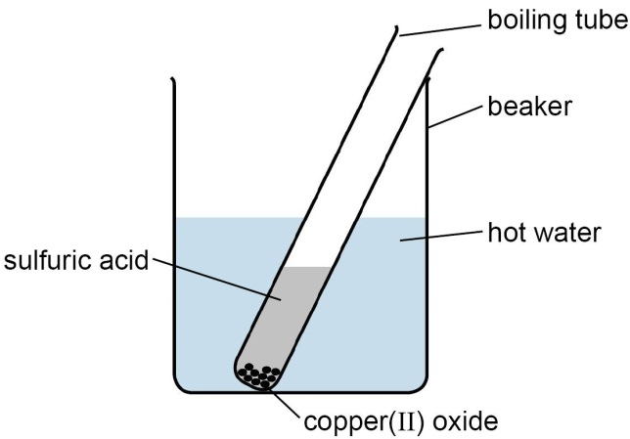 | 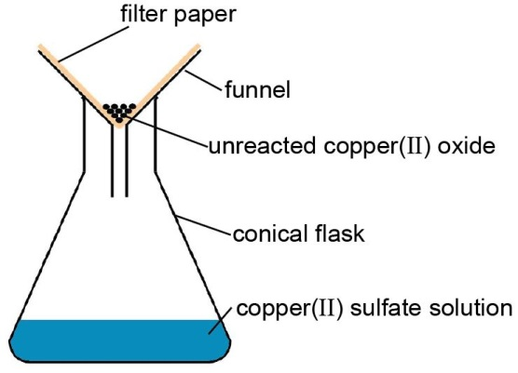
Stage 1 | Stage 2
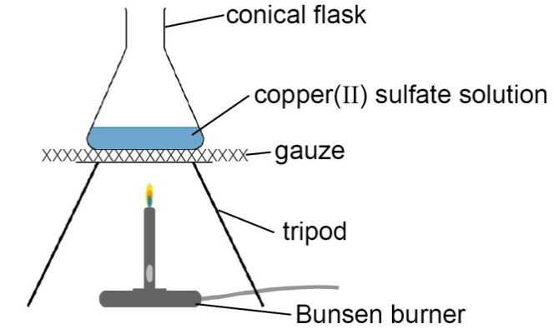 | 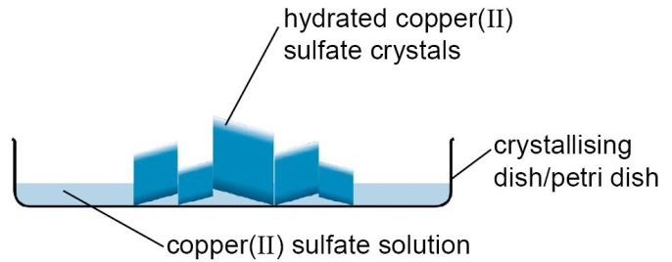
Stage 3 | Stage 4
Figure 1: The steps involved in producing hydrated copper(II) sulfate crystals

Method
Synthesis of copper sulfate
- Half fill a 250 cm³ beaker with boiling water from a kettle.
- Add 15 cm³ 1.2 mol dm^{–3} sulfuric acid into a boiling tube and place in the hot water.
- Weigh out between 1.8 and 2.0 g copper(II) oxide onto a weighing boat.
- Add about one quarter of the copper(II) oxide to the boiling tube.
- Lift the tube from the beaker and agitate, then return the tube to the water.
- Add another quarter of the copper(II) oxide and agitate the tube as before.
- Replace the water in the beaker with boiling water from a kettle.
- Add another quarter of the copper(II) oxide and agitate the tube as before.
- Add the remaining copper(II) oxide, and agitate every minute of so over five minutes –
the resultant mixture should be cloudy.

Purification of copper(II) sulfate solution
- Set up a filter funnel in a 100 cm³ conical flask, with a folded Whatman No. 1 filter paper – ask your teacher is you can’t remember how to fold this.
- Filter the mixture from the boiling tube into the conical flask.

Production of hydrated copper(II) sulfate crystals
- Label and measure the mass of a crystallising dish / petri dish. Record the mass.
- Place the conical flask on a tripod and gauze.
- Boil the solution for 3 MINUTES ONLY – DO NOT ALLOW TO BOIL DRY.
- Turn off the Bunsen burner, and allow the solution to stop boiling.
- Using a folded paper towel, carefully pick up the conical flask, and pour the hot solution into your dish.
- Allow the solution to cool for five minutes – you may observe crystals forming at this point.
- Your teacher will arrange for your dish to be stored somewhere warm where it won’t be disturbed until your next lesson.

Measuring the mass of product
- Measure the mass of your dish and the copper sulfate crystals.
- Transfer the crystals to a stock jar – they can be used in other practical activities later on.
- Rinse and return your equipment.

Analysis of results
You can draw your own table, or use the one below:
Item | mass / g
crystallising/petri dish+ crystals (measured)
dish (measured)
crystals (calculated)

Your ability to analyse your observations may depend on how much of the GCSE Chemistry/Combined Science course you have studied. Your teacher will let you know which questions you should focus on:
1. | The theoretical yield for this reaction is 4.5 g. Showing you workings, calculate your percentage yield. [3 mark]

2. | Evaluate the practical procedure, suggesting improvements that could be made to increase your percentage yield. [4 marks]

Extension opportunities
1. | Write the word equation, symbol equation and ionic equation for the reactions between copper(II) carbonate and copper(II) hydroxide, and sulfuric acid. Name the type of reaction occurring. [7 marks]

2. | Describe how the method you use would be modified if an insoluble salt was being synthesised. [3 marks]

DfE Apparatus and Techniques covered
If you are using the OCR Practical Activity Learner Record Sheet (Chemistry / Combined Science) you may be able to tick off the following skills:

Chemistry |  |  |  |  | Combined Science
1-i | 1-iv | 4-i | 4-ii |  | 1-iii | 1-vi | 9-i | 9-ii
4-iii | 6-i |  |  |  | 9-iii | 11-i

