Chemistry PAG 2: Electrolysis

Combined Science PAG C1: Electrolysis

Suggested Activity 3: Some gas tests

Instructions and answers for teachers
and technicians
These instructions cover the learner activity section which can be found on page 13. This Practical activity supports OCR GCSE Chemistry and Combined Science.
When distributing the activity section to the learners either as a printed copy or as a Word file you will need to remove the teacher instructions section.
This is a suggested practical activity that can be used as part of teaching the GCSE (9-1) Gateway Science (A) and Twenty First Century Science (B) specifications.
These are not controlled assessment tasks, and there is no requirement to use these particular activities.
You may modify these activities to suit your learners and centre. Alternative activities are available from, for example, Royal Society of Biology, Royal Society of Chemistry, Institute of Physics, CLEAPSS, SSERCand publishing companies, or of your own devising.
Further details are available in the specifications (Practical Skills Topics), and in these videos.
OCR recommendations:
Before carrying out any experiment or demonstration based on this guidance, it is the responsibility of teachers to ensure that they have undertaken a risk assessment in accordance with their employer’s requirements, making use of up-to-date information and taking account of their own particular circumstances. Any local rules or restrictions issued by the employer must always be followed.
CLEAPSS resources are useful for carrying out risk-assessments: (http://science.cleapss.org.uk).
Centres should trial experiments in advance of giving them to learners. Centres may choose to make adaptations to this practical activity, but should be aware that this may affect the Apparatus and Techniques covered by the learner.

Introduction
In this activity, learners can produce a variety of gases using ‘kitchen chemistry’. Carrying out practical work in this manner can help facilitate discussions about the role of chemistry in our everyday life, from cooking to cleaning to health-care. The suggested equipment and methods can be adapted to use standard laboratory equipment.
This activity can be modified to reduce the number of observations the learners are making, allowing them to focus on less chemistry at with greater depth. For example, Method 1 and 2 are stand alone. The red cabbage indicator can be tested with standard laboratory reagents such as 0.1 mol dm^{–3} sodium hydroxide and/or hydrochloric acid. Method 4 could be carried out using universal indicator solution rather than the red cabbage solution.
Further activities to do with cabbage indicators can be found at http://www.rsc.org/learn-chemistry/resource/res00001214/outreach-red-cabbage-ph-indicator.

Aims
To carry out ‘kitchen chemistry’ preparations of oxygen, carbon dioxide and chlorine, and to analyse the products formed.

Intended class time
30–45 minutes

DfE Apparatus and Techniques covered
The codes used below match the OCR Practical Activity Learner Record Sheet (Chemistry / Combined Science) and Trackers (Chemistry / Combined Science) available online. There is no requirement to use these resources.
By doing this experiment, learners have an opportunity to develop the following skills:
6 [11]: Safe use and careful handling of gases, liquids and solids, including: i) careful mixing of reagents under controlled conditions; ii) using appropriate apparatus to explore chemical changes and/or products
7 [12]: Use of appropriate apparatus and techniques to: i) draw electrochemical cells for separation and production of elements and compounds; ii) set up and use electrochemical cells for separation and production of elements and compounds
8: Use of appropriate qualitative reagents and techniques to analyse and identify unknown samples or products including: i) gas tests

Links to Specifications:

Gateway Science (Suite A) – including Working Scientifically (WS)
C3.3f recall that carbonates and some metals react with acids and write balanced equations predicting products from given reactants
C3.4a recall that metals (or hydrogen) are formed at the cathode and non-metals are formed at the anode in electrolysis using inert electrodes
C3.4d describe electrolysis in terms of the ions present and reactions at the electrodes
C3.4e describe the technique of electrolysis using inter and non-inert electrodes
C4.1a recall the simple properties of Groups 1, 7 and 0
C4.2a describe tests to identify selected gases
W1.3a presenting observations and other data using appropriate methods
W1.3e interpreting observations and other data
W1.3f presenting reasoned explanations
W1.4a use scientific vocabulary, terminology and definitions
WS2a carry out experiments
WS2b make and record observations and measurements using a range of apparatus and methods
WS2c presenting observations using appropriate methods

Twenty First Century Science (Suite B) – including Ideas about Science (IaS)
C1.4.2 describe a test to identify chlorine (using blue litmus paper)
C2.2.6 recall the simple properties of Group 7 elements including their states and colours at room temperature and pressure, their colours as gases, their reactions with Group 1 elements and their displacement reactions with other metal halides
C2.2.7 describe experiments to identify the reactivity pattern of Group 7 elements including displacement reactions
C3.2.5 explain why electrolysis is used to extract some metals from their ores
C3.3.1 describe electrolysis in terms of the ions present and reactions at the electrodes
C3.3.3 recall that metals (or hydrogen) are formed at the cathode and non-metals are formed at the anode in electrolysis using inert electrodes
C3.3.4 use the names and symbols of common elements and compounds and the principle of conversation of mass to write half equations
C3.3.5 explain reduction and oxidation in terms of gain or loss of electrons, identifying which species is oxidised and which are reduced
C3.3.8 describe the technique of electrolysis of an aqueous solution of a salt
C6.1.1 recall that acids react with some metals and with carbonates and write equations predicting products from given reactants
IaS2.1 present observations and other data using appropriate formats
IaS2.11 in a given context interpret observations and other data (presented in diagrammatic, graphical, symbolic or numerical form) to make inferences and to draw reasoned conclusions, using appropriate scientific vocabulary and terminology to communicate the scientific rationale for findings and conclusions

Mathematical Skills covered
No defined mathematical skill is covered in this experiment.

Technical Requirements – PER GROUP

Chemicals
Identity | Approximate quantity required or produced PER GROUP | Hazard information |  | Risk information
sodium chloride (table salt), NaCl(s) | c. 2 g | Not classified as hazardous
calcium carbonate (indigestion tablets), CaCO₃(s) | c. 1 g | Not classified as hazardous
0.8 mol dm^{–3} ethanoic acid (white vinegar)  CH₃COOH(aq) | c. 10 cm³ | Currently not classified as hazardous at this concentration.
pieces of liver (e.g. calf) | c. 2 g | Not classified as hazardous |  | Ensure hands are thoroughly washed after use.
3% (w/w) hydrogen peroxide solution (contact lens cleaner), H₂O₂(aq) | c. 5 cm³ | Not classified as hazardous
saturated calcium hydroxide solution (limewater), Ca(OH)₂(aq) | c. 10 cm³ | Currently not classified as hazardous – however treat as an irritant (skin, eye) |  | Eye protection should be worn.
hydrogen gas, H₂(g) PRODUCED | c. 5 cm³ |  | DANGER: Extremely flammable. | Wear eye protection. Ensure laboratory is well ventilated. Ensure there are no naked flames in close proximity to electrolysis apparatus.
chlorine gas, Cl₂(g) PRODUCED | c. 5 cm³ |  | DANGER  May cause or intensity fire; oxidiser. Causes skin irritation. Causes serious eye irritation. Toxic if inhaled. May cause respiratory irritation. Very toxic to aquatic organisms. | Work in a well-ventilated laboratory. Remind learners NOT to sniff the gas.  Ensure the electrolysis is turned off as after the 1–2 minutes – this will minimise release of chlorine into the laboratory. Be particularly aware of class members with respiratory problems.
sodium hydroxide solution, NaOH(aq) PRODUCED | c. 20 cm³ at <0.1 mol dm^{–3} | Currently not classified as hazardous at this concentration

Equipment
3 × 30 cm³ plastic ‘shot glasses’
3 × polystyrene cup
teaspoon
grater
sieve
access to a kettle
2 × pencils
pencil sharpener
splints and lighter
9V battery
2 × wire with crocodile clips on either end
washing up liquid
red cabbage

Notes
Check the ingredients of the indigestion tablet carefully ensuring it contains calcium carbonate.
f regular laboratory equipment is available, red cabbage indicator can be made following this activity: http://www.rsc.org/learn-chemistry/resource/res00000422/making-a-ph-indicator. Alternatively, grate red cabbage can be soaked in just boiled water in a cup for a few minutes, then filtered through a sieve.
Limewater can be made up using CLEAPSS Recipe 20 (http://www.cleapss.org.uk/attachments/article/0/RBPrint.pdf). Small quantities could be made up by shaking a small amount of hydrated (builder’s) lime in a sealed jar of water and allowing to settle. Suitable risk assessment should be carried out and personal protective equipment used when handling the solid (DANGER: Corrosive and irritant).
The reaction between the contact lens solution and liver can be quite slow – if available, a demonstration of the reaction with laboratory grade hydrogen peroxide and a catalyst such as manganese dioxide can be used: http://www.rsc.org/learn-chemistry/resource/download/res00002144/cmp00002415/pdf
While aimed at teachers of primary school children, the ‘G5p Using chemicals safely’ document from CLEAPSS includes a range of useful information for carrying out practical work with commonly available materials around the home: http://www.cleapss.org.uk/attachments/article/0/G5p.pdf?Primary/Resources/Guides/?New%20teachers/
Release of chlorine can be minimised using a cardboard lid over the cup, which the pencil electrodes can be pushed through.

Health and Safety
Learners should wear eye protection during all practical work.
Ensure the room/laboratory is well ventilated, especially during the electrolysis reaction.
Ensure learners wash their hands thoroughly after all practical work.

Method
This activity is intended to be used by those with limited access to a regular secondary school laboratory, perhaps those in an alternative provision school. Should regular equipment/reagents be available they could be used.
Learners will produce oxygen by the catalytic decomposition of hydrogen peroxide, then test with a glowing splint. They will produce carbon dioxide by the decomposition of calcium carbonate with acid, then test with lime water. They will produce a pH indicator from red cabbage, electrolyse brine solution and test for chlorine gas and sodium hydroxide solution.

Images from trials
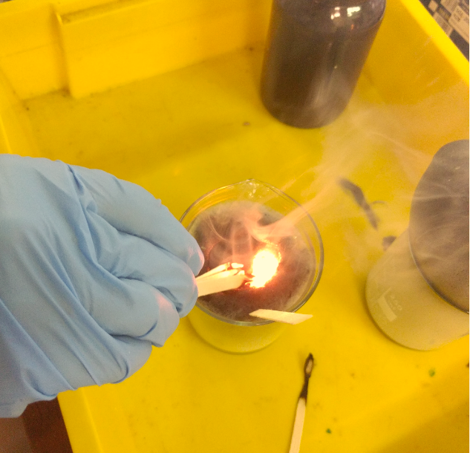STAGE 1: Decomposition of hydrogen peroxide. The washing up liquid helps trap the oxygen in bubbles which can relight a glowing splint | 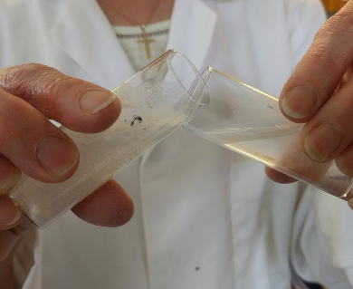  STAGE 2: Effervescence of carbon dioxide in the left hand tube – the dense CO₂ spills over into the limewater (right hand tube) causing the precipitation of CaCO₃
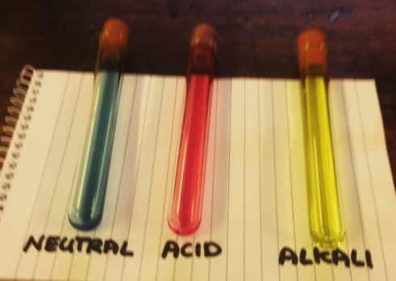  STAGE 3: Red cabbage contains anthrocyanins which change colour in acid and alkali solutions. | 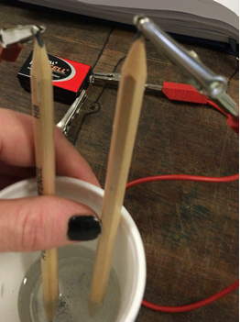  STAGE 4: Electrolysis of salt water with a 9V battery and two pencils

Analysis of results – trial results
Test carried out | Observation
glowing splint in oxygen bubbles | the splint relights
carbon dioxide into lime water | a white precipitate forms
boiling red cabbage | a blue/green solution forms
passing current through brine – positive electrode | bubbles form
passing current through brine – negative electrode | bubbles form
damp blue litmus paper near positive electrode | paper turns briefly pink/red then white
red cabbage indicator in remaining brine solution | solution turns paler green

1. | For a flame to form you need the three components of the fire triangle, fuel, heat and oxygen. Describe and explain the evidence you have for the production of oxygen gas. [3 marks]
 | The glowing splint provides the heat and fuel for the fire . As the splint relights , indicating the bubbles contain concentrated oxygen .
2. | Carbon dioxide forms an insoluble substance in limewater. Describe and explain the evidence you have for the production of carbon dioxide. [3 marks]
 | A white precipitate forms when the gas produced in the indigestion tables/vinegar shot glass spills into the lime water solution , indicating the gas contains carbon dioxide .
3. | Chlorine is an acidic gas. Describe and explain the evidence you have for the production of chlorine gas [3 marks]
 | Chlorine gas dissolves in to the water forming hydrochloric acid and a chlorate bleach . Blue litmus paper tests turns red in the presence of acids , and turns white in the presence of a bleach .

4. | Sodium hydroxide forms an alkaline solution. Describe and explain the evidence you have for the production of sodium hydroxide [2 marks]
 | The remaining solution after the electrolysis of brine turned the red cabbage indicator blue/green , indicating an alkaline solution .

Extension opportunities
1. | Write a word and symbol equation for the different reactions that have occurred:  [14 marks]
  - catalytic decomposition of hydrogen peroxide (H₂O₂)
hydrogen peroxide → hydrogen + water
2H₂O₂(aq) → O₂(g) + 2H₂O(l)

  - combustion of the splint (assume wood has the formula C₆H₁₂O₆)
wood + oxygen → carbon dioxide + water
C₆H₁₂O₆(s) + 6O₂(g) → 6CO₂(g) + 6H₂O(g)

  - carbon dioxide in lime water
carbon dioxide + calcium hydroxide → calcium carbonate + water
CO₂(g) + Ca(OH)₂(aq) → CaCO₃(s) + H₂O(l)

  - Half equation at the positive electrode (anode)
chloride ions → chlorine + electrons
2Cl–(aq) → Cl₂(g) + 2e–

  - Half equation at the negative electrode (cathode)
2H⁺(aq) + 2e– → H₂(g)
hydrogen ions → hydrogen + electrons

  - Full redox equation in the sodium chloride solution
chloride ions + hydrogen ions → chlorine + hydrogen
2H⁺(aq) + 2Cl–(aq) → H₂(g) + Cl₂(g)

  - Squeaky pop test in the hydrogen tube
hydrogen + oxygen → water
2H₂(g) + O₂(g) → 2H₂O(g)

2. | Identify which of the two half equations is a reduction and which an oxidation. Explain what these terms mean. [4 marks]
Reduction: The reaction at the cathode (negative electrode) is a reduction reaction, i.e. gain of electrons by the species reacting.

Oxidation: The reaction at the anode (positive electrode) is an oxidation reaction, i.e. loss of electrons by the species reacting.

3. | Draw a diagram showing the electrochemical cell you used in Stage 4 [3 marks]
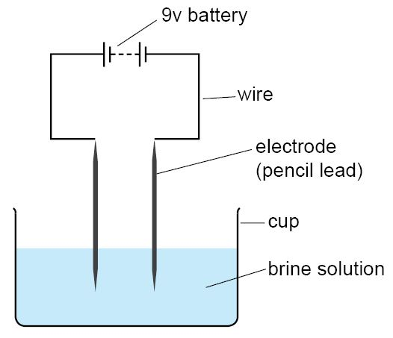
Battery correctly shown , two electrodes shown electrolyte solution shown

4. | Research the uses of the product of electrolysis of sodium chloride solution. Give at least two examples for each product and make sure say where you found the information. Try to use at least one offline (text book / encyclopaedia) and one online (web page) source.

Product | Use | Source
sodium hydroxide | cleaning product  making soap | https://hpd.nlm.nih.gov/cgi-bin/household/search?tbl=TblChemicals&queryx=1310-73-2, accessed on 26/04/2016  Modern Organic Chemistry by ROC Norman and DJ Waddington, (Mills and Boon , 1972)
chlorine | making bleaches  making plastics | https://en.wikipedia.org/wiki/Bleach, accessed on 26/4/2016  Chemistry in Context, Graham Hill and John Holman (Nelson Thornes Ltd, 2000)
hydrogen | rocket fuel  making margarine | http://www.nasa.gov/topics/technology/ hydrogen/hydrogen_fuel_of_choice.html , accessed on 26/04/2016  Essential Science for GCSE, Susanne Lakin and John Patefield (Nelson Thornes, 1998)

Document updates
v0.1 May 2016 Original – published on the OCR community
v1.1 February 2017 Consolidated labelling and formatting of activities
v1.2 June 2017 Updated hazard and risk assessments

OCR Resources: the small print
This formative assessment resource has been produced as part of our free GCSE teaching and learning support package. All the GCSE teaching and learning resources, including delivery guides, topic exploration packs, lesson elements and more are available on the qualification webpages.
If you are looking for examination practice materials, you can find Sample Assessment Materials (SAMs) on the qualification webpages: here

OCR’s resources are provided to support the teaching of OCR qualifications, but in no way constitute an endorsed teaching method that is required by the Board, and the decision to use them lies with the individual teacher. Whilst every effort is made to ensure the accuracy of the content, OCR cannot be held responsible for any errors or omissions within these resources.
© OCR 2017 - This resource may be freely copied and distributed, as long as the OCR logo and this message remain intact and OCR is acknowledged as the originator of this work.
OCR acknowledges the use of the following content: n/a
Please get in touch if you want to discuss the accessibility of resources we offer to support delivery of our qualifications: resources.feedback@ocr.org.uk
We’d like to know your view on the resources we produce. By clicking on ‘Like’ or ‘Dislike’ you can help us to ensure that our resources work for you. When the email template pops up please add additional comments if you wish and then just click ‘Send’. Thank you.
If you do not currently offer this OCR qualification but would like to do so, please complete the Expression of Interest Form which can be found here: www.ocr.org.uk/expression-of-interest
Looking for a resource? There is now a quick and easy search tool to help find free resources for your qualification:
www.ocr.org.uk/i-want-to/find-resources/

Chemistry PAG 2: Electrolysis

Combined Science PAG C1: Electrolysis

Suggested Activity 3: Some gas tests

Learner Activity

Introduction
Some simple gas substances can be produced relatively easily, and their indicative tests carried out. In this experiment, you will synthesis chlorine, oxygen and carbon dioxide and carry out the tests.
Contact lens solution, which contains hydrogen peroxide solution, can be decomposed with liver and the oxygen gas collected in washing up liquid bubbles. The gas can be tested with a glowing splint which will relight in the presence of oxygen.
Indigestion tablets contain calcium carbonate, which can be decomposed with vinegar, which contains acetic acid, to produce gaseous carbon dioxide. Lime water, which is saturated calcium hydroxide solution, will turn cloudy in the presence of carbon dioxide.
Brine, which contains sodium chloride in solution, can be electrolysed using a 9 V battery and two pencils as electrodes, producing hydrogen and chlorine gas. The chlorine can be tested with damp blue litmus paper, and the resultant alkaline solution, containing sodium hydroxide, can be tested with red cabbage indicator.

Aims
To make chlorine, oxygen and carbon dioxide gases and carry out simple tests on them.

Intended class time
30-45 minutes

Chemicals and equipment (per group)

3 × 30 cm³ plastic ‘shot glasses’
3 × polystyrene cup
teaspoon
grater
sieve
access to a kettle
2 × pencils
pencil sharpener
splints and lighter
9V battery
2 × wire with crocodile clips on either end
washing up liquid
red cabbage
table salt (sodium chloride)
indigestion tablets (contains calcium carbonate)
vinegar (contains ethanoic acid)
calf liver (contains catalase)
contact lens cleaning solution (contains hydrogen peroxide;
limewater (irritant to skin and eyes)
blue litmus paper

Health and Safety
Learners should wear eye protection during all practical work.
Ensure the room/laboratory is well ventilated, especially during the electrolysis reaction.
Ensure learners wash their hands thoroughly after all practical work.

Method
Method 1 – Making a testing oxygen  - About one-third fill a plastic shot glass with the contact lens / hydrogen peroxide solution.  - Add 1-2 drops of washing up liquid and stir thoroughly with a splint.  - Add the piece of liver to the liquid.  You should observe bubbles forming from the liver surface and being trapped in bubbles.  - Light a splint, allow to burn for 10 seconds, then blow it out.  Ensure the end of the splint is still glowing red.  - Place the glowing red end of the splint in the oxygen bubbles.  The splint should relight. | 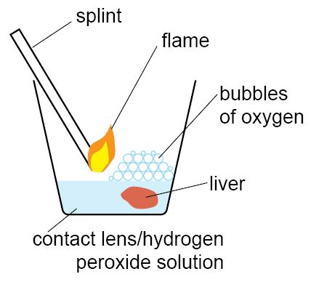
Method 2 – Making and testing carbon dioxide  - Half fill one shot glass with lime water.  - Half fill a second shot glass with vinegar.  - Add two indigestion tablets to the vinegar.  You should see the tablets fizzing.  - Tip the tablet/vinegar shot glass to about 45° and hold the top close to the top of the lime water glass. The carbon dioxide formed as the tablet reacts with the vinegar is denser than air so ‘spills’ out of one glass into the other.  - Gently swirl the lime water shot glass.  You should observe white precipitate forming due to the reaction of carbon dioxide with the limewater. | 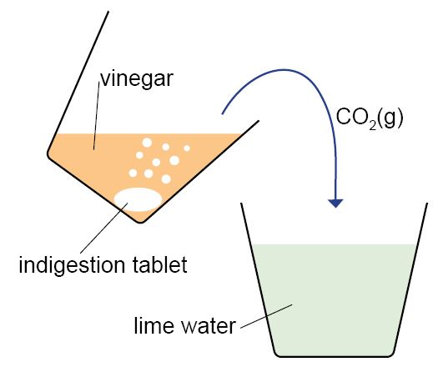

Method 3 – Making the red cabbage indicator  - Grate about a quarter of a red cabbage into a cup.  - Fill to cup with just boiled water to the level of the top of cabbage, and leave for 30 minutes.  - Pour the liquid through a sieve into another cup.  You should have a purple solution. | 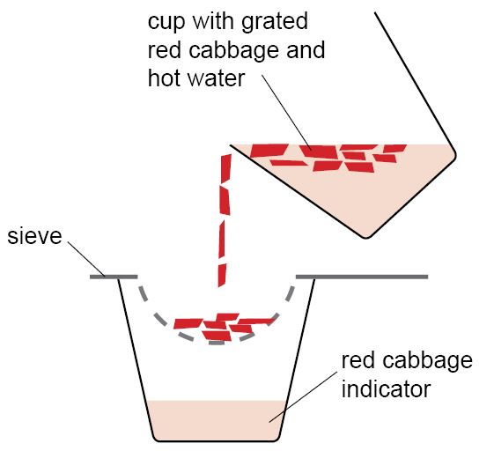
Method 4 – Making and testing chlorine  - One quarter fill a polystyrene cup with tap water.  - Add half a teaspoon of table salt to the water and mix thoroughly until completely dissolved.  You have made brine solution.  - Sharpen both ends of two pencils – these are your electrodes.  - Place both pencils into your brine solution.  - Use one wire with crocodile clips to connect the top end of one pencil to the positive terminal on the 9 V battery. This is your anode.  - Use the other wire to connect the other pencil to the negative terminal of the battery. This is your cathode.  You should now observe bubbles forming at two pencil leads in the solution.  - Dampen a piece of blue litmus paper, and hold close to the bubbles forming at the anode (positive electrode).  Write down your observations.  - Allow electrolysis to run for about 1-2 minutes, then remove the pencils from the cup and disconnect from the battery.  - Pour about half your cabbage indicator into the solution  You should observe a change in colour of the indicator from purple to blue. | 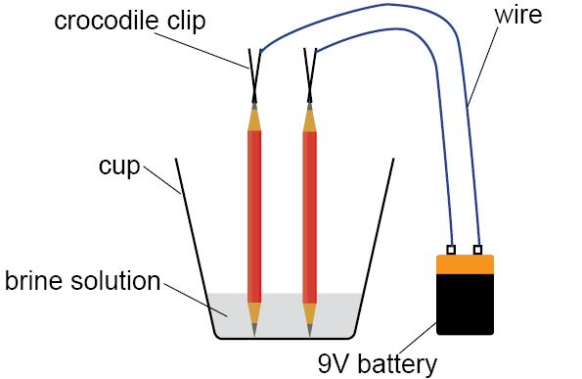

Analysis of results
You can draw your own table, or use the one below:
Test carried out | Observation
glowing splint in oxygen bubbles
carbon dioxide into lime water
boiling red cabbage
passing current through brine – positive electrode
passing current through brine – negative electrode
damp blue litmus paper near positive electrode
red cabbage indicator in remaining brine solution

Your ability to analyse your observations may depend on how much of the GCSE Chemistry/Combined Science course you have studied. Your teacher will let you know which questions you should focus on:
1. | For a flame to form you need the three components of the fire triangle, fuel, heat and oxygen. Describe and explain the evidence you have for the production of oxygen gas. [3 marks]

2. | Carbon dioxide forms an insoluble substance in limewater. Describe and explain the evidence you have for the production of carbon dioxide. [3 marks]

3. | Draw a diagram showing the electrochemical cell you used in Stage 4. [3 marks]

4. | Chlorine is an acidic gas. Describe and explain the evidence you have for the production of chlorine gas. [3 marks]

4. | Sodium hydroxide forms an alkaline solution. Describe and explain the evidence you have for the production of chlorine gas. [2 marks]

Extension Opportunities
1. | Write a word and symbol equation for the different reactions that have occurred:  [14 marks]
- catalytic decomposition of hydrogen peroxide (H₂O₂)

- combustion of the splint (assume wood has the formula C₆H₁₂O₆)

- carbon dioxide in lime water

- Half equation at the positive electrode (anode)

- Half equation at the negative electrode (cathode)

- Full redox equation in the sodium chloride solution

- Squeaky pop test in the hydrogen tube

2. | Identify which of the two half equations is a reduction and which an oxidation. Explain what these terms mean. [4 marks]
Reduction:

Oxidation:

3. | Research the uses of the product of electrolysis of sodium chloride solution. Give at least two examples for each product and make sure say where you found the information. Try to use at least one offline (text book / encyclopedia) and one online (web page) source.

DfE Apparatus and Techniques covered
The codes used below match the OCR Practical Activity Learner Record Sheet (Chemistry / Combined Science) and Trackers (Chemistry / Combined Science) available online. There is no requirement to use these resources.
Chemistry |  |  |  |  | Combined Science
6–i | 6–ii | 7–i | 7–ii |  | 11–i | 11–ii | 12–i | 12–ii
8–i

