Chemistry PAG 1: Reactivity trends

Suggested Activity 1: Reactivity trends of the halogens

Instructions and answers for teachers
and technicians
These instructions cover the learner activity section which can be found on page 12. This Practical activity supports OCR GCSE Chemistry and Combined Science. Note that while this PAG is not one of the Combined Science PAGs, this activity covered chemistry taught in the Combined Science course.
When distributing the activity section to the learners either as a printed copy or as a Word file you will need to remove the teacher instructions section.
This is a suggested practical activity that can be used as part of teaching the GCSE (9-1) Gateway Science (A) and Twenty First Century Science (B) specifications.
These are not controlled assessment tasks, and there is no requirement to use these particular activities.
You may modify these activities to suit your learners and centre. Alternative activities are available from, for example, Royal Society of Biology, Royal Society of Chemistry, Institute of Physics, CLEAPSS and publishing companies, or of your own devising.
Further details are available in the specifications (Practical Skills Topics), and in these videos.

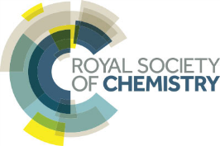 | This resource is adapted from the Practical Chemistry project, developed by the Nuffield Foundation and the Royal Society of Chemistry – http://www.rsc.org/learn-chemistry/collections/experimentation/practical-chemistry specifically the practical ‘Reactions of halogens (as aqueous solutions)’ – http://www.rsc.org/learn-chemistry/resource/res00000733/reactions-of-halogens-as-aqueous-solutions

OCR recommendations:
Before carrying out any experiment or demonstration based on this guidance, it is the responsibility of teachers to ensure that they have undertaken a risk assessment in accordance with their employer’s requirements, making use of up-to-date information and taking account of their own particular circumstances. Any local rules or restrictions issued by the employer must always be followed.
CLEAPSS resources are useful for carrying out risk-assessments: (http://science.cleapss.org.uk).
Centres should trial experiments in advance of giving them to learners. Centres may choose to make adaptations to this practical activity, but should be aware that this may affect the Apparatus and Techniques covered by the learner.

Introduction
In this activity, learners carry out a range of experiments with halogen solutions to determine the reactivity trend within Group 7.
An alternative activity is the RSC Classic chemistry experiment #19 “Reactions of halogens”: http://www.rsc.org/learn-chemistry/resource/res00000403/reactions-of-the-halogens.

DfE Apparatus and Techniques covered
The codes used below match the OCR Practical Activity Learner Record Sheet (Chemistry / Combined Science) and Trackers (Chemistry / Combined Science) available online. There is no requirement to use these resources.
By doing this experiment, learners have an opportunity to develop the following skills:
3 [8]: Use of appropriate apparatus and techniques for i) conducting and monitoring chemical reactions
6 [11]: Safe use and careful handling of gases, liquids and solids, including: i) careful mixing of reagents under controlled conditions, ii) using appropriate apparatus to explore chemical changes and/or products

Aims
To investigate the relative reactivity of the halogen via displacement reactions, and their bleaching power.

Intended class time
30 minutes

Links to Specifications:

Gateway Science (Suite A) – including Working Scientifically (WS)
C3.1b use the names and symbols of common elements and compounds and the principle of conservation of mass to write formulae and balanced chemical equations and half equations
C3.3b explain reduction and oxidation in terms of gain or loss of electrons, identifying which species are oxidised and which are reduced
C4.1a recall the simple properties of Group 1, 7 and 0 [to include physical and chemical properties]
C4.1b explain how observed simple properties of Groups 1, 7 and 0 depend on the outer shell of electrons of the atoms and predict properties from given trends down the groups [to include ease of electron gain or loss; physical and chemical properties]
C4.1d predict possible reactions and probable reactivity of elements from their positions in the periodic table
WS1.2e evaluate methods and suggest possible improvements and further investigations
WS1.3a presenting observations and other data using appropriate methods
WS1.3e interpreting observations and other data
WS1.3f presenting reasoned explanations relating data to hypotheses
WS1.4a use scientific vocabulary, terminology and definitions
WS2a carry out experiments
WS2b make and record observations and measurements using a range of apparatus and methods
WS2c presenting observations using appropriate methods to include descriptive, tabular diagrammatic and graphically

Twenty First Century Science (Suite B) – including Ideas about Science (IaS)
C1.1.10 use the names and symbols of common elements and compounds and the principle of conservation of mass to write formulae and balanced chemical equations
C2.2.5 recall the simple properties of Group 1 elements including their reaction with moist air, water, and chlorine
C2.2.6 recall the simple properties of Group 7 elements including their states and colours at room temperature and pressure, their colours as gases, their reactions with Group 1 elements and their displacement reactions with other metal halides
C2.2.7 predict possible reactions and probable reactivity of elements from their positions in the Periodic Table
C2.2.8 describe experiments to identify the reactivity pattern of Group 7 elements including displacement reactions
C3.3.4 use the names and symbols of common elements and compounds and the principle of conservation of mass to write half equations
C3.3.5 explain reduction and oxidation in terms of gain or loss of electrons, identifying which species are oxidised and which are reduced
IaS1.8. use appropriate scientific vocabulary, terminology and definitions to communicate the rationale for an investigation and the methods used using diagrammatic, graphical, numerical and symbolic forms
IaS2.1. present observations and other data using appropriate formats
IaS2.8. when analysing data identify patterns/trends, use statistics (range and mean) and obtain values from a line on a graph (including gradient, interpolation and extrapolation),
IaS2.11. in a given context interpret observations and other data (presented in diagrammatic, graphical, symbolic or numerical form) to make inferences and to draw reasoned conclusions, using appropriate scientific vocabulary and terminology to communicate the scientific rationale for findings and conclusions

Mathematical Skills covered
No defined mathematical skill is covered in this experiment.

Technical Requirements – PER GROUP

Chemicals
Identity | Approximate quantity required or produced PER GROUP | Hazard information |  | Risk information
c. 0.1% w/v chlorine water, Cl₂(aq)  (see CLEAPSS Recipe Book 25) | c. 1 cm³ |  | Chlorine water is currently not classified as hazardous. However, chlorine gas readily diffuses from the solution so label as:  DANGER: Toxic and corrosive (inhalation). Oxidiser. Very toxic to aquatic organisms. | Ensure the room is well ventilated. Be particularly aware of any learners with respiratory diseases (e.g. asthma).  Do not inhale the gas. Effects can be delayed.  Use a fume cupboard if available.
c. 0.1% w/v bromine water, Br₂(aq)  (see CLEAPSS Recipe Book 17) | c. 1 cm³ | Currently not classified as hazardous at this concentration
0.01 mol dm⁻³ iodine in 0.05 mol dm⁻³ potassium iodide solution,  I₂(aq)  (see CLEAPSS Recipe Book 50) | c. 1 cm³ | Currently not classified as hazardous at this concentration
0.1 mol dm⁻³ aqueous potassium chloride, KCl(aq) | c. 1 cm³ | Currently not classified as hazardous at this concentration
0.1 mol dm^{–3} aqueous potassium bromide solution, KBr(aq) | c. 1 cm³ | Currently not classified as hazardous at this concentration
0.1 mol dm^{–3} aqueous potassium iodide solution, KI(aq) | c. 1 cm³ | Currently not classified as hazardous at this concentration
cyclohexane, C₆H₁₂(l) | c. 1 cm³ |  | DANGER  May be fatal is swallowed and enters airways. May cause drowsiness or dizziness. Highly flammable liquid and vapour. Causes skin irritation. Very toxic or toxic to aquatic life with long lasting effects. | Ensure the room is well ventilated.  Ensure there are no naked flames in the laboratory.  If available, bromine water and the hydrocarbons should be placed in a fume cupboard and learners carry out the qualitative tests at the fume cupboard.

NOTE: Larger volumes will be required for the teacher demonstration of STAGE 1 (3–4 cm³ of each halogen water, and 5–6 cm³ of cyclohexane, plus 3 boiling tubes and bungs.

Equipment
- spotting tiles (minimum 4 × 3 wells)
- pipettes (or solutions in dropper bottles)
- universal indicator paper
- access to waste containers (see Notes)

Notes
These solutions are best made available in dropper bottles to help contain the reagents, minimise unintentional mixing due to incorrect use of dropper pipettes and for general convenience.
Disposal of solutions: have a large container sited in the fume cupboard for pouring solutions into. Have a large basin of water for glassware and spotting tiles to be placed in. The water can be disposed of down the foul water drain.

Health and Safety
Eye protection should be worn at all times.
Ensure the laboratory is well ventilated. Take particular care if you have any asthmatic members of the group.
The small volumes of cyclohexane and chlorine water suggested reduce the risks of these particularly hazardous substances. In practice, the hazardous concentrations exist close to the apparatus, so learners should refrain from having apparatus close to their face.

Method
Learners will observe the colour of the three halogens in organic solvent (pale yellow/green, orange/brown and pink/purple respectively) in the teacher demonstration, and should note that the colour is similar to that of the halogen vapour.
They will carry out reactions on spotting tiles, investigating the relative reactivity of the halogens (based on their ability to displace halides from solutions) and the bleaching power of the aqueous halogen solutions.
Ensure the learners understand the hazards of the chlorine water solution and cyclohexane, and they handle these with due care and respect, and dispose of them as instructed. Universal indicator paper can be disposed of in the bin.

Images from trials
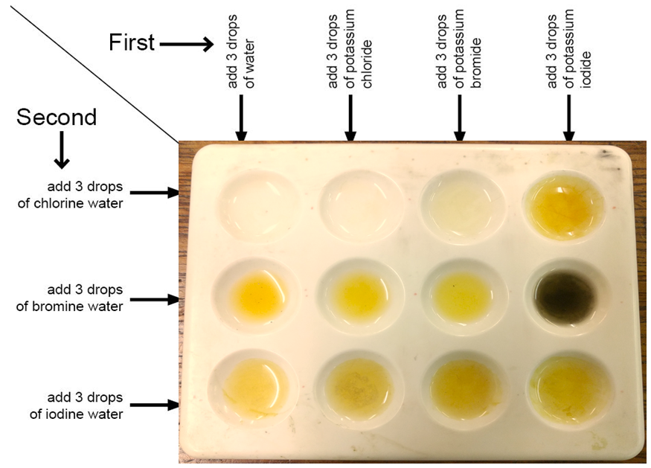 | Note the clearer change in colour with Cl₂ + KBr compared with Br₂ + KI (top row),  and then Br₂ + KI.
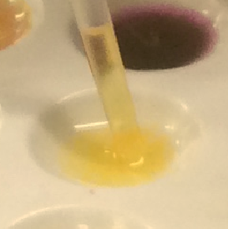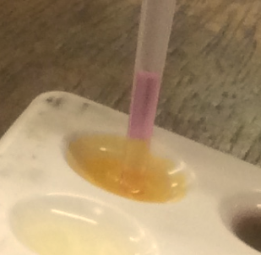 | The presence of halogens is more clearly seen with extraction into the cyclohexane layer  (left Br₂ in cyclohexane; right I₂ in cyclohexane).
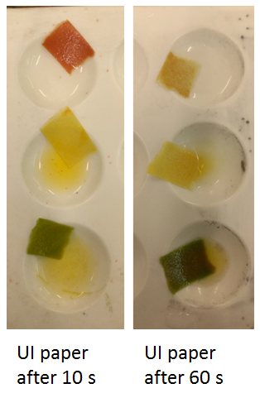 | Reaction of the halogen waters with universal indicator paper. Note the different acidity of the solutions, and the bleaching of the paper by chlorine water over time.

Analysis of results – Trial results
Halogen | Colour of upper organic layer after shaking with hydrocarbon solvent | Effect of indicator paper | Reaction with potassium chloride solution | Reaction with potassium bromide solution | Reaction with potassium iodide solution
chlorine | aqueous: pale yellow-green to colourless cyclohexane: colourless to pale yellow-green | turns red then quickly bleaches to a pale brown | no change in colour | very pale yellow solution formed | orange solution formed
bromine | aqueous: yellow-orange to colourless cyclohexane: colourless to pale yellow-orange | turns yellow – no obvious bleaching | no change in colour | no change in colour | colour darkens from yellow-orange to brown
Iodine | aqueous: brown to colourless cyclohexane: colourless to pink/purple | paper turns green – no obvious bleaching | no change in colour | no change in colour | no change in colour

Answer to questions
1. | Compare the colour of the halogens in the cyclohexane with the colour of their vapours [2 marks]
The vapour colours of the halogens are chlorine – pale yellow/green, bromine –orange/brown, iodine – pink/purple
The colour of the halogen solution in cyclohexane are similar to the
halogen vapour colours

2. | Using specific examples from your observations state and explain the trend in the reactivity of the halogens. Make specific reference to the outer shell electrons of the halogen atoms. [6 marks]
The reactivity trend of the halogens is chlorine > bromine > iodine
Chlorine displaces bromine and iodine from solution as shown by the dark solutions formed when chlorine water is mixed with potassium bromide and potassium iodide
Bromine displaces iodine, but not chlorine, from solution as shown by the darker solution forming when bromine water is mixed with potassium iodide
Chlorine is the most reactive of these three halogens as its outer electron shell is closest to its nucleus and therefore is a stronger oxidising agent (OR attracts electrons more strongly) than bromine or iodine

3. | Describe the trend in the bleaching power of the halogen solutions.[1 mark]
 | The bleaching power of the halogens increases up Group 7

Extension opportunities
1. | Explain why comparing the colour of the mixtures formed with solutions in the multi-well plate is more valid than with the solutions in the reagent bottles. [2 marks]
 | The volumes / depths of the solutions are the same so a fair comparison can be made about the colour difference

2. | Write word and symbol equations for all displacement reactions that occurred.  [6 marks]
chlorine + sodium bromide → bromine + sodium chloride
Cl₂(aq) + 2NaBr → Br₂(aq) + 2NaCl (aq)

chlorine + sodium iodide → iodine + sodium chloride
Cl₂(aq) + 2NaI → I₂(aq) + 2NaCl (aq)

bromine + sodium iodide → iodine + sodium bromide
Br₂(aq) + 2NaI → I₂(aq) + 2NaBr(aq)

3. | For the reaction between chlorine and potassium iodide, identify the oxidising and reducing agents, and explain the reaction in terms of movement of electrons.  [3 marks]
 | Chlorine is the oxidising agent and accepts an electron from iodide, which is the reducing agent .

4. | Chlorine is an acidic gas, forming acidic solutions in water. Some bleaches have the general formula HXO, where X is a halogen. Use this information to help you write a balanced symbol equation for the reaction that occurs when chlorine gas is bubbled through water. [2 marks]
Cl₂(g) + H₂O(l) → HCl (aq) + HClO(aq)
correct species correct state symbols

5. | Discuss the role of the potassium ions in the Stage 2 reactions. [2 marks]
 | Potassium ions are spectator ions so play no part in the redox reactions

Document updates
v1.1 February 2017 Published on qualification page
We’d like to know your view on the resources we produce. By clicking on ‘Like’ or ‘Dislike’ you can help us to ensure that our resources work for you. When the email template pops up please add additional comments if you wish and then just click ‘Send’. Thank you.
If you do not currently offer this OCR qualification but would like to do so, please complete the Expression of Interest Form which can be found here: www.ocr.org.uk/expression-of-interest
Looking for a resource? There is now a quick and easy search tool to help find free resources for your qualification:
www.ocr.org.uk/i-want-to/find-resources/
OCR Resources: the small print
This formative assessment resource has been produced as part of our free GCSE teaching and learning support package. All the GCSE teaching and learning resources, including delivery guides, topic exploration packs, lesson elements and more are available on the qualification webpages.
If you are looking for examination practice materials, you can find Sample Assessment Materials (SAMs) on the qualification webpages: here

OCR’s resources are provided to support the teaching of OCR qualifications, but in no way constitute an endorsed teaching method that is required by the Board, and the decision to use them lies with the individual teacher. Whilst every effort is made to ensure the accuracy of the content, OCR cannot be held responsible for any errors or omissions within these resources.
© OCR 2017, © Royal Society of Chemistry/Nuffield Foundation – this resource may freely copied and distributed by teachers for teaching purposes, student assessment and private use and by students for private use only. The OCR logo, this message and the notice of Content from the Royal Society of Chemistry/Nuffield Foundation must remain intact.
OCR acknowledges the use of the following content: http://www.rsc.org/learn-chemistry/resource/res00000733/reactions-of-halogens-as-aqueous-solutions?cmpid=CMP00006118
Please get in touch if you want to discuss the accessibility of resources we offer to support delivery of our qualifications: resources.feedback@ocr.org.uk

Chemistry PAG 1: Reactivity trends

Suggested Activity 1: Reactivity trends of the halogens

Learner Activity

Introduction
The elements of Group 7 in the Periodic Table are commonly called the halogens, meaning salt-formers, after the Greek term hals (salt). The halogens have many uses as elements, e.g. chlorine is used in producing bleach and plastics, and as compounds, e.g. sodium iodide is a dietary supplement to combat iodine deficiency. The halogens show trends in their chemical and physical properties. In this experiment, you will determine the order of reactivity of the halogens with respect to their bleaching ability and each other.

Aims
To investigate the relative reactivity of the halogen via displacement reactions, and their bleaching power.
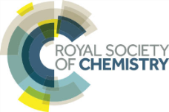 | This resource is adapted from the Practical Chemistry project, developed by the Nuffield Foundation and the Royal Society of Chemistry – http://www.rsc.org/learn-chemistry/collections/experimentation/practical-chemistry specifically the practical ‘Reactions of halogens (as aqueous solutions)’ – http://www.rsc.org/learn-chemistry/resource/res00000733/reactions-of-halogens-as-aqueous-solutions?cmpid=CMP00006118

Intended class time
30 minutes

Chemicals and equipment (per group)
- eye protection
- spotting tiles (4 × 3 wells)
- access to test tubes
- access to dropper bottles of
  - chlorine water (DANGER: Chlorine gas is toxic and corrosive– do not inhale the vapour)
  - bromine water
  - iodine water
  - potassium chloride solution
  - potassium bromide solution
  - potassium iodide solution
  - cyclohexane (DANGER: May be fatal is swallowed, may cause drowsiness or dizziness, highly flammable and irritant)
- universal indicator paper

Health and Safety
- Eye protection should be worn at all times.
- Ensure the laboratory is well-ventilated.
- Do NOT allow solutions of cyclohexane or chlorine water close to your face.
- Dispose of your reaction mixtures as instructed by your teacher.

Method
Your teacher will demonstrate this stage:
STAGE 1: Identifying the colour of halogens in an organic solvent
1. Label three boiling tubes ‘Cl₂ in ^{c}hex’, ‘Br₂ in ^{c}hex’ and ‘I₂ in ^{c}hex’.
2. Add 4–5 cm³ of chlorine water, bromine water and iodine water separately to the tubes.
3. Add 1–2 cm³ cyclohexane (^{c}hex) to each tube.
The ^{c}hex layer will be the upper layer – notice the initial colour of this layer.
4. Stopper the test tube with a bung to minimise the release of cyclohexane vapours.
5. Shake the tube vigorously side-to-side for 20 seconds.

As the layers separate you should see the upper organic layer has become coloured.
6. Repeat the shaking if the colouring is not strong, then record your observations.

STAGE 2: Investigating the trend in reactivity of the halogens

1. Set up a spotting tile as shown in Figure 1.
2. Each well requires a total of six drops.
3. Start by adding the solutions in columns (i.e. water, then the potassium halides). Add three drops of water to each well in the first column.
4. Repeat this process for potassium chloride, potassium bromide then potassium iodide.
5. Now add the halogen water rows: add three drops of chorine water to the first well in the first row, then three drops in each of the second, third and fourth well in the first row.
6. Repeat this process for bromine water then iodine water.

Observe carefully as you mix two substances together – is there an appreciable change in the colour of the mixture compared to the individual solutions?

- You can use the wells in the first column to compare with your reaction mixtures. Why does this allow a better comparison compared with the bottles of reagents?

Figure 1: The set-up of the spotting tiles

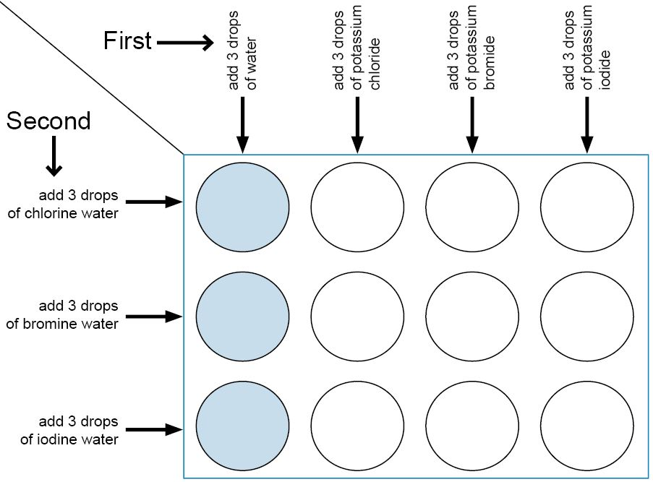

Your teacher may demonstrate stage 3

STAGE 3: Confirming the formation of halogens
For each drop where you noted a reaction occurring (significant change in colour):
- Add 4-5 drops of cyclohexane and mix several times with a pipette (pipette the mixture in and out).
- If the colour of the organic layer is not easy to observe, suck the liquid up into the pipette and observe the upper layer.

STAGE 4: The trend in bleaching power of the halogens
1. Place a small piece of universal indicator paper into the chlorine water drop on your spotting tile.
2. Repeat for the bromine water and iodine water drops.
3. Record your observations.

Analysis of results
You can draw your own table, or use the one below:
Halogen | Colour of upper organic layer after shaking with hydrocarbon solvent | Effect of indicator paper | Reaction with potassium chloride solution | Reaction with potassium bromide solution | Reaction with potassium iodide solution
chlorine
bromine
Iodine
Your ability to analyse your observations may depend on how much of the GCSE Chemistry/Combined Science course you have studied. Your teacher will let you know which questions you should focus on:
1. | Compare the colour of the halogens in the cyclohexane with the colour of their vapours [2 marks]

2. | Using specific examples from your observations state and explain the trend in the reactivity of the halogens. Make specific reference to the outer shell electrons of the halogen atoms. [6 marks]

3. | Describe the trend in the bleaching power of the halogen solutions.[1 mark]

Extension opportunities
1. | Explain why comparing the colour of the mixtures formed with solutions in the multi-well plate is more valid than with the solutions in the reagent bottles. [2 marks]

2. | Write word and symbol equations for all displacement reactions that occurred.  [6 marks]

3. | For the reaction between chlorine and potassium iodide, identify the oxidising and reducing agents, and explain the reaction in terms of movement of electrons.  [3 marks]

4. | Chlorine is an acidic gas, forming acidic solutions in water. Some bleaches have the general formula HXO, where X is a halogen. Use this information to help you write a balanced symbol equation for the reaction that occurs when chlorine gas is bubbled through water. [2 marks]

5. | Discuss the role of the potassium ions in the Stage 2 reactions. [2 marks]

DfE Apparatus and Techniques covered
If you are using the OCR Practical Activity Learner Record Sheet (Chemistry / Combined Science) you may be able to tick off the following skills:

Chemistry |  |  |  |  | Combined Science
3-i | 6-i | 6-ii |  |  | 8-i | 11-i | 11-ii

