Chemistry PAG 8: Measuring the rates of reaction

Combined Science PAG C5: Measuring the rates of reaction

Suggested Activity 3: Investigating reaction energetics

Instructions and answers for teachers
and technicians
These instructions cover the learner activity section which can be found on page 11. This Practical activity supports OCR GCSE Chemistry and Combined Science.
When distributing the activity section to the learners either as a printed copy or as a Word file you will need to remove the teacher instructions section.
This is a suggested practical activity that can be used as part of teaching the GCSE (9-1) Gateway Science (A) and Twenty First Century Science (B) specifications.
These are not controlled assessment tasks, and there is no requirement to use these particular activities.
You may modify these activities to suit your learners and centre. Alternative activities are available from, for example, Royal Society of Biology, Royal Society of Chemistry, Institute of Physics, CLEAPSS and publishing companies, or of your own devising.
Further details are available in the specifications (Practical Skills Topics), and in these videos.

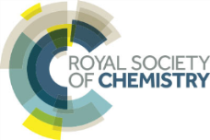 | This resource is adapted from the Practical Chemistry project, developed by the Nuffield Foundation and the Royal Society of Chemistry – http://www.rsc.org/learn-chemistry/collections/experimentation/practical-chemistry specifically the practical ‘Exothermic or endothermic?’ – http://www.rsc.org/learn-chemistry/resource/res00000406/exothermic-or-endothermic

OCR recommendations:
Before carrying out any experiment or demonstration based on this guidance, it is the responsibility of teachers to ensure that they have undertaken a risk assessment in accordance with their employer’s requirements, making use of up-to-date information and taking account of their own particular circumstances. Any local rules or restrictions issued by the employer must always be followed.
CLEAPSS resources are useful for carrying out risk-assessments: (http://science.cleapss.org.uk).
Centres should trial experiments in advance of giving them to learners. Centres may choose to make adaptations to this practical activity, but should be aware that this may affect the Apparatus and Techniques covered by the learner.

Introduction
Learners measure temperature changes of four reactions, and classify the reactions as exothermic or endothermic.

DfE Apparatus and Techniques covered
The codes used below match the OCR Practical Activity Learner Record Sheet (Chemistry / Combined Science) and Trackers (Chemistry / Combined Science) available online. There is no requirement to use these resources.
By doing this experiment, learners have an opportunity to develop the following skills:
1 [1] Use of appropriate apparatus to make and record a range of measurements accurately, including: (iii) temperature
3 [8] Use of appropriate apparatus and techniques for: (i) conducting and monitoring chemical reactions
5 [10] Making and recording of appropriate observations during chemical reactions including: (i) changes in temperature
6 [11] Safe use and careful handling of gases, liquids and solids, including: (i) careful mixing of reagents under controlled conditions (ii) using appropriate apparatus to explore chemical changes and/or products

Aims
To investigate a series of chemical reactions and determine whether they are exothermic or endothermic

Intended class time
30–50 minutes depending on planning time.

Links to Specifications:

Gateway Science (Suite A) – including Working Scientifically (WS)
C3.1a use chemical symbols to write the formulae of elements and simple covalent and ionic compounds
C3.1f describe the physical states of products and reactants using state symbols (s, l, g and aq)
C3.2a distinguish between endothermic and exothermic reactions on the basis of the temperature change of the surroundings
C3.3d describe neutralisation as acid reacting with alkali or a base to form a salt plus water
C3.3f recall that carbonates and some metals react with acids and write balanced equations predicting products from given reactants
WS1.2a use scientific theories and explanations to develop hypotheses
WS1.2b plan experiments or devise procedures to make observations, produce or characterise a substance, test hypotheses, check data or explore phenomena
WS1.3a Apply the cycle of collecting, presenting and analysing data, including: presenting observations and other data using appropriate methods
W1.3f Apply the cycle of collecting, presenting and analysing data, including: presenting reasoned explanations
WS2a carry out experiments
WS2b make and record observations and measurements using a range of apparatus and methods
WS2c presenting observations using appropriate methods
WS2d communicating the scientific rationale for investigations, methods used, findings and reasoned conclusions.

Twenty First Century Science (Suite B) – including Ideas about Science (IaS)
C1.2.1 distinguish between endothermic and exothermic reactions on the basis of the temperature change of the surroundings
C1.2.7 describe how you would investigate a chemical reaction to determine whether it is endothermic or exothermic (separate science only)
C2.4.1 use chemical symbols to write the formulae of elements and simple covalent and ionic compounds
C2.4.4 describe the physical states of products and reactants using state symbols (s, l, g and aq)
C5.4.4 describe neutralisation as acid reacting with alkali to form a salt plus water including the common laboratory acids hydrochloric acid, nitric acid and sulfuric acid and the common alkalis, the hydroxides of sodium, potassium and calcium
C6.1.1 recall that acids react with some metals and with carbonates and write equations predicting products from given reactants
IaS1.1 in given contexts use scientific theories and tentative explanations to develop and justify hypotheses and predictions
IaS2.1 present observations and other data using appropriate formats
IaS2.11 in a given context interpret observations and other data (presented in diagrammatic, graphical, symbolic or numerical form) to make inferences and to draw reasoned conclusions, using appropriate scientific vocabulary and terminology to communicate the scientific rationale for findings and conclusions

Mathematical Skills covered
No defined mathematical skill is covered in this experiment.

Technical Requirements – PER GROUP

Chemicals
Identity | Approximate quantity required or produced PER GROUP | Hazard information |  | Risk information
magnesium ribbon | 1 × 4 cm strip | Not currently classified as hazardous in this form. |  | Magnesium ribbon is flammable. Pre-cut the ribbon and supervise its distribution. Do not have the stock roll in the laboratory.
magnesium powder | access to small pot |  | DANGER: Flammable solid. Self-heating in large quantities (> 1kg); may catch fire. In contact with water releases flammable gases. | Portion out in small pots. Ensure there are no naked flames in the laboratory.
citric acid solid, | access to small pot |  | WARNING  Irritant (skin, eyes)  Irritant (respiratory) | Ensure learners wash hands / clean up spills promptly
0.4 mol/dm³ copper(II) sulfate solution | c. 20 cm³ |  | DANGER  Corrosive (eyes)  Irritant (skin)
0.4 mol dm^{–3} aqueous hydrochloric acid, HCl(aq) | c. 20 cm³ | Currently not classified as hazardous at this concentration
0.4 mol dm^{–3} sodium hydroxide solution | c. 20 cm³ |  | WARNING  Irritant (skin, eyes)
0.4 mol/dm³ sulfuric(VI) acid, H₂SO₄(aq) | c. 20 cm³ | Currently not classified as hazardous at this concentration
0.4 mol dm^{–3} aqueous sodium hydrogen carbonate, NaHCO₃(aq) | c. 20 cm³ | Currently not classified as hazardous at this concentration
hydrogen gas, H₂(g) PRODUCED | c. 25 cm³ |  | DANGER: Extremely flammable | Wear eye protection. Ensure laboratory is well ventilated. Ensure there are no naked flames.

Equipment
- eye protection
- polystyrene cup
- beaker (250 cm³)
- thermometer (–10°C to 110°C)
- measuring cylinder (10 cm³)
- spatula
- paper towels

Health and Safety
Eye protection should be worn at all times.
Ensure that there are no open flames in the laboratory
Ensure that no learner is allowed to remove magnesium from the laboratory

Method
Learners will plan their own method to carry out these reactions. They should recognise that they need to take a temperature measurement before mixing the reagents and afterwards. Therefore, placing a liquid reagent in the polystyrene cup first is preferred. They should recognise the need to carefully rinse and dry the cup between reactions to prevent any unexpected reactions.

Sample method:
- Place the polystyrene cup in the beaker to stabilise the cup, and provide some insulation.
- Add 20 cm³ of hydrochloric acid into the cup.
- Measure and record the temperature of the solution.
- Add 20 cm³ of sodium hydroxide into the cup.
- Stir the mixture with the thermometer and note the highest temperature.
- Dispose of the reaction mixture down the sink with plenty of water.
- Rinse and dry the cup.
- Repeat for the remaining mixtures.

Sample table:
Reaction | Final temperature / °C | Initial temperature / °C | Change in temperature / °C | Exothermic or endothermic reaction
hydrochloric acid + sodium hydroxide
sodium hydrogen carbonate solution + citric acid solid
copper sulfate solution + magnesium powder
sulfuric acid + magnesium ribbon

Images from trials
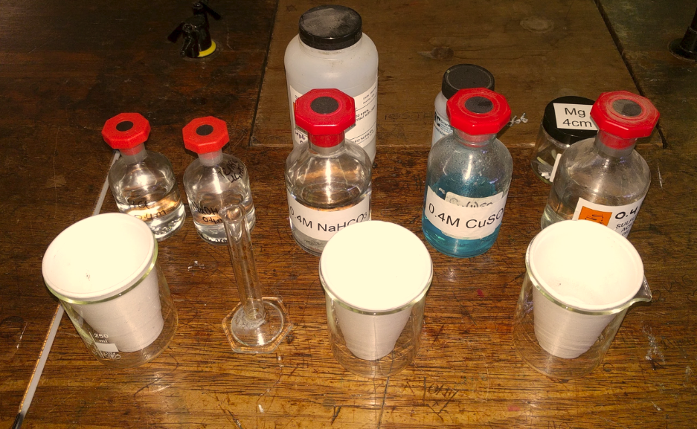
A sample experimental setup

Analysis of results – trial
Reaction | Final temperature / °C | Initial temperature / °C | Change in temperature / °C | Exothermic or endothermic reaction
20 cm³ hydrochloric acid  + 20 cm³ sodium hydroxide | 21 | 18 | + 3 | exothermic
20 cm³ sodium hydrogen carbonate solution  + 4 spatulas citric acid solid | 16 | 18 | – 2 | endothermic
20 cm³ copper sulfate solution  + 2 spatulas magnesium powder | 39 | 19 | + 20 | exothermic
20 cm³ sulfuric acid  + 4 cm magnesium ribbon | 30 | 19 | +11 | exothermic

1. | Which reactions are neutralisation reactions? [2 marks]
sodium hydroxide and hydrochloric acid
sodium hydrogen carbonate and citric acid

2. | Which reactions are displacement reactions? [2 marks]
copper sulfate and magnesium
sulfuric acid and magnesium

Extension opportunities
1. | Write word and symbol equations for the different reactions that have occurred:  - Reaction 1 [2 marks]
sodium hydroxide + hydrochloric acid → sodium chloride + water
NaOH(aq) + HCl(aq) → NaCl(aq) + H₂O(l)

- Reaction 2 [2 marks]
copper sulfate + magnesium → magnesium sulfate + copper
CuSO₄(aq) + Mg(s) → MgSO₄(aq) + Cu(s)
- Reaction 3 [2 marks]
sulfuric acid + magnesium → magnesium sulfate + hydrogen
H₂SO₄(aq) + Mg(s) → MgSO₄(aq) + H₂(g)
- Reaction 4 (just word equation) [1 mark]
sodium hydrogencarbonate + citric acid → sodium citrate + water + carbon dioxide

Document updates
v1.1 February 2017 Published on qualification page

We’d like to know your view on the resources we produce. By clicking on ‘Like’ or ‘Dislike’ you can help us to ensure that our resources work for you. When the email template pops up please add additional comments if you wish and then just click ‘Send’. Thank you.
If you do not currently offer this OCR qualification but would like to do so, please complete the Expression of Interest Form which can be found here: www.ocr.org.uk/expression-of-interest
Looking for a resource? There is now a quick and easy search tool to help find free resources for your qualification:
www.ocr.org.uk/i-want-to/find-resources/
OCR Resources: the small print
This formative assessment resource has been produced as part of our free GCSE teaching and learning support package. All the GCSE teaching and learning resources, including delivery guides, topic exploration packs, lesson elements and more are available on the qualification webpages.
If you are looking for examination practice materials, you can find Sample Assessment Materials (SAMs) on the qualification webpages: here

OCR’s resources are provided to support the teaching of OCR qualifications, but in no way constitute an endorsed teaching method that is required by the Board, and the decision to use them lies with the individual teacher. Whilst every effort is made to ensure the accuracy of the content, OCR cannot be held responsible for any errors or omissions within these resources.
© OCR 2017, © Royal Society of Chemistry/Nuffield Foundation – this resource may freely copied and distributed by teachers for teaching purposes, student assessment and private use and by students for private use only. The OCR logo, this message and the notice of Content from the Royal Society of Chemistry/Nuffield Foundation must remain intact.
OCR acknowledges the use of the following content: http://www.rsc.org/learn-chemistry/resource/res00000406/exothermic-or-endothermic
Please get in touch if you want to discuss the accessibility of resources we offer to support delivery of our qualifications: resources.feedback@ocr.org.uk

Chemistry PAG 8: Measuring the rates of reaction

Combined Science PAG C5: Measuring the rates of reaction

Suggested Activity 3: Investigating reaction energetics

Learner Activity

Introduction
During a chemical reaction, energy is transferred between the system and the surroundings. An exothermic reaction transfers energy to the surrounding, while an endothermic reaction gains energy from the surroundings. When energy transfers as heat, the change in the temperature can be measured using a thermometer. In this experiment, you will measure the temperature change in a series of chemical reactions in order to determine whether they are exothermic or endothermic.

Aims
To investigate a series of chemical reactions and determine whether they are exothermic or endothermic

Intended class time
10-20 minutes planning time + 20-30 minutes practical time

Chemicals and equipment (per group)

- eye protection
- polystyrene cup
- beaker (250 cm³)
- thermometer (-10°C to 110°C)
- measuring cylinder (10 cm³)
- spatula
- paper towel
- magnesium ribbon
- magnesium powder (DANGER: Flammable)
- citric acid solid (WARNING: Irritant)
- 0.4 mol dm^{–3} copper(II) sulfate (DANGER: Corrosive and irritant)
- 0.4 mol dm^{–3} hydrochloric acid
- 0.4 mol dm^{–3} sodium hydroxide (WARNING: Irritant)
- 0.4 mol dm^{–3} sulfuric acid
- 0.4 mol dm^{–3} sodium hydrogen carbonate

Health and Safety
- Eye protection should be worn at all times.
- Ensure that there are no open flames in the laboratory
- DO NOT remove any chemical from the classroom.

Method
Using the equipment available to you, plan an experimental method to investigate the reaction energetics of the following reactions:
- sodium hydroxide solution + hydrochloric acid solution
- copper sulfate solution + magnesium powder
- sulfuric acid solution + magnesium ribbon.
- sodium hydrogen carbonate solution + citric acid solid
Consider the measurements that you will need to make to determine the temperature change of the reaction, and hence determine whether the reaction is exothermic or endothermic.
Write down your method, draw an appropriate table to collect and analyse your data, and have your teacher approve these before you start any experimental work.

Method

Results

Your ability to analyse your observations may depend on how much of the GCSE Chemistry/Combined Science course you have studied. Your teacher will let you know which questions you should focus on:
1. | Which reactions are neutralisation reactions? [2 marks]
2. | Which reactions are displacement reactions? [2 marks]

Extension opportunities
1. | Write word and symbol equations for the different reactions that have occurred:
 | - Reaction 1 [2 marks]
 | - Reaction 2 [2 marks]
 | - Reaction 3 [2 marks]
 | - Reaction 4 (just word equation) [1 mark]

DfE Apparatus and Techniques covered
If you are using the OCR Practical Activity Learner Record Sheet (Chemistry / Combined Science) you may be able to tick off the following skills:

Chemistry |  |  |  |  | Combined Science
1-iii | 3-i | 5-i | 6-i |  | 1-iii | 8-i | 10-i | 11-i
6-ii |  |  |  |  | 11-ii

