Lesson Element

Experimental Designs

Instructions and answers for teachers

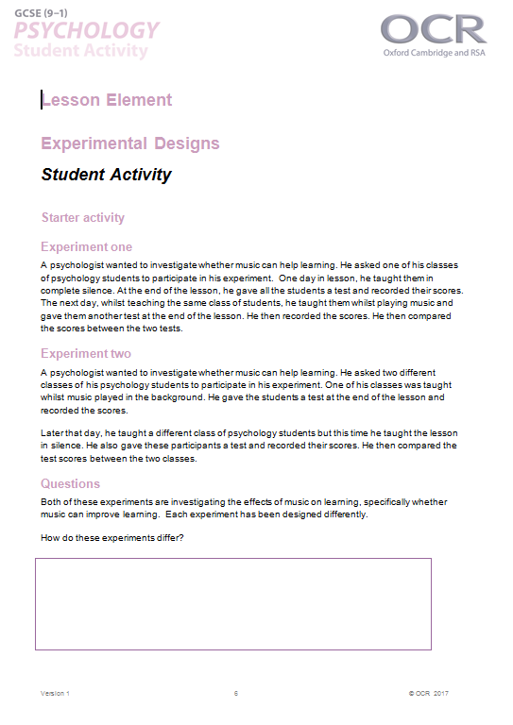
These instructions cover the student activity section which can be found on page 8. This Lesson element supports OCR GCSE Psychology.
When distributing the activity section to the students either as a printed copy or as a Word file you will need to remove the teacher instructions section.

Introduction
Students are required to have knowledge of the different types of experimental designs: Independent measures and repeated measures. They should be able to identify strengths and weaknesses of using the designs and suggest ways in which the potential weaknesses can be overcome.
An experiment is the only research method used by psychologists which tests cause and effect. It does this by manipulating the independent variable to see the effect it has on the dependent variable. As such all experiments will have two or more conditions of the independent variable.
The way the experiment is constructed will directly affect the outcome. There are three ways in which an experiment can be constructed and these are called experimental designs. They are: the independent measures design, the repeated measures design and the matched pairs design. However, for the OCR GCSE specification students will only need to know independent measures design and repeated measures design. These all reflect the way participants are allocated to the conditions of the independent variable.
The key objectives are to familiarise students with:
- How participants are allocated to conditions of the independent variable in experiments using an Independent measures and repeated measures.
- The strengths and weaknesses of using these experimental designs.


- How these weaknesses can be overcome (for example using counterbalancing in repeated measures designs).
This activity offers an opportunity for English skills development.
This activity offers an opportunity for maths skills development.

Lesson Guidance
Students must have an understanding of variables BEFORE they learn about experimental designs.

Starter Activity
This lesson could begin by giving students the extract sheet. This describes two experiments; the first adopting an independent measures experimental design and the second a repeated measures experimental design. Working in pairs or alone, students should read the extracts and the following questions could be posed to them:
- What is different about the experiments?
- How might the way it’s been designed affect the outcome of the experiment?
- How might the experiments be designed differently? What might be the benefit of doing this?
Stretch and challenge: There is an opportunity here to stretch students. They could be asked to identify the independent and dependent variable in each extract or to write an aim or hypothesis (from previous lessons). Or to identify possible extraneous variables and controls such as the use of the same test or using different tests to measure learning.
This should stimulate discussion and can be used to illustrate that experiments can be designed differently and that how they are designed can affect the outcome.

Teacher answers for starter activity
In experiment one, the teacher has used same group of participants twice. This could lead the following problems:
The participants may guess what the teacher is trying to investigate (demand characteristics).
The participants may get better the second time because they have done it before (practice effect).
The participants may get bored doing it twice (boredom).
The participants may be tired the second time round (fatigue).
This is an experiment using a repeated measures design.
In experiment two, the teacher has used two different groups of students in each condition (music and silence). This could lead to inaccurate results as the participants could vary in their ability to learn naturally regales of whether music is being played or not. For example the students in the music condition could be ‘stronger’ in ability in than those who do the lesson later that day.
This is an experiment using an independent measures design.

Worksheet 1 and Activity 1
Using the worksheet - take students through the construction of the two experimental designs.
In order to ensure students understand these experimental designs, the class could be asked to decide whether independent measures or repeated measures are being used in the scenarios in Activity A, as part of this reasons why could be written. As an extension activity, the experimental designs within the key research studies could also be identified.
Activity B: Students are required to use the two experimental designs to construct an investigation. If necessary help them to identify the independent variable and the two conditions (coffee (1) and water (2)).
Working in small groups, students are required to use the two experimental designs to allocate the participants to the two conditions. Once achieved, they should discuss the potential problems with each of the designs and for extension, they could be asked to consider how they might be overcome.
This activity will assess understanding of the two experimental designs and allow students to apply their knowledge to a novel source, this should also stimulate discussion on the weaknesses of the designs.
Namely you should focus on the following weaknesses:
Independent measures design | There may be participant variables because different participants take part in each condition. These will naturally affect the independent variable. Increased potential for demand characteristics.
Repeated measures design | Because participants are doing both conditions, one or more of the following may occur: Order effects – fatigue, boredom or practice
OCR Resources: the small print
OCR’s resources are provided to support the teaching of OCR specifications, but in no way constitute an endorsed teaching method that is required by the Board, and the decision to use them lies with the individual teacher. Whilst every effort is made to ensure the accuracy of the content, OCR cannot be held responsible for any errors or omissions within these resources.
© OCR 2015 - This resource may be freely copied and distributed, as long as the OCR logo and this message remain intact and OCR is acknowledged as the originator of this work.
OCR acknowledges the use of the following content: Maths icon: Air0ne/Shutterstock.com
Please get in touch if you want to discuss the accessibility of resources we offer to support delivery of our qualifications: resources.feedback@ocr.org.uk

Activity 1
Ideas for possible problems that students may come up with and how they might be overcome are outlined below.
INDEPENDENT MEASURES
Divide the twenty participants in half. 10 take part in condition 1 (drink coffee) and complete the concentration task and the other 10 take part in condition 2 (drink water) and complete the concentration task.
Potential problems….
Some people may be naturally better at concentrating than others regardless of coffee intake.
Some participants may have drank coffee before they arrived at the experiment.
Some people may drink coffee all the time and some may never drink it so the caffeine will affect them differently.
Extension: How might we overcome these?
Ask them not to drink coffee on the day of the experiment (control).
Make sure that we randomly allocate the participants to the conditions.
Potential problems….
Doing the concentration task twice means they may be better second time round anyway as they will have had some practice at it.
Participants may get bored doing it twice so not do as well in condition 2.
Participants may guess what the experiment is looking for and behave differently.
Extension: How might we overcome these?
Change the concentration task in condition 2.
Use counterbalancing (ABBA).

REPEATED MEASURES
All twenty participants do condition 1 (drink coffee) and complete the concentration task. The next day all of the participants come back and do condition 2 (drink water) and complete the concentration task.

Worksheet 2
This hand-out gives students information on the process of counterbalancing as a method of reducing order effects (caused by practice or boredom). This also includes an activity whereby students can apply the knowledge they have acquired on this topic to a novel situation.

Worksheet 3
This could be given as a homework activity. The aim is for students to consolidate their knowledge of the strengths and weaknesses of the designs and how to overcome these problems. This can be referred to later as a revision aid. Examples of the different experimental design could also be added to the table.

Worksheet 3 Strengths and Weaknesses of Experimental Designs
Teacher answers
Experimental Design | Strengths | Weaknesses | Overcome by
Independent measures | Demand characteristics are less likely as the participants only take part in one condition.  No chance of order effects; practice, fatigue or boredom. | Individual differences are a problem, characteristics such as age and gender could affect the dependent variable. | Randomly assign participants to the conditions.
Repeated measures  We’d like to know your view on the resources we produce. By clicking on ‘Like’ or ‘Dislike’ you can help us to ensure that our resources work for you. When the email template pops up please add additional comments if you wish and then just click ‘Send’. Thank you.  Whether you already offer OCR qualifications, are new to OCR, or are considering switching from your current provider/awarding organisation, you can request more information by completing the Expression of Interest form which can be found here: www.ocr.org.uk/expression-of-interest  Looking for a resource? There is now a quick and easy search tool to help find free resources for your qualification:  www.ocr.org.uk/i-want-to/find-resources/ | Reduces the effects of individual differences as all participants take part in both conditions. | Order effects can be problem including practice (getting better in condition 2 because they’ve done it before), or participants may become bored or tired. | Counterbalancing can reduce order effects.
OCR Resources: the small print
OCR’s resources are provided to support the teaching of OCR specifications, but in no way constitute an endorsed teaching method that is required by the Board, and the decision to use them lies with the individual teacher. Whilst every effort is made to ensure the accuracy of the content, OCR cannot be held responsible for any errors or omissions within these resources.
© OCR 2017 - This resource may be freely copied and distributed, as long as the OCR logo and this message remain intact and OCR is acknowledged as the originator of this work.
OCR acknowledges the use of the following content: English and Maths icon: Air0ne/Shutterstock.com, open book: LankS, games console: Nata-Lia/Shutterstock.com, Beer: Boule/Shutterstock.com, flags: PhotoStockImage/Shutterstock.com, stress ball: Lars Hallstrom/Shutterstock.com, Su Doku: Roberto Sanchez/Shutterstock.com, ABBA: PA IMAGES MOVED ACROSS / PA ARCHIVE IMAGES / EMPICS Sports Photo Agency / John Birdsall Social Issues Photo Library / Press Association Images / Universal Images Group
Please get in touch if you want to discuss the accessibility of resources we offer to support delivery of our qualifications: resources.feedback@ocr.org.uk
We’d like to know your view on the resources we produce. By clicking on ‘Like’ or ‘Dislike’ you can help us to ensure that our resources work for you. When the email template pops up please add additional comments if you wish and then just click ‘Send’. Thank you.
Whether you already offer OCR qualifications, are new to OCR, or are considering switching from your current provider/awarding organisation, you can request more information by completing the Expression of Interest form which can be found here: www.ocr.org.uk/expression-of-interest
Looking for a resource? There is now a quick and easy search tool to help find free resources for your qualification:
www.ocr.org.uk/i-want-to/find-resources/

We’d like to know your view on the resources we produce. By clicking on ‘Like’ or ‘Dislike’ you can help us to ensure that our resources work for you. When the email template pops up please add additional comments if you wish and then just click ‘Send’. Thank you.
Whether you already offer OCR qualifications, are new to OCR, or are considering switching from your current provider/awarding organisation, you can request more information by completing the Expression of Interest form which can be found here: www.ocr.org.uk/expression-of-interest
Looking for a resource? There is now a quick and easy search tool to help find free resources for your qualification:
www.ocr.org.uk/i-want-to/find-resources/

We’d like to know your view on the resources we produce. By clicking on ‘Like’ or ‘Dislike’ you can help us to ensure that our resources work for you. When the email template pops up please add additional comments if you wish and then just click ‘Send’. Thank you.
Whether you already offer OCR qualifications, are new to OCR, or are considering switching from your current provider/awarding organisation, you can request more information by completing the Expression of Interest form which can be found here: www.ocr.org.uk/expression-of-interest
Looking for a resource? There is now a quick and easy search tool to help find free resources for your qualification:
www.ocr.org.uk/i-want-to/find-resources/

We’d like to know your view on the resources we produce. By clicking on ‘Like’ or ‘Dislike’ you can help us to ensure that our resources work for you. When the email template pops up please add additional comments if you wish and then just click ‘Send’. Thank you.
Whether you already offer OCR qualifications, are new to OCR, or are considering switching from your current provider/awarding organisation, you can request more information by completing the Expression of Interest form which can be found here: www.ocr.org.uk/expression-of-interest
Looking for a resource? There is now a quick and easy search tool to help find free resources for your qualification:
www.ocr.org.uk/i-want-to/find-resources/

We’d like to know your view on the resources we produce. By clicking on ‘Like’ or ‘Dislike’ you can help us to ensure that our resources work for you. When the email template pops up please add additional comments if you wish and then just click ‘Send’. Thank you.
Whether you already offer OCR qualifications, are new to OCR, or are considering switching from your current provider/awarding organisation, you can request more information by completing the Expression of Interest form which can be found here: www.ocr.org.uk/expression-of-interest
Looking for a resource? There is now a quick and easy search tool to help find free resources for your qualification:
www.ocr.org.uk/i-want-to/find-resources/

Lesson Element

Experimental Designs

Student Activity

Starter activity

Experiment one
A psychologist wanted to investigate whether music can help learning. He asked one of his classes of psychology students to participate in his experiment. One day in lesson, he taught them in complete silence. At the end of the lesson, he gave all the students a test and recorded their scores. The next day, whilst teaching the same class of students, he taught them whilst playing music and gave them another test at the end of the lesson. He then recorded the scores. He then compared the scores between the two tests.

Experiment two
A psychologist wanted to investigate whether music can help learning. He asked two different classes of his psychology students to participate in his experiment. One of his classes was taught whilst music played in the background. He gave the students a test at the end of the lesson and recorded the scores.
Later that day, he taught a different class of psychology students but this time he taught the lesson in silence. He also gave these participants a test and recorded their scores. He then compared the test scores between the two classes.

Questions
Both of these experiments are investigating the effects of music on learning, specifically whether music can improve learning. Each experiment has been designed differently.
How do these experiments differ?

What problems are there with the way each experiment has been designed?

How do you think the way they have been designed will affect the outcome of the experiment?

Can you suggest any improvements to the experiment’s designs?

Worksheet 1 Experimental Design
An experiment must have two (or more) conditions and these conditions can be arranged in a number of ways. The way in which they are arranged is called the Experimental Design.
Types of Experimental Design
- Independent measures.
- Repeated measures.
Experimental design is important, as the validity of an experiment is directly affected by the way it’s constructed.
Let’s imagine we recruit twenty participants to take part in an experiment. There are two ways in which we could allocate them to the conditions of the independent variable.
1) INDEPENDENT MEASURES
Different participants take part in each condition of the independent variable and so 10 participants would be placed into condition 1 and 10 in condition 2.
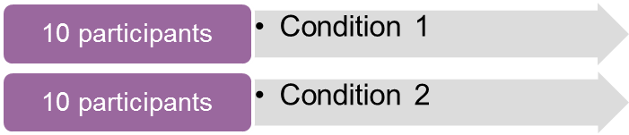
The participants remain independent from each other.
2) REPEATED MEASURES
All of the participants take part in BOTH conditions of the independent variable.

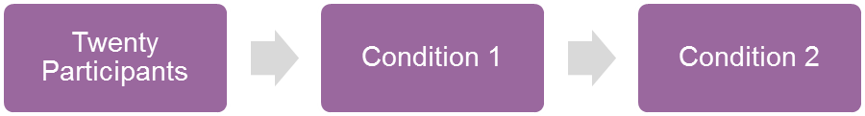
The participants repeat the experiment whilst taking part in all of the conditions.

Worksheet 1 – Activity A
 |  | Answer
An investigation into whether teenage girls read more books than middle aged men. | 
A study into whether a group of 15 year old boys prefer playing Call of Duty or Grand Theft Auto. | 
Research into whether a sample of students from one University spends more time in the library or in the pub. | 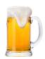
Researching whether time to complete a Sudoku puzzle is quicker before or after lunch in a group of 20 pensioners. | 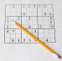

Worksheet 1 – Activity B
You have been asked to investigate whether participants who drink coffee have an increased concentration span than those who drink water. You have recruited twenty participants. Your task is to design an experiment using the two experimental designs: Independent measures and repeated measures.
The independent variable is
And so:
Condition 1 is:
Condition 2 is:
Once you have done this, consider what problems you may encounter with each design. For example, think about how using that design may affect the outcome of the research (i.e. the results)

Activity 1 – Experimental Design
INDEPENDENT MEASURES
REPEATED MEASURES

Potential problems….
Extension: How might we overcome these?
Potential problems….
Extension: How might we overcome these?

Worksheet 2 Experimental Designs

Counterbalancing
Counterbalancing is a technique used to reduce order effects when using a repeated measures design.
It varies the order in which participants take part in each condition of the independent variable so the order in which they do each condition is different.
Let’s take two conditions and label them Condition A and condition B. Using twenty participants we could allocate them as follows:
A (condition 1)
B (condition 2)

10 participants
10 participants

Participants do condition 1 first, followed by condition 2.
An order effect may occur here as all of the participants are taking part in condition B second.

Now let’s implement counterbalancing known as the ‘ABBA’ design.
A (condition 1)
B (condition 2)
5 participants
5 participants

B (condition 2)
A (condition 1)
5 participants
5 participants

So it’s called ABBA as half of the participants take part in condition A first, then do condition B (AB) and the other half take part in condition B first, then do A (BA). As such the order in which the participants take part is different and so the order effect is removed, or at the very least reduced.

Activity
Let’s imagine you are running an experiment to test the effects of colour on reading ability. Your hypothesis is ‘participants who read text on coloured paper will read with increased accuracy (less errors) than those who read text on white paper’.
Identify the independent and dependent variable:
IV
DV
Your task is to design the experiment using a repeated measures design incorporating counterbalancing.

Worksheet 3 Strengths and Weaknesses of Experimental Designs
Complete the table.
Experimental Design | Strengths | Weaknesses | Overcome by
Independent measures
Repeated measures

