# Multiple Choice Questions (MCQ) topic quiz

# Set 4 Field and particle physics

## Instructions and answers for teachers

These instructions cover the learner activity section which can be found on page 28 of this document.

This Lesson Element supports OCR AS and A Level Physics B (Advancing Physics).

**When distributing the activity section to the students either as a printed copy or as a   
Word file you will need to remove the teacher instructions section.**

### The Activity

This Lesson Element is a teaching and learning resource containing 33 multiple choice questions (MCQs) on the theme of Particles and medical physics. Some questions might require synoptic thinking, using knowledge and ideas from various topics across the full A Level content.

This resource can be used to test and consolidate understanding at the end of a topic or to revisit and refresh knowledge at a later point in the course.

### Introduction

Multiple choice questions allow rapid coverage of a wide range of sub-topics.

Contrary to a widespread belief among students, multiple choice questions are not necessarily easy – they can be easy, moderate or difficult.

The questions are written so that the incorrect answers are plausible distractors based on common errors or misconceptions.

When the developers are writing such questions they have to provide the logic to support their answers and the reasoning for each distractor.

**For example for question 4:**

24 A bar magnet is allowed to fall vertically through a coil.

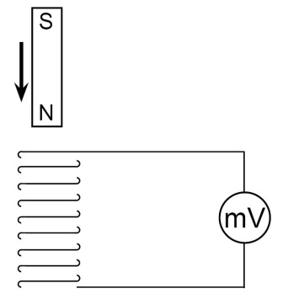

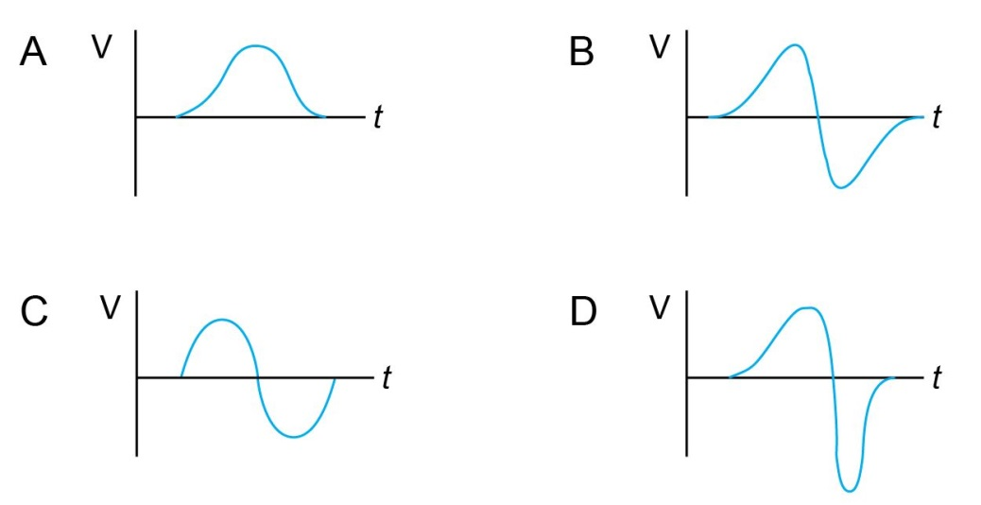Which graph shows the variation in induced emf. V across the ends of the coil with time t while the magnet passes through the coil?

**Rationale for the key and distractors:**

**D**  Induced emf increases as magnet approaches with increasing speed. Emf reverses as magnet passes through centre. Emf reaches a higher value as magnet comes out because speed is greater, but the emf is for a shorter time.

**A** No reversal of emf as magnet passes through.

**B** Emf is symmetrical – acceleration has not been taken into account.

**C** Sine curve – does not account for initial motion from rest, the acceleration through the coil or the rate of change of flux tending to zero as magnet falls away underneath.

**Possible techniques for completion**

For calculation questions completing the calculation before looking at the alternative answers can avoid being deflected by the distractors and ensure an impartial response.

For questions involving thinking skills and logical deduction it may be possible to eliminate at least one answer as being a distractor, thus reducing the final choice.

It is not good practice to leave any answer blank, unless the marking for the multiple choice questions includes a penalty for incorrect answers, so it is worthwhile using knowledge or intuition to select what you believe is the most likely answer.

# Contents

**Teacher section**

Multiple Choice Questions topic quiz - answers – Electromagnetism 5

Multiple Choice Questions topic quiz - answers – Ionising radiation and risk 23

**Learner section**

Multiple Choice Questions topic quiz – Electromagnetism 28

Multiple Choice Questions topic quiz – Ionising radiation and risk 46

# Multiple Choice Questions topic quiz - answers – Electromagnetism

|  |  |  |
| --- | --- | --- |
| **1** |  | A dynamo is rotated at a constant rate and produces a varying e.m.f. shown below. |
|  |  | A dynamo is rotated at a constant rate and produces a varying e.m.f. shown below. |
|  |  | The rate of rotation is doubled.  Which of the following traces shows the new variation of the e.m.f.?  **Four diagrams showing differing rates of e.m.f.** |

**D**

Your answer

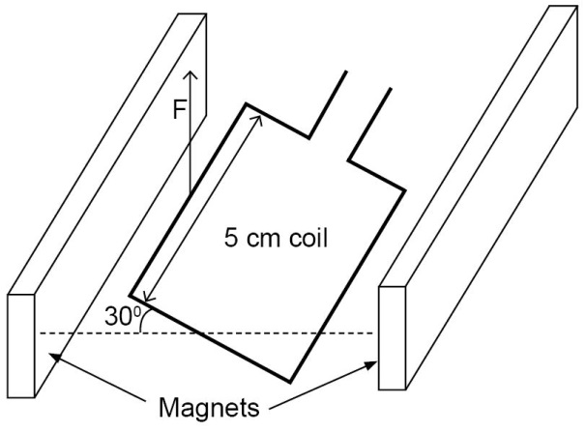**2** A coil with side length 5.0 cm is free to rotate with its axis parallel to the face of two magnets. The current in the coil is 0.4 A . There is a uniform magnetic field of flux density 40 mT between the magnets.

What is the magnitude of the force F acting on one side of the coil?

|  |  |  |
| --- | --- | --- |
| **A** | 0.9 x 10-4 N |  |
| **B** | 1.0 x 10-4 N |  |
| **C** | 4.0 x 10-4 N |  |
| **D**  **D** | 8.0 x 10-4 N |  |

Your answer

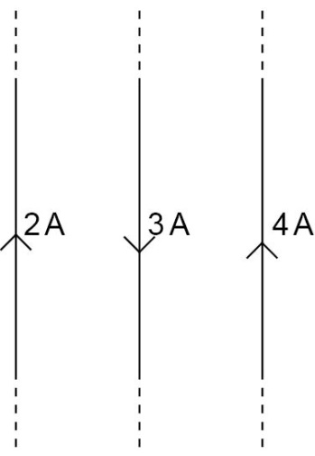**3** Three equally spaced identical long straight wires carry different currents.

In which direction will the middle wire try to move when the currents are switched on?

|  |  |  |
| --- | --- | --- |
| **A** | to the left |  |
| **B** | to the right |  |
| **C** | out of the page, towards the viewer |  |
| **D**  **A** | Into the page, away from the viewer |  |

Your answer

**4** A bar magnet is allowed to fall vertically through a coil.



Which graph shows the variation in induced e.m.f. *V* across the ends of the coil with   
time *t* while the magnet passes through the coil?

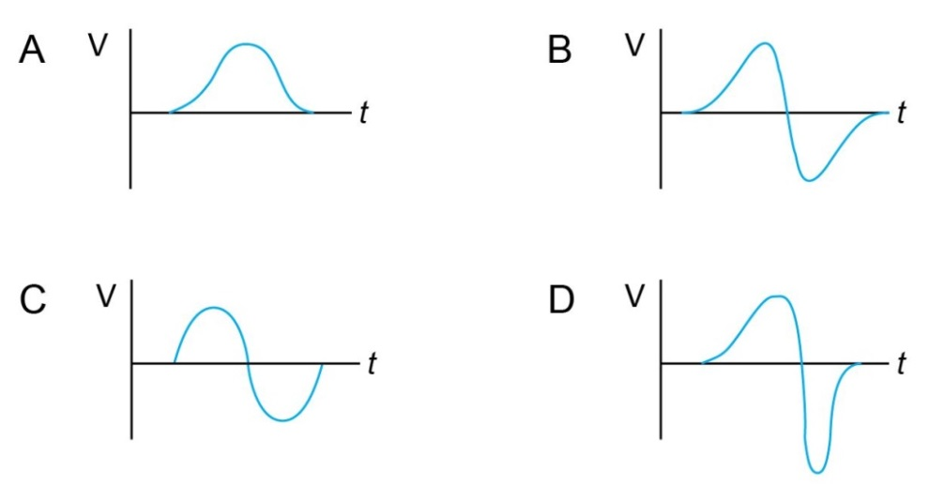

**D**

Your answer

**5** The diagram shows a wire, carrying a current *I*, placed between the poles of a magnet.

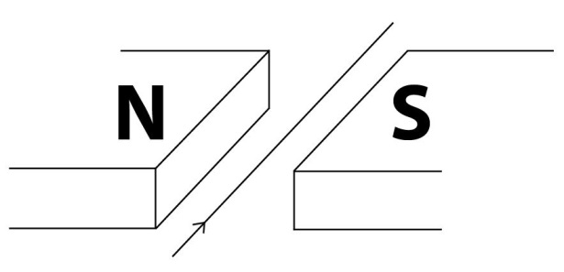

In which direction does the force on the wire act?

|  |  |  |
| --- | --- | --- |
| **A** | down |  |
| **B** | up |  |
| **C** | towards the N pole of the magnet |  |
| **D**  **A** | towards the S pole of the magnet |  |

Your answer

**6** The diagram shows an iron-cored transformer assumed to be 100% efficient.

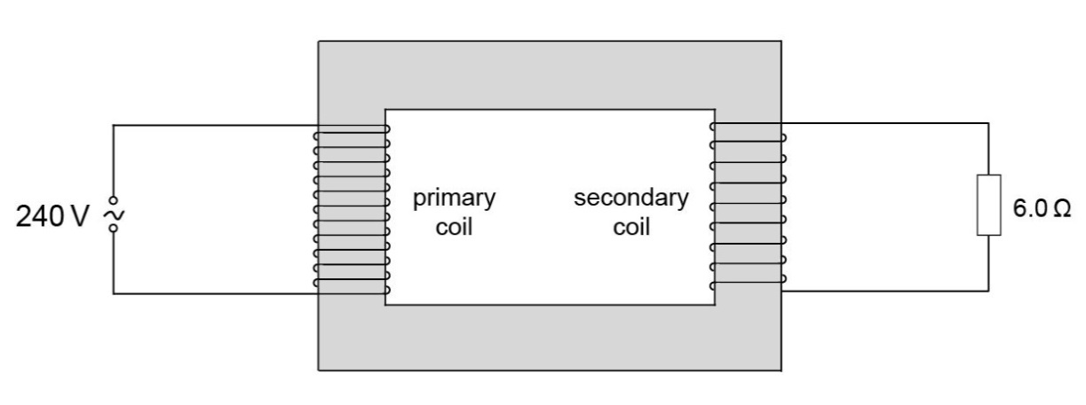The ratio of the secondary turns to the primary turns is 1:20.

A 240V a.c. supply is connected to the primary coil and a 6.0Ω resistor is connected to the secondary coil.

What is the current in the primary coil?

|  |  |  |
| --- | --- | --- |
| **A** | 0.10 A |  |
| **B** | 0.14 A |  |
| **C** | 2.0 A |  |
| **D**  **A** | 40 A |  |

Your answer

**7** A wire of length 3.0 cm is placed at right angles to a magnetic field of flux density 0.040 T.

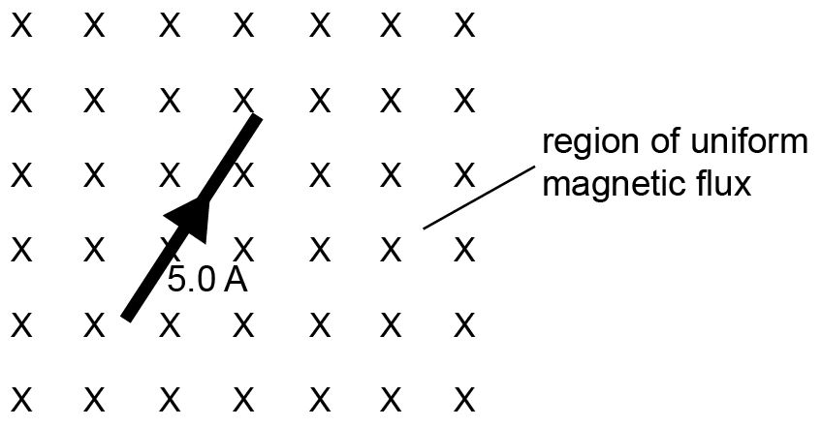

The wire carries a current of 5.0 A.

What is the magnitude of the force which the field exerts on the wire?

|  |  |  |
| --- | --- | --- |
| **A** | less than 0.006 N |  |
| **B** | 0.0060 N |  |
| **C** | Greater than 0.0060 N but less than 0.60 N |  |
| **D**  **B** | 0.60 N |  |

Your answer

|  |  |  |  |  |  |
| --- | --- | --- | --- | --- | --- |
| **8** |  | The relationship *flux = permeance x current-turns* for a magnetic circuit is analogous to a relationship between *potential difference, current* and *conductance* in an electrical circuit.  Which of the following combinations correctly matches the magnetic and electrical circuit terminology? | | | |
|  |  |  |  |  |  |
|  |  |  | *potential difference* | *current* | *conductance* |
|  |  | **A** | permeance | current-turns | flux |
|  |  | **B** | flux | current-turns | permeance |
|  |  | **C** | current-turns | flux | permeance |
|  |  | **D** | current-turns | permeance | flux |
|  |  |  | | |  |
|  |  |  | | | **C**  Your answer |

|  |  |  |  |  |  |
| --- | --- | --- | --- | --- | --- |
| **9** |  | A transformer with a 4000 turn primary and 1000 turn secondary transfers 200 kW from the grid to local supply.  Which of these combinations is possible for this transformer? | | |  |
|  |  |  |  |  |  |
|  |  | |  |  |  |  | | --- | --- | --- | --- | |  | primary voltage / V |  | secondary current / A | | **A** | 100 |  | 500 | | **B** | 400 |  | 125 | | **C** | 1000 |  | 800 | | **D** | 4000 |  | 50 | | | |  |
|  |  |  | | |  |
|  |  |  | | | **C**  Your answer |

|  |  |  |  |  |  |
| --- | --- | --- | --- | --- | --- |
| **10** |  | Transformers may be constructed using insulated steel laminations.  Here are three true statements about such a transformer construction. | | |  |
|  |  | 1. Steel laminations have a low permeance 2. The insulation reduces the effects of eddy currents 3. Steel laminations have a high conductivity | | |  |
|  |  | Which combination of these factor(s) is important in designing an efficient transformer? | | |  |
|  |  |  |  |  |  |
|  | A | Statement 1 | | |  |
|  | B | Statement 1 and 2 | | |  |
|  | C | Statements 2 and 3 | | |  |
|  | D | All three statements | | |  |
|  |  |  | | | Your answer  **B** |
|  |  |  | | |  |

|  |  |  |  |  |  |
| --- | --- | --- | --- | --- | --- |
| **11** |  | Which of the following is equivalent to the unit of e.m.f.? | | |  |
|  |  |  |  |  |  |
|  | **A** | Wb m-2 | | |  |
|  | **B** | Wb m2 | | |  |
|  | **C** | T s-1 | | |  |
|  | **D** | T m2 s-1 | | | Your answer  **D** |
|  |  |  | | |  |
|  |  |  | | |  |

# 

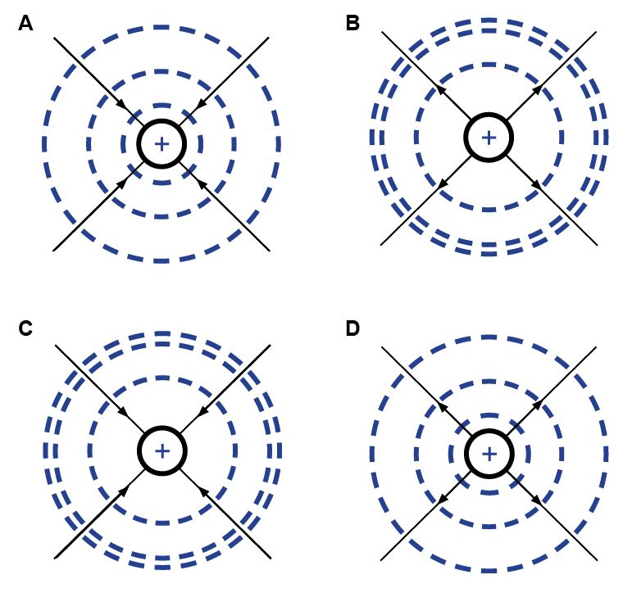**12.** Which of the diagrams shows correctly the electric field lines (arrowed lines) and equipotential lines (dashed lines) near a proton?

**D**

Your answer

**13** Charges of +2 μC and -2μC are situated at points **P** and **Q** respectively, as shown.

**X** is midway between point **P** and **Q**.

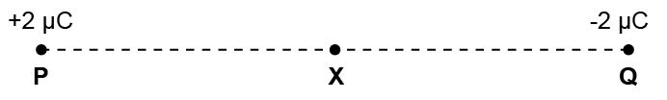

Which of the following correctly describes the electric field and the electric potential   
at point **X**?

|  |  |  |
| --- | --- | --- |
|  | electric field | electric potential |
| **A** | towards Q | zero |
| **B** | towards Q | negative |
| **C** | towards P | zero |
| **D**  **A** | towards P | positive |

Your answer

**14** The charge on a uranium nucleus is 1.5 x 10-17 C and the charge on the α-particle   
is 3.2 x 10-19 C.

What is the electrostatic force between a uranium nucleus and an α-particle when separated by a distance of 1.0 x 10-13 m.

|  |  |  |
| --- | --- | --- |
| **A** | 4.3 x 10-20 N |  |
| **B** | 4.3 x 10-13 N |  |
| **C** | 4.3 N |  |
| **D**  **C** | 4.3 x 1010 N |  |

Your answer

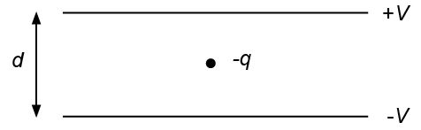**15** An oil droplet has a charge – *q* and is situated between two parallel horizontal metal plates as shown in the diagram.

|  |
| --- |
| The separation of the plates is *d*.  The droplet is observed to be stationary when the upper plate is at a potential +*V* and the lower plate at potential –*V*.  For this to occur the weight of the droplet is equal in magnitude to |
|  |
|  |

|  |  |
| --- | --- |
| **A** |  |
| **B** |  |
| **C** |  |
| **D**  **B** |  |

Your answer

**16** A thundercloud and the Earth’s surface may be regarded as a pair of charged parallel plates separated by a distance *h* as shown in the diagram.

The capacitance of the system is *C*.

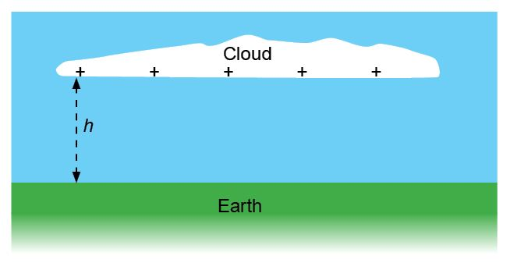

When a lightning flash of mean current *I* and time *t* occurs, the electric field strength between the cloud and Earth is reduced by

|  |  |
| --- | --- |
| **A** |  |
| **B** |  |
| **C** |  |
| **D** | *CIt* |

**A**

Your answer

**17** Two horizontal metal plates are separated by 4mm.

The lower plate is at a potential of -6V.

Two horizontal metal plates are separated by 4mm.
The lower plate is at a potential of -6V.


What potential should be applied to the upper plate to create an electric field of strength   
4000 Vm-1 upwards in the space between the plates?

|  |  |  |
| --- | --- | --- |
| **A** | +22V |  |
| **B** | +10V |  |
| **C** | -10V |  |
| **D**  **B** | -22V |  |

Your answer

# 

**18** An electron is projected at right angles to a uniform electric field *E*.

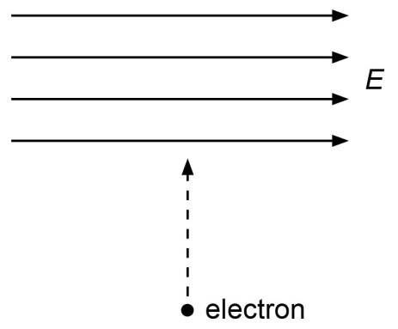

In the absence of other fields, in which direction is the electron deflected?

|  |  |  |
| --- | --- | --- |
| **A** | Into the paper |  |
| **B** | Out of the paper |  |
| **C** | To the left |  |
| **D**  **C** | To the right |  |

Your answer

**19** An electron enters a region of space where there is a uniform electric field *E* as   
shown below.

An electron enters a region of space where there is a uniform electric field E as 
shown below.


Initially, the electron is moving parallel to, and in the direction of the electric field.

What is the subsequent path and change of speed of the electron?

|  |  |  |
| --- | --- | --- |
|  | **path** | **change of speed** |
| **A** | linear | decreases |
| **B** | linear | increases |
| **C** | curved | decreases |
| **D**  **A** | curved | increases |

Your answer

**20** Four particles independently move at the same speed in a direction perpendicular to the same magnetic field.

Which particle is deflected most?

|  |  |  |
| --- | --- | --- |
| **A** | a neutron |  |
| **B** | a helium nucleus |  |
| **C** | an electron |  |
| **D**  **C** | a proton |  |

Your answer

**21** Hot air from a hair-dryer contains many positively charged ions.

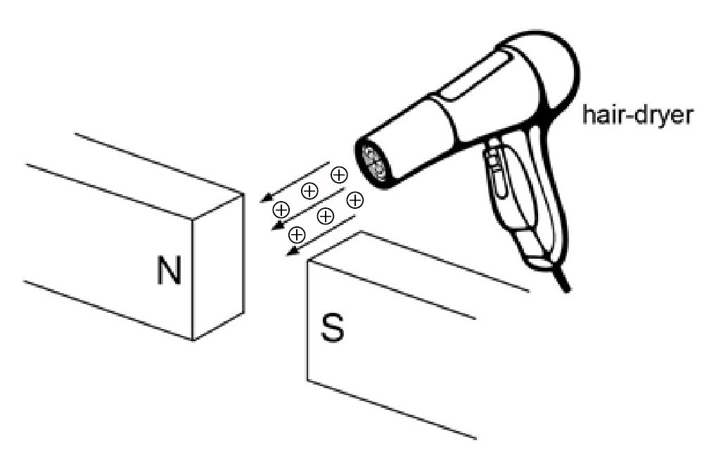

In which direction are the ions deflected?

|  |  |  |
| --- | --- | --- |
| **A** | towards the north pole N |  |
| **B** | Towards the south pole S |  |
| **C** | downwards |  |
| **D**  **D** | upwards |  |

Your answer

**22** Which statement correctly describes a nucleon?

|  |  |  |
| --- | --- | --- |
| **A** | a neutron or a proton |  |
| **B** | a neutron, proton or an electron |  |
| **C** | any atomic nucleus |  |
| **D**  **A** | A radioactive atomic nucleus |  |

Your answer

|  |
| --- |
| **23** In Rutherford’s alpha scattering experiment most of the alpha particles passed directly through a metal foil without deviation, some alpha particles continued through the foil but were deviated, a very small number rebounded back from the foil.  Which of the following statements are conclusions which can be drawn from this experiment? |
| 1. most of the atom is empty space |
| 1. the space between nuclei is many orders greater than the diameter of the nuclei |
| 1. alpha particles are deviated when they collide with the nucleus |

|  |  |  |
| --- | --- | --- |
| **A** | only 1 is true |  |
| **B** | 1 and 2 are true |  |
| **C** | 1 and 3 are true |  |
| **D**  **B** | 1, 2 and 3 are all true |  |

Your answer

|  |  |  |  |  |
| --- | --- | --- | --- | --- |
| **24** |  | What is the relativistic factor for a particle travelling at 80% of the speed of light? | | |
|  |  |  |  |  |
|  | **A** | 0.22 | | |
|  | **B** | 1.0 | | |
|  | **C** | 1.7 | | |
|  | **D** | 2.2  **C**  Your answer | | |
|  |  |  | | |
|  |  |  | | |

|  |  |  |
| --- | --- | --- |
| **25** |  | Which of the following is the correct expression for the electric potential energy of a de Broglie wave in an atom of radius r = λ/2 ? |
|  |  |  |
|  | **A** |  |
|  | **B** |  |
|  | **C** |  |
|  | **D** |  |
|  |  | Your answer  **B** |
|  |  |  |

**26** The diagram shows the principle of a simple form of mass spectrometer.

Ions are passed through narrow slits, S1 and S2 into the velocity selector.

The selected ions, after passage through the slit S3, are deviated by the uniform magnetic field.

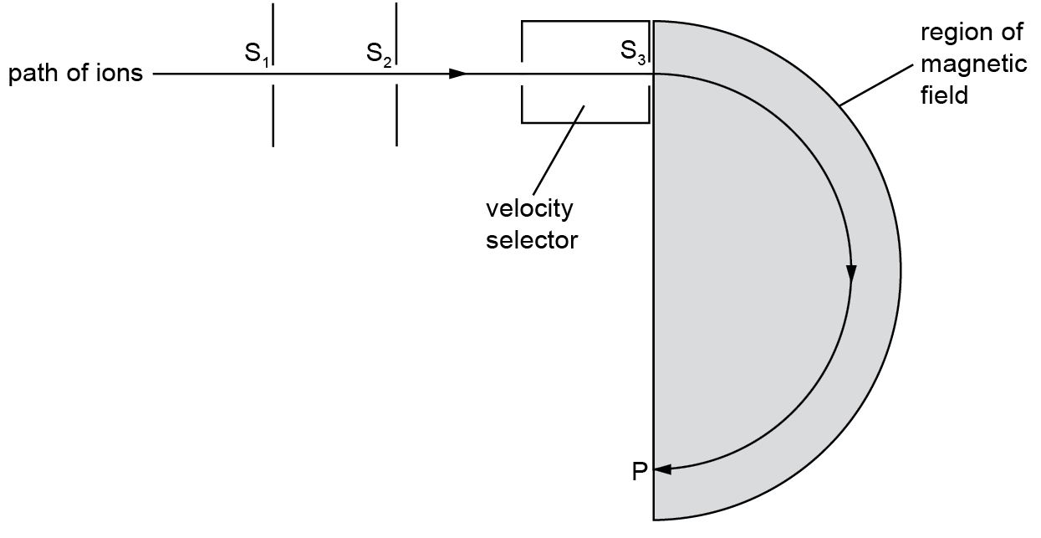

Which of the following quantities must be the same for all ions arriving at point P?

|  |  |  |
| --- | --- | --- |
| **A** | charge |  |
| **B** | charge ÷ mass |  |
| **C** | mass |  |
| **D**  **B** | momentum |  |

Your answer

**Multiple Choice Questions topic quiz - answers – Ionising radiation and risk**

**27** A student conducts an experiment using an α-particle source.

When considering safety precautions, what can be considered the maximum range   
of α-particles in air?

|  |  |  |
| --- | --- | --- |
| **A** | Between 0 and 5 mm |  |
| **B** | Between 5 mm and 200 mm |  |
| **C** | Between 200 mm and 500 mm |  |
| **D**  **A** | Between 500 mm and 1000 mm |  |

Your answer

|  |
| --- |
| **28** As a result of successive decays in a radioactive series, the nucleon number of an isotope decreases by 4 while its proton number is unchanged.  Which of the following combination of α and β particles being emitted would give this outcome? |

|  |  |  |
| --- | --- | --- |
|  | Number of  α particles | Number of  β particles |
| **A** | 1 | 1 |
| **B** | 1 | 2 |
| **C** | 1 | 4 |
| **D** | 2 | 2 |
| **B** |  |  |

Your answer

**29** The graph below shows the variation of the strong nuclear force with nucleon separation.

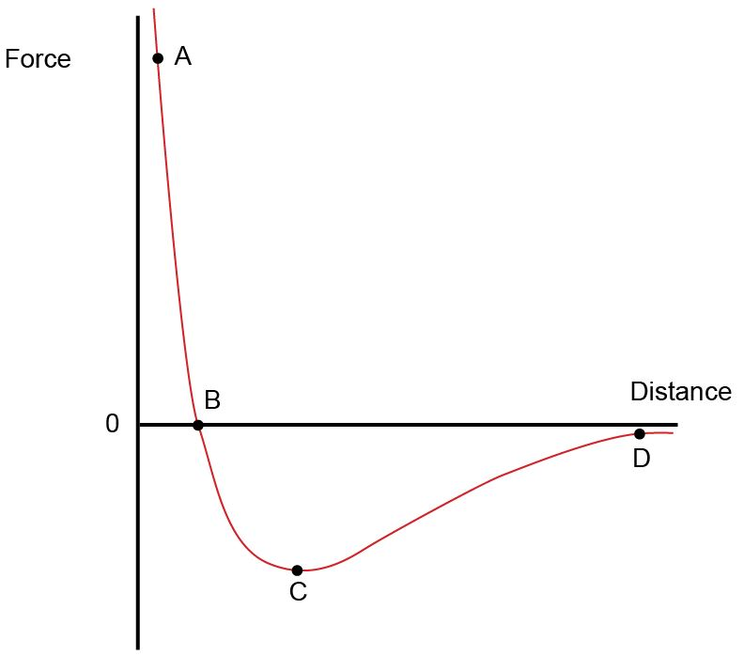

Which of the points **A**, **B**, **C** or **D** shows the repulsive nature of the strong nuclear force?

**A**

Your answer

**30** The sketch graph shows how the binding energy per nucleon varies with the nucleon   
number for naturally occurring nuclides.

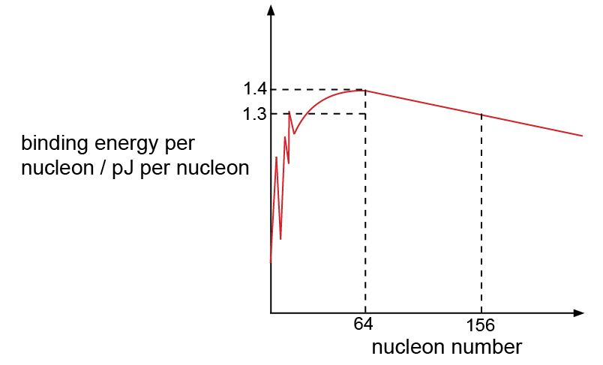

|  |  |  |
| --- | --- | --- |
|  | 156  64 |  |
| What is the total binding energy of the nuclide Gd | | |

|  |  |  |
| --- | --- | --- |
| **A** | 83 pJ |  |
| **B** | 90 pJ |  |
| **C** | 203 pJ |  |
| **D**  **C** | 218 pJ |  |

Your answer

|  |  |  |  |  |  |
| --- | --- | --- | --- | --- | --- |
| **31** |  | Which of the following is the effective dose in gray when 3 x 1010 beta particles, with mean energy per particle of 9 x 10-14 J, are absorbed by a tumour of mass 50g? | | |  |
|  |  |  |  |  |  |
|  | **A** | 5 x 10-5 Gy | | |  |
|  | **B** | 3 x 10-2 Gy | | |  |
|  | **C** | 5 x 10-2 Gy | | |  |
|  | **D** | 2 x 1022 Gy | | | **C**  Your answer |
|  |  |  | | |  |
|  |  |  | | |  |

|  |  |  |  |  |  |
| --- | --- | --- | --- | --- | --- |
| **32** |  | The nuclear fission reactor in a power station produces more than one neutron per atom decaying. Which combination of the following action(s) would allow the reactor to continue in a stable self-sustaining reaction?   1. Reduce the temperature of operation 2. Insert control rods to absorb excess neutrons 3. Reduce the amount of fissile material to a sub-critical mass | | |  |
|  |  |  |  |  |  |
|  | **A** | 1 and 2 | | |  |
|  | **B** | Only 2 | | |  |
|  | **C** | 1 and 3 | | |  |
|  | **D** | Only 3 | | |  |
|  |  |  | | | Your answer  **B** |
|  |  |  | | |  |

40

18

|  |  |  |  |  |  |
| --- | --- | --- | --- | --- | --- |
| **33** |  | An isotope of Argon,  *Ar,* has a binding energy of 344 MeV.  What is the binding energy in joules per nucleon? | | |  |
|  |  |  |  |  |  |
|  | **A** | 1.375 x 10-12 J | | |  |
|  | **B** | 3.056 x 10-12 J | | |  |
|  | **C** | 5.5 x 10-11 J | | |  |
|  | **D** | 8.6 x 10-11 J | | |  |
|  |  |  | | |  |
|  |  | A  Your answer | | |  |

We’d like to know your view on the resources we produce. By clicking on ‘[Like’](mailto:resources.feedback@ocr.org.uk?subject=I%20liked%20the%20AS%20and%20A%20Level%20Physics%20A%20and%20Physics%20B%20%20Set%204%20-%20Field%20and%20particle%20physics) or ‘[Dislike](mailto:resources.feedback@ocr.org.uk?subject=I%20disliked%20the%20AS%20and%20A%20Level%20Physics%20A%20and%20Physics%20B%20Set%204%20-%20Field%20and%20particle%20physics)’ you can help us to ensure that our resources work for you. When the email template pops up please add additional comments if you wish and then just click ‘Send’. Thank you.

If you do not currently offer this OCR qualification but would like to do so, please complete the Expression of Interest Form which can be found here: [www.ocr.org.uk/expression-of-interest](http://www.ocr.org.uk/expression-of-interest)

**OCR Resources**: *the small print*OCR’s resources are provided to support the teaching of OCR specifications, but in no way constitute an endorsed teaching method that is required by the Board, and the decision to use them lies with the individual teacher. Whilst every effort is made to ensure the accuracy of the content, OCR cannot be held responsible for any errors or omissions within these resources.   
© OCR 2017 - This resource may be freely copied and distributed, as long as the OCR logo and this message remain intact and OCR is acknowledged as the originator of this work.

OCR acknowledges the use of the following content: n/a

Please get in touch if you want to discuss the accessibility of resources we offer to support delivery of our qualifications: [resources.feedback@ocr.org.uk](mailto:resources.feedback@ocr.org.uk)

This formative assessment resource has been produced as part of our free Physics teaching and learning support package. All the Physics teaching and learning resources, including delivery guides, topic exploration packs, lesson elements and more are available on the qualification webpages.

If you are looking for examination practice materials, you can find Sample Assessment Materials (SAMs) and a link to the Practice Papers on the qualification webpages: [Physics B](http://www.ocr.org.uk/qualifications/as-a-level-gce-physics-b-advancing-physics-h157-h557-from-2015/).

# Multiple Choice Questions topic quiz – Electromagnetism

# 1

|  |  |  |
| --- | --- | --- |
| **1** |  | A dynamo is rotated at a constant rate and produces a varying e.m.f. shown below. |
|  |  | A dynamo is rotated at a constant rate and produces a varying e.m.f. shown below. |
|  |  | The rate of rotation is doubled.  Which of the following traces shows the new variation of the e.m.f.?  **Four diagrams showing differing rates of e.m.f.** |

Your answer

**2** A coil with side length 5.0 cm is free to rotate with its axis parallel to the face of two magnets. The current in the coil is 0.4 A . There is a uniform magnetic field of flux density 40 mT between the magnets.

What is the magnitude of the force F acting on one side of the coil?

|  |  |  |
| --- | --- | --- |
| **A** | 0.9 x 10-4 N |  |
| **B** | 1.0 x 10-4 N |  |
| **C** | 4.0 x 10-4 N |  |
| **D** | 8.0 x 10-4 N |  |

Your answer

**3** Three equally spaced identical long straight wires carry different currents.

In which direction will the middle wire try to move when the currents are switched on?

|  |  |  |
| --- | --- | --- |
| **A** | to the left |  |
| **B** | to the right |  |
| **C** | out of the page, towards the viewer |  |
| **D** | Into the page, away from the viewer |  |

Your answer

**4** A bar magnet is allowed to fall vertically through a coil.



Which graph shows the variation in induced e.m.f. *V* across the ends of the coil with   
time *t* while the magnet passes through the coil?



Your answer

**5** The diagram shows a wire, carrying a current *I*, placed between the poles of a magnet.



In which direction does the force on the wire act?

|  |  |  |
| --- | --- | --- |
| **A** | down |  |
| **B** | up |  |
| **C** | towards the N pole of the magnet |  |
| **D** | towards the S pole of the magnet |  |

Your answer

**6** The diagram shows an iron-cored transformer assumed to be 100% efficient.

The ratio of the secondary turns to the primary turns is 1:20.

A 240V a.c. supply is connected to the primary coil and a 6.0Ω resistor is connected to the secondary coil.

What is the current in the primary coil?

|  |  |  |
| --- | --- | --- |
| **A** | 0.10 A |  |
| **B** | 0.14 A |  |
| **C** | 2.0 A |  |
| **D** | 40 A |  |

Your answer

**7** A wire of length 3.0 cm is placed at right angles to a magnetic field of flux density 0.040 T.



The wire carries a current of 5.0 A.

What is the magnitude of the force which the field exerts on the wire?

|  |  |  |
| --- | --- | --- |
| **A** | less than 0.006 N |  |
| **B** | 0.0060 N |  |
| **C** | Greater than 0.0060 N but less than 0.60 N |  |
| **D** | 0.60 N |  |

Your answer

|  |  |  |  |  |  |
| --- | --- | --- | --- | --- | --- |
| **8** |  | The relationship *flux = permeance x current-turns* for a magnetic circuit is analogous to a relationship between *potential difference, current* and *conductance* in an electrical circuit.  Which of the following combinations correctly matches the magnetic and electrical circuit terminology? | | | |
|  |  |  |  |  |  |
|  |  |  | *potential difference* | *current* | *conductance* |
|  |  | **A** | permeance | current-turns | flux |
|  |  | **B** | flux | current-turns | permeance |
|  |  | **C** | current-turns | flux | permeance |
|  |  | **D** | current-turns | permeance | flux |
|  |  |  | | |  |
|  |  | Your answer | | |  |

|  |  |  |  |  |  |
| --- | --- | --- | --- | --- | --- |
| **9** |  | A transformer with a 4000 turn primary and 1000 turn secondary transfers 200 kW from the grid to local supply.  Which of these combinations is possible for this transformer? | | |  |
|  |  |  |  |  |  |
|  |  | |  |  |  |  | | --- | --- | --- | --- | |  | primary voltage / V |  | secondary current / A | | **A** | 100 |  | 500 | | **B** | 400 |  | 125 | | **C** | 1000 |  | 800 | | **D** | 4000 |  | 50 | | | |  |
|  |  |  | | |  |
|  |  |  | | | Your answer |

|  |  |  |  |  |  |
| --- | --- | --- | --- | --- | --- |
| **10** |  | Transformers may be constructed using insulated steel laminations.  Here are three true statements about such a transformer construction. | | |  |
|  |  | 1. Steel laminations have a low permeance 2. The insulation reduces the effects of eddy currents 3. Steel laminations have a high conductivity | | |  |
|  |  | Which combination of these factor(s) is important in designing an efficient transformer? | | |  |
|  |  |  |  |  |  |
|  | A | Statement 1 | | |  |
|  | B | Statement 1 and 2 | | |  |
|  | C | Statements 2 and 3 | | |  |
|  | D | All three statements | | | Your answer |
|  |  |  | | |  |
|  |  |  | | |  |

|  |  |  |  |  |  |
| --- | --- | --- | --- | --- | --- |
| **11** |  | Which of the following is equivalent to the unit of e.m.f.? | | |  |
|  |  |  |  |  |  |
|  | **A** | Wb m-2 | | |  |
|  | **B** | Wb m2 | | |  |
|  | **C** | T s-1 | | |  |
|  | **D** | T m2 s-1 | | | Your answer |
|  |  |  | | |  |
|  |  |  | | |  |

**12.** Which of the diagrams shows correctly the electric field lines (arrowed lines) and equipotential lines (dashed lines) near a proton?

Your answer

**13** Charges of +2 μC and -2μC are situated at points **P** and **Q** respectively, as shown.

**X** is midway between point **P** and **Q**.



Which of the following correctly describes the electric field and the electric potential   
at point **X**?

|  |  |  |
| --- | --- | --- |
|  | electric field | electric potential |
| **A** | towards Q | zero |
| **B** | towards Q | negative |
| **C** | towards P | zero |
| **D** | towards P | positive |

Your answer

**14** The charge on a uranium nucleus is 1.5 x 10-17 C and the charge on the α-particle   
is 3.2 x 10-19 C.

What is the electrostatic force between a uranium nucleus and an α-particle when separated by a distance of 1.0 x 10-13 m.

|  |  |  |
| --- | --- | --- |
| **A** | 4.3 x 10-20 N |  |
| **B** | 4.3 x 10-13 N |  |
| **C** | 4.3 N |  |
| **D** | 4.3 x 1010 N |  |

Your answer

**15** An oil droplet has a charge – *q* and is situated between two parallel horizontal metal plates as shown in the diagram.

|  |
| --- |
| The separation of the plates is *d*.  The droplet is observed to be stationary when the upper plate is at a potential +*V* and the lower plate at potential –*V*.  For this to occur the weight of the droplet is equal in magnitude to |
|  |
|  |

|  |  |
| --- | --- |
| **A** |  |
| **B** |  |
| **C** |  |
| **D** |  |

Your answer

**16** A thundercloud and the Earth’s surface may be regarded as a pair of charged parallel plates separated by a distance *h* as shown in the diagram.

The capacitance of the system is *C*.



When a lightning flash of mean current *I* and time *t* occurs, the electric field strength between the cloud and Earth is reduced by

|  |  |
| --- | --- |
| **A** |  |
| **B** |  |
| **C** |  |
| **D** | *CIt* |

Your answer

**17** Two horizontal metal plates are separated by 4mm.

The lower plate is at a potential of -6V.

Two horizontal metal plates are separated by 4mm.
The lower plate is at a potential of -6V.


What potential should be applied to the upper plate to create an electric field of strength   
4000 Vm-1 upwards in the space between the plates?

|  |  |  |
| --- | --- | --- |
| **A** | +22V |  |
| **B** | +10V |  |
| **C** | -10V |  |
| **D** | -22V |  |

Your answer

**18** An electron is projected at right angles to a uniform electric field *E*.



In the absence of other fields, in which direction is the electron deflected?

|  |  |  |
| --- | --- | --- |
| **A** | Into the paper |  |
| **B** | Out of the paper |  |
| **C** | To the left |  |
| **D** | To the right |  |

Your answer

**19** An electron enters a region of space where there is a uniform electric field *E* as   
shown below.

An electron enters a region of space where there is a uniform electric field E as 
shown below.


Initially, the electron is moving parallel to, and in the direction of the electric field.

What is the subsequent path and change of speed of the electron?

|  |  |  |
| --- | --- | --- |
|  | **path** | **change of speed** |
| **A** | linear | decreases |
| **B** | linear | increases |
| **C** | curved | decreases |
| **D** | curved | increases |

Your answer

**20** Four particles independently move at the same speed in a direction perpendicular to the same magnetic field.

Which particle is deflected most?

|  |  |  |
| --- | --- | --- |
| **A** | a neutron |  |
| **B** | a helium nucleus |  |
| **C** | an electron |  |
| **D** | a proton |  |

Your answer

**21** Hot air from a hair-dryer contains many positively charged ions.



In which direction are the ions deflected?

|  |  |  |
| --- | --- | --- |
| **A** | towards the north pole N |  |
| **B** | Towards the south pole S |  |
| **C** | downwards |  |
| **D** | upwards |  |

Your answer

**22** Which statement correctly describes a nucleon?

|  |  |  |
| --- | --- | --- |
| **A** | a neutron or a proton |  |
| **B** | a neutron, proton or an electron |  |
| **C** | any atomic nucleus |  |
| **D** | A radioactive atomic nucleus |  |

Your answer

|  |
| --- |
| **23** In Rutherford’s alpha scattering experiment most of the alpha particles passed directly through a metal foil without deviation, some alpha particles continued through the foil but were deviated, a very small number rebounded back from the foil.  Which of the following statements are conclusions which can be drawn from this experiment? |
| 1. most of the atom is empty space |
| 1. the space between nuclei is many orders greater than the diameter of the nuclei |
| 1. alpha particles are deviated when they collide with the nucleus |

|  |  |  |
| --- | --- | --- |
| **A** | only 1 is true |  |
| **B** | 1 and 2 are true |  |
| **C** | 1 and 3 are true |  |
| **D** | 1, 2 and 3 are all true |  |

Your answer

|  |  |  |  |  |
| --- | --- | --- | --- | --- |
| **24** |  | What is the relativistic factor for a particle travelling at 80% of the speed of light? | | |
|  |  |  |  |  |
|  | **A** | 0.22 | | |
|  | **B** | 1.0 | | |
|  | **C** | 1.7 | | |
|  | **D** | 2.2  Your answer | | |
|  |  |  | | |
|  |  |  | | |

|  |  |  |
| --- | --- | --- |
| **25** |  | Which of the following is the correct expression for the electric potential energy of a de Broglie wave in an atom of radius r = λ/2 ? |
|  |  |  |
|  | **A** |  |
|  | **B** |  |
|  | **C** |  |
|  | **D** |  |
|  |  | Your answer |
|  |  |  |

**26** The diagram shows the principle of a simple form of mass spectrometer.

Ions are passed through narrow slits, S1 and S2 into the velocity selector.

The selected ions, after passage through the slit S3, are deviated by the uniform magnetic field.



Which of the following quantities must be the same for all ions arriving at point P?

|  |  |  |
| --- | --- | --- |
| **A** | charge |  |
| **B** | charge ÷ mass |  |
| **C** | mass |  |
| **D** | momentum |  |

Your answer

**Multiple Choice Questions topic quiz   
– Ionising radiation and risk**

**27** A student conducts an experiment using an α-particle source.

When considering safety precautions, what can be considered the maximum range   
of α-particles in air?

|  |  |  |
| --- | --- | --- |
| **A** | Between 0 and 5 mm |  |
| **B** | Between 5 mm and 200 mm |  |
| **C** | Between 200 mm and 500 mm |  |
| **D** | Between 500 mm and 1000 mm |  |

Your answer

|  |
| --- |
| **28** As a result of successive decays in a radioactive series, the nucleon number of an isotope decreases by 4 while its proton number is unchanged.  Which of the following combination of α and β particles being emitted would give this outcome? |

|  |  |  |
| --- | --- | --- |
|  | Number of  α particles | Number of  β particles |
| **A** | 1 | 1 |
| **B** | 1 | 2 |
| **C** | 1 | 4 |
| **D** | 2 | 2 |
|  |  |  |

Your answer

**29** The graph below shows the variation of the strong nuclear force with nucleon separation.



Which of the points **A**, **B**, **C** or **D** shows the repulsive nature of the strong nuclear force?

Your answer

**30** The sketch graph shows how the binding energy per nucleon varies with the nucleon   
number for naturally occurring nuclides.



|  |  |  |
| --- | --- | --- |
|  | 156  64 |  |
| What is the total binding energy of the nuclide Gd | | |

|  |  |  |
| --- | --- | --- |
| **A** | 83 pJ |  |
| **B** | 90 pJ |  |
| **C** | 203 pJ |  |
| **D** | 218 pJ |  |

Your answer

|  |  |  |  |  |  |
| --- | --- | --- | --- | --- | --- |
| **31** |  | Which of the following is the effective dose in gray when 3 x 1010 beta particles, with mean energy per particle of 9 x 10-14 J, are absorbed by a tumour of mass 50g? | | |  |
|  |  |  |  |  |  |
|  | **A** | 5 x 10-5 Gy | | |  |
|  | **B** | 3 x 10-2 Gy | | |  |
|  | **C** | 5 x 10-2 Gy | | |  |
|  | **D** | 2 x 1022 Gy | | |  |
|  |  |  | | |  |
|  |  | Your answer | | |  |

|  |  |  |  |  |  |
| --- | --- | --- | --- | --- | --- |
| **32** |  | The nuclear fission reactor in a power station produces more than one neutron per atom decaying. Which combination of the following action(s) would allow the reactor to continue in a stable self-sustaining reaction?   1. Reduce the temperature of operation 2. Insert control rods to absorb excess neutrons 3. Reduce the amount of fissile material to a sub-critical mass | | |  |
|  |  |  |  |  |  |
|  | **A** | 1 and 2 | | |  |
|  | **B** | Only 2 | | |  |
|  | **C** | 1 and 3 | | |  |
|  | **D** | Only 3 | | | Your answer |
|  |  |  | | |  |
|  |  |  | | |  |

|  |  |  |  |  |  |
| --- | --- | --- | --- | --- | --- |
| **33** |  | An isotope of Argon, , *Ar* has a binding energy of 344 MeV.  40  18  What is the binding energy in joules per nucleon? | | |  |
|  |  |  |  |  |  |
|  | **A** | 1.375 x 10-12 J | | |  |
|  | **B** | 3.056 x 10-12 J | | |  |
|  | **C** | 5.5 x 10-11 J | | |  |
|  | **D** | 8.6 x 10-11 J  Your answer | | |  |
|  |  |  | | |  |
|  |  |  | | |  |