Lesson Element

DNA Modelling

Instructions and answers for teachers

These instructions cover the learner activity section which can be found on page 4. This Lesson Element supports OCR GCSE (9–1) Gateway Science Biology A and the Twenty First Century Science Biology B qualifications.
When distributing the activity section to the learners either as a printed copy or as a Word file you will need to remove the teacher instructions section.

Mapping to specification level (Learning outcomes)
GCSE (9–1) Gateway Science Biology A/Combined Science A
B1.2a describe DNA as a polymer
B1.2b describe DNA as being made up of two strands forming a double helix
B1.2c describe that DNA is made from four different nucleotides; each nucleotide consisting of a common sugar and phosphate group with one of four different bases attached to the sugar
GCSE (9–1) Twenty First Century Science Biology B/Combined Science B
B1.1.3 describe DNA as a polymer made up of nucleotides, forming two strands in a double helix
B1.1.7 describe DNA as a polymer made from four different nucleotides, each nucleotide consisting of a common sugar and phosphate group with one of four different bases attached to the sugar (separate science only)

Prior Preparation
Equipment will need to be ordered in advance: different coloured pipe cleaners (students will need 2 pipe cleaners of the same colour and 4 pipe cleaners in other colours), a small lump of modelling clay and a 5cm² piece of strong card for each learner.

Introduction
This activity is designed to consolidate the idea of the basic structure of DNA and complimentary base pairing. It can therefore be used as a foundation teaching resource and for higher ability learners to build on.
Prior knowledge required
Learners will need to have been taught the basic structure of DNA. All learners must be aware that DNA is arranged in base pairs (A-T, G-C) and that DNA is a double helix structure.
Some learners can find it difficult to understand the arrangement of base pairs; this activity provides a visual illustration for them. Some learners can find it difficult to picture not just how the bases pair together but also their arrangement along the sugar phosphate backbone.
Notes for teachers
Depending on the group, teachers could either lead the activity step by step, explaining what each part of the model represents or learners could be given an instruction sheet and build the model for themselves.

The basic activity
Using the instruction sheet learners should decide which coloured pipe cleaner represents each DNA base and also keep in mind its correlating pair. Any cuts that need to be made should then be done. Once cut to shape the pairs of colours should be matched and the ends twisted together.
Learners should then arrange these in a ladder formation on their work bench. This is when the teacher can reinforce that the arrangement of the base pairs is different depending on the gene and their individual alleles. Depending on the ability of the group additional time could be built into the activity for additional help/discussion.
Using the two (same coloured) pipe cleaners that remain (uncut) learners should place one either side of the ladder arrangement and careful twist each end of the base pairs (paired) to the backbone pipe cleaner. Once the ladder structure is made modelling clay can be used to attach the ladder to the small piece of thick card. Learners can then twist the structure to form the double helix.
Extension Activities:
There are many opportunities to extend this activity.
- Learners could cut the purines (A and G) and pyrimidine nucleotides (C and T) to different lengths (longer and shorter respectively).
- The sugar phosphate backbone could be made from alternating two different coloured pipe cleaners (remembering that the nitrogenous bases will only bind to the sugar residues). This will require an additional coloured pipe cleaner.
- Learners could twist the G and Cs round three times, the A and T twice to indicate the number of hydrogen bonds between the complimentary bases.

Task 1
Higher level learners could use sticky labels to annotate with explanations of coding for proteins and amino acids if desired by the teacher.

Task 2 – Questions on triplet code
Answers:
20 different amino acids make the many thousands of proteins that are found in all living organisms. The instructions to build all these proteins must be coded within the DNA molecule.
If you read the bases in threes along a gene, it is possible to predict the amino acids that will be made and the order they will be made in. This is the triplet code. Each triplet, a group of three bases, codes for a specific amino acid.
Here are the triplet codes for four different amino acids:
alanine GCA methionine ATG glutamine CAA serine TCA isoleucine ATA
- Write down the order of the amino acids in the protein coded for by this length of DNA:
CAAATGATAGCATCA.
Glutamine Methionine Isoleucine Alanine Serine

- Write down the sequence of bases which would code for this chain of amino acids:
serine–methionine–isoleucine–glutamine–alanine.
TCA –ATG – ATA – CAA – GCA

We’d like to know your view on the resources we produce. By clicking on ‘Like’ or ‘Dislike’ you can help us to ensure that our resources work for you. When the email template pops up please add additional comments if you wish and then just click ‘Send’. Thank you.
Whether you already offer OCR qualifications, are new to OCR, or are considering switching from your current provider/awarding organisation, you can request more information by completing the Expression of Interest form which can be found here: www.ocr.org.uk/expression-of-interest
Looking for a resource? There is now a quick and easy search tool to help find free resources for your qualification:
www.ocr.org.uk/i-want-to/find-resources/

OCR Resources: the small print
OCR’s resources are provided to support the delivery of OCR qualifications, but in no way constitute an endorsed teaching method that is required by the Board, and the decision to use them lies with the individual teacher. Whilst every effort is made to ensure the accuracy of the content, OCR cannot be held responsible for any errors or omissions within these resources.
© OCR 2017 - This resource may be freely copied and distributed, as long as the OCR logo and this message remain intact and OCR is acknowledged as the originator of this work.
OCR acknowledges the use of the following content: n/a
Please get in touch if you want to discuss the accessibility of resources we offer to support delivery of our qualifications: resources.feedback@ocr.org.uk

Lesson Element

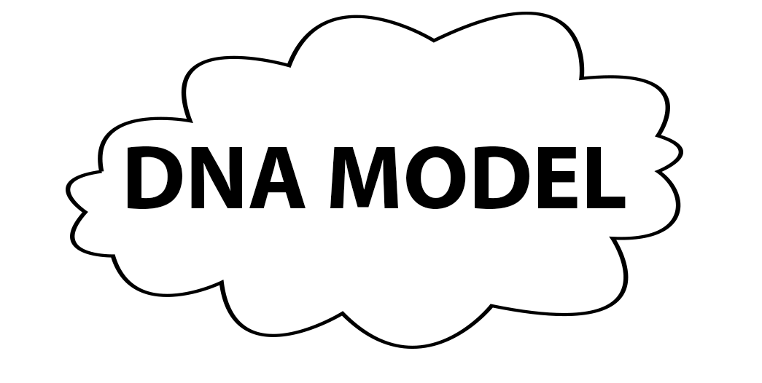
DNA Modelling

Learner Activity

Activity 1

Equipment needed:
- 6 pipe cleaners (2 of one colour and 4 pipe cleaners in different colours)
- A small lump of modelling clay
- Strong card

- Put the 2 pipe cleaners of the same colour to one side – these should not be cut.
- Using the remaining 4 different coloured pipe cleaners decide which colour represents which DNA base e.g. Red = A
Green = T
Blue = G
Yellow = C.
- Cut each pipe cleaner into 3 equal lengths.

- Match up the cut segments into the corresponding base pairs.
A T

- Twist the pipe cleaners together at one end.

- Do the same for all the base pairs. Be careful! Only match the corresponding colours together
e.g. Red + Green (A + T)
Blue + Yellow (G + C).

- Line all the twisted together segments in a ladder line.

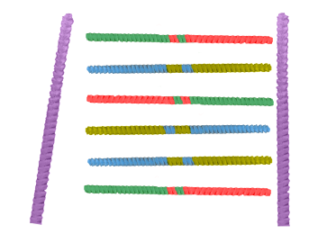
- Collect the 2 pipe cleaners of the same colour that were set aside earlier place each down either side of the ladder line.

- Twist the ends of the base pair segments onto the long pipe cleaners.

- Stick the end of the 2 pipe cleaners into the modelling clay.

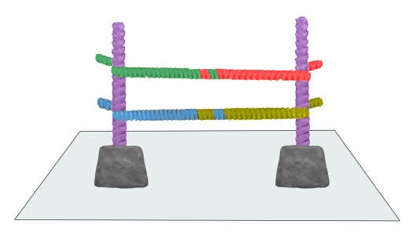
- Stick the modelling clay onto the card.

- Twist the ladder structure to form a double helix.

Questions on triplet code
20 different amino acids make the many thousands of proteins that are found in all living organisms. The instructions to build all these proteins must be coded within the DNA molecule.
If you read the bases in threes along a gene, it is possible to predict the amino acids that will be made and the order they will be made in. This is the triplet code. Each triplet, a group of three bases, codes for a specific amino acid.
Here are the triplet codes for four different amino acids:
alanine GCA methionine ATG glutamine CAA serine TCA isoleucine ATA

- Write down the order of the amino acids in the protein coded for by this length of DNA:
CAAATGATAGCATCA.

- Write down the sequence of bases which would code for this chain of amino acids:
serine–methionine–isoleucine–glutamine–alanine.

