Lesson Element

Roots and Shoots

Instructions and answers for teachers
These instructions cover the learner activity section which can be found on page 4. This Lesson Element supports OCR GCSE (9–1) Gateway Science Biology A and the Twenty First Century Science Biology B qualifications.
When distributing the activity section to the learners either as a printed copy or as a Word file you will need to remove the teacher instructions section.

Mapping to specification level (Learning outcomes)
GCSE (9–1) Gateway Science Biology A/Combined Science A
B3.2g explain how plant hormones are important in the control and coordination of plant growth and development, with reference to the role of auxins in phototropisms and gravitropisms
B3.2h describe some of the variety of effects of plant hormones, relating to auxins, gibberellins and ethane
GCSE (9–1) Twenty First Century Science Biology B/Combined Science B
B4.4.1 a) explain how plant hormones are important in the control and coordination of plant growth and development, with reference to the role of auxins in phototropisms and gravitropisms
b) describe practical investigations into the role of auxin in phototropism
PAG6

Introduction to the task
This activity offers an opportunity for English skills development.
This lesson element contains a modelling activity to demonstrate the role that auxins play in plant growth. Learners should have prior knowledge of basic plant organs and their functions from Key Stage 3. Learners should have been introduced to auxins and their functions within plants, and be familiar with how roots and shoots respond to light and gravity.
Learners often have difficulties in understanding that the auxins in the roots and shoots are the same but their behaviour is different. In the roots the auxins prohibit growth and prevent growth in the area they are distributed. However In the shoots they stimulate growth on the regions they are distributed.

Notes for teachers
Learners will be modelling auxin distribution in shoots and roots using beads (or coloured circles provided) and a readymade layout. For this activity learners will require a white board/ learner sheet, the readymade layout of roots and shoots and beads (you may wish to use the coloured circles). The key points of information which the learners need to know are included on the PowerPoint. Each task should be completed as a modelling task with beads and then followed by a drawing task on white boards/ learner sheet. There is opportunity for discussion after each scenario.

Activity
Using the PowerPoint display the scenarios of the sun shining on roots and shoots. Learners are to use their basic layout and using 2 different coloured beads, buttons or circles which are provided, place them in the correct places. One colour will represent stimulation of growth and the second colour which represents inhibition of growth. This will help learners to understand that behaviour of auxins is different in shoots and roots.
Between each activity learners could then use the white board/learner sheet they have been provided with to draw what would happen to the growth of the shoot or root and try to explain the behaviour.

Guidance and suggested answers to each scenario
Scenario 1:
Learners are to use the green coloured circles. They should be placed along the bottom of the shoots. On the white boards/learner sheet the learners should have drawn the shoots growing upwards.
Explanation
The sun causes the auxins to be distributed in the shaded area along bottom of the shoots. The green coloured circles are used in the shoots where the auxins stimulate growth. The cells along the bottom will elongate causing the shoots to grow upwards.
Scenario 2:
Learners are to use the red coloured circles. They should be placed along the bottom of the roots. On the white board/learner sheet learners should have drawn roots going downwards.
Explanation
Gravity causes the auxins to be distributed along the bottom of the roots. The red coloured circles are used in the roots where the auxins prohibit growth. The cells along the top of the roots will elongate causing the roots to grow downwards.
Scenario 3:
Learners are to use the green coloured circles. They should be placed along the bottom of the shoots. On the white board/learner sheet learners have drawn shoots growing upwards.
Explanation
Gravity causes the auxins to be distributed along the bottom of the shoots. The green coloured circles are used as in the shoots the auxins stimulate growth. The cells along the bottom of the shoots will elongate causing the shoots to grow upwards.
Supporting information
Teacher should ensure they understand the behaviour of auxins. In the roots auxins prohibit growth and prevent growth in the area they are distributed. However In the shoots they stimulate growth on the regions they are distributed. Rules to keep in mind are:
- In shoots to light – auxins distributed on shaded area away from light
- In shoots to gravity – auxins distributed on underside due to gravity acting upon it
- In roots to gravity - auxins distributed on underside due to gravity acting upon it.
We’d like to know your view on the resources we produce. By clicking on ‘Like’ or ‘Dislike’ you can help us to ensure that our resources work for you. When the email template pops up please add additional comments if you wish and then just click ‘Send’. Thank you.
Whether you already offer OCR qualifications, are new to OCR, or are considering switching from your current provider/awarding organisation, you can request more information by completing the Expression of Interest form which can be found here: www.ocr.org.uk/expression-of-interest
Looking for a resource? There is now a quick and easy search tool to help find free resources for your qualification:
www.ocr.org.uk/i-want-to/find-resources/

OCR Resources: the small print
OCR’s resources are provided to support the delivery of OCR qualifications, but in no way constitute an endorsed teaching method that is required by the Board, and the decision to use them lies with the individual teacher. Whilst every effort is made to ensure the accuracy of the content, OCR cannot be held responsible for any errors or omissions within these resources.
© OCR 2017 - This resource may be freely copied and distributed, as long as the OCR logo and this message remain intact and OCR is acknowledged as the originator of this work.
OCR acknowledges the use of the following content: Earthquake damage: Baloncici/Shutterstock.com.
Please get in touch if you want to discuss the accessibility of resources we offer to support delivery of our qualifications: resources.feedback@ocr.org.uk

Lesson Element

Roots and Shoots

Learner Activity

Learner Task 1
For each of the scenarios you should:
- Decide on the behaviour of the auxins (plant hormones that stimulate or inhibit growth).
- Draw on the diagram the hormones in the correct location on the shoot or root.
- Amend the diagram by drawing what you would think the outcome would be in each case.

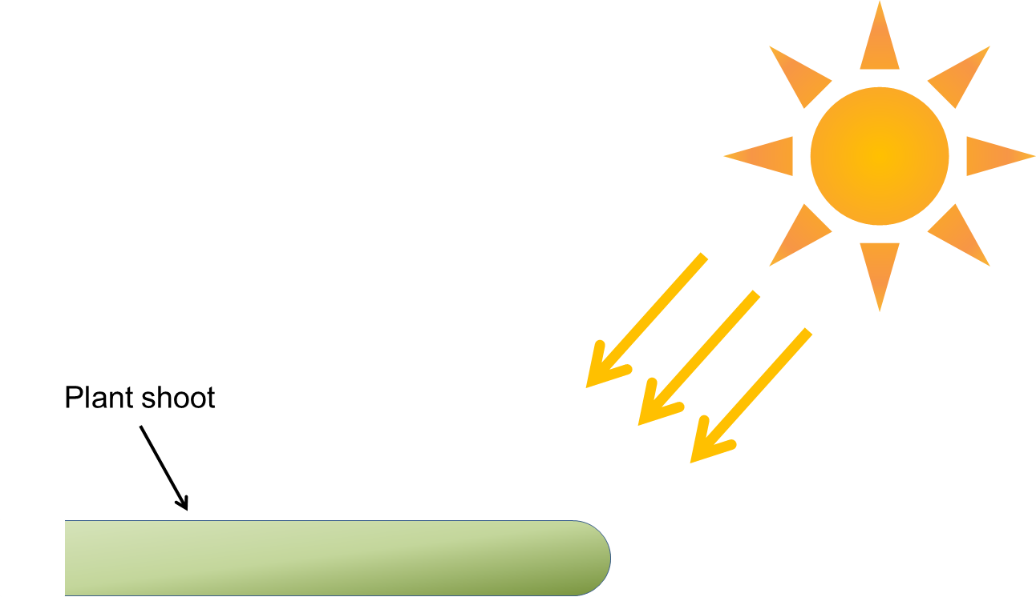
Auxins in Shoots

Auxins in Roots
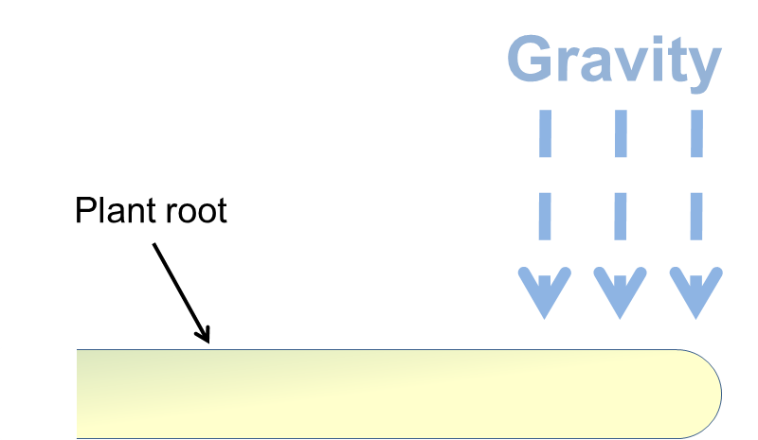

Auxins in Shoots

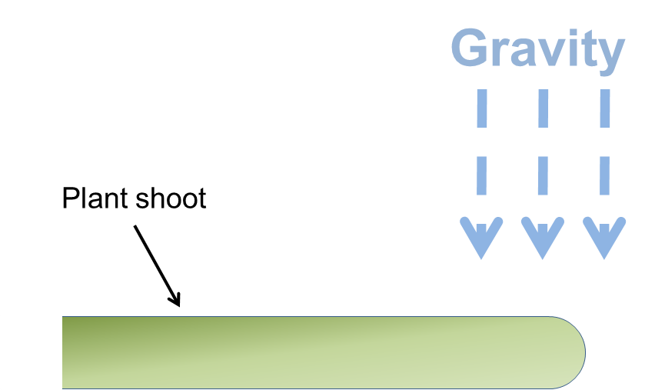

Counters
Key

= Stimulate growth

= Prohibit growth
Note: there are not 2 types of auxins they just behave differently depending on where they are.

