Topic Exploration Pack

Enthalpy changes of dissolving
Learning outcomes 2
Introduction 2
Suggested Activities 4
Activity 1: A consideration of the changes that occur during dissolving 4
Activity 2: Producing enthalpy cycles for the dissolving process 10
Activity 3: Measuring the enthalpy change of solution for different ionic compounds 13
Activity 4: Relating charge density to enthalpy changes 16
Answers to test yourself questions 18
Learner activity 1 – The changes that occur during dissolving 23
Learner activity 2 – Producing enthalpy cycles for the dissolving process 29
Learner activity 3 – Measuring the enthalpy change of solution 33
Learner activity 4 – Relating charge density to enthalpy changes 38
Test yourself questions 41

Instructions and answers for teachers

These instructions cover the student activity section which can be found on page 23. This Topic Exploration Pack supports OCR A Level Chemistry B (Salters).
When distributing the activity section to the students either as a printed copy or as a Word file you will need to remove the teacher instructions section.

Learning outcomes
O(a) the factors determining the relative solubility of a solute in aqueous and non-aqueous solvents
O(b) the terms hydrated ions, enthalpy change of solution (Δ_{sol}H), lattice enthalpy (Δ_{LE}H) and enthalpy change of hydration of ions (Δ_{hyd}H), and:
(i) the solution of an ionic solid in terms of enthalpy cycles and enthalpy level diagrams involving these terms
(ii) use of these enthalpy cycles to perform calculations
(iii) techniques and procedures for measuring the energy transferred in experiments involving enthalpy changes in solution
O(c) the dependence of the lattice enthalpy of an ionic compound and the enthalpy change of hydration of ions on the charge density of the ions

Introduction
Prior knowledge and understanding
This Topic Exploration Pack is focused on the enthalpy changes associated with the process of dissolving with a close look at the dissolving of ionic substances in water. Learners should be very clear about the concept of an ionic bond and how this type of bonding leads to the formation of a giant ionic lattice. There is some degree of misconception that the ionic bond requires the exchange of one or more electrons to form anions and cations. While this can lead to ionic bonding, the bond itself is simply the electrostatic attraction between oppositely charged ions. Learners are typically very familiar with the idea that this type of bonding is very strong and ionic substances will tend to have very high melting points and will be electrical insulators when in a solid state as the charged particles cannot move.
Learners will have studied ionic substances in solution in the first year of the course, encountering the idea that ions in solution separate and become, effectively, two independent chemical species. This idea gives rise to the concept of spectator ions. So learners should be able to picture that one ion can react while the other is not involved in the reaction.
This topic also involves the application of Hess’ Law, which learners encountered in Developing fuels in the first year. They should be familiar with the look of a Hess cycle and be able to calculate an unknown change from known values. They will build on this law to produce an enthalpy cycle for the dissolving process.
Learners will also need to use and apply their experience of calorimetry from the first year to measure enthalpy changes of solution experimentally. They have met this idea of the use of the specific heat capacity of water to find energy transfers in class in Developing fuels and as part of the Practical Endorsement.
Key points in this topic
Enthalpy changes
Ideas about intermolecular forces apply in this topic with a look at how bonds form between the solvent and solute. Learners will need to review ideas of intermolecular forces to consider whether or not a solute will dissolve. Learners will meet ion–dipole bonds and learn to use this term to describe the bonding between an ion in solution and the dipole of a polar solvent, especially water. Although this is a new term, the underlying idea of attraction between positive and negative charges remains firmly at the centre of the bonding topic.
By considering the forces involved in the dissolving of an ionic substance, learners will be introduced to the concept of the energy required to break an ionic lattice and they meet the term lattice enthalpy. This term actually refers to the formation of one mole of an ionic lattice, so it will be the negative value of the energy required to break a mole of a lattice into its constituent (gaseous) ions.
For sodium chloride, the reaction expressing the lattice enthalpy is:
Na⁺(g) + Cl–(g) → NaCl(s)
The gaseous ions are considered to be far away from any other particles so that they experience no interactions, but act as independent chemical species. We picture the energy released as the ions come together from ‘infinite’ separation to form the lattice, so they start in the gas state.
The value of the lattice enthalpy is always large in magnitude and negative in sign, due to the strong ionic bonds formed.
Learners need to note that lattice enthalpy is different from the enthalpy change of formation, although parts of the definition sound similar.
Another new enthalpy change is the enthalpy change of hydration. This is also typically large in magnitude and exothermic. This relates to the formation of the ion–dipole bonds between gaseous ions and the polar molecules of the solvent. In this case we need to consider the ions separately from each other, e.g. sodium and chloride:
Na⁺(g) + aq → Na⁺(aq)
Cl–(g) + aq → Cl–(aq)
Charge density
Learners will have encountered the idea of charge density (sometimes called surface charge density in books) in Elements of life in explaining the trend in thermal stability of Group 2 carbonates. Here, the concept is linked to lattice enthalpies and enthalpy changes of hydration. A smaller, more highly charged ion will typically show a more exothermic lattice enthalpy in a compound and a more exothermic enthalpy of hydration. This is because the higher charge density allows the formation of stronger ionic bonds within a lattice as well as stronger ion–dipole bonds in aqueous solution.
Enthalpy cycles
The conceptual centre of the topic is the enthalpy cycle formed by the lattice enthalpy, the enthalpy change of hydration and the enthalpy change of solution. E.g. for sodium chloride:
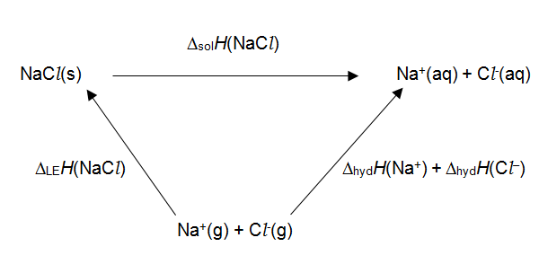
This cycle is generally used to calculate lattice enthalpies or enthalpy changes of hydration rather than the enthalpy change of solution. This is because enthalpy changes of solution are much easier to measure directly, whereas lattice enthalpies and enthalpy changes of hydration are much harder to find via calorimetry or similar.

Suggested Activities

Activity 1: A consideration of the changes that occur during dissolving
In this circus activity learners circulate around four workstations to look at the effect of different solvents on different solutes and develop a model to describe their observations. They go on to link this model to the bonds that form and break in the dissolving process and meet the key terms used in this topic.
Practical requirements
Task 1
- sodium chloride
- paraffin wax
- cyclohexane (DANGER: May be fatal if swallowed and enters airways. May cause drowsiness or dizziness. Highly flammable liquid and vapour. Causes skin irritation. Very toxic or toxic to aquatic life with long lasting effect.)
- distilled water
- test tubes and bungs
- spatula

Task 2
- sodium chloride
- anhydrous sodium carbonate (the hydrated salt dissolves endothermically) (WARNING: Causes serious eye irritation.)
- potassium chloride
- mass balance
- 3 plastic or Styrofoam cups per group
- 250 cm³ beaker
- –10 to 100 ºC thermometer
Task 3
- burettes set up with
  - distilled water
  - ethanol (DANGER: Highly flammable.)
  - cyclohexane (DANGER: May be fatal if swallowed and enters airways. May cause drowsiness or dizziness. Highly flammable liquid and vapour. Causes skin irritation. Very toxic or toxic to aquatic life with long lasting effect.)
- 3 100 cm³ beakers
- plastic rods and dusters to statically charge rods
Task 4 (teacher demo)
- distilled water
- cyclohexane (DANGER: May be fatal if swallowed and enters airways. May cause drowsiness or dizziness. Highly flammable liquid and vapour. Causes skin irritation. Very toxic or toxic to aquatic life with long lasting effect.)
- 2 latex balloons
- dropping pipette
Health and safety
- Health and safety should always be considered by a centre before undertaking any practical work. A full risk assessment of any activity should always be undertaken.
- It is advisable to check the CLEAPSS website (http://www.cleapss.org.uk) in advance of undertaking the practical tasks.
- Learners should wear eye protection throughout.
- Ensure laboratory is well-ventilated with regard to use of cyclohexane.
- For the demo in Task 4, be aware the solvent may be splashed when the balloon bursts. Keep learners 2 metres away and hold the balloon at arm’s length. Use only a very little solvent – 1 or 2 drops is sufficient. Some learners are scared of balloons popping.
Task 1: Is there a relationship between solute and solvent?
The key principle here is one of similar bonding between solvent molecules and solute molecules. For a compound to dissolve then the bonds between the solvent molecules must be broken as well as the bonds between molecules of solute. New bonds will then reform between the solvent and solute. If these new bonds are much weaker than the original bonds that had to be broken, then the substance is unlikely to dissolve. Encourage learners to move their thinking on in terms of energy. If less energy is released in making solute–solvent bonds than required to break the bonds within the solute and solvent, then the solute is not likely to dissolve readily. (Entropy also plays a part, but this can be left until later in the topic.)
Answers to questions:
1. What kind of bonding exists in sodium chloride? What type of bonds do you find in water, wax and cyclohexane? Think about intramolecular and intermolecular bonding.
NaCl has ionic bonds.
Water, wax and cyclohexane all contain covalent bonds.
The most significant type of intermolecular bonding in water is hydrogen bonding.
Wax and cyclohexane form only instantaneous dipole–induced dipole bonds.
2. Think about the cases where the solid actually dissolved. What pattern do you notice about the bonding between the particles in the solid and bonding between the particles in the solvent?
Wax and cyclohexane both form id–id bonds.
NaCl (ionic bonds) dissolves in water (hydrogen bonds).
There is a correlation between the strength of the types of bonds in the solute and solvent where solution occurs.
3. Think about the cases where the solid did not dissolve. Use ideas of bonding to explain why it did not dissolve.
Wax does not dissolve in water. Bonds that form between wax and water molecules are not strong enough to compensate for the breaking of the hydrogen bonds in water.
NaCl does not dissolve in cyclohexane. Bonds that form between ions and cyclohexane molecules are not strong enough to compensate for the breaking of the ionic bonds.

Task 2: What energy changes are associated with the process of dissolving?
In this experiment learners compare the temperature changes on dissolving three salts, to show that solution can be either endothermic or exothermic. The investigation is qualitative, so the method does not call for exact measurements. However, a calculation is included to provide opportunity for ongoing practice.
Sodium carbonate will give a strong exothermic change, potassium chloride will be endothermic and sodium chloride has an enthalpy change of solution so close to zero that it is unlikely they will observe a temperature change.
Answers to questions:
1. What type of intermolecular forces exist in water?
Hydrogen bonds (most significantly).
2. What type of bonding holds the structure together in the three solids?
Ionic bonding. (Two of the solids also contain covalent bonds within compound ions, but these are not relevant to the solution process.)
3. To allow the solid to dissolve, what bonds were broken and what new bonds were made?
Ionic bonds and hydrogen bonds were broken. Ion–dipole bonds were formed.
4. Considering each salt in turn, look at the temperature results and explain what this tells you about the relative strength of the bonds involved.
Na₂CO₃ – exothermic dissolving – the ion–dipole bonds formed are stronger than the bonds broken.
NaCl – no (significant) temperature change – bonds formed and the bonds broken are similar in strength.
KCl – endothermic dissolving – the bonds broken were stronger than the new ion–dipole bonds formed.
Task 3: Is a solvent polar or non-polar?
A common activity, to review ideas about intermolecular bonds and reinforce the idea of the polarity of a solvent – a key factor in the dissolving process. The water and ethanol streams will deviate as the rod is brought near because the molecules are polar. With its non-polar molecules, cyclohexane will be unaffected.

Answers to questions:
1. What is the nature of the intermolecular forces that occur in the three different solvents?
Water and ethanol – primarily hydrogen bonding (other bonding does exist, e.g. id–id bonding between the alkyl parts of the ethanol molecules).
Cyclohexane – only instantaneous dipole–induced dipole bonds.
2. Draw a diagram depicting the intermolecular forces for all three solvents, including relevant partial charges and lone pairs.
For water and ethanol:
- δ+ charge on the H of the O–H bond and δ– on the O.
- Lone pair on the oxygen.
- Dashed line from hydrogen (of the OH bond) of one molecule to a lone pair on the oxygen of another molecule.
For cyclohexane learners might simply draw dashed lines between neighbouring molecules to indicate attractive forces, with no partial charges. Some learners might attempt to draw a 2-step diagram, showing an instantaneous dipole on one molecule inducing a dipole on another molecule – in this case partial charges would be appropriate.
3. Use the sketches you have produced to explain the difference in results in the static electricity experiment you have just completed. Remember that the rod, having been rubbed, will carry a large positive or negative charge.
Water and ethanol molecules are polar and are attracted to the charged rod. Cyclohexane has no polarity and so is not attracted to the charged rod.
Task 4: What is the effect of a non-polar solvent on a solid?
This is best done as a demonstration at the end of the lesson and it follows very nicely from Task 3, in which the learners explored the polarity of solvents.
Inflate two balloons. Drop a couple of drops of water on one, and a couple of drops of cyclohexane on the other – only a very little solvent is required! Water will have no effect on the balloon, so do not worry about what may happen here. However, cyclohexane will cause the balloon to burst. Wear eye protection, hold the balloon at arm’s length, and ask the pupils to stand about 2 metres away as the solvent will splash out. It will burst very suddenly.
Instead of cyclohexane you can also use orange oil or squeeze some liquid from orange peel – limonene is the key component here.
The balloon bursts because cyclohexane molecules mix with the latex polymer chains, reducing the forces between chains and weakening the balloon. Although water does induce a dipole in the latex polymer and there will be attractions between these two different molecules, water will not mix with the latex. This is because it is not energetically favourable for the much stronger hydrogen bonds in water to be broken, only for weaker bonds to form with the latex.
This issue of breaking bonds in the solvent in order to form new bonds with the solute is a key issue in the solubility of substances, especially salts in water.
If you are feeling brave, the weakness of the intermolecular forces holding the latex polymer chain together is highlighted by the trick in which a BBQ skewer covered in petroleum jelly is pushed through a balloon without it popping. A simple method for this trick can be found at:
http://weirdsciencekids.com/BalloonSkewer.html
Answers to questions:
1. What type of intermolecular forces exist between molecules of water? What about cyclohexane and latex?
Water – hydrogen bonds (primarily)
Cyclohexane and latex form only id–id bonds
2. What were your observations when water and cyclohexane were dropped on the balloons?
Water – nothing happened; cyclohexane – balloon burst.
3. Can you explain your observations with ideas about intermolecular bonding?
Cyclohexane molecules mix with latex polymer chains. Both form only instantaneous dipole–induced dipole bonds, so there is not much difference in enthalpy between the bonding within the compounds and between the compounds. The balloon weakens and bursts because there are fewer bonds between the latex polymer chains.
Water does not mix with the latex polymer chains because it forms strong hydrogen bonds. It is not energetically favourable for the bonds between the water molecules to break, as any bonds between water and latex molecules would be much weaker.

Activity 2: Producing enthalpy cycles for the dissolving process
This is a Hess’ Law worksheet to help learners understand the relationship between enthalpy change of solution, enthalpy change of hydration and lattice enthalpy.
Answers to questions
1. Write the equations for the reactions that relate to these enthalpy changes.
(a) Δ_{sol}H for sodium chloride
NaCl(s) → Na⁺(aq) + Cl–(aq)
(b) Δ_{LE}H for potassium bromide
K⁺(g) + Br–(g) → KBr(s)
(c) Δ_{LE}H for ammonium nitrate
NH₄⁺(g) + NO₃–(g) → NH₄NO₃(s)
(d) Δ_{sol}H for copper(II) nitrate
Cu(NO₃)₂(s) → Cu²⁺(aq) + 2NO₃–(aq)
(e) Δ_{LE}H for sodium carbonate
2Na⁺(g) + CO₃^{2–}(g) → Na₂CO₃(s)
2. Write the equations for the reactions that relate to these enthalpy changes.
(a) Δ_{hyd}H for sodium ions
Na⁺(g) + aq → Na⁺(aq)
(b) Δ_{hyd}H for copper(II) ions
Cu²⁺(g) + aq → Cu²⁺(aq)
(c) Δ_{hyd}H for sulfate ions
SO₄^{2–} + aq → SO₄^{2–}(aq)
3. (a) Firstly, the ionic lattice is broken up into separate gaseous ions.
Describe the enthalpy change for this reaction using a scientific term.
This is the NEGATIVE of the lattice enthalpy.
(b) Secondly, the ions are hydrated by forming ion–dipole bonds with water molecules.
Describe the enthalpy change for this reaction using a scientific term.
This is the SUM of the enthalpy changes of hydration of the ions present in the ionic solid.
4. Complete the Hess cycle below for sodium chloride. Label all the arrows, and use the correct state symbols. Be careful with the direction of the arrows!
5. Construct the enthalpy level diagram for sodium chloride using the given data.
Δ_{LE}H(NaCl) = –788 kJ mol^{–1}
Δ_{hyd}H(Na⁺) = –406 kJ mol^{–1}
Δ_{hyd}H(Cl–) = –346 kJ mol^{–1}
Start with the energy level for solid sodium chloride (NaCl(s)) at the bottom of the diagram. Then use the values above to add in the energy levels of the gaseous ions and the final dissolved salt, consisting of aqueous ions.
Label all three arrows and use the data and the diagram to calculate the enthalpy change of solution of sodium chloride.
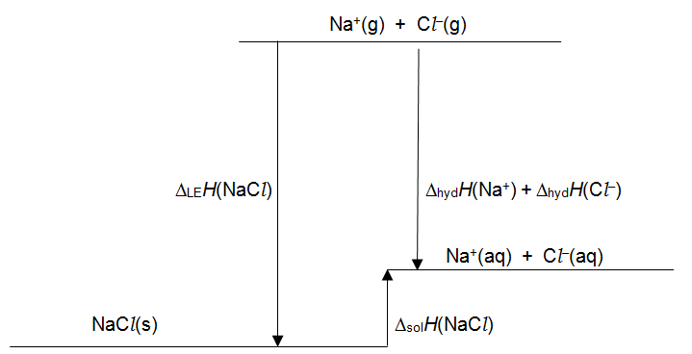
Δ_{sol}H(NaCl) = –Δ_{LE}H(NaCl) + Δ_{hyd}H(Na⁺) + Δ_{hyd}H(Cl–)
= –(–788) + (–406) + (–346)
= +36 kJ mol^{–1}
6. Now consider the dissolving of zinc chloride, ZnCl₂.
(a) Draw and label a Hess cycle for the solution of zinc choride, including the enthalpy change of hydration and the lattice enthalpy.
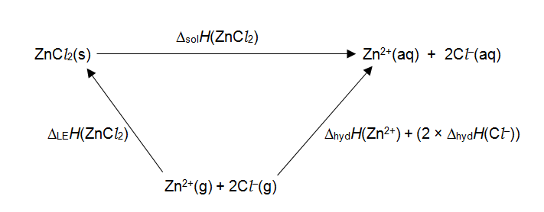
(b) Draw and label the enthalpy level diagram for the dissolving of zinc chloride. Use the following data to ensure the levels are at correct heights relative to each other.
Δ_{LE}H(ZnCl₂) = –2734 kJ mol^{–1}
Δ_{hyd}H(Zn²⁺) = –2046 kJ mol^{–1}
Δ_{hyd}H(Cl–) = –346 kJ mol^{–1}
Use your diagram and the data to calculate the enthalpy change of solution for zinc chloride.
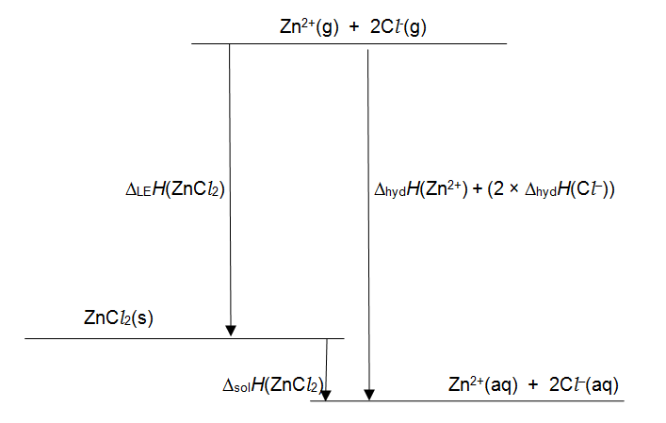
Δ_{sol}H(ZnCl₂) = –Δ_{LE}H(ZnCl₂) + Δ_{hyd}H(Zn²⁺) + (2 × Δ_{hyd}H(Cl–))
= –(–2734) + (–2046) + (2 × (–346))
= –4 kJ mol^{–1}

Activity 3: Measuring the enthalpy change of solution for different ionic compounds
This is a practical activity in which the learners use the procedure of calorimetry to find the enthalpy change of solution of different ionic compounds. The results of the experiment are analysed and then used to produce an enthalpy cycle, which enables learners to calculate lattice enthalpies and enthalpy changes of hydration.
Practical requirements
Chemicals
- lithium chloride (WARNING: Harmful if swallowed. Causes skin irritation and serious eye irritation.)
- potassium chloride
- distilled water

Apparatus
- plastic or Styrofoam cups
- 250 cm³ beaker
- –10 to 100 ºC thermometer
- mass balance (to 2 d.p.)
- 50 cm³ bulb pipette and safety filler
- stopclock
- graph paper

Health and safety
- Health and safety should always be considered by a centre before undertaking any practical work. A full risk assessment of any activity should always be undertaken.
- It is advisable to check the CLEAPSS website (http://www.cleapss.org.uk) in advance of undertaking the practical tasks.
- Learners should wear eye protection throughout.
Learners dissolve 0.1 mol of each salt in exactly 50 cm³ of distilled water to find the temperature change. The method proposed involves measuring temperature over time. Learners then plot graphs of their results and extrapolate back to the point at which the salt was added. This should give a more accurate temperature change than simply measuring the greatest temperature difference, as it takes into account heat exchanges with the surroundings as well as the time taken to dissolve all the salt. If you have additional time, learners might compare and evaluate those two methods.
A simple step takes the learners to a value of the enthalpy change of solution for each salt and then there is an opportunity to study and apply the enthalpy cycle for the dissolving process. This will enable the learners to apply ideas of lattice enthalpy and enthalpy change of hydration and use the results of their practical work to predict the value of these quantities for the salts and ions present.
Analysis
The learners will need to use their temperature/time graphs to find a value for ΔT, which is then substituted into the equation:
q = mcΔT
They can use 4.18 J K^{–1} g^{–1} as an approximation of the specific heat capacity of the solution formed. For the mass, the combined mass of the water and the salt should be used as this represents the mass of the final solution. A measurement of the mass of the solution could be included in the procedure, rather than approximating the mass through the volume of water used.
Having found the heat energy released learners need to calculate the amount (in mol) of salt they actually added, which may have been more or less than the recommended 0.1 mol. These figures will get them to a final answer of the enthalpy change of solution in kJ mol^{–1}.
Answers to questions
1. Define the enthalpy change of solution.
The enthalpy change on the dissolving of 1 mol of a substance (to infinite dilution).
2. Write the equations out for the following enthalpy changes. You must include state symbols.
(a) The enthalpy change of solution of lithium chloride.
LiCl(s) → Li⁺(aq) + Cl–(aq)
(b) The lattice enthalpy of lithium chloride.
Li⁺(g) + Cl–(g) → LiCl(s)
(c) The enthalpy change of hydration of Li⁺ ions.
Li⁺(g) + aq → Li⁺(aq)
(d) The enthalpy change of hydration of Cl– ions
Cl–(g) + aq → Cl–(aq)
3. (a) Now take all these enthalpy changes and combine them into an enthalpy cycle (a Hess cycle).
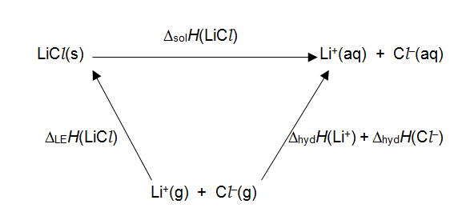
(b) Use the completed cycle to express Δ_{sol}H(LiCl) in terms of Δ_{LE}H(LiCl), Δ_{hyd}H(Li⁺) and Δ_{hyd}H(Cl–).
Δ_{sol}H(LiCl) = –Δ_{LE}H(LiCl) + Δ_{hyd}H(Li⁺) + Δ_{hyd}H(Cl–)
The following data is essential for the next question:
Δ_{hyd}H(Li⁺) = –515 kJ mol^{–1}
Δ_{hyd}H(K⁺) = –322 kJ mol^{–1}
Δ_{hyd}H(Cl–) = –364 kJ mol^{–1}
(c) Use your values for the enthalpy change of solution of lithium chloride and potassium chloride to find the lattice enthalpy of both salts.
You will need to apply the expression for the relationship between the enthalpy changes that you devised in the last question.
They will need to substitute values from the data and from their practical into the formula from part (b), and in the equivalent expression for potassium chloride.
4. Lithium and potassium are both in Group 1, so they are very similar chemically.
Suggest what may be causing the difference in the enthalpy changes between the two salts. Focus on the lattice enthalpy and the enthalpy change of hydration.
The Li⁺ ion is smaller than the K⁺ ion, so has smaller charge density. Therefore, it attracts water molecules more strongly, and hydration is more exothermic for Li⁺ than for K⁺. Similarly, Li⁺ attracts chloride ions in the salt lattice more strongly, so the lattice enthalpy for LiCl has a greater value than that for KCl.

Activity 4: Relating charge density to enthalpy changes
This mathematical activity allows learners to better understand what is meant by charge density when discussing ions and how this factor affects enthalpy changes, especially enthalpy changes of hydration and lattice enthalpies.
This activity gets learners to think about charge density. They place small coloured stickers on the outside of a ping-pong ball and a tennis ball. The two balls represent ions of different radii and the stickers represent the amount of charge on each ion. How closely packed the stickers are in each case described represents the charge density (which is often refered to as ‘surface charge density’ in A Level textbooks).
The surface area of the tennis ball is about 3 times that of the ping pong ball, so 10 stickers on each ball should be roughly three times more spaced out on the tennis ball than on the ping pong ball. Even when the charge on the tennis ball is doubled, the ping-pong ball still has greater charge density.
The activity then makes a qualitative link between charge density and enthalpy change of hydration and lattice enthalpy. A higher charge density will result in more exothermic values for both these enthalpy changes. The learner worksheet has a simple explanation, but this may be an excellent opportunity to bridge into some A Level Physics.
When we consider the electric field strength around an ion, the equation used is:
E = kQ / r²
electric field strength = constant × charge on ion / (radius)²
The electric field strength is the force felt per unit charge, which can be seen as the attraction between adjacent ions (or partial charges on water molecules). Therefore, the equation tells us that a larger charge or a smaller radius will both result in a stronger electric field strength.
Provide learners with graph paper for question 3.
Answers to questions
1. What two factors affect the charge density on an ion?
The charge and the radius of the ion.
2. Which factor has the greater effect according to your observations? Can you explain why this factor is more important?
(It may help to remember that the surface you are studying is the surface area of a sphere.)
The radius is more important as the surface area is proportional to the radius². Surface area of a sphere = 4πr²
3. The table shows values for the enthalpy change of hydration and the ionic radius of some Group 2 ions.
Ion | Δ_{hyd}H / kJ mol^{–1} | Ionic radius / nm
Mg²⁺ | –1926 | 0.078
Ca²⁺ | –1579 | 0.106
Sr²⁺ | –1446 | 0.127

Plot a suitable graph to show how the enthalpy change of hydration varies with charge density for these three ions.
Learners will ideally plot graphs of charge density (with unit C m^{–2}) against Δ_{hyd}H. You may also see plots against surface area or against radius.
4. Describe and explain the trend seen on the graph. What does the graph show you about the relationship between charge density and Δ_{hyd}H?
- higher charge density → more exothermic Δ_{hyd}H
- water ligands are polar
- negative charge in the water dipole is attracted to the positive ion
- higher charge density → stronger attraction to water molecules
- more energy released as ion–dipole bonds form.

Answers to test yourself questions
1. Calcium nitrate dissolves exothermically into water. Here are some enthalpy changes that relate to the dissolving process:
Δ_{sol}H(Ca(NO₃)₂) = –19 kJ mol^{–1}
Δ_{hyd}H(Ca²⁺) = –1650 kJ mol^{–1}
Δ_{hyd}H(NO₃–) = –166 kJ mol^{–1}
Construct a Hess cycle for the dissolving of calcium nitrate.
Use the cycle to calculate the lattice enthalpy of Ca(NO₃)₂.
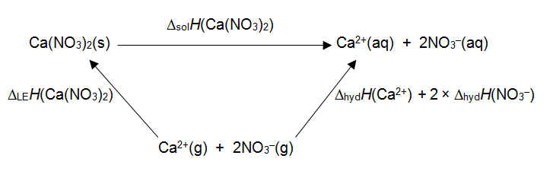
(The Hess cycle could also be drawn with the reaction representing lattice enthalpy going along the top line, as this is the unknown.)
Δ_{LE}H(Ca(NO₃)₂) = Δ_{hyd}H(Ca²⁺) + 2 × Δ_{hyd}H(NO₃–) – Δ_{sol}H(Ca(NO₃)₂)
= –1650 + 2 × –166 – –19
= –1963 kJ mol^{–1}

2. (a) When ammonium nitrate dissolves in water, the solution will become much colder.
Use this information to complete an energy level diagram for the solution of ammonium nitrate.
Label all relevant arrows on the energy level diagram.
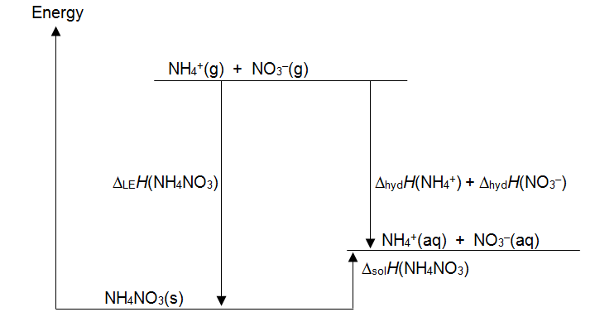
(b) Even though the dissolving process is endothermic for ammonium nitrate, the salt is still very soluble. Entropy is a factor that tells us a lot about whether or not a salt will dissolve.
Discuss the entropy changes that occur to the solute and the solvent in the dissolving process.
In the solute the entropy increases. Ions are initially fixed in an ionic lattice, then are free to move through the solution. There is more disorder in the solution, so higher entropy. In the solvent the entropy decreases as some water molecules form ion–dipole bonds with the ions, therefore the disorder decreases.
3. This question is about vitamins.
Some vitamins are soluble in water and some are soluble in fat. Vitamin C is an example of a water-soluble vitamin. Up to 330 g can be dissolved in 1 dm³ of water at 298 K.
The structure of vitamin C (also known as ascorbic acid) is shown below:
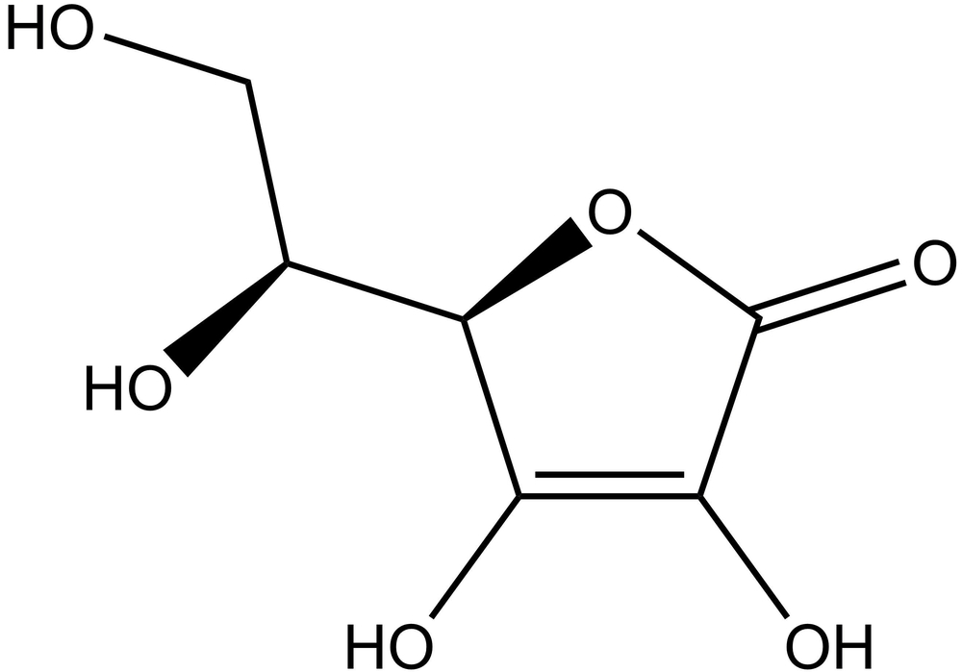
(a) Use ideas of intermolecular forces to explain why vitamin C is much more soluble in water than it is in fat.
Vitamin C has 4 separate OH groups, which can form strong hydrogen bonds with water molecules. Fat consists mainly of non-polar molecules, so fat does not form hydrogen bonds with vitamin C. Vitamin C dissolves in water because the energy released in forming vitamin C–water bonds makes up for breaking the intermolecular bonds in vitamin C. There is not sufficient energy released in forming vitamin C–fat bonds, so vitamin C is not soluble in fat.
Vitamin A is much more soluble in fat and is effectively insoluble in water.
Retinol is one of the animal forms of vitamin A and its structure is shown below.
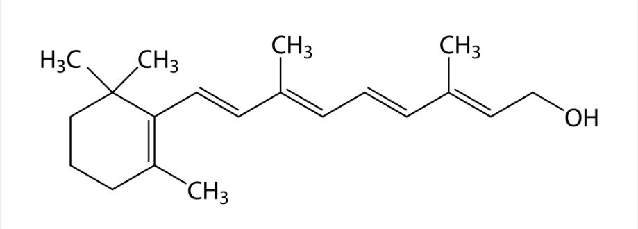
(b) Explain why vitamin A is soluble in fat and why it is not soluble in water. Refer to any intermolecular forces that are relevant to your answer.
Vitamin A is mostly non-polar apart from the OH group, so has limited ability to form hydrogen bonds with water molecules. The energy used to break hydrogen bonds between water molecules is not made up for by the bonds formed between water and vitamin A, so vitamin A is insoluble in water.
When vitamin A dissolves in fat, the bonds broken and made are mainly induced dipole–instantaneous dipole bonds of similar energy, so vitamin A is soluble in fat.
4. Seawater is a mixture of many soluble salts, the most common being sodium chloride.
Seawater is salty for two main reasons. Firstly, salts from the land dissolve in rain water as it flows over the rocks towards the sea. Secondly and more importantly, salts dissolve into seawater from underwater rocks and especially volcanoes that cause soluble salts to be released into the deep ocean.

Use the information below to answer the following questions:
Enthalpy change | kJ mol^{–1}
Δ_{hyd}H(Na⁺) | –406
Δ_{hyd}H(Ag⁺) | –446
Δ_{hyd}H(Al³⁺) | –4680
Δ_{hyd}H(Cl–) | –364
Δ_{LE}H(NaCl) | –788
Δ_{LE}H(AgCl) | –905
Δ_{LE}H(AlCl₃) | –5443
(a) Why is sodium chloride very soluble in water?
Δ_{sol}H(NaCl) = – –788 + –406 + –364 = +18 kJ mol^{–1}
Dissolving is slightly endothermic, but there is a positive entropy change as the ions go from being fixed in a lattice to moving freely in solution.
(b) Why does silver chloride have a very low solubility in water?
Δ_{sol}H(AgCl) = – –905 + –446 + –364 = +95 kJ mol^{–1}
Dissolving is fairly endothermic. The main difference with sodium chloride is the value of the lattice enthalpy. The energy required to break the ionic bonds in the AgCl lattice is not compensated by energy released from ion–dipole bonds or by any change in entropy.
(c) Aluminium is one of the most abundant elements in the Earth’s crust. Suggest why the amount of aluminium ions (Al³⁺) in seawater is very low?
Δ_{sol}H(AlCl₃) = – –5443 + –4680 + 3 × –364 = –329 kJ mol^{–1}
The enthalpy change of solution for aluminium chloride is very exothermic, so it will be very soluble. Aluminium must be found in rocks as part of a different compound that is less soluble.

OCR Resources: the small print
OCR’s resources are provided to support the teaching of OCR specifications, but in no way constitute an endorsed teaching method that is required by the Board, and the decision to use them lies with the individual teacher. Whilst every effort is made to ensure the accuracy of the content, OCR cannot be held responsible for any errors or omissions within these resources.
© OCR 2017 - This resource may be freely copied and distributed, as long as the OCR logo and this message remain intact and OCR is acknowledged as the originator of this work.
OCR acknowledges the use of the following content: vitamin A: Raimundo79/Shutterstock.com; vitamin C: Chromatos/Shutterstock.com
Please get in touch if you want to discuss the accessibility of resources we offer to support delivery of our qualifications: resources.feedback@ocr.org.uk
We’d like to know your view on the resources we produce. By clicking on ‘Like’ or ‘Dislike’ you can help us to ensure that our resources work for you. When the email template pops up please add additional comments if you wish and then just click ‘Send’. Thank you.
Whether you already offer OCR qualifications, are new to OCR, or are considering switching from your current provider/awarding organisation, you can request more information by completing the Expression of Interest form which can be found here: www.ocr.org.uk/expression-of-interest
Looking for a resource? There is now a quick and easy search tool to help find free resources for your qualification:
www.ocr.org.uk/i-want-to/find-resources/

Topic Exploration Pack

Enthalpy changes of dissolving

Learner activity 1 – The changes that occur during dissolving
This is a circus activity with four workstations. The activities are designed to build up your ideas of what happens when solids dissolve in solvents, and what energy changes are involved.
At each station you should complete the task and answer the questions given.
Health and safety
- Wear eye protection.
- Ethanol (Task 3) and cyclohexane (Task 1 and Task 3) are highly flammable.
- Cyclohexane may be fatal if swallowed, may cause drowsiness and causes skin irritation. Take care to avoid inhaling fumes.
Task 1: Is there a relationship between solute and solvent?
This task involves two solids and two solvents. You will attempt to dissolve each solid in each solvent and make observations.
The two solids are sodium chloride and paraffin wax. (Wax is a solid consisting of long hydrocarbon chains, very much like those found in alkanes.)
The two solvents are water and cyclohexane.
Draw up a results table ready to note down your observations.
Use about half a spatula of each solid and try to dissolve it in roughly 5 cm³ of solvent. You will need to shake each test tube, so place a bung in the test tube before shaking. Leave each tube to settle for several minutes in case the change is slow to occur.
Note all your observations.
Questions:
1. What kind of bonding exists in sodium chloride? What type of bonds do you find in water, wax and cyclohexane? Think about intramolecular and intermolecular bonding.
2. Think about the cases where the solid dissolved. What pattern do you notice about the bonding between the particles in the solid and bonding between the particles in the solvent?
3. Think about the cases where the solid did not dissolve. Use ideas of bonding to explain why it did not dissolve.
Task 2: What energy changes are associated with the process of dissolving?
This experiment looks at the energy changes that can occur when a solid dissolves in water.
You have three ionic solids: sodium chloride, sodium carbonate and potassium chloride.
1. Calculate the mass of 0.1 mol of each solid.
2. Put the plastic cup inside the large beaker. This insulates the experiment and makes it more stable.
3. Place about 100 cm³ of water in the plastic cup. Measure and record the temperature of the water.
4. Weigh out 0.1 mol of one of the solids. Add the solid to the water and stir briskly to dissolve the substance.
5. Note the temperature as the solid dissolves. Record the final temperature at the end of the process.
6. Repeat steps 2–5 for the other two solids. Record your results in a suitable table.
Questions:
1. What type of intermolecular forces exist in water?
2. What type of bonding holds the structure together in the three solids?
3. To allow the solid to dissolve, what bonds were broken and what new bonds were made?
4. Considering each salt in turn, look at the temperature results and explain what this tells you about the relative strength of the bonds involved.
Task 3: Is a solvent polar or non-polar?
Three labelled burettes have been set up for you containing different solvents: water, ethanol and cyclohexane. You will allow a slow stream of solvent to run from each burette and test to see whether the stream is deflected by a statically charged rod.
Before you test each solvent, charge the rod by rubbing it vigorously on a dry cloth (preferably a duster or synthetic material).
Turn the burette tap so that a slow flow of solvent falls into the beaker below.
Bring the charged rod close to the stream and record your observations.
Questions:
1. What is the nature of the intermolecular forces that occur in the three different solvents?
2. Draw a diagram depicting the intermolecular forces for all three solvents, including relevant partial charges and lone pairs.
3. Use the sketches you have produced to explain the difference in results in the static electricity experiment you have just completed. Remember that the rod, having been rubbed, will carry a large positive or negative charge.
Task 4: What is the effect of a non-polar solvent on a solid?
You will be shown the effect of a polar and a non-polar solvent on a latex balloon. Latex is a non-polar polymer called cis-polyisoprene (systematic name: cis-poly-2-methyl-1,3-butadiene), very much like the addition polymers you met in the first year of the course.
Watch the demonstration and think about the following questions.
Questions:
1. What type of intermolecular forces exist between molecules of water? What about cyclohexane and latex?
2. What were your observations when water and cyclohexane were dropped on the balloons?
3. Can you explain your observations with ideas about intermolecular bonding?

Learner activity 2 – Producing enthalpy cycles for the dissolving process
This is a worksheet activity designed to help you understand the links between the three important enthalpy changes in dissolving:
- Δ_{sol}H – the enthalpy change of solution
- Δ_{LE}H – the lattice enthalpy
- Δ_{hyd}H – the enthalpy change of hydration
To practise these terms, complete the following exercise.
1. Write the equations for the reactions that relate to these enthalpy changes.
(a) Δ_{sol}H for sodium chloride
(b) Δ_{LE}H for potassium bromide
(c) Δ_{LE}H for ammonium nitrate
(d) Δ_{sol}H for copper(II) nitrate
(e) Δ_{LE}H for sodium carbonate
The enthalpy change of hydration is considered for cations and anions separately.
2. Write the equations for the reactions that relate to these enthalpy changes.
(a) Δ_{hyd}H for sodium ions
(b) Δ_{hyd}H for copper(II) ions
(c) Δ_{hyd}H for sulfate ions
When we consider the dissolving of an ionic compound in water, we can visualise the process in two steps.
3. (a) Firstly, the ionic lattice is broken up into separate gaseous ions.
Describe the enthalpy change for this reaction using a scientific term.
(b) Secondly, the ions are hydrated by forming ion–dipole bonds with water molecules.
Describe the enthalpy change for this reaction using a scientific term.
You can combine these two enthalpy changes with the enthalpy change of solution to produce a Hess cycle.
4. Complete the Hess cycle below for sodium chloride. Label all the arrows, and use the correct state symbols. Be careful with the direction of the arrows!
NaCl(s) Na⁺(aq) + Cl–(aq)

This diagram is often shown as an enthalpy level diagram.
5. Construct the enthalpy level diagram for sodium chloride using the given data.
Δ_{LE}H(NaCl) = –788 kJ mol^{–1}
Δ_{hyd}H(Na⁺) = –406 kJ mol^{–1}
Δ_{hyd}H(Cl–) = –346 kJ mol^{–1}
Start with the energy level for solid sodium chloride (NaCl(s)) at the bottom of the diagram. Then use the values above to add in the energy levels of the gaseous ions and the final dissolved salt, consisting of aqueous ions.
Label all three arrows and use the data and the diagram to calculate the enthalpy of solution of sodium chloride.
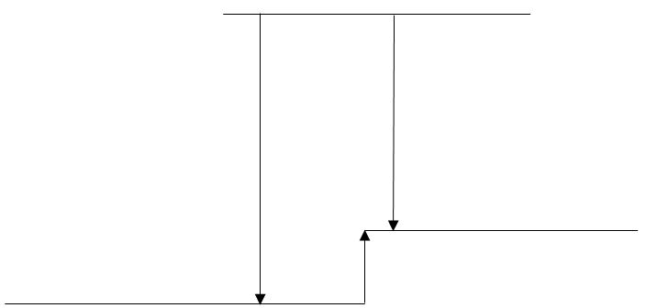

Note that the enthalpy level diagram in question 5 shows an endothermic enthalpy change of solution. An enthalpy level diagram for an exothermic solution process would look a little different. Have a think about what the difference would be.
6. Now consider the dissolving of zinc chloride, ZnCl₂.
(a) Draw and label a Hess cycle for the solution of zinc chloride, including the enthalpy change of hydration and the lattice enthalpy.
(b) Draw and label the enthalpy level diagram for the dissolving of zinc chloride. Use the following data to ensure the levels are at correct heights relative to each other.
Δ_{LE}H(ZnCl₂) = –2734 kJ mol^{–1}
Δ_{hyd}H(Zn²⁺) = –2046 kJ mol^{–1}
Δ_{hyd}H(Cl–) = –346 kJ mol^{–1}
Use your diagram and the data to calculate the enthalpy change of solution for zinc chloride.

Learner activity 3 – Measuring the enthalpy change of solution
In this practical activity you will use calorimetry to find the enthalpy change of solution of two different ionic compounds. You will analyse the results of the experiment and produce an enthalpy cycle, which will enable you to calculate lattice enthalpies and enthalpy changes of hydration.
You will have used calorimetry before to measure enthalpy changes. The principle is that the enthalpy change of a reaction is measured through the temperature change of a quantity of water. As the specific heat capacity of water is known, we can substitute values to find the energy released or taken in:
energy = mass of solution × specific heat capacity × change in temperature
q = m × c × ΔT
We then need to calculate the amount (in mol) of salt added to the solution to find the enthalpy change per mole.
You should repeat the procedure to find the enthalpy change of solution of both chloride salts provided.
Health and safety
- Wear eye protection.
- Solid lithium chloride is harmful if swallowed, and causes skin irritation and serious eye irritation.
Procedure
1. Calculate the mass in grams of 0.1 mol of each salt and weigh this quantity out. Record the actual mass used for each salt.
2. Place a plastic cup inside the beaker. This stabilises the cup during the experiment and provides extra insulation for the experiment to lessen heat loss to the environment.
3. Use the pipette to add exactly 50 cm³ of water to the cup. Record the temperature of the water.
In this practical you will take temperature readings every 30 seconds and record these values. The salt will be added 2 minutes after the clock has started, so the readings will be steady at first and then change.
Continue to take readings for a further 8 minutes after adding the salt. You can use the thermometer to stir the mixture after adding the salt, to aid solution.
4. Before you begin, prepare a suitable results table to record the temperatures in the experiment.
5. Start the clock and take temperature readings for two minutes, then add the salt. Continue to take readings until the clock reads ten minutes.
6. Repeat steps 2–5 for the second salt.
Analysis
1. Plot your temperature measurements for each experiment on suitable axes.
2. To find the value of ΔT to use in your calculations, you need to look at the temperature plot after the solution of the salt, as it slowly moves back to room temperature. Extrapolate this line back to the point where time = 120 s (i.e. where you added the salt).
3. Use the temperature at this point on the graph to determine the value of ΔT. This is the temperature change that would have occurred if there was no heat exchange with the surroundings.
4. Calculate the energy change that occurred in each experiment. For the mass, use the mass of solution formed – this is the mass that changes temperature.
5. Now calculate the actual amount (in mol) of salt you used in your experiment and use this figure to find the enthalpy change in kJ mol^{–1}.
Questions
1. Define the enthalpy change of solution.
2. Write the equations out for the following enthalpy changes. You must include state symbols.
(a) The enthalpy change of solution of lithium chloride.
(b) The lattice enthalpy of lithium chloride.
(c) The enthalpy change of hydration of Li⁺ ions.
(d) The enthalpy change of hydration of Cl– ions

3. (a) Now take all these enthalpy changes and combine them into an enthalpy cycle (a Hess cycle).
(b) Use the completed cycle to express Δ_{sol}H(LiCl) in terms of Δ_{LE}H(LiCl), Δ_{hyd}H(Li⁺) and Δ_{hyd}H(Cl–).
The following data is essential for the next question:
Δ_{hyd}H(Li⁺) = –515 kJ mol^{–1}
Δ_{hyd}H(K⁺) = –322 kJ mol^{–1}
Δ_{hyd}H(Cl–) = –364 kJ mol^{–1}
(c) Use your values for the enthalpy change of solution of lithium chloride and potassium chloride to find the lattice enthalpy of both salts.
You will need to apply the expression for the relationship between the enthalpy changes that you devised in the last question.

4. Lithium and potassium are both in Group 1, so they are very similar chemically.
Suggest what may be causing the difference in the enthalpy changes between the two salts. Focus on the lattice enthalpy and the enthalpy change of hydration.

Learner activity 4 – Relating charge density to enthalpy changes
This is a mathematical activity allowing you to better understand what is meant by charge density when discussing ions and how this factor affects enthalpy changes, especially enthalpy changes of hydration and lattice enthalpies.
Background ideas
The charge on an ion always comes in discrete units equal to the charge of an electron. The size of this charge is 1.6 × 10^{–19} coulomb, but that is a very difficult unit to use, so we just shorten it to ‘e’.
A sodium atom will form a Na⁺ ion when it reacts. The ‘+’ sign means that there is one ‘load’ (1 e) of positive charge on the ion. Magnesium makes a 2+ ion (Mg²⁺) and this ion has exactly twice as much charge as the sodium ion.
So charge can only come in units of ‘e’ and ions can have 1+, 2+, 2– or lots of other integer combinations of this unit of charge.
We are going to think about this charge being spread out over the outer surface of an ion, like the population of the Earth is spread out over the surface of the planet. However, in the case of charge on an ion, the charge is spread out evenly, unlike the population of the Earth. We are doing this because the density of charge on the outside of an ion is a useful indicator of the properties of the ion in solution or in a solid.
Visualisation
You will need:
- a ping-pong ball (diameter about 40 mm)
- a tennis ball (diameter about 66 mm)
- a pack of small stickers.
1. Take each ball and put 10 stickers on the outside of the ball. Try to spread the stickers out as evenly as possible. Stop and look at how the stickers are distributed.
(This represents two ions of a different size with the same amount of charge on each.)
The tennis ball is a bit more than 1.5 times bigger then the ping pong ball in its diameter. Are the stickers spread out in roughly the same ratio? Think about the number of stickers per unit of area.
2. Now add a further 10 stickers to the outside of the tennis ball, so that there are now 20 stickers on the outside. Once again, look at how tightly packed the stickers are on each ball.
(The ‘tennis ball’ ion now has twice as much charge as the ping pong ball.)
Thinking about the number of stickers per unit area on each ball, which ball now shows the higher density of stickers on the outside?
3. Finally add a further 10 stickers to the ping pong ball so that the ‘charge’ on each ball is the same. Which ball now shows the higher charge density?
Questions
1. What two factors affect the charge density on an ion?
2. Which factor has the greater effect according to your observations? Can you explain why this factor is more important?
(It may help to remember that the surface you are studying is the surface area of a sphere.)
The effect of a greater charge density is that the attraction to nearby charges will be greater. Therefore, we expect ions with greater charge density to have a more exothermic enthalpy change of hydration, as the water ligands are attracted more strongly. Also, a higher charge density will result in a more exothermic lattice enthalpy as neighbouring ions are held more tightly.
3. The table shows values for the enthalpy change of hydration and the ionic radius of some Group 2 ions.
Ion | Δ_{hyd}H / kJ mol^{–1} | Ionic radius / nm
Mg²⁺ | –1926 | 0.078
Ca²⁺ | –1579 | 0.106
Sr²⁺ | –1446 | 0.127
Plot a suitable graph to show how the enthalpy change of hydration varies with charge density for these three ions.
Hints:
- The charge density is a measure of charge per unit of surface area for an ion, so you will need to think about how to calculate this value for each ion.
- The surface area of a sphere can be calculated using the formula 4πr².
- Also think about the units of the charge density.
4. Describe and explain the trend seen on the graph. What does the graph show you about the relationship between charge density and Δ_{hyd}H?

Test yourself questions
1. Salts can have a very wide variation in solubility in water. Even when a salt is very soluble in water, the dissolving process can make the solution either hotter or colder.
Calcium nitrate dissolves exothermically into water. Here are some enthalpy changes that relate to the dissolving process:
Δ_{sol}H(Ca(NO₃)₂) = –19 kJ mol^{–1}
Δ_{hyd}H(Ca²⁺) = –1650 kJ mol^{–1}
Δ_{hyd}H(NO₃–) = –166 kJ mol^{–1}
Construct a Hess cycle for the dissolving of calcium nitrate.
Use the cycle to calculate the lattice enthalpy of Ca(NO₃)₂.
2. (a) When ammonium nitrate dissolves in water, the solution will become much colder.
Use this information to complete an energy level diagram for the solution of ammonium nitrate.
Label all relevant arrows on the energy level diagram.
(b) Even though the dissolving process is endothermic for ammonium nitrate, the salt is still very soluble. Entropy is a factor that tells us a lot about whether or not a salt will dissolve.
Discuss the entropy changes that occur to the solute and the solvent in the dissolving process.
3. This question is about vitamins.
Some vitamins are soluble in water and some are soluble in fat. Vitamin C is an example of a water-soluble vitamin. Up to 330 g can be dissolved in 1 dm³ of water at 298 K.
The structure of vitamin C (also known as ascorbic acid) is shown below:
(a) Use ideas of intermolecular forces to explain why vitamin C is much more soluble in water than it is in fat.
Vitamin A is much more soluble in fat and is effectively insoluble in water.
Retinol is one of the animal forms of vitamin A and its structure is shown below.
(b) Explain why vitamin A is soluble in fat and why it is not soluble in water. Refer to any intermolecular forces that are relevant to your answer.
4. Seawater is a mixture of many soluble salts, the most common being sodium chloride.
Seawater is salty for two main reasons. Firstly, salts from the land dissolve in rain water as it flows over the rocks towards the sea. Secondly and more importantly, salts dissolve into seawater from underwater rocks and especially volcanoes that cause soluble salts to be released into the deep ocean.
Use the information below to answer the following questions:
Enthalpy change | kJ mol^{–1}
Δ_{hyd}H(Na⁺) | –406
Δ_{hyd}H(Ag⁺) | –446
Δ_{hyd}H(Al³⁺) | –4680
Δ_{hyd}H(Cl–) | –364
Δ_{LE}H(NaCl) | –788
Δ_{LE}H(AgCl) | –905
Δ_{LE}H(AlCl₃) | –5443
(a) Why is sodium chloride very soluble in water?
(b) Why does silver chloride have a very low solubility in water?
(c) Aluminium is one of the most abundant elements in the Earth’s crust. Suggest why the amount of aluminium ions (Al³⁺) in seawater is very low?

