Lesson Element

Genes, inheritance and selection

Instructions and answers for teachers

These instructions cover the learner activity section which can be found on page 8. This Lesson Element supports OCR GCSE (9–1) Gateway Science Biology A.
When distributing the activity section to the learners either as a printed copy or as a Word file you will need to remove the teacher instructions section.

Learning outcomes
B5.1i - explain single gene inheritance
B5.1j - predict the results of single gene crosses
B5.1k - describe sex determination in humans using a genetic cross

Introduction
This lesson element guides learners through the process of identifying the genotype, phenotypes and possible gametes for individuals before assisting them in applying this to simple inheritance patterns including those of gender inheritance.

Teacher preparation
Learners should understand that genes inherited from parents control many of our characteristics (e.g. eye colour). They should understand that we have two copies of every gene, one from each parent (note this is true for somatic chromosomes & sex chromosome homologous regions, but not the differential region of the X and Y chromosomes in males – leading to sex linked diseases). They should understand that men have XY chromosomes whilst women have XX chromosomes.
The activity can be run as an independent task. Most learners will require little additional assistance. More difficult questions and open ended extension questions exist for more able learners to tackle. Estimated time - 10 minutes.

Task 1 – Inheritance
Most people have a gene that controls their eye colour. There are many different forms of this gene called alleles and these lead to differences in eye colour that we see. For example the gene for eye colour has the alleles: blue, brown, green, grey and hazel.
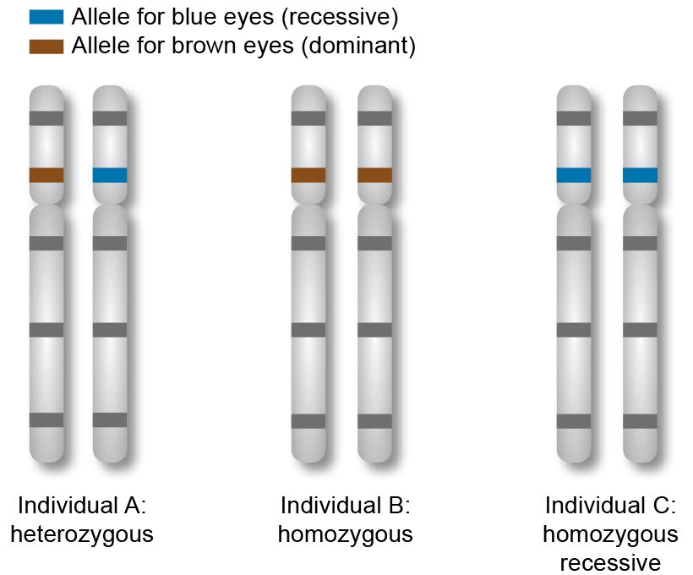

Tip!
a. The genotype is the combination of alleles (forms of the gene) that a person has for a particular trait.
b. Homozygous means both alleles are the same and heterozygous means that both alleles are different.
c. Dominant alleles are expressed over recessive alleles. Recessive alleles are only expressed where no dominant alleles present.

1. State the genotypes of the three individuals above (i.e. which alleles for eye colour do
they have?)
1. Brown and blue (Bb)
2. Brown and brown (BB)
3. blue and blue (bb)

The phenotype is the physical result of the expression of a genotype, i.e. how the person ‘appears’ when the gene is expressed.

2. State the phenotypes of the three individuals above (i.e. what will their eye colour be?)
1. Brown eyes
2. Brown eyes
3. Blue eyes

When gametes (egg and sperm cells) are formed, they can only pass on one allele for each of genes. This is how offspring inherit information from each parent.
3. State the alleles that could be passed on from each of the three individuals above.
1. Brown or blue (B or b)
2. Brown or Brown (B)
3. blue or blue (b)

When we work out the inheritance patterns, we use letters rather than colours. Dominant genes are represented by capital letters whilst recessive genes are shown in lower case letters.

Example
When a red plant is crossed with a white plant, all of the new plants are red. 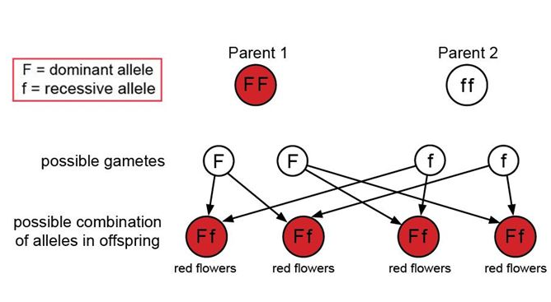
We can also show this in the form of a punnet square.
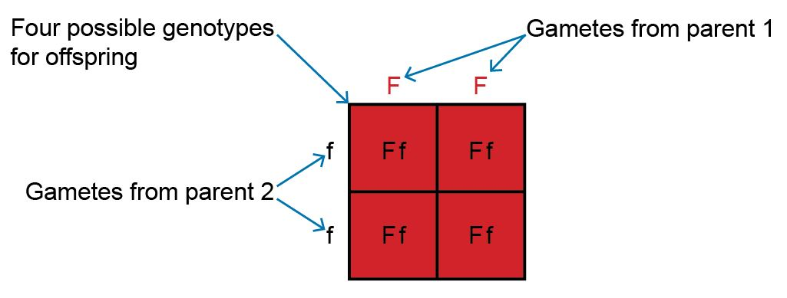

4. Complete your own diagram (using either format) and predict the outcome when two of the red plants produced above (Ff) were used. What are the genotypes and phenotypes of the plants produced and what ratio of red : white would be produced?
OCR Resources: the small print
OCR’s resources are provided to support the teaching of OCR specifications, but in no way constitute an endorsed teaching method that is required by the Board, and the decision to use them lies with the individual teacher. Whilst every effort is made to ensure the accuracy of the content, OCR cannot be held responsible for any errors or omissions within these resources.
© OCR 2015 - This resource may be freely copied and distributed, as long as the OCR logo and this message remain intact and OCR is acknowledged as the originator of this work.
OCR acknowledges the use of the following content: n/a
Please get in touch if you want to discuss the accessibility of resources we offer to support delivery of our qualifications: resources.feedback@ocr.org.uk
We’d like to know your view on the resources we produce. By clicking on ‘Like’ or ‘Dislike’ you can help us to ensure that our resources work for you. When the email template pops up please add additional comments if you wish and then just click ‘Send’. Thank you.
If you do not currently offer this OCR qualification but would like to do so, please complete the Expression of Interest Form which can be found here: www.ocr.org.uk/expression-of-interest

 | F | f
F | FF | Ff
f | Ff | ff

3 red plants: 1 white

Challenge
Can you work out the ratio of red : white plants when a heterozygous plant is crossed with a homozygous white plant? Tip: Start off with their phenotypes and genotypes, work out their gametes and then do the punnet square.

 | F | f
f | Ff | ff
f | Ff | ff

Red plant
Genotype Ff
Gametes F or f
White plant
Genotype ff
Gametes f or f
Offspring ratio
1:1 red : white

Task 2 – Gender
We can use a method similar to the one above to work out what gender a child will be and gender is worked out by X and Y chromosomes, one from each parent.
1. Fill in the combination of chromosomes for the two individuals shown below:
Male XY
Female XX
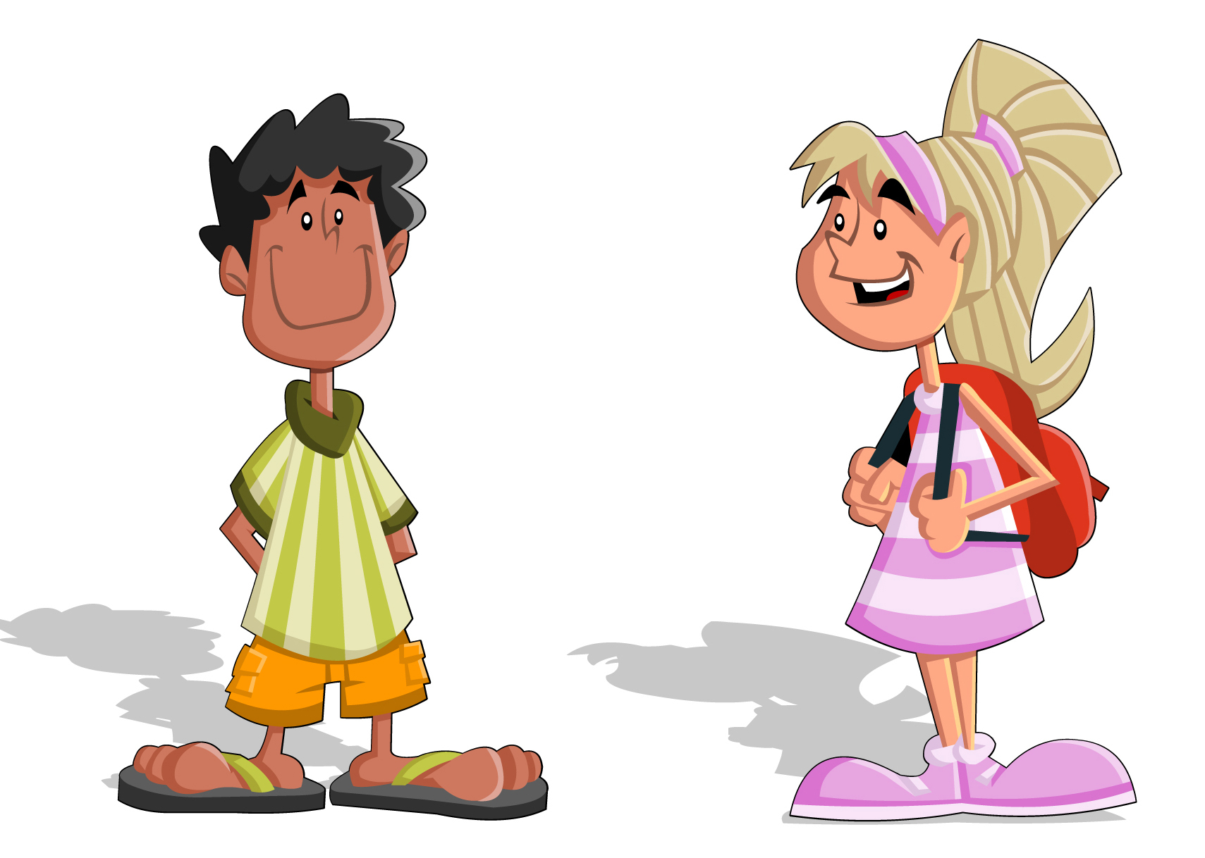

2. Complete the punnet square below, for the two parents above and work out the ratio of boys : girls they would have. Can you show this as a probability?
 | X | X
X | XX | XX
Y | XY | XY

Challenge
We have two copies of every gene necessary to make up a person, one from each parent. Suggest what you think might happen if we inherited more than one copy from one of our parents (i.e. had three copies of a gene for example).
• This can be lethal (especially if the additional chromosome is large e.g. chromosome 1)
• An example of a whole chromosome addition (trisomy) e.g. downs syndrome and the effect this may cause e.g. delayed development
• An examples of gender trisomy and its effect e.g. XXY Kleinfelter syndrome (can be infertile) or XXX (no significant effect – may be taller and only one X chromosome usually active)

OCR Resources: the small print
OCR’s resources are provided to support the teaching of OCR specifications, but in no way constitute an endorsed teaching method that is required by the Board, and the decision to use them lies with the individual teacher. Whilst every effort is made to ensure the accuracy of the content, OCR cannot be held responsible for any errors or omissions within these resources.
© OCR 2017 - This resource may be freely copied and distributed, as long as the OCR logo and this message remain intact and OCR is acknowledged as the originator of this work.
OCR acknowledges the use of the following content: Pages 6 and 12 – Babies – Pushkin/Shutterstock.com
Please get in touch if you want to discuss the accessibility of resources we offer to support delivery of our qualifications: resources.feedback@ocr.org.uk
We’d like to know your view on the resources we produce. By clicking on ‘Like’ or ‘Dislike’ you can help us to ensure that our resources work for you. When the email template pops up please add additional comments if you wish and then just click ‘Send’. Thank you.
If you do not currently offer this OCR qualification but would like to do so, please complete the Expression of Interest Form which can be found here: www.ocr.org.uk/expression-of-interest

Lesson Element

Genes, inheritance and selection

Learner Activity

Task 1 – Inheritance
Most people have a gene that controls their eye colour. There are many different forms of this gene called alleles and these lead to differences in eye colour that we see. For example the gene for eye colour has the alleles: blue, brown, green, grey and hazel.

Tip!
a. The genotype is the combination of alleles (forms of the gene) that a person has for a particular trait.
b. Homozygous means both alleles are the same and heterozygous means that both alleles are different.
c. Dominant alleles are expressed over recessive alleles. Recessive alleles are only expressed where no dominant alleles present

1. State the genotypes of the three individuals above (i.e. which alleles for eye colour do
they have?)
1.
2.
3.

The phenotype is the physical result of the expression of a genotype, i.e. how the person ‘appears’ when the gene is expressed.
2. State the phenotypes of the three individuals above (i.e. what will their eye colour be?)
1.
2.
3.

When gametes (egg and sperm cells) are formed, they can only pass on one allele for each of genes. This is how offspring inherit information from each parent.
3. State the alleles that could be passed on from each of the three individuals above.
1.
2.
3.

When we work out the inheritance patterns, we use letters rather than colours. Dominant genes are represented by capital letters whilst recessive genes are shown in lower case letters.

Example
When a red plant is crossed with a white plant, all of the new plants are red.
We can also show this in the form of a punnet square.

4. Complete your own diagram (using either format) and predict the outcome when two of the red plants produced above (Ff) were used. What are the genotypes and phenotypes of the plants produced and what ratio of red : white would be produced?
OCR Resources: the small print
OCR’s resources are provided to support the teaching of OCR specifications, but in no way constitute an endorsed teaching method that is required by the Board, and the decision to use them lies with the individual teacher. Whilst every effort is made to ensure the accuracy of the content, OCR cannot be held responsible for any errors or omissions within these resources.
© OCR 2015 - This resource may be freely copied and distributed, as long as the OCR logo and this message remain intact and OCR is acknowledged as the originator of this work.
OCR acknowledges the use of the following content: n/a
Please get in touch if you want to discuss the accessibility of resources we offer to support delivery of our qualifications: resources.feedback@ocr.org.uk
We’d like to know your view on the resources we produce. By clicking on ‘Like’ or ‘Dislike’ you can help us to ensure that our resources work for you. When the email template pops up please add additional comments if you wish and then just click ‘Send’. Thank you.
If you do not currently offer this OCR qualification but would like to do so, please complete the Expression of Interest Form which can be found here: www.ocr.org.uk/expression-of-interest

Challenge
Can you work out the ratio of red : white plants when a heterozygous plant is crossed with a homozygous white plant? Tip: Start off with their phenotypes and genotypes, work out their gametes and then do the punnet square.

Task 2 – Gender
We can use a method similar to the one above to work out what gender a child will be and gender is worked out by X and Y chromosomes, one from each parent.
1. Fill in the combination of chromosomes for the two individuals shown below:
Male __
Female __

2. Complete the punnet square below, for the two parents above and work out the ratio of boys : girls they would have. Can you show this as a probability?

Challenge
We have two copies of every gene necessary to make up a person, one from each parent. Suggest what you think might happen if we inherited more than one copy from one of our parents (i.e. had three copies of a gene for example).

