# OCR 09 Congruence and Similarity (Foundation)

1. Write down the vector shown on the grid below as a column vector.



1. Write down the vector shown on the grid below as a column vector.

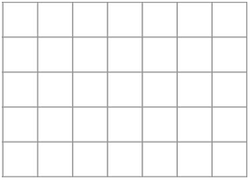

1. Calculate .
2. Calculate .
3. Give two vectors parallel to .
4. In the diagram below, triangle ABC is similar to triangle PQR. Find the length *x.*

A

B

20 cm

*x*

50 cm

40 cm

C

R

Q

P

c

c

**Not to scale**

1. On the grid below, shape **A** has been enlarged to give shape **B**.

Identify the centre of enlargement from shape **A** to shape **B**.

*y*

**A**

**B**

*x*

1. On the grid in question 7, what scale factor is used to enlarge shape **A** to give shape **B**?
2. Identify the line of reflection between the two triangles in the diagram below.

*y*

*x*

1. Identify a pair of congruent triangles on the grid below.



**A**

**D**

**C**

**F**

**B**

**E**

1. On the grid below, reflect shape **A** in the line  and label this shape **B**. Then reflect shape **B** in the line  and label this shape **C**.

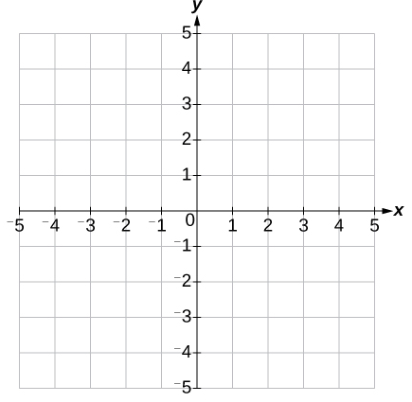

**A**

1. Using your answer from question 11, describe a single transformation that maps shape **A** to shape **C**.
2. Draw the image of hexagon **H** after a translation of .

*y*

**H**

*x*

1. In the diagram below, M is the midpoint of straight lines AC and BD.

Prove that triangles AMB and CMD are congruent giving full reasoning.

A

C

D

M

B

**Not to scale**

1. In the diagram below, quadrilateral ABCD is a kite.

Prove that triangles ABC and ADC are congruent giving full reasoning.

A

B

C

D

**Not to scale**

1. A model is made of a sculpture. The model has height 30 cm and is an enlargement with scale factor 0.25 of the sculpture. The sculpture is on a podium with height 1 m. Calculate the height of the sculpture and the podium together.
2. Three points, A, B and C, are on a grid. The vector  represents travel from A to B. The vector  represents travel from B to C. Calculate the vector representing travel from A to C.
3. Find the missing length *x* in the diagram below.

*x*

48 cm

5 cm

15 cm

**Not to scale**

1. A rectangle, **A**, has length 10 cm and width 6 cm. A similar rectangle, **B**, has length 2.5 cm. What is the area of rectangle **B**?
2. Triangle **A** can be mapped onto triangle **B** by translation .

Find *c* and *d*.

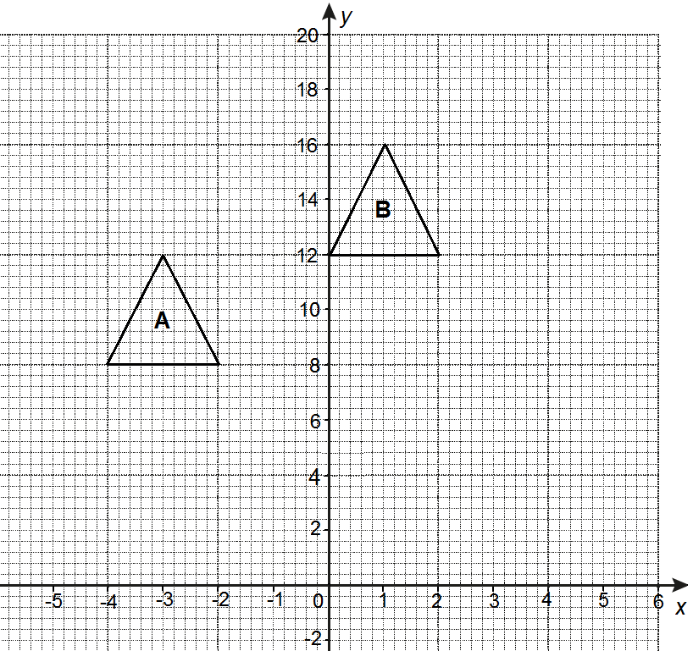

### Answers

1. 
2. 
3. 
4. 
5. Any multiple of the vector i.e. 
6. 25 cm
7. Centre of enlargement (2, -4)
8. Scale factor 
9. 
10. A and E



**C**

**B**

**A**

1. 180° rotation about (-1, 1)

*y*

*x*

**H**

**translation**

1. AM  CM and BM  DM as M is the midpoint of lines AC and BD.

Angle AMB  angle CMD using opposite angles.

Triangles ABM and CMD are congruent (SAS).

1. AC is common to both triangle ABC and triangle ADC.

AB  AD and BC  DC.

Triangle ABC and triangle ADC are congruent (SSS).

1. 30 cm ÷ 0.25  120 cm

1 m  100 cm

120 cm + 100 cm  220 cm

1. 
2. Separate the triangles to see them more clearly.

**Not to scale**

5 cm

20 cm

*x*

48 cm

It is then easy to see that *x* must be  of 48 so cm.

1. **Width or rectangle B** **cm**

**Area of rectangle B** **cm2**

1. Translation of 4 horizontally , so .

Translation of 4 vertically , so .

**OCR Resources**: *the small print*OCR’s resources are provided to support the delivery of OCR qualifications, but in no way constitute an endorsed teaching method that is required by the Board, and the decision to use them lies with the individual teacher. Whilst every effort is made to ensure the accuracy of the content, OCR cannot be held responsible for any errors or omissions within these resources. This formative assessment resource has been produced as part of our free GCSE teaching and learning support package. All the GCSE teaching and learning resources, including delivery guides, topic exploration packs, lesson elements and more are available on the qualification webpages. If you are looking for examination practice materials, you can find Sample Assessment Materials (SAMs) and Practice Papers on the qualification webpage <http://www.ocr.org.uk/qualifications/gcse-mathematics-j560-from-2015/>

© OCR 2017 - This resource may be freely copied and distributed, as long as the OCR logo and this message remain intact and OCR is acknowledged as the originator of this work.

OCR acknowledges the use of the following content: n/a

Please get in touch if you want to discuss the accessibility of resources we offer to support delivery of our qualifications: [resources.feedback@ocr.org.uk](mailto:resources.feedback@ocr.org.uk)

We’d like to know your view on the resources we produce. By clicking on ‘[Like’](mailto:resources.feedback@ocr.org.uk?subject=I%20liked%20the%20GCSE%20(9-1)%20Mathematics%20Check%20In%2009%20Foundation) or ‘[Dislike’](mailto:resources.feedback@ocr.org.uk?subject=I%20disliked%20the%20GCSE%20(9-1)%20Mathematics%20Check%20In%2009%20Foundation) you can help us to ensure that our resources work for you. When the email template pops up please add additional comments if you wish and then just click ‘Send’. Thank you.

Whether you already offer OCR qualifications, are new to OCR, or are considering switching from your current provider/awarding organisation, you can request more information by completing the Expression of Interest form which can be found here: [www.ocr.org.uk/expression-of-interest](http://www.ocr.org.uk/expression-of-interest)

Looking for a resource? There is now a quick and easy search tool to help find free resources for your qualification:   
[www.ocr.org.uk/i-want-to/find-resources/](http://www.ocr.org.uk/i-want-to/find-resources/)

| **Assessment Objective** | **Qu.** | **Topic** | **R** | **A** | **G** |  | **Assessment Objective** | **Qu.** | **Topic** | **R** | **A** | **G** |
| --- | --- | --- | --- | --- | --- | --- | --- | --- | --- | --- | --- | --- |
| AO1 | 1 | Represent a 2D vector as a column vector |  |  |  |  | AO1 | 1 | Represent a 2D vector as a column vector |  |  |  |
| AO1 | 2 | Represent a 2D vector as a column vector |  |  |  |  | AO1 | 2 | Represent a 2D vector as a column vector |  |  |  |
| AO1 | 3 | Calculate with vectors |  |  |  |  | AO1 | 3 | Calculate with vectors |  |  |  |
| AO1 | 4 | Calculate with vectors |  |  |  |  | AO1 | 4 | Calculate with vectors |  |  |  |
| AO1 | 5 | Find parallel vectors |  |  |  |  | AO1 | 5 | Find parallel vectors |  |  |  |
| AO1 | 6 | Find a length in similar shapes |  |  |  |  | AO1 | 6 | Find a length in similar shapes |  |  |  |
| AO1 | 7 | Find centre of enlargement |  |  |  |  | AO1 | 7 | Find centre of enlargement |  |  |  |
| AO1 | 8 | Identify a scale factor |  |  |  |  | AO1 | 8 | Identify a scale factor |  |  |  |
| AO1 | 9 | Identify a line of reflection |  |  |  |  | AO1 | 9 | Identify a line of reflection |  |  |  |
| AO1 | 10 | Identify congruent triangles |  |  |  |  | AO1 | 10 | Identify congruent triangles |  |  |  |
| AO2 | 11 | Reflect a shape |  |  |  |  | AO2 | 11 | Reflect a shape |  |  |  |
| AO2 | 12 | Describe a single transformation |  |  |  |  | AO2 | 12 | Describe a single transformation |  |  |  |
| AO2 | 13 | Translate a shape using a column vector |  |  |  |  | AO2 | 13 | Translate a shape using a column vector |  |  |  |
| AO2 | 14 | Prove that two triangles are congruent using SAS |  |  |  |  | AO2 | 14 | Prove that two triangles are congruent using SAS |  |  |  |
| AO2 | 15 | Prove that two triangles are congruent using SSS |  |  |  |  | AO2 | 15 | Prove that two triangles are congruent using SSS |  |  |  |
| AO3 | 16 | Solve a real-life problem with scale factors |  |  |  |  | AO3 | 16 | Solve a real-life problem with scale factors |  |  |  |
| AO3 | 17 | Calculate with vectors |  |  |  |  | AO3 | 17 | Calculate with vectors |  |  |  |
| AO3 | 18 | Find a missing side length using similar triangles |  |  |  |  | AO3 | 18 | Find a missing side length using similar triangles |  |  |  |
| AO3 | 19 | Calculate an area using similar shapes |  |  |  |  | AO3 | 19 | Calculate an area using similar shapes |  |  |  |
| AO3 | 20 | Translate with column vectors |  |  |  |  | AO3 | 20 | Translate with column vectors |  |  |  |