# Section Check In – 1.06 Exponentials and Logarithms

## Questions

1. Solve the equation .

2. Evaluate .

3. Sketch the graph of . Indicate clearly any points where the curve touches the axes and any asymptotes.

4. Find the exact solution to the equation .

5. Find the equation of the tangent to the curve  at the point where . Give your answer in the form  where  and  are exact values.

6. (a) Sketch the graph of . Indicate clearly any points where the curve crosses the axes and any asymptotes.

(b) Find  and find the largest possible domain and range for this function.

(c) Sketch  and  on the same axis showing the relationship between them.

7. Solve the equation .

8. Find the coordinates of the stationary point on the curve .

9. The average number of visitors per month at a local museum between the year 2000 and 2005 is shown below.

|  |  |  |  |  |  |  |
| --- | --- | --- | --- | --- | --- | --- |
| Year | 2000 | 2001 | 2002 | 2003 | 2004 | 2005 |
| Average number of visitors per month | 350 | 455 | 585 | 761 | 989 | 1285 |

The average number of visitors per month can be modelled by an equation of the form , where is the number of years after 2000.

(a) Using base 10, show that this equation can be written as .

(b) (i) Fill in the table below and draw a graph to plot  against .

|  |  |  |  |  |  |  |
| --- | --- | --- | --- | --- | --- | --- |
|  | 0 | 1 | 2 | 3 | 4 | 5 |
|  |  |  |  |  |  |  |

*x*

log *n*

(ii) Draw a line of best fit on your graph and use it to estimate the values of 

and .

(iii) Use your values of  and  to predict the average number of visitors per month in the year 2010. Comment on the reliability of this estimate.

10. The radioactive decay of a substance is given by , , where  is the number of atoms after time, , years and  is a positive constant.

(a) How many atoms were there when the substance started to decay?

The half-life of the substance is 730 years.

(b) Find the value of  to three decimal places.

(c) How many atoms will be left after 1000 years?

(d) Find the rate at which the substance is decaying when .

(e) Sketch the graph of  against .

**Extension**

As a rule,  and .

Solve the equation , giving exact values for .

For each of these values of , find the value of  so that .

## Worked solutions

1. 





 (3 s.f.)

2. 





3.

*y*

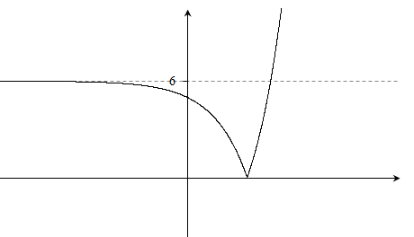

*x*



(0, 5)

4. 









 Positive answer only.

5.   when 

 when 





6. (a)

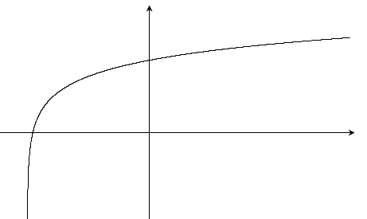

(e-2 ‒ 3, 0)

(0, 2 + ln 3)

-3

f(*x*)

*x*

(b) 







So . Domain is all real numbers. Range is .

(c)

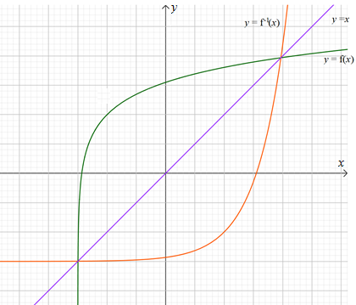

 is a reflection of  in the line .

7.  Let 



  or 

If  then  so  (3 d.p.)

If  then  so  (3 d.p.)

8.  where  and

, 



 when  so stationary point is

9. (a) 







(b) (i)

|  |  |  |  |  |  |  |
| --- | --- | --- | --- | --- | --- | --- |
|  | 0 | 1 | 2 | 3 | 4 | 5 |
|  | 2.54 | 2.66 | 2.77 | 2.88 | 3.00 | 3.11 |

(i) and (ii)

log *n*

*x*

Intercept is  so 

Gradient is  so 

(iii) In 2010,  and .

This is extrapolation. 2010 is 5 years after the data given. The museum may not have the capacity for 4825 visitors per month or it may close or change etc. The figure is not reliable.

10. (a) 500

(b) 







(c) When  atoms.

(d) 

When , rate of decay is  atoms per year.

(e)

**Extension**





Let 











So 



If 





This is not possible for any value of .

If 

















If 















 This is a negative value so is not a solution of the original equation.

**OCR Resources**: *the small print*OCR’s resources are provided to support the delivery of OCR qualifications, but in no way constitute an endorsed teaching method that is required by the Board, and the decision to use them lies with the individual teacher. Whilst every effort is made to ensure the accuracy of the content, OCR cannot be held responsible for any errors or omissions within these resources.

© OCR 2020 - This resource may be freely copied and distributed, as long as the OCR logo and this message remain intact and OCR is acknowledged as the originator of this work.

OCR acknowledges the use of the following content: n/a

Please get in touch if you want to discuss the accessibility of resources we offer to support delivery of our qualifications: [resources.feedback@ocr.org.uk](mailto:resources.feedback@ocr.org.uk)

We’d like to know your view on the resources we produce. By clicking on [‘Like’](mailto:resources.feedback@ocr.org.uk?subject=I%20liked%20the%20AS%20and%20A%20Level%20Maths%20Section%20Check%20In%20–%201.06%20Exponentials%20and%20Logarithms) or [‘Dislike’](mailto:resources.feedback@ocr.org.uk?subject=I%20disliked%20%20the%20AS%20and%20A%20Level%20Maths%20Section%20Check%20In%20–%201.06%20Exponentials%20and%20Logarithms) you can help us to ensure that our resources work for you. When the email template pops up please add additional comments if you wish and then just click ‘Send’. Thank you.

Whether you already offer OCR qualifications, are new to OCR, or are considering switching from your current provider/awarding organisation, you can request more information by completing the Expression of Interest form which can be found here: [www.ocr.org.uk/expression-of-interest](http://www.ocr.org.uk/expression-of-interest)

Looking for a resource? There is now a quick and easy search tool to help find free resources for your qualification:   
[www.ocr.org.uk/i-want-to/find-resources/](http://www.ocr.org.uk/i-want-to/find-resources/)