Prescribed Sources for Britannia: from conquest to province, AD 43–c.84

Literary sources

Cassius Dio, 60.19–60.23.6

60.19
[1] Meanwhile these events were taking place at Rome; at the same time Aulus Plautius, a Senator and a man of great reputation, led a campaign against Britain; for a certain Berikos, who had been driven out of the island due to a war between tribes, persuaded Claudius to send a force there. [2] So, as a result, Plautius took charge of the campaign, but he had some difficulty in getting his army to leave Gaul, because they were angry at the idea of campaigning outside the boundaries of the Roman world. They would not obey Plautius, until Narcissus, who had been sent out by Claudius, went up onto the tribunal of Plautius and tried to speak to them. [3] At that point they became much angrier at this attempt by Narcissus and would not allow him even to say anything. Then suddenly altogether they started shouting the familiar chant ‘Io Saturnalia’. [At the Saturnalia the slaves put on the clothes of the master and hold a festival.] Straightaway they willingly obeyed Plautius. But all this had delayed their leaving late in the season. [4] They were sent over in three divisions, so that they would not be prevented from landing, as might have happened if they had happened to be a single force. While crossing, they became disheartened when driven back, but then were encouraged when a flash of light coming from the east shot towards the west in the direction they were sailing. They landed on the island with no one to oppose them.
[5] For the Britons did not expect them to arrive because of the information they had received, and they had not gathered together a force. Even then, they did not come to close quarters, but fled into the swamps and forests, hoping instead to wear down the Romans and force them to sail away again empty handed, just as had happened at the time of Julius Caesar.
60.20
[1] Therefore Plautius had great difficulty in finding them; when he finally did find them he first defeated Caractacus, and then Togodumnus, the sons of Cunobelinus, who had died recently. The Britons at that time were not independent but different kings ruled each tribe. [2] These two kings fled and Plautius gained the surrender of part of the Bodunni tribe, whom the Catuvellauni controlled. He then left behind a garrison, and advanced further into the island. When he reached a certain river, the Barbarians thought the Romans would be unable to cross without a bridge. Because of this, they took less care in camping on the opposite bank of the river. Plautius sent across some German auxiliaries, who were used to crossing the strongest currents in their armour. [3] When they unexpectedly fell upon the enemy, they did not attack any of the men but the horses which drew their chariots. In the subsequent confusion not even the Britons’ mounted men were able to get to safety. Next Plautius sent across Flavius Vespasianus, who later became emperor, and his brother Sabinus, who was his second-in-command. [4] So they also got across the river and, surprising the barbarians, killed many of them. The rest did not flee, but on the next day they joined the battle again. The outcome of the battle was uncertain until Gaius Hosidius Geta, after just avoiding being captured, at last overcame the enemy so effectively that he was awarded the honours of a triumph, even though he had not been a consul. [5] At this point the Britons retreated back to the River Thames, at a place where it enters the sea and forms a pool at high tide. They crossed this easily, since they knew where there were places of solid ground and easy passages.
[6] However, the Romans, in pursuing them, failed in their efforts to cross. So again the Germans swam across, and others went a little way upstream and crossed by a bridge. Then they attacked the enemy from different sides at the same time, and massacred many of them. They pursued the survivors without thinking and fell into swamps that were hard to get out of, and many were lost.
60.21
[1] Because of this and also because Togodumnus had died, the Britons, far from surrendering, united all the more to avenge him. Plautius being afraid did not advance further, but secured what he had gained at present and sent for Claudius. [2] This he had been ordered to do, if there was some stronger resistance; and besides, a lot of other equipment had already been put together for the expedition, including elephants. On the arrival of the message, Claudius placed other matters in Rome and command of the army in the hands of Lucius Vitellius, his fellow consul (for he had made him remain as consul for the full half-year like himself). Then he set out for the army in Britain. [3] He sailed down the River Tiber to Ostia, and next sailed by the coastal route to Massilia (Marseilles). [4] From there he travelled both by road and river until he reached the Ocean. He crossed over to Britain and joined the army which was waiting for him at the River Thames. Taking command of the legions, he crossed the river, and attacked the barbarians who had gathered to oppose his arrival; he defeated them in battle and took Camulodunum (Colchester), the capital of Cunobelinus. As a result of this, he won over several tribes, some through mutual agreement, others by force, and was saluted as Imperator a number of times contrary to normal practice [5] (for it is the custom for no one to be given this title more than once from the same war). He took away the weapons from those who surrendered and put these tribes under the command of Plautius. He ordered him to subdue the remainder of the island. He himself hurried back to Rome, sending ahead the announcement of his victory by his sons-in-law Magnus and Silanus.
60.22
[1] When the Senate learned of these successes, they gave him [Claudius] the title of Britannicus and awarded him permission to hold a triumph. They also voted that there should be an annual festival in celebration of the event and that two triumphal arches should be set up, one in Rome and one in Gaul, because it was from there that he had set sail and crossed to Britain. [2] They also granted the same title of Britannicus to his son, with the result that eventually the boy came to be called Britannicus normally. They also granted Messalina the right of using a front seat at the theatre, just as Livia had enjoyed, and the right of using the carpentum (a covered carriage). ...
60.23
[1] In this way, parts of Britain were taken into the Empire at this time. After this, in the year when Gaius Crispus (for the second time) and Titus Statilius were consuls, Claudius returned having been away from Rome for six months; of these he spent only 16 days in Britain. He then celebrated his triumph. He did everything else according to custom, ascending the steps of the Capitol on his knees, supported by his sons-in-law on either side. [2] He granted to the Senators, who had campaigned with him the triumphal ornaments, and not just to those who had been consuls ... something he did often on other occasions very freely. To Rufrius Pollio, the Praetorian Prefect, he granted an image and a seat in the Senate, whenever he went into the Senate House with Claudius. So that it might not be thought he was doing something new, he said that Augustus had done the same in the case of Valerius, the Ligurian. He also awarded Laco, the former prefect of the night-watch (vigiles), now the procurator of Gaul, with the same honours and with the rank of ex-consul. [4] After dealing with these matters, he held his triumph, taking on a consular power for this purpose. The Festival was celebrated in the two theatres at the same time. Often he himself left the theatre, while others took part in his place. [5] He announced as many horse-races as could be fitted into a day, however, never more than ten of them. For between the races, bears were slaughtered, and athletes competed, and boys from Asia had been sent for and performed the Pyrrhic dance. [6] Similarly another festival was held to celebrate his victory by artists from the stage, with the agreement of the Senate. This was all done because of the events in Britain; so that others might more easily be persuaded to come to an agreement with the Romans, it was decreed that all agreements, which either Claudius or his legates had made, should have the same authority as if made by the Senate and the Roman People.

Cassius Dio, 60.30.2

Plautius, after his excellent handling of the war in Britain and the success of his achievements, was both praised by Claudius and awarded a triumph.

Cassius Dio, 62.1–62.3, 62.7–62.9, 62.12

62.1
While this sort of child’s play was going on in Rome, a terrible disaster happened in Britannia: two cities were sacked, 80,000 of the Romans and their allies perished, and control of the island was lost. Even worse, all this was brought upon them by a woman, a point of particular shame. There had, in fact, been divine warnings about the catastrophe beforehand. At night the shouting and laughing of barbarians had been heard in the Senate House, and outcries and lamentation in the theatre, although no mortal had shouted or lamented. Houses were seen under the water of the River Thames, and once the Ocean between the island and Gaul turned blood-red at high tide.
62.2
A pretext for the war was found in the confiscation of the money that Claudius had given to the most important Britons: this (according to Decianus Catus, the procurator of the island) had to be paid back. Another reason was the fact that Seneca, with an eye on a good interest rate, had lent the reluctant islanders 40,000,000 sesterces, and then called in the loan all at once, extracting it from them by force. But the person who above all stirred up the Britons and persuaded them to go to war against the Romans, who was thought worthy of being their leader and the commander of the whole war was Boudicca, a British woman and member of the royal family, who was unusually intelligent for a woman. When she had assembled an army about 120,000 strong, she ascended a rostrum, built in Roman fashion of heaped up earth. She was very tall and forbidding; her eyes were piercing and her voice was harsh; her mass of tawny hair fell to her hips, and she wore a large golden necklace and a tunic of many colours over which a thick mantle was fastened with a brooch. This was how she always dressed. Now she took up a spear in order to increase the effect on all, she made this speech:
62.3
“You have learned from experience the difference between freedom and slavery. In the past, some of you may, though your ignorance of what was better, have been deceived by the Romans’ enticing promises. But now you have tried both, and learned how wrong you were to prefer a foreign tyranny to your ancestors’ way of life, and how much better it is to be poor but free, than rich and enslaved. Have we not suffered every kind of shameful and demeaning treatment ever since these men arrived in Britannia? Have we not lost all of our most important possessions, while we are forced to pay taxes on those that remain? On top of pasturing and cultivating all our other lands for them, do we not pay a yearly tax on our very bodies? Would it not have been better if we had been sold to masters once and for all? As it is, we ransom ourselves every year while meaninglessly calling ourselves free! Would it not have been better to have died in battle than to live with a tax on our heads? But why do I mention death? Among them, even dying isn’t free of charge – we give them fees even for our dead! [...]”
62.7
So Boudicca addressed her people, and then led her army against the Romans, who by chance were leaderless, as their commander Paulinus had gone on an expedition to Mona [Anglesey], an island near Britain. This enabled her to sack and plunder two Roman cities and to carry out the indescribable slaughter I have mentioned. Those taken prisoner by the Britons suffered every kind of barbarism, and the worst and most bestial was when they hung up, naked, the most noble and beautiful women, cut off their breasts, and sewed them into their mouths to make the women seem to be eating them. Then they impaled the women on sharp stakes run through the length of the whole body. As they did all this in their sacred places, and in particular the grove of Andate, they sacrificed, feasted and abandoned all restraint. Andate was their name for Victory, and they revered her exceptionally.
62.8
By now Paulinus had conquered Mona, and so when he heard of the disaster in Britain he sailed back at once. He was unwilling to risk a conflict with the barbarians immediately, as he was apprehensive about their numbers and their desperation, and so preferred to delay the battle to a more favourable moment. But as he began to run out of food, and the barbarians relentlessly attacked, he was forced against his will to engage them. Boudicca led an army of about 230,000 men, and drove around in a chariot, assigning others to their various positions. Paulinus could not stretch his army out to match the length of hers; their numbers were so small that even if the men had been drawn up only one deep, they would not have reached far enough. Nor did he dare fight in a single body for fear of being surrounded and cut to pieces. He therefore divided his army into three, in order to fight on several fronts at the same time, and made each division draw up in close formation so it could not be broken through.
62.9
As he assigned his men their orders and positions he gave them words of encouragement: “Come on, my comrades! Come on, Romans! Show these murderers that we surpass them even in the midst of our misfortune. It would be shameful for you to ingloriously lose now what you won a short time ago with your bravery. We and our fathers have triumphed many times against greater odds. Don’t fear their numbers or their rebelliousness – their audacity rests on nothing more than rashness, unsupported by arms or training. Don’t fear them because they burned a couple of cities – they didn’t capture them by force or after a battle, but one was betrayed and the other abandoned to them. Punish them now for this as they deserve, and let them learn from experience between themselves and us, those they have wronged.”
62.12
After making this and other similar speeches to them, he gave the signal for battle. The two sides came together. The barbarians yelled and sang menacing battle-songs, while the Romans advance was silent and disciplined, until they came within a spear’s throw of the enemy. Then, while the enemy were still walking, they leapt forward at a signal and charged them with great force. They easily broke through the opposing ranks, and then were surrounded by great numbers of the enemy and had to fight on all sides at once.
The struggle took many forms. Light-armed troops hurled missiles at their counterparts, heavy-armed fought heavy-armed, cavalry charged cavalry, and the Roman archers tackled the barbarian chariots. The barbarians would rush the Romans in their chariots, throw them into disarray, and as the Britons were fighting without breastplates were then themselves driven back by the arrows. Cavalry overthrew infantry, and the infantry struck down horsemen; a group of Romans in close ranks would advance to meet the chariots, and others would be scattered by them; a band of Britons would come up to the archers and rout them, but others dodged their arrows from a distance. All this went on not just in one place but with all three divisions.
There was a great battle, and both sides were driven by equal vehemence and daring. But at last, late in the day, the Romans prevailed; many of the enemy were killed in the melee beside the wagons and the forest, and many more were taken captive. Even so, large numbers escaped and prepared to fight again, but in the meantime Boudicca fell sick and died. The Britons profoundly mourned her and gave her an elaborate funeral; but, believing that they were now truly defeated, they scattered to their homes. So much for the affairs in Britannia.

Suetonius, Caligula 44.2, 46.1

44.2
He [Caligula] did nothing more than receive the submission of Adminius, the son of Cunobellinus, a king of the Britons, who had been exiled by his father and came over to the Romans with a small band of men. Yet, as if the whole island had been surrendered to him, Caligula dispatched elaborate letters to Rome ordering the imperial messengers to proceed by carriage right into the forum and to the Senate House, and only to deliver the letters to the consuls in the temple of Mars, and at a fully assembled Senate.
46.1
Finally, as if he were about to undertake a war, with his battle line drawn up on the edge of the Channel, with his ballistas and other artillery deployed and with nobody knowing or guessing what on earth he was about to do, suddenly Caligula ordered them to collect seashells and to fill their helmets and laps of their tunics, calling these “spoils of the Ocean owed to the Capitoline and Palatine”. As a mark of his victory, he erected a very tall tower from which – as at Pharos in Alexandria – fires would shine out at night to guide the passage of ships. Caligula then announced to the soldiers a bounty of a hundred denarii per man, as if he had outshone every example of generosity. He said “Go away happy: Go away rich.”

Suetonius, Claudius 13.2

Asinius Gallus and Statilius Corvinus, grandsons of the orators Pollio and Messala, plotted a revolution, bringing along with them several of Claudius’ freedmen and slaves. Furius Camillus Scribonianus, his governor in Dalmatia, started the rebellion, but it was quashed in the space of five days by the legions who had changed their allegiance. For when orders were given them to march to meet their new emperor, the eagles could not be decorated, nor the standards pulled out of the ground, whether it was by accident, or divine intervention.

Suetonius, Claudius 17.1–17.3

[1] He [Claudius] undertook only one expedition, and that was quite a modest one. The Senate had (earlier) decreed him triumphal ornaments, but he regarded this as beneath his dignity as emperor. He sought the honour of a real triumph, and chose Britain as the best field in which to seek this, for no one had attempted an invasion since the time of Julius Caesar and the island at this time was in a turmoil because certain refugees had not been returned to the island.
[2] When Claudius was sailing to Britain from Ostia he was twice very nearly sunk by the violent winds, once near Liguria, and again near the islands called Isles d’Hyeres. Completing the march by land from Massilia (Marseilles) to Gesoriacum (Boulogne), he crossed from there and without battle or bloodshed, and within a very few days received the submission of part of the island. He returned to Rome in the sixth month from the time of his departure, and celebrated a triumph in the most splendid manner. [3] To witness the show, he not only gave leave to governors of provinces to come to Rome, but even certain exiles. From among the enemy spoils he fixed on the gable end of his house on the Palatine, a naval crown next to the civic one, as a commemoration of his having travelled over and as it were “conquered” the Ocean. Messalina, his wife, followed his triumphal chariot in a covered carriage. Those who had gained triumphal decorations in the same war, followed behind, on foot, in robes with broad stripes. Marcus Crassus Frugi was on a horse with ceremonial regalia and in a robe embroidered with palm leaves, because this was the second time that he had obtained the honour.

Suetonius, Claudius 21.6

He [Claudius] also put on, as a re-enactment, on the Campus Martius, the assault and sacking of a town, and the surrender of the kings of Britain, and oversaw the proceedings in his general’s cloak.

Suetonius, Claudius 24.3

He decreed to Aulus Plautius the honour of an ovation, going to meet him as he entered the city, and walked with him to the Capitol, and on the way back, Claudius took the left side, giving him the post of honour.

Suetonius, Vespasian 4.1–4.2

[1] In the reign of Claudius, thanks to Narcissus, Vespasian was sent to Germany in command of a legion. Being transferred from there to Britain, he engaged with the enemy thirty times. He conquered two very powerful tribes, captured more than twenty towns (oppida), and the Isle of Wight, which is very close to Britain; partly under the command of Aulus Plautius, a commander of consular rank and partly under Claudius himself. [2] As a result, he received triumphal decorations, and within a short time, two priesthoods, besides the consulship, which he held during the last two months of the year.

Josephus, Jewish War, 3.1.2

[Nero] only found Vespasian capable of doing what was necessary and able to take on a war of such a size as this one. Having been a soldier from his youth he had grown old in the army. Previously he had brought peace back to the Romans in the west when it had been thrown into disorder by the Germans. With his men he had won over Britain which was not known up until that time. By this victory there he provided [Nero’s] father Claudius with the opportunity to lead a triumph at no personal effort.

Tacitus, Annals 12.23

The Emperor Claudius widened the city boundary (pomerium) of Rome, in accordance with the ancient custom, according to which, those who had enlarged the empire were permitted also to extend the boundaries of Rome. But Roman generals, even after the conquest of great nations, had never exercised this right, except Lucius Sulla and the Divine Augustus.

Tacitus, Annals 12.31–12.40

12.31
Meanwhile, in Britain the pro-praetor Publius Ostorius had a troubled reception. The enemy had poured into the territory of our allies with a violence that was all the greater because they thought that a new commander, with an unfamiliar army and with winter coming, would not engage them. Ostorius, aware that the first events are those which produce fear or confidence, swept his cohorts forward at speed, cut down those who had resisted, and chased those in disarray. He wanted to prevent them from regrouping so that a bitter and disloyal peace would not follow which would allow no rest to either the commander or to his troops. He disarmed all suspects and suppressed the whole area on this side of the rivers Trent and Severn using garrisons.
The first to revolt against this were the Iceni, a powerful tribe not yet broken in battle, as they had voluntarily become allies. At their suggestion, the surrounding tribes selected a position for battle what was protected by a rustic earthwork with an approach too narrow to allow access to the cavalry. The Roman commander prepared to break through this defence, though he was leading an auxiliary force without the strength of the legions, and distributing the cohorts in appropriate positions, turned even his dismounted cavalry to infantry work. Then, on the signal, they broke through the earthwork. They threw the enemy into confusion, imprisoned by their own defences. With the rebellion on their mind, and every exit barred, the Britons performed many heroic feats; and during the engagement the legate’s son, Marcus Ostorius, earned the decoration for saving the life of a Roman citizen.
12.32
After the Iceni defeat, all those who were wavering between war and peace settled down, and the army moved against the Decangi. The fields were devastated, booty collected everywhere, while the enemy declined to risk an open battle, or, if they made a stealthy attempt to ambush the column, found their trickery punished. And now Ostorius was not far from the sea facing Ireland, when an outbreak of rebellion among the Brigantes summoned him back. He was determined to attempt new conquests only when he had secured the old. The Brigantes uprising, indeed, was quashed with the execution of a handful of men, who had started the hostilities, and with the pardon of the others. However, neither severity nor mercy converted the Silurian tribe, which continued the struggle and had to be repressed by the setting up of a legionary garrison. In order to achieve that, a colony (colonia) was settled on conquered lands at Camulodunum (Colchester). This was a strong detachment of veterans and they were to serve as a defence against revolt and to get the natives to have a positive attitude towards observing the laws.
12.33
The march then proceeded against the Silurians, whose native boldness was heightened by their confidence in the power of Caratacus. Caratacus’ many successes, which he had either matched or defeated the Romans, had raised him head and shoulders above the other British leaders. On this occasion, though inferior in military strength but supported by the treacherous nature of the countryside, he shifted the war to the territory of the Ordovices. After being joined there by all who feared a Roman peace, he made his last stand. The place selected for the struggle was one where approaches, exits, every local feature would be unfavourable to ourselves and advantageous to his own forces. On one side the hills were sheer; and wherever a point could be reached by a gentle climb, the way was blocked with stones in the form of rampart. Along the front ran a river with no safe place to cross, and bands of warriors were in position along the defences.
12.34
In addition, the tribal chieftains were going around, encouraging the men and confirming their spirits by minimising fear, by kindling hope, and by applying the various incitements of war. As for Caratacus, he flew here and there, protesting that this day – this field – would be the beginning of their regaining freedom or their ever-lasting slavery. He called upon the names of their ancestors, who had driven off the dictator Julius Caesar. It was due to their bravery that they were immune from Roman authority and tributes and still kept their wives and children unassaulted. To these appeals and similar, the crowd shouted in agreement, and every man took his tribal oath to give way neither to weapons nor to wounds.
12.35
This eagerness threw the Roman general; at the same time the intervening river, the added rampart, the threatening ridges and the absence of any point that was not defiant and crowded with defenders terrified him. But the soldiers insisted on battle; they shouted that with courage, no place was impregnable; and prefects and tribunes, employing the same language, intensified the eagerness of the army.
After surveying the ground to discover its impenetrable and its vulnerable points, Ostorius now put himself at the head of the enthusiastic troops and crossed the river without difficulty. When the earthwork was reached, while the struggle was fought with missiles, most of the wounds and numerous casualties fell to our own side. A tortoise-shell formation was made and, once the crude and shapeless heap of stones had been demolished and in the engagement at close quarters the armies were equally matched. The barbarians withdrew to the hill-tops. Yet even there the light and heavy troops broke in, the lighter armed attacked with javelins, the heavier advancing in closer formation, while the British ranks opposite were in complete confusion: for they lacked the protection of breastplates and helmets. If they offered any resistance to the auxiliaries, they were struck down by the swords and javelins of the legionaries. If they faced the legionaries, they fell under the broadswords and spears of the auxiliaries. It was a notable victory. The wife and daughter of Caratacus were taken prisoners and his brothers surrendered.
12.36
Caratacus himself – vulerable as those who have failed always are – sought the protection of the queen of the Brigantes Cartimandua, but was arrested and handed to the victors. This was in the ninth year from the beginning of the war in Britain. Caratacus’ reputation had spread beyond the islands, had spread through the neighbouring provinces, and was known in Italy itself; where there was curiosity to see what sort of man it was that had for so many years defied our power. Even in Rome, the name of Caratacus was not without honour; and Claudius, by attempting to heighten his own glory, added distinction to the conquered Caratacus. For the people were invited as if to some fine spectacle; the praetorian cohorts stood armed on the parade ground in front of their camp. Then, while Caratacus’ client princelings filed past, decorations and neck-rings and prizes won in his foreign wars were carried in procession; next Caratacus’ brothers, wife, and daughter were placed on view; finally, Caratacus himself. The rest stooped to unworthy begging through fear; but Caratacus did not give a downcast look nor ask for pity in his words. He stood at the tribunal, and spoke as follows:
12.37
“Had my family tree and my rank been equalled by only moderate success, I should have entered this city as a friend rather than as a captive; nor would you have turned your nose up to admit into a peaceful alliance, a king descended from famous ancestors and ruling over many peoples. My present situation, if to me a humiliation, is to you a glory. I had horses and men, arms and riches. Do you wonder if I have lost them with a sense of sadness? For if you want to rule the world, does it follow that the world must welcome slavery? If I were dragged before you after surrendering without a blow, there would have been little heard either of my fall or of your triumph: punishment of me will be followed by oblivion; but save me alive, and I shall be an everlasting reminder of your mercy.”
The answer was Claudius’ pardon for Caratacus, his wife, and his brothers. Freed from their chains, they paid their homage to Agrippina too – a noticeable figure on another raised platform not far away – in the same terms of praise and gratitude which they had used for the emperor. It was clearly a new procedure and unprecedented, that a woman should sit in state before Roman standards: she was laying her claim to her share in the empire handed down by her ancestors.
12.38
The Senators, who were called together later, delivered long and complimentary speeches on the capture of Caratacus – an incident as glorious as the parading of Syphax by Scipio Africanus, and of Perseus by Lucius Paulus, or all the other chained kings brought before the Roman people. Triumphal decorations were awarded to Ostorius. His fortunes, up until now unblemished, soon were called into question – possibly because, with the removal of Caratacus, our enthusiasm on the battlefield had been lessened in the belief that the war was won, or possibly sympathy with their great king had whetted the enemy’s appetite to avenge him. A camp-prefect and some legionary cohorts, left behind to construct forts in Silurian territory, were surrounded and, if help had not quickly reached the besieged troops from the nearest forts – having found out from messengers – they might have perished. As it was, the prefect, eight centurions and the most determined members from the ranks were killed. Nor was it long before both a Roman scouting party and the squadrons dispatched to help were totally put to flight by the enemy.
12.39
Ostorius then brought up his light cohorts; but even so he failed to check the rout, until the legions entered the battle. Their strength evened up the fight, which eventually turned in our favour. As the day was drawing to a close, the enemy escaped with a few losses. Frequent engagements followed, generally of the raiding party type, in woodland and fens; decided by individual luck or bravery; accidental or prearranged; with hatred or plunder for the motives; by orders, or sometimes without the knowledge of the generals. Particularly exceptional was the stubbornness of the Silures, who were infuriated by a widely-repeated remark of the Roman commander, that, just as once upon a time the Sugambri had been annihilated or transferred to the Gallic provinces, so the Silurian name ought once for all to be wiped out. They accordingly cut off two auxiliary cohorts which, through the greed of their officers, were ravaging the country rather carelessly, and by freely distributing the spoils and captives they drew other tribes into the revolt. Broken by the weary load of anxiety, Ostorius died, much to the delight of the enemy, who considered that, perhaps not a battle, but certainly a campaign had disposed of a general whom it was impossible to despise.
12.40
On receiving the news of the governor’s death, Claudius, so as not to leave the province without a governor, appointed Aulus Didius. In spite of a rapid crossing, he found matters deteriorated, as the legion under Manlius Valens had been defeated in the meantime. Reports of the event were exaggerated among the enemy, with the hope of alarming the new commander on his arrival. The commander magnified the version he heard with the hope of securing additional credit, if he settled the disturbances, and a more legitimate excuse if the disturbances persisted. In this case, again, the loss had been inflicted by the Silurians, and they carried their insurgences far and wide, until repelled by the arrival of Didius. Since the capture of Caratacus, the Briton with an exceptional knowledge of the art of war was Venutius, from the Brigantes tribe as I mentioned before. He had long been loyal, and had received the protection of Roman arms while married to Queen Cartimandua. Then had come a divorce, followed by immediate war, and he had extended his hostility to ourselves. At first, however, they fought each other and Cartimandua cleverly trapped Venutius’ brother and family members. Incensed at her act, and smarting at the humiliating prospect of being ruled by a woman, the enemy, a powerful body of young hand-picked warriors, invaded her kingdom. That event had been foreseen by us, and the cohorts sent to the rescue fought a fierce battle, with a doubtful outcome at the beginning but a more favourable conclusion. The conflict had a similar outcome in the case of the legion, which was commanded by Caesius Nasica; since Didius, slowed by his years and heaped with honours, was content to act through his subordinates and to hold the enemy at distance. (These campaigns, though conducted by two pro-praetors over a period of years, I have related consecutively because if treated separately, they should leave an inadequate impression on the memory.)

Tacitus, Annals 14.29–14.39

14.29
In the consulship of Caesonius Paetus and Petronius Turpilianus [AD 61], a serious disaster was experienced in Britain, where, as I have mentioned, Aulius Didius, the emperor’s governor, had only just held onto our existing territories. His successor Veranius, after having ravaged the Silures with some limited expeditions, was prevented by death from extending the war. While he lived, he had a great name for manly independence, though, in his will’s final words, he betrayed a flatterer’s weakness. For, after heaping adulation on Nero, Veranius added that he would have conquered the province for him, had he lived for the next two years. The next, however, to govern Britain was Suetonius Paulinus, who was Corbulo’s rival in military knowledge and in popular talk, which allows no one to be without a rival. He aspired to subjugate Rome’s enemies and equal the glory won by Corbulo for the recovery of Armenia. He therefore prepared to attack the island of Anglesey which had a dense population and was a sanctuary for fugitives. He built flat-bottomed boats to cope with the unknown straits. In this way, the infantry crossed, while the cavalry followed by fording, or, where the water was deep, swam by the side of their horses.
14.30
On the shore stood the opposing army with its dense array of armed warriors, while between the ranks dashed women, dressed in black robes like the Furies, with dishevelled hair, waving torches. All around, the Druids, lifting their hands to heaven, and pouring forth dreadful prayers, scared our soldiers by the unfamiliar sight, so that, as if their limbs were paralysed, they stood motionless, and exposed as a target. Then urged on by their general’s appeals and mutual encouragements not to be weak before a troop of frenzied women, they carried the standards onwards, cut down all resistance, and engulfed the enemy in the flames of their own torches. A force was next sent over to the conquered island, and their groves, devoted to inhuman superstitions, were destroyed. The Druids considered it indeed a duty to drench their altars with the blood of captives and to consult their deities through human entrails. Suetonius Paulinus while doing these things received news of the sudden revolt of the province.
14.31
Prasutagus, the King of the Iceni, well-known for his long-held wealth, had made Nero his heir alongside his two daughters, hoping that such grovelling behaviour would keep his kingdom and family safe from any danger. Quite the reverse happened: his kingdom was plundered by Roman officers, and his household by slaves, as if they were captives. First his wife Boudicca was whipped, and his daughters raped. All the leading Iceni, as if the entire kingdom had been accepted as a gift, were stripped of their ancestral property, and the king’s relatives were treated like slaves. Because of these abuses, and the fear of worse that might happen when they became part of a province, the people took up arms and stirred up into rebellion the Trinobantes and others not yet broken to slavery, making secret vows to win back their liberty. They hated the veterans most of all, because the new colonists at Camulodunum (Colchester) had driven them from their homes, emptied their lands, and called them captives and slaves. The soldiers encouraged the veterans: their way of life was the same, and they hoped for similar freedom. More than this, the temple of divine Claudius was considered to be the fortress of eternal Roman domination, while those who served as his priests poured away their wealth for the sake of religion. Destroying the colony seemed an easy job: it had no defences, because our commanders had been concerned more with what was pleasant to look at rather than with what the town actually needed.
14.32
Meanwhile, the statue of Victory at Camulodunum fell for no reason with its back turned, as if it was retreating from an enemy. Women in a mad frenzy wailed about impending doom, they say they had heard the growling of barbarians in the Senate House; the theatre echoed with the sound of wailing, and the ghostly image of a ruined colony was seen in the Thames estuary. Even the Ocean appeared blood-red, and when the tide withdrew it left what looked like human corpses. For the Britons these signs brought hope; but they left the veterans afraid.
But Suetonius Paulinus was far away, and so they begged the procurator, Catus Decianus, for help. He sent just 200 men, inadequately armed. There was also a handful of soldiers left in the colony. The colonists trusted the temple for their protection, and, hindered by those who secretly knew about the rebellion and were hampering their plans, they built neither a ditch nor a wall. Nor did they move their old men and women, to leave only their young men. As if caught unaware in peace time, they were surrounded by the barbarian horde. Everything was plundered and burned, except the temple in which the soldiers clustered, which was stormed after a two-day siege. The victorious Britons went off to face Petilius Cerialus, the legate of the Ninth Legion, who was pressing on with reinforcements: they crushed the legion and what infantry it brought with it; Cerialis escaped with his cavalry to a fortress and the shelter of its defences. The procurator, Catus, terrified by the disaster and the hatred of the provincials whom he had been driven to war with his greed, fled to Gaul.
14.33
But Suetonius Paulinus, with astonishing perseverance, marched through enemy territory to Londinium, which had not been given the name of a colony, but was a major centre for merchants and commerce. He debated making this his headquarters for the war, but, considering the small size of his army and the obvious lesson to be learned from Petilius’ recklessness, he decided to sacrifice one town in order to save the province. The tears and wailing of those who were begging his help could not deter him from giving the signal to set out, and those who wished were permitted to accompany the army; those unfit for war – the elderly and the women – or those who remained out of love for the place were massacred by the enemy. The town of Verulamium (St Albans) suffered the same misfortune, because the barbarians, glorying in spoils and exhausted by their labour bypassed the forts defended by soldiers and headed for the undefended places most rich in plunder. It is agreed that as many as 70,000 citizens and allies died at the places I have mentioned. The enemies were rushing not to take and sell captives or any of the other business of war, but to slaughter, hang, burn or crucify, as if they were about to pay the penalty for their crimes, and were snatching their vengeance in the meantime.
14.34
By now Suetonius Paulinus had the Fourteenth Legion, with the veterans of the Twentieth, and the nearest auxiliaries, a total of nearly 10,000 armed men; he decided to delay no longer and draw up his battle lines. He chose a narrow gully, blocked off at the rear by a wood, and ensured that there were no enemies except at the front, where the ground was open and free from the risk of ambush. Therefore his legionaries were positioned in close ranks with the lighter-armed troops on each side, and the cavalry massed on the wings. But the British masses were exulting; with their bands of infantry and cavalry in random array they were a greater host than had ever been seen before. They were so fiercely confident that they had even brought their wives with them to witness their victory; they were riding in wagons which had been placed on the far edges of the plain.
14.35
Boudicca, in a chariot with her daughters in front of her, rode up to each tribe, affirming that the British were used to being led to war by a female commander. She proclaimed that “Now I do not fight as the as the daughter of mighty ancestors, to recover my lost kingdom and riches, but I fight as one of the people to avenge lost freedom, my whipped body, the rape of my daughters. Roman lust has grown so great that not even our very bodies, neither the old or the innocent, are left unviolated. But the gods are here with a just revenge: a legion which dared to fight us has perished; the rest are hiding in their camp or searching for a chance to escape. They won’t bear the noise and roar of so many thousands, let alone our charge and fighting hand-to-hand. Consider the strength of our forces, the causes of our war, and know that in this battle we must win or die. This is a woman’s resolve: let men live and be enslaved.”
14.36
With so much in the balance, Suetonius Paulinus did not stay silent either: although he trusted in the bravery of his men, he still urged them with a mixture of encouragement and appeals to ignore the noise of the barbarians and their empty threats: “There are more women over there than fighting men! They are unwarlike and unarmed. They will give way the instant they recognise the swords and courage which have defeated them so many times. Even among many legions it is only a few men who decide the outcome of a battle; your glory will only be greater when our small force wins the fame of an entire army. Keep close ranks, throw your spears and continue the slaughter and butchery with your swords and shield-bosses. Don’t think about plunder. After the victory, everything will be yours.” So great was the enthusiasm that followed his words, and so eager were the veteran soldiers, with all their years of battlefield experience, to hurl their spears that Suetonius Paulinus, confident of the outcome, gave the signal for battle.
14.37
At first the legion held its position and clung to the defence of the narrow place accurately hurling their spears at the approaching enemy, but when they ran out of missiles they burst out in a wedge-shaped formation. At the same moment the auxiliaries attacked, and the cavalry with lances extended smashed through those who put up a strong opposition. The rest turned their backs to flee, but their retreat was hindered by the wagons that stood around the battlefield. The soldiers did not hesitate to kill the women too, and even the pack animals were skewered with spears and bulked up the mound of corpses.
A glorious victory, equal to those of old, was won that day. Some report that just under 80,000 Britons fell, with 400 Roman dead and a slightly greater number wounded. Boudicca killed herself with poison. When Poenius Postumus, the camp-prefect of the Second Legion, learned of the Fourteenth and Twentieth Legions’ success, fell on his sword: he had cheated his legion of equal glory, and broken military discipline by disobeying his general’s orders.
14.38
Then the whole army was drawn together and kept under canvas to finish the remainder of the war. To boost their numbers the emperor sent 2,000 legionaries from Germania, with eight cohorts of auxiliaries and a thousand cavalry. With the arrival of these legionaries the Ninth Legion was brought up to full strength, and the allied cohorts were placed in new winter quarters. The territory of any tribe that had wavered in its loyalty or joined the enemy was laid waste with fire and sword. But it was famine that most caused the natives to suffer. They had neglected to sow their crops, and recruited men of all ages to fight, intending to take our food supplies for themselves. The fiercest peoples were reluctant to submit because Julius Classicanus, who had been sent to replace Catus, disagreed with Suetonius Paulinus and obstructed the common good for the sake of his personal feud. He had put it about that it was worth them waiting for a new governor, who would treat those who had surrendered more generously, without an enemy’s anger or a conqueror’s arrogance. He also sent messages to Rome saying that they could expect no end to the fighting until Suetonius Paulinus was replaced. He attributed Suetonius Paulinus’ failures to perverseness and his successes to fortune.
14.39
Therefore the emperor’s freedman Polyclitus was sent to assess the situation in Britain. Nero’s great hope was that, because of his authority, Polyclitus might not only be able to create harmony between the procurator and the governor but pacify the rebellious barbarians. Polyclitus, who had burdened Italia and Germania with his enormous entourage, crossed the Ocean and did inspire fear even in the Roman troops. But to our enemies he was a laughing stock. Among them the flame of liberty was still burning, and they weren’t yet aware of the power of freedmen. They were astonished that a general and army who had carried out such a successful campaign should obey a slave. In reports to the Emperor, however, everything was portrayed in a better light. Suetonius Paulinus remained in charge, but afterwards, when he lost a few ships which had run aground, and their crews, he was ordered to surrender as if the war was still going on, and was replaced by Petronius Turpilianus, who had just finished his consulship. Turpilianus neither aggravated the enemy, and nor was he provoked. He graced this lazy inactivity with the name of ‘peace’.

Tacitus, Histories 3.44–3.45

3.44
In Britain, the troops generally favoured Vespasian, because he had been put in command of the Second Legion there by Claudius and had distinguished himself in battle. He secured Britain but not without some resistance on the part of the other legions, in which there were many centurions and soldiers who owed their promotions to Vitellius, and were anxious about changing their allegiance from an emperor of whom they had already had some experience.
3.45
Inspired by the disagreement of the legions and by the many rumours of civil war that reached them, the Britons plucked up courage under the leadership of Venutius who, in addition to his feisty spirit and hatred of the mention of “Roman”, was fired by his personal resentment toward Queen Cartimandua. Cartimandua ruled the Brigantes, securely through her high birth. She had later strengthened her power when she was credited with having captured King Caratacus by treachery and so provided a fancy addition for the triumph of Claudius. From this came the wealth and the self-indulgence associated with success. Despising Venutius (he was her husband), she took his armour-bearer Vellocatus as her husband and consort. The power of her house was at once shaken by this scandalous act. The people of the tribe supported Venutius, only the passion and her savage spirit of the queen supported the adulterer. So Venutius, calling in aid from outside and at the same time assisted by a revolt of the Brigantes themselves, put Cartimandua into an extremely dangerous position. Then she asked the Romans for protection, and in fact some infantry cohorts and cavalry, after a number of different engagements, finally succeeded in rescuing the queen from danger. The throne was left to Venutius; we were left with a war to fight.

Tacitus, Agricola 10–27, 29–37

10
I shall not mention the position and peoples of Britain described by many writers with the view to comparing myself with them in literary style and accuracy, but because it has recently been subjugated. And so, where my predecessors embellished with fine language things that had not yet been investigated, here I shall relate matters with a faithful adherence to known facts. Britain, the largest of all the islands which have come within the knowledge of the Romans, stretches on the east towards Germany, on the west towards Spain, and on the south it is even within sight of Gaul. Its northern extremity has no land opposite, but is pounded by a wide-open sea. Livy, the most eloquent of ancient, and Fabius Rusticus, the most eloquent of modern writers, have compared the figure of Britain to an oblong shoulder-blade, or a two-edged axe. And this is its appearance, below Caledonia from where the statement is applied to the whole country. But when you have crossed into Caledonia, a huge and shapeless area stretching out to an immense length towards the furthest shore, is gradually curved into a wedge formation. The Roman fleet, at that time first sailing around this remotest coastline, established the fact that Britain is an island; and at the same time discovered and subdued the islands which they call the Orkneys, till then unknown. Thule was also distinctly seen, which was all that the winter and their orders had allowed up to now. They say the sea is sluggish and heavy-going for rowers and cannot even be whipped up by winds as much (as other seas). The reason for this I believe is the lack of land and mountains, the cause and source of storms, that put in motion the mighty mass of waters of an open sea. It is not the business of this work to investigate the nature of the ocean and the tides, a subject which many writers have already written about. I shall only add one observation: that the dominion of the sea is nowhere more extensive, that it carries many currents in this direction and in that, and its ebbs and flows are not only on the shore, but it penetrates deep inside the land, and works its way among even the ridges and mountains, as though it were in its own place.
11
Who the first inhabitants of Britain, whether indigenous or incomers, as is usual among barbarians, is debated. Their physical types vary, and as a result deductions are formed from that variation. Thus, the red hair of those living in Caledonia and their large limbs point towards a German origin. The swarthy complexion and generally curly hair of the Silures, together with their situation opposite to Spain, render it probable that ancient Iberians came over and possessed that territory. Those who are nearest Gaul resemble them whether from a steely genetic origin, or whether when lands jut forward in opposite directions, the climate gives the same body type to the same bodies. On a general overview, however, it appears probable that the Gauls originally took possession of the neighbouring coast. You will find there Gaulish-style rites and religious beliefs. Their languages do not differ greatly. Their audacity in provoking dangers, and fear in retreating when danger approaches, is the same. The Britons, however, display more ferocity, as long-term peace has not softened them. For we understand that the Gauls were once renowned in war, but after a while, a life of ease and idleness crept over them, and they lost both their courage and their liberty. The same change has also happened among those of the Britons who have been long subdued but the rest continue such as the Gauls were.
12
Their strength is in infantry; certain tribes also fight battles in the chariot. The more noble person drives the chariot and his dependant fights for him. The Britons used to give obedience to their kings, but at present they are divided into warring factions of rival chiefs. In fact nothing has been more useful for us against the most powerful tribes than the fact that they cannot agree! It is seldom that two or three communities agree in repelling the common danger; and so, while they fight on their own, they are all subdued. The sky in this country is spoiled by frequent rains and clouds; but there is no extreme cold. The length of the days greatly exceeds that in our part of the world. The night is bright, and, at the far north of the island, so short, that the evening and morning twilight is scarcely distinguished by a noticeable interval. They say when clouds do not block it, sunshine is visible during the whole night, and that it does not appear to rise and set, but to move across the sky. Perhaps the extreme and flat parts of the earth, casting a low shadow, does not lift the darkness to any height, and so night fails to reach the sky and the stars. The soil, except for the olive, the vine, and other crops suited to warmer climates, is productive of crops, and rich in cattle. They are slow to ripen but quick to grow, both from the same reason: the great humidity of the ground and the atmosphere. Britain yields gold and silver and other metals, the reward of victory. The Ocean also produces pearls but they are dark and spotty. Some people think that the natives are unskilled in gathering them. For in the Red Sea the oysters are plucked from the rocks alive and breathing, but in Britain they are collected as the sea throws them up. For my own part, I am more inclined to believe that the quality of the pearls is lacking rather than greed on our part.
13
The Britons themselves actively submit to the levy, tributes, and the other obligations of government, provided that they are not treated unfairly. They bitterly resent unfair treatment, their subjection only extending to obedience, not to slavery. Accordingly, Julius Caesar, the first of all Romans who entered Britain with an army, although he terrified the inhabitants by a successful engagement and gained control of the shore, may be considered to have made posterity aware of it rather than handed the country to posterity. Soon came our civil wars; the arms of the generals were turned against the Republic; and Britain was neglected long even after the establishment of peace. The divine Augustus called this “policy” and Tiberius “precedent”. It is certainly agreed that an expedition into Britain had entered Caligula’s thoughts, natural fickleness making him swift to change his mind, together with the mighty attempts against Germany meant it came to nothing. The deified Claudius was the man who carried out such a great task: legions and auxiliary units were conveyed across the Channel and Vespasian was given a share in the command: this was the start of the good fortune which was soon to follow him. Tribes were crushed, kings were captured, and Vespasian’s greatness was revealed by the fates.
14
Aulus Plautius, the first man of consular rank to be appointed governor, and his successor Ostorius Scapula were both outstanding in warfare. Little by little, the closest part of Britain was reduced into the form of a province, and moreover a colony of veterans was settled. Certain tribal areas were presented to King Cogidubnus, (and he continued in utter loyalty within our own memory) there being an ancient and long established practice of the Roman people to have the kings responsible for slavery. Didius Gallus, the next governor, consolidated the gains of his predecessors, and added a few fortified garrisons in the remoter parts through which he could claim that he had increased size of the province. Veranius succeeded Didius, but died within the year. Suetonius Paulinus then commanded with success for two years, subduing various tribes, and establishing garrisons. Through confidence in these achievements, he undertook an expedition against the Isle of Anglesey, which had provided supplies to rebels, and thereby exposed his back to an opportunistic attack.
15
For the Britons, relieved from immediate fear by the absence of the governor, began to complain amongst themselves about the miseries of slavery, to compare their several insults, and inflame each by drawing the worse conclusions: that there was nothing to gain by patience for a people who were putting up with heavier burdens so easily. Formerly they had one king at a time; now two were set over them, the governor – and he vented his rage upon their life’s blood – and the procurator upon their property. The agreement or disagreement of these governors was equally fatal to those whom they ruled. The gangs of the centurions of the one, and the slaves of the other combined force and insults so that nothing was safe from their greed, nothing from their lust. In battle, it was the bravest who took the spoils; but as things were their homes were ransacked by cowards and shirkers, their children forced away, and conscriptions imposed, as if the only lesson of suffering of which they were ignorant was how to die for their country. Yet how little would the number of soldiers invading be if the Britons were just to count their own forces! From considerations like these, Germany had thrown off the yoke of subjugation though it was defended by a river and not the ocean. For the Germans, the welfare of their country, their wives, and their parents were the motives for war, while for the Romans it was greed and luxury. The Romans would withdraw as even Julius Caesar had done, if Britons would match the courage of their ancestors, and not be afraid at a loss in one or two battles. Those who get lucky, attack, but those who experience suffering, stay firm. Even the gods now seemed to be compassionate to the Britons, by keeping the general away, and the army on another island. The most difficult point, assembling for the purpose of deliberation, was already accomplished. There was always more danger from the discovery of their planning, than from actually daring to do it.
16
Mutually inspired by such suggestions, under the command of Boudicca, a woman of royal descent (for they make no distinction on the grounds of sex in succession to the throne), they all rose in arms, and attacking the soldiers dispersed through the garrisons, stormed the fortified posts, and invaded the colony itself, as the headquarters of slavery. Fury and victory left out no type of cruel characteristic of barbarians; and had not Suetonius Paulinus, on being informed of the unrest of the province, marched speedily to help, Britain would have been lost. The fortune of a single battle, however, returned it to its former subjection; though many rebels still remained at arms, as guilt of revolt and particular fear of the governor unnerved them. They feared that Suetonius Paulinus, although otherwise exemplary, would take too harsh measures against those who surrendered, like a man who was revenging his own personal insult. Therefore, Petronius Turpilianus was sent in his place, as a rather more lenient person and one who, being unfamiliar with the enemy’s offences, could more readily accept their submission. After having restored things to their former quiet state, he risked doing nothing more and he delivered the command to Trebellius Maximus. Trebellius was rather lazy and inexperienced in military affairs though he maintained peace in the province by affable administration; for even the barbarians had now learned to condone the seductive vices; and the intervention of the civil wars afforded a legitimate excuse for doing nothing. Mutiny however infected the army, who, being used to military services, ran riot in idleness. Trebellius, escaped the fury of his army by running away and hiding. Humiliated and dishonoured, he regained control, but only just. There was a sort of pact, the general kept safe, and the army kept its freedom to run riot. This mutiny was without bloodshed. Nor was Vettius Bolanus, who took command during the continuation of the civil wars, willing to bring discipline into Britain. The same inaction towards the enemy, and the same indiscipline in the camp, continued. However Bolanus being decent, and not hated because of any wrongdoings, won affection instead of authority.
17
When Vespasian received the possession of Britain together with the rest of the world, there was a succession of great commanders and outstanding armies, which diminished the confidence of the enemy. Petilius Cerealis struck terror by an attack on the Brigantes tribe who are reputed to be the most populous tribe of the whole province. Many battles were fought, sometimes not blood free; and he subjugated the greater part of the Brigantes territory either in victory or ongoing conflict. The administration and reputation of Cerealis were so brilliant that they would have blotted out that of a successor; yet Julius Frontinus a truly great man, rose to and upheld the task, as far as circumstances would permit and he subdued the strong and warlike tribe of the Silures in which expedition, besides the courage of the enemy, he had the difficulties of the land to struggle with.
18
Such was the state of Britain, and such were the shifting positions of the war, which Agricola found on his crossing over about midsummer. Our soldiers, as if all fighting was over, took the opportunity to rest and the enemy took the opportunity! The Ordovices tribe, shortly before Agricola’s arrival, had destroyed nearly the whole of a squadron of allied cavalry stationed in their territory. Such a strike raised the hopes of the province. All who wished for war approved of the example, and anxiously watched the temper of the new governor. The summer was over, the detachments were scattered throughout the province, and the soldiers had taken for granted that there would be no more fighting that year; in fact it was unfavourable for anyone intended to launch a campaign and most thought it best to garrison the weak points. Meanwhile Agricola was determined to meet the danger. He collected a force of veterans and a small band of auxiliaries; then, because the Ordovices would not dare to come down to the open plain, led his men up into the hills, himself at the front of the column to inspire the others with his own courage by sharing the danger. The tribe was all but exterminated. Well aware that his reputation must be followed up, and that according to how his first attack turned out would be the degree of terror inspired by his other campaigns, he had it in mind to subjugate the island of Anglesey, from the occupation of which Paulinus had been recalled, as I have already mentioned above, by the rebellion of entire Britain. But, as is natural in hastily formed plans, he had no fleet. The skill and resolve of the general accomplished the crossing. He selected men from the auxiliaries, who knew the shallows of the Menai straits and had a talent in swimming which allows them to take care not only of themselves but also their arms and horses, and freed them of all equipment. He attacked so unexpectedly that the astonished enemy, who were looking for a fleet of ships and an assault by sea, thought that nothing could be too tough or invincible for those attacking them. And so, peace having been sought, the island surrendered. Agricola was considered a great and famous man: when entering the province, a time which others spend in pageantry and a round of ceremonial visits, he had preferred toil and danger. Agricola did not use his success for self-glorification, nor did he call a campaign and victory a way to repress conquered people. He did not even describe his achievements in laurel-wreathed dispatches. Yet by thus disguising his fame he really increased it, for men jumped to the conclusion that he had great ambition for the future from his silence about such great achievements.
19
Besides, with a thorough understanding of the feelings of his province, and having learned from the experience of others, that little is gained by conquest if abuse follows, he determined to root out the causes of war. Beginning first with himself and his staff, he kept his own house in order, a thing as hard for many as ruling a province. He conducted no public business through freedmen or slaves; no private lobbying, no recommendations or petitions from friends moved him in the selection of centurions and soldiers, but it was always the best man whom he thought most trustworthy. He knew everything, but did not always act on everything. Small transgressions were treated with leniency, serious offences with severity. Nor was it always punishment, but far more often it was just being sorry, which satisfied him. He preferred to give office and power to men who would not break the law, rather than have to condemn an offender. He lightened the demand of corn and tribute by an equal distribution of the burden, while he cut the means for profiteering which were more resented than the tribute itself. Up till now, the people had been compelled to endure the farce of waiting by the closed granary and of purchasing corn unnecessarily and raising it to a fictitious price. Delivery was set down for them to difficult back routes and distant districts, so that states which had winter camps close to them were told to carry corn to remote and inaccessible parts of the country. Thus a service which should have been easy for all, was obstructed to became profitable to a few.
20
By suppressing these abuses in the first year of his administration, he established a favourable view of peace, which, through the negligence or oppression of his predecessors, had been feared as much as war. But when summer arrived, he assembled his army and was present everywhere on the march; he commended discipline, and checked the stragglers. He marked out the encampments himself and explored in person the estuaries and forests. Meanwhile he allowed no rest for the enemy by constantly launching plundering raids. Then, when he had terrorised them enough, by being merciful he offered the attractions of peace. By this way of management, many tribes, which till that time had asserted their independence, now lay aside their animosity and delivered hostages. These areas were surrounded with garrisons and forts, placed with so much care and good judgement, that never had any new part of Britain come into Roman hands with so few problems.
21
The following winter passed without disturbance, and was spent in worthwhile activities. Agricola had to deal with a population scattered and uncivilised and therefore inclined to war. His desire was to accustom the people to rest and to be quiet through the appeal of luxuries. Agricola gave private encouragement and public aid to the building of temples, public squares and private houses, praising the keen and reprimanding the slack. And so, a rivalry for honour took the place of forcing them. He likewise provided an education for the sons of the chiefs in the liberal arts, and showed such a preference for the natural abilities of the Britons over the trained skill of the Gauls that they who lately despised the Latin language now desired to speak eloquently in it. Hence, too, a liking sprang up for our style of dress, and the ‘toga’ was everywhere. Step by step they went astray to things which lead to vice: porticoes, baths, elegant banquets. All this in their ignorance they called civilisation, when it was just a part of their enslavement.
22
The third year of his campaigns opened up new tribes, with the laying waste of the tribes as far as the Tay estuary. This struck such terror into the enemy so that they did not dare to attack our army, harassed though it was by violent storms. There was even time to establish forts. Experienced officers noted that no general had ever shown better judgement in choosing suitable positions, and that not a single fort established by Agricola was either stormed by the enemy or abandoned through surrender or flight. Raids were frequent; for these positions were secured from a long-drawn-out siege by a year’s supply. So winter brought with it no scares, and each garrison could hold its own, as the baffled and despairing enemy, who had been accustomed often to make good their losses in summer by successes in winter, were now driven back in both. Agricola was never greedy in taking credit for the achievements of others; the centurion and the prefect both found in him an impartial witness. Some persons used to say that he was too harsh in his reprimands, and that he was as gentle to the good as unpleasant to the bad. Besides from his displeasure there was no secret resentment; so that you did not have to fear his silence. He thought it more honourable to offend than to harbour resentment.
23
The fourth summer was spent in securing what he had overrun. If the courage of our armies and the renown of the Roman name allowed it, a limit to our conquests might have been found in Britain itself. For the Clyde and Forth are separated by only a narrow strip of land, being estuaries where the tides of two opposite seas extended far back into the country. Agricola then began to secure this strip of land with garrisons, and, as all the country to the south was now occupied, the enemy were pushed into what might be called another island.
24
In the fifth year of the campaign, Agricola, himself in the leading ship crossed the Clyde, and subdued in a series of victories, tribes up until now unknown. He posted troops in the part of Britain which faces Ireland, in the hope of fresh conquest rather than fear of an attack. Ireland, being situated between Britain and Spain, and within easy reach of the sea around Gaul might have been a valuable link between the parts of the empire in heavy demand. Its size is small if it is compared with Britain, but is larger than the islands of our Mediterranean Sea. In soil and climate and the temperament and habits of its population, it does not differ much from Britain. Its harbours and approaches are known through trading and business links. Agricola took in one of the minor kings of the nation, driven out by internal unrest, and detained him under the pretence of friendship till he could make use of him. I have often heard him say that Ireland could be reduced and held by a single legion with a few auxiliaries, and that it would prove effective against Britain for Roman arms to be seen everywhere, if freedom so to speak were removed from the face of the earth.
25
In the summer in which he entered on the sixth year of his office, his operations embraced the states beyond the River Forth, and, as he dreaded a general uprising among the remoter tribes, as well as the perils which would fall on an invading army, he explored the harbours with a fleet. The fleet at first was employed by him as an integral part of his force and continued to accompany him. The war pushed on in this way at the same time by sea and land. Infantry, cavalry, and marines, mixed together in the same encampment, joyously sharing the same meals, would often dwell on their own achievements and adventures, comparing, with a soldier’s boastfulness, at one time the deep recesses of the forest and the mountain with the dangers of waves and storms, or, at another, battles by land with victories over the ocean. The Britons, too, as was heard from the prisoners, were stunned by the sight of a fleet, as if, now that their inmost seas were penetrated, the conquered had their last refuge closed to them. The tribes inhabiting Caledonia turned to arms, and with large-scale preparations, made greater by the rumours which always exaggerate the unknown, advanced to attack our fortresses, and in this way added to the alarm, as if they were throwing out a challenge. To retreat south of the Forth, and to retire rather than to be driven out, was what the shirkers advised under the pretence of caution, when Agricola learnt that the enemy’s attack would be made with several columns. Fearing that with their superior numbers and their knowledge of the countryside they would hem him in, he himself divided his forces into three divisions, and so advanced.
26
When the enemy got to know this, they suddenly changed their plan. At night and with their whole force they attacked the ninth Legion, who were especially weak. Cutting down the sentries, who were asleep or panic-stricken, they broke into the camp and now the battle was raging within the camp itself. Agricola, who had learnt from his scouts the enemy’s line of march, kept close on their tracks. He ordered the fastest of his cavalry and infantry to attack the rear of the assailants, while a battle cry was to be raised by everyone. Soon his standards shimmered in the first light of the day. The Britons were alarmed by a double peril, while the courage of the ninth Legion revived; and feeling sure of their safety, they now fought for glory. They rushed to attack, and there was a furious conflict within the narrow entrances of the camp gates till the enemy were driven back. Both armies did their utmost, the one to bring aid, the other trying not to needed support. Had the fleeing enemy not been sheltered by marshes and woodland, this victory would have ended the war.
27
Fired up with self-confidence and glory, our army exclaimed that nothing could get in the way of their courage and that they must penetrate deeper into Caledonia and fight battle after battle until they discover the furthest end of Britain. Those who now were cautious and careful, became after the event determined and boastful. It is the very unfair peculiarity of war that all claim the success, while a disaster is attributed to one alone. But the Britons regarding themselves confused, not so much by our courage as by our general’s skill and taking an opportunity. None of this lessened their arrogance, in so far as they armed their youth, removed their wives and children to places of safety, and assembling together to confirm, with sacred rites, a coalition of all their tribes. Thus, with angry feelings on both sides, the campaign was ended.
29
At the beginning of the summer, Agricola received a personal blow as he lost a son born a year before. He bore this loss not in an undemonstrative way like many stoic men, nor, on the other hand, with womanly tears and grief. In his sorrow he found a source of relief in war. Agricola sent the fleet ahead to plunder various places to spread uncertainty and cause great alarm. He advanced with a lightly armed force, to whom he had added some of the bravest Britons whose loyalty had been proven during the long time of peace, as far as the Grampian mountains, which the enemy had already occupied. For the Britons in no way undaunted by the result of the most recent engagement, waiting to be either avenged or enslaved. They were convinced at last that a common danger must be averted by working together. They had, by delegations and treaties, called up the strength of all their states. Over 30,000 armed men were now to be seen, and still there were streaming in all the youth, together with men renowned in war, whose old age was yet hale and hearty, and each wearing battle honours of his own. Meanwhile, among the many leaders, one stood out among the rest in courage and in birth, Calgacus by name. He is said to have spoken to the crowd gathered around him who were clamouring for battle.
30
“Whenever I consider the origin of this war and our own needs, I am confident that this day, and this coalition, will be the beginning of freedom for the whole of Britain. You have all joined together and have nothing to do with slavery. There are no lands beyond us, and even the sea is not safe from a menacing Roman fleet. And so war and battle are a source of glory to the brave and a source of safety for the cowardly. In all the battles which have been fought, with varying fortune, against the Romans, still left hope and respite in our hands, because being the most renowned of Britain, living in the very furthest parts of the country, and not facing the shores of the conquered, we could keep even our eyes free from the taint of slavery. To us who dwell in the furthest parts of the world, and of the free world, this remote sanctuary of Britain’s glory has up to this time been a defence. Now, however, the furthest limits of Britain lie open, and the unknown is always seen as of huge value. But now there are no tribes beyond us, nothing but waves and rocks, and still more hostile Romans, from whose oppression you could escape only through submission and humiliation. As robbers of the world, after they have stripped the land by their plundering, they plunder the sea. If the enemy is rich, they are greedy. If poor, they lust for power. Neither the East nor the West has satisfied them. Alone among men they desire with equal fondness, riches and poverty. With lying words, robbery, butchery, seizure, they call ‘empire’: devastation they call ‘peace’.”
31
“Nature has willed that every man’s children and relatives should be his dearest. Yet these are torn from us by conscriptions to be slaves elsewhere. Our wives and our sisters, even though they may escape rape from the enemy, are seduced under the names of friendship and hospitality. Our goods and fortunes they collect for their tribute, our land and yearly produce for their corn supply. Our very hands and bodies, with lashings and insults are worn down by making roads through woodland and marshes. Creatures born to slavery are sold once, and are, moreover, fed by their masters; but Britain is paying daily, is feeding daily, her own enslaved people. Just as in a household, the newcomer among the slaves is always the butt of jokes to his fellow slaves so we in the household world which is long used to slavery, as the newest and cheapest, are marked out for destruction. We have neither fertile fields, nor mines, nor harbours, for the working of which we may be spared. What’s more, courage and a fighting spirit in subjects, are not commendable to rulers; besides, remoteness and seclusion, while they give safety, provoke suspicion. Since all hope has been lost, at last take courage, whether it be safety or honour that you hold most precious. Under a woman’s leadership the Brigantes were able to burn down a colony, to storm a camp, and had not success led to carelessness, they might have thrown off the yoke. Let us, an uncorrupted and unconquered people, never likely to regret getting back our freedom, show immediately at the very beginning what sort of men Caledonia has kept in reserve.”
32
“Or do you suppose that the Romans will be as brave in war as they are lustful in peace? No, it is to our disagreements and disharmony that they owe their reputation, and they turn the errors of an enemy to the fame of their own army, an army which, composed as it is of every variety of nations. Just as its success holds it together so disaster will break it up. Or do you really think the Gauls and Germans, and, I am ashamed to say, several Britons are bound by loyalty and affection? They may be lending their lives to support a stranger’s rule, but they have been its enemies longer than its slaves. Fear and terror are feeble bonds of attachment; if you remove them, those who have ceased to fear will begin to hate. All the incentives to victory are on our side. No wives fire up the Romans; no parents ready to taunt their running away, many have either no country or one far away. Few in number, dismayed by their ignorance, looking around upon a sky, a sea, and woodland which are all unfamiliar to them; hemmed in, as it were, and enmeshed, the Gods have delivered them into our hands. Don’t let their appearance terrify you, or the glitter of gold and of silver, which can neither protect nor wound. In the very ranks of the enemy we shall find our own helping hands. The Britons will acknowledge their own cause. The Gauls will remember past freedom. The rest of the Germans will abandon them, as the Usipi have just done. There is nothing more to fear: the forts are empty; the colonies contain old men; the towns sick and in disagreement, torn between disloyal subjects and unjust rulers. On the one side, you have a general and an army; on the other, tribute, the mines, and the other penalties of slavery. Whether you endure these forever, or avenge them at once, this battlefield is to decide. Think, therefore, as you advance into action, both of those who went before you and those to come after you.”
33
They received his speech enthusiastically, and as is the custom with barbarians, with whoops, and songs, and discordant cries. And now there was the assembling of troops and the glint of arms, as the boldest warriors went at the front. As the line was forming, Agricola, thinking it necessary to inspire his troops who were cheerful and could be kept scarcely within the entrenchments spoke as follows:
“Comrades, this is the seventh year, through the greatness and blessings of the Roman Empire and through your own loyalty and hard work, you have been conquering Britain. In our many campaigns and battles, which needed courage when facing the foe, or toil and endurance in struggling almost against nature itself, I have never been ashamed of my soldiers, and you with your general. And so, you and I have gone beyond the limits of previous governors and previous armies and we now occupy the last frontier of Britain, not by rumour and report, but with encampments and armed forces. Britain has been discovered and subdued. Often on the march, when marshes, or mountains, and rivers were tiring, I used to hear bravest men exclaim: “When will the enemy be presented to us? When shall we fight?” They have come, driven from their lairs, your wishes and your courage have a free rein, and everything is favourable for victors, everything is hard for the vanquished. To have accomplished so great a march, to have traversed forests and to have crossed estuaries, is a great and glorious achievement. If we look ahead, so, if we retreat, today’s great success will prove our greatest danger. We don’t know about the countryside or have the same abundance of supplies, but we have arms in our hands, and in them we have everything. As for me, I have long been convinced that retreat is neither safe for an army or for its leader. An honourable death is better than a life of shame, and safety and renown is found in the same place for us and it would be not inglorious to fall on the extreme edges of the world and of nature.”
34
“If strange tribes and an unknown enemy line had met you, I would encourage you by the examples set of other armies. Now look back upon your own battle honours, question your own eyes. These are the men who last year under cover of darkness having attacked a single legion, were subdued by a battle cry. Of all the Britons, these run away the most, and this is why they have survived so long. In the same way, as when we penetrated the woodlands and the thickets, the most courageous animal rushed out to attack us, while the timid and feeble ones were scared away by the very sound of our approach. The bravest of the Britons have fallen long ago; and the rest is a bunch of cowards and wimps. The fact that you have at last found them is not because they have stood their ground, but because they have been caught. Their desperate situation, and paralysing fear has stopped them in their tracks where you could achieve a splendid and outstanding victory. Put an end to campaigns; crown fifty years’ service with one great day; prove to your country that her armies could never have been blamed with delaying a war or with causing a rebellion.”
35
While Agricola was still speaking, the enthusiasm of the soldiers was evident, and the close of his speech followed a great outburst of joy. In a moment, they went to arms. He arranged his inspired troops, ready to rush in, in such a way that the auxiliary infantry, 8,000 in number, should make a strong centre, while 3,000 cavalry were posted on the flanks. The legions stood in front of the rampart. His victory would be more glorious if won without shedding Roman blood, and he would have support if they were driven back. The battle lines of the British, in order to give a terrifying impression, stood on high ground in such a formation that the front line was on the plain, while the rest of his army rose in tiers up the slope of a hill. The horses and charioteers filled the middle of the plain, noisily charging around. Agricola widened his ranks, fearing that from the enemy’s superior force would simultaneously attack his front and flanks. His line was going to be quite thinly dispersed and several officers advised him to bring up the legions. But he was always optimistic and resolute in the face of danger. He sent away his horse and took his stand on foot before the standards.
36
The action began with fighting from a distance. The Britons, with their huge swords and small shields, skilfully avoided or threw off the missiles of our soldiers, while they themselves rained on us a huge shower of missiles, until Agricola urged four Batavian cohorts and two Tungrian cohorts to bring the battle hand to hand at sword point. This was a familiar battle tactic for the soldiers, but was awkward for an enemy armed with small shields and unwieldy weapons. The swords of the Britons are not pointed, and do not allow them to clash weapons, or to fight in close combat. The Batavians started to trade blows and to strike the enemy with their shield bosses, to disfigure their faces, and after overthrowing the enemy on the plain advanced their line up the hill. This encouraged the other auxiliary cohorts to attack and cut down the nearest enemy. Many were left behind half dead and some even unwounded, due to the speed of our victory. Meantime the squadrons of our cavalry routed the charioteers and had joined in the infantry battle. Although the cavalry at first spread fresh panic, they were soon hindered by the close columns of the enemy and by the unevenness of the ground. The battle had anything but the appearance of a cavalry action, since our men, standing with difficulty on the slope were jostled by the bodies of the horses. Often the odd empty chariot and terrified horses without drivers, as panic drove them, dashed sideways, or came in direct collision with our ranks.
37
The Britons, who had occupied the hill-tops and had not yet taken part in the action, sat idly scorning the smallness of our numbers. They began gradually to descend and to hem in the rear of our victorious army. Agricola, who anticipated this very moment, opposed their advance with four squadrons of cavalry held in reserve for any sudden emergencies. As ferocious as their attack had been, so their repulse and setting to flight was as severe. Thus, the enemy’s plan backfired. On the general’s order, the cavalry which had wheeled round from the front of the opposing armies attacked the rear of the enemy. Then, indeed, the open plain presented an amazing and awful sight. Our men pursued, wounded, captured and then butchered the same men as others came along. And now some bands of armed enemy, according to each one’s character, turned their backs on just a few pursuers, while others who were unarmed, actually rushed in voluntarily and gave themselves up to death. Everywhere there were weapons, corpses, and mangled limbs, and the earth was soaked with blood. Even the conquered sometimes found fury and courage.
After the enemy approached the woods, they regrouped and ambushed the first and least cautious of their pursuers, as they knew the ground. If Agricola, who was present everywhere, had not ordered some strong cohorts of light infantry, in the manner of a hunt, to search wherever the woods were denser, and a detachment of cavalry to search where it was not so thick, serious loss would have been sustained through the excessive confidence. When, however, the enemy saw that we were after them again and set up in solid battle lines, they turned and fled. No longer in lines as before, each looking for his comrade, but dispersing and avoiding one another as they made for distant and pathless places. Night and an excess of bloodshed put an end to the pursuit. Up to 10,000 of the enemy were slain; on our side 360 men fell, and among them Aulus Atticus, the commander of the cohort, who had engaged the midst of the enemy with youthful enthusiasm and a fearless horse.

Archaeological sources

Gold stater of Cunobelinus, c.AD 10–40

Front of coin (observe) |  | Back of coin (reverse)
Ear of corn, CA and MV (LODVNVM) |  | Horse, CVNO(BELINVS)

British Museum 1977,0434.11

Bronze coin of Cunobelinus, c.AD 10–40

Front of coin (observe) |  | Back of coin (reverse)
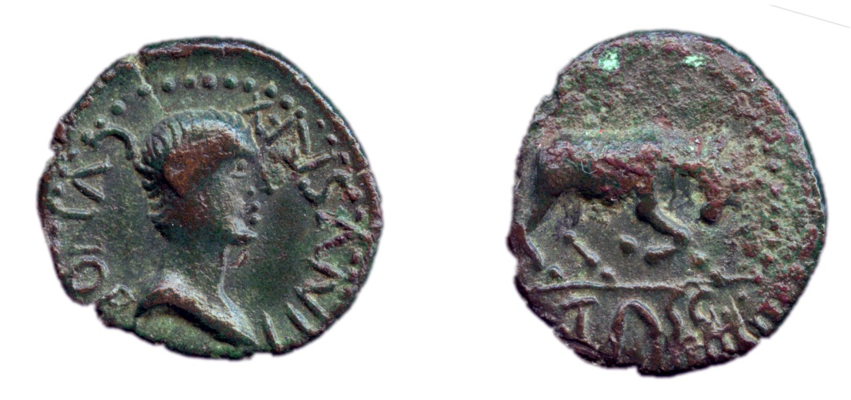
Front of coin: Head (perhaps intended for that of Cunobelinus.) Around CVNOBELINVS REX |  | Back of coin: Bull butting, TASC(IOVANI FILIVS)
The titulature runs continuously from the front of the coin to the back of the coin, “King Cunobelinus, son of Tasciovanus”

British Museum 1925,1201.1

Gold stater of Verica, c.AD 10–40

Front of coin (observe) |  | Back of coin (reverse)
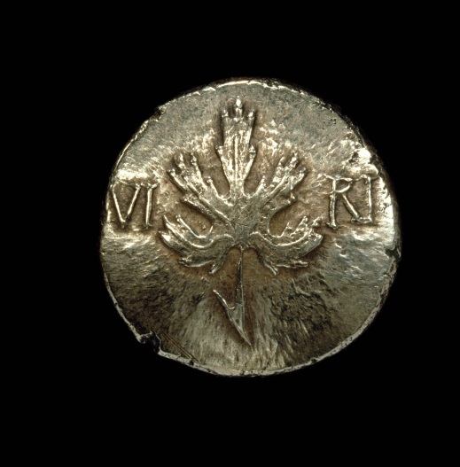 |  | 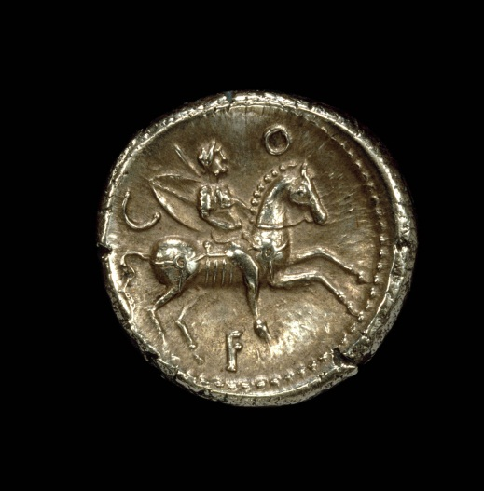
VIRI(CA), split by vine-leaf |  | COM(MMI) F(ILIVS)
The titulature runs continuously from the front of the coin to the back of the coin, “Virica, son of Commius”

British Museum 1919,0213.165

Aureus of Claudius

Front of coin (observe) |  | Back of coin (reverse)
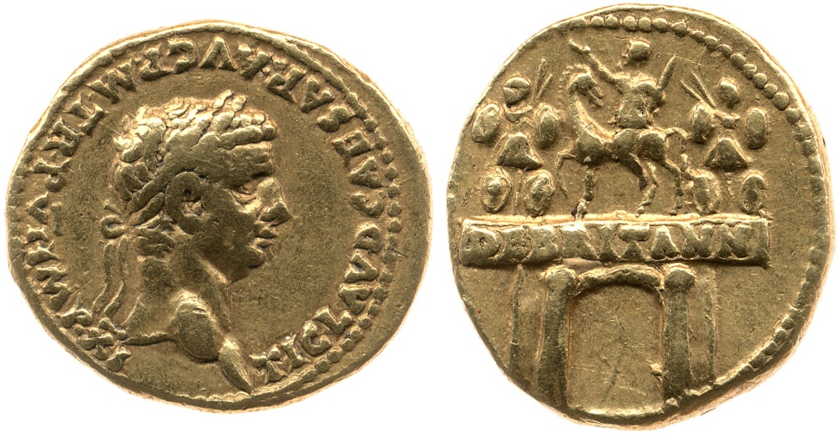
Head of Claudius wearing laurel wreath, facing right. |  | Triumphal arch with an equestrian statue on top, with two trophies, one either side
TI(BERIVS) CLAVD(IVS) CAESAR AVG(VSTVS) P(ONTIFEX) M(AXIMVS) TR(IBVNICIA) P(OTESTATE) VI IMP(ERATOR) XI / DE BRITANN(IS)
Tiberius Claudius Caesar Augustus, chief priest, in his sixth year of tribunician power, hailed imperator eleven times / (erected in commemoration of victory) over the Britons.
Struck circa AD 46–47

British Museum 1863,0501.1; RIC Claudius 9; BMC Claudius 32

Silver didrachma of Claudius

Front of coin (observe) |  | Back of coin (reverse)
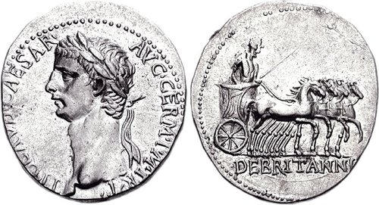
Head of Claudius with laurel wreath |  | Claudius in a four-horse chariot holding eagle sceptre
TI CLAVDIVS CAESAR AVG GERM P M TR P / DE BRITANNIS
Tiberius Claudius Caesar Augustus Germanicus Pontifex Maximus Tribune of the Plebs / (victory) over the Britons
Struck circa AD 43–48

RIC 122, RSC015, RPC 3625, BMCRE 237, Sydenham 055

Arch of Claudius

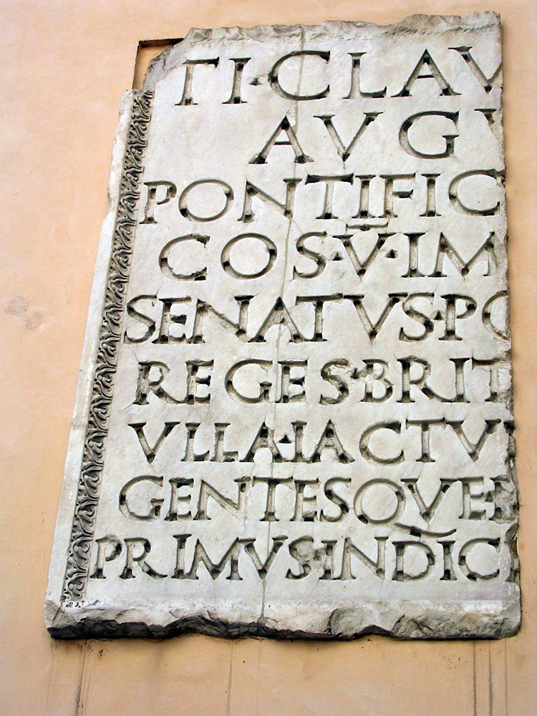
CIL VI 40416 = CIL VI 31203 = ILS 216

Translation:
To Tiberius Claudius Caesar Augustus Germanicus, the son of Drusus, pontifex maximus, holding the tribunician power for the 11th time, consul for the 5th time, imperator for the 22nd (?) time, censor, the father of the fatherland, from the Senate and Roman people because he has conquered eleven Britain kings in few days without any losses and have been the first to transfer their kingdoms and the barbarous peoples situated beyond the Ocean into the power of the Roman people.

Tombstone of Sextus Valerius Genialis (RIB 109)
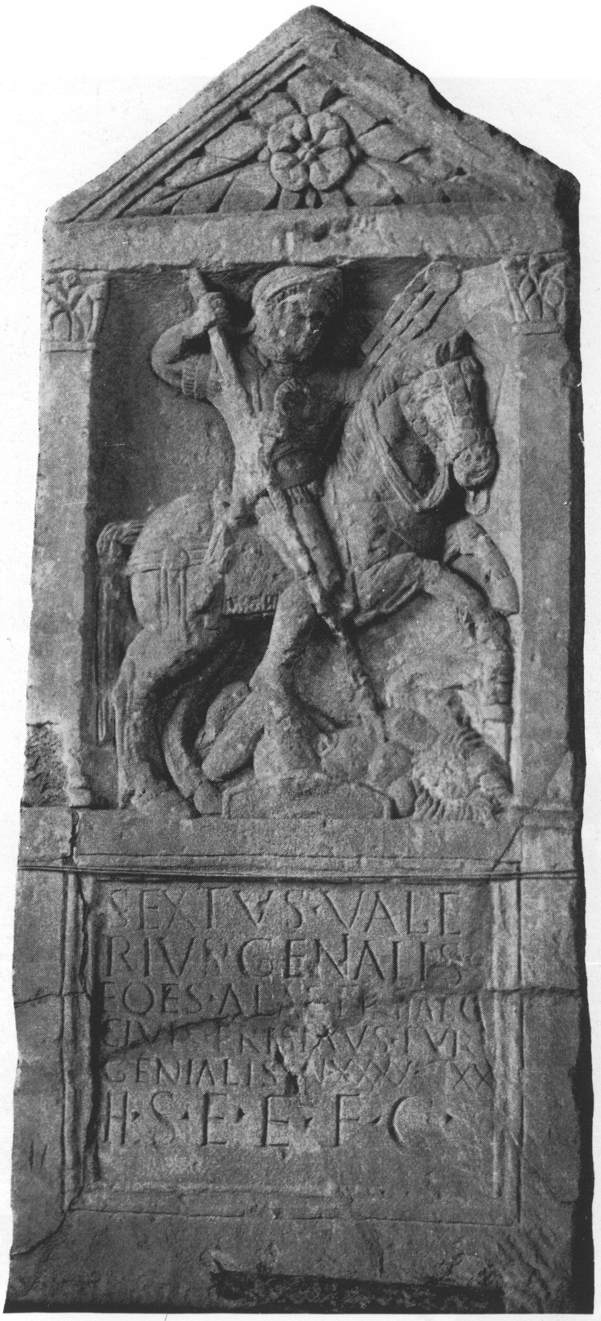
RIB 109

Translation:
Sextus Valerius Genialis, trooper of the Cavalry Regiment of Thracians, a Frisiavone tribesman, from the troop of Genialis, aged 40, of 20 years' service, lies buried here. His heir had this set up.

Tombstone of Rufus Sita (RIB 121)

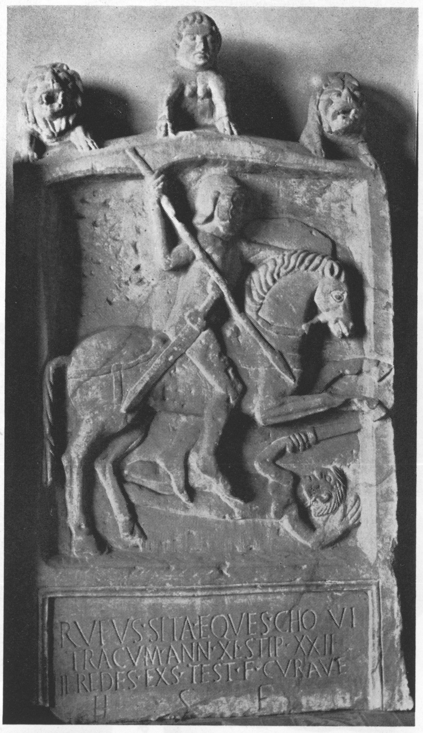
RIB 121, Gloucester

Translation:
Here lies Rufus Sita, cavalryman in the Sixth Cohort of Thracians. He lived for 40 years and served for 22 years. His heirs had this set up, according to his will.

Vindolanda tablet ‘concerning supplies’ (Tab. 343)

‘Octavius to his brother Candidus, greetings. The hundred pounds of sinew from Marinus – I will settle up. From the time when you wrote about this matter, he has not even mentioned it to me. I have several times written to you that I have bought about 5,000 modii of ears of grain, on account of which I need cash. Unless you send me some cash, at least 500 denarii, the result will be that I shall lose what I have laid out as a deposit, about 300 denarii, and I shall be embarrassed. So, I ask you, send me some cash as soon as possible. The hides which you write are at Cataractonium – write that they be given to me and the wagon about which you write. And write to me what is with that wagon. I would have already been to collect them except that I did not care to injure the animals while the roads are bad. See with Tertius about the 8 denarii which he received from Fatalis. He has not credited them to my account. Know that I have completed the 170 hides and I have 119 modii of threshed bracis. Make sure that you send me cash so that I may have ears of grain on the threshing-floor. Moreover, I have already finished threshing all that I had. A messmate of our friend Frontius has been here. He was wanting me to allocate (?) him hides and that being so, was ready to give cash. I told him I would give him the hides by 1 March. He decided that he would come on 13 January. He did not turn up nor did he take any trouble to obtain them since he had hides. If he had given the cash, I would have given him them. I hear that Frontinius Iulius has for sale at a high price the leather ware (?) which he bought here for five denarii apiece. Greet Spectatus and ... and Firmus. I have received letters from Gleuco. Farewell. (Back) (Deliver) at Vindolanda. ‘
Tab. Vindol 2.343

Vindolanda tablet detailing the procurement of materials for the fort

‘Metto (?) to his Advectus (?)
very many greetings.
I have sent you wooden materials through the agency of Saco:
hubs, number, 34
axles for carts, number, 38
therein an axle turned on the lathe, number, 1
spokes, number, 300
planks (?) for a bed, number, 26
seats, number, 8 (?)
knots (?), number, 2 (?)
boards (?), number, 20+
..., number, 29
benches (?), number, 6
I have sent you goat-skins, number, 6
I pray that you are in good health, brother.” ‘

Tab. Vindol. 309

Vindolanda tablet requesting to know if there is an inn to lodge at

... order (accommodation?) to be given to ...; accommodation moreover where the horses are well housed. Farewell, my dearest brother.

Tab. Vindol. III 632

Copyright Information:

Copyright for all the literary translations are held by OCR.
Gold stater of Verica: © The Trustees of the British Museum
Gold stater of Cunobelinus: © The Trustees of the British Museum
Bronze coin of Cunobelinus: © The Trustees of the British Museum
Aureus of Claudius: © The Trustees of the British Museum
Silver didrachma of Claudius: www.cngcoins.com, Classical Numismatic Group, Inc.
Arch of Claudius: © Olga Liubimova, The Online Database of Ancient Art, www.ancientrome.ru
Tombstone of Sex. Valerius Genialis image: © W D Moss, Roman Inscriptions of Britain, www.romaninscriptionsofbritain.org. Permission to reproduce all copyright material has been applied for. In some cases, efforts to contact copyright-holders have been unsuccessful and OCR will be happy to rectify any omissions of acknowledgements in future papers if notified.
Tombstone of Sex. Valerius Genialis text: RIB 109. Funerary Inscription for Sextus Valerius Genialis, www.romaninscriptionsofbritain.org, Roman Inscriptions of Britain. Reproduced under the terms of the Creative Commons Attribution 4.0 International License.
Tombstone of Rufus Sita image: © Gloucester City Museum
Tombstone of Rufus Sita text: RIB 121. Funerary Inscription for Rufus Sita, www.romaninscriptionsofbritain.org, Roman Inscriptions of Britain. Reproduced under the terms of the Creative Commons Attribution 4.0 International License.
Vindolanda tablet ‘concerning supplies’ (Tab. 343): vt02.classics.ox.ac.uk, Vindolanda Tablets Online II. Reproduced under the terms of the Creative Commons Attribution-NonCommercial-ShareAlike 2.0 UK: England & Wales.
Vindolanda tablet detailing the procurement of materials for the fort (Tab. 309): vt02.classics.ox.ac.uk, Vindolanda Tablets Online II. Reproduced under the terms of the Creative Commons Attribution-NonCommercial-ShareAlike 2.0 UK: England & Wales.
Vindolanda tablet requesting to know if there is an inn to lodge at (Vindol Tab. III 632): © The Trustees of the British Museum - reproduced under the terms of the Creative Commons Attribution-NonCommercial-ShareAlike 4.0 International licence.

OCR is committed to seeking permission to reproduce all third-party content that it uses in the assessment materials. OCR has attempted to identify and contact all copyright holders whose work is used in this paper. To avoid the issue of disclosure of answer-related information to candidates, all copyright acknowledgements are reproduced in the OCR Copyright Acknowledgements booklet. This is produced for each series of examinations and is freely available to download from our public website (www.ocr.org.uk) after the live examination series.

If OCR has unwittingly failed to correctly acknowledge or clear any third-party content in this assessment material, OCR will be happy to correct its mistake at the earliest possible opportunity.

For queries or further information please contact the Copyright Team, First Floor, 9 Hills Road, Cambridge CB2 1GE.

OCR is part of the Cambridge Assessment Group; Cambridge Assessment is the brand name of University of Cambridge Local Examinations
Syndicate (UCLES), which is itself a department of the University of Cambridge.

This is an error in Cassius Dio’s account – he was granted an ovation, see Suetonius, Claudius 24.3.
Vespasian was given the task of putting down the Jewish Revolt, which began in AD 66
AD 47–c.52

