# Section Check In – 4.03 Matrices

## Questions

**For questions involving calculations with purely numerical matrices, try the question by hand first, then check with your calculator.**

1. Let



Calculate where possible:

(i) 

(ii) 

(iii) 

(iv) 

2. Find the matrix such that .

3. Solve using matrix methods, giving your answer in terms of  and .





What is the condition on  and for there to be a solution?

4. Find the inverse of



in terms of . What condition is on to ensure that the inverse exists?

5. You are given that the matrix  maps the points  and .

Find the matrix .

6. Let

 and 

where is a constant.

(i) Find in terms of .

(ii) Given that , where  is a constant, find  and .

(iii) Write down .

7. A transformation is represented by the matrix

.

By considering what happens to points on the line  under this transformation, find the value(s) of  such that the line  is an invariant line.

8.* It is given that  is non-singular.

(i) Find the set of possible values of .

(ii) Find the inverse of .

(iii) Solve the equations



in terms of , assuming that  lies in the set found in part (i).

9. Let  and .

(i) By considering what happens to the unit square with vertices describe the transformation represented by the matrix .

(ii) Similarly describe the transformation represented by the matrix .

(iii) Matrix  is defined so that . Find .

10.* Solve the system of equations and interpret your answers geometrically.







**Extension**

(i) The matrix for a general rotation is given by .

Prove that .

How could you use this result to prove De Moivre’s theorem?

HINT: Use addition formulae for trigonometry.

(ii) Let  be the matrix of co-factors of a non-singular  matrix , .   
  
Prove that .

## Worked solutions

1. (i) 







(ii) 







(iii) 





(iv) 















1. We need to calculate the inverse of 

which is 

and hence the matrix  can be calculated by





1. First it is written in matrix form



The determinant of the matrix on the LHS is calculated



and the solution can then be calculated as





Therefore the condition for there to be a solution, 

and hence

4. First the determinant is calculated to see if the matrix is singular.









The matrix is non-singular if . First, we have to calculate the matrix of co-factors:



The transpose is



and hence the inverse is

.

5. Let



Therefore, we have



and



These become a set of 4 equations:



Solving the first and third equation gives



and the second and fourth



and hence

.

6. (i) The product  is written as







(ii) For the product to be equal to , we have



and



which means that



(iii) The inverse of  is therefore



or



1. The line  can be written as



Therefore, in the primed coordinates







For the points on  to lie on the line, we must have









As a check, for 



as required.

For :



as required.

8. (i) The determinant is calculated









Solving for : 

so for **A** to be non-singular 

(ii) The matrix of co-factors is



The transpose is



and hence dividing by the determinant gives



(iii) Hence by matrix multiplication the solution is



and the solution is, , .

9. (i) The points get mapped as









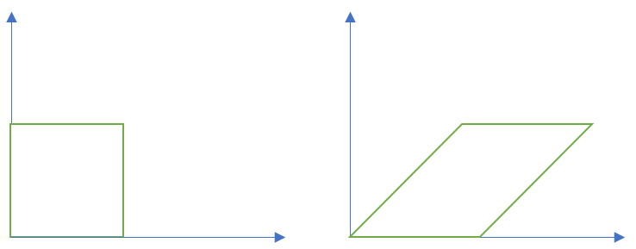

This a shear of magnitude 1 in the *x* direction

(ii) Like before









and hence

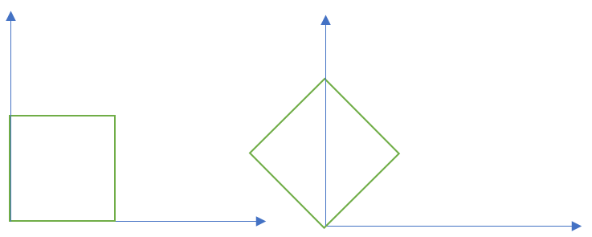

This a rotation about the origin; angle  anticlockwise.

(iii) 

Therefore, to find  we post-multiply by 



There are many ways to find the inverse of . The simplest is using the fact that it   
 represents a rotation of  radians anticlockwise. Therefore, the inverse is just a   
 rotation of  radians clockwise. Hence





10. The equations are first put in matrix form



The determinant is calculated





The matrix is singular and matrix methods (in this course at least) will not work here.   
Each equation represents a plane in the *xyz* space. The normals for each plane are

.

None of these are parallel, hence the solution set consists of either a sheaf of planes or a prism of planes – either infinite solutions or no solutions.

To proceed, first we eliminate  from the first two equations to get .

Next, we note that eliminating from the second two equations also gives .

So the equations are consistent and there are infinitely many solutions (for example ), so the solution set is a sheaf of planes.

(Note that just finding the point above would be enough to prove that it is a sheaf; the existence of *any* solution is enough once the matrix has been shown to be singular.)

**Extension**

(i) We have to calculate



which is



which upon using the trigonometrical identities becomes



as required.

To prove De Moivre’s theorem we note that from above



Now we interpret a complex number as a matrix in the form



then this is almost a proof for De Moivre’s theorem as complex multiplication is represented by rotation in the Argand plane.

(ii) From the definition of the matrix of cofactors we have



Now taking the determinant of both sides



Now the RHS is the determinant of a diagonal matrix which is just the product of the diagonal entries. Therefore



and hence



as required.

**OCR Resources**: *the small print*OCR’s resources are provided to support the teaching of OCR specifications, but in no way constitute an endorsed teaching method that is required by the Board, and the decision to use them lies with the individual teacher. Whilst every effort is made to ensure the accuracy of the content, OCR cannot be held responsible for any errors or omissions within these resources.   
© OCR 2016 - This resource may be freely copied and distributed, as long as the OCR logo and this message remain intact and OCR is acknowledged as the originator of this work.

OCR acknowledges the use of the following content: n/a

Please get in touch if you want to discuss the accessibility of resources we offer to support delivery of our qualifications: [resources.feedback@ocr.org.uk](mailto:resources.feedback@ocr.org.uk)

We’d like to know your view on the resources we produce. By clicking on ‘[Like](mailto:resources.feedback@ocr.org.uk?subject=I%20liked%20the%20AS%20and%20A%20Level%20Further%20Maths%20A%20Section%20Check%20In%20–%204.03%20Matrices)’ or ‘[Dislike](mailto:resources.feedback@ocr.org.uk?subject=I%20disliked%20the%20AS%20and%20A%20Level%20Further%20Maths%20A%20Section%20Check%20In%20–%204.03%20Matrices)’ you can help us to ensure that our resources work for you. When the email template pops up please add additional comments if you wish and then just click ‘Send’. Thank you.

If you do not currently offer this OCR qualification but would like to do so, please complete the Expression of Interest Form which can be found here: [www.ocr.org.uk/expression-of-interest](http://www.ocr.org.uk/expression-of-interest)