M3.3 – Understand that y = mx + c represents a linear relationship

Teacher answers

Quiz
1. Sketch a graph to show how cardiac output changes as heart rate increases if stroke volume does not change.
Note: if you have covered topic 3.1.2 Transport in animals you should already know the equation that relates cardiac output to stroke volume and heart rate. In an exam you could be tested, as part of a question like this, on whether you can remember the equation but here is a reminder:
$$cardiac output=heart rate ×stroke volume$$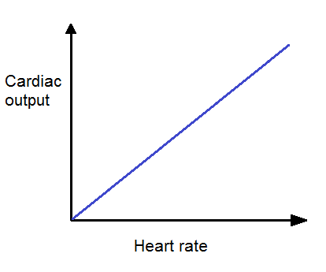
2. Data from an experiment show that the mean height attained by seedling shoots in the first 48 hours after germination is directly proportional to the concentration of auxin applied to the germinating seed. Seedlings without any auxin treatment grew to a mean height of 12 mm. Seedlings exposed to the maximum concentration of auxin grew to a mean height of 31 mm.
Sketch a graph to show the relationship between mean seedling height and auxin concentration.
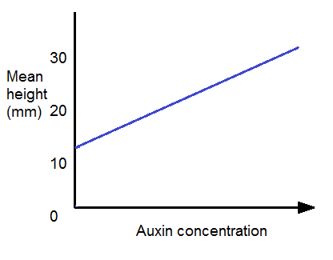

Produced in collaboration with the University of East Anglia
This formative assessment resource has been produced as part of our free A Level teaching and learning support package. All the A Level teaching and learning resources, including delivery guides, topic exploration packs, lesson elements and more are available on the qualification webpages.
If you are looking for examination practice materials, you can find the Sample Assessment Materials (SAMs) on the qualification webpages: Biology A / Biology B

We’d like to know your view on the resources we produce. By clicking on ‘Like’ or ‘Dislike’ you can help us to ensure that our resources work for you. When the email template pops up please add additional comments if you wish and then just click ‘Send’. Thank you.
If you do not currently offer this OCR qualification but would like to do so, please complete the Expression of Interest Form which can be found here: www.ocr.org.uk/expression-of-interest
Looking for a resource? There is now a quick and easy search tool to help find free resources for your qualification:
www.ocr.org.uk/i-want-to/find-resources/

OCR Resources: the small print
OCR’s resources are provided to support the delivery of OCR qualifications, but in no way constitute an endorsed teaching method that is required by the Board, and the decision to use them lies with the individual teacher. Whilst every effort is made to ensure the accuracy of the content, OCR cannot be held responsible for any errors or omissions within these resources.
© OCR 2017 - This resource may be freely copied and distributed, as long as the OCR logo and this message remain intact and OCR is acknowledged as the originator of this work.
OCR acknowledges the use of the following content: n/a
Please get in touch if you want to discuss the accessibility of resources we offer to support delivery of our qualifications: resources.feedback@ocr.org.uk

