M3.4 – Determine the intercept of a graph

Tutorials
Learners may be tested on their ability to:
- read off an intercept point from a graph, e.g. compensation point in plants.
Determining the intercept of a graph
An intercept is where one line on your graph crosses another. This could be where a line of best fit crosses either the x or y axis. Or it could be where two lines of best fit cross each other.
In section M3.3 we talked about graphs represented by the linear relationship y = mx + c, where “m” represents the gradient of the line, and “c” represents the y-intercept. Finding the y-intercept is easy – it is simply where the line crosses the y axis, where x = 0. Similarly, the x-intercept is where the line crosses the x axis, where y = 0.
Intercepts = where the line crosses either the x or y axis
Note: if your x axis doesn’t start from zero, you will not be able to read off the y intercept in this way. If you need to find the y intercept you should start your x axis from zero. Likewise, if you are aiming to find the x intercept when you have plotted your data you should make sure that your y axis starts from zero.
As well as finding the intercepts of a graph, you also need to be able to find and read off the intersection of two or more data series from a graph. This is basically where two different curves on the same axes intersect.
For example, you may be asked to find the compensation points in plants. Compensation points are where the rate of photosynthesis exactly matches the rate of respiration. In this graph the compensation points (L) are where the graphs representing the rate of photosynthesis and the rate of plant respiration intersect.

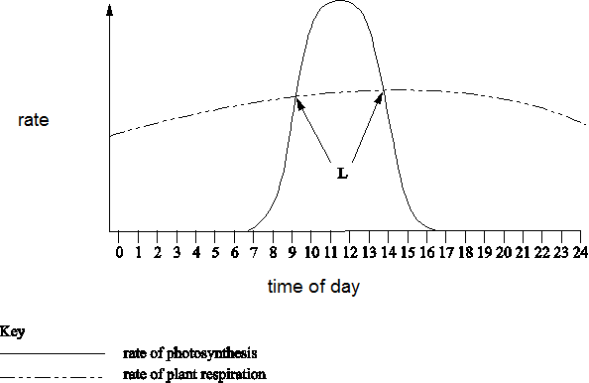

This resource has been produced as part of our free A Level teaching and learning support package. All the A Level teaching and learning resources, including delivery guides, topic exploration packs, lesson elements and more are available on the qualification webpages.
If you are looking for examination practice materials, you can find the Sample Assessment Materials (SAMs) on the qualification webpages: Biology A / Biology B

OCR Resources: the small print
OCR’s resources are provided to support the delivery of OCR qualifications, but in no way constitute an endorsed teaching method that is required by the Board, and the decision to use them lies with the individual teacher. Whilst every effort is made to ensure the accuracy of the content, OCR cannot be held responsible for any errors or omissions within these resources.
© OCR 2017 - This resource may be freely copied and distributed, as long as the OCR logo and this message remain intact and OCR is acknowledged as the originator of this work.
OCR acknowledges the use of the following content: n/a
Please get in touch if you want to discuss the accessibility of resources we offer to support delivery of our qualifications: resources.feedback@ocr.org.uk

Produced in collaboration with the University of East Anglia
We’d like to know your view on the resources we produce. By clicking on ‘Like’ or ‘Dislike’ you can help us to ensure that our resources work for you. When the email template pops up please add additional comments if you wish and then just click ‘Send’. Thank you.
If you do not currently offer this OCR qualification but would like to do so, please complete the Expression of Interest Form which can be found here: www.ocr.org.uk/expression-of-interest
Looking for a resource? There is now a quick and easy search tool to help find free resources for your qualification:
www.ocr.org.uk/i-want-to/find-resources/

