M3.4 – Determine the intercept of a graph

Teacher answers

Quiz
1. An experiment was carried out to find the water potential of the cells in potato tubers.
Cylinders of potato were cut from potatoes and weighed. These cylinders were then immersed in sucrose solutions of different concentrations for 4 hours. The cylinders were then weighed again and the percentage change in mass was recorded.
The results were plotted and the line of best fit is shown in the graph below.
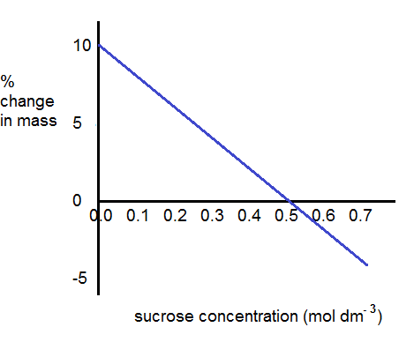
What are the intercepts in this graph?
The y intercept is (0, 10) meaning that when sucrose concentration was 0 mol dm⁻³ the potato cylinders increased in mass by 10%

The x intercept is (0.5, 0) meaning that there was no change in mass of the cylinders when the sucrose concentration was 0 mol dm⁻³

Which intercept will be used to find the water potential of the cells?
The x intercept will be used to find the water potential. This is tells us the sucrose concentration where the water potential of the sucrose solution is the same as that of the potato cells and so there is no net movement of water by osmosis in or out of the cells.

2. Measurements were made of pressure changes within the left side of the heart and the aorta during the cardiac cycle of a healthy adult human. The intercepts of the various curves indicate moments in the cycle when pressure is equal in the two chambers or vessels. This is when valves open and close.
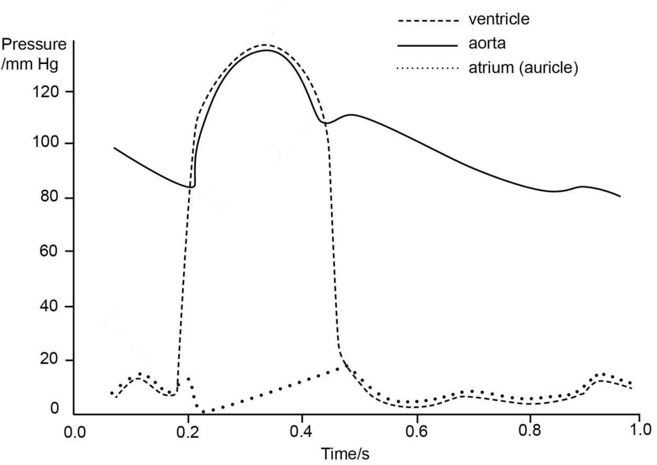
Identify the intercepts and give their meanings in terms of valve opening/closing.
(0.18, 10): at 0.18 s the pressure in the atrium and ventricle is equal at 10 mm Hg. The bicuspid (or atrioventricular) valve closes.

(0.48, 18): at 0.48 s the pressure in the atrium and ventricle is equal at 18 mm Hg. The bicuspid (or atrioventricular) valve opens.

(0.20, 84): at 0.20 s the pressure in the ventricle and aorta is equal at 84 mm Hg. The semilunar (or aortic) valve opens.

(0.44, 108): at 0.44 s the pressure in the ventricle and aorta is equal at 108 mm Hg. The semilunar (or aortic) valve closes.

We’d like to know your view on the resources we produce. By clicking on ‘Like’ or ‘Dislike’ you can help us to ensure that our resources work for you. When the email template pops up please add additional comments if you wish and then just click ‘Send’. Thank you.
If you do not currently offer this OCR qualification but would like to do so, please complete the Expression of Interest Form which can be found here: www.ocr.org.uk/expression-of-interest
Looking for a resource? There is now a quick and easy search tool to help find free resources for your qualification:
www.ocr.org.uk/i-want-to/find-resources/

This formative assessment resource has been produced as part of our free A Level teaching and learning support package. All the A Level teaching and learning resources, including delivery guides, topic exploration packs, lesson elements and more are available on the qualification webpages.
If you are looking for examination practice materials, you can find the Sample Assessment Materials (SAMs) on the qualification webpages: Biology A / Biology B

OCR Resources: the small print
OCR’s resources are provided to support the delivery of OCR qualifications, but in no way constitute an endorsed teaching method that is required by the Board, and the decision to use them lies with the individual teacher. Whilst every effort is made to ensure the accuracy of the content, OCR cannot be held responsible for any errors or omissions within these resources.
© OCR 2017 - This resource may be freely copied and distributed, as long as the OCR logo and this message remain intact and OCR is acknowledged as the originator of this work.
OCR acknowledges the use of the following content: n/a
Please get in touch if you want to discuss the accessibility of resources we offer to support delivery of our qualifications: resources.feedback@ocr.org.uk

Produced in collaboration with the University of East Anglia

