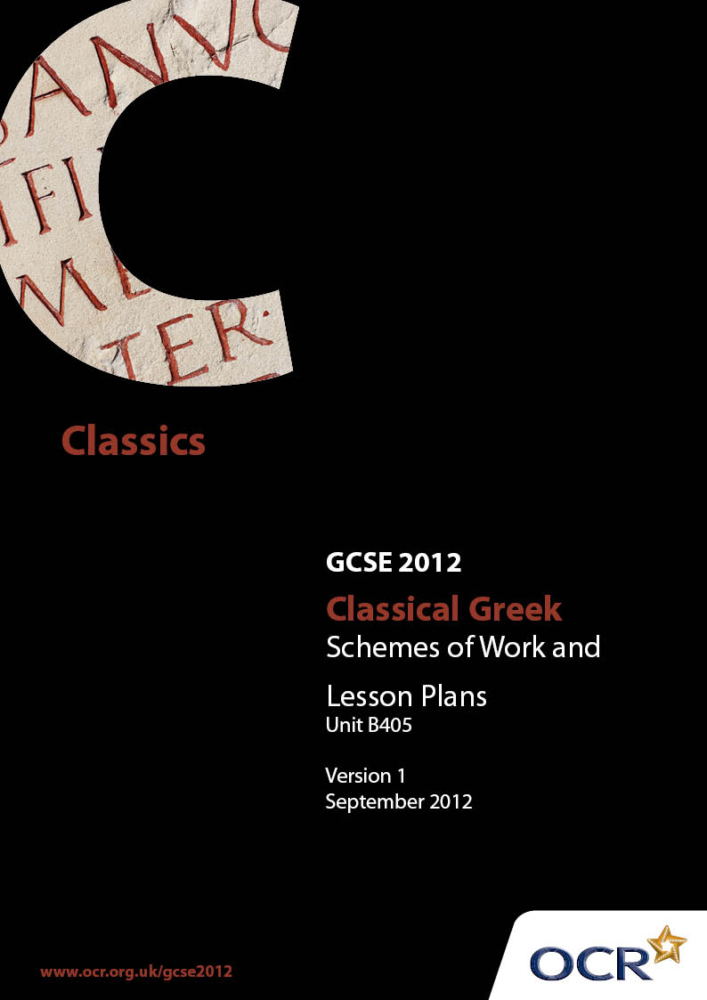

Contents
Contents 2
Introduction 3
Unit B405: Sources for Classical Greek – Sample Scheme of Work 5
Unit B405: Sources for Classical Greek – Sample Lesson Plan 19

Introduction

Background
OCR has produced a summary brochure, which summarises the changes to Classical Greek. This can be found at www.ocr.org.uk, along with the new Specification.
In addition and in response to reforms announced by the Government and in response to Ofqual mandated changes to GCSEs, unitised assessment of this qualification is being replaced by linear assessment from September 2012. This means that candidates commencing a two year course from September 2012 will take all of their GCSE units at the end of the course in June 2014.
In order to help you plan effectively for the implementation of the new specification we have produced these Schemes of Work and Sample Lesson Plans for Classical Greek B405. These Support Materials are designed for guidance only and play a secondary role to the Specification.

Our Ethos
OCR involves teachers in the development of new support materials to capture current teaching practices tailored to our new specifications. These support materials are designed to inspire teachers and facilitate different ideas and teaching practices.
Each Scheme of Work and set of sample Lesson Plans is provided in Word format – so that you can use it as a foundation to build upon and amend the content to suit your teaching style and students’ needs.
The Scheme of Work and sample Lesson Plans provide examples of how to teach this unit. The teaching hours are suggestions only. Some or all of it may be applicable to your teaching.
The Specification is the document on which assessment is based and specifies what content and skills need to be covered in delivering the course. At all times, therefore, this Support Material booklet should be read in conjunction with the Specification. If clarification on a particular point is sought then that clarification should be found in the Specification itself.

A Guided Tour through the Scheme of Work

= Innovative Teaching Idea
This icon is used to highlight exceptionally innovative ideas.


= ICT Opportunity
This icon is used to illustrate when an activity could be taught using ICT facilities.

Unit B405: Sources for Classical Greek
Suggested teaching time | 2 hours | Topic | Introduction
Topic outline |  | Suggested teaching and homework activities |  | Suggested resources | Points to note
To introduce students to the requirement of the unit |  | - Issue each student with a copy of B405 unit description. Highlight key words and discuss.  - Students should annotate their copies with appropriate ‘student friendly’ explanation in readily accessible vocabulary.  - Explain that the topic involves social history, archaeology, literature and inscriptions.  - Reassure them that the written sources have been translated into English.  - Explain that the unit requires a balance of knowledge and skills. |  | - Photocopy the relevant section of the specification. | - This introductory session could be run with either Greek or Latin students doing the Sources paper, or both.  - This enables students to be an active partner in their own learning.
To introduce the concept of primary sources |  | - Invite definitions of primary and secondary sources from the students.  - Group work: give each group a double-page spread from a well-illustrated book on Greek. Invite them to discuss which are primary and which are secondary materials.  - Modern primary sources: provide students with photocopies of popular celebrity features in newspapers – my favourite room; my favourite objects etc. Invite them to consider what these tell us about the celebrity features.  - Whole group considers real objects collected from a popular teacher in the school, e.g. football scarf, distinctive jewellery, favourite tie, favourite CD. Students invited to comment on what these tell us about the person they belong to. They are invited to guess which teacher it is.  - Students invited to consider which of these things might survive in 2000 years.  - Brainstorm session – what has survived from Ancient Greece, i.e. poetry, buildings, pots, tombstones etc. |  | - The school library or resource centre might be a suitable location for this lesson.  - Suitable books might include Ancient Greece by Anne Pearson Dorling Kindersley 2002 (Eyewitness series) or any that have a good selection of pictures even if target audience is KS2. Books do not necessarily have to be specifically about Classical Greece.  - Photocopies of relevant newspaper features, e.g. Guardian / Observer colour supplement.  - Realia collected from a colleague or teacher himself/herself.  - Whiteboard to record students’ ideas. | - Many students will be aware of the concept of primary and secondary sources from their history lessons.  - Some students like to engage with more philosophical concepts, e.g. ‘is a picture of a primary source a primary source?’ or (more importantly) ‘how far you can trust an English translation of a Greek text?’
To look at some Greek resources |  | - Whole-task activity: look at a short but dramatic Greek primary source. Challenge students to think of as many things as possible that it might tell us.  - Group activity: give each group a different primary source to replicate the above skills. They then present their source and their findings to the whole class.  - Homework: give each student an interesting Classical primary source or invite them to find their own (postcards etc. from school trips / holiday photos etc.). They should squeeze as much information from them as possible for a quick presentation at the start of the next lesson. |  | - Primary-source photocopy or project data.  - Copies of primary sources for each group. | - This activity is to model inference skills.  - It is important that these sources are straightforward to analyse and as dramatic as possible.  - A variant of this exercise might be to use real artefacts or alternatively reproductions of materials if available. Some local museums have handling boxes which they lend to schools. Alternatively the lesson could be conducted in a museum with a relevant collection with student groups doing mini-presentations on particular objects – but teachers must encourage them to build up their inference from the objects themselves not the museum labels.

Unit B405: Sources for Classical Greek
Suggested teaching time | 2 hours | Topic | Work and Domestic: Houses
Topic outline |  | Suggested teaching and homework activities |  | Suggested resources | Points to note
To introduce evidence for private housing |  | - Students could make a quick ground plan of their own house – labelling what activity goes on in each room.  - Teacher could encourage students to think about differences in room activities in a house in Ancient Greece – especially the concept of the andron and the gynaeceum.  - Students consider ground plan of a Greek house (e.g. House at Olynthos) and what each of the rooms might be used for.  - Each student given a picture of a domestic object, e.g. spindle, loom weight, tile end decoration / cooking vessel / spinning top / pyxis / krater etc. (or could choose). They are given a short time to research their object, present a short description – what does this object tell us about Greek domestic life? And then suggest where in the house the object might be found.  - Discussion of Xenophon, Oeconomicus 9.2–4.  - Homework: what does the available evidence fail to tell us about Greek houses and domestic life? |  | - Ground plan of House at Olynthos.  - Pictures of key domestic objects.  - Xenophon Oeconomicus 9.2–4. | - Aspects of this topic could link with women on the specification.  - This activity could become an attractive wall display and revision aid.

Unit B405: Sources for Classical Greek
Suggested teaching time | 2 hours | Topic | Work and Domestic Life: Women, Relations between Men and Women
Topic outline |  | Suggested teaching and homework activities |  | Suggested resources | Points to note
To study the lives of women through primary sources  - Spinning  - Domestic duties |  | - Using Lysistrata 565–586, students write quick bullet- point ‘beginner’s guide to spinning’.  - Students look at pictures of pots showing women spinning and weaving. They are asked to consider if there are any men in the pictures – and, if not, why not and to discuss the economic importance of spinning and weaving in the domestic economy.  - Students read Xenophon Oikonomikos 7.33ff (or any similar passage outlining wifely duties) and either write the wife’s reply or write a comparable statement by a 21st-century husband. |  | - Copies of relevant passages from Lysistrata.  - Pictures of pots showing women spinning and weaving on data projector or in books.  - Copies of Xenophon Oikonomikos 7.33ff.  - Or any similar passage outlining wifely duties. | - Textiles departments might well have sheep’s wool or spindles so that students can experiment with the process themselves. Some ancient sites, e.g. Butser Ancient Farm, Hampshire, sell excellent hand spindles.  - If using sheep’s wool, check student allergies.
- Betrothal and marriage |  | - Students compare and contrast vase paintings of wedding preparations and wedding processions with photographs of a modern wedding. |  | - Pictures of vase paintings depicting wedding procession and wedding preparations.  - Photographs of a modern wedding.
- Other aspects of female life |  | - Magazine project: divide class into small groups or pairs to research and write a short feature article for an Ancient Greek woman’s magazine. Each is given a small area to research, e.g. fashion / tips for mothers / problem page / marriage – how to prepare for your big day etc. Each feature article must include at least one primary source. |  | - Copies of relevant sources may be distributed by the teacher to each group.  - Dowswell, P, Greek Gazette Usborne 1999 might be a springboard for ideas. | - The computer room might be a suitable location this lesson.  - Scope for ICT skills researching via the internet and word processing article.  - The finished magazine can be photocopied for each member of the class as an excellent revision aid.

Unit B405: Sources for Classical Greek
Suggested teaching time | 2 hours | Topic | Work and Domestic Life: Slaves
Topic outline |  | Suggested teaching and homework activities |  | Suggested resources | Points to note
To understand the role slaves played in the life and economy of Ancient Greece |  | - Students make a list of the ‘slaves’ in their own homes, e.g. washing machine / dishwasher / vacuum cleaner / water heater / central heating.  - They consider the effect of these on their lives – what do these devices enable them and their family to do instead?  - Students consider what happens when these need replacing and if they treat more expensive items more carefully than cheaper items.  - Students are asked to consider if they would like to go without these items.  - Students read relevant sections of opening chapter of Aristotle’s Politics. They could hold an impromptu debate: This house believes that slavery is part of the natural order of things.  - Homework: read Plutarch Comparison of Nicias and Crassus 1 on slaves and mining. Make a list of modern forms of human slavery. |  | - Aristotle, Politics  - Plutarch, Comparison of Nicias and Crassus 1 | - Discussion of slavery is particularly relevant to citizenship, allowing students to reach moral judgements and express personal views on moral and ethical issues.

Unit B405: Sources for Classical Greek
Suggested teaching time | 2 hours | Topic | Work and Domestic Life – Occupations
Topic outline |  | Suggested teaching and homework activities |  | Suggested resources | Points to note
To introduce students to a variety of primary sources describing occupations |  | - Each student is given a primary source referring to a particular occupation and is given time to consider what that job might be like – skills involved, hardships to be faced, economic worth etc. based on the source. It is important that each occupation is not known to the rest of the class.  - Each student in turn is in role and is asked questions by the rest of the class. The teacher might like to discuss a range of generic questions before the interrogation starts. The class have to guess what the job might be.  - Homework: a job-based primary source for the students to analyse. Pooling of ideas might inform the next lesson. |  | - Sources for a variety of occupations.  - A useful book could be Vicki Leon, Working IX to V; orgy planners, funeral clowns and other prized professions of the Ancient, Walker and Co, 2007. Although this contains no primary sources it is an excellent source of lively information. | This activity:  - develops questioning skills;  - gives the whole class an overview of types of occupations;  - allows each student to analyse a source in depth.

Unit B405: Sources for Classical Greek
Suggested teaching time | 1 hour | Topic | Social life and citizenship:synposia
Topic outline |  | Suggested teaching and homework activities |  | Suggested resources | Points to note
To consider the reliability of Greek vases as evidence for social life in Classical Greece |  | - Teacher could give a short illustrated presentation describing how Greek vases were made.  - In pairs, students discuss the advantages and disadvantages of using vases as evidence of social life. |  | - Collection of photos/slides/images of Greek vases. | - The school might consider a Classics trip to a museum or gallery which has a collection of vases, e.g. British Museum; Fitzwilliam Museum, Cambridge; Ure Museum, University of Reading, Lady Lever Art Gallery, Liverpool etc.
To consider the evidence for symposia |  | - Teacher gives a short factual account of what went on at a symposium.  - Students divided into small groups. Each given a suitable vase picture to consider. Each group gives a presentation to the rest of the class, mimicking or ‘freeze-framing’ the vase scene with each figure articulating what the scene tells us. Alternatively, one student could act as ‘vase curator’ explaining the scene while his/her fellow students remained frozen in position.  - Homework: students consider written evidence for symposia and write a brief analysis describing what the source tells us, e.g. Theognis 31–38. |  | - As above.  - Theognis 31–38

Unit B405: Sources for Classical Greek
Suggested teaching time | 1 hour | Topic | Social Life and Citizenship: Sparta
Topic outline |  | Suggested teaching and homework activities |  | Suggested resources | Points to note
To compare Spartan lives with those in other parts of Ancient Greece |  | - Student read Xenophon, Constitution of the Spartans 1.3-8 and 2.1-8 on Spartan education and Aelian, Varia Historia 12.50 on Spartan attitudes to culture and work.  - Students are split into two groups – Spartans and Other Greeks.  - The Greeks spend some time composing questions to ask the Spartans about their way of life.  - The Spartans are then hot-seated about their lives and culture.  - The groups could then reverse with the Spartans firing questions at the Greeks.  - Homework: students write a quick summary of the key features of Spartan culture. |  | - Xenophon, Constitution of the Spartans 2.1-8  - Aelian, Varia Historia 12.50  - The sources are in Dillon, M and Garland, L, Ancient Greece: social and historical documents from Archaic times to the death of Socrates, Routledge, 2000 (pages 168-9 and 179ff). | - It might be appropriate for this part of the specification to be delivered towards the end of the scheme of work.

Unit B405: Sources for Classical Greek
Suggested teaching time | 1 hour | Topic | Social Life and Citizenship: Education
Topic outline |  | Suggested teaching and homework activities |  | Suggested resources | Points to note
To understand chief features of education in Classical Greece |  | - Students look at their own school’s website or brochure. They might compare it with the publicity from a contrasting school.  - What does this publicity material tell us about education in 21st-century Britain?  - Students read Plato, Republic 3.411a-e; Plato, Protagoras 325–326. They compose a short publicity brochure or page for a website for an imaginary Greek school.  - Homework: students label a relevant picture from a Greek vase with points of interest. |  | - School website or brochure  - Plato, Republic 3.411a-e  - Plato, Protagoras 325–326  - For example Attic red-figure cup by Douris. West Berlin, Staatliche Museen F 2285. | - To understand chief features of education in Classical Greece.

Unit B405: Sources for Classical Greek
Suggested teaching time | 1 hour | Topic | Social Life and Citizenship: Democracy
Topic outline |  | Suggested teaching and homework activities |  | Suggested resources | Points to note
To consider the nature of modern democracy throughout the world |  | - Teacher displays a variety of newspapers covering political campaigns and elections anywhere in the world.  - These could be contrasted with states that do not have a democratic political system.  - Students are invited to list what they might see as the features of a modern democracy. |  | - A variety of newspapers covering current political campaigns and elections anywhere in the world.
To consider the nature of Greek democracy |  | - Students read Thucydides 2.37.1–40.2. They compare aspects of the text with the features they listed above. What are the differences and similarities?  - Homework: students could write their own analysis of another suitable text, e.g. Herodotus 6.18, 21.2 (from the Core Primary Source material). |  | - Thucydides 2.37.1–40.2 (in Dillon, M and Garland, L, Ancient Greece: social and historical documents from Archaic times to the death of Socrates, Routledge, 2000, pages 301ff). | - To consider the nature of Greek democracy.

Unit B405: Sources for Classical Greek
Suggested teaching time | 1 hour | Topic | Social Life and Citizenship: Religion – Athletics
Topic outline |  | Suggested teaching and homework activities |  | Suggested resources | Points to note
To understand the connection between sporting excellence and religion in Classical Greece |  | - Students watch video clips of modern track and field competitions in which athletes make religious gestures before or after the races. Why do they do this?  - Students are asked if they know of any other modern sportspersons who have strong religious beliefs.  - Students consider why Greek athletic competitions were held in the context of a religious festival.  - Students read and make brief notes on Plutarch, Moralia Table-talk 2 639D–640 and Plato, Republic 3.411a-e.  - Homework: students read Plutarch, Alcibiades 11.1-12.1 and Sophocles, Electra 698–756 and write a modern ‘sports report’ on a chariot race. |  | - Video clips of major track and field events – Olympic Games / world championships.  - Plutarch, Moralia Table-talk 2 639D–640  - Plato, Republic 3.411a-e  - Plutarch, Alcibiades 11.1-12.1 (see Dillon p. 371).  - Sophocles, Electra 698–756  - Sports page of any newspaper or magazine as stimulus. | - The RE department might well have lists of sportsmen and women who have strong religious beliefs.  - The PE department might well have suitable videos or DVDs to help in the delivery of this section.  - Alternatively, students could look at a variety of sports using both visual and written stimuli and make a series of sports reports covering boxing, racing, long jumping, discus throwing etc.

Unit B405: Sources for Classical Greek
Suggested teaching time | 1 hour | Topic | Social Life and Citizenship: Religion – the Theatre
Topic outline |  | Suggested teaching and homework activities |  | Suggested resources | Points to note
To understand the significance of the theatre in Classical Greece |  | - Teacher shows pictures of Greek theatres and modern theatres to invite students to comment on the differences and similarities between them.  - Teacher-led presentation on Greek theatre and performance.  - Students are asked if any have taken part in competitive music or drama festivals and share their experience. They might use this experience to consider why drama festivals were competitive in Ancient Greece.  - Homework: students find a suitable picture of the remains of a Greek theatre and label it, making their own assumptions and conjectures. |  | - Pictures of Greek theatres and modern theatres.  - PowerPoint might be appropriate here. | - It would be appealing if modern theatres could include local venues and theatres students may have visited on school trips etc.

Unit B405: Sources for Classical Greek
OCR recognises that the teaching of this qualification will vary greatly from school to school and from teacher to teacher. With that in mind this Lesson Plan is offered as a possible approach but will be subject to modifications by the individual teacher.
Lesson length is assumed to be one hour.

Learning Objectives for the Lesson
Objective 1 | Students to explore the key primary sources on women in Classical Greece and make their own conclusions.
Objective 2 | Students to make informed comparisons on gender expectations in Classical Greece and Modern Europe.

Recap of Previous Experience and Prior Knowledge
- In previous lessons, students may have looked at the rooms in a house in Classical Greece and the activities that went on within them.

Content
Time | Content
5 minutes | Warm-up activity to assess prior knowledge. Teacher asks students what they remember about the rooms of a Greek house – especially the gynaecium.
5 minutes | Students read Lysistrata lines 565–586.
20 minutes | Using computers, students write a beginner’s guide to spinning based on the Lysistrata they have read. Using the internet, they can illustrate their booklet with suitable Greek vases showing spinning scenes.
5 minutes | *Students read Xenophon Oikonomikos 7.33ff (or any similar passage outlining wifely duties).
10 minutes | Students either write the wife’s reply or write a comparable statement by a 21st-century husband.
10 minutes | *Dramatic oral presentation of Xenophon and some of the replies above.

Consolidation
Time | Content
5 minutes | Students recall briefly the expected duties of Classical Greek women and how their role differs from those of today.

Homework task – Consolidation and Development
Time | Content
20 minutes | Students to analyse another source, e.g. Lysias 1, Against Eratosthenes 6ff or Hesiod, Works and Days 695–705 to elicit information about women’s lives.

