**1** An object of mass 7.0 kg is pulled vertically upwards by a rope. The acceleration of the object is 2.0 m s-2.

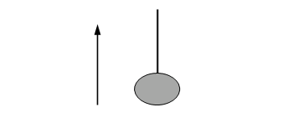

rope

direction of travel

object

What is the tension in the rope?

**A** 14 N

**B** 55 N

**C** 69 N

**D** 83 N

**Your answer [1]**

**2** A bottle cork floats on water. It is partially submerged in the water.

cork



water

Which of the following statements is/are true?

**1** The net force acting on the cork is equal to the weight of the water displaced.

**2** The weight of the cork is equal to the upthrust on the cork.

**3** The upthrust on the cork is equal to the mass of the water displaced.

**A** 1, 2 and 3

**B** Only 2 and 3

**C** Only 3

**D** Only 2

**Your answer [1]**

**3** A compression spring is being tested in an engineering laboratory. The diagram shows the spring before and after the forces are applied to its opposite ends.

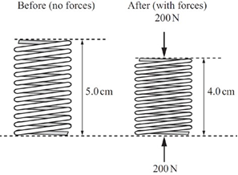

The initial length of the spring is 5.0 cm and during the application of the forces its length is 4.0 cm.

What is the force constant of this spring?

**A** 4.0 × 103 N m–1

**B** 5.0 × 103 N m–1

**C** 2.0 × 104 N m–1

**D** 4.0 × 104 N m–1

**Your answer [1]**

**4** A balloon is travelling vertically downwards at a constant acceleration. The upthrust on the balloon is *U*, its weight is *W* and it experiences air resistance *F*.

Which statement is correct?

**A** *F* + *W* > *U*

**B** *W* + *U* > *F*

**C** *F* > *W* + *U*

**D** *W* > *U* + *F*

**Your answer [1]**

**5** A brick of mass *m* has sides of lengths *a*, *b* and *c*, where *a* < *b* < *c*. The brick is placed on a horizontal table such that the pressure it exerts on the table is a maximum.

What is the maximum pressure *p* acting on the table?

**A** *p* = $\frac{mg}{ab}$

**B** *p* = $\frac{mg}{ac}$

**C** *p* = $\frac{mg}{bc}$

**D** *p* = $\frac{mg}{abc}$

**Your answer [1]**

**6** Two balls **X** and **Y** are dropped from a very tall building. Both balls reach terminal velocity before hitting the ground. The balls have the same diameter. The mass of **X** is greater than the mass of **Y**.

Which statement is correct?

**A** The balls hit the ground at the same time.

**B** The terminal velocity of **Y** is greater than that of **X**.

**C** The initial acceleration of both balls is the same.

**D** The balls have the same kinetic energy just before hitting the ground.

**Your answer [1]**

**7** A small electric motor is 20% efficient. Its input power is 9.6 W when it is lifting a mass of 0.50 kg at a steady speed *v*.

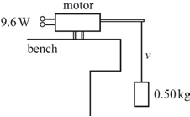

What is the value of *v*?

**A** 0.39 m s−1

**B** 2.0 m s−1

**C** 2.8 m s−1

**D** 3.8 m s−1

**Your answer [1]**

**8** A car accelerates uniformly from rest along a level road.

The effects of air resistance on the car are negligible.

The car travels 12 m in the second second of its journey.

How far does it travel in the fourth second?

**A** 28 m

**B** 35 m

**C** 48 m

**D** 64 m

**Your answer [1]**

**9 Fig. 22.2** shows an arrangement used to investigate how the kinetic energy of a toy car varies with its distance d from the top of the ramp.

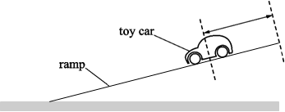

*d*

**Fig. 22.2**

Design a laboratory experiment to determine the kinetic energy of the car at one particular distance d from the top of the ramp.

In your description pay particular attention to

• how the apparatus is used

• what measurements are taken

• how the data is analysed.

…………………………………………………………………………………………......

……………………………………………………………………………………………..

……………………………………………………………………………………………..

…………………………………………………………………………………………......

……………………………………………………………………………………………..

……………………………………………………………………………………………..

…………………………………………………………………………………………......

……………………………………………………………………………………………..

……………………………………………………………………………………… **[3]**

**10 (a) Fig. 23.2** shows a graph of stress against strain for the metal.

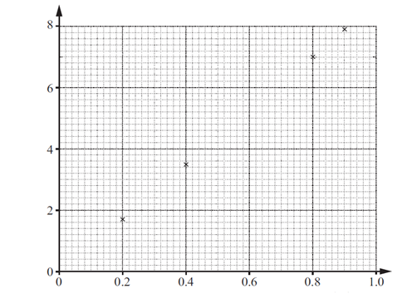

Stress / 107 Pa

strain / 103

**Fig. 23.2**

**(i)** On **Fig. 23.2**, plot the data point corresponding to the tension of 5.9 N and draw the line of best fit through all the data points.

**[1]**

**(ii)** Use **Fig. 23.2** to determine the Young modulus of the metal.

Young modulus = ………………….Pa **[2]**

**(b)** The micrometer screw gauge used to determine the diameter of the wire had a zero error. The diameter recorded by a student was larger than it should have been.

Discuss how the actual value of the Young modulus would differ from the value calculated in **(a)(ii).**

…………………………………………………………………………………………......

……………………………………………………………………………………………..

…………………………………………………………………………………………......

……………………………………………………………………………………………..

…………………………………………………………………………………………......

……………………………………………………………………………………………..

…………………………………………………………………………………………......

……………………………………………………………………………………………..

……………………………………………………………………………………………..

…………………………………………………………………………………………......

………………………………………………………………………………………. **[3]**

**11 Fig. 1.1** shows a sign hanging from a rod fixed to a vertical wall. A metal wire attached between the rod and the wall holds the rod horizontal.

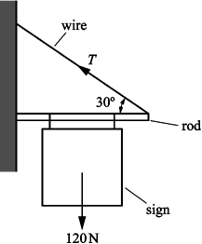

**Fig.1.1**

The weight *W* of the sign and rod act through the centre point of the rod. The value *W* is 120 N. The angle between wire and rod is 30o.

**(i)** Draw an arrow on **Fig. 1.1** to show the direction of the force exerted on the rod by the wall.

**[1]**

**(ii)** State how you chose this direction.

.............................................................................................................................

.............................................................................................................................

.......................................................................................................................... **[1]**

**12** A sports manufacturer is testing the quality of one of their footballs.

**(a) Fig. 3.1** shows how the force*F* applied to a football varies with time *t* whilst it is being kicked horizontally. The ball is initially at rest.

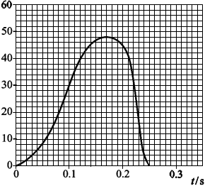

**Fig. 3.1**

1. Use the graph to find:

**1** the maximum force applied to the ball …………………. .N

**2** the time the boot is in contact with the ball………………s.

**[1]**

**(ii)** The mean force multiplied by the time of contact is called the impulse delivered to the ball. The impulse delivered to the ball is about 6.5 N s.

Explain how you would use the graph to show that the impulse has this value.

.......................................................................................................................

.......................................................................................................................

.......................................................................................................................

................................................................................................................ **[2]**

**(b)** The mass of the ball is 0.60 kg. Use your answers in **(a)** to calculate

**(i)** the maximum acceleration of the ball

acceleration = ………………. m s−2 **[2]**

1. the final speed of the ball.

speed = ………………….. m s−1 **[2]**

**13 (a)** Define the *force constant* of a spring.

.................................................................................................................................

........................................................................................................................... **[1]**

**(b) Fig. 3.1** shows a trolley attached by two **stretched** springs **A** and **B** to fixed supports.

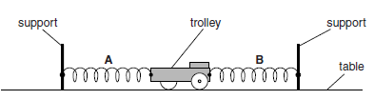

**Fig. 3.1**

The trolley is on a horizontal table and at rest. The springs **A** and **B** are identical.

**(i)** On **Fig. 3.1**, draw an arrow to show the direction of the force exerted by spring **A** on the trolley. Label this arrow **F. [1]**

**(ii)** The mass of the trolley is 0.80 kg. The force constant of each spring is 14 N m–1. A student pulls the trolley to the left as shown in **Fig. 3.2**.

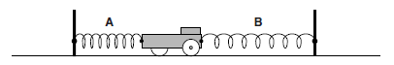

**Fig. 3.2**

The extension of spring A is 0.30 m and the extension of spring B is 0.50 m. The student releases the trolley. Calculate the initial values of

**1** the acceleration of the trolley

acceleration = ................................................ m s–2 **[3]**

**2** the ratio



ratio = ......................................................... **[2]**

**(iii)** Explain why the acceleration of the trolley decreases as it travels a small distance to the right.

.......................................................................................................................

.................................................................................................................. **[1]**

**(iv)** State and explain how the acceleration in your answer to (ii)1 would be different when a heavy object is fixed to the trolley.

.......................................................................................................................

.......................................................................................................................

.......................................................................................................................

.................................................................................................................. **[2]**

**14** The braking distance of an empty van travelling at a steady speed on a level road is 50 m.

The van is now fully loaded with goods and travels at the same speed on the same road.

Explain whether or not the braking distance would be the same. Assume that the driver applies the same braking force.

..........................................................................................................................................

..........................................................................................................................................

..........................................................................................................................................

..........................................................................................................................................

..........................................................................................................................................

..........................................................................................................................................

.................................................................................................................................... **[3]**

**15 Fig. 3.1** shows the stress against strain graph for a metal X up to its breaking point.

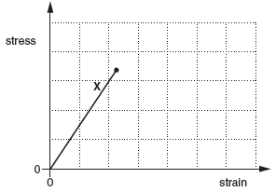

**Fig. 3.1**

**(i)** Use **Fig. 3.1** to state the physical properties of this metal.

*In your answer, you should use appropriate technical terms, spelled correctly.*

.................................................................................................................................

.................................................................................................................................

.................................................................................................................................

........................................................................................................................... **[2]**

**(ii)** On the axes of **Fig. 3.1**, sketch a graph for a ductile material, having a larger Young modulus value than the metal **X**, up to its breaking point. **[2]**

**16** A student is given a metre rule, a stopwatch and a tennis ball.

Explain how this equipment can be used to determine an approximate value for the acceleration *g* of free fall.

..........................................................................................................................................

..........................................................................................................................................

..........................................................................................................................................

..........................................................................................................................................

..........................................................................................................................................

..........................................................................................................................................

.................................................................................................................................... **[3]**

**17 Fig. 6.1** shows an electric crane lifting a mechanical digger.

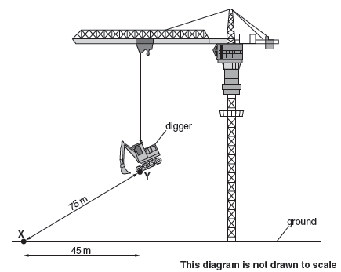

**Fig. 6.1**

The mass of the digger is 5200 kg. The crane takes 1.5 minutes to lift the digger from **X** to **Y**.

**(i)** Calculate the rate of work done to lift the digger from **X** to **Y**.

rate of work done = ................................................. J s–1 **[3]**

**(ii)** The total input power to the motors of the crane is 170 kW. Calculate the efficiency of the lifting operation.

efficiency = ..................................................... % **[1]**

**[Total Marks: 50]**

**MARK SCHEME**

**CATEGORISATION OF MARKS**

The marking schemes categorise marks on the MACB scheme.

**B** marks: These are awarded as independent marks, which do not depend on other marks. For a **B**-mark to be scored, the point to which it refers must be seen specifically in the candidate’s answers.

**M** marks: These are method marks upon which **A**-marks (accuracy marks) later depend. For an **M**-mark to be scored, the point to which it refers must be seen in the candidate’s answers. If a candidate fails to score a particular **M**-mark, then none of the dependent **A**-marks can be scored.

**C** marks: These are compensatory method marks which can be scored even if the points to which they refer are not written down by the candidate, providing subsequent working gives evidence that they must have known it. For example, if an equation carries a **C**-mark and the candidate does not write down the actual equation but does correct working which shows the candidate knew the equation, then the **C**-mark is given.

**A** marks: These are accuracy or answer marks, which either depend on an **M**-mark, or allow a **C**-mark to be scored.

**Note about significant figures:**

If the data given in a question is to 2 sf, then allow to 2 or more significant figures.

If an answer is given to fewer than 2 sf, then penalise once only in the entire paper.

Any exception to this rule will be mentioned in the Additional Guidance.

**MARK SCHEME**

| **Question** | **Mks** | **Answer** | **Question Source and Guidance Notes** | **Topics** | **Demand** |
| --- | --- | --- | --- | --- | --- |
| **1** | 1 | D | *Q2 - GCE - Physics A - Specimen - H156/01* | Forces in action; Dynamics | H |
| **2** | 1 | D | *Q3 - GCE - Physics A - Specimen - H156/01* | Forces in action; Dynamics; Density and pressure | L |
| **3** | 1 | C | *Q4 - GCE - Physics A - Specimen - H156/01* | Materials; Springs | L |
| **4** | 1 | D | *Q5 - GCE - Physics A - Specimen - H156/01* | Forces in action; Dynamics; Motion with non-uniform acceleration | L |
| **5** | 1 | A | *Q6 - GCE - Physics A - Specimen - H156/01* | Forces in action; Density and pressure; Dynamics | M |
| **6** | 1 | C | *Q7 - GCE - Physics A - Specimen - H156/01* | Forces in action; Motion with non-uniform acceleration | L |
| **7** | 1 | A | *Q8 - GCE - Physics A - Specimen - H156/01* | Work, energy and power; Power | H |
| **8** | 1 | A | *Q9 - GCE - Physics A - Specimen - H156/01* | Motion; Linear motion | H |
| **9** | B1  B1  B1 | Correct use of light-gate and timer or light-gate and data-logger or video technique to determine time interval.  Speed determined by dividing length of car or interrupt card by time taken (to pass through light gate).  Mass of car determined using scales and KE = ½ × mass × speed2. | *Q22(b) - GCE - Physics A - Specimen - H156/01* | Motion; Work, energy and power; Linear motion; Kinetic and potential energies; Practical skills assessed in a written examination; Planning; Implementing; Analysis | L |
| **10(a)(i)** | B1 | Data point plotted to within ± ½ small square and correct line of best fit though all the data points. | *Q23(b)(i) - GCE - Physics A - Specimen - H156/01* | Materials; Mechanical properties of matter; Practical skills assessed in a written examination; Analysis | L,M |
| **10(a)(ii)** | M1  A1 | Gradient of line determined.  *E* = gradient = (8.8 ± 0.1) × 1010 (Pa). | *Q23(b)(ii) - GCE - Physics A - Specimen - H156/01*  **Allow** 1 mark for (8.8 ± 0.1) × 10n Pa; where n ≠ 10 |
| **10(b)** | 3 | The actual cross-sectional area will be smaller.  The actual stress values on the graph will be larger (because stress ∝ area–1)  The gradient of the graph will be larger; hence the Young modulus of the metal must be larger than the student’s value. | *Q23(c) - GCE - Physics A - Specimen - H156/01* | Materials; Mechanical properties of matter; Practical skills assessed in a written examination; Evaluation | M,H |

| **Question** | **Mks** | **Answer** | **Question Source and Guidance Notes** | **Topics** | **Demand** |
| --- | --- | --- | --- | --- | --- |
| **11(i)** | B1 | arrow from rod wall junction through point where T and line of W cross. | *Q1(c)(i) - GCE - Physics A - Specimen - H156/02* | Forces in action; Equilibrium | L |
| **11(ii)** | B1 | require triangle of forces for equilibrium or the forces must pass through a point for equilibrium. | *Q1(c)(ii) - GCE - Physics A - Specimen - H156/02* |
| **12(a)(i)** | A1 | 48 (N);0.25 (s) | *Q3(a)(i) - GCE - Physics A - Specimen - H156/02*  both values correct; no tolerance | Newton’s laws of motion and momentum; Newton’s laws of motion; Practical skills assessed in a written examination; Analysis | L,M |
| **12(a)(ii)** | B1  B1 | estimate area under graph  by counting squares  or  method of estimating mean F  multiplied by time of contact (0.25 s) | *Q3(a)(ii) - GCE - Physics A - Specimen - H156/02*  second mark awarded for some detail about how to estimate area.  e.g. areas above and below mean under curve are equal. |
| **12(b)(i)** | C1  A1 | (F = ma) a = 48/0.6  a = 80 (m s–2) | *Q3(b)(i) - GCE - Physics A - Specimen - H156/02*  **ecf a(i)** | Newton’s laws of motion and momentum; Newton’s laws of motion | L,M |
| **12(b)(ii)** | C1  A1 | (Ft = mv) v = 6.5/0.6  v = 11 (m s–1) | *Q3(b)(ii) - GCE - Physics A - Specimen - H156/02*  **ecf a(i)**  **allow** 10.8 |
| **13(a)** | B1 | force/extension or force per (unit) extension | *Q3(a) - GCE - Physics A - June 2013 - G481/01*  **Allow**: force/compression  **Not**: *F* = *kx* and the labels are defined, because *k* is not the subject | Materials; Springs | M |

| **Question** | **Mks** | **Answer** | **Question Source and Guidance Notes** | **Topics** | **Demand** |
| --- | --- | --- | --- | --- | --- |
| **13(b)(i)** | B1 | Arrow showing the force exerted by A is to the left on Fig.3.1 | *Q3(b)(i) - GCE - Physics A - June 2013 - G481/01*  **Allow** an unlabelled arrow | Materials; Forces in action; Springs; Dynamics; Mechanical properties of matter | L,M,H |
| **13(b)(ii)** | C1  C1  A1  C1  A1 | **1**  (*F*A =) 14 x 0.30 (= 4.2 N) or (*F*B =) 14 x 0.50 (=  7.0 N) or (net force =) 2.8 (N)  a = 2.8/0.80  acceleration = 3.5 (m s-2)  **2**  *E* = ½ *Fx* or *E* = ½ *kx*2 or 1.75 (J) or 0.63 (J)  ratio | *Q3(b)(ii) - GCE - Physics A - June 2013 - G481/01*  **Allow**: (net force =) 14 x [0.50 – 0.30] = 2.8 (N)  **Allow**: acceleration of either 5.25 (m s-2) or 8.75 (m s-2)  **Allow** this C1 mark for a = 8.75 – 5.25    *Q3(b)(ii) - GCE - Physics A - June 2013 - G481/01*  **Note**: Using *E* = *Fx* scores zero because of wrong physics  **Note**: Answer to 3 sf is 2.78  **Allow** fractions  (Ignore any units given for the ratio) |
| **13(b)(iii)** | B1 | The resultant force (on the trolley) is smaller (AW) | *Q3(b)(iii) - GCE - Physics A - June 2013 - G481/01* |
| **13(b)(iv)** | M1  A1 | The acceleration decreases  Correct reasoning, eg:  For the same (net force) *F*, a = *F/m* (therefore a is smaller)  For the same (net force) *F*, a x 1*/m* (therefore a is smaller) | *Q3(b)(iv) - GCE - Physics A - June 2013 - G481/01*  **Allow**: *F* = *m*a. As m increases then a must decrease because *F* is constant |
| **14** | B1  B1  B1 | The (braking) distance is more (than 50m)  KE = *Fx*  Correct reasoning for longer braking distance, eg: (KE increases and) x KE  Or  The (braking) distance is more (than 50m)  The van has smaller deceleration (for the same force)  Correct reasoning for longer braking distance in terms of *v*2 = *u*2 + 2*as* | *Q7(b) - GCE - Physics A - June 2013 - G481/01*  Alternative:  *Fx* = ½ *mv*2 B1  Correct reasoning for longer braking distance, eg:  x m B1  **Allow**: smaller acceleration  **Allow**: Correct reasoning for longer distance in terms of equations of motion | Work, energy and power; Work and conservation of energy; Kinetic and potential energies | L,M |
| **15(i)** | B1  B1 | The material is brittle.  The material is also elastic. | *Q3(a)(i) - GCE - Physics A - June 2014 - G481/01*  **The term *brittle* to be included and spelled correctly to gain the first B1 mark.**  **Allow** ‘does not show plastic (deformation)’ | Materials; Springs; Mechanical properties of matter | L |
| **15(ii)** | B1  B1 | Straight line through origin followed by correct curve to show plastic behaviour.  Straight line has greater gradient than X. | *Q3(a)(ii) - GCE - Physics A - June 2014 - G481/01*  **Note**: Tolerance for the origin is shown below |
| **16** | B1  B1  B1 | Drop the ball from a given height and measure time of fall.  *s* = *ut* + ½ *at*2 and *u* = 0 or *s* = ½ *at*2  (The acceleration of free fall is determined using) a = 2*s*/*t*2 | *Q4(b) - GCE - Physics A - June 2014 - G481/01*  **Allow** *a* ≡ *g* and *h* ≡ *s*  **Note**: a must be the subject to gain this B1 mark  **Note**: a = 2*s*/*t*2 will score the last two B1 marks  **Allow** full credit for graphical approach: Drop ball from different heights & measure the times of fall (B1) ; plot a graph of *s* against *t*2 (B1) ; *g* = 2 × gradient (B1) | Motion; Linear motion | L,M |
| **17(i)** | C1  C1  A1 | vertical distance = (752 – 452)1/2 or vertical distance = 60 (m)  work done = 5200 × 9.81 × 60 or work done = 3.06 × 106 (J)  power = 3.06 × 106/90  power = 3.4 × 104 (J s-1) | *Q6(d)(i) - GCE - Physics A - June 2014 - G481/01*  **Allow** 2 marks for an answer of 2.04 × 106 (J s-1); 1.5 used instead of 90 s  No credit for [5200 × g × 75]/90 or [5200 × g × 45]/90 | Work, energy and power; Kinetic and potential energies; Power | L,M |
| **17(ii)** | B1 |  | *Q6(d)(ii) - GCE - Physics A - June 2014 - G481/01*  **Possible ecf from (i)** |
| **Total** | **50** |  |  |  |  |

**OCR Resources**: *the small print*OCR’s resources are provided to support the teaching of OCR specifications, but in no way constitute an endorsed teaching method that is required by the Board, and the decision to use them lies with the individual teacher. Whilst every effort is made to ensure the accuracy of the content, OCR cannot be held responsible for any errors or omissions within these resources. We update our resources on a regular basis, so please check the OCR website to ensure you have the most up to date version.  
© OCR 2016