Investigating Terminal Velocity

Aim
In this activity you will drop a steel ball in a tube containing a viscous fluid (e.g. oil) and measure the distance travelled in equal time intervals. You will then organise your measurements and process them to help you to plot a displacement -time graph. Using the graph, you will determine a value for the terminal velocity of the ball as it falls in the viscous fluid.
Time required for activity: 90 min

Introduction
Prior GCSE Knowledge: Sketch and label the forces that act on a parachutist who is free-falling and who has reached a terminal velocity.
The forces acting on a ball which is falling at a terminal velocity in a viscous fluid may similarly be equated. (A viscous fluid is one that provides a resistance to motion within it.)
A Level Knowledge: A ball that is stationary and suspended in a liquid, experiences an upward force (Archimedes’ Principle) which is equal to the weight of liquid displaced by the ball.
When a ball is falling through a viscous liquid, it experiences two upwards forces:
1. the upthrust (equal to the weight of viscous liquid displaced) and
2. a frictional force as the ball moves through the viscous liquid. (A liquid such as oil is more viscous than water, as it has a larger resistance to flow.)
When the ball reaches terminal velocity:
weight of the ball = weight of the liquid displaced (Archimedes Principle) + frictional force (due to movement in the liquid)

Key Stages of the activity
The radius of the ball is determined from measuring the diameter. The volume of the ball is also determined from the diameter (and hence the volume of liquid displaced).
The density of the liquid is determined using the equation: density = mass ÷ volume.
The ball is dropped through the liquid, and measurements of displacement are recorded at fixed time intervals. The results are plotted on a displacement–time graph.
The terminal velocity of the ball in the liquid is determined.

Extension:
The frictional force of the ball due to the viscous fluid is calculated.
The uncertainty in the value for the terminal velocity is determined together with a value for the viscosity of the liquid.

Specification Content Links
Physics A H556: 3.1.1 a; 3.1.1 b; 3.1.1 c; 3.2.1b; 3.2.2 a; 3.2.2 b; 3.2.2 c; 3.2.2 di; 3.2.2 dii; 3.2.4 a; 3.2.4 c
Physics B Advancing Physics H557: 4.2 avii; 4.2 bii; 4.2 ciii; 4.2 diii

Health and Safety
Work carefully when dropping the ball into the liquid, to avoid spilling the liquid or knocking the glass tube over.
The steel ball will be covered in the liquid when retrieved from the tube.

Equipment
- measuring cylinder
- beaker containing viscous liquid (e.g.oil)
- tube filled with viscous liquid
- small elastic bands (>6) and other method of marking distances along tube (e.g. a felt-tipped pen)
- steel ball
- magnet
- metre rule
- stopwatch
- paper towels
- access to a balance and micrometer

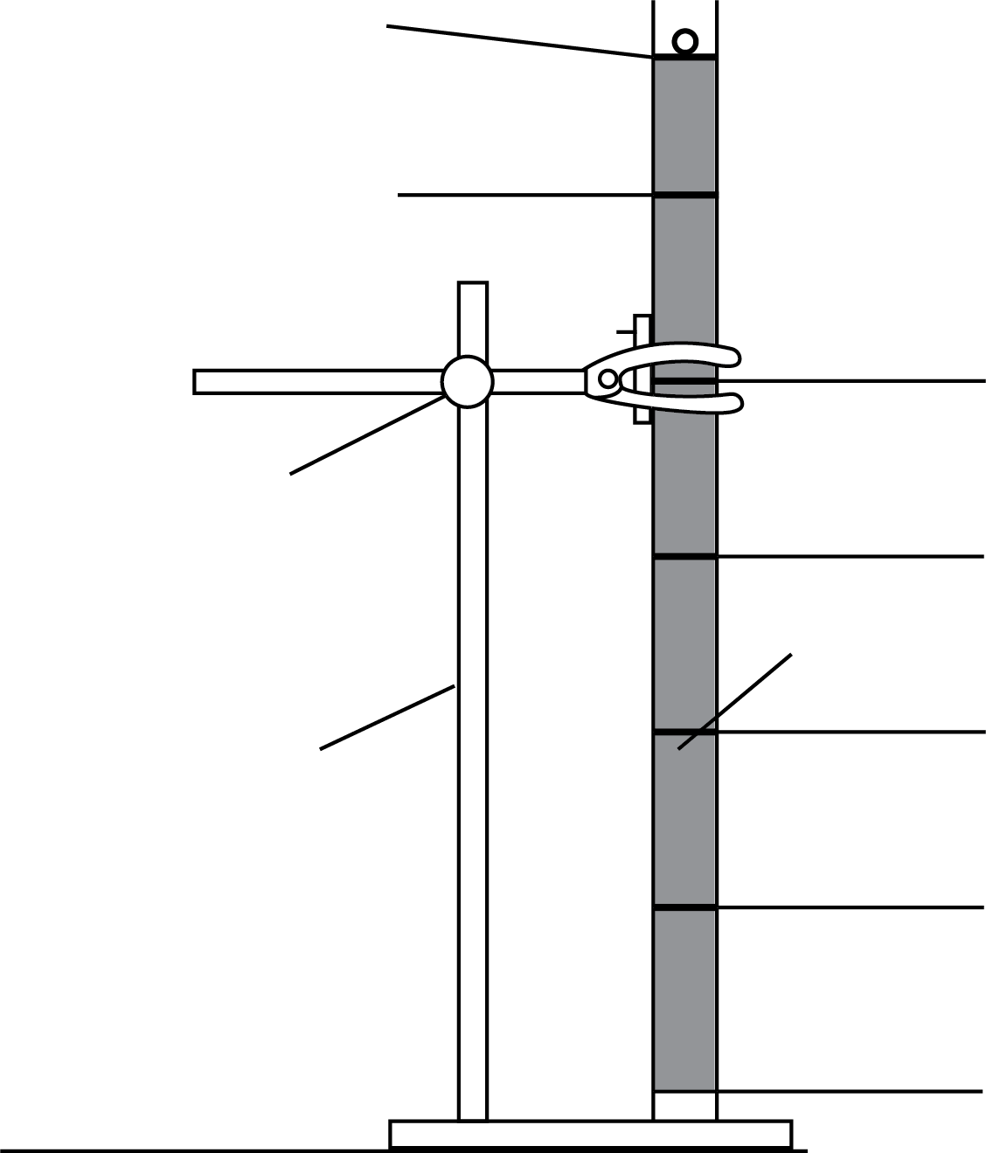
displacement s = 0
displacement s = 0
elastic band s₁
elastic band s₂
elastic band s₃
elastic band s₄
elastic band s₅
elastic band s₆
viscous liquid
stand
boss

Fig. 1

Procedure | Understanding
- Measure and record the mass m and diameter d of the steel ball. | Record the measurements to the appropriate number of decimal places, to match the resolution of the measuring instruments.  How do you know the ball is spherical? Can you check by measuring the diameter several times?
- Carefully drop the ball into the centre of the liquid and watch it fall. See Fig. 1.  Measure the time it takes for the ball to fall through the length of liquid in the tube. | Consider how the resolution of the stopwatch  compares to your reaction time.
- As the ball falls through the liquid, use a felt-tipped pen on the glass tube to mark the positions of the ball at fixed time intervals (e.g. every 2 seconds)  Use the value you measured in Step 2 to decide on the time intervals so that you have six marked positions of the ball before it hits the bottom of the tube.  Placing rubber bands around the tube at the felt-tipped marks will help you to see the positions more clearly.  A magnet may be used to drag the steel ball out of the tube to repeat your measurements and refine the position of the rubber bands. | How will you estimate an uncertainty in the position of your mark for each time interval?  If the repeated data differs from the first set of data, what action will you take to position the rubber bands as accurately as possible?
- Use the metre rule to determine the six displacements from the top of the liquid s₁ to s₆, marked by each band/mark.
- Record all your results in a table. | Which column should contain the independent variable?  Consider the number of decimal places to which data will be recorded in each column.
- Plot a graph of displacement s, on the y-axis against time t (from the release of the ball) on the x-axis. | Have you labelled the axes with the quantities and  units?
- If the ball reached terminal velocity, then it will be clear that there is a section of the graph with constant gradient. Draw a straight line of best fit for this section. Determine a value for the terminal velocity of the ball in the liquid. | The gradient of a displacement–time graph is the velocity.  When determining the gradient from a triangle on the linear region of the graph, the length of the hypotenuse must be greater than half of the length of the linear region drawn.
- How could you improve the accuracy of the measurements? | What alternative apparatus arrangements could be used to reduce the uncertainty in the results?

Extension Activities and Further Investigations

Extension 1: to determine the uncertainty in the value of the terminal velocity
Procedure | Understanding
- Using the uncertainty in the measurement of time, add horizontal error bars to the linear section of your displacement–time graph. | Vertical error bars could also be drawn if a record of all of the felt-tipped marks at each time interval were kept. The error at each value for time would be +/- half of the range of displacement values.
- Draw a worst acceptable fit line and determine an uncertainty in the value for the terminal velocity. | Does it matter if you draw the steepest or shallowest line when determining a worst acceptable value for the terminal velocity?

Extension 2: to determine a value for the upthrust on the ball when totally immersed in the viscous liquid
Procedure | Understanding
- Measure the mass of an empty measuring cylinder. Pour some of the viscous liquid into the measuring cylinder.  Record the volume of liquid and the new mass of the measuring cylinder and contents. | What is the resolution of the balance (the smallest  difference it can detect)?  Why is the resolution important?  If the reading ends with a zero after the decimal  point, why is it important to record the zero?
- Determine the density of the liquid. | Use the equation density = mass ÷ volume  What units should you use for density?
- Use the mass balance to measure the mass of the steel ball.
- Use the micrometer to measure the diameter d of the steel ball. | Why is this measurement taken more than once at different positions around the ball?
- Calculate a value for the upthrust on the ball due to the liquid. | According to Archimedes’ Principle, how is the upthrust related to the weight of fluid displaced?

Extension 3: to determine a value for the frictional force due to the viscous fluid and hence determine a value for the coefficient of viscosity of the liquid, with an uncertainty
Procedure | Understanding
- By equating the downward and upward forces when the terminal velocity has been reached, determine a value for the frictional force due to the viscous fluid. | Use the equation outlined in the introduction:  weight of the ball = upthrust (Archimedes’ Principle) + frictional force (due to the viscous fluid)
- The frictional force F is related to the radius of the ball and the terminal velocity by the equation  F = 6πη r v  where:  η = coefficient of viscosity of liquid  r = radius of the ball  m = mass of the ball  ρ = density of the liquid  g = acceleration of free fall  ν = terminal velocity  Determine a value for the coefficient of viscosity η of the viscous fluid. | Warm honey is less ‘runny’ than water.  Does honey have a higher or lower coefficient of viscosity than water?
- Calculate an absolute uncertainty in your value for η. | Combine the percentage uncertainties for each measurement made and convert this to an absolute uncertainty.

Practical skills, apparatus and techniques assessed
a | Reference | Description of skill/technique
 | 1.2.1 b | Safely and correctly uses a range of practical equipment and materials including digital timer and metre rule / ruler
 | 1.2.1 c | Follows written instructions
 | 1.2.1 d | Make and record observations / measurements including time and distance
 | 1.2.1 e | Keep an appropriate record of experimental activities
 | 1.2.1 f | Present information and data in a scientific way to include the appropriate number of decimal places for each measurement.
 | 1.2.2 b | Use of appropriate digital instruments, e.g. digital timer
 | 1.2.2 c | Use of methods to increase accuracy of measurements, e.g. measuring the diameter several times across different planes on the ball and calculating an average
 | 1.2.2 d | Use of stopwatch for timing
 | 1.2.2 e | Use of caliper and/or micrometer for small distances

Scientific and Practical Understanding
Measurement of time: while a stopwatch may measure time with a resolution of 0.01 s or 0.001 s, the
operator reaction time is significantly longer and may vary, increasing the total uncertainty in the measurement.
Repeat drops will produce a range of values for the displacement measured (at any specific time). The spread of these displacement values may be used as an indication of uncertainty.
Uncertainties may be estimated by using either:
- the fraction of the measurement that the instrument resolution produces or
- +/- half of the range of a set of repeat readings.
It is important that errors in measurement are minimised. The tube of liquid should be vertical for the duration of the experiment. Refined readings should be taken with the eye level with each mark.
If the ball falls along (or very close to) the edge of the tube, the drop should be repeated, as other forces will affect the motion of the ball.
The use of a mobile phone camera to take a video of the falling ball allows the frame to be frozen (depending on the frame rate used) to at least the nearest 0.1s. This will enable a degree of fine adjustment in the position of the elastic band/mark.

Notes and References
Value bath bubble liquid or similar such products may have suitable viscosity.
Health and safety should always be considered before undertaking any practical work. A full risk assessment of any activity should always be undertaken.
It is advisable to check the CLEAPSS website in advance of undertaking the practical tasks.
We recommend that this practical is trialled in advance of giving it to students. Keep the trial results as part of centre records for assessing the Practical Endorsement.

Health & Safety
Materials being dropped should not be likely to break or shatter. Care should also be taken to avoid possible injury from dropped materials.
If using wallpaper paste as the viscous liquid, use a non-fungicide version.
If using any soap or detergent product staff should determine that no student has an allergy to that product.
Before carrying out any experiment or demonstration based on this guidance, it is the responsibility of teachers to make sure that they have undertaken a risk assessment in accordance with their employer’s requirements, making use of up-to-date information and taking account of their own particular circumstances. Any local rules or restrictions issued by the employer must always be followed.

